Task 6: Password Strength Evaluation
Cybersecurity Internship — Elevate Labs
Tool Used: Bitwarden Password Strength Tester (bitwarden.com/password-strength/)

1. Objective
Understand what makes a password strong by creating passwords with varying complexity and evaluating them using an online password strength checker. Identify best practices for password creation and analyze how complexity affects resistance to common attacks.

2. Passwords Tested & Results
Three passwords of varying complexity were created and tested on the Bitwarden Password Strength Testing Tool:

Password | Strength | Crack Time | Length | Character Types
1234567890 | Very Weak | Less Than A Second | 10 chars | 10 digits only
Bddfgs@1235 | Good | 1 Month | 11 chars | Upper+Lower+Special+Digits
Ahkgjjhv@1432676 | Strong | Centuries | 16 chars | Upper+Lower+Special+Digits, longer

3. Test Results — Detailed

3.1 Password 1: 1234567890 (Very Weak)
Strength Rating: Very Weak
Estimated Crack Time: Less Than A Second
Analysis:
- Contains only sequential digits — extremely predictable
- No uppercase, lowercase, or special characters
- Trivially cracked by dictionary and brute-force attacks
- Appears in every common password list

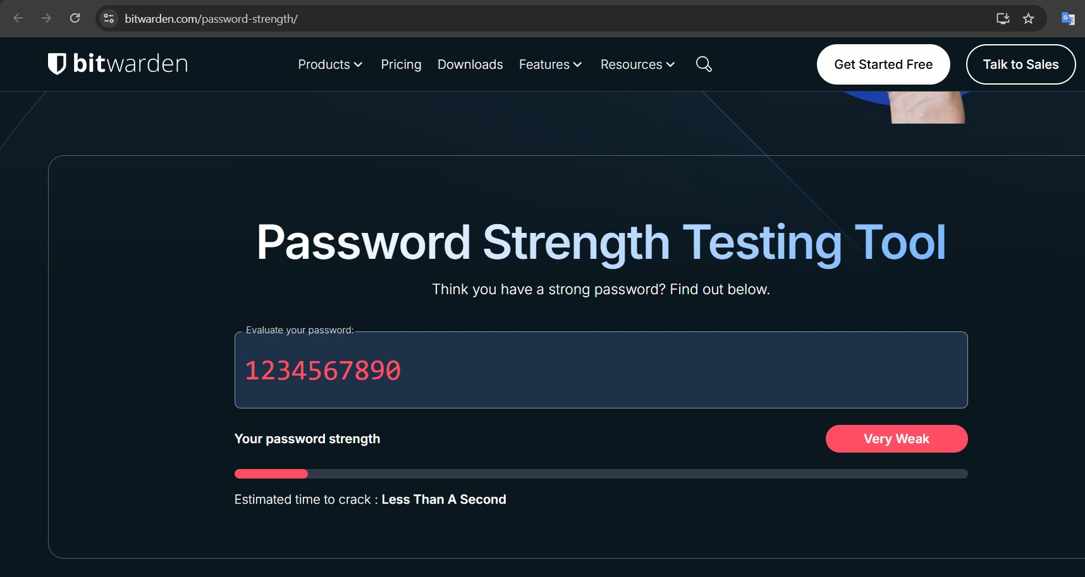

3.2 Password 2: Bddfgs@1235 (Good)
Strength Rating: Good
Estimated Crack Time: 1 Month
Analysis:
- Mixes uppercase, lowercase, numbers, and special character (@)
- 11 characters — sufficient length
- Not a dictionary word — random-looking string
- 1 month crack time means not yet brute-force resistant at scale
- Adding more length or symbols would push to 'Strong'

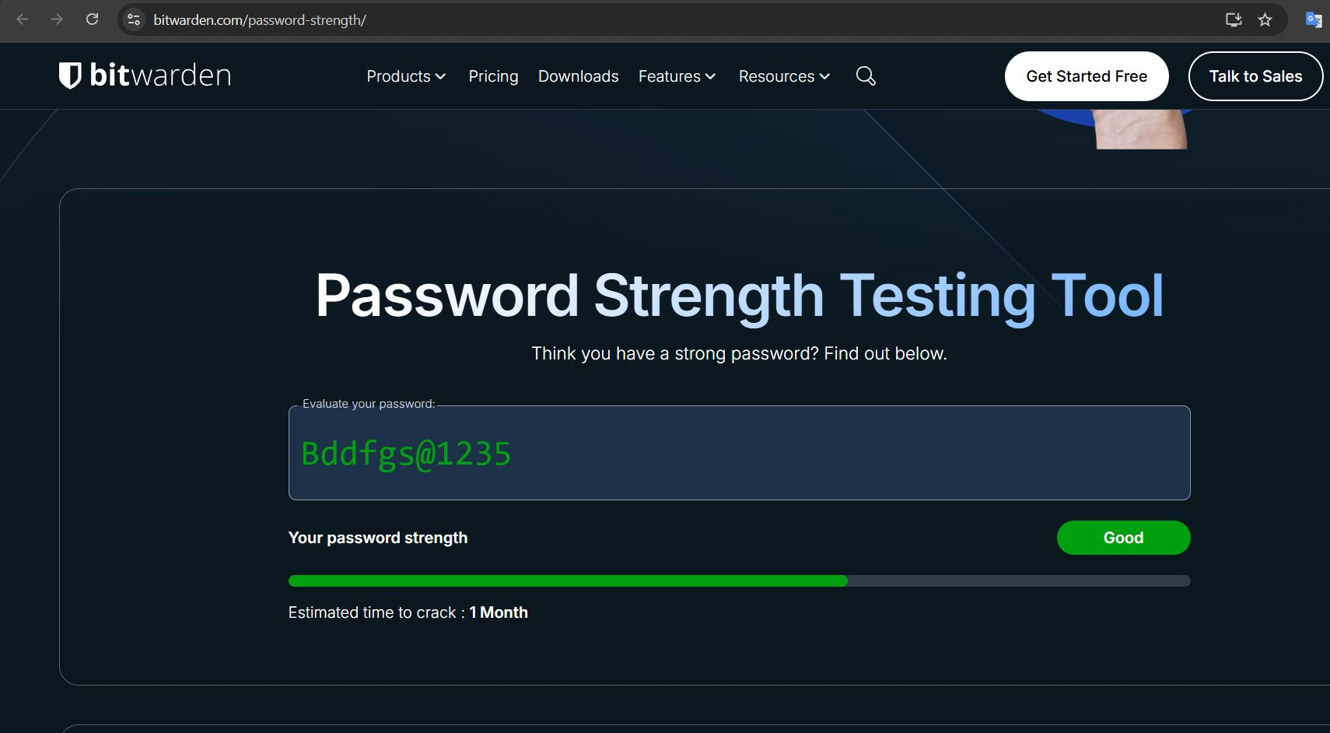

3.3 Password 3: Ahkgjjhv@1432676 (Strong)
Strength Rating: Strong
Estimated Crack Time: Centuries
Analysis:
- 16 characters — length is the biggest strength factor
- Contains uppercase, lowercase, digits, and special character (@)
- Estimated crack time: Centuries — effectively uncrackable
- Optimal for real-world use in accounts requiring high security

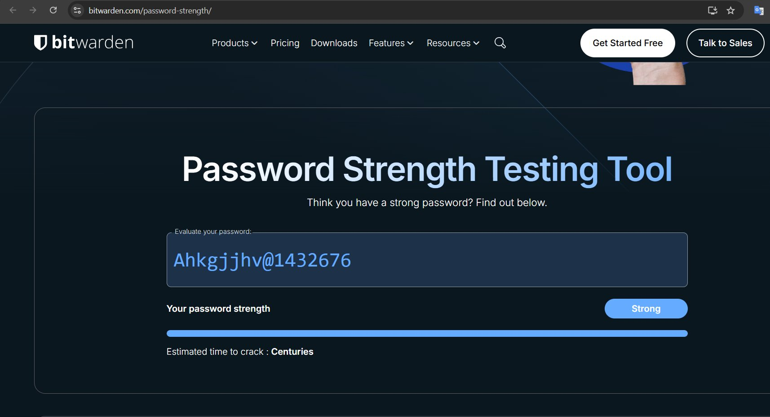

4. Common Password Attacks

4.1 Brute Force Attack
- Tries every possible combination of characters
- Time depends directly on password length and character set size
- Example: 6-char lowercase = 26^6 = ~300 million combinations
- Counter: long passwords (14+ chars) make brute force computationally infeasible

4.2 Dictionary Attack
- Uses wordlists of common passwords, words, and known leaked passwords
- Highly effective against passwords like '1234567890', 'password', 'qwerty'
- Hybrid attacks combine dictionary words with number/symbol substitutions
- Counter: avoid real words; use random character strings or passphrases

4.3 Credential Stuffing
- Uses previously leaked username/password pairs from data breaches
- Effective when users reuse passwords across multiple sites
- Counter: unique password for every account

5. Best Practices for Strong Passwords
- Minimum 12–16 characters in length
- Mix uppercase, lowercase, numbers, and special characters (!@#$%^&*)
- Avoid sequential patterns: no 1234, abcd, qwerty
- Avoid personal info: names, DOB, phone numbers
- Use a different password for every account
- Use a password manager (e.g., Bitwarden, KeePass) to manage complexity
- Enable MFA/2FA wherever available as additional layer
- Passphrases (4+ random words) are strong and memorable: e.g., 'Horse-Lamp-River-42!'

6. Conclusion
This task demonstrated how password complexity directly impacts resistance to attack. A simple numeric password ('1234567890') was crackable in under a second, while a 16-character mixed-type password ('Ahkgjjhv@1432676') would take centuries to brute force. The key takeaways are: length matters most, character diversity multiplies the search space, and random non-dictionary strings are always safer than recognizable patterns. Using a password manager to generate and store long, random passwords is the recommended practice for real-world security.

— End of Task 6 Report —

