**Embedded System Design Lab**

**Experiment : Sound Generation using Digital to Analog converter**

**Aim:** To generate analog output signal from TM4C using digital to analog converter.

**Components**: Tiva Launchpad, breadboard, wires, resistors ,headphone/speakers, push buttons.

**DAC:** Digital to analog converter circuits are widely used in embedded systems to convert digital data to analog signal. The DAC circuitry is implemented in two methods, they are binary-weighted DAC, and R-2R ladder circuit.

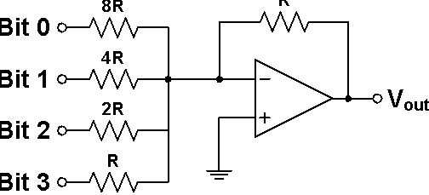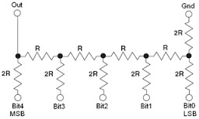

R-2R Ladder circuit Binary-weighted circuit

**Converting digital sound to analog:**

In this experiment, musical notes will be generated which are familiar to us. Most of these notes are sinusoidal waves with specific frequency. The sinusoidal wave can be stored digitally by quantizing and sampling the signal. The quantized value of the sinusoid is stored in an array. After each sampling interval, the digital sinusoid value is sent to the output pins. These pins are connected to DAC circuitry which converts digital data to analog signal.

To estimate the sampling interval, let’s take an example of 100Hz sine wave. If we would like to quantize this to 4 bit, the minimum number of samples required for faithful reproduction of analog signal is 16. The sampling period for this case becomes (1/100*16) = 0.625ms (sampling rate 16 times the given frequency). Hence at every 0.625ms, the system should output digital data to the pins.

To achieve this sampling interval, we use SysTick timer. The reload value for a particular frequency *f* with *n* samples for one period is,

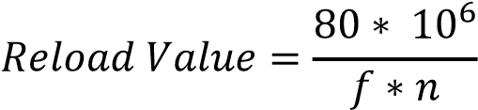

**Schematic for 3-bit DAC:**

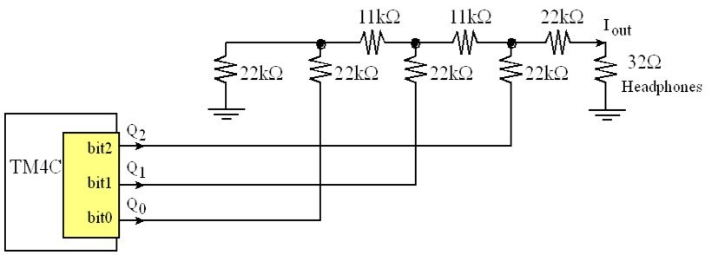

**Exercise 1:** Generate a sine wave of a tone of your choice and listen to the tone using headphone/speaker.

**Exercise 2:** Design a 4-input digital piano which will generate four different tones for four push button switches. 0