**PlayStation 4 AND Xbox One**

The **PlayStation 4** and the **Xbox One** video game consoles offer significant

improvements over — and break compatibility with — the previous generation

consoles in their respective families: the PS3 and Xbox 360, each of which sold

over 100 million units. Both the PS4 and Xbox One offer souped-up graphics

processors, more memory than previous systems, redesigned controllers, and allin-

one access to “apps” like Amazon Prime, Netflix, Hulu, and NFL Network,

among others.

This comparison of the two leading consoles in the market examines their

hardware specs and performance, price, gameplay, and rules governing the

purchase and play of online games.

Both consoles are priced similarly; a $399 Xbox One console without the Kinect is

priced to match the PS4. When Microsoft first released the Xbox One, it was

priced at $499 and the Kinect was bundled in, offering a camera and motion

sensing capabilities.

**Play-Station 4:-**

The **PlayStation 4** (officially abbreviated as **PS4**) is an [eighth-generation](https://en.wikipedia.org/wiki/Eighth_generation_of_video_game_consoles) [home video game console](https://en.wikipedia.org/wiki/Home_video_game_console) developed by [Sony Interactive Entertainment](https://en.wikipedia.org/wiki/Sony_Interactive_Entertainment). Announced as the successor to the [PlayStation 3](https://en.wikipedia.org/wiki/PlayStation_3) in February 2013, it was launched on November 15 in North America, November 29 in Europe, South America and Australia, and on February 22, 2014, in Japan. It competes with [Microsoft](https://en.wikipedia.org/wiki/Microsoft)'s [Xbox One](https://en.wikipedia.org/wiki/Xbox_One) and [Nintendo](https://en.wikipedia.org/wiki/Nintendo)'s [Wii U](https://en.wikipedia.org/wiki/Wii_U" \o "Wii U) and [Switch](https://en.wikipedia.org/wiki/Nintendo_Switch).

Moving away from the more complex [Cell microarchitecture](https://en.wikipedia.org/wiki/Cell_(microprocessor)) of its predecessor, the console features an [AMD](https://en.wikipedia.org/wiki/Advanced_Micro_Devices" \o "Advanced Micro Devices)[Accelerated Processing Unit](https://en.wikipedia.org/wiki/AMD_Accelerated_Processing_Unit) (APU) built upon the [x86-64](https://en.wikipedia.org/wiki/X86-64) architecture, which can theoretically peak at 1.84 [teraflops](https://en.wikipedia.org/wiki/Teraflops); AMD stated that it was the "most powerful" APU it had developed to date. The PlayStation 4 places an increased emphasis on social interaction and integration with other devices and services, including the ability to play games off-console on [PlayStation Vita](https://en.wikipedia.org/wiki/PlayStation_Vita) and other supported devices ("[Remote Play](https://en.wikipedia.org/wiki/Remote_Play)"), the ability to [stream](https://en.wikipedia.org/wiki/Screencast) gameplay online or to friends, with them controlling gameplay remotely ("Share Play"). The console's [controller](https://en.wikipedia.org/wiki/DualShock#DualShock_4) was also redesigned and improved over the PlayStation 3, with improved buttons and analog sticks, and an integrated [touchpad](https://en.wikipedia.org/wiki/Touchpad) among other changes. The console also supports [HDR10](https://en.wikipedia.org/wiki/HDR10) [High-dynamic-range video](https://en.wikipedia.org/wiki/High-dynamic-range_video) and playback of [4K resolution](https://en.wikipedia.org/wiki/4K_resolution) multimedia.

The PlayStation 4 was released to critical acclaim, with critics praising Sony for acknowledging its consumers' needs, embracing [independent game development](https://en.wikipedia.org/wiki/Independent_game_development), and for not imposing the restrictive [digital rights management](https://en.wikipedia.org/wiki/Digital_rights_management) schemes like those originally announced by Microsoft for the Xbox One. Critics and third-party studios also praised the capabilities of the PlayStation 4 in comparison to its competitors; developers described the performance difference between the console and Xbox One as "significant" and "obvious".[[11]](https://en.wikipedia.org/wiki/PlayStation_4#cite_note-edge-11) Heightened demand also helped Sony top global console sales. By the end of December 2018, over 94 million PlayStation 4 consoles had been shipped worldwide, surpassing lifetime sales of the PlayStation 3.

On September 7, 2016, Sony unveiled the PlayStation 4 Slim, a smaller version of the console; and a high-end version called the PlayStation 4 Pro, which features an upgraded GPU and a higher CPU [clock rate](https://en.wikipedia.org/wiki/Clock_rate) to support enhanced performance and 4K resolution in supported games.

**Technical specifications :-**

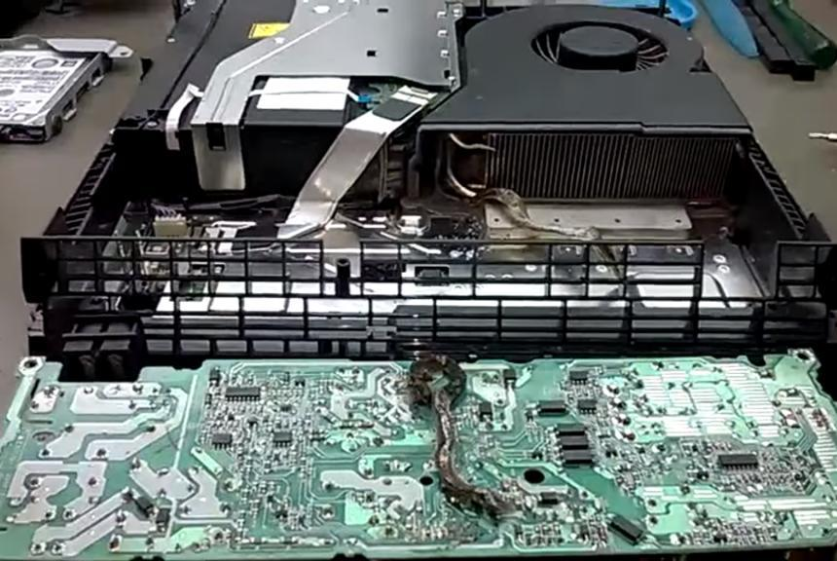

The PlayStation 4 uses an [Accelerated Processing Unit](https://en.wikipedia.org/wiki/Accelerated_Processing_Unit) (APU) developed by [AMD](https://en.wikipedia.org/wiki/AMD) in cooperation with Sony. It combines a [central processing unit](https://en.wikipedia.org/wiki/Central_processing_unit) (CPU) and [graphics processing unit](https://en.wikipedia.org/wiki/Graphics_processing_unit) (GPU), as well as other components such as a [memory controller](https://en.wikipedia.org/wiki/Memory_controller) and [video decoder](https://en.wikipedia.org/wiki/Video_decoder). The CPU consists of two [quad-core](https://en.wikipedia.org/wiki/Multi-core_processor) [Jaguar modules](https://en.wikipedia.org/wiki/Jaguar_(microarchitecture)) totaling 8 [x86-64](https://en.wikipedia.org/wiki/X86-64)cores, 7 of which are available for game developers to use. The GPU consists of 18 compute units to produce a theoretical peak performance of 1.84 [TFLOPS](https://en.wikipedia.org/wiki/FLOPS). The system's GDDR5 memory is capable of running at a maximum clock frequency of 2.75 GHz (5500 MT/s) and has a maximum memory bandwidth of 176 GB/s. The console contains 8 GB of [GDDR5](https://en.wikipedia.org/wiki/GDDR5) memory, 16 times the amount of RAM found in the PS3 and is expected to give the console considerable longevity. It also includes secondary custom chips that handle tasks associated with downloading, uploading, and social gameplay. These tasks can be handled seamlessly in the background during gameplay or while the system is in [sleep mode](https://en.wikipedia.org/wiki/Sleep_mode). The console also contains an audio module, which can support in-game chat as well as "a very large number" of audio streams for use in-game. All PlayStation 4 models support [high dynamic range](https://en.wikipedia.org/wiki/High_dynamic_range) (HDR) color profiles.

Its read-only optical drive is capable of reading [Blu-ray Discs](https://en.wikipedia.org/wiki/Blu-ray_Disc" \o "Blu-ray Disc) at speeds of up to three times that of its predecessor. The console features a hardware on-the-fly [zlib](https://en.wikipedia.org/wiki/Zlib" \o "Zlib)decompression module. The original PS4 model can output in [4K](https://en.wikipedia.org/wiki/4K_resolution) and play multimedia in the format, but does not play games in 4K. The console includes a 500 gigabyte hard drive for additional storage, which can be upgraded by the user. System Software 4.50, which was released on March 9, 2017, enabled the use of external USB hard drives up to 8 TB for additional storage.

The PlayStation 4 features [Wi-Fi](https://en.wikipedia.org/wiki/Wi-Fi) and [Ethernet](https://en.wikipedia.org/wiki/Ethernet) connectivity, [Bluetooth](https://en.wikipedia.org/wiki/Bluetooth), and two [USB 3.0](https://en.wikipedia.org/wiki/USB_3.0) ports. An auxiliary port is also included for connection to the [PlayStation Camera](https://en.wikipedia.org/wiki/PlayStation_4#PlayStation_Camera), a [motion detection](https://en.wikipedia.org/wiki/Motion_detection) digital camera device first introduced on the PS3. A mono headset, which can be plugged into the DualShock 4, is bundled with the system. Audio/video output options include [HDMI](https://en.wikipedia.org/wiki/HDMI) TV and [optical](https://en.wikipedia.org/wiki/TOSLINK) [S/PDIF](https://en.wikipedia.org/wiki/S/PDIF) audio. The console does not have an [analog](https://en.wikipedia.org/wiki/Analog_recording) audio/video output.

The PS4 features a "[Rest mode](https://en.wikipedia.org/wiki/Sleep_mode)" feature. This places the console in a low-power state, while allowing users to immediately resume their game or app once the console is awoken. The console also is able to download content such as game and OS updates while it is in this state.

### Controllers:-

### Image result for playstation 4 controller

The [DualShock 4](https://en.wikipedia.org/wiki/DualShock" \l "DualShock_4" \o "DualShock) is PlayStation 4's primary controller; it maintains a similar design to previous iterations of the DualShock series, but with additional features and design refinements. Among other tweaks, the caps of the analog sticks were given a concave design (similar to the [Xbox 360 controller](https://en.wikipedia.org/wiki/Xbox_360_controller)), the shape of the triggers and shoulder buttons were refined, the D-pad buttons were given a steeper downward angle to provide a resting space in the center for the user's thumb, and the hand grips were made thicker and given microtexturing to improve their feel.

A major addition to the DualShock 4 is a [touchpad](https://en.wikipedia.org/wiki/Touchpad); it is capable of detecting up to two simultaneous touch presses, and can also be pressed down as a button.[[74]](https://en.wikipedia.org/wiki/PlayStation_4#cite_note-vb-controller-74) The "Start" and "Select" buttons were replaced by "Options" and "Share" buttons; the latter is designed to allow access to the PlayStation 4's social features (including streaming, video recording, and screenshot tools). The DualShock 4 is powered by a non-removable, rechargeable lithium-ion battery, which can be charged using its [micro USB](https://en.wikipedia.org/wiki/Micro_USB)connector. The controller also features an internal speaker, and a [headphone jack](https://en.wikipedia.org/wiki/Headphone_jack) for headsets or headphones; the console is bundled with a pair of headset [earbuds](https://en.wikipedia.org/wiki/Headphones" \o "Headphones).

The controller's motion tracking system is more sensitive than those of the PlayStation 3's controllers. An [LED](https://en.wikipedia.org/wiki/Light-emitting_diode) "light bar" was additionally added to the front of the controller; it is designed to allow the [PlayStation Camera](https://en.wikipedia.org/wiki/PlayStation_Camera) accessory to further track its motion, but can also be used to provide visual effects and feedback within games (such as, for instance, reflecting a player's low [health](https://en.wikipedia.org/wiki/Health_(gaming)) by turning red).[[79]](https://en.wikipedia.org/wiki/PlayStation_4#cite_note-79)[[77]](https://en.wikipedia.org/wiki/PlayStation_4#cite_note-CNET_controller-77)[[76]](https://en.wikipedia.org/wiki/PlayStation_4#cite_note-Polygon_controller_detailed-76)[[80]](https://en.wikipedia.org/wiki/PlayStation_4#cite_note-80)

Although the PS4 and DualShock 4 continue to use [Bluetooth](https://en.wikipedia.org/wiki/Bluetooth) for wireless connectivity, the console is incompatible with PlayStation 3 controllers.[[81]](https://en.wikipedia.org/wiki/PlayStation_4#cite_note-81) An exception are the [PlayStation Move](https://en.wikipedia.org/wiki/PlayStation_Move) [motion controllers](https://en.wikipedia.org/wiki/Motion_controller) originally released for PS3, which are officially supported for use with the PlayStation Camera. In October 2013, [Shuhei Yoshida](https://en.wikipedia.org/wiki/Shuhei_Yoshida" \o "Shuhei Yoshida) stated on [Twitter](https://en.wikipedia.org/wiki/Twitter) that the DualShock 4 would support "basic functions" when attached to a PC. In August 2016, Sony unveiled an official USB wireless adapter for the DualShock 4, enabling use of all of the controller's functionality on PC. In December 2016, [Valve](https://en.wikipedia.org/wiki/Valve_Corporation)'s [Steam](https://en.wikipedia.org/wiki/Steam_(software)) platform was updated to provide support and controller customization functionality for DualShock 4, through existing [APIs](https://en.wikipedia.org/wiki/API) for the [Steam Controller](https://en.wikipedia.org/wiki/Steam_Controller).

A revision of the DualShock 4 was released alongside the "Slim" and Pro models in 2016, and is bundled with these systems. It is largely identical to the original model, except that the touchpad now contains a "stripe" along the top which the light bar's LED can shine through, and the controller can communicate non-wirelessly when connected to the console over USB.

### Camera:-

### Image result for playstation 4 camera

The PlayStation Camera is an optional [motion sensor](https://en.wikipedia.org/wiki/Motion_detector) and camera for the PlayStation 4, similar to [Kinect](https://en.wikipedia.org/wiki/Kinect" \o "Kinect) on [Xbox](https://en.wikipedia.org/wiki/Xbox). It includes two 1280×800 pixel lenses operating with an [aperture](https://en.wikipedia.org/wiki/Aperture) of *f*/2.0, with 30 cm focusing distance, and an 85° [field of view](https://en.wikipedia.org/wiki/Field_of_view). The dual camera setup allows for different modes of operation, depending on the initiated and running application. The two cameras can be used together for [depth-sensing](https://en.wikipedia.org/wiki/Photogrammetry#Stereophotogrammetry) of its surrounding objects in its field of vision. Alternatively, one of the cameras can be used for generating the video image, with the other used for motion tracking.

PlayStation Camera also features a four-channel microphone array, which helps reduce unwanted background noise and can be used for voice commands. With the PlayStation Camera connected, different users can automatically log-on to the system via [face detection](https://en.wikipedia.org/wiki/Face_detection).

### PlayStation VR:-

### Image result for playstation 4 vr

PlayStation VR is a [virtual reality](https://en.wikipedia.org/wiki/Virtual_reality) system for PlayStation 4; it consists of a [headset](https://en.wikipedia.org/wiki/Virtual_reality_headset), which features a [1080p](https://en.wikipedia.org/wiki/1080p) display panel, LED lights on the headset that are used by PlayStation Camera to track its motion, and a control box that processes [3D audio effects](https://en.wikipedia.org/wiki/3D_audio_effect), as well as video output to the external display (either simulcasting the player's VR perspective, or providing an asymmetrical secondary perspective). PlayStation VR can also be used with PlayStation Move motion controllers.

### PlayStation 4 system software:-

The PlayStation 4's [operating system](https://en.wikipedia.org/wiki/Operating_system) is called "Orbis OS", based upon a customized [FreeBSD](https://en.wikipedia.org/wiki/FreeBSD) 9.

The console does not require an Internet connection for usage, although more functionality is available when connected. The PS4 is the first to include a [WebKit](https://en.wikipedia.org/wiki/WebKit" \o "WebKit)-based web browser, which is a departure from its predecessor's [NetFront](https://en.wikipedia.org/wiki/NetFront" \o "NetFront) browser; it is based on the same modern WebKit core as [Google Chrome](https://en.wikipedia.org/wiki/Google_Chrome) and [Safari](https://en.wikipedia.org/wiki/Safari_(web_browser)), giving it high compatibility in [HTML5](https://en.wikipedia.org/wiki/HTML5) compliance testing.

The console introduces a customizable menu interface, the "PlayStation Dynamic Menu", featuring a variety of color schemes. The interface displays the player's profile, recent activity, notifications, and other details in addition to unlocked [trophies](https://en.wikipedia.org/wiki/PlayStation_Network_Trophies). It allows multiple user accounts, all with their own pass-codes. Each player account has the option to share their real name with friends, or use a nickname in other situations when anonymity is important. [Facebook](https://en.wikipedia.org/wiki/Facebook" \o "Facebook) profiles can be connected to PlayStation Network accounts, making it easier to recognize friends.The default home screen features real time content from friends. The "What's New" activity feed includes shared media, recently played games, and other notifications.Services from third-party vendors, such as [Netflix](https://en.wikipedia.org/wiki/Netflix) and [Amazon Video](https://en.wikipedia.org/wiki/Amazon_Video), can be accessible within the interface. [Multitasking](https://en.wikipedia.org/wiki/Computer_multitasking) is available during gameplay, such as opening the browser or managing party chat, and switching between applications is done by double-tapping the "PS" button.

The PlayStation Camera or a microphone enables the user to control the system using [voice input](https://en.wikipedia.org/wiki/Speech_recognition). Players can command the interface to start a game, take screenshots, and save videos. Saying "PlayStation" initiates voice control, and "All Commands" displays a list of possible commands.

### Multimedia features:-

The PlayStation 4 system software supports [Blu-ray](https://en.wikipedia.org/wiki/Blu-ray" \o "Blu-ray) and [DVD](https://en.wikipedia.org/wiki/DVD) playback and 3D functionality. Playing a CD is unsupported, but custom music and video files can be played from [DLNA](https://en.wikipedia.org/wiki/Digital_Living_Network_Alliance) servers and [USB drives](https://en.wikipedia.org/wiki/USB_flash_drive) using the Media Player app.

### PlayStation Network:-

The PlayStation 4 allows users to access a variety of free and premium PlayStation Network (PSN) services, including the [PlayStation Store](https://en.wikipedia.org/wiki/PlayStation_Store), [PlayStation Plus](https://en.wikipedia.org/wiki/PlayStation_Network#PlayStation_Plus)subscription service, [PlayStation Music](https://en.wikipedia.org/wiki/PlayStation_Music) powered by [Spotify](https://en.wikipedia.org/wiki/Spotify" \o "Spotify), and the [PlayStation Video](https://en.wikipedia.org/wiki/PlayStation_Video) subscription service, which allows owners to rent or buy TV shows and films [*à la carte*](https://en.wikipedia.org/wiki/%C3%80_la_carte). A United States-exclusive cloud-based [television-on-demand](https://en.wikipedia.org/wiki/Video_on_demand) service known as [PlayStation Vue](https://en.wikipedia.org/wiki/PlayStation_Vue) began beta testing in late November 2014. Sony intends to expand and evolve the services it offers over the console's lifespan.[Unlike PS3, a PlayStation Plus membership is required to access multiplayer in most games; this requirement does not apply to free-to-play or subscription-based games.

### Second screen and remote play:-

Smartphones and tablets can interact with the PlayStation 4 as [second screen](https://en.wikipedia.org/wiki/Second_screen) devices, and can also wake the console from sleep mode.[[109]](https://en.wikipedia.org/wiki/PlayStation_4#cite_note-Joystiq_always_on-109) A [Sony Xperia](https://en.wikipedia.org/wiki/Sony_Xperia)smartphone, tablet or the [PlayStation Vita](https://en.wikipedia.org/wiki/PlayStation_Vita) can be used for streaming gameplay from the console to handheld, allowing supported games to be played remotely from around a household or away from home.[[110]](https://en.wikipedia.org/wiki/PlayStation_4#cite_note-remoteplay-110)[[111]](https://en.wikipedia.org/wiki/PlayStation_4#cite_note-111) Sony has ambitions to make all PS4 games playable on PlayStation Vita.[[27]](https://en.wikipedia.org/wiki/PlayStation_4#cite_note-SCE_introduces_PS4-27) Developers can add Vita-specific controls for use via Remote Play.[[112]](https://en.wikipedia.org/wiki/PlayStation_4#cite_note-Engadget_near_final-112) This feature was later expanded to enable PS4 Remote Play functionality on [Microsoft Windows](https://en.wikipedia.org/wiki/Microsoft_Windows) PCs and on [Apple OS X](https://en.wikipedia.org/wiki/OS_X) Macs. The update, released in April 2016, allows for Remote Play functionality on computers running [Windows 8.1](https://en.wikipedia.org/wiki/Windows_8.1), [Windows 10](https://en.wikipedia.org/wiki/Windows_10), [OS X Yosemite](https://en.wikipedia.org/wiki/OS_X_Yosemite), and [OS X El Capitan](https://en.wikipedia.org/wiki/OS_X_El_Capitan). Remote Play supports [resolution](https://en.wikipedia.org/wiki/Display_resolution) options of 360p, 540p, and 720p (1080p is available on PS4 Pro), [frame rate](https://en.wikipedia.org/wiki/Frame_rate) options of 30-60 FPS, and the DualShock 4 can be connected via [USB](https://en.wikipedia.org/wiki/USB).

The PlayStation App allows [iOS](https://en.wikipedia.org/wiki/IOS" \o "IOS) and [Android](https://en.wikipedia.org/wiki/Android_(operating_system)) mobile devices to interact with the PlayStation 4 from their device. The user can use this application to purchase PS4 games from the console and have them remotely downloaded, watch live streams of other gamers, and/or view in-game maps while playing games.

### Community creation:-

Users have the option to create or join community groups based upon personal interest. Communities include a discussion board, accomplishments and game clips shared by other members, plus the ability to join group chat and launch cooperative games. Sony stated that "communities are a good way to socialize with like-minded players", particularly when "you want to tackle a big multiplayer raid, but don't have enough friends available".

### Media sharing:-

The DualShock 4 controller includes a "SHARE" button, allowing the player to cycle through the last 60 minutes of recorded gameplay to select a screenshot or video clip appropriate for sharing. Media is uploaded seamlessly from the console to other PSN users or social networking sites such as [Dailymotion](https://en.wikipedia.org/wiki/Dailymotion" \o "Dailymotion), [Facebook](https://en.wikipedia.org/wiki/Facebook" \o "Facebook), [Twitter](https://en.wikipedia.org/wiki/Twitter) and [YouTube](https://en.wikipedia.org/wiki/YouTube), or else users can copy media to a [USB flash drive](https://en.wikipedia.org/wiki/USB_flash_drive) and upload to a social network or website of their preference.Players can also use a free video editing application named ShareFactory to cut and assemble their favorite video clips, add custom music or voice commentary with green screen effects. Subsequent updates have added options for picture-in-picture layouts, the ability to create photo collages and [animated GIFs](https://en.wikipedia.org/wiki/Animated_GIFs).[[118]](https://en.wikipedia.org/wiki/PlayStation_4#cite_note-118)[[119]](https://en.wikipedia.org/wiki/PlayStation_4#cite_note-119)

### Live streaming:-

Gamers can either watch live gameplay of games which their friends are playing through the PS4 interface with cross-game camera and microphone input, spectate silently, or broadcast their own gameplay live via [DailyMotion](https://en.wikipedia.org/wiki/DailyMotion), [Twitch](https://en.wikipedia.org/wiki/Twitch.tv),[[120]](https://en.wikipedia.org/wiki/PlayStation_4#cite_note-120) [Ustream](https://en.wikipedia.org/wiki/Ustream),[[27]](https://en.wikipedia.org/wiki/PlayStation_4#cite_note-SCE_introduces_PS4-27) [Niconico](https://en.wikipedia.org/wiki/Niconico),[[121]](https://en.wikipedia.org/wiki/PlayStation_4#cite_note-121) or [YouTube Gaming](https://en.wikipedia.org/wiki/YouTube_Gaming),[[116]](https://en.wikipedia.org/wiki/PlayStation_4#cite_note-3.0-116) allowing for friends and members of the public to view and comment upon them from other web browsers and devices. If a user is not screen-casting, a friend can send them a "Request to Watch" notification.

### Share Play:-

Share Play allows users to invite an online friend to join their play session via streaming, even if they do not own a copy of the game. Users can pass control of the game entirely to the remote user, or partake in [cooperative multiplayer](https://en.wikipedia.org/wiki/Cooperative_gameplay) as if they were physically present. Mark Cerny says that remote assistance is particularly useful when confronted by a potentially game-defeating obstacle. "You can even see that your friend is in trouble and reach out through the network to take over the controller and assist them through some difficult portion of the game", he said. Share Play requires a PlayStation Plus subscription and can only be used for one hour at a time.

**Xbox One:-**

The **Xbox One** is an [eighth-generation](https://en.wikipedia.org/wiki/Eighth_generation_of_video_game_consoles) [home video game console](https://en.wikipedia.org/wiki/Home_video_game_console) that was developed by [Microsoft](https://en.wikipedia.org/wiki/Microsoft). Announced in May 2013, it is the successor to [Xbox 360](https://en.wikipedia.org/wiki/Xbox_360) and the third console in the [Xbox brand](https://en.wikipedia.org/wiki/Xbox). It was first released in North America, parts of Europe, Australia, and South America in November 2013, and in Japan, China, and other European countries in September 2014. It is the first Xbox game console to be released in China, specifically in the [Shanghai Free-Trade Zone](https://en.wikipedia.org/wiki/Shanghai_Free-Trade_Zone). Microsoft marketed the device as an "all-in-one entertainment system", hence the name 'Xbox One'.[[12]](https://en.wikipedia.org/wiki/Xbox_One#cite_note-12)[[13]](https://en.wikipedia.org/wiki/Xbox_One#cite_note-13) The Xbox One mainly competes against [Sony](https://en.wikipedia.org/wiki/Sony_Interactive_Entertainment)'s [PlayStation 4](https://en.wikipedia.org/wiki/PlayStation_4) and [Nintendo](https://en.wikipedia.org/wiki/Nintendo)'s [Wii U](https://en.wikipedia.org/wiki/Wii_U" \o "Wii U) and [Switch](https://en.wikipedia.org/wiki/Nintendo_Switch).

Moving away from its predecessor's [PowerPC](https://en.wikipedia.org/wiki/PowerPC)-based [architecture](https://en.wikipedia.org/wiki/Computer_architecture), the Xbox One marks a shift back to the [x86](https://en.wikipedia.org/wiki/X86)architecture used in the [original Xbox](https://en.wikipedia.org/wiki/Xbox_(console)); it features an [AMD](https://en.wikipedia.org/wiki/Advanced_Micro_Devices) [Accelerated Processing Unit](https://en.wikipedia.org/wiki/Accelerated_Processing_Unit) (APU) built around the [x86-64](https://en.wikipedia.org/wiki/X86-64)[instruction set](https://en.wikipedia.org/wiki/Instruction_set). Xbox One's [controller](https://en.wikipedia.org/wiki/Xbox_One_controller) was redesigned over the Xbox 360's, with a redesigned body, [D-pad](https://en.wikipedia.org/wiki/D-pad), and triggers capable of delivering directional [haptic feedback](https://en.wikipedia.org/wiki/Haptic_technology" \o "Haptic technology). The console places an increased emphasis on [cloud computing](https://en.wikipedia.org/wiki/Cloud_computing), as well as [social networking](https://en.wikipedia.org/wiki/Social_networking) features, and the ability to [record](https://en.wikipedia.org/wiki/Digital_video_recorder) and share video clips or screenshots from gameplay, or [live-stream](https://en.wikipedia.org/wiki/Screencasting)directly to streaming services such as [Mixer](https://en.wikipedia.org/wiki/Mixer_(website)) and [Twitch](https://en.wikipedia.org/wiki/Twitch.tv). Games can also be played off-console via a local area network on supported [Windows 10](https://en.wikipedia.org/wiki/Windows_10) devices. The console can play [Blu-ray Disc](https://en.wikipedia.org/wiki/Blu-ray_Disc" \o "Blu-ray Disc), and [overlay](https://en.wikipedia.org/wiki/Video_overlay) live television programming from an existing [set-top box](https://en.wikipedia.org/wiki/Set-top_box) or a digital tuner for [digital terrestrial television](https://en.wikipedia.org/wiki/Digital_terrestrial_television) with an enhanced [program guide](https://en.wikipedia.org/wiki/Electronic_program_guide). The console optionally included a redesigned [Kinect](https://en.wikipedia.org/wiki/Kinect" \o "Kinect) sensor, marketed as the "Kinect 2.0", providing improved [motion tracking](https://en.wikipedia.org/wiki/Motion_sensing) and [voice recognition](https://en.wikipedia.org/wiki/Speech_recognition).

The Xbox One received mostly positive reviews for its refined controller design, multimedia features, and voice navigation. Its quieter and cooler design was praised for making the console more reliable than its predecessor on-launch, but the console was generally criticized for running games at a technically lower graphical level than the PlayStation 4. Its original user interface was panned for being nonintuitive, although changes made to it and other aspects of the console's software post-launch received positive reception. Its Kinect received praise for its improved motion-tracking accuracy, its face recognition logins, and its voice commands.

The original Xbox One model was succeeded by the [**Xbox One S**](https://en.wikipedia.org/wiki/Xbox_One#Xbox_One_S) in 2016, which has a smaller form factor and support for [HDR10](https://en.wikipedia.org/wiki/HDR10) [high-dynamic-range video](https://en.wikipedia.org/wiki/High-dynamic-range_video), as well as support for [4K](https://en.wikipedia.org/wiki/4K_resolution) video playback and [upscaling](https://en.wikipedia.org/wiki/Video_scaler" \o "Video scaler) of games from [1080p](https://en.wikipedia.org/wiki/1080p) to 4K. It was praised for its smaller size, its on-screen visual improvements, and its lack of an external power supply, but its regressions such as the lack of a native Kinect port were noted. A high-end model, named [**Xbox One X**](https://en.wikipedia.org/wiki/Xbox_One#Xbox_One_X), was unveiled in June 2017 and released in November; it features upgraded hardware specifications, and support for rendering games at 4K resolution.

**Design:-**

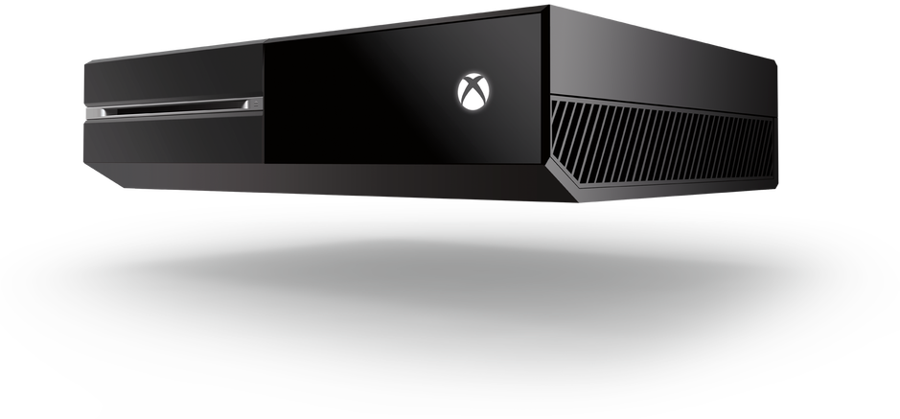

The original Xbox One's exterior casing consists of a two-tone "liquid black" finish; with half finished in a matte grey, and the other in a glossier black. The matte side of the top of the console consists of a large air vent. The design was intended to evoke a more entertainment-oriented and simplified look than previous iterations of the console; among other changes, the LED rings used by Xbox 360 are replaced by a glowing white Xbox logo used to communicate the system's status to the user.[[72]](https://en.wikipedia.org/wiki/Xbox_One#cite_note-polygon-onedesign-72) Due to the overall ventilation design of the console, the original Xbox One is designed to only sit horizontally.

Xbox One S utilizes a refreshed version of this design, with a case that is 40% smaller in size, and supports vertical orientation with a stand. The main Xbox One S SKU is colored in an entirely matte "Robot White" finish, with half of the console adorned with machined holes, and a visible circular vent on top of the console's right half. It utilizes push-button controls rather than capacitive keys,[[69]](https://en.wikipedia.org/wiki/Xbox_One#cite_note-techradar-onesreview-69) the side USB port and controller sync button were moved to the front of the console, and its power supply is integrated into the console's casing rather than sitting externally (plugging directly into the wall).

**Internals:-**

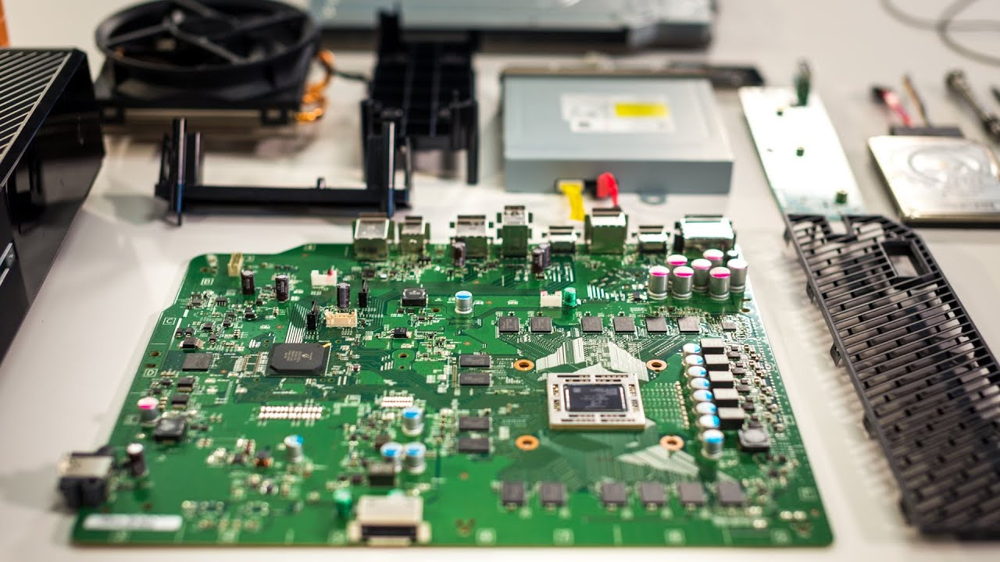

The Xbox One is powered by an [AMD](https://en.wikipedia.org/wiki/AMD) "[Jaguar](https://en.wikipedia.org/wiki/Jaguar_(microarchitecture))" [Accelerated Processing Unit](https://en.wikipedia.org/wiki/AMD_Accelerated_Processing_Unit) (APU) with two [quad-core](https://en.wikipedia.org/wiki/Multi-core_processor) modules totaling eight [x86-64](https://en.wikipedia.org/wiki/X86-64) cores clocked at 1.75 [GHz](https://en.wikipedia.org/wiki/Hertz), and 8 [GB](https://en.wikipedia.org/wiki/Gibibyte) of [DDR3](https://en.wikipedia.org/wiki/DDR3) [RAM](https://en.wikipedia.org/wiki/Random-access_memory) with a memory bandwidth of 68.3 GB/s. The memory subsystem also features an additional 32 MB of "embedded static" RAM, or [ESRAM](https://en.wikipedia.org/wiki/ESRAM), with a memory bandwidth of 109 GB/s. For simultaneous read and write operations, the ESRAM is capable of a theoretical memory bandwidth of 192 GB/s and a memory bandwidth of 133 GB/s has been achieved with operations that involved [alpha transparency](https://en.wikipedia.org/wiki/Alpha_compositing) blending. The system includes a non-replaceable hard driveand a [Blu-ray Disc](https://en.wikipedia.org/wiki/Blu-ray_Disc" \o "Blu-ray Disc) optical drive. 138 GB of hard drive space is used by the operating system, with the remainder available for the storage of games. Since the June 2014 software update, up to two USB drives can be connected to Xbox One to expand its capacity. External drives must support [USB 3.0](https://en.wikipedia.org/wiki/USB_3.0) and have a capacity of at least 256 GB.

It was reported that 3 GB of RAM would be reserved for the operating system and [utility software](https://en.wikipedia.org/wiki/Utility_software), leaving 5 GB for games. With [DirectX](https://en.wikipedia.org/wiki/DirectX) 11.2 as the console's [API](https://en.wikipedia.org/wiki/API), the [graphics processing unit](https://en.wikipedia.org/wiki/Graphics_processing_unit) (GPU) is based on an AMD [GCN](https://en.wikipedia.org/wiki/Graphics_Core_Next) architecture with 12 compute units, which have a total of 768 cores, running at 853 [MHz](https://en.wikipedia.org/wiki/Hertz) providing an estimated peak theoretical power of 1.31 T[FLOPS](https://en.wikipedia.org/wiki/FLOPS). For networking, Xbox One supports [Gigabit Ethernet](https://en.wikipedia.org/wiki/Gigabit_Ethernet), [802.11n](https://en.wikipedia.org/wiki/802.11n) wireless, and [Wi-Fi Direct](https://en.wikipedia.org/wiki/Wi-Fi_Direct).

"We purposefully did not target the highest-end graphics. We targeted more as a broad entertainment play and did it in an intelligent way."

—Greg Williams, GM of Xbox silicon development

The original Xbox One supports [1080p](https://en.wikipedia.org/wiki/1080p) and [720p](https://en.wikipedia.org/wiki/720p) video output; unlike the Xbox 360, the Xbox One does not support [1080i](https://en.wikipedia.org/wiki/1080i) and other [interlaced](https://en.wikipedia.org/wiki/Interlaced) resolutions. Xbox One supports [HDMI](https://en.wikipedia.org/wiki/HDMI) 1.4 for both input and output, and does not support [composite](https://en.wikipedia.org/wiki/Composite_video) or [component video](https://en.wikipedia.org/wiki/Component_video). Xbox One supports [7.1 surround sound](https://en.wikipedia.org/wiki/7.1_surround_sound), [Dolby Atmos](https://en.wikipedia.org/wiki/Dolby_Atmos), and [DTS X](https://en.wikipedia.org/w/index.php?title=DTS_X&action=edit&redlink=1).

Xbox One S additionally supports 2160p ([4K resolution](https://en.wikipedia.org/wiki/4K_resolution)) video output, and [high dynamic range](https://en.wikipedia.org/wiki/High_dynamic_range) (HDR) color using [HDR10](https://en.wikipedia.org/wiki/HDR10) (with a future update to add [Dolby Vision](https://en.wikipedia.org/wiki/Dolby_Vision) HDR support for streaming video). 4K video can be played from supported streaming services and [Ultra HD Blu-ray Disc](https://en.wikipedia.org/wiki/Ultra_HD_Blu-ray), Games are [upscaled](https://en.wikipedia.org/wiki/Video_scaler" \o "Video scaler) from 1080p resolution, and are not rendered at 4K. The GPU on Xbox One S has a higher [clock speed](https://en.wikipedia.org/wiki/Clock_speed) and ESRAM bandwidth than the original model, which can provide some performance improvements on games with dynamic resolution scaling or uncapped frame rates.

The console can monitor its internal temperature and adjust accordingly to prevent [overheating](https://en.wikipedia.org/wiki/Thermal_shock); alongside increasing fan speed, additional measures can be taken, including forcing the hardware to run in a lower power state—a feature that was not present on Xbox 360. Restricting power consumption lowers maximum performance, but the setting would be intended as a last resort to prevent permanent hardware damage.

**Controller:-**

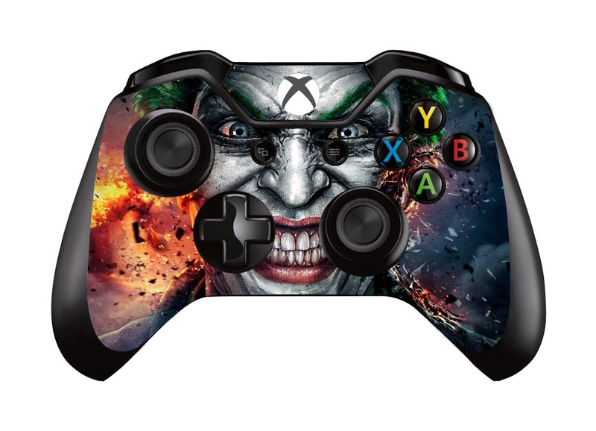

The Xbox One's [controller](https://en.wikipedia.org/wiki/Xbox_One_Controller) maintains the overall layout found in the [Xbox 360's controller](https://en.wikipedia.org/wiki/Xbox_360_Controller), but with various refinements to its form. Among its changes include a smoother form, textured analog sticks, a four-way [directional pad](https://en.wikipedia.org/wiki/Directional_pad), and redesigned triggers and shoulder buttons with a curved shape for [ergonomics](https://en.wikipedia.org/wiki/Ergonomics). "Menu" and "View" buttons have replaced the Start and Back buttons. Each trigger features independent rumble motors called "Impulse Triggers", which allows developers to program directional vibration. One trigger can be made to vibrate when firing a gun, or both can work together to create feedback that indicates the direction of an incoming hit The controller also contains light emitters that allow it to be tracked and paired using the Kinect sensor, and to detect when it's not being held to automatically enter a low-power state. An updated revision of the controller was released in June 2015, which includes a 3.5-millimeter headphone jack and other minor changes. A third revision was introduced alongside and first bundled with Xbox One S, with textured grips and [Bluetooth](https://en.wikipedia.org/wiki/Bluetooth) support.

The Xbox One controller includes a [micro USB](https://en.wikipedia.org/wiki/Micro_USB) port; when attached via a micro-USB cable, the controller can operate without battery power and can charge remotely, and is supported on computers running [Windows 7](https://en.wikipedia.org/wiki/Windows_7) or later with [drivers](https://en.wikipedia.org/wiki/Driver_(software)). The Xbox One Wireless Adapter accessory allows wireless use of Xbox One controllers on Windows computers also running Windows 7 or later.

The Elite Wireless Controller was released in October 2015. It was described and marketed as "an elite controller for the elite gamer", containing interchangeable parts, "hair trigger locks" for the triggers that allow users to reduce the amount of distance they must be pressed to register a press, and software for remapping buttons.

In May 2018, Microsoft announced the [Xbox Adaptive Controller](https://en.wikipedia.org/wiki/Xbox_Adaptive_Controller)—a special controller designed for [users with disabilities](https://en.wikipedia.org/wiki/Assistive_technology). It features two large dome-like buttons, and a series of connectors corresponding to standard Xbox controller buttons—which are used to attach specific types of buttons and other assertive peripherals. The controller can also be used in conjunction with Copilot—a feature introduced in 2017 that allows multiple controllers to be used in tandem on behalf of a single player.

As of the November 2018 update, developers may now optionally allow their titles to support computer [mice](https://en.wikipedia.org/wiki/Computer_mice) and [keyboards](https://en.wikipedia.org/wiki/Computer_keyboard) as input. Microsoft also unveiled an exclusive partnership with [Razer Inc.](https://en.wikipedia.org/wiki/Razer_Inc." \o "Razer Inc.) to produce a specific line of Xbox-optimized keyboard and mice peripherals, with Xbox system keys and support for Razer's Chroma LED lighting platform.

**Kinect 2.0 sensor:-**

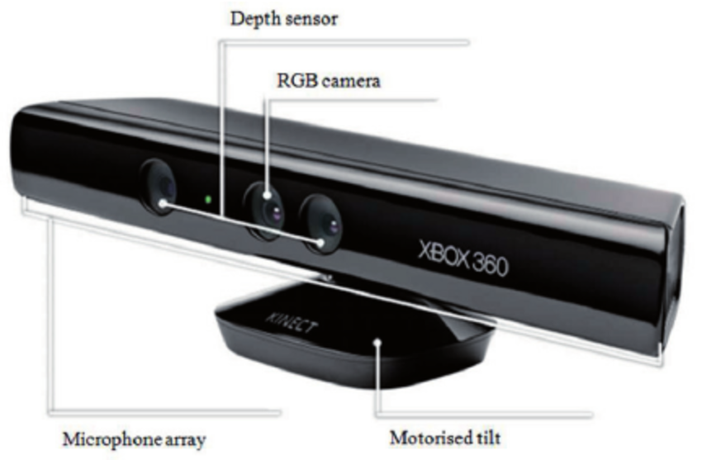The [Kinect](https://en.wikipedia.org/wiki/Kinect" \o "Kinect) 2.0, an updated [natural user interface](https://en.wikipedia.org/wiki/Natural_user_interface) sensor, was redesigned and recreated to provide motion-tracking and voice commands for the Xbox One.

Kinect 2.0 features a wide-angle [time-of-flight camera](https://en.wikipedia.org/wiki/Time-of-flight_camera)and a [1080p](https://en.wikipedia.org/wiki/1080p) camera, in comparison to the [VGA resolution](https://en.wikipedia.org/wiki/VGA_resolution) of the Xbox 360 version, and processes 2GB of data per second to map its environment. Kinect 2.0 has an improved accuracy over its predecessor; it can track up to 6 people simultaneously, referred to as "skeletons", perform [heart rate](https://en.wikipedia.org/wiki/Heart_rate) tracking, track controller gestures, and read [QR codes](https://en.wikipedia.org/wiki/QR_code) to redeem Xbox Live gift cards. By default, voice recognition is active at all times, so the console can receive voice commands from the user, even when the console is in [sleep mode](https://en.wikipedia.org/wiki/Sleep_mode). It is possible to wake the console with a command, although settings are available to change which individual Kinect functions are active.

Prior to and after the mandate, all Xbox One consoles initially shipped with the Kinect sensor included. On June 9, 2014, cheaper Xbox One bundles were introduced, which did not include the Kinect sensor.[[128]](https://en.wikipedia.org/wiki/Xbox_One#cite_note-128) Microsoft stated the decision to offer Xbox One bundles without Kinect was to "[offer] a choice to people that would allow people to buy an Xbox One and then ramp up to Kinect when they can afford to", while also allowing games to use processing power that was previously reserved for Kinect.[[129]](https://en.wikipedia.org/wiki/Xbox_One#cite_note-polygon_kinectless-129) An updated Xbox Development Kit issued in June 2014 allows developers to explicitly disable motion tracking functionality in games, allowing access to additional system resources that represent about 10% of the GPU processing power. These resources were previously reserved for Kinect skeletal tracking, regardless of whether the Kinect sensor was attached or in use.

A [Windows](https://en.wikipedia.org/wiki/Microsoft_Windows) compatible Kinect 2.0 was released on July 15, 2014.[[130]](https://en.wikipedia.org/wiki/Xbox_One#cite_note-Windows_Kinect_Release_Date-130) Kinect 2.0 was released as a standalone and optional item in October 2014; it is bundled with a digital copy of [*Dance Central Spotlight*](https://en.wikipedia.org/wiki/Dance_Central_Spotlight).

**Multimedia features:-**

The Xbox One can view and play content from [DLNA](https://en.wikipedia.org/wiki/Digital_Living_Network_Alliance) servers and USB storage devices using the "Media Player" app.[[153]](https://en.wikipedia.org/wiki/Xbox_One#cite_note-joystiq-sep14update-153) An application allows playback of video from [Blu-ray Disc](https://en.wikipedia.org/wiki/Blu-ray_Disc" \o "Blu-ray Disc), [DVD](https://en.wikipedia.org/wiki/DVD) and [CD](https://en.wikipedia.org/wiki/CD) media.[[49]](https://en.wikipedia.org/wiki/Xbox_One#cite_note-ms-blurayxb1-49)

The console provides the ability to feed live television by serving as an HDMI pass-through for an existing [television provider's](https://en.wikipedia.org/wiki/Multichannel_video_programming_distributor) [set-top box](https://en.wikipedia.org/wiki/Set-top_box) or an optional Digital TV Tuner accessory that allows use of [digital terrestrial television](https://en.wikipedia.org/wiki/Digital_terrestrial_television). The console provides its own [electronic program guide](https://en.wikipedia.org/wiki/Electronic_program_guide) known as OneGuide, augmenting the existing streaming functionality to provide show recommendations based on viewing history, integrated access to "App Channels" corresponding to online video services, and voice control via Kinect. The set-top box and television are controlled by OneGuide using an [IR blaster](https://en.wikipedia.org/wiki/IR_blaster).

The Xbox One does not provide full [DVR](https://en.wikipedia.org/wiki/Digital_video_recorder) functionality for recording television programs: executive Yusuf Mehdi indicated that the console would "work in tandem" with existing television services, but that Microsoft would need to work with them directly to provide extended functionality, such as DVR integration. The digital TV tuner accessory allows limited DVR functionality for pausing and rewinding live TV for up to 30 minutes. In June 2016, Microsoft announced that their plans for full [DVR](https://en.wikipedia.org/wiki/Personal_video_recorder) functionality for the Xbox One were on hold.

**Xbox Live:-**

The Xbox Live service has been scaled up to use 300,000 servers for Xbox One users. [Cloud storage](https://en.wikipedia.org/wiki/Cloud_storage) is available to save music, films, games and saved content, and developers are able to use Live servers (along with the [Microsoft Azure](https://en.wikipedia.org/wiki/Microsoft_Azure) [cloud computing](https://en.wikipedia.org/wiki/Cloud_computing) platform) to offer dynamic in-game content and other functionality. Users can have up to 1,000 friends. The December 2016 software update added the new social networking feature Clubs, which allows users to join groups focused on specific interests or games, and Looking for group (LFG), a system to help users locate players to join their party for multiplayer play.

Players can use the Upload Studio app to edit and share clips from the last five minutes of gameplay footage that is automatically recorded by the console. Games can also be developed so that recording can automatically be triggered in response to notable events, such as achievements. Xbox One supports streaming directly to the services [Mixer](https://en.wikipedia.org/wiki/Mixer_(website)) and [Twitch](https://en.wikipedia.org/wiki/Twitch_(website)). Users can use voice commands to immediately begin streaming footage of their current game directly to the service, and use Kinect's camera and microphone to record video and audio narration. Users can feature recorded clips on their Xbox Live profile page in a "Showcase" section.

As with Xbox 360, premium online features such as multiplayer, voice communication, broadcasting and Upload Studio require an [Xbox Live Gold](https://en.wikipedia.org/wiki/Xbox_Live_Gold) subscription to use. Unlike Xbox 360, a user's Xbox Live Gold subscription benefits apply to all other users of their designated "home" console as well, rather than requiring a separate subscription for each user Since June 2014, applications no longer require an Xbox Live Gold membership to use. Additional subscriptions for outside services such as [Netflix](https://en.wikipedia.org/wiki/Netflix) may still be required. Microsoft also extended its [Games with Gold](https://en.wikipedia.org/wiki/Games_with_Gold) program to Xbox One, providing free Xbox 360 and Xbox One games to Xbox Live Gold subscribers on a monthly basis.

**Second screen and streaming:-**

The [Xbox SmartGlass](https://en.wikipedia.org/wiki/Xbox_SmartGlass) [app](https://en.wikipedia.org/wiki/Mobile_app) provides extended functionality on Xbox One, allowing devices running [Windows Phone](https://en.wikipedia.org/wiki/Windows_Phone), [Windows 8](https://en.wikipedia.org/wiki/Windows_8), [iOS](https://en.wikipedia.org/wiki/IOS" \o "IOS) and [Android](https://en.wikipedia.org/wiki/Android_(operating_system)) to be used as a companion device for Xbox One features, such as powering on the console, a [remote control](https://en.wikipedia.org/wiki/Remote_control), accessing messages and the Activity Feed, purchasing content, and providing integration with certain games and content. The SmartGlass app can also be used to stream live television to Android and Windows devices if the console is using a USB digital television tuner.

On [Windows 10](https://en.wikipedia.org/wiki/Windows_10), SmartGlass is succeeded by the Xbox App, which supports the local streaming of games from Xbox One to [personal computers](https://en.wikipedia.org/wiki/Personal_computer) and [tablets](https://en.wikipedia.org/wiki/Tablet_computer) running Windows 10 An Xbox One controller must be used, but Windows-compatible headsets and microphones can be used for voice chat. Games requiring Kinect are not supported, while Game DVR and online streaming are not available while using this functionality.

Per a partnership with [Oculus VR](https://en.wikipedia.org/wiki/Oculus_VR), users will also be able to stream Xbox One games to the [Oculus Rift](https://en.wikipedia.org/wiki/Oculus_Rift) virtual reality headset by means of Xbox app for Windows 10; as of 2015 there were no immediate plans for direct integration between Xbox One and Oculus Rift.

**Comparison**:- 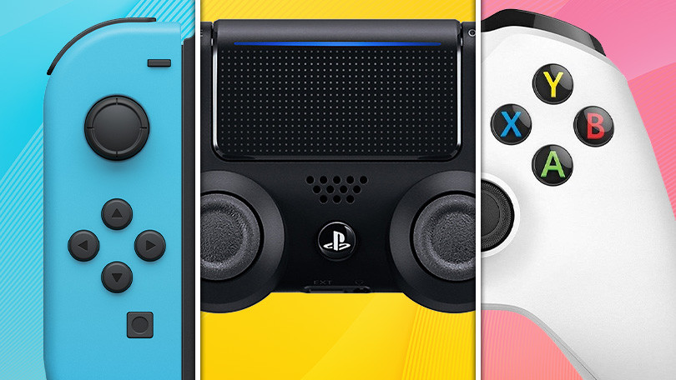

## Comparison chart

|  | | |
| --- | --- | --- |
| **Funcionalities** | **PlayStation 4**  **Similarity** | **Xbox One**  **Diffrence:-** |
|  | * current rating is 4.01/5 * [1](https://www.diffen.com/difference/PlayStation_4_vs_Xbox_One#j=1&q=27397) * [2](https://www.diffen.com/difference/PlayStation_4_vs_Xbox_One#j=2&q=27397) * [3](https://www.diffen.com/difference/PlayStation_4_vs_Xbox_One#j=3&q=27397) * [4](https://www.diffen.com/difference/PlayStation_4_vs_Xbox_One#j=4&q=27397) * [5](https://www.diffen.com/difference/PlayStation_4_vs_Xbox_One#j=5&q=27397)   **(862 ratings)** | * current rating is 3.65/5 * [1](https://www.diffen.com/difference/PlayStation_4_vs_Xbox_One#j=1&q=30134) * [2](https://www.diffen.com/difference/PlayStation_4_vs_Xbox_One#j=2&q=30134) * [3](https://www.diffen.com/difference/PlayStation_4_vs_Xbox_One#j=3&q=30134) * [4](https://www.diffen.com/difference/PlayStation_4_vs_Xbox_One#j=4&q=30134) * [5](https://www.diffen.com/difference/PlayStation_4_vs_Xbox_One#j=5&q=30134)   **(984 ratings)** |
| **CPU** | Single-chip x86 AMD "Jaguar" processor, 8 cores, Clock speed 1.6GHz, A secondary Custom ARM CPU and RAM for background processing such as downloading and recording gameplay. | Single-chip x86 AMD "Jaguar" processor, 8 cores, Clock speed 1.75GHz, 32MB of embedded SRAM memory. |
| **Online services** | PlayStation Plus. $59.99 annually, $17.99 quarterly or $9.99 monthly. | Xbox Live. $60 annually or $25 quarterly. |
| **Storage capacity** | 500 GB hard drive (removable; user upgradeable). About 93 GB of storage is for the OS so only about 407 GB of the 500 GB hard drive is actually available. | 500 GB [hard drive](https://www.diffen.com/difference/HDD_vs_SSD) (not removable or upgradable by user) / 1 TB |
| **Price** | $399 (US); £349 (UK); $549 (AU); €399 (EU) | $399 without Kinect. With Kinect: $499 (US) €499 £429. Xbox One/Titanfall bundle for $450 at Walmart and Best Buy. |
| **Sound** | 7.1 Dolby/DTS-HD Master Audio/PCM Surround Sound | [7.1 Surround Sound](https://www.diffen.com/difference/5.1_Surround_Sound_vs_7.1_Surround_Sound) |
| **Generation** | 8th generation console | 8th generation console |
| **Manufacturer** | Sony | Microsoft |
| **Graphics** | AMD Next Gen, Radeon HD 7xxx series equivalent | AMD Next Gen, Radeon HD 7xxx series equivalent |
| **Media** | Blu-ray, DVD, digital downloads | [Blu-ray, DVD](https://www.diffen.com/difference/Blu-ray_vs_DVD), CD, digital downloads |
| **Predecessor** | PlayStation 3 | Xbox 360 / 1st generation Kinect |
| **Units sold worldwide** | 43.5 million (as of June 30, 2016) | Over 20 million (as of March 2016) |
| **Available Versions** | Different bundles | 500 GB, 1 TB |
| **Backward compatibility** | Via PSNow | Backwards compatible with certain Xbox 360 games |
| **Internet Browser** | Yes (PS4 Web Browser) | Yes (Microsoft Edge) |
| **Motion Sensing** | PlayStation Camera; Gyroscope | Kinect |
| **Online Subscription Fee** | PlayStation Plus. $59.99 annually, $17.99 quarterly, or $9.99 monthly. | Xbox Live has a subscription with flexible pricing options. |
| **Controllers** | Up to 4 controllers (update expected) | Up to 8 controllers |
| **Wi-Fi** | 802.11 b/g/n | Dual-band 802.11 a/b/g/n, Wi-Fi Direct |
| **Processor** | Customized AMD x86-64 Jaguar | Customized AMD x86-64 Jaguar |
| **Product family** | PlayStation | Xbox |
| **Controller input** | Dualshock 4; PlayStation Camera; Voice Commands | Xbox One Controller, Kinect, Voice Commands |
| **Type** | Video game console | Video Game Console |
| **Memory (RAM)** | 8GB GDDR5 - 176 GB/s Bandwidth | 8 GB [DDR3](https://www.diffen.com/difference/DDR2_vs_DDR3) (5 GB available to games). 32MB ESRAM. 68GB/s Bandwidth. |
| **Video Output** | HDMI | [HDMI](https://www.diffen.com/difference/HDMI_vs_VGA) |
| **Ports** | Two USB 3.0 ports; AUX port; Ethernet; HDMI out; S/PDIF out for audio. | Three USB 3.0 ports; [Ethernet](https://www.diffen.com/difference/Cat5e_vs_Cat6); HDMI 1.4 in/out; IR port; Kinect port; S/PDIF out for audio. |
| **Resolutions** | 480p, 720p, [1080i, 1080p](https://www.diffen.com/difference/1080i_vs_1080p), 4096 × 2160 (4k) | [720p](https://www.diffen.com/difference/1080p_vs_720p), [1080p, 1080i](https://www.diffen.com/difference/1080i_vs_1080p) |
| **Audio Output** | Optical Toslink, HDMI | Optical Toslink, HDMI |
| **Developer** | Sony Computer Entertainment | Microsoft |
| **Video Connections** | HDMI Out | HDMI In, HDMI Out |
| **Release date** | November 15, 2013 | November 22, 2013 |
| **MSRP** | $399.99 | $499.99/£429, $399.99 |
| **GPU** | 800 MHz AMD Radeon GPU with 20 compute units (2 Disabled) 1,152 shaders (stream processors). 72 Texture Units, 32 ROPs, 64 Compute Commands | 853 MHz AMD Radeon GPU with 14 compute units (2 Disabled). 768 shaders (stream processors). 48 Texture Units, 16 ROPS, 16 Compute Commands. |
| **Camera** | PlayStation Camera (Not Included) | Kinect sensor (optional) |
| **Bluetooth** | Yes, Bluetooth 2.1 + EDR | No |
| **Website** | playstation.com/ps4 | www.xbox.com |
| **Input Methods** | Dualshock 4, PlayStation Camera, and voice commands | Xbox One Controller, Kinect, Voice Commands |
| **Included with the System** | PlayStation Wired Mono Headset, DualShock 4, HDMI Cable, USB Cable, and a 30 Day Free Trial for PlayStation Plus | Kinect (originally included, now optional); Xbox One Chat Headset; Xbox One Controller; HDMI Cable;14-day free trial of Xbox Live Gold |
| **Supported Resolutions** | 480p, 720p, 1080i, [1080p](https://www.diffen.com/difference/1080p_vs_720p), 4k | 1080p, [720p](https://www.diffen.com/difference/1080p_vs_720p) |
| **Operating system** | Orbis OS | Xbox OS (Upcoming update to integrate Windows 10 ) |
| **Virtual Reality** | PSVR Headset | No; (HoloLens with Windows 10) |