# 

**MSPM’S**

**Deogiri Institute of Engineering and Management Studies, Aurangabad**

**Department of Computer Science and Engineering**

Report on

**DELL INSIPRON 7572 (Laptop)**

Submitted By

**Patil Richa Vijay (26005)**

Under the Guidance of

**Prof. P. H. Durole**

Department of Computer Science and Engineering

(Deogiri Institute of Engineering and Management Studies)

2019-2020



CERTIFICATE

This is to Certify that Miss **Patil Richa Vijay (26005)** has completed report writing on **DELL INSIPRON 7572 (Laptop)** in subject Computer Architecture & Organization.

**Prof. P. H. Durole Prof. Sanjay Kalyankar Dr.Ulhas Shiurkar**

**Subject Teacher H.O.D. Director**

**Device name: Dell Inspiron 15 7572**

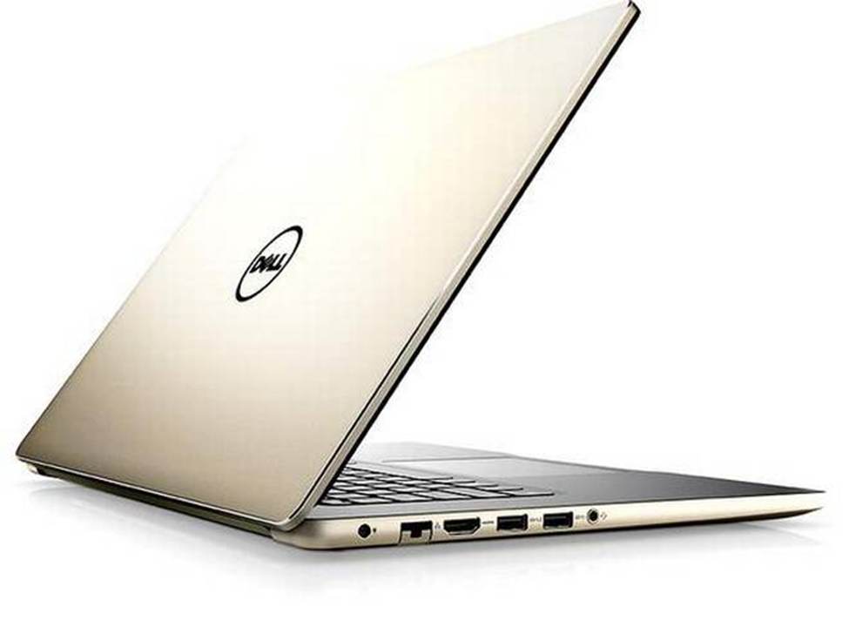

## **DELL INSPIRON 15 7572 SPECIFICATIONS**

**BASIC INFORMATION**

Model name: Dell Inspiron 15 7572

Launch date (global): 21-11-2018

Operating system (with version): Windows 10 home plus

Laptop type: Ultra-portal

**DISPLAY**

Resolution: 1920 x 1080 pixels (FHD)

Display size: 15.6 inches

Display technology: IPS Truelife

**Connectivity**

Wireless connectivity: 802.11ac

Bluetooth version: 4.1

**Memory**

Ram included: 8GB

Ram type: DDR4

Ram speed: 2400 MHz

**Physical specification**

Laptop weight: 2 kg

Laptop dimension: 19.5 x 385.16 x 246

Colors: Grey, Gold

**Processor**

Processor model: 8th generation Intel core i5 8250U

Base clock speed: 1.8 GHz

Burst clock speed: 4GHz

Cache: 6MB

Graphics processor: NVidia GeForce mx150

Graphic memory: 4MB

**Storage**

Hard disk: 1 TB

SSD: 128 GB

**Power**

Battery type: 42WHr, 3-cell battery

**Sound**

Sound technology: Waves MaxxAudio® Pro

**Warranty**

Warranty time: 1 year

**Inputs**

Web camera: Yes

Pointer device: Trackpad

Backlit keyboard: Yes

Internal mic: Yes

Speakers: 2 speakers

Touchscreen: No

Finger print sensor & reader: No

**Ports and slots**

USB ports: 1x USB 2.0,

1x USB 3.0(power share),

1x USB 3.0

HDMI port: Standard

Multi card slot: SD card reader

Headphone & mic combo jack: Yes

RJ45 Ethernet (LAN): Yes

Nobel lock security: Yes

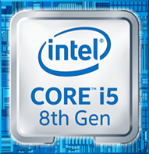**Processor architecture**

Core i5-8250U is a 64-bit quad-core performance x86 mobile microprocessor introduced by Intel in mid-2017.

This processor, which is based on an enhanced version of the Kaby Lake microarchitecture, is manufactured on Intel's 2nd generation enhanced 14nm+ process. The i5-8250U operates at 1.6 GHz with a TDP of 15 W and Turbo Boost frequency of up to 3.4 GHz. This MPU supports up to 32 GiB of dual-channel DDR4-2400 memory and incorporates Intel's UHD Graphics 620 IGP operating at 300 MHz with a burst frequency of 1.15 GHz.

This model has a configurable TDP-down of 10 W at 800 MHz and a TDP (thermal design power)-up of 25 W at 1.8 GHz.

**General specification:**

|  |  |
| --- | --- |
| **Family** | Core i5 |
| **Series** | i5-8000 |
| **Locked** | Yes |
| **Frequency** | 1,600 MHz |
| **Turbo Frequency** | 3,400 MHz (1 core),  3,400 MHz (2 cores),  3,400 MHz (3 cores),  3,400 MHz (4 cores) |
| **Bus type** | OPI |
| **Bus rate** | 4 GT/s (gigabyte/sec) |
| **Clock multiplier** | 16 |
| **Core** | 4 |
| **Threads** | 8 |

**Instruction set:**

The instruction set, also called ISA (instructionset architecture), and is part of a computer that pertains to programming, which is basically machine language. The instruction set provides commands to the processor, to tell it what it needs to do. The instruction set consists of addressing modes, instructions, native data types, registers, memory architecture, interrupt, and exception handling, and external I/O.

An example of an instruction set is the x86 instruction set, which is common to find on computers today. Different computer processors can use almost the same instruction set while still having very different internal design. Both the Intel Pentium and AMD Athlon processors use nearly the same x86 instruction set. An instruction set can be built into the hardware of the processor, or it can be emulated in software, using an interpreter. The hardware design is more efficient and faster for running programs than the emulated software version.

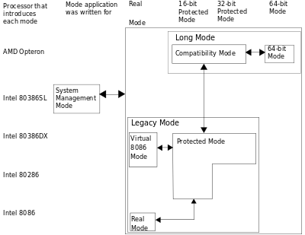

**Examples of instruction set**

* **ADD** - Add two numbers together.
* **COMPARE** - Compare numbers.
* **IN** - Input information from a device, e.g., keyboard.
* **JUMP** - Jump to designated RAM address.
* **JUMP IF** - Conditional statement that jumps to a designated RAM address.
* **LOAD** - Load information from RAM to the CPU.
* **OUT** - Output information to device, e.g., monitor.
* **STORE** - Store information to RAM.

**Memory**

**HDD**

Memory is the most essential element of a computing system because without it computer can’t perform simple tasks. Computer memory is of two basic type – Primary memory / Volatile memory and Secondary memory / non-volatile memory. Random Access Memory (RAM) is volatile memory and Read Only Memory (ROM) is non-volatile memory.

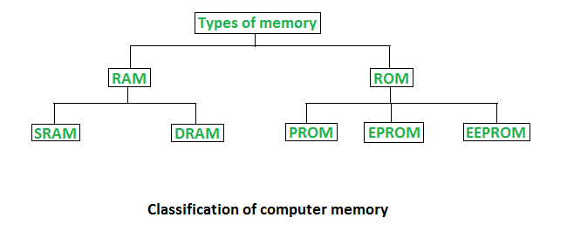

**1. Random Access Memory (RAM) –**

* It is also called as read write memory or the main memory or the primary memory.
* The programs and data that the CPU requires during execution of a program are stored in this memory.
* It is a volatile memory as the data loses when the power is turned off.
* RAM is further classified into two types- SRAM (Static Random Access Memory) and DRAM (Dynamic Random Access Memory).

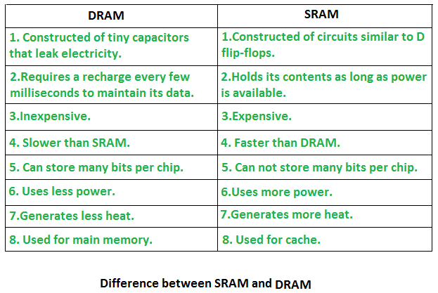

**2. Read Only Memory (ROM) –**

* Stores crucial information essential to operate the system, like the program essential to boot the computer.
* It is not volatile.
* Always retains its data.
* Used in embedded systems or where the programming needs no change.
* Used in calculators and peripheral devices.
* ROM is further classified into 4 types- ROM, PROM, EPROM, and EEPROM.

**Types of Read Only Memory (ROM) –**

1. **PROM (Programmable read-only memory) –** It can be programmed by user. Once programmed, the data and instructions in it cannot be changed.
2. **EPROM (Erasable Programmable read only memory)** – It can be reprogrammed. To erase data from it, expose it to ultra violet light. To reprogram it, erase all the previous data.
3. **EEPROM (Electrically erasable programmable read only memory)** – The data can be erased by applying electric field, no need of ultra violet light. We can erase only portions of the chip

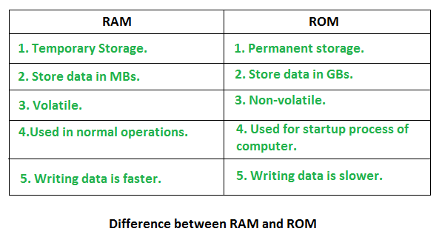

**SDD**

An SSD (solid-state drive) is a type of nonvolatile storage media that stores persistent data on solid-state flash memory. Two key components make up an SSD: a flash controller and NAND flash memory chips. The architectural configuration of the SSD controller is optimized to deliver high read and write performance for both sequential and random data requests. SSDs are sometimes referred to as flash drives or solid-state disks.

SSDs will use three main types of memory:

* 1. Single cell
  2. multi cell
  3. triple-level cells

1. Single-level cells can hold one bit of data at a time—a one or zero. Single-level cells (SLC) are the most expensive form of SSD, but it is also the fastest and most durable.
2. Multi-level cells (MLC) can hold two bits of data per cell and have a larger amount of storage space in the same amount of physical space as SLC. However, MLCs have slower write speeds.
3. Triple-level cells (TLC) can hold three bits of data in a cell. TLCs have a lower price, but slower write speeds and less durability. TLC-based SSDs deliver more flash capacity and are cheaper than an MLC or SLC.

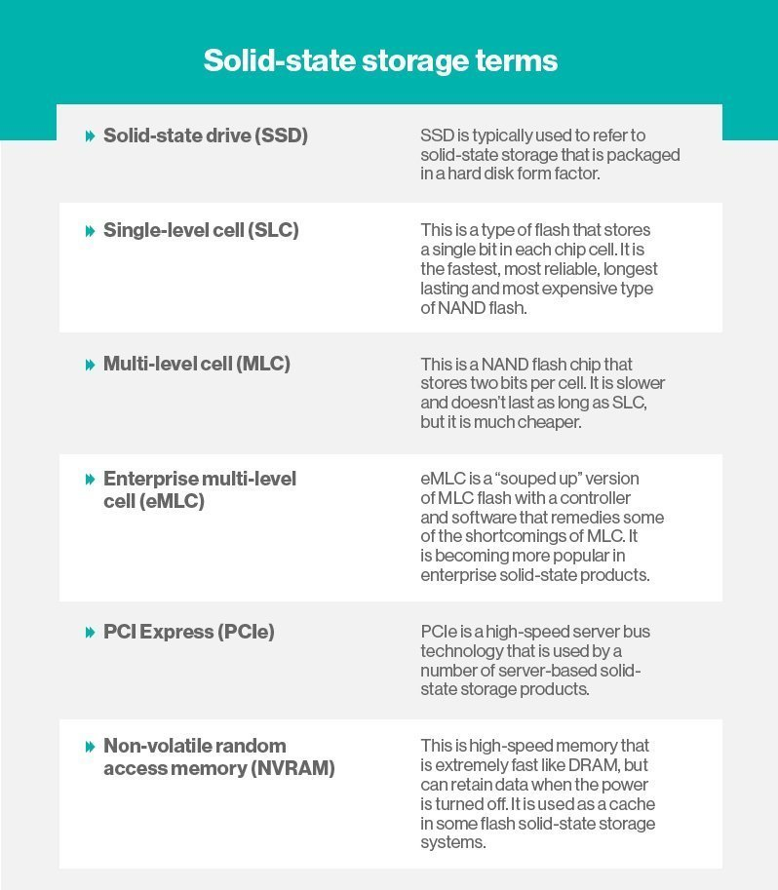

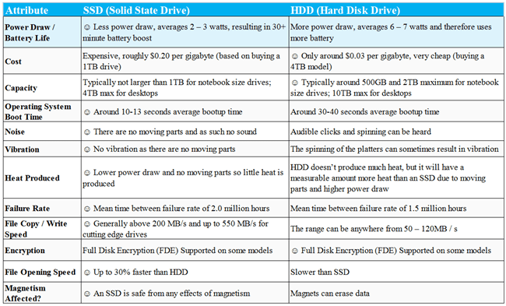

**Control unit**

A control unit (CU) handles all processor control signals. It directs all input and output flow, fetches code for instructions from microprograms and directs other units and models by providing control and timing signals. A CU component is considered the processor brain because it issues orders to just about everything and ensures correct instruction execution.

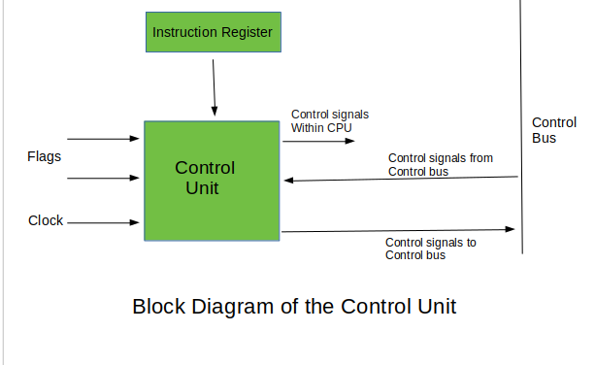

**CU functions are as follows:**

* Controls sequential instruction execution
* Interprets instructions
* Guides data flow through different computer areas
* Regulates and controls processor timing
* Sends and receives control signals from other computer devices
* Handles multiple tasks, such as fetching, decoding, execution handling and storing results

**CUs are designed in two ways:**

* **Hardwired control:**

Design is based on a fixed architecture. The CU is made up of flip-flops, logic gates, digital circuits and encoder and decoder circuits that are wired in a specific and fixed way. When instruction set changes are required, wiring and circuit changes must be made. This is preferred in a reduced instruction set computing (RISC) architecture, which only has a small number of instructions.

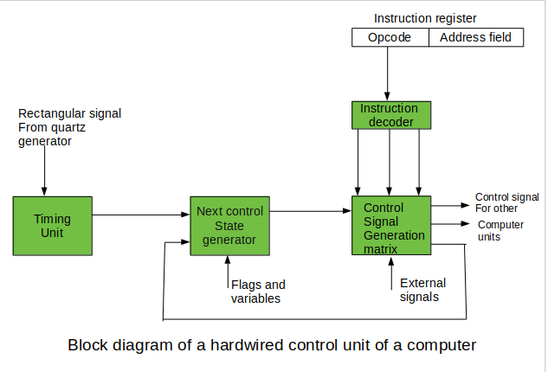

* **Microprogram control:**

Microprograms are stored in a special control memory and are based on flowcharts. They are replaceable and ideal because of their simplicity.

1. **With a single-level control store:**

In this, the instruction opcode from the instruction register is sent to the control store address register. Based on this address, the first microinstruction of a microprogram that interprets execution of this instruction is read to the microinstruction register. This microinstruction contains in its operation part encoded control signals, normally as few bit fields. In a set microinstruction field decoders, the fields are decoded. The microinstruction also contains the address of the next microinstruction of the given instruction microprogram and a control field used to control activities of the microinstruction address generator.

The last mentioned field decides the addressing mode (addressing operation) to be applied to the address embedded in the ongoing microinstruction. In microinstructions along with conditional addressing mode, this address is refined by using the processor condition flags that represent the status of computations in the current program. The last microinstruction in the instruction of the given microprogram is the microinstruction that fetches the next instruction from the main memory to the instruction register.

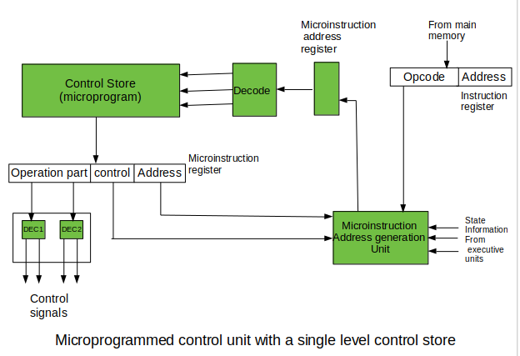

1. **With a two-level control store:**

In this, in a control unit with a two-level control store, besides the control memory for microinstructions, a nano-instruction memory is included. In such a control unit, microinstructions do not contain encoded control signals. The operation part of microinstructions contains the address of the word in the nano-instruction memory, which contains encoded control signals. The nano-instruction memory contains all combinations of control signals that appear in microprograms that interpret the complete instruction set of a given computer, written once in the form of nano-instructions.

In this way, unnecessary storing of the same operation parts of microinstructions is avoided. In this case, microinstruction word can be much shorter than with the single level control store. It gives a much smaller size in bits of the microinstruction memory and, as a result, a much smaller size of the entire control memory. The microinstruction memory contains the control for selection of consecutive microinstructions, while those control signals are generated at the basis of nano-instructions. In nano-instructions, control signals are frequently encoded using 1 bit/ 1 signal method that eliminates decoding.

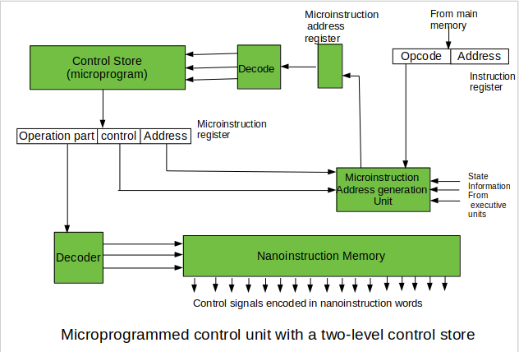

**Input & output mechanism**

**HDMI-**

Stands for "High-Definition Multimedia Interface." HDMI is a trademark and brand name for a digital interface used to transmit audio and video data in a single cable. It is supported by modern audio/video equipment. HDMI outputs "feed" audio and video signals into the HDMI inputs of digital devices, which receive and process them. The cables are terminated with plug connectors, typically featuring 19 pins. Many A/V receivers contain digital processors that can take analog video signals, from a VHS or DVD player, and convert them to HMDI.

**USB-**

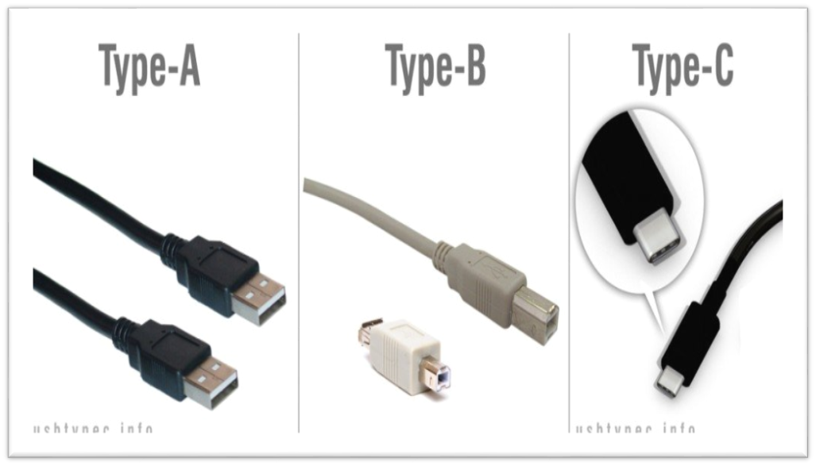

USB refers to Universal Serial Bus, which is a type of connection used to link computers to peripheral devices. USB ports are found on both the computers and the devices, and USB cables connect them to each other. USB ports function as both input and output ports. There are two types of USB ports, Type A and Type B, and information can go both directions on either one.

**USB Type A**

The most popular type of USB standard is Type A. You will most likely to find Type-A ports in host devices like desktop computers, gaming consoles and media players.

**USB Type B**

Type-B connectors are at the other end of a typical USB cable that plugs into a peripheral device, such as a smartphone, a printer or a hard drive.

**USB Type C**

Type-C over other existing variants is that it allows for ‘reverse plug orientation’. It can be also be used to share data, charging device.

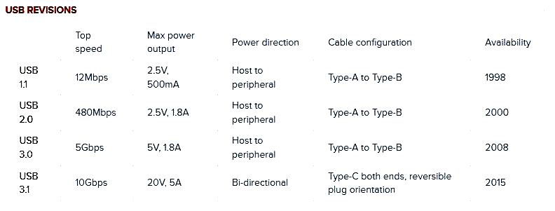

**Other functions**

**IPS Truelife display:**

A TrueLifeTM display has up to a 10% higher contrast ratio than the same display with an anti-glare coating. Dell TrueLife technology delivers darker blacks and colors that pop for vivid graphics and lifelike video. TrueLife displays offer a fantastic visual experience for those who want to play games, watch DVDs or streaming videos and look at their favorite digital photos.

**Graphics**

A Graphics Card is a processor designed specifically to handle 3D graphics and videos. It is so because having such a processor along with the main processor/CPU. It reduces the amount of pressure on your CPU. The CPU mainly does calculations very fast and a GPU mainly does the processing of graphics very fast

**NVidia GeForce MX150:**

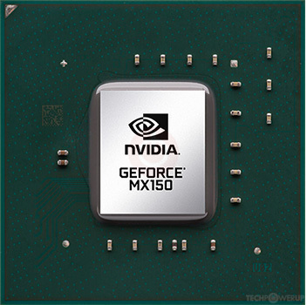

GPU Name: NVidia GeForce MX150

GPU Type: Dedicated video card

Number or Cores (Shaders): 384 unified

Core Clock Speed: Default 1,468 MHz, Boost 1,532 MHz

Memory Bus Width: 64-bit

Video Memory Size: 2GB, 4GB

Memory Type: GDDR5

Video Memory Speed: 6000 MHz

Production Technology: 14-nanometer