

**Deogiri Institute of Engineering And Management Studies, Aurangabad**

**Project Topic**

Samsung A30

Submitted By

**Manali Suhas Bansode**

**CSE Branch, SE-I and Roll No-26006**

**AND**

**Shrilaxmi Mokashi**

**CSE Branch, SE-I and Roll No-26032**

Under the Guidance of

**Prof.Pankaj Durole**

(Deogiri Institute of Engineering and Management Studies)

***CERTIFICATE***

This is to Certify that Manali Bansode and Shrilaxmi Mokashi has Completed Word Document Presentation of Computer Architecture And Organisation on **\*\*\*\*\*** For the partial fulfillment of Continuous Assessment on date______

**Name and Signature of Student Name and Signature of Subject Teacher**

***SAMSUNG:***



**INTRODUCTION:**

**SAMSUNG :**

Samsung was founded by Lee Byung-chul in 1938 as a trading company. Over the next three decades, the group diversified into areas including food processing, textiles, insurance, securities, and retail. Samsung entered the electronics industry in the late 1960s and the construction and shipbuilding industries in the mid-1970s; these areas would drive its subsequent growth. Following Lee's death in 1987, Samsung was separated into four business groups – Samsung Group, Shinsegae Group, CJ Group and Hansol Group. Since 1990, Samsung has increasingly globalised its activities and electronics; in particular, its mobile phones and semiconductors have become its most important source of income. As of 2017, Samsung has the 6th highest global brand value.

Notable Samsung industrial affiliates include Samsung Electronics (the world's largest information technology company, consumer electronics maker and chipmaker measured by 2017 revenues).

***Advancement of Samsung:***

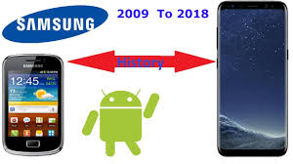

***Samsung ‘A’ Series Phones:***

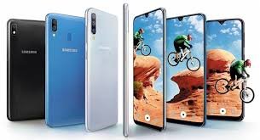

**SAMSUNG A30**

The Samsung Galaxy A30 is a less expensive version of the Galaxy A50. It doesn't have the in-display fingerprint sensor or third rear camera, and has a less powerful processor. The Galaxy A30 looks modern and has a vibrant 6.4-inch Super AMOLED screen with an Infinity-U notch for the selfie camera. There's only one configuration in India, with 4GB of RAM and 64GB of storage. You get a 4000mAh battery and Android 9 Pie with the new OneUI skin. Battery life is good, but we were disappointed with overall performance and the cameras. There are similarly priced models in the market from Samsung and its competitors that offer better value for money.

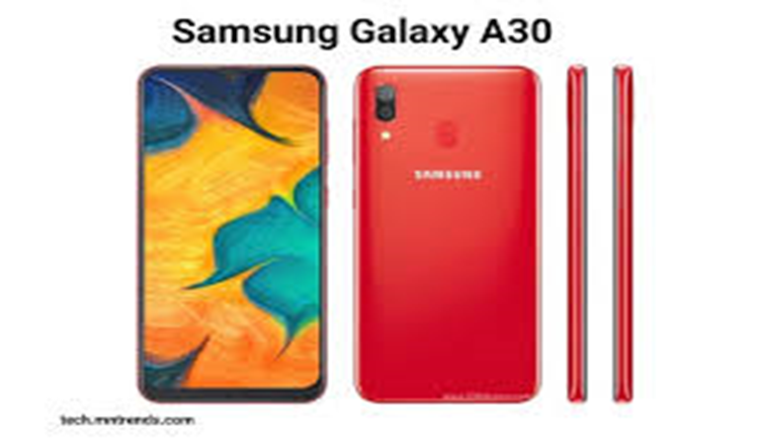

***SPECIFICATIONS:***

|  |  |
| --- | --- |
| Brand | Samsung |
| Model | Galaxy A30 |
| Release date | February 2019 |
| Launched in India | Yes |
| Form factor | Touchscreen |
| Dimensions (mm) | 158.50 x 74.70 x 7.70 |
| Battery capacity (mAh) | 4000 |
| Fast charging | Proprietary |
| Colours | Red, Blue, Black |

**Display**

|  |  |
| --- | --- |
| Screen size (inches) | 6.40 |
| Touchscreen | Yes |
| Resolution | 1080x2340 pixels |

**Hardware**

|  |  |
| --- | --- |
| Processor make | Exynos 7904 |
| RAM | 4GB |
| Internal storage | 64GB |
| Expandable storage | Yes |
| Expandable storage type | microSD |
| Expandable storage up to (GB) | 512 |
| Dedicated microSD slot | Yes |

**Camera**

|  |  |
| --- | --- |
| Rear camera | 16-megapixel (f/1.7) + 5-megapixel (f/2.2) |
| Rear autofocus | Yes |
| Rear flash | Yes |
| Front camera | 16-megapixel (f/2.0) |

**Software**

|  |  |
| --- | --- |
| Operating system | Android Pie |
| Skin | One UI |

**Connectivity**

|  |  |
| --- | --- |
| Wi-Fi | Yes |
| GPS | Yes |
| Bluetooth | Yes |
| USB Type-C | Yes |
| Headphones | 3.5mm |
| Number of SIMs | 2 |
| **SIM 1** | |
| SIM Type | Nano-SIM |
| GSM/CDMA | GSM |
| 3G | Yes |
| 4G/ LTE | Yes |
| **SIM 2** | |
| SIM Type | Nano-SIM |
| GSM/CDMA | GSM |
| 3G | Yes |
| 4G/ LTE | Yes |

**Sensors**

|  |  |
| --- | --- |
| Fingerprint sensor | Yes |
| Proximity sensor | Yes |
| Accelerometer | Yes |

***SAMSUNG MEMORY***

The Samsung 4GB memory card price in India was last generated on 29th August 2019. Samsung Micro SD cards are a great accessory for Samsung smartphones. The Samsung 4GB micro SD memory card price list contains least price of all Samsung 4GB Memory Cards available in the market. This list is updated every day and hence contains the latest price of all Samsung 4GB Memory Cards. The detailed features and larger images of the specific models are available in the respective product pages. The price of the 4GB memory card given in this list is the least price available across major ecommerce stores in India is the cheapest 4 GB micro SD card (costing Rupees 10000000) in this list while is the most expensive memory card (priced at Rupees 0).

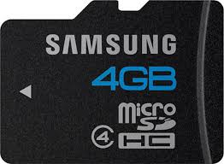

***Instruction Set Architecture:***

An **instruction set architecture** (**ISA**) is an abstract model of a computer. It is also referred to as **architecture** or **computer architecture**. A realization of an ISA is called an *implementation*. An ISA permits multiple implementations that may vary in performance, physical size, and monetary cost (among other things); because the ISA serves as the interface between software and hardware. Software that has been written for an ISA can run on different implementations of the same ISA. This has enabled binary compatibility between different generations of computers to be easily achieved, and the development of computer families. Both of these developments have helped to lower the cost of computers and to increase their applicability. For these reasons, the ISA is one of the most important abstractions in computing today.

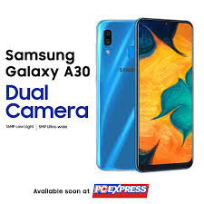

***PROCESSOR ARCHITECTURE***

**Exynos** (from the Greek words exypnos meaning smart and prasinos meaning green) is a series of ARM-based (reduced instruction set) System-on-Chips (SoCs) developed and manufactured by Samsung Electronics and is a continuation of Samsung's earlier S3C, S5L and S5P line of SoCs.

**Exynos Modem 303:**

* Supported modes LTE FDD, LTE TDD, WCDMA and GSM/EDGE
* LTE Cat. 6
* Downlink: 2CA 300Mbps 64-QAM
* Uplink: 100Mbps 16-QAM
* 28nm HKMG Process
* Paired with: Exynos 5 Octa 5430 and Exynos 7 Octa 5433
* Devices using: Samsung Galaxy Note 4, Samsung Galaxy Note Edge and Samsung Galaxy Alpha.

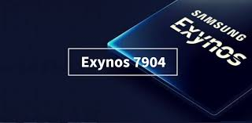

***Operating System:***

Andriod Pie:

Android Pie. Android Pie (codenamed **Android** P during development) is the ninth major release and the 16th version of the Android mobile operating system. It was first released as a developer preview on March 7, 2018, and released publicly on August 6, 2018.

**Preceded by:**Android 8.1 "Oreo"

**Succeeded by:**Android 10

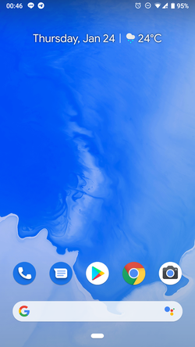

**Redmi note 6 pro**

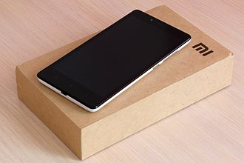

**Introduction**

**Xiaomi Corporation** is a Chinese electronics company founded in 2010 and headquartered in Beijing. Xiaomi makes and invests in smartphones, mobiles, apps, laptops, bags, trimmers, earphones, MI Television, Shoes, fitness bands, and many other products. Ranked 468th, Xiaomi is the youngest company on Fortune Global 500 List for 2019.

Xiaomi released its first smartphone in August 2011 and rapidly gained market share in China to become the country's largest smartphone company in 2014.

Xiaomi has 15,000 employees in China, India, Malaysia, Singapore and is expanding to other countries including Indonesia, the Philippines, and South Africa. According to Forbes magazine, Lei Jun, the founder and CEO, has an estimated net worth of US$12.5 billion. He is China's 11th richest person and 118th in the world. Xiaomi is the world's 4th most valuable technology start-up after receiving US$1.1 billion funding from investors, making Xiaomi's valuation more than US$46 billion.

Xiaomi produces many products. Notably, it produces smartphones which run on their own version of Android MIUI firmware. Observers suggest that part of Xiaomi's rapid success rests on its ability to differentiate itself within the Android universe. The company has increased its range of products; its smartphones include: Mi Series, Mi Note Series, Mi Max Series, Mi Mix Series, and the Redmi Series. Redmi Note and MI mobile phones are two different products of two different companies. As well as mobile phones, Xiaomi has started selling wearables, mobile accessories, and appliances such as television and speakers. In 2018 it was selling tablets, laptops, and smart-home devices.

Xiaomi operates on a vertically- integrated model that enables the company to sell hardware at cost or below in order to attract users and earn money by selling content. Hugo Barra, a former Google executive who served Xiaomi's vice president from 2014 to 2017, characterized the organization as "an Internet and a software company much more than a hardware company".

Xiaomi also keeps its prices low or close to by keeping most of its products in the market longer, eighteen months rather than the six-month norm followed by many smartphone companies. This strategy allows Xiaomi to take advantage of price reductions in the prices of key components of its products. It enables the company to sell hardware with specifications comparable to high-end devices at a fraction of the cost.

**Redmi Note 6 Pro**

**Xiaomi Redmi Note 6 Pro** is a smartphone developed by Xiaomi Inc .The phone comes in two variants, the base model comes with 4GB RAM and 64GB of internal storage for a price tag of ₹13,999 (US$200), while the top-end model of the device packs 6GB RAM and 64GB of internal storage, which is expandable via a microSD card up to 256GB.

The Redmi Note 6 Pro comes with a 6.26-inch Full HD+ IPS LCD display with an aspect ratio of 19:9. The phone is powered by a 1.8GHz (Max.) octa-core Snapdragon 636 processor paired with Adreno 509 GPU. The device is available in four colours including red, blue, black, and rose gold. It has 4000 mAh battery and supports Qualcomm's Quick Charge 3.0. The Xiaomi Redmi Note 6 Pro has a P2i Nano coating as a liquid repellent.

The construction of the device itself was enhanced with four cameras in total - two on the front and two on the back. This is the first time a Redmi device is being constructed using 6000 series aluminium. This is also the first Redmi Note phone with four cameras.

The Redmi Note 6 Pro is not a big upgrade over the Redmi Note 5 Pro. It brings only two significant improvements – a larger display along with the notch, and a dual-camera setup at the front.

The display is 6.26-inches as opposed to 5.99-inches on the Redmi Note 5 Pro. The notched bezel-less design increases the screen-to-body ratio from 77.4% on its predecessor to a respectable 81.4%. The IPS LCD technology and Gorilla Glass protection over it remains unchanged. While the Redmi Note 5 Pro already had a great 20MP camera at the front, there is now a 2MP depth-sensor in addition to it to improve the portrait mode. Although the dual-camera at the front comes at the cost of LED flash (the Redmi Note 5 Pro has it); hence, the low-light images won’t be as good now.

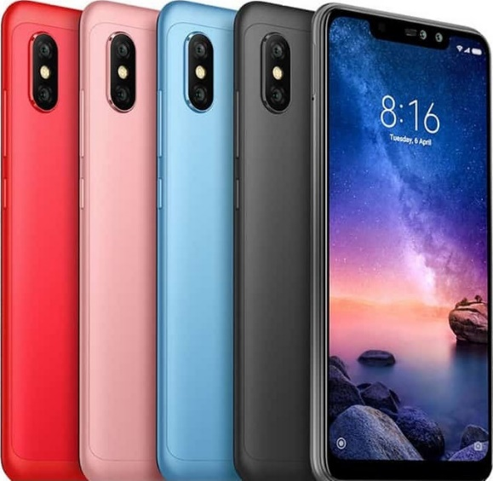

**Specifications**

**General**

|  |  |
| --- | --- |
| **In the Box** | * **Handset, Power Adapter, USB Data Cable,** * **Ultra-Thin Case, Warranty Card,** * **Getting Started Guide, SIM Ejector Pin** |
| **Model Number** | * **MZB6876IN** |
| **Model Name** | * **Redmi Note 6 Pro** |
| **Color** | * **Black** |
| **Browse Type** | * **Smartphones** |
| **SIM Type** | * **Dual Sim** |
| **Hybrid Sim Slot** | * **Yes** |
| **Touchscreen** | * **Yes** |
| **OTG Compatible** | * **Yes** |
| **Quick Charging** | * **Yes** |
| **Sound Enhancements** | * **Speaker - Single (Bottom Opening), 2 x Microphones** * **(Noise Cancellation)** |

**Display Features**

|  |  |
| --- | --- |
| **Display Size** | * **15.9 cm (6.26 inch)** |
| **Resolution** | * **2280 x 1080 pixels** |
| **Resolution Type** | * **FHD+** |
| **GPU** | * **Adreno 509** |
| **Display Type** | * **IPS (In-cell)** |
| **Other Display Features** | * **Notch Display, Corning Gorilla Glass** |

**Os & Processor Features**

|  |  |
| --- | --- |
| **Operating System** | * **Android Oreo 8.1** |
| **Processor Type** | * **Qualcomm Snapdragon 636** |
| **Processor Core** | * **Octa Core** |
| **Primary Clock Speed** | * **1.8 GHz** |
| **Operating Frequency** | * **GSM - B2, B3, B5, B8, WCDMA - B1, B2,** * **B5, B8, 4G LTE TDD - B40, B41,** * **FDD - B1, B3, B5** |

**Memory & Storage Features**

|  |  |
| --- | --- |
| **Internal Storage** | * **64 GB** |
| **RAM** | * **4 GB** |
| **Expandable Storage** | * **256 GB** |
| **Supported Memory Card Type** | * **microSD** |
| **Memory Card Slot Type** | * **Hybrid Slot** |

**Camera Features**

|  |  |
| --- | --- |
| **Primary Camera Available** | * **Yes** |
| **Primary Camera** | * **12MP + 5MP** |
| **Primary Camera Features** | * **12MP - f/1.9, 1.4micrometer, Dual PD,** * **5MP - f/1.9 Aperture, Dual Pixel Auto Focus** |
| **Secondary Camera Available** | * **Yes** |
| **Secondary Camera** | * **20MP + 2MP** |
| **Secondary Camera Features** | * **f2.0** |
| **Flash** | * **Rear Flash** |
| **Dual Camera Lens** | * **Primary & Secondary Camera** |

**Connectivity Features**

|  |  |
| --- | --- |
| **Network Type** | * **3G, 4G VOLTE, 4G, 2G** |
| **Supported Networks** | * **GSM, WCDMA, 4G VoLTE, 4G LTE,** * **UMTS** |
| **Internet Connectivity** | * **4G, 3G, Wi-Fi** |
| **3G** | * **Yes** |
| **Micro USB Port** | * **Yes** |
| **Bluetooth Support** | * **Yes** |
| **Bluetooth Version** | * **5** |
| **Wi-Fi** | * **Yes** |
| **Wi-Fi Version** | * **802.11a/b/g/n/ac** |
| **Infrared** | * **Yes** |
| **USB Connectivity** | * **Yes** |
| **Audio Jack** | * **3.5mm** |
| **Map Support** | * **Google Maps** |
| **GPS Support** | * **Yes** |

**Other Details**

|  |  |
| --- | --- |
| **Smartphone** | * **Yes** |
| **SIM Size** | * **Dual Nano SIM** |
| **Graphics PPI** | * **403 PPI** |
| **Sensors** | * **Rear Fingerprint Scanner,** * **Ambient Light Sensor, Proximity Sensor,** * **E-compass, Accelerometer, Gyroscope** |
| **Other Features** | * **Body - Metal Back, IR Blaster,** * **Charger - 5V/2A, Quick Charge 3.0** |
| **GPS Type** | * **A-GPS, GLONASS, BeiDou** |

**Battery & Power Features**

|  |  |
| --- | --- |
| **Battery Capacity** | * **4000 mAh** |

**Dimensions**

|  |  |
| --- | --- |
| **Width** | * **76.4 mm** |
| **Height** | * **157.9 mm** |
| **Depth** | * **8.26 mm** |
| **Weight** | * **181 g** |

**Warranty**

|  |  |
| --- | --- |
| **Warranty Summary** | * **Brand Warranty of 1 Year Available for** * **Mobile and 6 Months for Accessories** |

**Chipset -**

Mobile phones run on so-called embedded chipsets, which are designed to perform one or a few dedicated functions, often with real-time computing constraints. They are embedded as part of the complete device including hardware and mechanical parts.

The ever popular smartphones are equipped with more advanced embedded chipsets that can do many different tasks depending on their programming.

Thus their CPU (Central Processing Unit) performance is vital for the daily user experience and people tend to use the clock rate of the main CPU that's in the heart of the chipset to compare the performance of competing end products.

As we already pointed out, the clock rate of a processor is only useful for providing performance comparisons between computer chips in the same processor family and generation.

Also, as mobile gaming is increasingly gaining popularity, users have become more aware of the various types of GPU (Graphics Processing Unit) chips that come as part of the mobile chipsets and sometimes even consider their performance when making buying decisions.

**Qualcomm Snapdragon 636 -**

The Qualcomm Snapdragon 636 (SDM636) is a mid-range octa-core SoC with eight custom KRYO 260 cores at up to 1.8 GHz, an Adreno 509 GPU, a LPDDR4-2666 memory controller (1333 MHz) and a X12 LTE (Cat 12/13, 300 Mbps down, 150 Mbps up) modem. Furthermore, the chip supports 802.11ac WIFI and Bluetooth 5.0. It is manufactured in 14nm FINFET. Qualcomm states a 40% faster performance compared to the old Snapdragon 630 (8x ARM Cortex-A53)

**Display -**

LCD (Liquid Crystal Display)

* IPS-LCD (In-Plane Switching Liquid Crystal Display)
* OLED (Organic Light-Emitting Diode)
* AMOLED (Active-Matrix Organic Light-Emitting Diode)

The screen, when combined with the touch element, is 'the' major element of the user interface and as such we go to great lengths when testing screens during our review process to measure a displays quality by measuring Contrast Ratio, Color Calibration, Brightness and Sunlight Legibility.

**Screen Protection definition**

As touchscreen displays are growing larger in recent years, the need for enhanced scratch resistance and protection of the screens created the demand for usage of screen covers of increased resistance including chemically hardened glass.

Corning's Gorilla Glass is a popular brand of hardened glass used for high-end handset in the mobile industry.

Additionally, manufacturers has started applying oleophobic coating on top of its screens to make finger smudges less of an issue.

**OS (Operating System) - definition**

The Operating System is a base infrastructure software component of a computerized system. It controls all basic operations of the computer (or other electronic devices such as PDA, smartphone, etc.). The Operating System allows the user to install and execute third-party applications (commonly called apps for short), usually adding new functionality to the device.

Among the most popular computer operating systems are Microsoft's Windows and Apple's MacOS, along with the various distributions of Linux.

The most popular OS's for mobile devices (smartphones and tablets) are Apple's iOS and Google's Android and they are the only ones that still show growth. Down the ranks there are RIM's BlackBerry OS and Microsoft's Windows Mobile. Symbian holds a distant fifth place, while it wasn't that long ago it was still the most widely used mobile OS.



**Central Processing Unit**

CPU (Central Processing Unit) - otherwise known as a processor - is an electronic circuit that can execute computer programs. Both the miniaturization and standardization of CPUs have increased their presence far beyond the limited application of dedicated computing machines. Modern microprocessors appear in everything from automobiles to mobile phones.

The clock rate is one of the main characteristics of the CPU when performance is concerned. Clock rate is the fundamental rate in cycles per second (measured in hertz, kilohertz, megahertz or gigahertz) for the frequency of the clock in any synchronous circuit. A single clock cycle (typically shorter than a nanosecond in modern non-embedded microprocessors) toggles between a logical zero and a logical one state.

With any particular CPU, replacing the crystal with another crystal that oscillates with twice the frequency will generally make the CPU run with twice the performance. It will also make the CPU produce roughly twice the amount of waste heat.

Engineers are working hard to push the boundaries of the current architectures and are constantly searching for new ways to design CPUs that tick a little quicker or use slightly less energy per clock. This produces new cooler CPUs that can run at higher clock rates.

Scientists also continue to search for new designs that allow CPUs to run at the same or at a lower clock rate as older CPUs, but which get more instructions completed per clock cycle.

The clock rate of a processor is only useful for providing comparisons between computer chips in the same processor family and generation.

Clock rates can be very misleading since the amount of work different computer chips can do in one cycle varies. Clock rates should not be used when comparing different computers or different processor families. Rather, some kind of software benchmarks should be used.

Smartphones are equipped with more advanced embedded chipsets that can do many different tasks depending on their programming.

The performance of the CPU that's at the core of the chipset is vital for the daily user experience and the general computing performance of the smartphone. People tend to use the clock rate of the main CPU to compare the performance of competing end products. But as we already pointed out, the clock rate of a processor is only useful for providing performance comparisons between computer chips in the same processor family and generation. For all other purposes, it's best to use software benchmarks for determining comparative performance.

**Graphics Processing Unit**

The GPU (Graphics Processing Unit) is a specialized circuit designed to accelerate the image output in a frame buffer intended for output to a display.

GPUs are very efficient at manipulating computer graphics and are generally more effective than general-purpose CPUs for algorithms where processing of large blocks of data is done in parallel.

Modern smartphones are equipped with advanced embedded chipsets that can do many different tasks depending on their programming. GPUs are an essential part of those chipsets and as mobile games are pushing the boundaries of their capabilities, the GPU performance is becoming increasingly important .

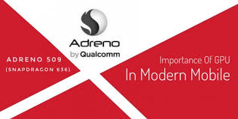

Qualcomm Adreno 509

The Qualcomm Adreno 509 is a mobile graphics card for mid-range smartphones and tablets (mostly Android based). It is included in the lower end Qualcomm Snapdragon 636 SoCs and based on the Adreno 500 architecture (like the Adreno 520 in the S820, which should be fully compatible in software).

The GPU supports modern standards like Vulkan 1.0 (according to Wikipedia), OpenGL ES 3.1 + AE (3.2 in other sources), OpenCL 2.0 and DirectX 12 (FL 12.1 according to Wikipedia, 11.1 according to Qualcomm). Furthermore, the GPU supports Universal Bandwidth Compression (UBWC) to save memory bandwidth.

**Sensors**

Smartphones today come with a wealth of sensors to facilitate a better user experience, provide apps with enhanced information about the world around the phone and provide robust and increased battery life.

**Biometrics**

Biometric related sensors provide levels of enhanced security by capturing and validating human related metrics. Including Finger Print recognition, IRIS (eye) scanning and full facial recognition.

Biometric sensors provide a more secure but more convenient way to unlock phones and pay for purchases.

Additionally, biometric sensors can be used to collect a user’s heart rate and SpO2 (the estimate of arterial oxygen saturation) for use within a vendors 'health' application.

**Dynamic Memory**

A way or organizing different types of data in the phone's memory. Also referred to as Shared memory.

Dynamic memory means that all types of data are stored in the same memory (there is no separate memory for photos, ringtones etc.).

An advantage of dynamic memory over partitioned memory is that it is more flexible - with partitioned memory, you can fill up the photo memory for example and you won't be able to take any more photos even if other types of memory are free.

**SAR (Specific absorption rate)** -

Each GSM handset has a radio transmitter and receiver in order to operate in the wireless GSM network. That transceiver is manufactured so that when used next to the ear and when worn on the belt, it won't exceed the limits for exposure to radio frequency energy set by the authorities.

The authorities in question here are the Federal Communications Commission (FCC) of the U.S. Government, Industry Canada of the Canadian Government (IC), and the Council of the European Union.

These limits are part of comprehensive guidelines that establish permitted levels of RF energy for the general population. The guidelines are based on standards that have been developed by independent scientific organizations through periodic and thorough evaluation of scientific studies.

The exposure standard for wireless devices employs a unit of measurement known as the Specific Absorption Rate, or SAR. Unfortunately the limits set by the FCC/IC and the Council of the European Union are measured over different amount of tissue so they are not directly comparable.

* The SAR limit set by the FCC/IC is 1.6W/kg averaged over 1 gram of actual tissue.
* The SAR limit recommended by the Council of the European Union is 2.0W/kg averaged over 10 g of actual tissue.

Although the SAR is determined at the highest certified power level, the actual SAR level of the device while operating can be well below the maximum value. This is because GSM phones are designed to operate at multiple power levels so as to use only the power required to reach the network. In general, the closer you are to a wireless base station antenna, the lower the power output of the device and vice versa.