

**MSPM’S**

**Deogiri Institute of Engineering and Management Studies, Aurangabad**

**Computer Science And Engineering Department**

Report on

Computer Architecture & Organization

Submitted By

**1) Mahesh Dhole (26009)**

**2) Riteeka Purnekar (26010)**

Under the Guidance of

Prof. P. H. Durole

**Computer Science And Engineering Department**

(Deogiri Institute of Engineering and Management Studies)

2019-2020



CERTIFICATE

This is to Certify that Mr. **Mahesh Dhole (26009)** and Miss. **Riteeka Purnekar** **(26010)** has completed a report writing in Computer Architecture & Organization subject on the topic Comparison between Acer Nitro 5 AN515 Laptop and Lenovo Yoga 530 Laptop model.

**Prof. P.H. Durole**  **Prof. S. B. Kalyankar Dr. Ulhas Shiukar**

**Subject Teacher H.O.D. Director**

CONTENTS

Introduction

* Processor
* Architecture
* Graphics Processing Unit
* Ram
* Storage
* Instruction Set
* Input output Mechanism

Laptop Specifications

* **Acer Nitro 5 AN515 Laptop** and
* Lenovo Yoga 530 (14,Intel)

Comparison of both laptops based on

* Processor
* Graphic Processor
* Others

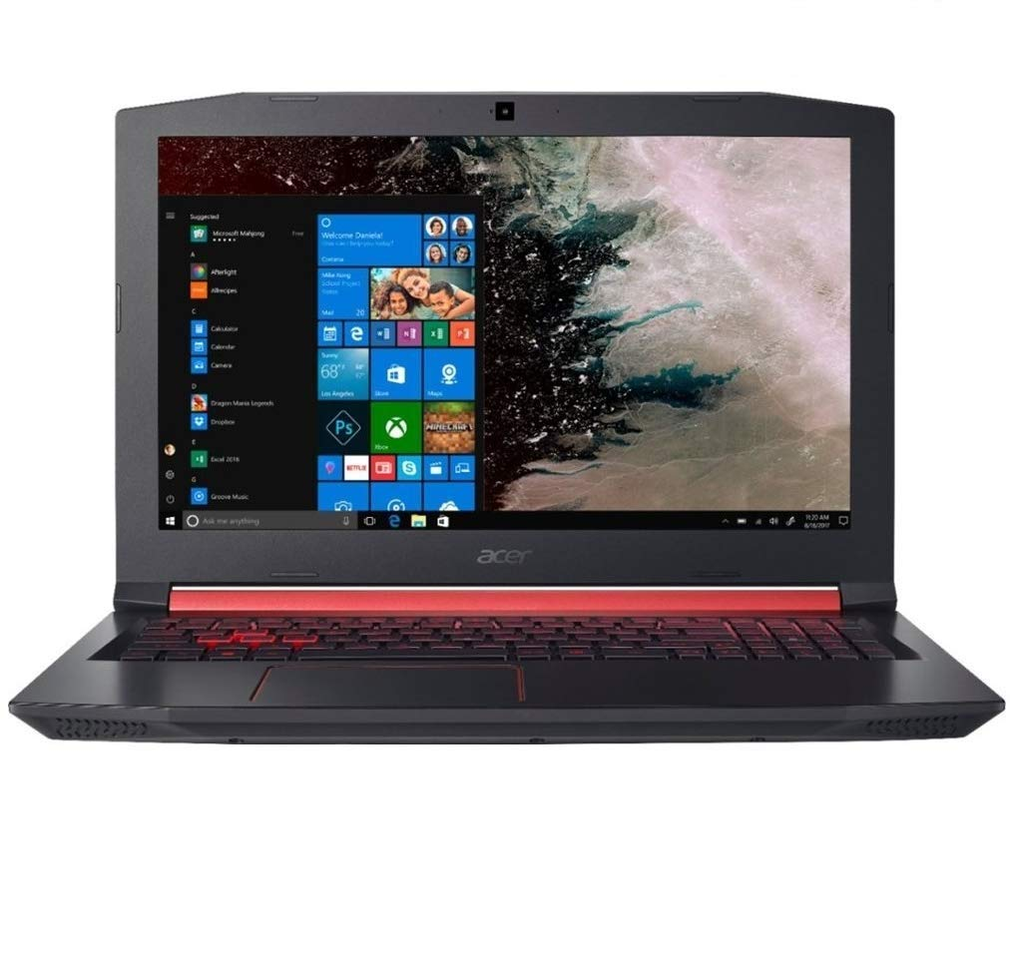

**Price**

**Rs. 58,000/-**

**Acer Nitro 5 AN515 Laptop Information**

|  |  |
| --- | --- |
| **Brand** | Acer |
| **Series** | Nitro 5 |
| **Colour** | BLACK |
| **Item Height** | 26.8 Millimeters |
| **Item Width** | 390 Millimeters |
| **Screen Size** | 15.6 Inches |
| **Maximum Display Resolution** | 1920 x 1080 |
| **Item Weight** | 2.7 kg |
| **Product Dimensions** | 10.5 x 15.4 x 1.1 inches |
| **Batteries:** | 2 D batteries required. (included) |
| **Item model number** | AN515-53-52FA |
| **Processor Brand** | Intel |
| **Processor Type** | Core i5 |
| **Memory Technology** | DDR4 SDRAM |
| **Hard Disk Interface** | Serial ATA |
| **Graphics Coprocessor** | NVIDIA GEFORCE GTX 1050 (4GB GDDR5) |
| **Graphics Card Ram Size** | 4 GB |
| **Number of USB 3.0 Ports** | 1 |
| **Number of HDMI Ports** | 1 |
| **Number of Internet Ports** | 1 |
| **Number of Microphone Ports** | 1 |
| **Optical Drive Type** | None |
| **Operating System** | Windows 10 Home |
| **Maximum Battery Run Time** | 8.50 Hours |
| **Lithium battery Weight** | 100 Grams |
| **Number of Lithium Ion Cells** | 4 |
| **Battery Capacity** | 3220 mAh |
| **Included Components** | Laptop, Adapter, User Manual |

**Device name: Lenovo yoga 530 (14, INTEL)**

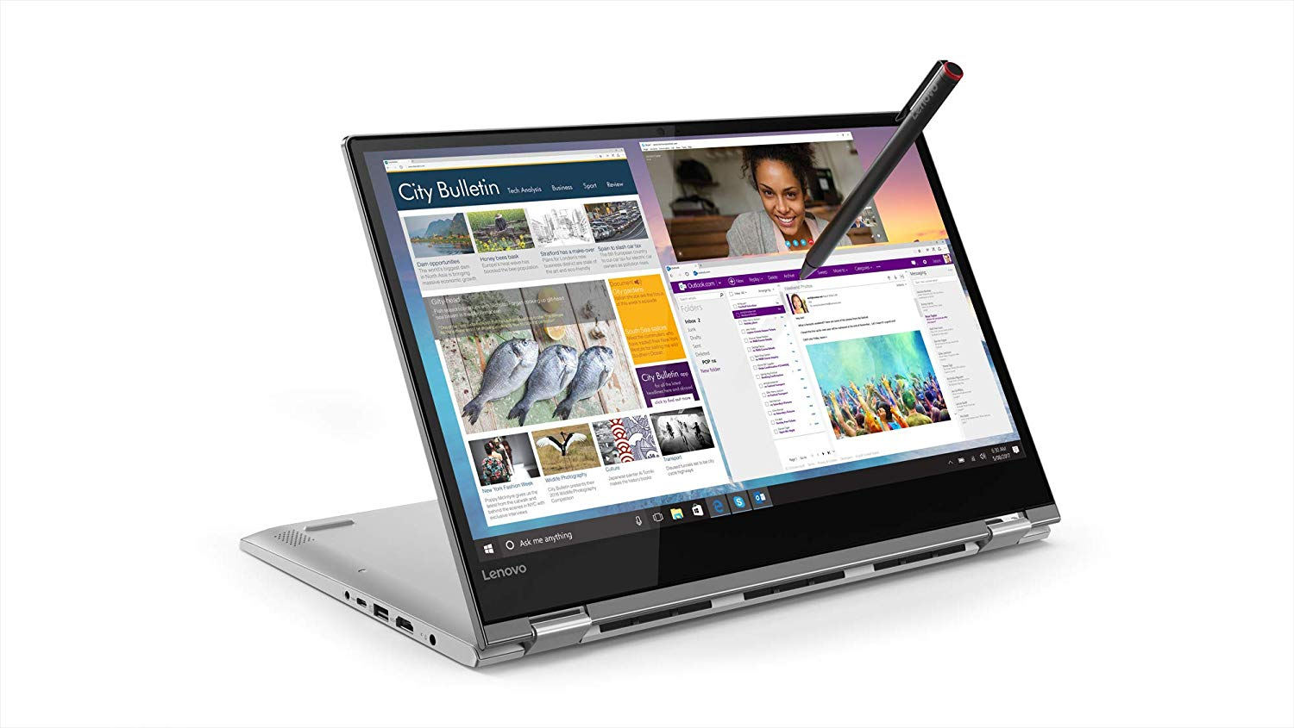

**Price**

Rs. 47,500/-

**Lenovo Yoga 530(14,Intel)**

**BASIC INFORMATION**

Model name: Lenovo Yoga 530 (14, Intel)

Launch date (global): June 2019

Operating system (with version): Windows 10 Home

Laptop type: Ultra-portal

**DISPLAY**

Resolution: 1920 x 1080 pixels (FHD)

Display size: 14 inches

**Connectivity**

Wireless connectivity: 2X2 AC

Bluetooth version: 4.1

**Memory**

Ram included: 16GB

Ram type: DDR4

Ram speed: 2400 MHz

**Physical specification**

Laptop weight: 1.6 kg

Laptop dimension (WxDxH): 328mmx229mmx17.6mm

Colors: Onyx Black

**Processor**

Processor model: 8th generation Intel core i3

Base clock speed: 1.60 GHz

Burst clock speed: 4GHz

Cache: 6MB

Graphics processor: Integrated Graphics

Graphic memory: 4MB

**Storage**

SSD: 128 GB

**Power**

Battery type: 45WH, 4-cell battery

**Sound**

Sound technology: Harman speakers with Dolby Audio™ Premium

**Warranty**

Warranty time: 1 year

**Inputs**

Web camera: Yes

Pointer device: Click pad

Backlit keyboard: Yes

Internal mic: Yes

Speakers: 2 speakers

Touch screen: Yes

Finger print sensor & reader: No

**Ports and slots**

USB ports: 2x USB 3.0,

1x USB-C

HDMI port: Standard

Multi card slot: 4-in-1 card reader

Headphone & microphone combo jack: Yes

RJ45 Ethernet (LAN): Yes

Nobel locks security: Yes

**General specification:**

|  |  |
| --- | --- |
| **Family** | Core i5 |
| **Series** | i3-813U |
| **Locked** | Yes |
| **Frequency** | 1,600 MHz |
| **Turbo Frequency** | 3,400 MHz (1 core), 3,400 MHz (2 cores), 3,400 MHz (3 cores), 3,400 MHz (4 cores) |
| **Bus type** | OPI |
| **Bus rate** | 4 GT/s (gigabyte/sec) |
| **Clock multiplier** | 16 |
| **Core** | 4 |
| **Threads** | 8 |

**Control unit**

A control unit (CU) handles all processor control signals. It directs all input and output flow, fetches code for instructions from micro programs and directs other units and models by providing control and timing signals. A CU component is considered the processor brain because it issues orders to just about everything and ensures correct instruction execution.

**CU functions are as follows:**

* Controls sequential instruction execution
* Interprets instructions
* Guides data flow through different computer areas
* Regulates and controls processor timing
* Sends and receives control signals from other computer devices
* Handles multiple tasks, such as fetching, decoding, execution handling and storing results

**CUs are designed in two ways:**

* **Hardwired control:**

Design is based on a fixed architecture. The CU is made up of flip-flops, logic gates, digital circuits and encoder and decoder circuits that are wired in a specific and fixed way. When instruction set changes are required, wiring and circuit changes must be made. This is preferred in a reduced instruction set computing (RISC) architecture, which only has a small number of instructions.

* **Microprogram control:**Microprograms are stored in a special control memory and are based on flowcharts. They are replaceable and ideal because of their simplicity.
* **With a single-level control store:**

In this, the instruction opcode from the instruction register is sent to the control store address register. Based on this address, the first microinstruction of a microprogram that interprets execution of this instruction is read to the microinstruction register. This microinstruction contains in its operation part encoded control signals, normally as few bit fields. In a set microinstruction field decoders, the fields are decoded. The microinstruction also contains the address of the next microinstruction of the given instruction microprogram and a control field used to control activities of the microinstruction address generator.

The last mentioned field decides the addressing mode (addressing operation) to be applied to the address embedded in the ongoing microinstruction. In microinstructions along with conditional addressing mode, this address is refined by using the processor condition flags that represent the status of computations in the current program. The last microinstruction in the instruction of the given microprogram is the microinstruction that fetches the next instruction from the main memory to the instruction register.

* **With a two-level control store:**

In this, in a control unit with a two-level control store, besides the control memory for microinstructions, a nano-instruction memory is included. In such a control unit, microinstructions do not contain encoded control signals. The operation part of microinstructions contains the address of the word in the nano-instruction memory, which contains encoded control signals. The nano-instruction memory contains all combinations of control signals that appear in microprograms that interpret the complete instruction set of a given computer, written once in the form of nano-instructions.

In this way, unnecessary storing of the same operation parts of microinstructions is avoided. In this case, microinstruction word can be much shorter than with the single level control store. It gives a much smaller size in bits of the microinstruction memory and, as a result, a much smaller size of the entire control memory. The microinstruction memory contains the control for selection of consecutive microinstructions, while those control signals are generated at the basis of nano-instructions. In nano-instructions, control signals are frequently encoded using 1 bit/ 1 signal method that eliminate decoding.

**Other functions**

**IPS Truelife display:**

A TrueLifeTM display has up to a 10% higher contrast ratio than the same display with an anti-glare coating. Lenovo TrueLife technology delivers darker blacks and colors that pop for vivid graphics and lifelike video. TrueLife displays offer a fantastic visual experience for those who want to play games, watch DVDs or streaming videos and look at their favorite digital photos.

**Graphics**

A Graphics Card is a processor designed specifically to handle 3D graphics and videos. It is so because having such a processor along with the main processor/CPU. It reduces the amount of pressure on your CPU. The CPU mainly does calculations very fast and a GPU mainly does the processing of graphics very fast

**NVIDIA GeForce MX150:**

GPU Name: NVIDIA GeForce MX150

GPU Type: Dedicated video card

Number or Cores (Shaders):384 unified

Core Clock Speed: Default 1,468 MHz, Boost 1,532 MHz

Memory Bus Width: 64-bit

Video Memory Size: 2GB, 4GB

Memory Type: GDDR5

Video Memory Speed: 6000 MHz

Production Technology: 14-nanometer

**Memory**

**HDD**

Memory is the most essential element of a computing system because without it computer can’t perform simple tasks. Computer memory is of two basic type – Primary memory / Volatile memory and Secondary memory / non-volatile memory. Random Access Memory (RAM) is volatile memory and Read Only Memory (ROM) is non-volatile memory.

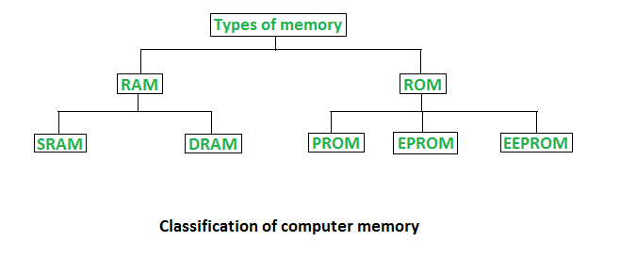

**Random Access Memory (RAM) –**

* It is also called as *read write memory* or the*main memory* or the *primary memory*.
* The programs and data that the CPU requires during execution of a program are stored in this memory.
* It is a volatile memory as the data loses when the power is turned off.
* RAM is further classified into two types- *SRAM (Static Random Access Memory)* and *DRAM (Dynamic Random Access Memory)*

**Double Data Rate 4 Synchronous Dynamic Random-Access Memory**, officially abbreviated as **DDR4 SDRAM**, is a type of [synchronous dynamic random-access memory](https://en.wikipedia.org/wiki/Synchronous_dynamic_random-access_memory) with a high [bandwidth](https://en.wikipedia.org/wiki/Bandwidth_(computing)) ("[double data rate](https://en.wikipedia.org/wiki/Double_data_rate)") interface.

Released to the market in 2014, it is one of the latest variants of [dynamic random-access memory](https://en.wikipedia.org/wiki/Dynamic_random-access_memory) (DRAM), of which some have been in use since the early 1970s, and a higher-speed successor to the [DDR2](https://en.wikipedia.org/wiki/DDR2_SDRAM) and [DDR3](https://en.wikipedia.org/wiki/DDR3_SDRAM) technologies.

DDR4 is not compatible with any earlier type of random-access memory (RAM) due to different signaling voltage and physical interface, besides other factors.

DDR4 SDRAM was released to the public market in Q2 2014, focusing on [ECC memory](https://en.wikipedia.org/wiki/ECC_memory), while the non-ECC DDR4 modules became available in Q3 2014, accompanying the launch of [Haswell-E](https://en.wikipedia.org/wiki/Haswell-E) processors that require DDR4 memory.

## Features

The primary advantages of DDR4 over its predecessor, DDR3, include higher module density and lower voltage requirements, coupled with higher [data rate transfer](https://en.wikipedia.org/wiki/Bit_rate#Goodput_(data_transfer_rate)) speeds. The DDR4 standard allows for [DIMMs](https://en.wikipedia.org/wiki/DIMM) of up to 64 [GB](https://en.wikipedia.org/wiki/Gibibyte) in capacity, compared to DDR3's maximum of 16 GB per DIMM.

Unlike previous generations of DDR memory, [prefetch](https://en.wikipedia.org/wiki/Prefetch_buffer) has *not* been increased above the 8n used in DDR3 the basic burst size is eight words, and higher bandwidths are achieved by sending more read/write commands per second. To allow this, the standard divides the DRAM banks into two or four selectable bank groups, where transfers to different bank groups may be done more rapidly.

Because power consumption increases with speed, the reduced voltage allows higher speed operation without unreasonable power and cooling requirements.

DDR4 operates at a voltage between 1.2 V and 1.4 V with a frequency between 800 and 2133 MHz (DDR4-1600 through DDR4-4266), compared to frequencies between 400 and 1067 MHz and voltage requirements of 1.5 or 1.65 V of DDR3. Due to the nature of DDR, speeds are typically advertised as doubles of these numbers (DDR3-1600 and DDR4-2400 are common, with DDR4-3200 and DDR4-4800 available at high cost). Although a low-voltage standard has yet to be finalized (as of August 2014), it is anticipated that low-voltage DDR4 will run at a voltage of 1.05 V, compared to DDR3's low-voltage standard ([DDR3L](https://en.wikipedia.org/wiki/DDR3L)) which requires 1.35 V to operate.

## Timeline

[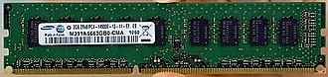](https://en.wikipedia.org/wiki/File:Samsung_displays_first_DDR4_module.jpg)

The first DDR4 memory module prototype was manufactured by [Samsung](https://en.wikipedia.org/wiki/Samsung) and announced in January 2011.

[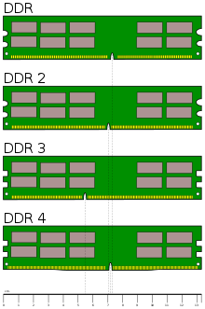](https://en.wikipedia.org/wiki/File:Desktop_DDR_Memory_Comparison.svg)

* **2005:** standards body [JEDEC](https://en.wikipedia.org/wiki/JEDEC) began working on a successor to DDR3 around 2005, about 2 years before the launch of DDR3 in 2007. The high-level architecture of DDR4 was planned for completion in 2008.
* **2007:** some advance information was published in 2007, and a guest speaker from [Qimonda](https://en.wikipedia.org/wiki/Qimonda) provided further public details in a presentation at the August 2008 [San Francisco](https://en.wikipedia.org/wiki/San_Francisco) [Intel Developer Forum](https://en.wikipedia.org/wiki/Intel_Developer_Forum) (IDF). DDR4 was described as involving a 30 nm process at 1.2 volts, with bus frequencies of 2133 [MT/s](https://en.wikipedia.org/wiki/MT/s) "regular" speed and 3200 MT/s "enthusiast" speed, and reaching market in 2012, before transitioning to 1 volt in 2013.
* **2009:** in February, [Samsung](https://en.wikipedia.org/wiki/Samsung) validated 40 nm DRAM chips, considered a "significant step" towards DDR4 development since in 2009, DRAM chips were only beginning to migrate to a 50 nm process.
* **2010:** subsequently, further details were revealed at MemCon 2010, [Tokyo](https://en.wikipedia.org/wiki/Tokyo) (a computer memory industry event), at which a presentation by a JEDEC director titled "Time to rethink DDR4" with a slide titled "New roadmap: More realistic roadmap is 2015" led some websites to report that the introduction of DDR4 was probably or definitely delayed until 2015. However, DDR4 [test samples](https://en.wikipedia.org/wiki/Engineering_sample)were announced in line with the original schedule in early 2011 at which time manufacturers began to advise that large scale commercial production and release to market was scheduled for 2012.
* **2011:** in January, [Samsung](https://en.wikipedia.org/wiki/Samsung) announced the completion and release for testing of a 2 GB DDR4 DRAM module based on a process between 30 and 39 [nm](https://en.wikipedia.org/wiki/Nanometer). It has a maximum data transfer rate of 2133 [MT/s](https://en.wikipedia.org/wiki/MT/s) at 1.2 V, uses [pseudo open drain](https://en.wikipedia.org/wiki/Open_drain) technology (adapted from [graphics DDR](https://en.wikipedia.org/wiki/GDDR) memory) and draws 40% less power than an equivalent DDR3 module.   
  In April, [Hynix](https://en.wikipedia.org/wiki/Hynix) announced the production of 2 GB DDR4 modules at 2400 MT/s, also running at 1.2 V on a process between 30 and 39 nm (exact process unspecified), adding that it anticipated commencing high volume production in the second half of 2012. Semiconductor processes for DDR4 are expected to transition to sub-30 nm at some point between late 2012 and 2014.
* **2012:** in May, [Micron](https://en.wikipedia.org/wiki/Micron_Technology) announced it is aiming at starting production in late 2012 of 30 nm modules.  
  In July, Samsung announced that it would begin sampling the industry's first 16 GB registered dual inline memory modules (RDIMMs) using DDR4 SDRAM for enterprise server systems.  
  In September, JEDEC released the final specification of DDR4.
* **2013:** DDR4 was expected to represent 5% of the DRAM market in 2013, and to reach [mass market](https://en.wikipedia.org/wiki/Mass_market) adoption and 50% [market penetration](https://en.wikipedia.org/wiki/Market_penetration) around 2015 as of 2013, however, adoption of DDR4 has been delayed and it is no longer expected to reach a majority of the market until 2016 or later. The transition from DDR3 to DDR4 is thus taking longer than the approximately five years taken for DDR3 to achieve mass market transition over DDR2. In part, this is because changes required to other components would affect all other parts of computer systems, which would need to be updated to work with DDR4.
* **2014:** in April, Hynix announced that it had developed the world's first highest-density 128 GB module based on 8 [Gb](https://en.wikipedia.org/wiki/Gibibit) DDR4 using 20 nm technology. The module works at 2133 MHz, with a 64-bit I/O, and processes up to 17 GB of data per second.
* **2016:** in April, Samsung announced that they had begun to mass-produce DRAM on a "10 nm-class" process, by which they mean the 1x nm node regime of 16 nm to 19 nm, which supports a 30% faster data transfer rate of 3,200 [megabits](https://en.wikipedia.org/wiki/Megabit) per second. Previously, a size of 20 nm was used.

**Read Only Memory (ROM) –**

* **ROM** is a type of non-volatile memory used in computers and other electronic devices. Data stored in ROM cannot be electronically modified after the manufacture of the memory device. Read-only memory is useful for storing software that is rarely changed during the life of the system, sometimes known as firmware. Software applications for programmable devices can be distributed as plug-in cartridges containing read-only memory.

Erasable programmable read-only memory (EPROM) and electrically erasable programmable read-only memory (EEPROM) can be erased and re-programmed, but usually this can only be done at relatively slow speeds, may require special equipment to achieve, and is typically only possible a certain number of times.

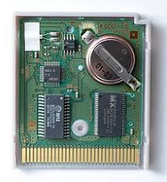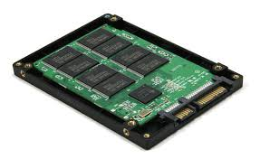

* Stores crucial information essential to operate the system, like the program essential to boot the computer.
* It is not volatile.
* Always retains its data.
* Used in embedded systems or where the programming needs no change.
* Used in calculators and peripheral devices.
* ROM is further classified into 4 types- *ROM*, *PROM*, *EPROM*, and *EEPROM*.

**Types of Read Only Memory (ROM) –**

1. **PROM (Programmable read-only memory)** – It can be programmed by user. Once programmed, the data and instructions in it cannot be changed.
2. **EPROM (Erasable Programmable read only memory)** – It can be reprogrammed. To erase data from it, expose it to ultra violet light. To reprogram it, erase all the previous data.
3. **EEPROM (Electrically erasable programmable read only memory)** – The data can be erased by applying electric field, no need of ultra violet light. We can erase only portions of the chip

**SSD**

An SSD (solid-state drive) is a type of nonvolatile storage media that stores persistent data on solid-state flash memory. Two key components make up an SSD: a flash controller and NAND flash memory chips. The architectural configuration of the SSD controller is optimized to deliver high read and write performance for both sequential and random data requests. SSDs are sometimes referred to as flash drives or solid-state disks.

SSDs will use three main types of memory:

* 1. Single cell
  2. Multi cell
  3. Triple-level cells

1. Single-level cells can hold one bit of data at a time—a one or zero. Single-level cells (SLC) are the most expensive form of SSD, but it is also the fastest and most durable.
2. Multi-level cells (MLC) can hold two bits of data per cell and have a larger amount of storage space in the same amount of physical space as SLC. However, MLCs have slower write speeds.
3. Triple-level cells (TLC) can hold three bits of data in a cell. TLCs have a lower price, but slower write speeds and less durability. TLC-based SSDs deliver more flash capacity and are cheaper than an MLC or SLC.

**Processor Architecture**

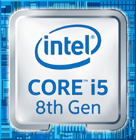 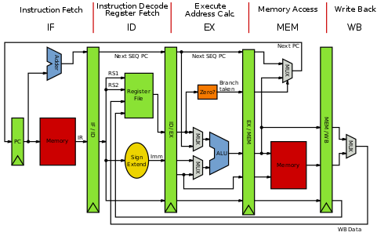

Core i5-8250U is a 64-bit quad-core performance x86 mobile microprocessor introduced by Intel in mid-2017.

This processor, which is based on an enhanced version of the Kaby Lake micro architecture, is manufactured on Intel's 2nd generation enhanced 14nm+ process. The i5-8250U operates at 1.6 GHz with a TDP of 15 W and Turbo Boost frequency of up to 3.4 GHz. This MPU supports up to 32 GiB of dual-channel DDR4-2400 memory and incorporates Intel's UHD Graphics 620 IGP operating at 300 MHz with a burst frequency of 1.15 GHz.

This model has a configurable TDP-down of 10 W at 800 MHz and a TDP (thermal design power)-up of 25 W at 1.8 GHz.

**General Architecture**

Since the 64-bit registers allow access for many sizes and locations, we define a byte as 8 bits, a word as 16 bits, a double word as 32 bits, a quad word as 64 bits, and a double quad word as 128 bits. Intel stores bytes “little endian,” meaning lower significant bytes are stored in lower memory address. shows sixteen general purpose 64-bit registers, the first eight of which are labeled (for historical reasons) RAX, RBX, RCX, RDX, RBP, RSI, RDI, and RSP. The second eight are named R8-R15. By replacing the initial R with an E on the first eight registers, it is possible to access the lower 32 bits (EAX for RAX).Similarly, for RAX, RBX, RCX, and RDX, access to the lower 16 bits is possible by removing the initial R (AX for RAX), and the lower byte of the these by switching the X for L (AL for AX), and the higher byte of the low 16 bits using an H (AH for AX).

**SIMD Architecture**

Single Instruction Multiple Data (SIMD) instructions execute a single command on multiple pieces of data in parallel and are a common usage for assembly routines. MMX and SSE commands (using the MMX and XMM registers respectively) support SIMD operations, which perform an instruction on up to eight pieces of data in parallel. For example, eight bytes can be added to eight bytes in one instruction using MMX.The eight 64-bit MMX registers MMX0-MMX7 are aliased on top of FPR0-7, which means any code mixing FP and MMX operations must be careful not to overwrite required values. The MMX instructions operate on integer types, allowing byte, word, and double word operations to be performed on values in the MMX registers in parallel.

**Working on Control Unit**

**Control Unit** is the part of the computer’s central processing unit (CPU), which directs the operation of the processor. It was included as part of the **Von Neumann**

**Architecture** by John von Neumann. It is the responsibility of the Control Unit to tell the computer’s memory, arithmetic/logic unit and input and output devices how to respond to the instructions that have been sent to the processor. It fetches internal instructions of the programs from the main memory to the processor instruction register, and based on this register contents, the control unit generates a control signal that supervises the execution of these instructions.

A control unit works by receiving input information to which it converts into control signals, which are then sent to the central processor. The computer’s processor then tells the attached hardware what operations to perform. The functions that a control unit performs are dependent on the type of CPU because the architecture of CPU varies from manufacturer to manufacturer. Examples of devices that require a CU are:

* Control Processing Units(CPUs)
* Graphics Processing Units(GPUs)

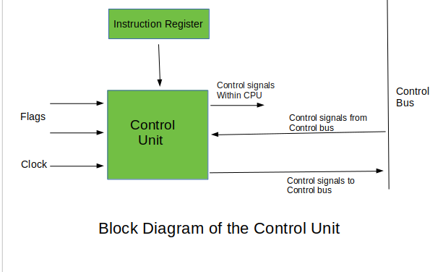

**INSTRUCTIONS SET**

|  |  |  |  |
| --- | --- | --- | --- |
| Opcode | Meaning | Opcode | Meaning |
| MOV | Move to/from/between | AND/OR/XOR/NOT | Bitwise operations |
|  | memory and registers |  |  |
| CMOV* | Various conditional moves | SHR/SAR | Shift right logical/arithmetic |
| XCHG | Exchange | SHL/SAL | Shift left logical/arithmetic |
| BSWAP | Byte swap | ROR/ROL | Rotate right/left |
| PUSH/POP | Stack usage | RCR/RCL | Rotate right/left through carry |
|  |  |  | Bit |
| ADD/ADC | Add/with carry | BT/BTS/BTR | Bit test/and set/and reset |
| SUB/SBC | Subtract/with carry | JMP | Unconditional jump |
| MUL/IMUL | Multiply/unsigned | JE/JNE/JC/JNC/J* | Jump if equal/not |
|  |  |  | equal/carry/not carry/ many |
|  |  |  | Others |
| DIV/IDIV | Divide/unsigned | LOOP/LOOPE/LOOPNE | Loop with ECX |
| INC/DEC | Increment/Decrement | CALL/RET | Call subroutine/return |
| NEG | Negate | NOP | No operation |
| CMP | Compare | CPUID | CPU information |

**Input & output mechanism**

**HDMI**

Stands for "High-Definition Multimedia Interface." HDMI is a trademark and brand name for a digital interface used to transmit audio and video data in a single cable. It is supported by modern audio/video equipment. HDMI outputs "feed" audio and video signals into the HDMI inputs of digital devices, which receive and process them. The cables are terminated with plug connectors, typically featuring 19 pins. Many A/V receivers contain digital processors that can take analog video signals, from a VHS or DVD player, and convert them to HMDI.

**USB**

USB" refers to Universal Serial Bus, which is a type of connection used to link computers to peripheral devices. USB ports are found on both the computers and the devices, and USB cables connect them to each other. USB ports function as both input and output ports. There are two types of USB ports, Type A and Type B, and information can go both directions on either one.

**USB Type A**

The most popular type of USB standard is Type A. You will most likely to find Type-A ports in host devices like desktop computers, gaming consoles and media players.

**USB Type B**

Type-B connectors are at the other end of a typical USB cable that plugs into a peripheral device, such as a smart phone, a printer or a hard drive.

**USB Type C**

Type-C over other existing variants is that it allows for ‘reverse plug orientation’. It can be also be used to share data, charging device.

**Conclusion**

* Currently except Apple **laptops**, the **good** ones are **Lenovo** in terms of everyday usage, performance, value for money and battery life. Also what I have realised over the years. The **brand** is not very important. Suit your needs with the specifications of the **laptop**. With a 36 out of 40, Lenovo turned in the highest score in the reviews category. And it also earned a class-leading 9 Editors’ Choice Awards. Lenovo i7 is the best brand.
* Lenovo laptops are best because they got the first price of best brand in 2019. Lenovo laptops are best sellings!
* What is the Longest Lasting **Lenovo Laptop**? Generally speaking, your typical mid-range **laptop** should **last** roughly three years. And if you take good care of your computer, it may even **last** a bit longer than that.
* Lenovo is fast paced and a next generation 7th component! The Lenovo Series comes with an enormous 512 GB Sata Hard Disk that is simply superb and revolves at an amazing speed of 5400 RPM.