

**Deogiri Institute of Engineering And Management Studies, Aurangabad**

**Project Topic**

**DELL LATITUDE 3390**

**HP PAVILION**

Submitted By

**YASH KHULE**

**CSE Branch, SE-I and Roll No-26019**

Under the Guidance of

**Prof.Pankaj Durole**

(Deogiri Institute of Engineering and Management Studies)

***CERTIFICATE***

This is to Certify that YASH KHULE has Completed Word Document Presentation of Computer Architecture And Organisation on **\*\*\*\*\*** For the partial fulfillment of Continuous Assessment on date______

**Name and Signature of Student Name and Signature of Subject Teacher**

**DELL LATITUDE 3390**

**2 IN 1**

**SPECIFICATIONS**

#### **Audio Input**

* + Type :Microphone

#### **Audio Output**

* + Audio Codec :Realtek ALC3253
  + Compliant Standards :High Definition Audio
  + Features :MaxxAudio Pro
  + Type :Stereo speakers

#### **Battery**

* + Capacity :42
  + Cells :3-cell
  + Technology :Lithium ion

#### **Cache Memory**

* + Installed Size :6 MB

#### **Digital Camera**

* + Features :720p HD movie recording, IR camera, Windows Hello
  + Frame Rate :30 frames per second
  + Resolution :1280 x 720
  + Resolution (MP) :0.92 Megapixel
  + Video Resolutions :1280 x 720
  + Webcam Capability :Yes

#### **Dimensions & Weight**

* + Depth :8.9 in
  + Height :0.8 in
  + Weight :3.46 lbs
  + Width :12.8 in

#### **Display**

* + Diagonal Size (metric) :33.782 cm
  + Display Resolution Abbreviation :Full HD
  + Projector Image Brightness :220 cd/m²
  + Projector Monitor Features :Anti-glare, Wide Viewing Angle
  + Touchscreen :Yes
  + Type :LCD
  + Widescreen Display :Yes

#### **Display (Projector)**

* + Diagonal Size :13.3 in
  + Max Resolution :1920 x 1080

#### **Hard Drive**

* + Hard Drive Features :Class 20
  + Interface :Serial ATA
  + SSD Form Factor :M.2 2280
  + Type :SSD

#### **Header**

* + Brand :Dell
  + Model :3390 2-in-1
  + Packaged Quantity :1
  + Product Line :Dell Latitude

#### **Input Device**

* + Type :Keyboard, Touchpad

#### **Interfaces**

* + Comment :Power Share
  + Interface :USB 3.1 Gen 1
  + HDMI Ports Qty :1
  + USB 2.0 Ports Qty :1
  + USB 3.0 Ports Qty :1
  + USB-C Ports Qty :1
  + Interface :HDMI
  + Interface :Headphone/microphone combo jack
  + Interface :USB 2.0
  + Interface :USB-C/DisplayPort

#### **Miscellaneous**

* + Color Category :Black
  + Included Accessories :Power adapter
  + Pricing Type :Build To Stock (BTS)
  + Security Slot Type :Noble Wedge security slot

#### **Networking**

* + Data Link Protocol :Bluetooth 4.1, IEEE 802.11a, IEEE 802.11ac, IEEE 802.11b, IEEE 802.11g, IEEE 802.11n
  + Interface Type :M.2 2230
  + Wireless NIC :Atheros QCA61x4A
  + Wireless Protocol :802.11a/b/g/n/ac, Bluetooth 4.1

#### **Optical Storage**

* + Drive Type :No optical drive
  + Type :None

#### **OS Provided**

* + Edition :Windows 10 Pro
  + Family :Windows 10
  + Type :Windows 10 Pro 64-bit Edition

#### **Power Device**

* + Frequency Required :50/60 Hz
  + Nominal Voltage :AC 120/230 V
  + Output Current :2.31 A
  + Power Provided :45 Watt
  + Voltage Provided :19.5 V

#### **Processor**

* + 64-bit Computing :Yes
  + Clock Speed :1.6 GHz
  + Features :Intel Turbo Boost Technology 2.0
  + Generation :8
  + Manufacturer :Intel
  + Max Turbo Speed :3.4 GHz
  + Number of Cores :Quad-Core
  + Processor Number :I5-8250U
  + Type :Core i5

#### **RAM**

* + Configuration Features :2 x 4 GB
  + Data Integrity Check :Non-ECC
  + Empty Slots :0
  + Form Factor :SO-DIMM 260-pin
  + Installed Size :8 GB
  + Max Supported Size :16 GB
  + Memory Speed :2400 MHz
  + Rated Memory Speed :2400 MHz
  + Slots Qty :2
  + Technology :DDR4 SDRAM

#### **Service & Support**

* + Bundled Services :1 Year Dell Hardware Service with Onsite/In-Home Service After Remote Diagnosis

#### **Software**

* + Type :Microsoft Office (30 days trial)

#### **Storage Hard Drive**

* + Capacity :256 GB

#### **System**

* + Embedded Security :Trusted Platform Module (TPM 2.0) Security Chip
  + Hard Drive Capacity :256 GB
  + Mechanical Design :360° flip design
  + Notebook Type :Notebook
  + Platform :Windows

#### **Video Memory**

* + Memory Allocation Technology :Shared video memory (UMA)

#### **Video Output**

* + Graphics Processor Series :Intel UHD Graphics
  + Graphics Processor Vendor :Intel UHD Graphics 620

**PROCESSOR –**

This article is about the Intel processor brand name. For the Intel microarchitecture that is the basis for the Core 2 processor family.

[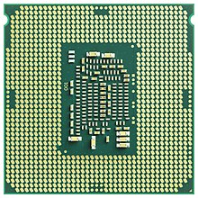](https://en.wikipedia.org/wiki/File:Intel_CPU_Core_i7_6700K_Skylake_bottom.jpg)

[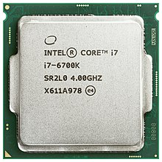](https://en.wikipedia.org/wiki/File:Intel_CPU_Core_i7_6700K_Skylake_top.jpg)

**Intel Core** is a line of mid- to high-end consumer, workstation, and enthusiast Central Processing Unit (CPU) marketed by Intel Corporation. These processors displaced the existing mid- to high-end Pentium processors of the time, moving the Pentium to the entry level, and bumping the Celeron series of processors to the low end. Identical or more capable versions of Core processors are also sold as Xeon Processors for the server and workstation markets.

**CORE I5**

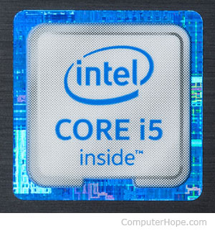

Developed and manufactured by Intel, the **Core i5** is a computer processor, available as dual-core or quad-core. It can be used in both desktop and laptop computers, and is one of three types of processors in the "i" series (also called the Intel Core family of processors).

The Core i5 processor is available in multiple speeds, ranging from 1.90 GHz up to 3.80 GHz, and it features 3 MB, 4 MB or 6 MB of cache. It utilizes either the LGA 1150 or LGA 1155 socket on a motherboard. Core i5 processors are most often found as quad-core, having four cores. However, a select few high-end Core i5 processors feature six cores.

The most common type of RAM used with a Core i5 processor is DDR3 1333 or DDR3 1600, however, higher performance RAM can be used as well (if the motherboard supports it).

Power usage varies for the Core i5 processors:

* Slower speeds (1.90 GHz to 2.30 GHz) use 11.5 W of power
* Medium speeds (2.60 GHz to 3.10 GHz) use 15 W, 25 W, 28 W or 37 W of power
* Faster speeds (3.20 GHz to 3.80 GHz) use 35 W, 37 W, 45 W, 47 W, 65 W or 84 W of power

Core i5 processors are commonly found in desktop computers for most everyday use and some higher performance needs. Some laptop computers feature Core i5 processors as well, to provide improved performance for heavier usage needs. At the lower speeds, battery usage is pretty conservative and can reach up to five hours or usage on a single charge. However, at higher speeds, battery usage is higher and may result in up to three hours or so of usage per charge.

**Serial ATA (Serial Advanced Technology Attachment or SATA)**

Serial ATA (Serial Advanced Technology Attachment or SATA) is a standard for connecting and transferring data from hard disk drives (HDDs) to computer systems. As its name implies, SATA is based on serial signaling technology, unlike Integrated Drive Electronics (IDE) hard drives that use parallel [signaling](https://whatis.techtarget.com/definition/signaling).

SATA has several advantages over the Parallel ATA (PATA) hard drives developed in the 1980s. SATA cables are thinner, more flexible and less massive than the ribbon cables required for conventional PATA hard drives.

**SETTING SATA CONTROLLER MODES**

Serial ATA hard drives connect to a computer's motherboard via SATA CONTROLLER hardware that manages the flow of data. Putting SATA in IDE mode means the hard drive is recognized as a PATA device -- a situation that provides better compatibility with older hardware, but comes with the tradeoff of lower performance.

Setting a SATA controller to Advanced Host Controller Interface (AHCI) offers higher performance than IDE mode, and also enables features such as hot swapping on SATA drives. The redundant array of independent disk (RAID) mode supports both AHCI functions and RAID data protection features.

**SSD ( SOLID-STATE-DRIVE)**

An SSD (solid-state drive) is a type of [nonvolatile](https://searchstorage.techtarget.com/definition/nonvolatile-memory) storage media that stores persistent data on solid-state flash memory. Two key components make up an SSD: a [flash controller](https://searchstorage.techtarget.com/definition/flash-controller) and [NAND flash memory](https://searchstorage.techtarget.com/definition/NAND-flash-memory) chips. The architectural configuration of the SSD controller is optimized to deliver high read and write performance for both sequential and random data requests. SSDs are sometimes referred to as flash drives or solid-state disks.

Unlike a hard disk drive ([HDD](https://searchstorage.techtarget.com/definition/hard-disk-drive)), an SSD has no moving parts to break or spin up or down. A traditional HDD consists of a spinning disk with a read/write head on a mechanical arm called an [actuator](https://internetofthingsagenda.techtarget.com/definition/actuator). The HDD mechanism and hard disk are packaged as an integrated unit. Businesses and computer manufacturers have used spinning disk historically, owing to their lower unit cost and higher average durability, although SSDs are now common in desktop and laptop PCs.

**DDR4 SDRAM**

DDR4 SDRAM is the abbreviation for “double data rate fourth generation synchronous dynamic random-access memory,” the latest variant of memory in computing. DDR4 is able to achieve higher speed and efficiency thanks to increased transfer rates and decreased voltage. The last dynamic random-access memory update, DDR3, came out in 2007, but developers began working on DDR4 back in 2005. Samsung manufactured the first DDR4 memory console in 2011 and this technology is expected to hit the consumer market sometime in 2014. External hardware receives more hype, but this new memory technology is one example of the internal developments that enable computing advancements.

DDR4 chips are expected to support transfer rates between 2133 MT/s (million transfers per second) and 4266 MT/s. By comparison, DDR3 technology supports only up to 800 to 2133 MT/s. This significant memory transfer boost will enable hardware developers to produce DDR4 chips with more powerful processors and more capable devices. This new memory also uses less power -- 1.2 Volts compared to 1.65 Volts of DDR3 chips. This reduced power consumption should lead to better battery life in portable devices such as phones and tablets. DDR4 doesn’t fundamentally change the way memory operates, but it features a new command signal to indicate the active command. The /ACT command consolidates the previous process, which demanded three separate commands when an active command is in use.

Major technology manufacturers have already started integrating DDR4 chips into their lines of products. AMD has been sampling DDR4 in its latest chip sets. Intel also announced that it would use DDR4 technology in an upcoming computing product. Consumers may not celebrate this significant advance in memory technology, but they will appreciate the performance it provides and new features it enables. Under-the-hood technology is the engine that drives computers, and DDR4 is compact piece of muscle.

**OPERTAING SYSTEM**

**Available with Windows 10** **Pro** - for a smooth, versatile PC experience.

[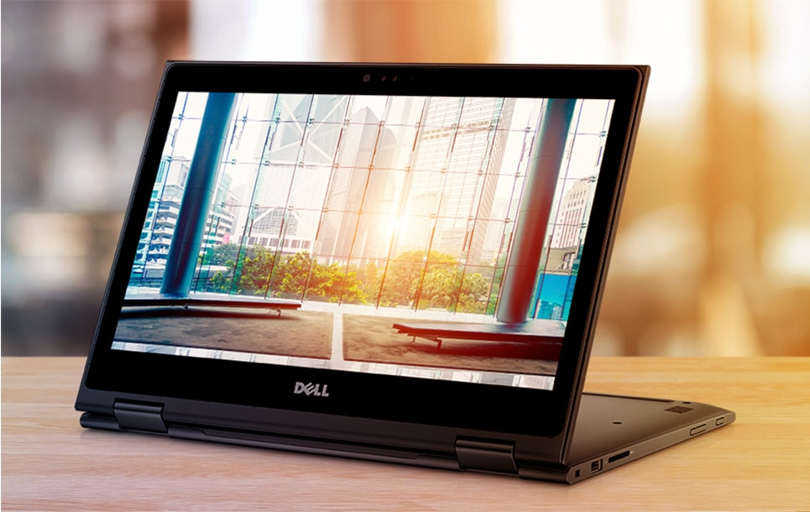](https://ccsprodus1.blob.core.windows.net/media-server/5d4dd8161cb92edc7bc46400fd36dcd2/original)

OO

**OFFICE EVERYWHERE**

Latitude’s superior security, versatility and accessories empower the way you work because your success relies on the ability to maintain office-level productivity, wherever your job takes you.

**MADE FOR MULTI-TASKING**

**Organize your work load:** High performance comes courtesy of 8th Generation Intel® Core™ processors, which help you power through any task. Choose a solid-state drive (SSD) for longer battery life, faster response time, quieter performance and improved shock resistance, or add a hard disk drive (HDD) and maximize your storage capacity.  
  
**Work better from any angle:** Four flexible modes mean you can view your screen from whichever angle suits the task at hand, letting you work comfortably for longer.

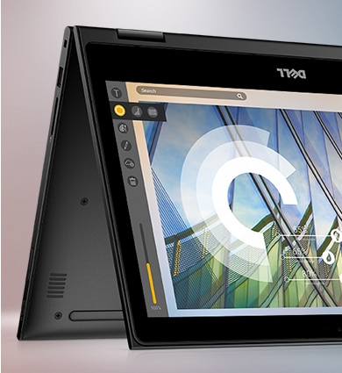

**EXPECT EXTRA**

**Illuminate your after hours:** Choose between a non-backlit or backlit keyboard to conveniently type in dim light.  
  
**Get recognized:** Forgetting your password won’t interrupt your day. Windows Hello 3.0 pairs with the infrared camera for password-free login.  
   
**Make the most of every minute:** The USB Type-C offers a range of docking flexibility with a single wire, letting you connect and power your 2-in-1 whether you’re on the move or at your desk.

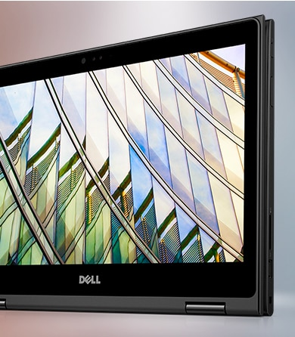

**Workday powerhouse:** Four modes mean you can bring your sleek system with you, no matter what you happen to be doing. Laptop at the office, tablet on the go, tent mode for viewing on narrow surface areas and stand mode for presentations: this machine will tag along and make your busy day even more efficient.  
  
**Premium and portable:** At 19.5mm thin, its light, durable frame is well suited to work at home and everywhere in-between.  
  
**Bold and beautiful:** Jet black casing looks sharp and sophisticated in any environment.  
  
**Expansive views:** Thin bezels and extra screen space make it simple to spread out your work and view presentations comfortably.

[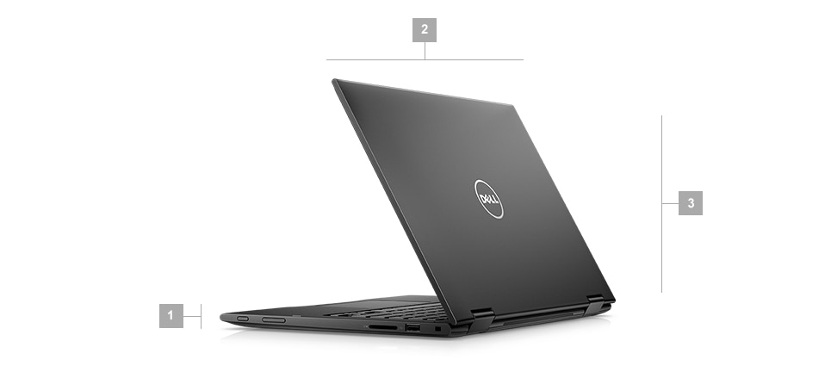](https://ccsprodus1.blob.core.windows.net/media-server/767b8b3a210561f50e404663b5b8533f/original)

**RAM (Random Access Memory)**

RAM (Random Access Memory) is the hardware in a computing device where the operating system ([OS](https://whatis.techtarget.com/definition/operating-system-OS)), application programs and data in current use are kept so they can be quickly reached by the device's [processor](https://whatis.techtarget.com/definition/processor). RAM is the main memory in a computer, and it is much faster to read from and write to than other kinds of storage, such as a hard disk drive ([HDD](https://searchstorage.techtarget.com/definition/hard-disk-drive)), solid-state drive ([SSD](https://searchstorage.techtarget.com/definition/SSD-solid-state-drive)) or optical drive.

Random Access Memory is volatile. That means data is retained in RAM as long as the computer is on, but it is lost when the computer is turned off. When the computer is rebooted, the OS and other files are reloaded into RAM, usually from an HDD or SSD.

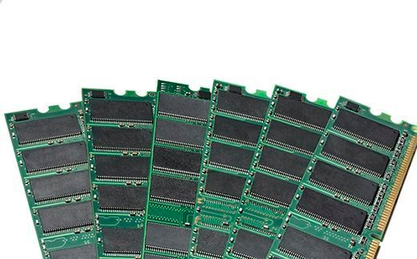

**FUNCTIONS OF RAM**

Because of its volatility, RAM can't store permanent data. RAM can be compared to a person's short-term memory, and a hard disk drive to a person's long-term memory. Short-term memory is focused on immediate work, but it can only keep a limited number of facts in view at any one time. When a person's short-term memory fills up, it can be refreshed with facts stored in the brain's long-term memory.

A computer also works this way. If RAM fills up, the computer's processor must repeatedly go to the hard disk to overlay the old data in RAM with new data. This process slows the computer's operation.

A computer's hard disk can become completely full of data and unable to take any more, but RAM won't run out of memory. However, the combination of RAM and storage memory can be completely used up.

**TYPES OF RAM**

RAM comes in two primary forms:

* **Dynamic Random Access Memory (**[**DRAM**](https://searchstorage.techtarget.com/definition/DRAM)**)** makes up the typical computing device's RAM and, as was previously noted, it needs that power to be on to retain stored data.

Each DRAM cell has a charge or lack of charge held in an electrical capacitor. This data must be constantly refreshed with an electronic charge every few milliseconds to compensate for leaks from the capacitator. A transistor serves as a gate, determining whether a capacitor's value can be read or written.

* **Static Random Access Memory (**[**SRAM**](https://whatis.techtarget.com/definition/SRAM-static-random-access-memory)**)** also needs constant power to hold on to data, but it doesn't need to be continually refreshed the way DRAM does.

In SRAM, instead of a capacitor holding the charge, the transistor acts as a switch, with one position serving as 1 and the other position as 0. Static RAM requires several transistors to retain one bit of data compared to dynamic RAM which needs only one transistor per bit. As a result, SRAM chips are much larger and more expensive than an equivalent amount of DRAM.

However, SRAM is significantly faster and uses less power than DRAM. The price and speed differences mean static RAM is mainly used in small amounts as [cache memory](https://searchstorage.techtarget.com/definition/cache-memory) inside a computer's processor.

**UHD Graphics 620**

**UHD Graphics 620** is an integrated graphics processor introduced by Intel in 2017 for their low-power performance mobile Kaby Lake R microprocessors. The 620 are the mid-range (GT2) IGP offered by Intel with 24 execution units. UHD Graphics 620 are found in 8th generation mobile Core i5 and Core i7 processors.

The UHD Graphics 620 is simply a rebranding and is otherwise identical to the HD Graphics 620.



**Deogiri Institute of Engineering And Management Studies, Aurangabad**

**Project Topic**

**HP PAVILION**

Submitted By

**VIRENDRA PATIL**

**CSE Branch, SE-I and Roll No-26020**

Under the Guidance of

**Prof.Pankaj Durole**

(Deogiri Institute of Engineering and Management Studies)

***CERTIFICATE***

This is to Certify that VIRENDRA PATIL has Completed Word Document Presentation of Computer Architecture And Organisation on **\*\*\*\*\*** For the partial fulfillment of Continuous Assessment on date______

**Name and Signature of Student Name and Signature of Subject Teacher**

**HP**

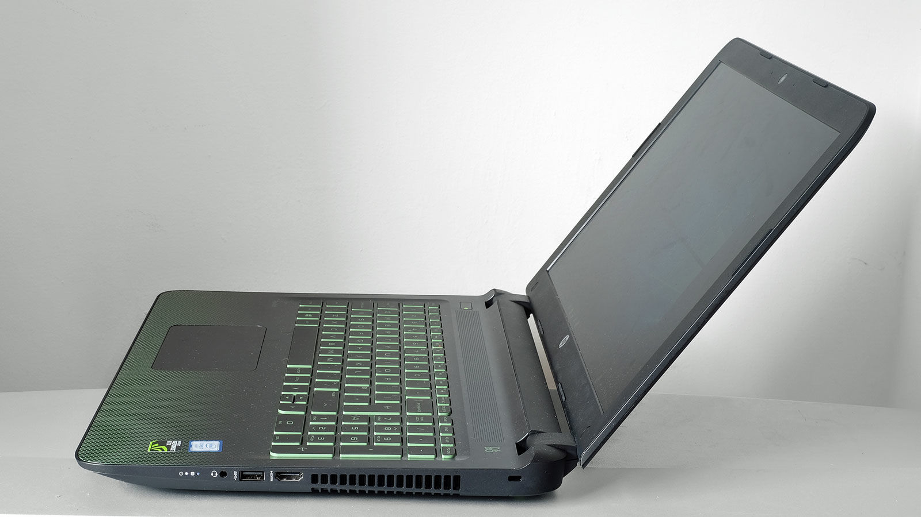

**HP PAVILION GAMING LAPTOP**

# **DESIGN:**HP Pavilion Gaming Core i5 8th Gen 15.6-inch FHD Gaming Laptop (8GB/128GB SSD + 1TB HDD/Windows 10/NVIDIA GTX 1050 4GB Graphics/Shadow Black/2.17 kg), 15-bc407TX

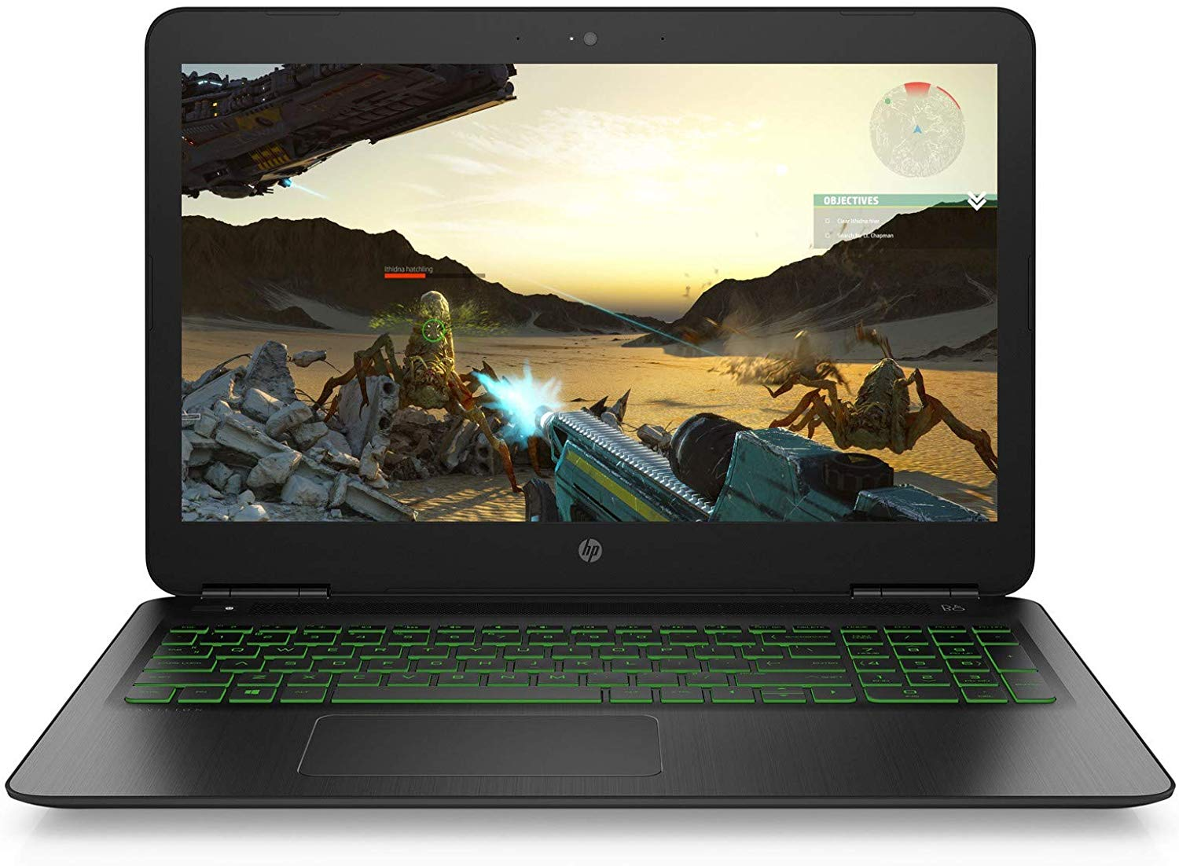

**SPECIFICATIONS:**

* **Summary**

DISPLAY : 15.6” (39.62 cm) display, 1920 x 1080 px

STORAGE : 1 TB HDD

PROCESSOR : Intel Core i5 (8th Gen) Processor

RAM : 8 GB DDR4 RAM

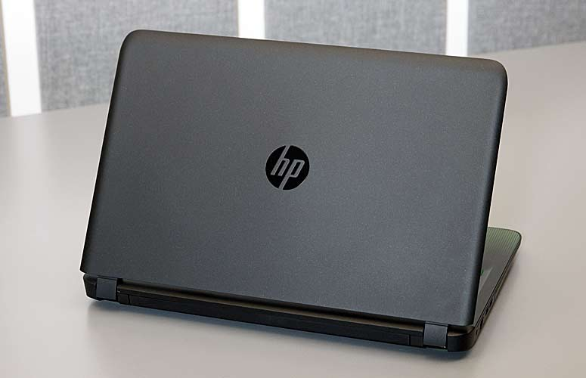

-**Multimedia**

SECONDARY CAMREARFACING : No

MICROPHONE TYPE : Integrated Dual Array Digital Microphone

INBUILT MICROPHONE : Yes

WEBCAM : yes

AUDIO SOLUTION : Bang & O Play

SPEAKERS : Dual Speakers

VIDEO RECORDING : HD 720p

-**Performance**

GRAPHICS MEMORY : 4 GB

CLOCKSPEED : 2.3 G hz

GRAPHIC PROCESSOR : NVIDIA GeForce GTX 1050

CHIPSET : Intel HM370 Express

PROCESSOR : Intel Core i5-8300H (8th Gen)

-**Memory**

MEMORY LAYOUT : 1 x 8 Gigabyte

EXPANDABLE MEMORY : 16 GB

RAM TYPE : DDR4

MEMORY SLOT : S1

RAM SPEED : 2400 Mhz

CAPACITY : 8 GB

-**Display Details**

DISPLAY TYPE : LED

DISPLAY RESOLUTION : 1920 x 1080 Pixels

DISPLAY TOUCHSCREEN : No

DISPLAY FEATURES : Diagonal FHD SVA Anti-Glare WLED-Backlit Display

DISPLAY SIZE : 15.6 Inches (39.62 cm)

-**Peripherals**

KEYBOARD : Full -size island-style keyboard with numeric English keypad

BACKLIT KEYBOARD : Yes

POINTING DEVICEHP Image : pad with Multi-touch Gesture Support

OPTICAL DRIVE : No

FINGERPRINT SCANNER : No

**-General Information**

DIMENSIONS : WXHXD382.4 x 252.5 x 24.5 mm

OPERATING SYSTEM : TYPE64-bit

WEIGHT : 2.2 Kg

OPERATING SYSTEM : Windows 10 Home Basic

MODEL : 15-bc407tx (4WD02PA)

BRAND : HP

**COLORSBlack**

-**Networking**

WIRELESS LAN : 802.11 a/b/g/n/ac

BLUETOOTH : Yes

BLUETOOTH VERSION : 4.2

-**Storage**

HDD SPEED : RPM5400 RPM

SSD CAPACITY : 128 GB

HDD CAPACITY : 1 TB

HDD TYPE : SATA

-**Battery**

POWER SUPPLY : 52 W AC Adapter W

BATTERY CELL : 3 Cell

BATTERY TYPE : Li-Ion

-**Ports**

SD CARD READER : Yes

HEADPHONE JACK : Yes

USB : 2.0 SLOTS1

MICROPHONE JACK : Yes

-**Others**

SALES PACKAGE : Laptop, Battery, AC Adapter, User Guide

LOCKPORT : No

WARRANTY : 1 Year

**Hp pavilion :**

HP Pavilion is a line of personal computers produced by Hewlett-Packard and introduced in 1995. The name is applied to both desktops and laptops for the Home and Home Office product range.

In 1995, HP introduced the Pavilion PC, an IBM-compatible computer of the desktop type, which marked the company’s introduction into the home-computing market. Dave Packard published The HP Way, a book which chronicled the rise of Hewlett-Packard and gave consumers insight into its business practices, culture and management style. HP also produced a low-cost, high-speed infrared transceiver that allowed wireless data exchange in a range of portable computing applications; these included telephones, computers, printers, cash registers, automatic teller machines, and digital cameras.[1]

The first HP Pavilion PC

The HP Pavilion 5030 was technically HP’s second multimedia PC designed specifically for the home market. The first was called the HP Multimedia PC; model numbers were 6100, 6140S and 6170S. Pavilion went on to become a popular model. Its specifications included a quad-speed CD-ROM drive, Altec Lansing speakers, software for online service access and Microsoft Windows 95. This entry-level model featured a 75 MHz Intel Pentium processor, 8 MB RAM and an 850 MB hard drive.[2]

Notebooks

HP Pavilion dv2500se

HP produces eight notebook models: HP Pavilion, 2 under HDX, 4 under HP Mini, 1 under TouchSmart, 3 under G series, and 1 under Compaq Presario. These are customizable in the US only. A variety of different models with different setups are available in other countries.

**Display**

I'm used to colors looking a little washed out on a matte screen, but the hues on the Pavilion 15's 15.6-inch, 1920 x 1080 panel were so muted that almost everything on the screen looked like it had been through the wash one time too many. For instance, when I watched the Keanu trailer, Jordan Peele's normally spearmint green hoodie looked faded, as did the dusty, red couch on which he lay.

The faded coloring made its way into my gaming session, draining the vibrancy from The Witcher 3: Wild Hunt. The almost-bubblegum pink and the light orange in the dawn sky were paler than normal, which diminished a usually gorgeous scene. I also had difficulty making out the individual links in the protagonist's chain-mail armor.

It was no big surprise when we found that the laptop could reproduce only 62 percent of the sRGB gamut. While on a par with the Y700 (61 percent), it was well below the mainstream average (86 percent), the Inspiron 15 7000 (70 percent) and the Alienware 15 (103.4 percent).

Luckily, the Pavilion 15's color accuracy was better than its color-reproduction abilities, hitting 0.71 on the Delta-E test (0 is ideal), which beats the 7.3 average. That score was also enough to defeat Alienware 15's 1.3, but not the Y700 (0.7) or the Inspiron 15 7000 (0.41)

You might need a spare candle or two with this one. The Pavilion 15 averaged a muted 176 nits, which is well below the 252-nit average. The Inspiron 15 7000, Y700 and Alienware 15 were much brighter, at 222, 263 and 311 nits, respectively.

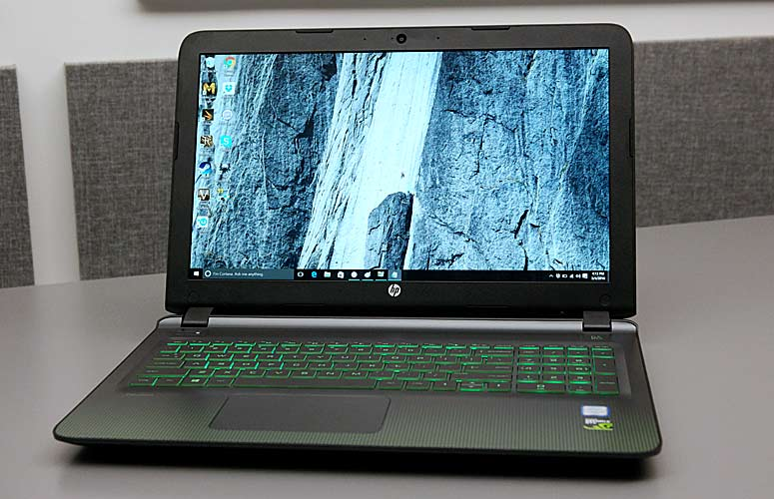

**Audio**

Even though the Pavilion 15 has Bang & Olufsen speakers, the audio didn't have the punch and clarity that I expected. At higher volumes, you'll start to hear distortions on the highs, as I noticed on Spree Wilson's "Counterfeit." The keyboards turned into a muddy mess, leaving little room for the percussion to breathe. The mids were relatively clear, allowing the vocalist's airy vocals to float above the distortion. For the best result, I would recommend keeping the volume at 80 percent.

The notebook delivered clear, distinct dialogue during Witcher 3, allowing me to hear all the gruffness in Geralt's voice. However, sound effects like the clashing of swords sounded hollow while the yelp of a large wolf I had dispatched seemed muffled.

**Keyboard and Touchpad**

Even though HP crammed in a full number pad on the Pavilion 15's deck, the green, backlit keys on the island-style keyboard were nicely sized with good spacing. I had a comfortable typing experience, quickly hitting my usual 60 words per minute on the 10FastFingers Typing Test. The keys were a little mushy, but had a fairly standard 1.3-millimeter key travel and 60 grams of actuation (the force needed to depress a key).

The large, 4.3 x 2.5-inch Synaptics clickpad was accurate and responsive. Performing gestures such as two-finger scroll and three-finger flick was a breeze. But I wish the corners of the pad had more feedback, since it I felt like I was pressing on a sponge at times.

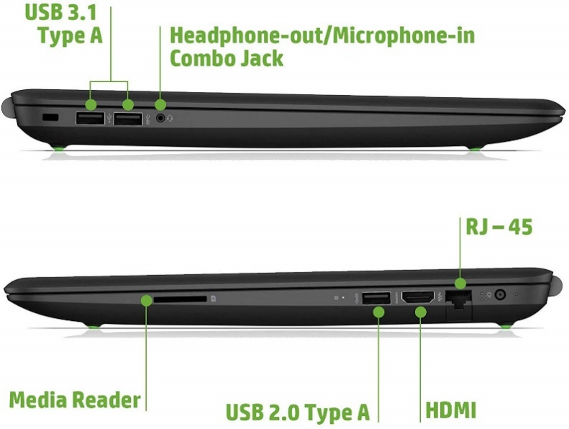

**Intel Core i5**

Core i5-8300H is a 64-bit quad-core mid-range performance x86 mobile microprocessor introduced by Intel in 2018. This processor, which is based on the Coffee Lake microarchitecture, is manufactured on Intel’s 3rd generation enhanced 14nm++ process. The i5-8300H operates at 2.3 GHz with a TDP of 45 W and a turbo boost of up to 4 GHz. This chip integrates Intel’s UHD Graphics 630 GPU operating at 350 MHz with a burst frequency of up to 1 GHz and supports up to 64 GiB of dual-channel DDR4-2666 memory.This model has a configurable TDP-down of 35 W.

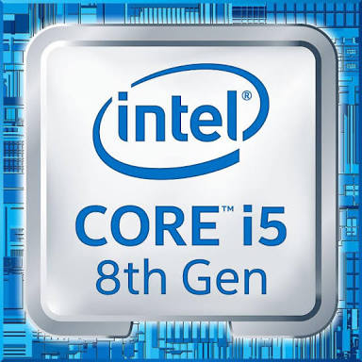

**Graphic card:**

The GeForce GTX 1050 is a mid-range graphics card by NVIDIA, launched in October 2016. Built on the 14 nm process, and based on the GP107 graphics processor, in its GP107-300-A1 variant, the card supports DirectX 12.0. The GP107 graphics processor is an average sized chip with a die area of 132 mm² and 3,300 million transistors. Unlike the fully unlocked GeForce GTX 1050 Ti, which uses the same GPU but has all 768 shaders enabled, NVIDIA has disabled some shading units on the GeForce GTX 1050 to reach the product's target shader count. It features 640 shading units, 40 texture mapping units and 32 ROPs. NVIDIA has placed 2,048 MB GDDR5 memory on the card, which are connected using a 128-bit memory interface. The GPU is operating at a frequency of 1354 MHz, which can be boosted up to 1455 MHz, memory is running at 1752 MHz.   
Being a dual-slot card, the NVIDIA GeForce GTX 1050 does not require any additional power connector, its power draw is rated at 75 W maximum. Display outputs include: 1x DVI, 1x HDMI, 1x DisplayPort. GeForce GTX 1050 is connected to the rest of the system using a PCI-Express 3.0 x16 interface. The card measures 145 mm in length, and features a dual-slot cooling solution. Its price at launch was 109 US Dollars.

