

**MSPM’S**

**Deogiri Institute of Engineering and Management Studies, Aurangabad**

**Department of Basic Science and Humanities**

Report on

Name of the Topic

HP LAPTOP

Submitted By

**Name of the Student**

**Rasika Joshi**

**Roll No:26028**

Under the Guidance of

**Name of the Subject Teacher**

**Mr.Pankaj Durole Sir**

Asst. Prof. /Asso. Prof. /Prof. Department of Basic Sciences and Humanities

(Deogiri Institute of Engineering and Management Studies)

2018-2019



CERTIFICATE

This is to Certify that Miss. Rasika Joshi has Completed Report of Computer Architecture And Oraganisation For the partial fulfillment of Continuous Assessment on date 30/08/2019

Rasika Joshi Mr. Pankaj Durole Sir

**Name and Signature of Student Name and Signature of Subject Teacher**

CONTENT

**1. HISTORY OF HP LAPTOP**

**2. GENERAL SPECIFICATION OF LAPTOP**

**3. PROCESSOR ARCHITECTURE**

**4.MEMORY**

**5.WORKING CONTROL UNIT**

**6.INPUT OUTPUT MECHANISM**

**7.ADDITIONAL SPECIFICATION**

HISTORY OF HP LAPTOP

**HP Pavilion is a line of personal computers produced by Hewlett-Packard and introduced in 1995. The name is applied to both desktops and laptops for the Home and Home Office product range. The Pavilion mainly competes against computers such as Acer's Aspire, Dell's Inspiron and XPS, Lenovo's IdeaPad and Toshiba's Satellite**

**When HP merged with Compaq in 2002, it took over Compaq's existing naming rights agreement. As a result, HP sold both HP and Compaq-branded machines until 2013.**

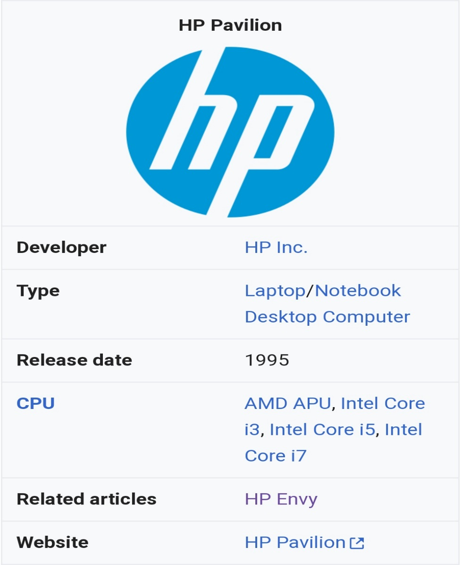

**In 1995, HP introduced the Pavilion PC, an IBM-compatible computer of the desktop type, which marked the company's introduction into the home-computing market. Dave Packard published *The HP Way,* a book which chronicled the rise of Hewlett-Packard and gave consumers insight into its business practices, culture and management style. HP also produced a low-cost, high-speed infrared transceiver that allowed wireless data exchange in a range of portable computing applications; these included telephones, computers, printers, cash registers, automatic teller machines, and digital cameras**

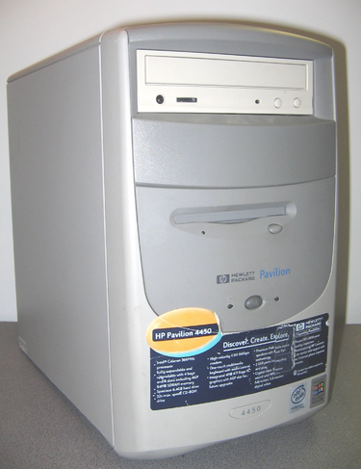

**The HP Pavilion 5030 was technically HP's second multimedia PC designed specifically for the home market. The first was called the HP Multimedia PC; model numbers were 6100, 6140S and 6170S. Pavilion went on to become a popular model. Its specifications included a quad-speed CD-ROM drive, Altec Lansing speakers, software for online service access and Microsoft Windows 95. This entry-level model featured a 75 MHz**[**Intel**](https://en.wikipedia.org/wiki/Intel)[**Pentium**](https://en.wikipedia.org/wiki/Intel_P5_(microarchitecture))**processor, 8 MB RAM and an 850 MB hard drive.**

**GENERAL SPECIFICATION OF LAPTOP**

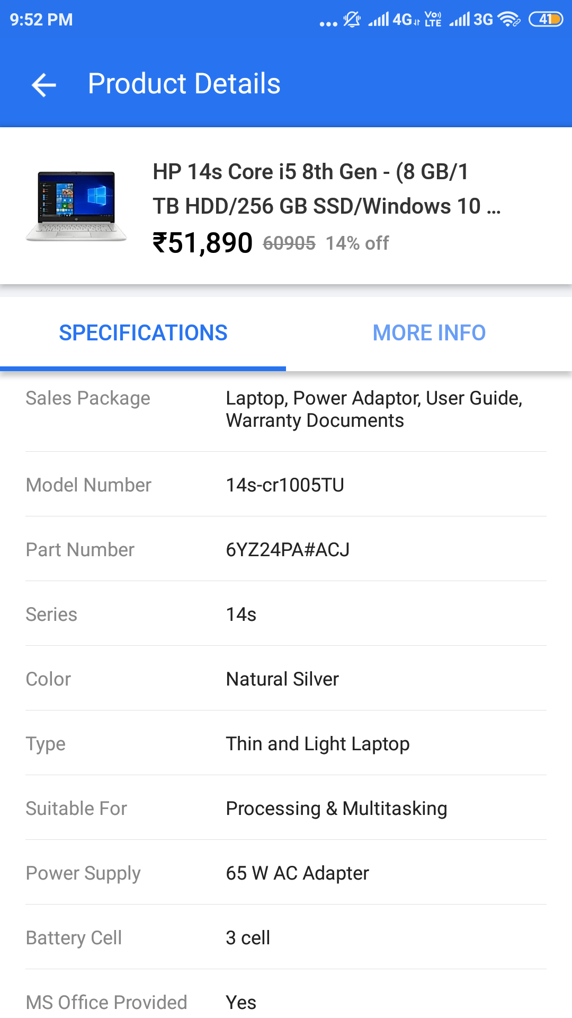

**HP 14s-cr1005tu (6YZ24PA) Laptop (Core i5 8th Gen/8 GB/1 TB 256 GB SSD/Windows 10) laptop has a 14 Inches (35.56 cm) display for your daily needs. This laptop is powered by Intel Core i5-8265U (8th Gen) processor, coupled with 8 GB of RAM and has 1 TB HDD storage at this price point.  
It runs on Windows 10 Home Basic operating system. As far as the graphics card is concerned this notebook has a Intel UHD 620 graphics card to manage the graphical functions. To keep it alive, it has a 3 Cell Li-Ion battery and weighs 1.43 Kg.**

**HP 14S-CR1005TU (6YZ24PA) LAPTOP (CORE I5 8TH GEN/8 GB/1 TB 256 GB SSD/WINDOWS 10) PRICE IN INDIA**

* HP 14s-cr1005tu (6YZ24PA) Laptop (Core i5 8th Gen/8 GB/1 TB 256 GB SSD/Windows 10) phone price in India is Rs 51,890.

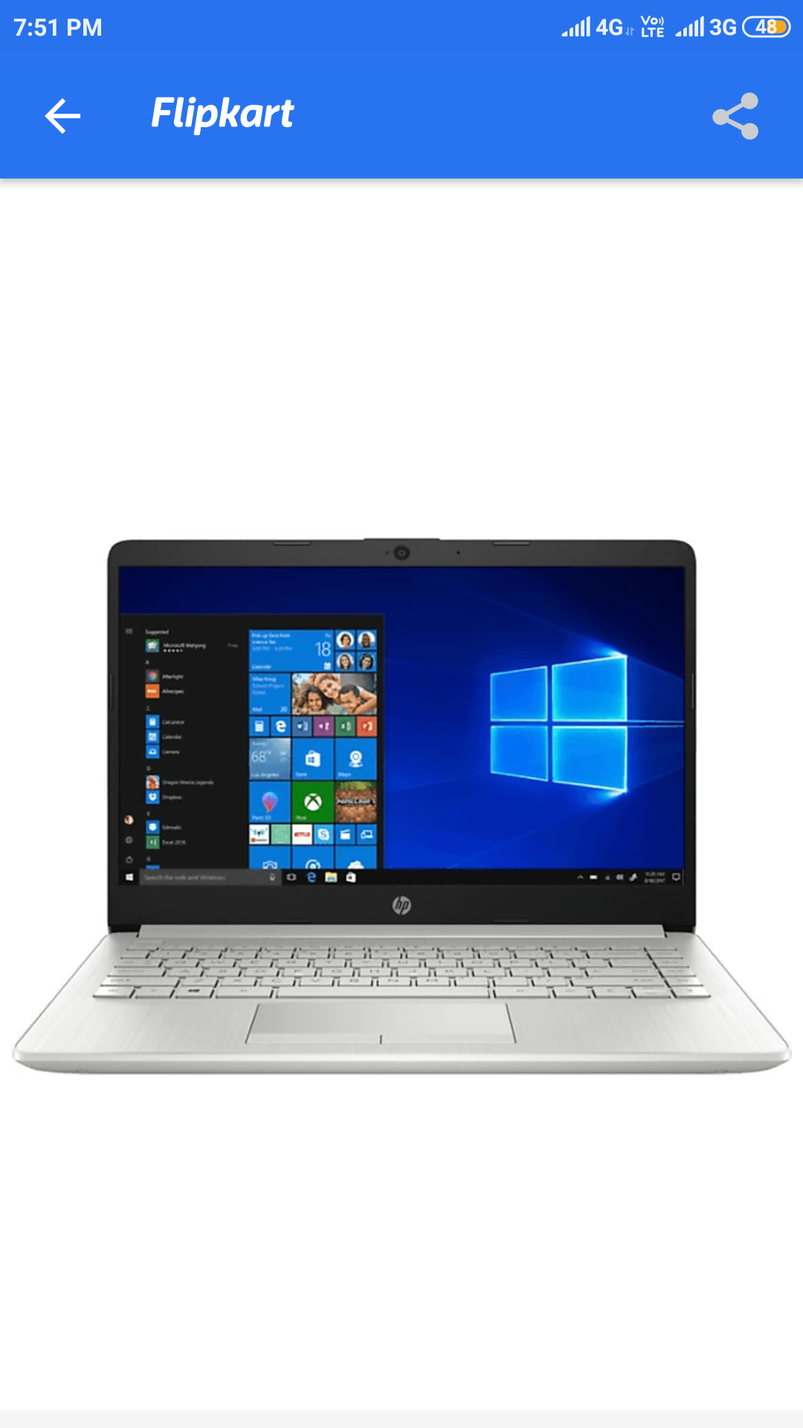

**PROCESSOR ARCHITECTURE**

* **Processor**

**8th Generation (Coffee Lake)**

**8th Generation-core based on the**[**Coffee Lake**](https://en.wikichip.org/wiki/intel/microarchitectures/coffee_lake)**microarchitecture were introduced in early 2018. Those parts offer are manufactured on Intel's third generation**[**14 nm++ process**](https://en.wikichip.org/wiki/14_nm_process)**which allowed for higher clock frequencies.** [**Coffee Lake**](https://en.wikichip.org/wiki/intel/microarchitectures/coffee_lake)**-based Core i5s were introduced in late 2017 with a number of high-end SKUs. A larger number of SKUs were introduced in April 2018. Although they still use standard**[**Socket LGA-1151**](https://en.wikichip.org/wiki/intel/lga-1151)**, those parts are no longer backwards compatible with earlier 100/20series**[**chipsets**](https://en.wikichip.org/w/index.php?title=chipsets&action=edit&redlink=1)**and must be paired with an appropriate**[**300-series chipset**](https://en.wikichip.org/w/index.php?title=intel/300-series_chipset&action=edit&redlink=1)**. A significant configuration change has taken place with the introduction of Coffee Lake including bumping the core count for the Core i5s from**[**4 cores**](https://en.wikichip.org/wiki/4_cores)**to**[**6**](https://en.wikichip.org/wiki/6_cores)**and appropriately increasing the**[**L3 cache**](https://en.wikichip.org/w/index.php?title=L3_cache&action=edit&redlink=1)**which has significantly increased the performance of those parts over the prior generation. Note that with the doubling of the core, Intel has dropped**[**hyper-threading**](https://en.wikichip.org/w/index.php?title=intel/hyper-threading&action=edit&redlink=1)**support from those models. All models have the following features in common:**

* [**Hexa-core**](https://en.wikichip.org/wiki/Hexa-core)**without**[**Hyper-threading**](https://en.wikichip.org/w/index.php?title=intel/hyper-threading&action=edit&redlink=1)**, 9 MiB**[**L3$**](https://en.wikichip.org/w/index.php?title=L3$&action=edit&redlink=1)
* **Mem: Up to 64 [GiB](https://en.wikichip.org/wiki/GiB" \o "GiB) of 2666 MT/s**[**DDR4**](https://en.wikichip.org/w/index.php?title=DDR4&action=edit&redlink=1)
* **I/O: PCIe Gen 3.0 x16 lanes**
* **TDP: 95 W (HP), 65 W (SP), 35 W (LP)**
* **GPU:**[**UHD Graphics 630**](https://en.wikichip.org/wiki/intel/uhd_graphics_630)**@ 350 MHz with bursts of 1.05-1.15 GH**

### **Core i5**

**The first Core i5 using the**[**Nehalem**](https://en.wikipedia.org/wiki/Nehalem_(microarchitecture))**microarchitecture was introduced on September 8, 2009, as a mainstream variant of the earlier Core i7, the**[**Lynnfield**](https://en.wikipedia.org/wiki/Lynnfield_(microprocessor))**core. Lynnfield Core i5 processors have an 8 MB**[**L3 cache**](https://en.wikipedia.org/wiki/L3_cache)**, a DMI bus running at 2.5 GT/s and support for dual-channel DDR3-800/1066/1333 memory and have**[**Hyper-threading**](https://en.wikipedia.org/wiki/Hyper-threading)**disabled. The same processors with different sets of features (Hyper-threading and other clock frequencies) enabled are sold as**[**Core i7-8xx**](https://en.wikipedia.org/wiki/Intel_Core_i7)**and**[**Xeon 3400-series**](https://en.wikipedia.org/wiki/Xeon#3400-series_%22Lynnfield%22)**processors, which should not be confused with high-end Core i7-9xx and Xeon 3500-series processors based on**[**Bloomfield**](https://en.wikipedia.org/wiki/Bloomfield_(microprocessor))**. A new feature called Turbo Boost Technology was introduced which maximizes speed for demanding applications, dynamically accelerating performance to match the workload.**

* **Intel 8265 Processor :**

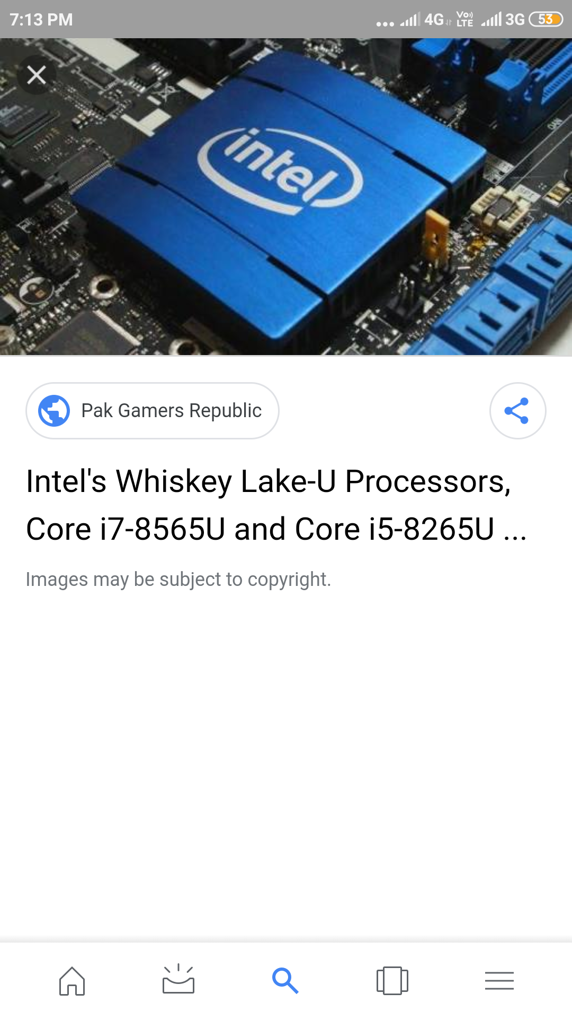

# Intel Core i5-8265U 8th Gen Quad-Core Laptop CPU

[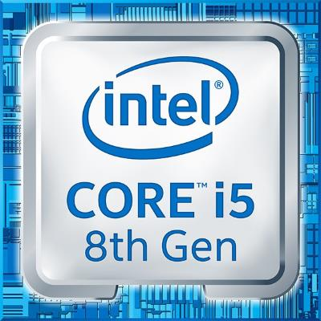](https://laptoping.com/cpus/wp-content/uploads/2019/03/Inte-Core-i5-8265U-8th-Gen.jpg)

**The 8th Generation Intel Core i5-8265U is a mid-range laptop processor. It replaces the widely adopted 8th Gen**[**i5-8250U**](https://laptoping.com/cpus/product/intel-core-i5-8250u/)**. Both of these quad-core processors belong to the same 8th Gen Intel Core family, so it’s not surprise they are very similar in terms of specs and performance. The only notable difference is that the 8th Gen i5-8265U “Whiskey Lake” chip offers a higher maximal clock speed “TurboBoost” frequency of 3.9 GHz instead of 3.4 GHz.**

* **Intel Core i5-8265U CPU Benchmark**

**Indeed, the benchmarks show a slight advantage of the i5-8265U over the i5-8250U. But in the real-world use, it’s questionable whether you’ll be able to tell the difference at all. Both chips are perfectly suitable for the regular daily computing duties like web browsing, text and spreadsheet processing, video playback, and similar. They also offer a good potential for some heavier stuff like video editing.**

**As for gaming, the Core i5-8265U features the same integrated graphics processor as the i5-8250U, without change of the specs. It’s the**[**Intel UHD 620**](https://laptoping.com/gpus/product/intel-uhd-620-graphics-review/)**integrated graphics, which is capable of rendering light games and some more demanding titles but on low detail settings. Thanks to the higher** **clock**

**speed, the i5-8265U can have a slight advantage in some games and gaming scenarios that greatly utilize the main processing cores.**

## Intel Core i5-8265U Benchmark

* **Specifications of the Intel Core i5-8265U**

|  |  |
| --- | --- |
| **Processor Name** | *Intel Core i5-8265U* |
| **CPU Family** | *8th Generation Intel Core "Whiskey Lake"* |
| **Number of Cores** | *Quad-core / 2 threads per core* |
| **CPU Clock Speed** | *1.6 – 3.9 GHz* |
| **Cache Size** | *6MB* |
| **Memory Support** | *DDR3 2133MHz DDR4 2400MHz* |
| **Integrated Graphics** | *Intel UHD 620* |
| **Power Consumption** | *15W* |

# **Instruction set**

# **The instruction set, also called ISA (instruction set architecture), is part of a computer that pertains to programming, which is basically**[**machine language**](https://www.computerhope.com/jargon/m/machlang.htm)**. The instruction set provides commands to the processor, to tell it what it needs to do. The instruction set consists of addressing modes, instructions, native data types, registers, memory architecture, interrupt, and exception handling, and external**[**I/O**](https://www.computerhope.com/jargon/i/io.htm)**. An example of an instruction set is the**[**x86**](https://www.computerhope.com/jargon/x/x86.htm)**instruction set, which is common to find on computers today. Different computer processors can use almost the same instruction set while still having very different internal design. Both the**[**Intel**](https://www.computerhope.com/comp/intel.htm)**Pentium and**[**AMD**](https://www.computerhope.com/comp/amd.htm)**Athlon processors use nearly the same x86 instruction set. An instruction set can be built into the hardware of the processor, or it can be emulated in software, using an interpreter. The hardware design is more efficient and faster for running programs than the emulated software version.**

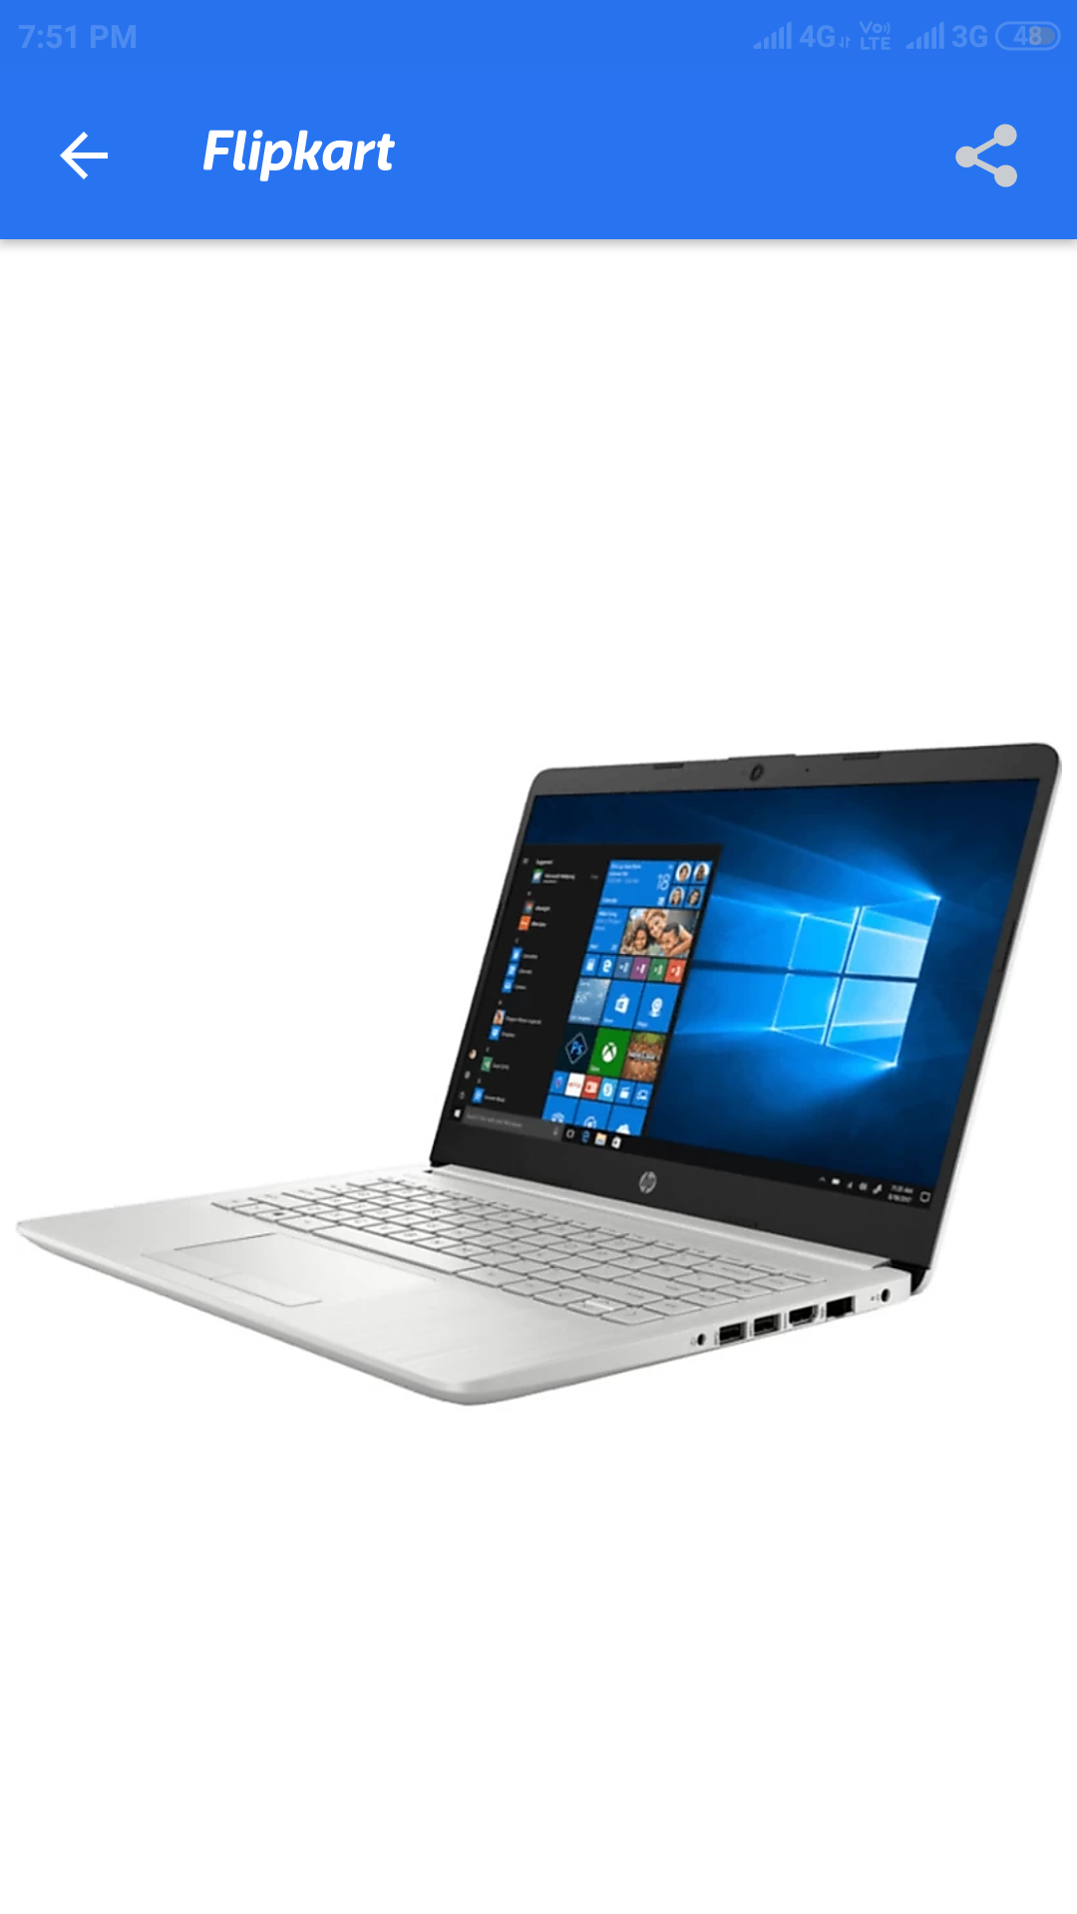

**MEMORY**

**SATA stands for Serial Advanced Technology Attachment. It is a type of rewritable mass storage device, or hard drive, that transfers data to a computer by means of serial signaling technology. SATA replaces Parallel ATA (PATA) and is known for its excellent storage capacity and solid transmission speed.**

**Right off the bat, SATA drives are far more common and much less expensive. I don't like to use the word “cheap” because that gives off a negative connotation. They're just less expensive than solid-state drives. SATA drives are slower to boot up and slower in calling up data that you request. There are varying speeds of SATA drives with speeds up to 7400 RPMs, but the higher RPM the higher likelihood of the drive malfunctioning.**

**If you are looking for a drive that you can find in increments of terabytes then SATA is your drive of choice. SATA drives are heavier than SSDs and therefore less popular for the laptop owner, although most new laptops ship with a SATA drive in place due to the reduced cost. With SATA drives there is a higher chance that they'll go bad simply because there are several moving parts that can break. If you are looking to save money and get more bang for your buck, SATA drives should be your choice**

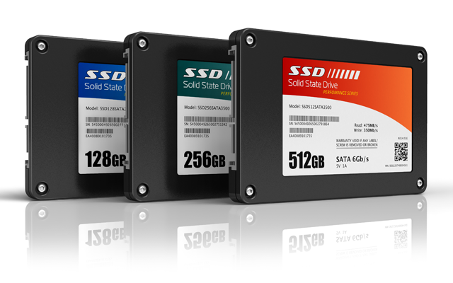

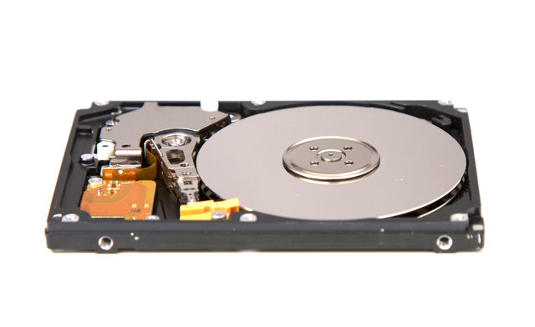

**Now that you've had a crash course on the common types of hard drives and their features, you should feel confident going into your local computer shop or electronics store to make an informed decision. If you are shopping for your desktop, you should consider having the best of both worlds. Most desktops have multiple hard drive slots inside the case. If this is your situation then you can install a SATA drive and an SSD and get speed and capacity at the same time.**

**A lot of people will get a SATA drive to store their data, such as iTunes files, documents and pictures, while their operating system is stored on the SSD. With your OS stored on the SSD it will boot faster and respond snappier than it would on a SATA drive. Plus, most operating systems only need a small amount of space to run efficiently, so buying a SSD with only 20 to 40 GBs of space still saves you money. With a huge SATA drive to store your data, you'll be less likely to run out of storage in the near future.**

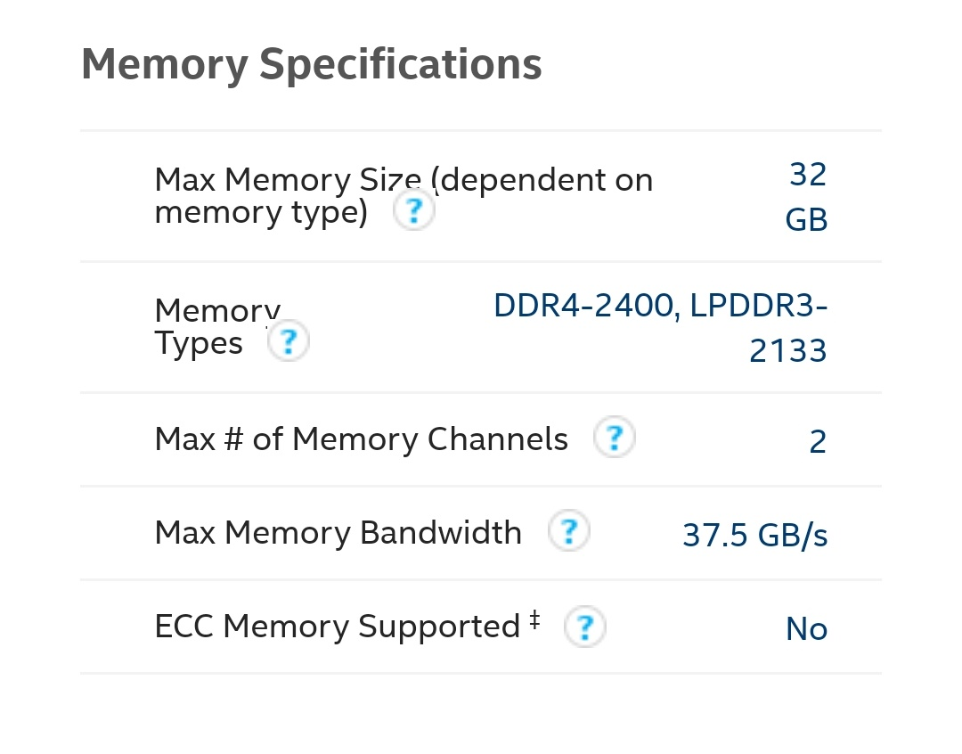

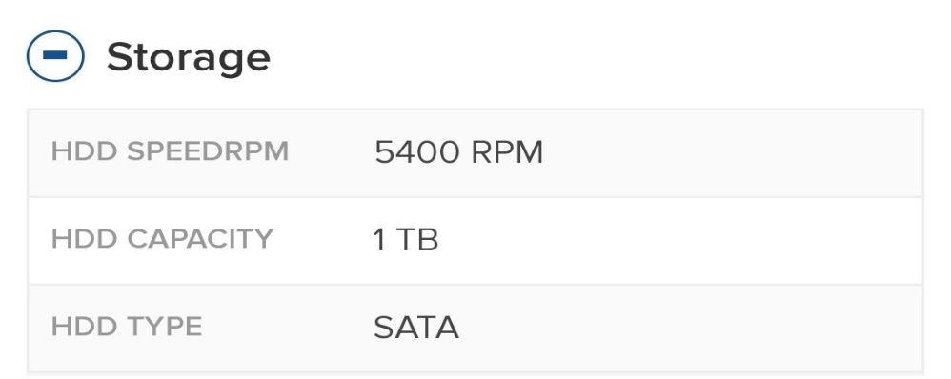

* **Processor Graphics:**

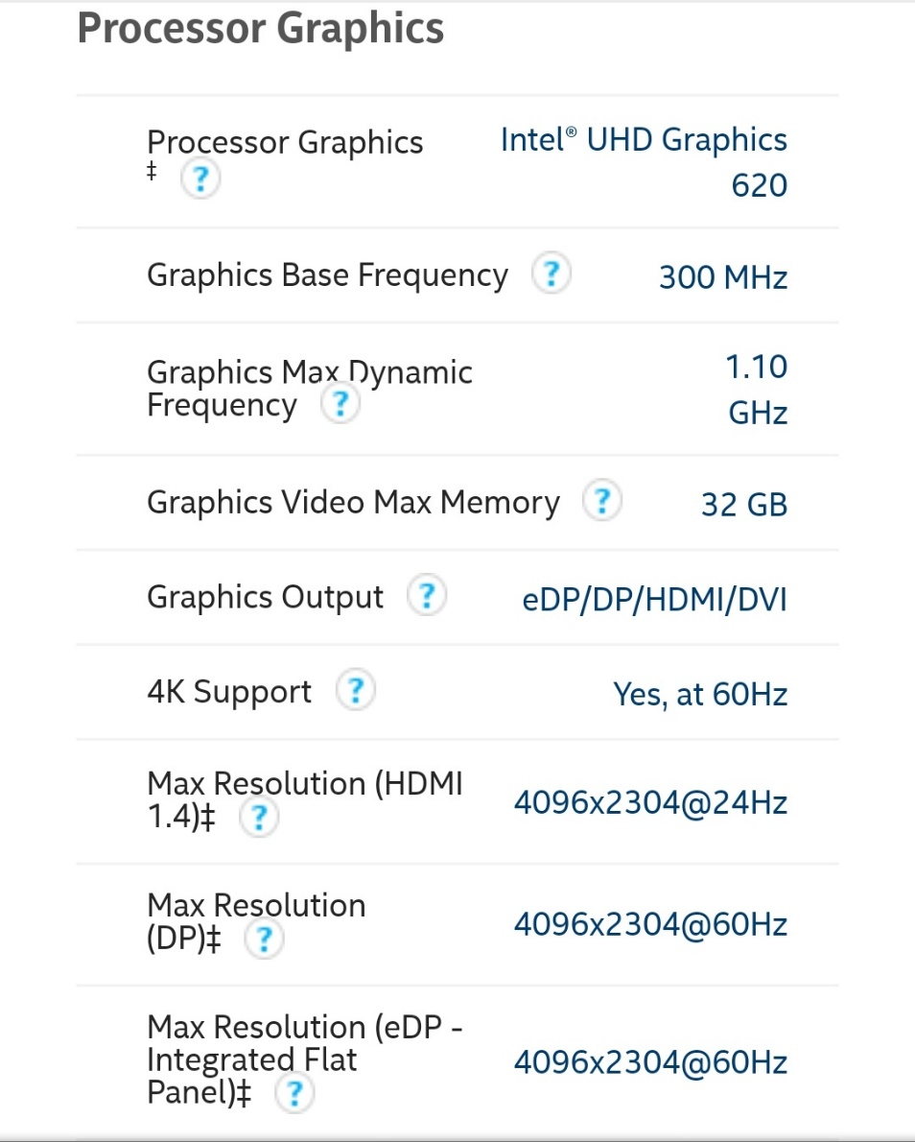

WORKING CONTROL UNIT

**A computer control unit is the control unit that is a part of the computer processor. The control unit fetches internal instructions of programs from the main memory to the processor (computer) instruction register and, based on this register contents, generates control signals that supervise execution of these instructions. The control signals are distributed to all smaller and larger elements of the computer that participate in execution of instructions and need to be controlled. The control signals are usually transmitted by the part of the overall system bus called the control bus.**

**There are two types of control units in computers:**

* **hardwired control units**
* **micro-programmable (microprogrammed) control units.**

**A general block diagram of the hardwired control unit is shown in the figure below.**

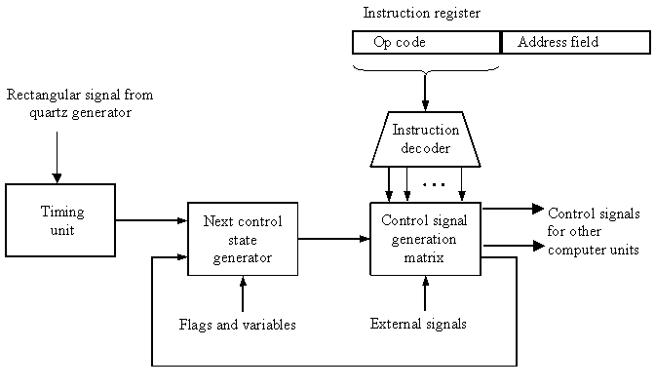

**Block diagram of a hardwired control unit of a computer**

**The name - hardwired control unit originates from the fact that a part of the control unit - the control signal generator, is hardwired. It means that the control signals that are necessary for instruction execution control are generated by specially designed hardware logical circuits, in which we can not modify the signal generation method without physical change (redesign) of the circuit structure.**

**Basic data for control signal generation are contained in the operation code (op code) of an instruction. The operation code is decoded in the instruction decoder. The instruction decoder constitutes (in general) a set of many decoders that decode different fields of the instruction op code. As a result, usually several output lines going out from the instruction decoder obtain active signal values. These lines are connected to the inputs of the matrix that generates control signals for executive units of the computer. This matrix implements logical combinations of the decoded signals from the instruction op code with the outputs from the matrix that generates signals representing consecutive control unit states and with signals coming from the outside of the processor, e.g. interrupt signals. The matrices are built in a similar way as programmable logical arrays.**

**Control signals for an instruction execution have to be generated not in a single time point but during entire time interval that corresponds to the instruction execution cycle. Following the structure of this cycle, the appropriate sequence of internal states is organized in the control unit. A number of signals generated by the control signal generator matrix is sent back to inputs of the next control state generator matrix. This matrix combines these signals with the timing signals generated by the timing unit based on the rectangular patterns usually supplied by the quartz generator. When a new instruction arrives to the control unit, the control units is in the initial state of new instruction fetching. Instruction decoding makes the control unit enter the first state relating execution of the new instruction, which lasts as long as the timing signals and other input signals as flags and state information of the computer, remain unchanged. A change of any of the mentioned signals stimulates the change of the control unit state. This causes that a new respective input is generated for the control signal generator matrix. When an external signal appears, e.g. an interrupt, the control unit enters a next control state that is the state concerned with the reaction to this external signal, e.g. interrupt processing. The values of flags and state variables of the computer are used to select appropriate states for the instruction execution cycle. The last states in the cycle are control states that initiate fetching the next instruction of the program: sending the program counter content to the main memory address buffer register and next, reading the instruction word to the instruction register of the computer. When the current instruction is the stop instruction that ends program execution, the control unit enters an operating system state, in which it waits for a next user directive.**

**The block diagrams of microprogrammed control units are shown in next two figures. The basic difference between these unit structures and the structure of the hardwired control unit is the existence of the control store (microprogram memory) that is used for storing words containing encoded control signals necessary for instruction execution.In microprogrammed control units, subsequent instruction words are fetched into the instruction register in a usual way. However, the operation code of each instruction is not directly decoded to enable immediate control signal generation but it constitutes the initial address of a microprogram contained in the control store.**

**We will now discuss the functioning of the microprogrammed control unit with a single level control unit (see the block diagram below).**

**The instruction op code from the instruction register is sent to the control store address register. Based on this address, the first microinstruction of a microprogram that interprets execution of this instruction is read to the microinstruction register. This microinstruction contains in its operation part encoded control signals, usually as several bit fields. The fields are decoded in a set microinstruction field decoders. Besides the encode control signal fields, the microinstruction contains the address of the next microinstruction of the given instruction microprogram and a control field used to control activities of the microinstruction address generator. The last mentioned field determines the addressing mode (addressing operation) to be applied to the address embedded in the current microinstruction. In microinstructions with the conditional addressing mode, this address is modified with the use of the processor condition flags that represent the status of computations in the current program. The last microinstruction in the microprogram of a given instruction is the microinstruction that fetches the next instruction from the main memory to the instruction register.**

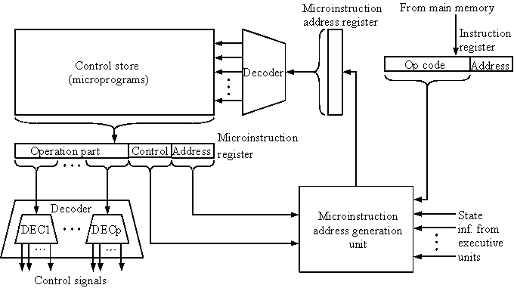

**Microprogrammed control unit with a single level control store**

**In a control unit with a two-level control store, besides the control memory for microinstructions, a nanoinstruction memory is included (see the figure below). In such control unit, microinstructions do not contain encoded control signals. The operation part of microinstructions contains the address of the word in the nanoinstruction memory, which contains encoded control signals. The nanoinstruction memory contains all combinations of control signals that appear in microprograms that interpret the complete instruction set of a given computer, written once in the form of nanoinstructions. In this way, redundant storing of the same operation parts of microinstructions is avoided. The microinstruction word in this case can be much shorter than with the single level control store. It gives a much smaller volume in bits of the microinstruction memory and, as a result, a much smaller volume of the entire control memory. The microinstruction memory contains the control for selection of consecutive microinstructions, while that control signals are generated at the basis of nanoinstructions. In nanoinstructions, control signals are frequently encoded using 1 bit/ 1 signal method that eliminates decoding. However, signal encoding in multi-bit fields that requests decoding is also possible.**

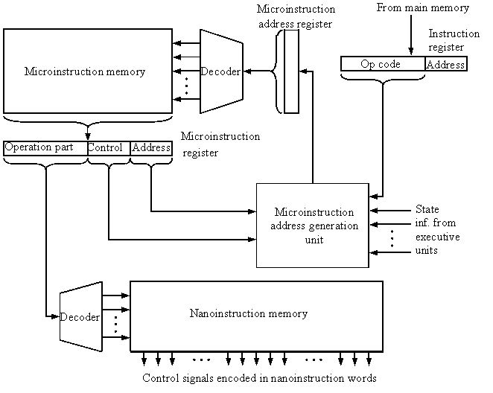

**Microprogrammed control unit with a two-level control store**

**Microprogrammed control units are frequently applied in the design of contemporary microprocessors. Microprocessors of INTEL x86 series (USA), used in personal computers of the IBM PC type, have microprogrammed control units with a single level control store. Microprocessors Motorola 68xxx series (USA), used for the design of Mackintosh personal computers of the Apple company, have microprogrammed control units with two-level control stores. Microprocessors of the RISC type, designed by DEC-Alpha, Hewlett-Packard, Compaq, SUN companies, have hardwired control units.**

**INPUT AND OUTPUT MECHANISM**

**The central processing unit is the unseen part of a computer system, and users are only dimly aware of it. But users are very much aware of the input and output associated with the computer. They submit input data to the computer to get processed information, the output.**

**Sometimes the output is an instant reaction to the input. Consider these examples:**

1. **Zebra-striped bar codes on supermarket items provide input that permits instant retrieval of outputs - price and item name - right at the checkout counter.**
2. **A bank teller queries the computer through the small terminal at the window by giving a customer's account number as input. The same screen immediately provides the customer's account balance as output.**
3. **A forklift operator speaks directly to a computer through a microphone. Words like left, right, and lift are the actual input data. The output is the computer's instant response, which causes the forklift to operate as requested.**
4. **A medical student studies the human body on a computer screen, inputting changes to the program to show a close-up of the leg and then to remove layers of tissue to reveal the muscles and bone underneath. The screen outputs the changes, allowing the student (without donning a mask, sanitary gloves, or operating gown) to simulate surgery on the computer.**
5. **A sales representative uses an instrument that looks like a pen to enter an order on a special pad. The handwritten characters are displayed as "typed" text and are stored in the pad, which is actually a small computer.**

* **Input and output may sometimes be separated by time or distance or both. Here are some examples:**
* **Factory workers input data by punching in on a time clock as they go from task to task. The time clock is connected to a computer. The outputs are their weekly pay-checks and reports for management that summarize hours per project on a quarterly basis.**
* **A college student writes checks. The data on the checks is used as input to the bank computer, which eventually processes the data to prepare a bank statement once a month.**
* **Charge-card transactions in a retail store provide input data that is processed monthly to produce customer bills.**
* **Water-sample data is collected at lake and river sites, keyed in at the environmental agency office, and used to produce reports that show patterns of water quality.**
* **The examples in this section show the diversity of computer applications, but in all cases the process is the same: input-processing-output. We have already had an introduction to processing. Now, in this chapter we will examine input and output methods in detail.**

SOME ADDITIONAL FEATURE

