

**MSPM'S        
 Deogiri Institute of Engineering and Management   
             Studies, Aurangabad  
  
 Department of computer science and Engineering  
  
                 Report on  
             Dell G3 and HP 7020U  
                Submitted**

**by                                                              
             KSHITIJA SHASTRI(26029)  
              MEDHAVI RATHOD (26030)  
                Div: CSE(A)**

**Under the Guidance of  
            Prof. Durole Sir.**

|  |  |
| --- | --- |
|  |  |

**Device name: Dell G3 3579**

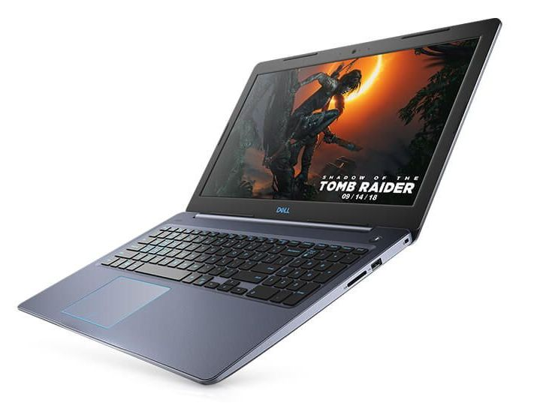

The **Dell G3 15 3579**, also known as **G3579**, is a 15.6-inch gaming laptop PC. It is a high-performance notebook, but also an entry-level machine by gaming notebook standards. The Dell G3 15 3579 / G3579 features a Full HD IPS screen and powerful higher-mid range video card options – the Nvidia Geforce GTX 1050 Ti 4GB and GTX 1060 (Max Q) 6GB. Faster GTX 1070 and 1080 are not available on this model. Processor options include the 8th Generation Intel Core i5-8300H quad-core and i7-8750H six core. They are among the fastest laptop processors on the market currently. The laptop has two RAM slots, with a total of up to 16GB of offered RAM capacity. There’s also a 16GB Intel Optane memory option (for data storage speed boost). For data storage, the Dell’s 3579 / G3579 provides a solid state or a hard drive, or a combination of both. SSD capacity is up to 256GB, while the HDD is 1-Terabyte. The laptop has a 4-cell 56 WHr capacity. The notebook’s internal components consume more power than the average mainstream laptop. The Dell G3 15 3579 has optional keyboard backlight and is made of plastics. It comes in black, “recon blue”, or “alpine white” color. A nice perk is optional Thunderbolt 3.0 interface.

**Key features**

Windows 10 Operating System

8th Generation Intel Core i7 Processor

NVIDIA GeForce GTX 1050 4 GB Graphics

8 GB RAM, 1 TB HDD + 128 GB SSD

15.6-inch FHD IPS Anti-Glare LED Backlit Display

**Laptop Category**

Laptop Type : Ultrabook

Lifestyle : Gaming Home

**Manufacturer Details**

Brand : Dell

Model Series : Inspiron G3 3579

Model Number : B560112WIN9-BLK

**Operating System**

OS Type : Windows

OS Name & Version : Windows 10 Home (Single Language)

OS Architecture : 64-bit

**Laptop Screen Specifications**

Size : 15.6  Inches

Type : IPS Screen

Resolution : 1920 x 1080 pixels

Ratio : 16:9

**Laptop Processor Details**

Brand : Intel

Name : Core i5

Generation : 8th Generation

Processor Variant : 8300H

Number Of Cores : 4

Processor Speed : 2.3  GHz

Maximum Turbo Speed : 4  GHz

Cache : 8  MB

**Internal Memory**

RAM : 8  GB

Type Of RAM : DDR4

RAM Frequency : 2666  MHz

RAM Configuration : 1 x 8GB

**Intel Optane Specification**

Intel Optane Capacity : 16  GB

**Storage Specification**

Type Of Storage : HDD

HDD Capacity : 1TB

Hard Disk Speed : 5400  rpm

SSD Capacity : No SSD

Optical Drive : Optical Drive Not Included

**Graphic Processor**

Brand : NVIDIA

Model : GeForce GTX 1050

Type : Dedicated

Video Memory : 4GB GDDR5

**Sound**

Speaker Brand : Waves MaxxAudio Pro

Speaker Type : Stereo Speakers

Audio Jack : 3.5mm - Headphone/Microphone Combo Jack

**Ports & Slots**

USB Types Supported : USB 3.1

Number Of USB Ports : 3 x USB 3.1

HDMI Type : HDMI

Number Of HDMI Ports : 1 x HDMI

Type Of Thunderbolt Port : Thunderbolt 3

Number Of Thunderbolt Ports : 1 x Thunderbolt 3

External Card Supported : 2-in-1 SD Card Reader

Ethernet Supported : Yes

Ethernet Specifications : Integrated Ethernet LAN

Ethernet Features : 1 x RJ-45

**Network Connectivity**

WiFi Supported : Yes

WiFi Features : Dual Band 2.4GHz & 5GHz

Bluetooth Supported : Yes

Bluetooth Specifications : Bluetooth 5.0

**Laptop Camera Type**

Camera Type : Webcam

Camera Resolution : 720p

**Laptop Battery**

Type : Non-Removable

Technology : Lithium-Ion

Number Of Cells : 4  Cell

Standard Battery Life : 56 WHr

**Plug Details**

Power : 130 W

Power Pin Type : AC Charging Adapter

**Keyboard Specification**

Type Of Keyboard : Standard Keyboard

**Mouse Specification**

Type Of Mouse : Touchpad

Mouse Configuration : Multi-touch Gesture Support

**Additional Features**

Included Software : McAfee Multi Device Security 15 Months Subscription

**Product Aesthetics**

Color : Black

Color Family : Black

**Product Dimensions (Open)**

Dimensions in CM (W x D x H) : 38.00 x 25.80 x 2.27

Dimensions in Inches (W x D x H) : 14.96 x 10.16 x 0.89

Weight : 2530  g

Depth : 10.16  Inches

Width : 14.96  Inches

Height : 0.89  Inches

Weight : 2.53  Kg

**Media-card reader:**

|  |  |
| --- | --- |
| Type | One SD-card slot |
| Cards supported | Secure Digital (SD) card  Multimedia Card (MMC) |

**Keyboard:**

|  |  |
| --- | --- |
| Type | Standard keyboard  Backlit keyboard (optional) |
| Shortcut keys | Some keys on your keyboard have two symbols on them. These keys can be used to type alternate characters or to perform secondary functions. To type the alternate character, press Shift and the desired key. To perform secondary functions, press Fn and the desired key. |

**Touchpad:**

|  |  |  |
| --- | --- | --- |
| Resolution: |  |  |
|  | Horizontal | 1229 |
|  | Vertical | 929 |
| Dimensions: |  |  |
|  | Width | 105 mm (4.13 in.) |
|  | Height | 80 mm (3.15 in.) |

**Power adapter:**

|  |  |  |  |
| --- | --- | --- | --- |
| Type |  | 130 W (For computers shipped with NVIDIA 1050 graphics card) | 180 W (For computers shipped with NVIDIA 1060 graphics card) |
| Diameter (connector) |  | 7.4 mm | 7.4 mm |
| Input voltage |  | 100 VAC-240 VAC | 100 VAC-240 VAC |
| Input frequency |  | 50 Hz-60 Hz | 50 Hz-60 Hz |
| Input current (maximum) |  | 1.80 A/2.34 A/2.50 A | 1.80 A/2.34 A/2.50 A |
| Output current (continuous) |  | 6.70 A/9.23 A | 6.70 A/9.23 A |
| Rated output voltage |  | 19.50 VDC | 19.50 VDC |
| Temperature range: |  |  |  |
|  | Operating | 0°C to 40°C (32°F to 104°F) |  |
|  | Storage | –40°C to 70°C (–40°F to 158°F) |  |

**Battery:**

|  |  |  |
| --- | --- | --- |
| Type |  | 4-cell “smart” lithium-ion (56 WHr) |
| Voltage |  | 11.40 VDC |
| Weight (maximum) |  | 0.2 kg (0.44 lb) |
| Dimensions: |  |  |
|  | Height | 5.90 mm (0.23 in.) |
|  | Width | 233.06 mm (9.18 in.) |
|  | Depth | 90.73 mm (3.57 in.) |
| Temperature range: |  |  |
|  | Operating | 0°C to 35°C (32°F to 95°F) |
|  | Storage | –40°C to 65°C (–40°F to 149°F) |
| Operating time |  | Varies depending on operating conditions and can significantly reduce under certain power-intensive conditions. |
| Charging time (approximate) |  | 4 hours (when the computer is off) |
| Life span (approximate) |  | 300 discharge/charge cycles |
| Coin-cell battery |  | CR-2032 |
|  |  |  |

**Display:**

|  |  |  |
| --- | --- | --- |
| Type |  | 15.6-inch FHD non-touchscreen panel |
| Resolution (maximum) |  | 1920x1080 |
| Panel Technology |  | In-Plane Switching (IPS) |
| Color gamut |  | NTSC 45% |
| Brightness |  | 220 nits (typical)/187 nits (minimum) |
| Gsync/Freesync support |  | No |
| Viewing angle |  | 80/80/80/80 |
| Pixel pitch |  | 0.179 mm |
| **Dimensions:** |  |  |
|  | Height | 0.179 mm |
|  | Width | 223.80 mm (8.81 in.) |
|  | Diagonal | 396.24 mm (15.60 in.) |
| Refresh rate |  | 60 Hz |
| Operating angle |  | 0 degree (closed) to 135 degrees |
| Controls |  | Brightness can be controlled using shortcut keys |

**Control Unit (CU) :**

Definition – What does Control Unit mean?

A control unit (CU) handles all processor control signals. It directs all input and output flow, fetches code for instructions from microprograms and directs other units and models by providing control and timing signals. A CU component is considered the processor brain because it issues orders to just about everything and ensures correct instruction execution.

A CU takes its input from the instruction and status registers. Its rules of operation, or microprogram, are encoded in a programmable logic array (PLA), random logic or read-only memory (ROM).  
  
CU functions are as follows:

Controls sequential instruction execution

Interprets instructions

Guides data flow through different computer areas

Regulates and controls processor timing

Sends and receives control signals from other computer devices

Handles multiple tasks, such as fetching, decoding, execution handling and storing results

CUs are designed in two ways:

Hardwired control: Design is based on a fixed architecture. The CU is made up of flip-flops, logic gates, digital circuits and encoder and decoder circuits that are wired in a specific and fixed way. When instruction set changes are required, wiring and circuit changes must be made. This is preferred in a reduced instruction set computing (RISC) architecture, which only has a small number of instructions.

Microprogram control: Microprograms are stored in a special control memory and are based on flowcharts. They are replaceable and ideal because of their simplicity.

**I/O mechanism :**

The process of giving input to computer and giving output from computer is called input/ output. The mechanism almost same for input and output. The operating system is mainly responsible for input output operating interrupt and error handling is important terms related to input/outputs. So, operating system is responsible to handle interrupt and error. It should also provide an interface between the device and rest of system.

**Principles:**

Different people look at I/O hardware in different ways. Electrical engineer look at in term of chips, wires, power supplies and all other physical components that make up the hardware programmers look at interface presented to the software the commands the hardware accepts, the functions it carries out and the error that can be reported back.

**I/O Devices:**

I/O devices are divided into two categories:-

1. Block devices: -   A block devices is one that store information in fixed-sized blocks, each one, with its own address common blocked size ranges from 512 bytes to 32768 bytes. The essential property of a block device is that it is possible to read or write each block independently of all the other ones. In other word, at any instant, the program can read or write any of the blocks. The common examples of block device are disk. A disk is block addressable device because no matter where the arm currently is, it is always possible to seek to another cylinder and then wait for another block to rotate the head.

2. Character devices: -   A character device is one that delivers or accepts a stream of characters, without regards to any blocks structure. It is not accessible and does not have any such operation. The examples of character devices are printers, paper tapes, network interface card, mice and most other devices that are not disk like can be seen as.

**Device controller:**

I/O units typically consist of mechanical part and the electronic part. The electronic part is also called the device controller or adapter. On pc, device controller takes the form of printed circuit card that can be inserted into an expansion slots. The controller card actually has a connected on it, into which a cable leading to the device itself can be plugged many controllers can handle more than one identical devices. The standard for interface between controller and device are ANSI, ICE, IDE, SCSI, ISO etc.

The interface between the controller and device is often a very low level interface. The controller job is to convert the serial bit stream into a block of bytes and perform any error. Correction if necessary the block of bytes is typically first assembled, bit by bit in a buffer inside the controller. After its checksum has been verified and block declared to be error free, it can then be copied to main memory.

Each controller has some registers for communicating with CPU and many devices have data buffer, which the CPU can read and write data. The issues that arise of how the CPU communicates with the controller registers and the device data buffer has two alternatives.

 I/o mupped I/o:-  in this approach, each control register is assign an i/o port number and 8 bits or 16 bits integer. The scheme uses I/O instruction for I/O such as in OUT PORT, REG (CPU register).

Memory mupped I/O:- in this approach, all the control register are mapped into the memory space. Each control register is assigned a unique memory address to which no memory is assigned. Usually, the assigned address is at the top of the address space. In this approach memory instruction like mov, stor, load are used.

*The general connection of device controller :* Device controller is interface between I/O device and computer. The computer here indicates CPU and memory. CPU memory controllers all are connected to system bus. The controller takes information and gives information to the operating system from the system memory. Large mainframe computer uses I/O channel for I/O processing where I/O channels are processor.

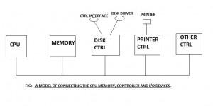

The general connection of device controller.

**Interrupt**

An interrupt is a special request signal originated from some device to CPU to achieve the CPU time for some job.  Interrupt is identified by some special number and is managed by interrupt controller.

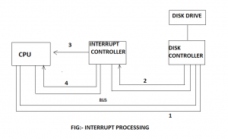

**Interrupt**

Input and output can be done in three different ways. In this simplest method, a user program issues the system call, which the kernel then translates into a procedure call to the appropriate driver. The driver then starts the I/O and sits in the tight loop continuously. Polling the device to see if it is done when the I/O has completed, the driver puts the data where they are needed and returns. The operating system then returns control to the caller. This method is called busy waiting and has the disadvantage of typing up the CPU pooling the device until it is finished.

The second method is for the driver to start the device and ask it to give an interrupt when it is finished. At that print the driver returns. The operating system then blocks the caller if need be and looks for other work to do. When the controller detects the end of transfer, it generates an interrupt to signal completion.

**I/O software**

The general goals for I/O software are easy to state. The basic idea is to organize the software as a series of layers, while the lower ones and the upper ones concerned with presenting a nice, clean, regular interface to the user.

**Layers of I/O software**

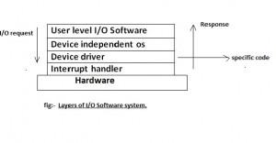

layer of input output system software

The layers of I/O software system are described below:-

1. **User level I/O software: -**

these are application level software which use I/O system calls for the input and output for example, in c programming, printf and scanf functions are used for output and input. Not all user level software consists of library procedures. Another important category is the spooling system. It is the way of dealing with delicate I/O devices in the multiprogramming system. In printer, a special process called a daemon and a special directory called a spooling directory are used to manage the output. To print a file, a process that generates the entire file to be printed and puts it in the spooling directory to use the printer’s special file, to print the file in directory.

**b. Device independent i/o software:-**   The basic function on device independent i/o software or operating system are:-

To provide uniform interface to the user level software.

To perform I/O functions those are common to all devices.

Buffering.

Error reporting.

Allocating and relating dedicated devices.

Providing a device independent block size.

Device naming.

Device protection.

 Different disk may have different sizes. It is up to the devices independent software to hide this fact and provide a uniform block size to higher layers.

**c.   Device driver: -**   each and every I/O device attached to computer needs some device specific code for controlling it. This code is called as device driver, written by devices manufacturer and deliver along with the device. Drivers are specific to operating system. A driver in computer science is a software program that expands the capability of computer to control various input and output devices. Many driver programs come as the part of computer’s operating system. The software that schedules task, allocates data storage and co-ordinates data transmission between the computer, connect 5ed devices and other computers. When connecting peripherals devices, the user often must load a new driver into the computer for each device. All devices require driver program to function.

In computer a driver serves as a translator between the devices and the program that send commands to the devices. When user selects the print command in word processing program, a program sends the generic comment to print, through operating system. The driver interpret commands and translate it, converting it into specialized command that printer can understand. The driver program then access the hardware registers of the devices.

The command issues from the application program is send to device controller and store the information to device controller’s register and provide for device driver. In case of printer the information cannot perform by storing information in device driver it to provide error reporting to the caller procedure as well as status reporting of device.

**d. Interrupt handler: -**   Many devices have an interrupt handler that notifies user if a device’s functionality is interrupted. The driver software may then supplies the user with information on the device and often error co procedure message in dos driver file has .sys extension. In windows driver file has .read.drv.

**HP i3-7020U**

Intel Core i3-7020U

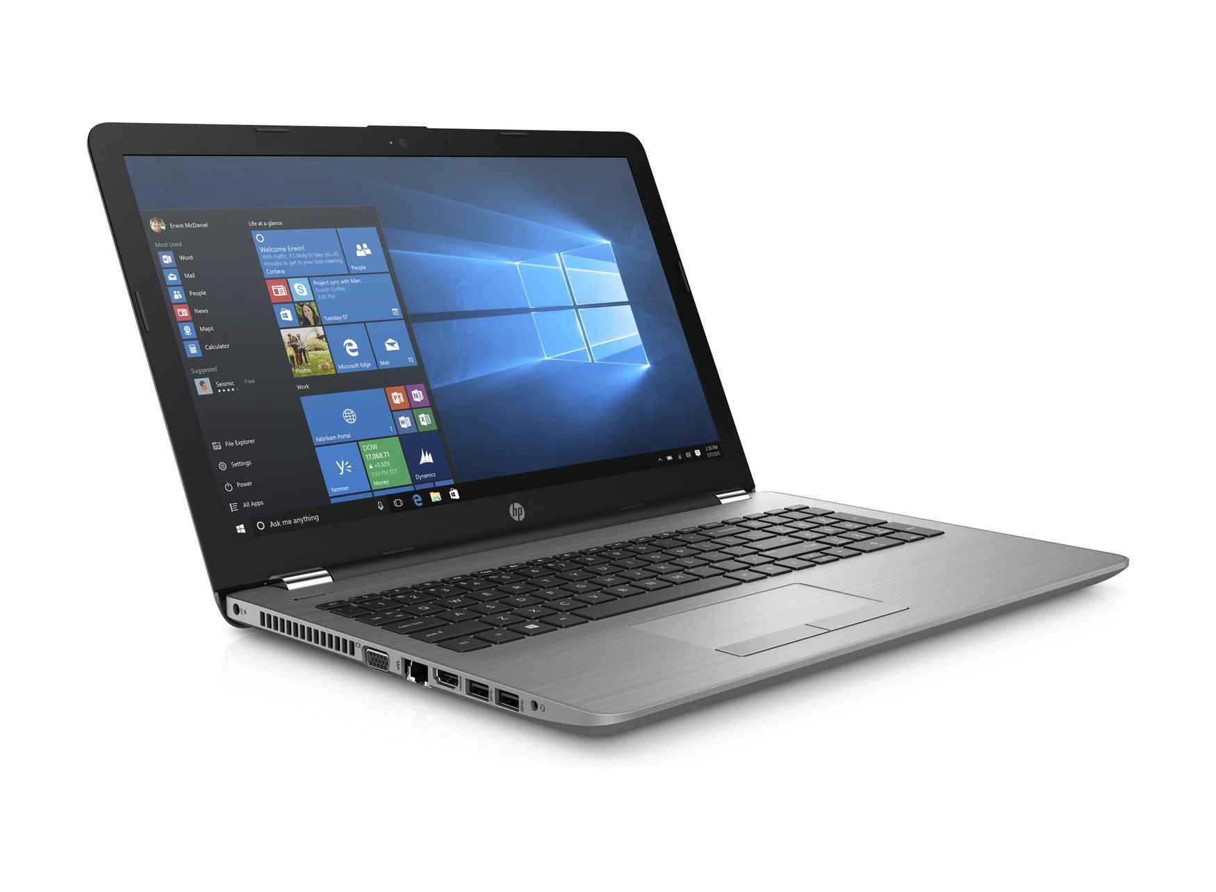

**Intel 7020U**

The Intel Core i3-7020U is a dual-core processor of the Kaby Lake architecture. It offers two CPU cores clocked at 2.3 GHz (without Turbo Boost) and integrates Hyper Threading to work with up to 4 threads at once. The architectural differences are rather small compared to the Skylake generation, therefore the performance per MHz should be very similar. The SoC includes a dual channel DDR4 memory controller and Intel HD Graphics 620 graphics card (clocked at 300 - 1000 MHz). It is manufactured in an improved 14nm FinFET process at Intel. Compare to the old i3-7100U, the newer i3-7020U is clocked 100 MHz lower (CPU cores) and therefore the current entry level model for the Core i3 line. The similar Pentium Gold 4415U offers less Cache (2 versus 3 MB) and a slower GPU.

**Architecture**

Intel basically uses the same micro architecture compared to Skylake, so the per-MHz performance does not differ. The manufacturer only reworked the Speed Shift technology for faster dynamic adjustments of voltages and clocks, and the improved 14nm process allows much higher frequencies combined with better efficiency than before.

**Display and Battery**

The HP 15-da0352tu (5XD50PA) laptop is built with the standard screen size of 15.6-inch, along with full HD resolution of 1,920 x 1,080 pixels. Added to this, it has a diagonal SVA anti-glare WLED backlit display.

It gains all its power from a 3 cell Li-ion battery that gives it a pretty decent backup. You can comfortably work for a few hours without much trouble.

**Build and Connectivity**

It is available in a black colour body and is not too heavy with just 1.77Kg. For the input peripherals, it has a standard notebook keyboard, a touchpad with multi-touch gestures enabled and a DVD R/W writer as the optical drive. It is supported by Windows 10 operating system.

It comes with a wireless LAN 802.11 a/b/g/n/ac, an SD card reader, a Bluetooth v4.2 and one USB 2.0 slot as the connectivity features.

**Performance and Storage**

It is assisted by Intel Core i3-7020U (7th Gen) processor that can clock at a speed of 2.3GHz. Multitasking becomes easy with the help of a 4GB DDR4 RAM type that works at a speed of 2133MHz. It also has an integrated graphics processor from Intel HD 620.

It comes with a huge storage capacity of 1TB HDD that works at a speed of 5400 RPM. It provides you with ample space to house a gallery of files and multimedia.

Series : Intel Core i3

Clock Rate : 2300 MHz

Level 1 Cache : 128 KB

Level 2 Cache : 512 KB

Level 3 Cache : 3 MB

Number of Cores / Threads : 2 / 4

Max. Power Consumption (TDP = Thermal Design Power) : 15 Watt

Manufacturing Technology : 14 nm

Max. Temperature : 100 °C

Socket : BGA1356

Features : Dual-Channel DDR4 Memory Controller, HyperThreading, AVX, AVX2, Quick Sync, Virtualization, AES-NI

GPU : Intel HD Graphics 620 (300 - 1000 MHz)

64 Bit : 64 Bit support

Starting Price : $281 U.S.

Announcement Date : 08/30/2016 = 1085 days old

**GENERAL**

Packaged Quantity : 1

Manufacturer : HP

**PROCESSOR / CHIPSET**

CPU : Intel Core i3 (7th Gen) 7020U / 2.3 GHz

Number of Cores : Dual-Core

Cache : 3 MB

64-bit Computing : Yes

**CACHE MEMORY**

Installed Size : 3 MB

**STORAGE**

Interface : Serial ATA

Optical Drive : DVD-Writer

**MEMORY**

Technology : DDR4 SDRAM

Speed : 2133 MHz

Form Factor : SO-DIMM 260-pin

Slots Qty : 1

Empty Slots : 0

**RAM**

Memory Speed : 2133 MHz

Configuration Features : 1 x 4 GB

Technology : DDR4 SDRAM

Installed Size : 4 GB

**DISPLAY**

LCD Backlight Technology : WLED backlight

Resolution : 1366 x 768 (HD)

Widescreen Display : Yes

Monitor Features : HD standard-viewing angle (SVA) BrightView

Type : LED

Diagonal Size (metric) : 39.6 cm

Display Resolution Abbreviation : HD

**AUDIO & VIDEO**

Graphics Processor : Intel HD Graphics 620

Sound : Stereo speakers, microphone

**HARD DRIVE**

Spindle Speed : 5400 rpm

Type : HDD

Capacity : 1 TB

**INPUT**

Type : keyboard, touchpad

Localization & Layout : US

Features : multi-touch touchpad

**COMMUNICATIONS**

Wireless Protocol : 802.11b/g/n, Bluetooth 4.2

Wired Protocol : Gigabit Ethernet

Features : single stream (1x1)

**PROCESSOR**

CPU Type : Core i3

Processor Number : i3-7020U

Generation : 7

Manufacturer : Intel

Clock Speed : 2.3 GHz

Processor Graphics : Intel HD Graphics 620

Graphics Base Frequency : 300 MHz

Graphics Max Dynamic Frequency : 1.00 GHz

Graphics Video Max Memory : 32 GB

Graphics Output : eDP/DP/HDMI/DVI

4K Support : Yes, at 60Hz

Max Resolution (HDMI 1.4) : 4096x2304@24Hz

Max Resolution (DP) : 4096x2304@60Hz

Max Resolution (eDP - Integrated Flat Panel) : 4096x2304@60Hz

DirectX Support : 12

OpenGL Support : 4.5

Intel Quick Sync Video : Yes

Intel InTru 3D Technology : Yes

Intel Clear Video HD Technology : Yes

Intel Clear Video Technology :Yes

Device ID : 0x5916

**OPTICAL STORAGE**

Drive Type : DVD-Writer

Type : DVD-Writer

**CARD READER**

Type : card reader

Supported Flash Memory : SD Memory Card

**BATTERY**

Capacity : 41 Wh

Cells : 3-cell

Technology : lithium ion

Run Time (Up To) : 11.25 hour(s)

**AC ADAPTER**

Output : 45 Watt

**CONNECTIONS & EXPANSION**

Interfaces : 2 x USB 3.1 Gen 1

USB 2.0

HDMI

LAN

Headphone/microphone combo jack

Memory Card Reader : Yes (SD Card)

**HEADER**

Brand : HP

Product Line : HP

Model : 15-da0020nr

Localization : English

Country Kits : United States

**NETWORKING**

Data Link Protocol : Bluetooth 4.2, Ethernet, Fast Ethernet, Gigabit Ethernet, IEEE 802.11b, IEEE 802.11g, IEEE 802.11n

**MISCELLANEOUS**

Color : HP finish in smoke gray and ash silver in a matte maglia vertical brushed pattern

Compliant Standards: low halogen

Included Accessories : power adapter

Theft/Intrusion Protection : security lock slot (cable lock sold separately)

Security Slot Type : Kensington mini security slot

**SYSTEM**

Notebook Type : notebook

Platform : Windows

Hard Drive Capacity : 1 TB

**MONITOR**

Diagonal Size : 15.6 in

**DIMENSIONS & WEIGHT**

Width : 14.8 in

Depth : 9.7 in

Height : 0.9 in

**AUDIO OUTPUT**

Compliant Standards : High Definition Audio

**MANUFACTURER WARRANTY**

Type : 1 year warranty

**ENVIRONMENTAL STANDARDS**

ENERGY STAR Certified : Yes

**PHYSICAL CHARACTERISTICS**

Weight : 4.61 lbs

**OPERATING SYSTEM / SOFTWARE**

OS Provided-Type : Windows 10 Home

**VIDEO OUTPUT**

Graphics Processor : Intel HD Graphics 620

Graphics Processor Series : Intel HD Graphics

**INPUT DEVICE**

Numeric Keypad : Yes

**CAMPARISON**

**Dell G3 15 3579** **HP i3 7020**

DISPLAY 15.6”(39.62 cm)display 15.6”(39.62 cm)display

Storage 1 TB HDD 1 TB HDD

Processor Intel core i7(8th gen) Intel core i3(7th gen)

RAM 8 GB 4GB DDR4

Graphics memory 4GB N/A

Graphics processor NVIDIA Getforce GTX 1050Ti Intel HD 620

Processor Intel core i7-8750H(8th gen) Intel core i3(7th gen)

Prize Rs. 72,388 Rs.47,000