

**MSPM’S**

**Deogiri Institute of Engineering and Management Studies,**

**Aurangabad**

# Department of Computer Science and Engineering

Survey Based Project ​**Report**​ on

**Acer One AO-Z422**

**Subject: Computer Architecture and Organization**

Submitted By

**Utkarsha Jagtap (26032)**

Under the Guidance of

# Prof. P. H. Durole

Asst. Prof. Department of CSE

(Deogiri Institute of Engineering and Management Studies)

2018-2019



CERTIFICATE

This is to Certify that Ms. Utkarsha Jagtap had Successfully Completed their Survey Based Project on Acer one AO-Z422 laptop on date 29/08/2019.

**Name of Guide : Prof. P. H. Durole**

**Asst. Prof. Department of CSE**

Index

1. Processors
2. Memory
3. Storage
4. Removable Drives
5. Acer One AO-Z422

Processors

A processor (CPU) is the logic circuitry that responds to and processes the basic instructions that drive a computer. The CPU is seen as the main and most crucial integrated circuitry (IC) chip in a computer, as it is responsible for interpreting most of computers commands. CPUs will perform most basic arithmetic, logic and I/O operations, as well as allocate commands for other chips and components running in a computer.

The term processor is used interchangeably with the term central processing unit (CPU), although strictly speaking, the CPU is not the only processor in a computer. The GPU (graphics processing unit) is the most notable example, but the hard drive and other devices within a computer also perform some processing independently. Nevertheless, the term processor is generally understood to mean the CPU.

Processors can be found in PCs, smartphones, tablets and other computers. The two main competitors in the processor market are Intel and AMD.

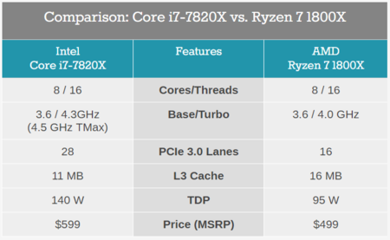

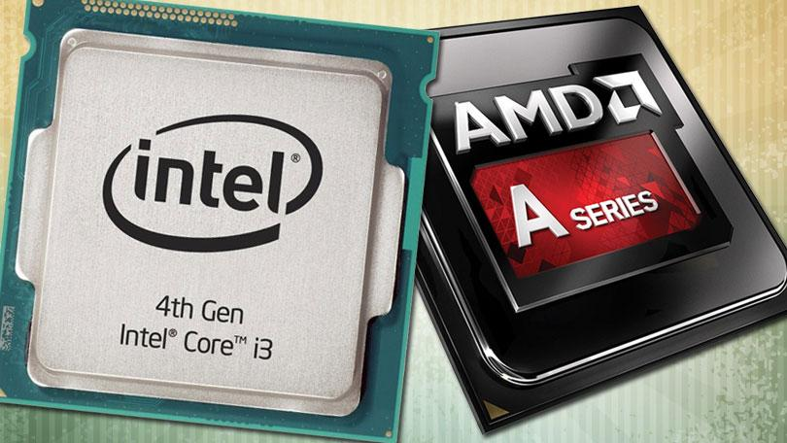

The basic elements of a processor include:

* The arithmetic logic unit (ALU), which carries out arithmetic and logic operations on the operands in instructions.
* The floating point unit (FPU), also known as a math coprocessor or numeric coprocessor, specialized coprocessors that manipulates numbers more quickly than the basic microprocessor circuitry can.
* Registers, which hold instructions and other data. Registers supply operands to the ALU and store the results of operations.
* L1 and L2 cache memory. Their inclusion in the CPU saves time compared to having to get data from random access memory (RAM).

Memory

Computer **memory** is any physical device capable of storing information temporarily like RAM (random access memory), or permanently, like ROM (read-only memory). Memory devices utilize integrated circuits and are used by operating systems, software, and hardware.

Memory can be either volatile and non-volatile memory. **Volatile memory** is a memory that loses its contents when the computer or hardware device loses power. Computer RAM is an example of a volatile memory and is why if your computer freezes or reboots when working on a program, you lose anything that hasn't been saved. **Non-volatile memory**, sometimes abbreviated as NVRAM, is a memory that keeps its contents even if the power is lost. EPROM is an example of a non-volatile memory.

As mentioned above, because RAM is a volatile memory, when the computer loses power anything stored in RAM is lost. For example, as you are working on creating a document it is stored in RAM if it is not saved to a non-volatile memory (e.g., the hard drive) it would be lost if the computer lost power.

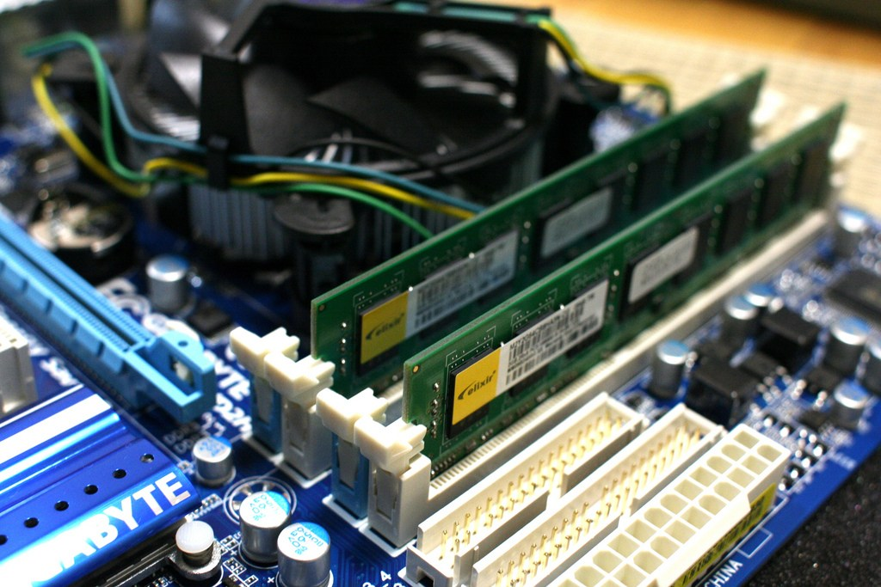

### Characteristics of Main Memory

* These are semiconductor memories.
* It is known as the main memory.
* Usually volatile memory.
* Data is lost in case power is switched off.
* It is the working memory of the computer.
* Faster than secondary memories.
* A computer cannot run without the primary memory.

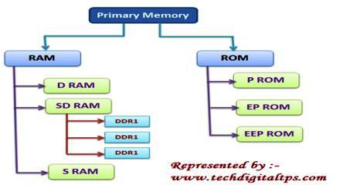

Storage

**Computer data storage**, often called storage or **memory**, is a technology consisting of computer components and recording media that are used to retain digital data. It is a core function and fundamental component of computers.

The central processing unit (CPU) of a computer is what manipulates data by performing computations. In practice, almost all computers use a storage hierarchy, which puts fast but expensive and small storage options close to the CPU and slower but larger and cheaper options farther away. Generally the fast volatile technologies (which lose data when off power) are referred to as "memory", while slower persistent technologies are referred to as "storage".

Even the very first computer designs, Charles Babbage's Analytical Engine and Percy Ludgate's Analytical Machine, clearly distinguished between processing and memory (Babbage stored numbers as rotations of gears, while Ludgate stored numbers as displacements of rods in shuttles). This distinction was extended in the Von Neumann architecture, where the CPU consists of two main parts: The control unit and the arithmetic logic unit (ALU). The former controls the flow of data between the CPU and memory, while the latter performs arithmetic and logical operations on data.

In modern computers, hard disk drives (HDDs) or solid-state drives (SSDs) are usually used as secondary storage. The access time per byte for HDDs or SSDs is typically measured in milliseconds (one thousandth seconds), while the access time per byte for primary storage is measured in nanoseconds (one billionth seconds). Thus, secondary storage is significantly slower than primary storage. Rotating optical storage devices, such as CD and DVD drives, have even longer access times. Other examples of secondary storage technologies include USB flash drives, floppy disks, magnetic tape, paper tape, punched cards, and RAM disks.

Storage technologies at all levels of the storage hierarchy can be differentiated by evaluating certain core characteristics as well as measuring characteristics specific to a particular implementation. These core characteristics are volatility, mutability, accessibility, and addressability. For any particular implementation of any storage technology, the characteristics worth measuring are capacity and performance.

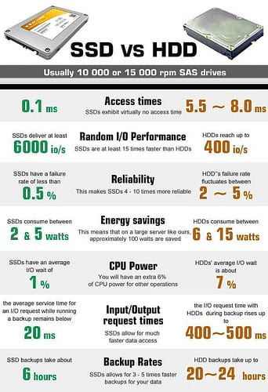

Removable Drives

Removable media is any type of storage device that can be removed from a computer while the system is running. Examples of removable media include CDs, DVDs and Blu-Ray disks, as well as diskettes and USB drives. Removable media makes it easy for a user to move data from one computer to another.

In a storage context, the main advantage of removable disks is that they can deliver the fast data backup and recovery times associated with storage area networks (SANs) while also providing the portability of tape that may be required to meet corporate backup and recovery requirements. The main drawback of removable media is that it's more expensive than tape.

## USB Memory Drives :

USB memory drives, also called flash drives, memory sticks or thumb drives, are one of the most popular forms of portable data storage. USB flash drives are only about the size of a pack of gum and have a USB plug built in to the end of the device, allowing the drive itself to plug directly into a USB port. Once the device is plugged in, it is usually automatically recognized as a mass storage device by a computer, allowing data to be quickly pulled off the device or copied over to it. While USB flash drives have far smaller storage capacities than a full external hard drive, their appeal is in their portability--it is easy to slip one in the pocket or even wear one on a key chain to have access to certain data or the ability to copy data at all times.

## Memory Cards

Popular consumer devices like cellular phones and portable MP3 or video players often contain internal flash memory in the form of a memory card. According to Microsoft, common types of removable media products include Compact Flash, ATA Flash, Secure Digital (SD), and Multimedia Card (MMC). Two other types of memory cards are XD and SDHC, which are often used in digital cameras. Devices that use these types of cards can interface with a computer using a special USB cable, a USB-based memory card reader or even a memory card reader built into the computer.

## CDs and DVDs

New forms of removable storage devices have largely replaced CDs and DVDs as the workhorses of data storage, but burning data to disks is still a viable way of storing data. An advantage of using CDs and DVDs is that most computers, even older ones, can read CDs or DVDs.

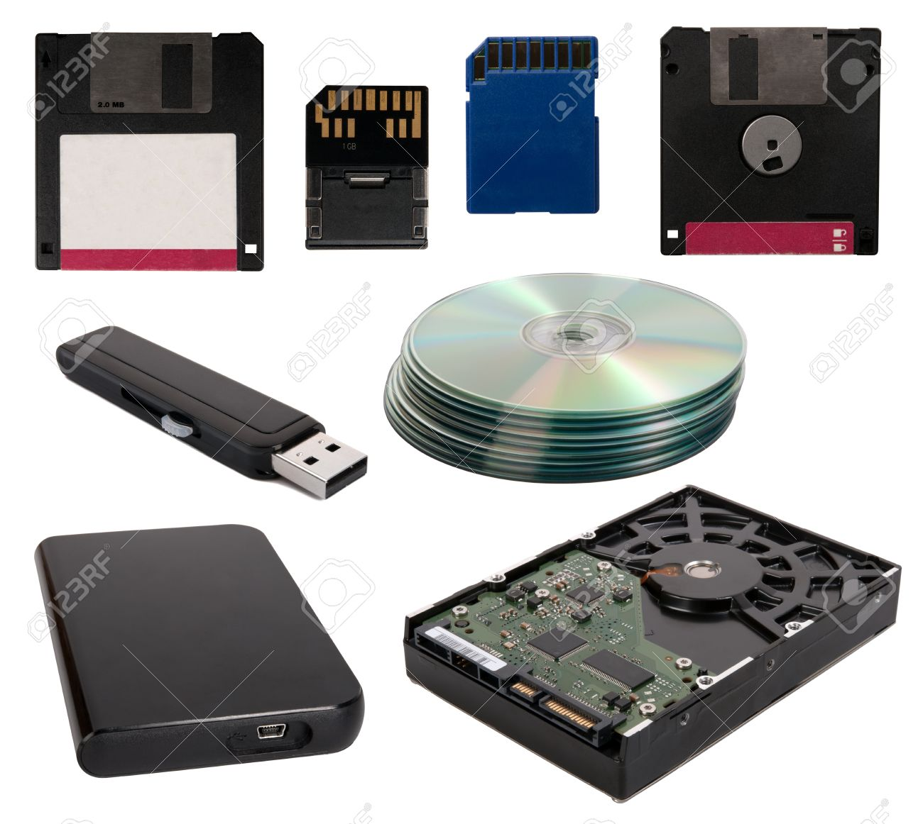

Acer one ao-z422

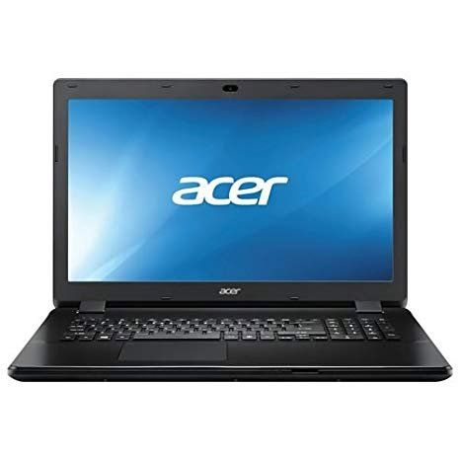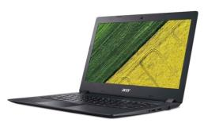

Specifications :

|  |  |
| --- | --- |
| Brand | Acer |
| Series | Acer One |
| Colour | Black |
| Item Height | 32 Millimeters |
| Item Width | 33.9 Centimeters |
| Screen Size | 14 Inches |
| Maximum Display Resolution | 1366x768 |
| Item Weight | 1.9 Kg |
| Product Dimensions | 24.6 x 33.9 x 3.2 cm |
| Batteries: | 1 Lithium Polymer batteries required. (included) |
| Item model number | AO-Z422 |
| Processor Brand | AMD |
| Processor Type | A Series |
| Processor Speed | 2.40 GHz |
| RAM Size | 4 GB |
| Memory Technology | DDR3 |
| Maximum Memory Supported | 16 GB |
| Hard Drive Size | 1024 GB |
| Hard Disk Technology | Mechanical Hard Drive |
| Speaker Description | High-definition audio support, Two built-in stereo speakers, Built-in microphone |
| Graphics Coprocessor | Radeon R4 Graphics |
| Connectivity Type | Wi-Fi, Bluetooth-V4, Infrared |
| Wireless Type | 802.11bgn |
| Number of USB 2.0 Ports | 2 |
| Number of USB 3.0 Ports | 1 |
| Number of HDMI Ports | 1 |
| Number of Audio-out Ports | 1 |
| Number of Ethernet Ports | 1 |
| Number of Microphone Ports | 1 |
| Number of VGA Ports | 1 |
| Voltage | 220 |
| Operating System | Linux |
| Lithium Battery Energy Content | 31.68 Watt Hours |
| Lithium battery Weight | 0.85 Grams |
| Number of Lithium Ion Cells | 4 |
| Included Components | Laptop, Battery, AC Adapter |