****

**MSPM’S**

**Deogiri Institute of Engineering and Management Studies, Aurangabad**

**Project Topic**

Laptops

Asus Tuf fx 505 VS Hp Spectre x360 15t

Submitted By

**YASH KULKARNI**

**CSE Branch, SE-I and Roll No-26036**

**AND**

**RUTUJA MORE**

**CSE Branch, SE-I and Roll No-26035**

Under the Guidance of

**Prof.Pankaj durole**

(Deogiri Institute of Engineering and Management Studies)

2018-2019

CERTIFICATE

This is to Certify that Yash Kulkarni and Rutuja more has Completed Word Document Presentation of Computer Architecture And Organisation on *Comparison of Laptops* For the partial fulfillment of Continuous Assessment on date

**Name and Signature of Student Name and Signature of Subject Teacher**

**CONTENTS**

* Introduction
* Processor Architecture
* Instruction Set
* Working on Control Unit
* Input/Output Mechanism
* Comparison
* Conclusion

INTRODUCTION

**ASUS**

Asus was founded in Taipei in 1989 by T.H. Tung, Ted Hsu, Wayne Hsieh and M.T. Liao, all four having previously worked at Acer as hardware engineers. At this time, Taiwan had yet to establish a leading position in the computer-hardware business. Intel Corporation would supply any new processors to more established companies like IBM first, and Taiwanese companies would have to wait for approximately six months after IBM received their engineering prototypes. According to the legend, the company created a prototype for a motherboard using an Intel 486, but it had to do so without access to the actual processor. When Asus approached Intel to request a processor to test it, Intel itself had a problem with its own 486 motherboard. Asus solved Intel's problem and it turned out that Asus' own motherboard worked correctly without the need for further modification. Since then, Asus was receiving Intel engineering samples ahead of its competitors

In September 2005, Asus released the first PhysX accelerator card In December 2005, Asus entered the LCD TV market with the TLW32001 model. In January 2006, Asus announced that it would cooperate with Lamborghini to develop the VX laptop series.

On 9 March 2006, Asus was confirmed as one of the manufacturers of the first Microsoft Origami models, together with Samsung and Founder Technology.  On 8 August 2006, Asus announced a joint venture with Gigabyte Technology. On 5 June 2007, Asus announced the launch of the Eee PC at COMPUTEX Taipei. On 9 September 2007, Asus indicated support for Blu-ray, announcing the release of a BD-ROM/DVD writer PC drive, BC-1205PT. ASUS subsequently released several Blu-ray based notebooks.

In January 2008, Asus began a major restructuring of its operations, splitting into three independent companies: Asus (focused on applied first-party branded computers and electronics); Pegatron and Unihan Corporation (focused on non-PC manufacturing such as cases and molding). In the process of the restructuring, a highly criticized pension-plan restructuring effectively zeroed out the existing pension balances. The company paid out all contributions previously made by employees.

**Hp**

The **Hewlett-Packard Company** (commonly referred to as **HP**, and stylized as ***hp***) or **Hewlett-Packard** was an American [multinational](https://en.wikipedia.org/wiki/Multinational_corporation) [information](https://en.wikipedia.org/wiki/Information_technology) [technology company](https://en.wikipedia.org/wiki/Technology_company) headquartered in [Palo Alto, California](https://en.wikipedia.org/wiki/Palo_Alto,_California). It developed and provided a wide variety of hardware components as well as software and related services to consumers, small- and medium-sized businesses ([SMBs](https://en.wikipedia.org/wiki/Small_and_medium-sized_enterprises)) and large enterprises, including customers in the government, health and education sectors.

The company was founded in a [one-car garage](https://en.wikipedia.org/wiki/HP_Garage) in Palo Alto by [Bill Hewlett](https://en.wikipedia.org/wiki/Bill_Hewlett) and [David Packard](https://en.wikipedia.org/wiki/David_Packard), and initially produced a line of electronic test equipment. HP was the world's [leading PC manufacturer](https://en.wikipedia.org/wiki/Market_share_of_personal_computer_vendors) from 2007 to Q2 2013, at which time [Lenovo](https://en.wikipedia.org/wiki/Lenovo) ranked ahead of HP. HP specialized in developing and manufacturing computing, data storage, and networking hardware, designing software and delivering services. Major product lines included personal computing devices, enterprise and industry standard servers, related storage devices, networking products, software and a diverse range of printers and other imaging products. HP directly marketed its products to households, small- to medium-sized businesses and enterprises as well as via online distribution, consumer-electronics and office-supply retailers, software partners and major technology vendors. HP also had services and consulting business around its products and partner products.

Hewlett-Packard company events included the [spin-off](https://en.wikipedia.org/wiki/Corporate_spin-off) of its electronic and bio-analytical measurement instruments part of its business as [Agilent Technologies](https://en.wikipedia.org/wiki/Agilent_Technologies) in 1999, its [merger](https://en.wikipedia.org/wiki/Merger) with [Compaq](https://en.wikipedia.org/wiki/Compaq) in 2002, and the acquisition of [EDS](https://en.wikipedia.org/wiki/Electronic_Data_Systems) in 2008, which led to combined revenues of $118.4 billion in 2008 and a [Fortune 500](https://en.wikipedia.org/wiki/Fortune_500) ranking of 9 in 2009. In November 2009, HP announced the acquisition of [3Com](https://en.wikipedia.org/wiki/3Com), with the deal closing on April 12, 2010. On April 28, 2010, HP announced the buyout of [Palm, Inc.](https://en.wikipedia.org/wiki/Palm,_Inc.) for $1.2 billion. On September 2, 2010, HP won its [bidding war](https://en.wikipedia.org/wiki/Bid_price) for [3PAR](https://en.wikipedia.org/wiki/3PAR) with a $33 a share offer ($2.07 billion), which [Dell](https://en.wikipedia.org/wiki/Dell) declined to match.[[7]](https://en.wikipedia.org/wiki/Hewlett-Packard#cite_note-7)

Hewlett-Packard spun off its enterprise products and services business as [Hewlett Packard Enterprise](https://en.wikipedia.org/wiki/Hewlett_Packard_Enterprise) on November 1, 2015. Hewlett-Packard held onto the PC and printer businesses, and was renamed to [HP Inc.](https://en.wikipedia.org/wiki/HP_Inc.)

### Recent: 2013–2015

On December 31, 2013, HP revised the number of jobs cut from 29,000 to 34,000 up to October 2014. The current number of jobs cut until the end of 2013 was 24,600. At the end of 2013 the company had 317,500 employees. On May 22, 2014 HP announced it would cut a further 11,000 to 16,000 jobs, in addition to the 34,000 announced in 2013. "We are gradually shaping HP into a more nimble, lower-cost, more customer and partner-centric company that can successfully compete across a rapidly changing IT landscape," CEO Meg Whitman said at the time.

In June 2014, during the HP Discover customer event in [Las Vegas](https://en.wikipedia.org/wiki/Las_Vegas), Meg Whitman and Martin Fink announced a project for a radically new computer architecture called [*The Machine*](https://en.wikipedia.org/wiki/The_Machine_(computer_architecture)). Based on [memristors](https://en.wikipedia.org/wiki/Memristor" \o "Memristor) and [silicon photonics](https://en.wikipedia.org/wiki/Silicon_photonics), The Machine is supposed to come in commercialization before the end of the decade, meanwhile representing 75% of the research activity in HP Labs.

On October 6, 2014, Hewlett-Packard announced it was planning to split into two separate companies, separating its personal computer and printer businesses from its technology services. The split, which was first reported by [*The Wall Street Journal*](https://en.wikipedia.org/wiki/The_Wall_Street_Journal) and confirmed by other media, would result in two publicly traded companies: [Hewlett Packard Enterprise](https://en.wikipedia.org/wiki/Hewlett_Packard_Enterprise) and [HP Inc.](https://en.wikipedia.org/wiki/HP_Inc.) Meg Whitman would serve as chairman of HP Inc. and CEO of Hewlett Packard Enterprise, [Patricia Russo](https://en.wikipedia.org/wiki/Patricia_Russo) would be chairman of the enterprise business, and [Dion Weisler](https://en.wikipedia.org/wiki/Dion_Weisler) would be CEO of HP, Inc.

On October 29, 2014, Hewlett-Packard announced their new [Sprout](https://en.wikipedia.org/wiki/Sprout_(computer)) personal computer.

In May 2015, the company announced it would be selling its controlling 51 percent stake in its [Chinese](https://en.wikipedia.org/wiki/China) data-networking business to [Tsinghua Unigroup](https://en.wikipedia.org/wiki/Tsinghua_Unigroup) for a fee of at least $2.4 billion.

On November 1, 2015, as previously announced, Hewlett-Packard changed its name to HP Inc. and spun off Hewlett Packard Enterprise as a new publicly traded company. Because of this, HP Inc. retains Hewlett-Packard's stock price history and its stock ticker symbol, [HPQ](https://www.nyse.com/quote/XNYS:HPQ), while Hewlett Packard Enterprise trades under its own symbol, [HPE](https://www.nyse.com/quote/XNYS:HPE).

**ASUS TUF FX505**

The Asus TUF Gaming FX505 finally lives up to its "TUF" moniker by gaining a MIL.STD-810G rating, meaning it can easily withstand the abuse of day-to-day life. The performance of the laptop was also satisfactory with all our test games running on their max graphic settings with a minimum frame-rate of 100fps.

Creative professionals could also use this for their editing needs as the laptop could easily handle photo and video editing, but showed some signs of distress while colour grading fullHD footage.

Asus TUF Gaming FX505 is a stylish and powerful Gaming Laptop and is powered by Intel Core i7 - 8750H processor clocked at 2.2 GHz.

It sports a 15.6-inch FHD IPS display with a 144Hz refresh rate, meaning smoother gameplay while recreating accurate and crisp colours.

Powering the visual experience is the Nvidia GTX1060 with 6GB of video memory

The screen size is big enough for an enriching gaming, surfing and video watching experience.

On the memory front, the laptop comes with 16GB DDR4 RAM pre-installed with an additional empty DIMM slot for expanding the RAM up to 32GB.

The laptop is also equipped with a 256GB NVMe SSD and a 1TB Seagate FireCuda drive. All the above features ensure that you can run all your favourite games at their best settings, without losing any visual fidelity.

The connectivity options available on the device are gigabit LAN and Gigabit Wi-Fi and 2x2 MIMO configuration for wider coverage.

It is backed up by a 48Whr battery that keeps the device running long enough for day to day tasks, but if you’re going to be gaming

you would be best served by having this plugged into the power.

**Hp spectra x360 15t**

**Features**:Crafted to transform the way you create, our most powerful Spectre yet fuses impeccable craftsmanship with incredible performance, power, and speed. Edit videos, build complex digital files to be the master of your craft. With an iconic gem-cut design and cutting-edge processor, it empowers the driven to redefine what’s possible.

## Our most powerful Spectre yet

Equipped with an Intel® Core™ processor and a long battery life, you have power and speed. Elevate your Spectre's performance to a new level by managing thermal settings by choosing from quiet, cool, or performance modes, depending on needs.

## An immersive creating experience

Edit photos with precision with a 15.6" diagonal high definition, micro-edge display you can truly bring your visions to life in vivid detail.

## Security in a class of its own

Effortlessly move through your world with enhanced security features designed to safeguard your privacy. From an integrated IR camera, fingerprint reader, and Webcam kill switch for secure interactions with your PC, you can work confidently knowing your information is secure and private.

## Return & exchange information

HP.com will accept returns or exchanges for this product up to 30 days after delivery. A restocking fee may apply.

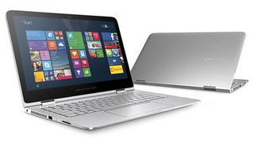

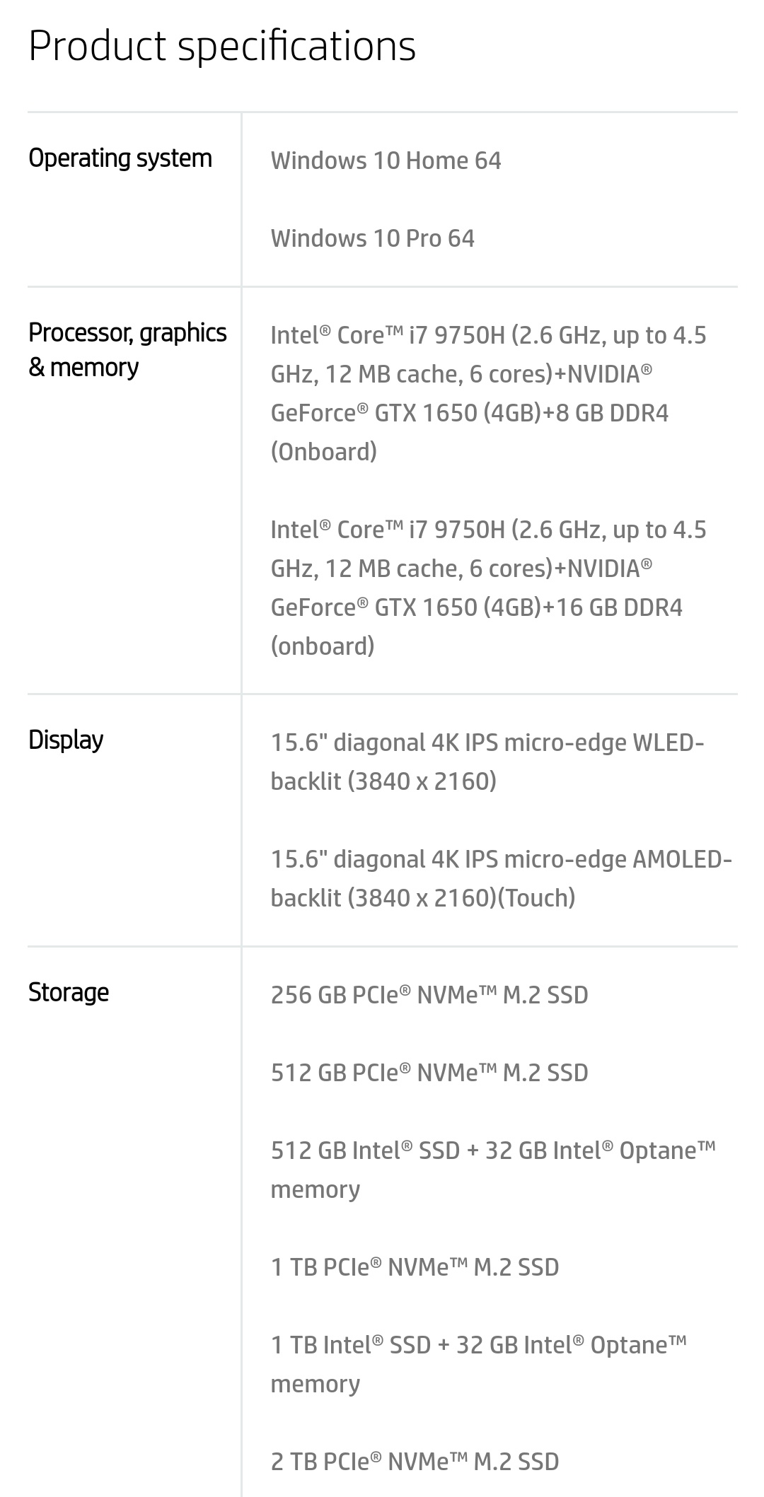 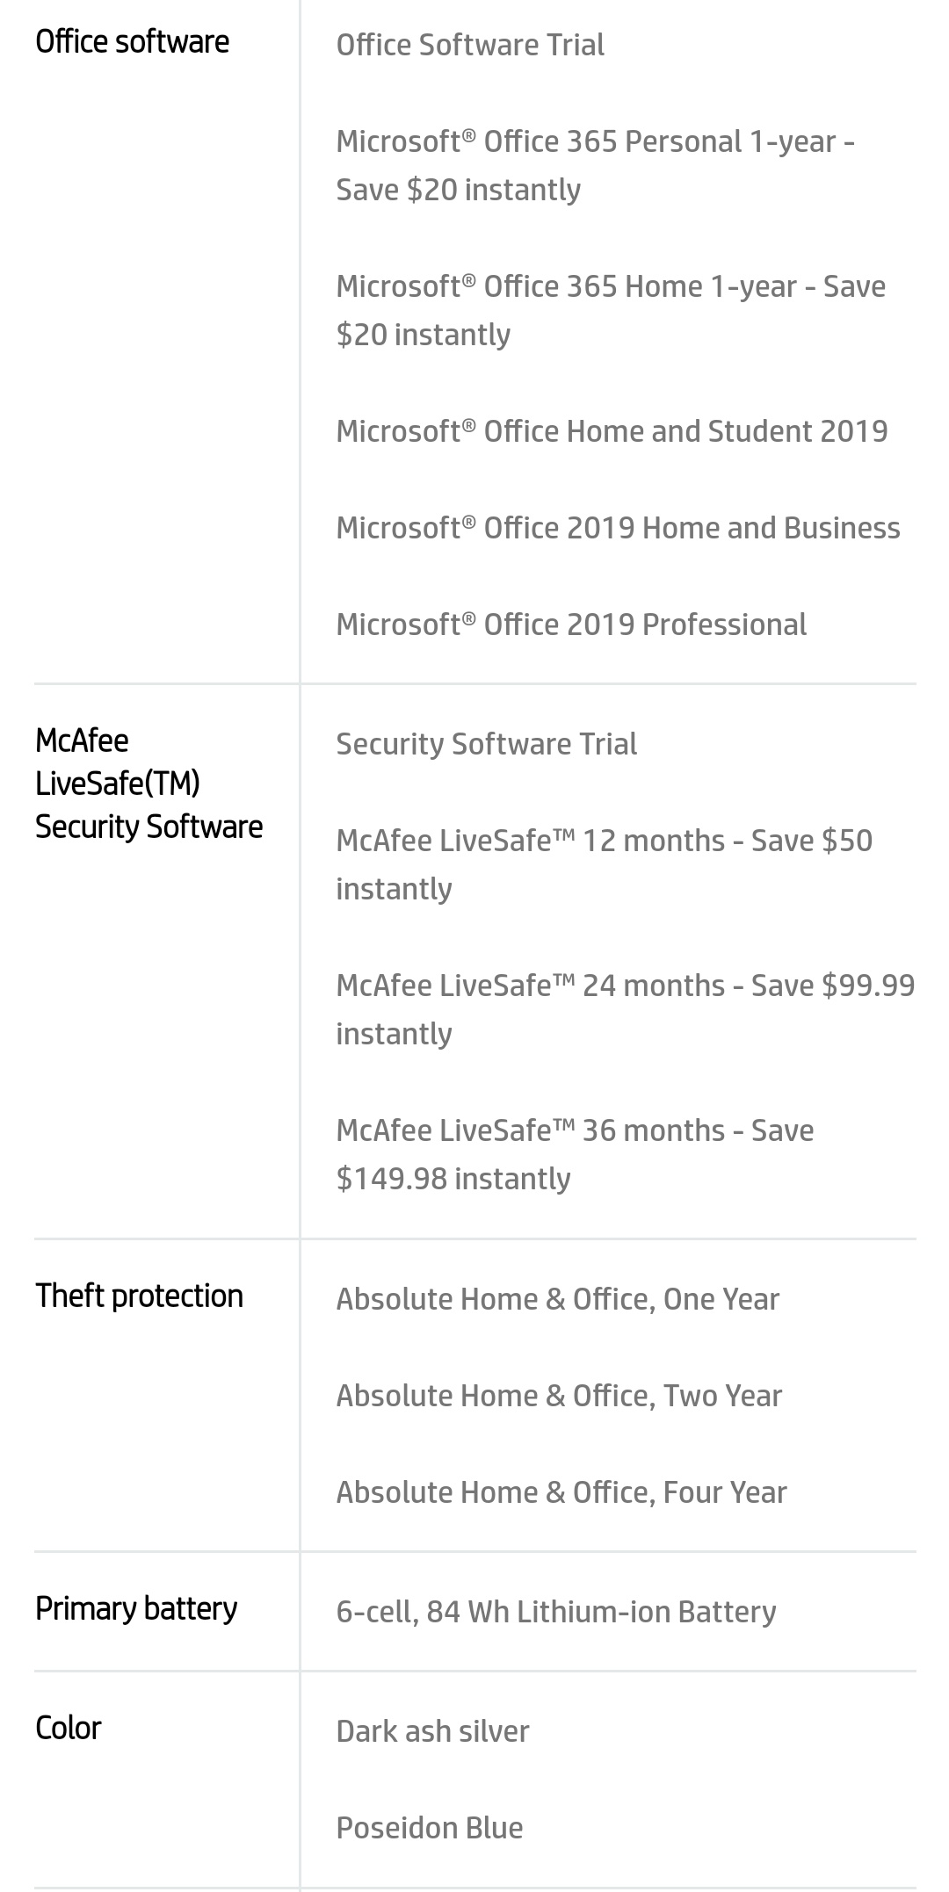 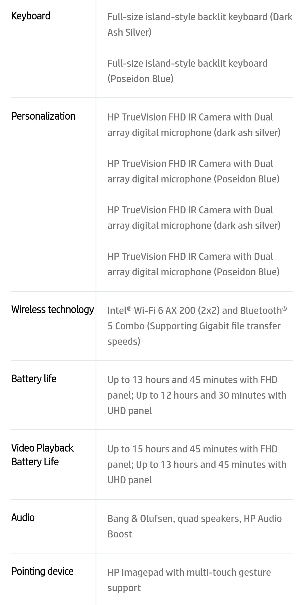

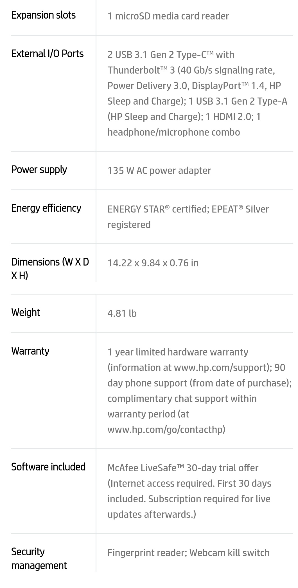

* 4K content required to view full 4K images.
* Windows 10/ MM14 battery life will vary depending on various factors including product model, configuration, loaded applications, features, use, wireless functionality, and power management settings. The maximum capacity of the battery will naturally decrease with time and usage.

PROCESSOR ARCHITECTURE

When learning assembly for a given platform, the first place to start is to learn the register set.

**General Architecture**

Since the 64-bit registers allow access for many sizes and locations, we define a byte as 8 bits, a word as 16 bits, a double word as 32 bits, a quad word as 64 bits, and a double quad word as 128 bits. Intel stores bytes “little endian,” meaning lower significant bytes are stored in lower memory address.

[Figure 1](file:///C:\Users\Jai-Hanuman\Downloads\Introduction_to_x64_Assembly.docx#page2)

shows sixteen general purpose 64-bit registers, the first eight of which are labeled (for historical reasons) RAX, RBX, RCX, RDX, RBP, RSI, RDI, and RSP. The second eight are named R8-R15. By replacing the initial R with an E on the first eight registers, it is possible to access the lower 32 bits (EAX for RAX).

Similarly, for RAX, RBX, RCX, and RDX, access to the lower 16 bits is possible by removing the initial R (AX for RAX), and the lower byte of the these by switching the X for L (AL for AX), and the higher byte of the low 16 bits using an H (AH for AX).

The new registers R8 to R15 can be accessed in a similar manner like this: R8 (qword), R8D (lower d word), R8W (lowest word), R8B (lowest byte MASM style, Intel style R8L).

Note there is no R8H.

**SIMD Architecture**

Single Instruction Multiple Data (SIMD) instructions execute a single command on multiple pieces of data in parallel and are a common usage for assembly routines. MMX and SSE commands (using the MMX and XMM registers respectively) support SIMD operations, which perform an instruction on up to eight pieces of data in parallel. For example, eight bytes can be added to eight bytes in one instruction using MMX.

The eight 64-bit MMX registers MMX0-MMX7 are aliased on top of FPR0-7, which means any code mixing FP and MMX operations must be careful not to overwrite required values. The MMX instructions operate on integer types, allowing byte, word, and double word operations to be performed on values in the MMX registers in parallel. Most MMX instructions begin with „P‟ for “packed”. Arithmetic, shift/rotate, comparison, e.g.: PCMPGTB “Compare packed signed byte integers for greater than”.

The sixteen 128-bit XMM registers allow parallel operations on four single or two double precision values per instruction.

Some instructions also work on packed byte, word, double word, and quad word integers. These instructions, called the Streaming SIMD Extensions (SSE), come in many flavors: SSE, SSE2, SSE3, SSSE3, SSE4, and perhaps more by the time this prints. Intel has announced more extensions along these lines called Intel® Advanced Vector Extensions (Intel® AVX), with a new 256-bit-wide data path. SSE instructions contain move, arithmetic, comparison, shuffling and unpacking, and bitwise operations on both floating point and integer types. Instruction names include such beauties as PMULHUW and RSQRTPS.

Finally, SSE introduced some instructions for memory pre-fetching (for performance) and memory fences (for multi-threaded safety).

[Table](file:///C:\Users\Jai-Hanuman\Downloads\Introduction_to_x64_Assembly.docx#page5) lists some command sets, the register types operated on, the number of items manipulated in parallel, and the item type. For example, using SSE3 and the 128-bit XMM registers, you can operate on 2 (must be 64-bit) floating point values in parallel, or even 16 (must be byte sized) integer values in parallel.

To find which technologies a given chip supports, there is a CPUID instruction that returns processor-specific information.

**Table**

|  |  |  |  |
| --- | --- | --- | --- |
| Technology | Register size/type | Item type | Items in Parallel |
| MMX | 64 MMX | Integer | 8,4,2,1 |
| SSE | 64 MMX | Integer | 8,4,2,1 |
| SSE | 128 XMM | Float | 4 |
| SSE2/SSE3/SSSE3… | 64 MMX | Integer | 2,1 |
| SSE2/SSE3/SSSE3… | 128 XMM | Float | 2 |
| SSE2/SSE3/SSSE3… | 128 XMM | Integer | 16,8,4,2,1 |

**Addressing Modes**

Before covering some basic instructions, you need to understand addressing modes, which are ways an instruction can access registers or memory. The following are common addressing modes with examples:

* Immediate: the value is stored in the instruction.

**ADD EAX, 14; add 14 into 32-bit EAX**

* Register to register

**ADD R8L, AL** **; add 8 bit AL into R8L**

* Indirect: this allows using an 8, 16, or 32 bit displacement, any general purpose registers for base and index, and a scale of 1, 2, 4, or 8 to multiply the index.

Technically , these also be prefixed with segment FS: or GS: but this is rarely required.

**MOV R8W, 1234[8\*RAX+RCX]; move word at address 8\*RAX+RCX+1234 into R8W**

There are many legal ways to write this. The following are equivalent

|  |  |  |  |  |
| --- | --- | --- | --- | --- |
| **MOV** | **ECX, dword ptr table[RBX][RDI]** | | | |
| **MOV** | **ECX, dword ptr table[RDI][RBX]** | | | |
| **MOV** | **ECX,** | **dword** | **ptr** | **table[RBX+RDI]** |
| **MOV** | **ECX,** | **dword** | **ptr** | **[table+RBX+RDI]** |

The **dword ptr** tells the assembler how to encode the **MOV** instruction.

* RIP-relative addressing: this is new for x64 and allows accessing data tables and such in the code relative to the current instruction pointer, making position independent code.

Easier to implement.

**MOV AL, [RIP]; RIP points to the next instruction aka NOP NOP**

INSTRUCTIONS SET

Table lists some common instructions. \* denotes this entry is multiple opcodes where the \* denotes a suffix.

**Table – Common Opcodes**

|  |  |  |  |
| --- | --- | --- | --- |
| Opcode | Meaning | Opcode | Meaning |
| MOV | Move to/from/between | AND/OR/XOR/NOT | Bitwise operations |
|  | memory and registers |  |  |
| CMOV\* | Various conditional moves | SHR/SAR | Shift right logical/arithmetic |
| XCHG | Exchange | SHL/SAL | Shift left logical/arithmetic |
| BSWAP | Byte swap | ROR/ROL | Rotate right/left |
| PUSH/POP | Stack usage | RCR/RCL | Rotate right/left through carry |
|  |  |  | bit |
| ADD/ADC | Add/with carry | BT/BTS/BTR | Bit test/and set/and reset |
| SUB/SBC | Subtract/with carry | JMP | Unconditional jump |
| MUL/IMUL | Multiply/unsigned | JE/JNE/JC/JNC/J\* | Jump if equal/not |
|  |  |  | equal/carry/not carry/ many |
|  |  |  | others |
| DIV/IDIV | Divide/unsigned | LOOP/LOOPE/LOOPNE | Loop with ECX |
| INC/DEC | Increment/Decrement | CALL/RET | Call subroutine/return |
| NEG | Negate | NOP | No operation |
| CMP | Compare | CPUID | CPU information |

**RAM (Random Access Memory)**

RAM is a form of computer memory that can be read and changed in any order, typically used to store working data and machine code. A random-access memory device allows data items to be read or written in almost the same amount of time irrespective of the physical location of data inside the memory. In contrast, with other direct-access data storage media such as hard disks, CD-Rs, DVD-RWs and the older magnetic tapes and drum memory, the time required to read and write data items varies significantly depending on their physical locations on the recording medium, due to mechanical limitations such as media rotation speeds and arm movement.

RAM contains multiplexing and de-multiplexing circuitry, to connect the data lines to the addressed storage for reading or writing the entry. Usually more than one bit of storage is accessed by the same address, and RAM devices often have multiple data lines and are said to be "8-bit" or "16-bit", etc. devices.

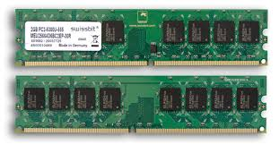Both static and dynamic RAM are considered *volatile*, as their state is lost or reset when power is removed from the system. By contrast, read-only memory (ROM) stores data by permanently enabling or disabling selected transistors, such that the memory cannot be altered. Writeable variants of ROM (such as EEPROM and flash memory) share properties of both ROM and RAM, enabling data to persist without power and to be updated without requiring special equipment. These persistent forms of semiconductor ROM include USB flash drives, memory cards for cameras and portable devices, and solid-state drives. ECC memory (which can be either SRAM or DRAM) includes special circuitry to detect and/or correct random faults (memory errors) in the stored data, using parity bits or error correction codes.

In general, the term *RAM* refers solely to solid-state memory devices (either DRAM or SRAM), and more specifically the main memory in most computers.

**Read-only memory (ROM)**

ROM is a type of non-volatile memory used in computers and other electronic devices. Data stored in ROM cannot be electronically modified after the manufacture of the memory device. Read-only memory is useful for storing software that is rarely changed during the life of the system, sometimes known as firmware. Software applications for programmable devices can be distributed as plug-in cartridges containing read-only memory.

Erasable programmable read-only memory (EPROM) and electrically erasable programmable read-only memory (EEPROM) can be erased and re-programmed, but usually this can only be done at relatively slow speeds, may require special equipment to achieve, and is typically only possible a certain number of times.

**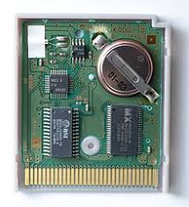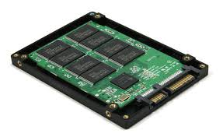**

WORKING ON CONTROL UNIT

The **control unit** (CU) is a component of a computer's central processing unit (CPU) that directs the operation of the processor. It tells the computer's memory, arithmetic and logic unit and input and output devices how to respond to the instructions that have been sent to the processor.

The Control unit (CU) is digital circuitry contained within the processor that coordinates the sequence of data movements into, out of, and between a processor's many sub-units.

The result of these routed data movements through various digital circuits (sub-units) within the processor produces the manipulated data expected by a software instruction (loaded earlier, likely from memory).

It controls (conducts) data flow inside the processor and additionally provides several external control signals to the rest of the computer to further direct data and instructions to/from processor external destinations (i.e. memory).

The Control Unit (CU) is generally a sizable collection of complex digital circuitry interconnecting and directing the many execution units (i.e. ALU, data buffers, registers) contained within a CPU.

The CU is normally the first CPU unit to accept from an externally stored computer program a single instruction (based on the CPU's instruction set).

The CU then decodes this individual instruction into several sequential steps (fetching addresses/data from registers/memory, managing execution ([i.e. data sent to the ALU or I/O]), and storing the resulting data back into registers/memory) that controls and coordinates the CPU's inner works to properly manipulate the data.

The design of these sequential steps is based on the needs of each instruction and can range in number of steps, the order of execution, and which units are enabled.

Thus by only using a program of set instructions in memory, the CU will configure all the CPU's data flows as needed to manipulate the data correctly between instructions.

This result in a computer that could run a complete program and require no human intervention to make hardware changes between instructions (as had to be done when using only punch cards for computations before stored

**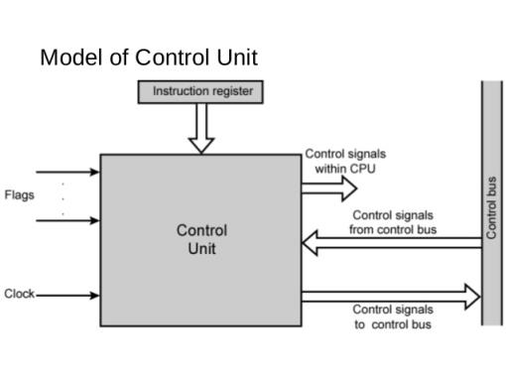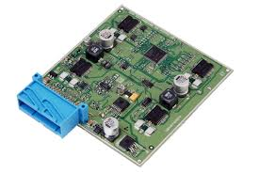**

INPUT/OUTPUT MECHANISM

The process of giving input to computer and giving output from computer is called input/ output. The mechanism almost same for input and output. The operating system is mainly responsible for input output operating interrupt and error handling is important terms related to input/outputs.

*I/O devices are divided into two categories*:-

1. **Block devices**: -

  A block devices is one that store information in fixed-sized blocks, each one, with its own address common blocked size ranges from 512 bytes to 32768 bytes. The essential property of a block device is that it is possible to read or write each block independently of all the other ones. In other word, at any instant, the program can read or write any of the blocks. The common examples of block device are disk. A disk is block addressable device because no matter where the arm currently is, it is always possible to seek to another cylinder and then wait for another block to rotate the head.

1. **Character devices**: -

  A character device is one that delivers or accepts a stream of characters, without regards to any blocks structure. It is not accessible and does not have any such operation. The examples of character devices are printers, paper tapes, network interface card, mice and most other devices that are not disk like can be seen as.

**Device controller**

I/O units typically consist of mechanical part and the electronic part. The electronic part is also called the device controller or adapter. On pc, device controller takes the form of printed circuit card that can be inserted into an expansion slots. The controller card actually has a connected on it, into which a cable leading to the device itself can be plugged many controllers can handle more than one identical devices. The standard for interface between controller and device are ANSI, ICE, IDE, SCSI, ISO etc.

The interface between the controller and device is often a very low level interface.The controller job is to convert the serial bit stream into a block of bytes andperform any error.

**COMPARISON**

## KEY FEATURES COMPARISION

### features_iconOS

HP Spectre x360 Windows 10 Professional

Asus TUF Gaming FX505 Windows 10 Pro

### features_iconDISPLAY

HP Spectre x36013.3" (1920x1080)

Asus TUF Gaming FX50515.6" (1920 x 1080)

### features_iconPROCESSOR

HP Spectre x360Intel Core i5 (7th Gen ) | 2.5 GHz

Asus TUF Gaming FX505Intel Core i7 - 87750H | 2.2 GHz

### features_iconMEMORY

HP Spectre x360360 GB NA/8GB DDR3

Asus TUF Gaming FX5051 TB SATA/16GB DDR4

BASIC INFORMATION

MODEL NAME

HP Spectre x360

:

HP Spectre x360

Asus TUF Gaming FX505

:

Asus TUF Gaming FX505

LAUNCH DATE (GLOBAL)

HP Spectre x360

:

05-07-2017

Asus TUF Gaming FX505

:

23-11-2018

OPERATING SYSTEM (WITH VERSION)

HP Spectre x360

:

Windows 10 Professional

Asus TUF Gaming FX505

:

Windows 10 Pro

LAPTOP TYPE

HP Spectre x360

:

Everyday

Asus TUF Gaming FX505

:

Gaming

DISPLAY

RESOLUTION

HP Spectre x360

:

1920x1080

Asus TUF Gaming FX505

:

1920 x 1080

DISPLAY SIZE (IN INCHES)

HP Spectre x360

:

13.3

Asus TUF Gaming FX505

:

15.6

DISPLAY TECHNOLOGY

HP Spectre x360

:

Asus TUF Gaming FX505

:

FHD

CONNECTIVITY

WIRELESS CONNECTIVITY

HP Spectre x360

:

Wi-Fi, Bluetooth

Asus TUF Gaming FX505

:

yes

CONNECTIVITY

HP Spectre x360

:

2xUSB 3.0 Ports,HDMI, Audio-out,Microphone

Asus TUF Gaming FX505

:

yes

MEMORY

RAM INCLUDED (IN GB)

HP Spectre x360

:

8

Asus TUF Gaming FX505

:

16

RAM TYPE

HP Spectre x360

:

DDR3

Asus TUF Gaming FX505

:

DDR4

PHYSICAL SPECIFICATIONS

LAPTOP WEIGHT (IN KGS)

HP Spectre x360

:

1.3

Asus TUF Gaming FX505

:

2.2

LAPTOP DIMENSION (IN MM)

HP Spectre x360

:

307 x 218 x 14

Asus TUF Gaming FX505

:

360.4 x 262.0 x 25.8

PROCESSOR

PROCESSOR MODEL NAME

HP Spectre x360

:

Intel Core i5 (7th Gen )

Asus TUF Gaming FX505

:

Intel Core i7 - 87750H

CLOCK SPEED

HP Spectre x360

:

2.5 GHz

Asus TUF Gaming FX505

:

2.2 GHz

GRAPHICS PROCESSOR

HP Spectre x360

:

Intel HD 620

Asus TUF Gaming FX505

:

NMvidia GTX 1060 (6GB)

STORAGE

HARD DRIVE TYPE

HP Spectre x360

:

Asus TUF Gaming FX505

:

SATA

HARD DRIVE CAPACITY

HP Spectre x360

:

360 GB

Asus TUF Gaming FX505

:

1 TB

HARD DRIVE SPEED (IN RPM)

HP Spectre x360

:

Asus TUF Gaming FX505

:

5400

POWER

BATTERY BACKUP (IN HOURS)

HP Spectre x360

:

15

Asus TUF Gaming FX505

:

NA

BATTERY TYPE

HP Spectre x360

:

3 cell

Asus TUF Gaming FX505

:

4 cell Li-ion

POWER SUPPLY

HP Spectre x360

:

Asus TUF Gaming FX505

:

100 -240 V AC

SOUND

SPEAKERS

HP Spectre x360

:

Bang and Olufsen Audio

Asus TUF Gaming FX505

:

2

SOUND TECHNOLOGY

HP Spectre x360

:

Asus TUF Gaming FX505

:

DTS

WARRANTY AND MANUFACTURER INFO

WARRANTY LENGTH

HP Spectre x360

:

1 year warranty provided by the manufacturer from date of purchase

Asus TUF Gaming FX505

:

NA

DETAILS OF PRE-INSTALLED SOFTWARE

PRE INSTALLED SOFTWARE

HP Spectre x360

:

Asus TUF Gaming FX505

:

Kensington lock fTPM (Firmware-based Trusted Platform Module)

**CONCLUSIONS**

The purpose of this comparison is to help prospective laptop purchasers in their decision. In today's mobile climate, the average person can make good use of a reliable portable computer; this report is designed to help in that search. Of the many perspective computers, only several brands have been selected for this comparison. Those that have been selected are i5 technology computers that boast the new MMX technology. MMX technology lends itself to portable computers because of the added internal processor cache, graphics acceleration, and lower power usage. The first two features add to the speed of the machine and the last to the travelling lifetime.

The final conclusion we have made for the above brands of laptops is that :

* Hp spectre is professional user accommodated laptop where as Asus tuf is the gaming laptop, both are heavier in their perspective.
* According to the value buying of the laptops we prefer to purchase the Asus Tuf laptop as it has additional features in it and has higher specification when compared.
* Hp spectre is for professional use where as Asus tuf is professional as well as user friendly.