

**MSPM’S**

**Deogiri Institute of Engineering and Management Studies,**

**Aurangabad**

# Department of Computer Science and Engineering

Survey Based Project ​**Report**​ on

**HP Laptop DR0006TX**

**Subject: Computer Architecture and Organization**

Submitted By

**Omkar Deshmukh (26039)**

Under the Guidance of

# Prof. P. H. Durole

Asst. Prof. Department of CSE

(Deogiri Institute of Engineering and Management Studies)

2018-2019



CERTIFICATE

This is to Certify that Mr. Omkar Deshmukh had Successfully Completed their Survey Based Project on HP Laptop DR0006TX on date 29/08/2019.

**Name of Guide : Prof. P. H. Durole**

**Asst. Prof. Department of CSE**

Introduction

* Processors- principles, operation and speed
* Memory- types and speed
* Fixed storage - operation, capacity and speed
* Types of removable storage - operation, capacity and speed
* HP Laptop DR0006TX

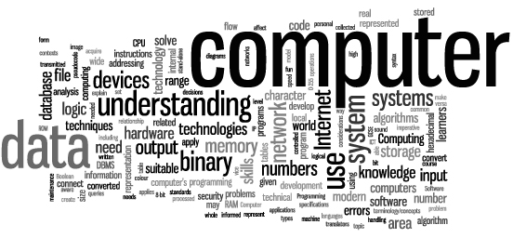

Processors

A processor (CPU) is the logic circuitry that responds to and processes the basic instructions that drive a computer. The CPU is seen as the main and most crucial integrated circuitry (IC) chip in a computer, as it is responsible for interpreting most of computers commands. CPUs will perform most basic arithmetic, logic and I/O operations, as well as allocate commands for other chips and components running in a computer.

One of the most common families of processors is the **Intel Pentium** range which ranges from the Pentium to the latest **Intel Pentium D** processors.

As well as Intel, the other major processor manufacturer is **Advanced Micro Devices Inc (AMD)**. AMD are Intels major rival and their processor family range from the **Athlon**and **Athlon XP** processors to the newer **AMD64** processors.

It is beyond the scope of this course to examine in detail the vast range of processors along with the slot and socket but the key factor when choosing a processor is the **motherboard**. The first thing to consider is whether the motherboard **chipset** supports the processor at its default clock speed.

A motherboard's chipset is designed to work with and support the architectural features of a processor and make most efficient use of the processor. Therefore, a motherboard that is designed for AMD processors will not support Intel Pentium processors because of the physical and architectural differences.

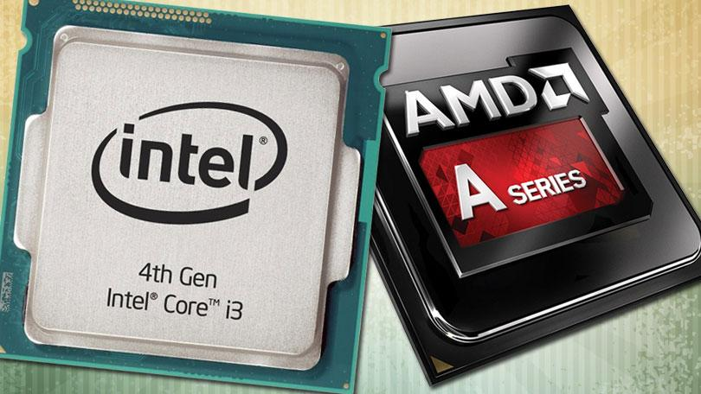

A processor or micro-processor is the 'brains' of a computer system. It is the processor that controls the working of all of the hardware and software.

The processor is sometimes referred to as the **Central Processing Unit (CPU).**

There are many processors available and processor specification is usually one of the first things considered when buying a new personal computer (PC). The type of processor and its speed have the greatest impact on the overall performance of a computer system. Processor performance is related directly to its speed of operation and its architecture

Competition among processor manufacturers is fierce and because of this there is a wide and diverse choice of processors in the market place. Processor manufacturers, such as **Intel** and **Advanced Micro Devices (AMD)** are continually developing more advanced processors and new models are released within the space of months rather than years. This is in stark contrast to earlier processor developments, such as the 8086, 80286 and 80386 which were released years apart.

Memory

(Types & Speed)

The memory in a computer system can be divided into:

* Random Access Memory (**RAM**)
* Read Only Memory (**ROM**)

**RAM** is temporary storage that the processor uses to store programs, and their associated data, while they are running. The idea of a program running from a computer's main memory is known as the 'stored program concept'. When invoked a program will be loaded from hard disk into RAM and any data entered is stored in RAM as well. RAM is **volatile**, which means that its contents are lost when the machine is turned off.

Memory size and speed, along with the processor type and speed, are factors which affect system performance. The more memory a machine has the faster it will be because the processor does not have to spend as much time transferring blocks of program code into RAM. The faster a processor can read and write to memory can also boost a machines performance.

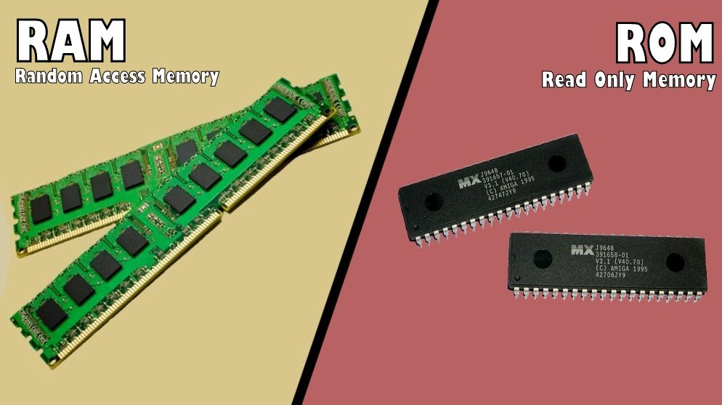

**RAM** Facts :

Currently RAM is measured in megabytes and gigabytes. A typical computer system will have from 256MB to 4MB installed. The general rule of thumb is that the more memory you have installed the faster the system will be.

Most modern computer systems have the capacity for more RAM to be added up to a maximum. The maximum allowed and the particular type and specification of the RAM will be found in the manual for the motherboard.

**ROM** Facts :

There are different variations on the classic ROM chips which were manufacturer produced and could not change. The most common are:

Programmable Read-Only Memory (PROM)

This type of ROM can be re-programmed by using a special device called a PROM programmer. Generally, a PROM can only be changed/updated once.

Erasable Programmable Read-Only Memory (EPROM)

This type of ROM can have its contents erased by ultraviolet light and then reprogrammed by an RPROM programmer. This procedure can be carried out many times; however, the constant erasing and rewriting will eventually render the chip useless.

Electrically Erasable Programmable Read-Only Memory (EEPROM)

This type of ROM works in a similar way to Flash memory in that it can its contents can be 'flashed' for erasure ad then written to without having to remove the chip from its environment. EEPROMs are used to store a computer system's BIOS, and can be updated without returning the unit to the factory. In many cases, BIOS updates can be carried out by computer users wishing a BIOS update.

Fixed storage

The predominant form of fixed storage in a PC is the **hard disk**. A hard disk is a magnetic storage device which stores data as changes in the magnetic field of an area. A hard disk actually consists of more than one disk or platter in a vacuum sealed compartment. Data is read from or written to each disk platter using a movable read/write head that moves in and out as the platters spin.

You can think of each storage area of the hard disk as being like a miniature magnet with north and south poles, i.e. magnetic north for '1' and magnetic south for '0'. Other technologies that use a similar method of magnetic storage are audio tape and video tape.

**Hard Disks :**

A hard disk is the main form of **secondary storage**, as opposed to RAM as primary storage. The hard disk stores all of the programs and data required by the computer and its user, e.g. the operating system. In comparison to RAM, the hard disk retains its data when power is switched off and its storage capacity is many times that of RAM, i.e. modern hard disks can store many gigabytes of data.

A modern hard disk is a complex, high precision device that contains a mixture of electrical and mechanical parts. The data is stored on both sides of rigid circular disks, i.e. **platters**. These platters are covered with a special magnetic coating. A typical hard disk has several platters mounted one above the other on a spindle which is used to rotate the platters at a high speed.

The platters of a hard disk have to be made to extremely precise specifications and are normally manufactured from an aluminium alloy.

**Fixed Storage Interfaces :**

There are three different ways which a hard disk can be connected to the motherboard:

* Parallel AT Attachment (PATA)
* Serial AT Attachment (SATA)
* Small Computer Systems Interface (SCSI)

1. **Parallel AT Attachment (PATA) :**
   1. The PATA interface is the traditional interface between hard disk and motherboard. Normally, the cable used would connect to IDE0 on the motherboard and this would leave two connections to which two hard disks could be connected, with one designated the master or primary and the other designated the secondary, or slave. Most motherboards also have anIDE1 which would be used to connect the CD drive and possibly a second hard disk or even a DVD drive.
   2. The cable is designed in such a way that it can only be connected to the motherboard in the correct way, this is also true of the other connectors that will only fit into the drive in the correct way. Another indication of the correct way to attach the cable is that the red strip end of the cable will slot into pins 0 and 1 on the device.
   3. Note: the AT in the name refers to the fact that the interface was originally designed for the IBM AT type PC.
   4. Different PATA hard disks are usually referred to by their speed of access, e.g. ATA66 is 66MB/s, ATA100 is 100MB/s and ATA133 is 133MB/s.
2. **Serial ATA :**
   1. Serial Advanced Technology Attachment was developed because of the physical limitations of PATA that is evident within all types of parallel transmission. Parallel transmission works best when the distance is short and certain speeds are not exceeded. One problem with parallel transmission is known as skew and this means that the signals on the parallel wires are received at the source at different times. Serial transmission overcomes these short comings and is the type of transmission used for all long distance data transmission.
   2. SATA cables are much more compact that PATA and this allows a better internal airflow and a greater bandwidth because the parallel problem of 'cross-linking' is avoided.
3. **SCSI Interfaces :**

**Small Computer System Interface (SCSI)** is a technology that is used for many different devices; it is not restricted to hard disks or CD-ROMs. Generally, SCSI will be used for peripherals that use fast data transfer rates, e.g. mass storage devices, scanners and printers.

SCSI, usually pronounced 'scuzzy' drives are more expensive than the others and also require a special interface card but this is balanced by increased speed and reliability.

SCSI is used for both internal and external devices.

There are different types of SCSI:

* SCSI 1
* SCSI 2
* Fast Wide SCSI
* SCSI 3
* Ultra SCSI

All of these SCSI standards follow the same operating principles with the main differences being higher speed and support for a wider range of devices.

One possible problem with SCSI is that backward compatibility is not supported, e.g. different connectors have been used.

Removable storage

There are many different forms of removable storage, some more popular than others. Due to changes in technology and with media that has higher storage capacities than others becoming cheaper certain media has started to become less used. One particular example of this is the floppy disk, which at one time was the ubiquitous removable storage media, but now has almost become extinct, with some new PCs being shipped without a floppy disk drive.

We will examine some of the most common forms of removable storage, which are:

* Floppy disk
* CD ROMs
* DVDs
* Flash Drives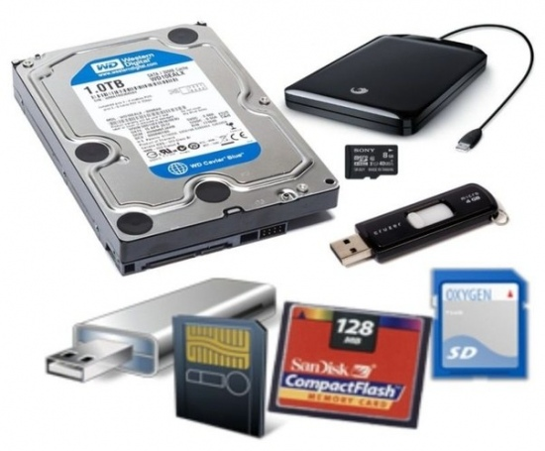

**Floppy Disks :**

We will look at the floppy disk because although its mass uses are probably passed, it still performs certain functions that will be useful for a first line support technician to be aware of, e.g. it can still be used to boot a PC to allow a new operating system to be installed.

The floppy disk works in a similar way to the hard disk with the main difference being that only a single magnetic platter is used and that the read/write head actually make contact with the disk surface rather than float above it.

Floppy disk technology was pushed to the limits by the mid 1990's, when it was no longer possible to expand the amount of data that could be stored on the disk. This was due to the concept of coercivity, i.e. if data is stored in magnetic spots then how near can they be to each other without affecting what is stored. In the case of the floppy disk, more data could not be squeezed onto this surface because if it was it would interfere with the other data.

Probably the most common type of floppy disk was the 31/2-inch High Density Disk which could store up to 1.44 MB. Other variations appeared throughout the 1990's and pushed the storage capacity higher, however, by then other devices had started to erode the floppy market, e.g. flash drives.

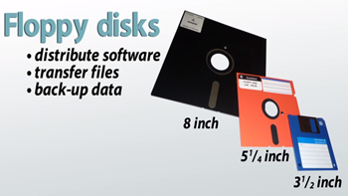

**CD-ROM :**

**Compact Disk-Read-Only Memory (CD-ROM)**devices are considered to be optical devices because they use a laser to read their contents. For many years, CD-ROM media was considered to be Write Once Read Many (Worm) and because it was a ROM media that it could not be written to. This has changed and there a now a wide variation of CD media and drives that can write to as well as read from CDs.

The Compact Disk (CD) has probably taken over from the floppy disk as the most common removable storage media and associated drive. A CD-ROM drive or compatible now comes with every PC as standard similar to the way a floppy disk drive did. Most computer software is still distributed in this format.

When a CD is created the data is written (imprinted) onto a layer making tiny indentations in the media's surface. These are called **pits** whereas, the area that is not changed are called **lands**. The data written, i.e. the pits and lands are written in the form of a spiral from the centre of the disk outwards. This differs from hard disks where the data is written in concentric circles.

CD Drives are usually differentiated by their speed, e.g. x2, x4, etc. Modern CD Drives are x44 and x50 meaning that they are up to 44 and 50 times faster than the original single speed CD drive. A typical CD can hold up to 650MB of data, i.e. the equivalent of 400 1.44MB floppy disks.

Compact Disks are faster, more robust and are not be affected by magnetic fields as are floppy disks, however, care should be taken when using the media to avoid scratches or anything else happening to the surface. Sometimes when a CD is not working properly it has to do with there being some foreign body on the surface.

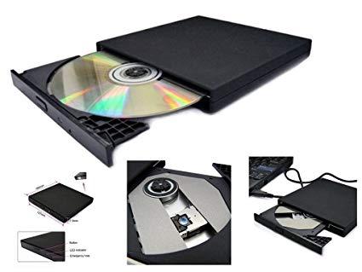

**Flash Drive :**

A **Universal Serial Bus (USB) pen drive** is a hot pluggable device. This means that the device can be connected to the system while the system is switched on.

The picture illustrates a USB Flash Drive next to a small coin.

The storage capacity of flash drives is continually increasing while the price is falling.

Typical sizes include:

* 256MB
* 512MB
* 1GB
* 2GB
* 4GB
* 8GB
* 16GB
* 32GB
* 64GB

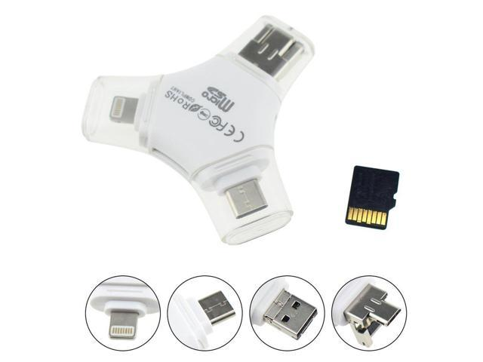

**HP Laptop DR0006TX**

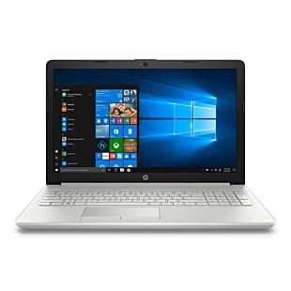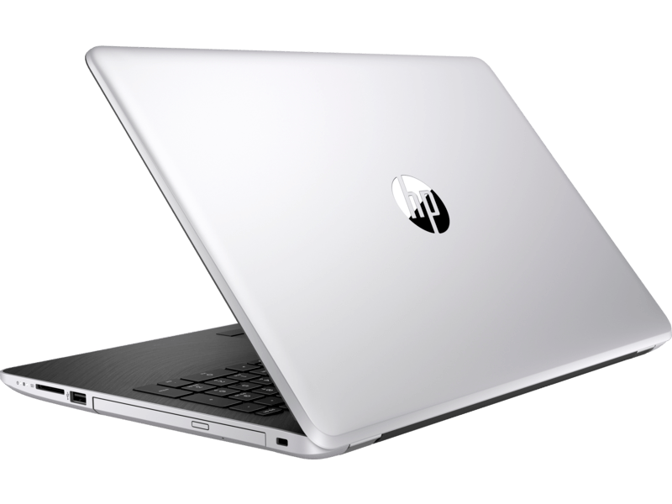

**Specifications :**

|  |  |
| --- | --- |
| Brand | HP |
| Series | 15 |
| Color | Natural Silver |
| Item Height | 23 Millimeters |
| Item Width | 24.6 Centimeters |
| Screen Size | 15.6 Inches |
| Notebook Display Technology | 39.52 cm (15.6) diagonal FHD SVA anti-glare micr |
| Screen Resolution | 1920 x 1080 |
| Maximum Display Resolution | 1920 x 1080 (Full HD) |
| Item Weight | 2.04 Kg |
| Product Dimensions | 37.6 x 24.6 x 2.3 cm |
| Batteries: | 1 Lithium Polymer batteries required. (included) |
| Item model number | DR0006TX |
| Processor Brand | Intel |
| Processor Type | Core i5 8250U |
| Processor Speed | 3.40 GHz |
| Processor Count | 4 |
| RAM Size | 8 GB |
| Memory Technology | DDR4 |
| Computer Memory Type | GDDR3 |
| Maximum Memory Supported | 16 GB |
| Hard Drive Size | 1 TB |
| Hard Disk Technology | Mechanical Hard Drive |
| Hard Drive Interface | eSATA |
| Speaker Description | Dual Speaker |
| Graphics Coprocessor | 2 GB NVIDIA Geforce MX110 |
| Graphics Card Ram Size | 2 GB |
| Connectivity Type | Wi-Fi, Bluetooth-V4 |
| Wireless Type | 801.11ac |
| Number of USB 2.0 Ports | 1 |
| Number of USB 3.0 Ports | 2 |
| Number of HDMI Ports | 1 |
| Number of Audio-out Ports | 1 |
| Number of Ethernet Ports | 1 |
| Number of Microphone Ports | 1 |
| Optical Drive Type | DVD+RW |
| Hardware Platform | Windows |
| Operating System | Windows 10 Home |
| Supported Software | Comes with pre-installed Microsoft Office Home & Student 2016 |
| Average Battery Life (in hours) | 7 Hours |
| Lithium Battery Energy Content | 41 Watt Hours |
| Lithium battery Weight | 0.85 Grams |
| Number of Lithium Ion Cells | 3 |
| Included Components | Laptop, Battery, AC Adapter, User Guide and Manuals |