

**MSPM’S**

**Deogiri Institute of Engineering and Management Studies, Aurangabad**

**Project Topic**

Laptop

LENOVO L340

Submitted By

**PATIL PRITESH**

**CSE Branch, SE-I and Roll No-26043**

Under the Guidance of

**Prof . Pankaj durole**

(Deogiri Institute of Engineering and Management Studies)

2018-2019

CERTIFICATE

This is to Certify that PATIL PRITESH has Completed Word Document Presentation of Computer Architecture And Organisation on **\*\*\*\*\*** For the partial fulfillment of Continuous Assessment on date______

**Name and Signature of Subject Teacher**

Contents

1.Introduction

- Lenovo

2.Lenovo l340

-Features

-Specifications

3.Processor Architecture

4.Instruction Set

5.Control Unit

**LENOVO**

**Introduction**

[Liu Chanzi](https://en.wikipedia.org/wiki/Liu_Chuanzhi) founded Lenovo on 1 November 1984 with a group of ten engineers in Beijing with 200,000 yuan. The Chinese government approved Lenovo's incorporation on the same day. Jiǎ Xùfú , one of the founders of Lenovo, indicates the first meeting in preparation for starting the company was held on 17 October of the same year. Eleven people, the entirety of the initial staff, attended. Each of the founders was a middle-aged member of the Institute of Computing Technology attached to the [Chinese Academy of Sciences](https://en.wikipedia.org/wiki/Chinese_Academy_of_Sciences). The 200,000 yuan used as start-up capital was approved by Zēng Màocháo. The name for the company agreed upon at this meeting was the Chinese Academy of Sciences Computer Technology Research Institute New Technology Development Company.

Their first significant effort, an attempt to import televisions, failed. The group rebuilt itself within a year by conducting quality checks on computers for new buyers. Lenovo soon started developing a circuit board that would allow IBM-compatible personal computers to process Chinese characters. This product was Lenovo's first major success. Lenovo also tried and failed to market a digital watch. Liu said, "Our management team often differed on which commercial road to travel. This led to big discussions, especially between the engineering chief and myself. He felt that if the quality of the product was good, then it would sell itself. But I knew this was not true, that marketing and other factors were part of the eventual success of a product." The fact that its staff had little business experience compounded Lenovo's early difficulties. "We were mainly scientists and didn't understand the market", Liu said. "We just learned by trial-and-error, which was very interesting—but also very dangerous", said Liu. In 1990, Lenovo started to manufacture and market computers using its own brand name.

LENOVO L340 GAMING LAPTOP

* FEATURES
* One serious gaming laptop

All the power and performance you need to test your wits against the very best. A full-sized keyboard with ambient backlighting. And a slick, stylish design. The IdeaPad L340 Gaming (15) is a real gamer's laptop, from the inside out.

Brings out the gamer in you

With up to 9th Gen Intel® Core™ i7 processing, the IdeaPad L340 Gaming has all the power you need to outshoot, outrun, and outsmart anyone. For an even better gaming experience, go with the Intel® Optane™ option for faster start-up times and quicker game launches.

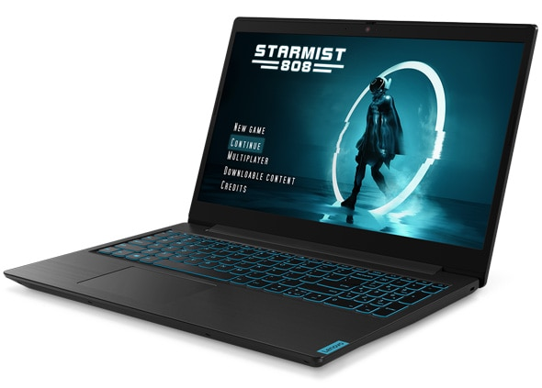

The new supercharger

GeForce® GTX 1650 gaming laptops are built with the breakthrough graphics performance of the award-winning NVIDIA Turing™ architecture to supercharge your favorite games.

Lose yourself in the game

Hardwired into every IdeaPad L340 is Dolby Audio™. This advanced sound technology is there to take your mobile gaming experience to new levels— and ensure that you have a real blast along the way.

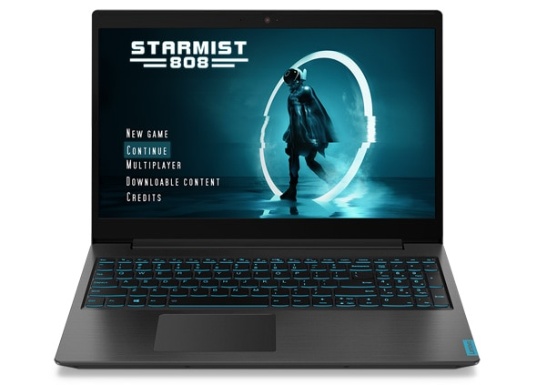

Call all the shots

The IdeaPad L340 has two distinct modes: ‘Quick’ for gaming and ‘Quiet’ for working. Each mode looks, feels, and acts differently. Simply flick between the two based on what you need to do.

Because your privacy counts

Livestream with ease on the IdeaPad L340—and keep your private things private. With a physical shutter on the webcam, you can shut off your camera from the outside world at any time.

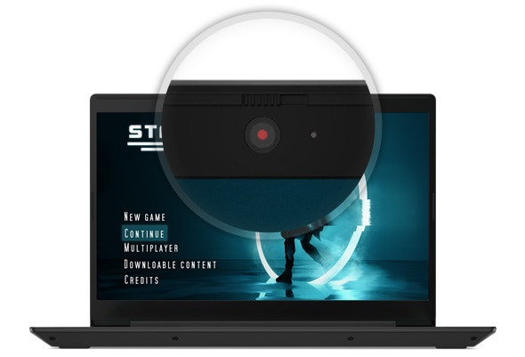

Put eye fatigue to bed

Too many hours gaming can affect your eyes. But with Lenovo Vantage’s Eye Care Mode, you can reduce blue light emission and adjust your display’s color tone, countering the risk of eye strain and fatigue.

Why waste valuable gaming time?

With up to 9 hours' battery life, the IdeaPad L340 lets you battle it out all day. Even better, the battery recharges rapidly to 80% within 60 minutes and to 100% within 120 minutes.

* SPECIFICATIONS
* **Processor**
* Intel Core i5-9300H Processor ( 2.40GHz 8MB )
* **Operating System**
* Windows 10 Home 64
* **Display Type**
* 15.6 FHD IPS AG
* **Memory**
* 8.0GB PC4-19200 DDR4 SODIMM 2400MHz
* **Hard Drive**
* 1TB 5400RPM
* **Optical Drive**
* No ODD
* **Warranty**
* 1 Year Onsite Warranty
* **Speaker**
* Stereo speakers
* **AC Adapter**
* 135W
* **Graphics**
* NVIDIA® GEFORCE® GTX 1650 (4GB GDDR5)
* **Ports**
* 2xUSB 3.1, 1xUSB 3.1 Type-C, headphone / microphone combo jack
* **Weight**
* 2.78 Kgs
* **Battery**
* 3Cell 45Wh
* **Bluetooth**
* NA
* **Camera**
* 720P
* **Fingerprint Reader**
* No
* **Pointing Device**
* ClickPad
* **Wireless**
* Intel Wireless-AC 9560 2x2 AC+BT5.0

|  |
| --- |
|  |

Processor Architecture

**Core i5-9300H** is a [64-bit](https://en.wikichip.org/wiki/64-bit_architecture) [quad-core](https://en.wikichip.org/wiki/quad-core) mid-range performance [x86](https://en.wikichip.org/wiki/x86) mobile microprocessor introduced by [Intel](https://en.wikichip.org/wiki/Intel) in [2018](https://en.wikichip.org/wiki/2018). This processor, which is based on the [Coffee Lake](https://en.wikichip.org/wiki/intel/microarchitectures/coffee_lake)microarchitecture, is manufactured on Intel's 3rd generation enhanced [14nm++ process](https://en.wikichip.org/wiki/14_nm_process). The i5-9300H operates at 2.4 GHz with a TDP of 45 W and a [turbo boost](https://en.wikichip.org/wiki/intel/turbo_boost) of up to 4.1 GHz. This chip integrates Intel's [UHD Graphics 630](https://en.wikichip.org/wiki/intel/uhd_graphics_630) GPU operating at 350 MHz with a burst frequency of up to 1 GHz and supports up to 64 GiB of dual-channel DDR4-2666 memory

.

|  |  |
| --- | --- |
| **Core i5-9300H** | |
| coffee lake h (front).png | |
| Coffee Lake H, Front | |
| General Info | |
| **Designer** | [Intel](https://en.wikichip.org/wiki/Intel) |
| **Manufacturer** | [Intel](https://en.wikichip.org/wiki/Intel) |
| **Model Number** | i5-9300H |
| **Market** | Mobile |
| **Introduction** | April 23, 2019 (announced) April 23, 2019 (launched) |
| General Specs | |
| **Family** | [Core i5](https://en.wikichip.org/wiki/intel/core_i5) |
| **Series** | i5-9000 |
| **Locked** | Yes |
| **Frequency** | 2,400 MHz |
| **Turbo Frequency** | 4,100 MHz (1 core) |
| **Bus type** | DMI 3.0 |
| **Bus rate** | 4 × 8 GT/s |
| **Clock multiplier** | 24 |
| Microarchitecture | |
| **ISA** | x86-64 (x86) |
| **Microarchitecture** | [Coffee Lake](https://en.wikichip.org/wiki/intel/microarchitectures/coffee_lake) |
| **Platform** | Coffee Lake |
| **Chipset** | 300 series |
| **Core Name** | [Coffee Lake HR](https://en.wikichip.org/wiki/intel/cores/coffee_lake_hr) |
| **Core Family** | 6 |
| **Core Model** | 158 |
| **Process** | [14 nm](https://en.wikichip.org/wiki/14_nm_process) |
| **Technology** | CMOS |
| **Die** | 126 mm² |
| **Word Size** | 64 bit |
| **Cores** | 4 |
| **Threads** | 8 |
| **Max CPUs** | 1 (Uniprocessor) |
| **Max Memory** | 64 GiB |
| Electrical | |
| **TDP** | 45 W |
| **cTDP down** | 35 W |
| **Tjunction** | 0 °C – 100 °C |
| Packaging | |
| |  |  | | --- | --- | | **Package** | [FCBGA-1440](https://en.wikichip.org/w/index.php?title=packages/fcbga-1440&action=edit&redlink=1) (BGA) | | **Dimension** | 42 mm x 28 mm x 1.49 mm | | **Pitch** | 0.65 mm | | **Ball Count** | 1440 | | **Ball Comp** | SAC405 | | **Interconnect** | BGA-1440 | | |

**Instruction set**

The **instruction set**,also called **ISA** (**instruction set architecture**), is part of a computer that pertains to programming, which is basically [machine language](https://www.computerhope.com/jargon/m/machlang.htm). The instruction set provides commands to the processor, to tell it what it needs to do. The instruction set consists of addressing modes, instructions, native data types, registers, memory architecture, interrupt, and exception handling, and external [I/O](https://www.computerhope.com/jargon/i/io.htm).

An example of an instruction set is the [x86](https://www.computerhope.com/jargon/x/x86.htm) instruction set, which is common to find on computers today. Different computer processors can use almost the same instruction set while still having very different internal design. Both the [Intel](https://www.computerhope.com/comp/intel.htm) Pentium and [AMD](https://www.computerhope.com/comp/amd.htm) Athlon processors use nearly the same x86 instruction set. An instruction set can be built into the hardware of the processor, or it can be emulated in software, using an interpreter. The hardware design is more efficient and faster for running programs than the emulated software version.

**Examples of instruction set**

* **ADD** - Add two numbers together.
* **COMPARE** - Compare numbers.
* **IN** - Input information from a device, e.g., keyboard.
* **JUMP** - Jump to designated RAM address.
* **JUMP IF** - Conditional statement that jumps to a designated RAM address.
* **LOAD** - Load information from RAM to the CPU.
* **OUT** - Output information to device, e.g., monitor.
* **STORE** - Store information to RAM

Control Unit

The **control unit** (CU) is a component of a computer's central processing unit (CPU) that directs the operation of the processor. It tells the computer's memory, arithmetic and logic unit and input and output devices how to respond to the instructions that have been sent to the processor

It directs the operation of the other units by providing timing and control signals. Most computer resources are managed by the CU. It directs the flow of data between the CPU and the other devices. John von Neumann included the control unit as part of the Von Neumann architecture. In modern computer designs, the control unit is typically an internal part of the CPU with its overall role and operation unchanged since its introduction.

Functions of the control unit

The Control unit (CU) is digital circuitry contained within the processor that coordinates the sequence of data movements into, out of, and between a processor's many sub-units. The result of these routed data movements through various digital circuits (sub-units) within the processor produces the manipulated data expected by a software instruction (loaded earlier, likely from memory). It controls (conducts) data flow inside the processor and additionally provides several external control signals to the rest of the computer to further direct data and instructions to/from processor external destinations (i.e. memory)