

**MSPM’S**

**Deogiri Institute of Engineering and Management Studies, Aurangabad**

**Project Topic**

Laptops

**Lenovo** Legion **Y730**

Submitted By

**Himanshu Gaikwad**

**Shivani Solunke**

**CSE Branch, SE-I and Roll No-26051,26052**

Under the Guidance of

**Prof.Pankaj Durole**

(Deogiri Institute of Engineering and Management Studies)

2018-2019

**INTRODUCTION**

LENOVO

**Lenovo Group Limited**, often shortened to **Lenovo** ([/lɛˈnoʊvoʊ/](https://en.wikipedia.org/wiki/Help:IPA/English) *[leh-NOH-voh](https://en.wikipedia.org/wiki/Help:Pronunciation_respelling_key" \o "Help:Pronunciation respelling key)*), is a Chinese  technology company with headquarters in [Beijing](https://en.wikipedia.org/wiki/Beijing). It designs, develops, manufactures, and sells [personal computers](https://en.wikipedia.org/wiki/Personal_computer), [tableT computers](https://en.wikipedia.org/wiki/Tablet_computer" \o "Tablet computer), [smartphones](https://en.wikipedia.org/wiki/Lenovo_smartphones), [workstations](https://en.wikipedia.org/wiki/Workstation), [servers](https://en.wikipedia.org/wiki/Server_(computing)), [electronic storage](https://en.wikipedia.org/wiki/Electronic_storage) devices, IT management software, and [smart televisions](https://en.wikipedia.org/wiki/Smart_TV). Lenovo is the [world's largest personal computer vendor](https://en.wikipedia.org/wiki/Market_share_of_personal_computer_vendors) by unit sales, as of March 2019. It markets the [ThinkPad](https://en.wikipedia.org/wiki/ThinkPad) and [ThinkBook](https://en.wikipedia.org/wiki/ThinkBook" \o "ThinkBook) business lines of notebook computers, [IdeaPad](https://en.wikipedia.org/wiki/IdeaPad), [Yoga](https://en.wikipedia.org/wiki/Lenovo_Yoga) and Legion consumer lines of notebook laptops, and the [IdeaCentre](https://en.wikipedia.org/wiki/IdeaCentre" \o "IdeaCentre) and [ThinkCentre](https://en.wikipedia.org/wiki/ThinkCentre) lines of desktops.

Lenovo has operations in more than 60 countries and sells its products in around 160 countries. Lenovo's principal facilities are in Beijing and [Morrisville](https://en.wikipedia.org/wiki/Morrisville,_North_Carolina) ([North Carolina](https://en.wikipedia.org/wiki/North_Carolina), U.S.), with Chinese research centers in Beijing, [Shanghai](https://en.wikipedia.org/wiki/Shanghai), [Shenzhen](https://en.wikipedia.org/wiki/Shenzhen), [Xiamen](https://en.wikipedia.org/wiki/Xiamen), [Chengdu](https://en.wikipedia.org/wiki/Chengdu), [Nanjing](https://en.wikipedia.org/wiki/Nanjing), and [Wuhan](https://en.wikipedia.org/wiki/Wuhan), [Yamato](https://en.wikipedia.org/wiki/Yamato,_Kanagawa) ([Kanagawa Prefecture](https://en.wikipedia.org/wiki/Kanagawa_Prefecture), Japan), and Morrisville. It also has a joint venture with [NEC](https://en.wikipedia.org/wiki/NEC), Lenovo NEC Holdings, which produces personal computers for the Japanese market.

Lenovo was founded in Beijing in November 1984 as **Legend** and was incorporated in [Hong Kong](https://en.wikipedia.org/wiki/Hong_Kong) in 1988. Lenovo acquired [IBM](https://en.wikipedia.org/wiki/IBM)'s personal computer business in 2005 and agreed to acquire its Intel-based server business in 2014. Lenovo entered the smartphone market in 2012 and as of 2014 was the largest vendor of smartphones in Mainland China. acquired the mobile phone handset maker [Motorola Mobility](https://en.wikipedia.org/wiki/Motorola_Mobility) from [Google](https://en.wikipedia.org/wiki/Google). [Liu Chuanzhi](https://en.wikipedia.org/wiki/Liu_Chuanzhi) founded Lenovo on 1 November 1984 with a group of ten engineers in Beijing with 200,000 yuan. The Chinese government approved Lenovo's incorporation on the same day. Jiǎ Xùfú (贾续福), one of the founders of Lenovo, indicates the first meeting in preparation for starting the company was held on 17 October of the same year. Eleven people, the entirety of the initial staff, attended. Each of the founders was a middle-aged member of the Institute of Computing Technology attached to the [Chinese Academy of Sciences](https://en.wikipedia.org/wiki/Chinese_Academy_of_Sciences). The 200,000 yuan used as start-up capital was approved by Zēng Màocháo (曾茂朝). The name for the company agreed upon at this meeting was the Chinese Academy of Sciences Computer Technology Research Institute New Technology Development Company.

**LENOVO LEGION Y730**

LENOVO at [E3 2018 in June](https://gadgets.ndtv.com/laptops/news/lenovo-legion-y730-y530-t730-t530-c730-c530-launched-price-specifications-features-1866078) and [IFA 2018 in August](https://gadgets.ndtv.com/laptops/news/lenovo-legion-t730-c730-nvidia-rtx-legion-y730-refresh-specifications-price-release-date-ifa-2018-1908799), announced a range of gaming PCs. The updated lineup that includes two new gaming laptops, a gaming tower, and a gaming cube are now available in India. At an event in New Delhi on Tuesday, Lenovo unveiled the Legion Y730 and Y530 Laptops, C730 Cube, and T730 and T530 Towers with a variety of configurations. Additionally, the company has also launched the Legion Y25f-10 gaming monitor in the country.

The new Lenovo Legion lineup comes with Intel Optane technology, said to improve the performance and response of PCs through adaptive machine learning. Gamers can now launch their favourite titles up to 2.48 times faster, load game levels up to 32 percent faster than on other PCs, and rapidly save their progress with up to 2.1 times better overall system performance, claims Lenovo. "As people passionate about technology, Lenovo's investment in research and development is about bringing to life the innovations we ourselves would love to use for the ultimate gaming experience," said Shailendra Katyal, Lenovo's Executive Director and India PCSD Consumer Leader.

First up, in the Lenovo Legion Y530 laptop that comes with 62 percent thinner bezels than previous Legion variants. It sports a 15-inch full-HD IPS panel. Processor options include the 8th Generation Intel Core i7-8750H or an Intel Core i5-8300H. It comes with a 144Hz panel, upto 32GB RAM, 512GB PCIe SSD, and a 2TB HDD. Graphics card choices that include a GeForce GTX 1050, 1050 Ti, and a GeForce GTX 1060. Additionally, it has a white backlit keyboard, and a 52.5WHr battery. According to the company, the laptop can be "optimally cooled via a re-engineered dual-channel cooling system".

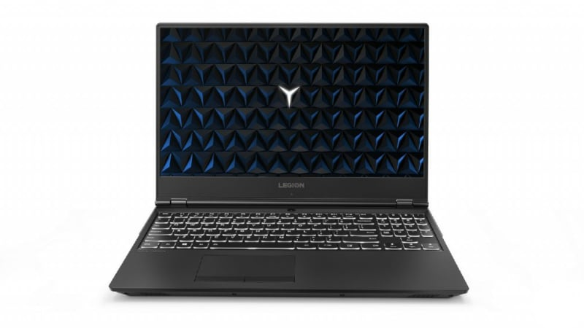

Lenovo Legion Y530

The Legion Y530 laptop is priced at Rs. 85,585 (exclusive of GST). It will be available via Lenovo's exclusive stores and other offline stores such as Croma, Reliance Digital, and Ezone. It will also be available via Lenovo's official site in India.

The Lenovo Legion Y730, on the other hand, comes with a starting price of Rs. 96,025. The laptop comes in 17-inch and 15-inch display variants. It comes with optional 16GB Corsair DDR4 RAM. The gaming laptop is equipped with a Corsair iCUE RGB backlit keyboard and system lighting. The keyboard also includes six custom macro "Y" keys. Further, it is made of aluminium - anodised in Iron Gray colour and includes Dolby Atmos speaker along with Dolby Sound Radar. It will also be available via Lenovo's exclusive stores and other offline stores such as Croma.

**PROCESSOR ARCHITECTURE**

When learning assembly for a given platform, the first place to start is to learn the register set.

**General Architecture**

Since the 64-bit registers allow access for many sizes and locations, we define a byte as 8 bits, a word as 16 bits, a double word as 32 bits, a quad word as 64 bits, and a double quad word as 128 bits. Intel stores bytes “little endian,” meaning lower significant bytes are stored in lower memory address.

Figure 1

shows sixteen general purpose 64-bit registers, the first eight of which are labeled (for historical reasons) RAX, RBX, RCX, RDX, RBP, RSI, RDI, and RSP. The second eight are named R8-R15. By replacing the initial R with an E on the first eight registers, it is possible to access the lower 32 bits (EAX for RAX).

Similarly, for RAX, RBX, RCX, and RDX, access to the lower 16 bits is possible by removing the initial R (AX for RAX), and the lower byte of the these by switching the X for L (AL for AX), and the higher byte of the low 16 bits using an H (AH for AX).

The new registers R8 to R15 can be accessed in a similar manner like this: R8 (qword), R8D (lower d word), R8W (lowest word), R8B (lowest byte MASM style, Intel style R8L).

Note there is no R8H.

**SIMD Architecture**

Single Instruction Multiple Data (SIMD) instructions execute a single command on multiple pieces of data in parallel and are common usage for assembly routines. MMX and SSE commands (using the MMX and XMM registers respectively) support SIMD operations, which perform an instruction on up to eight pieces of data in parallel. For example, eight bytes can be added to eight bytes in one instruction using MMX.

The eight 64-bit MMX registers MMX0-MMX7 are aliased on top of FPR0-7, which means any code mixing FP and MMX operations must be careful not to overwrite required values. The MMX instructions operate on integer types, allowing byte, word, and double word operations to be performed on values in the MMX registers in parallel. Most MMX instructions begin with „P‟ for “packed”. Arithmetic, shift/rotate, comparison, e.g.: PCMPGTB “Compare packed signed byte integers for greater than”.

The sixteen 128-bit XMM registers allow parallel operations on four single or two double precision values per instruction.

Some instructions also work on packed byte, word, double word, and quad word integers. These instructions, called the Streaming SIMD Extensions (SSE), come in many flavors: SSE, SSE2, SSE3, SSSE3, SSE4, and perhaps more by the time this prints. Intel has announced more extensions along these lines called Intel® Advanced Vector Extensions (Intel® AVX), with a new 256-bit-wide data path. SSE instructions contain move, arithmetic, comparison, shuffling and unpacking, and bitwise operations on both floating point and integer types. Instruction names include such beauties as PMULHUW and RSQRTPS.

Finally, SSE introduced some instructions for memory pre-fetching (for performance) and memory fences (for multi-threaded safety).

Table lists some command sets, the register types operated on, the number of items manipulated in parallel, and the item type. For example, using SSE3 and the 128-bit XMM registers, you can operate on 2 (must be 64-bit) floating point values in parallel, or even 16 (must be byte sized) integer values in parallel.

To find which technologies a given chip supports, there is a CPUID instruction that returns processor-specific information.

**Table**

|  |  |  |  |
| --- | --- | --- | --- |
| Technology | Register size/type | Item type | Items in Parallel |
| MMX | 64 MMX | Integer | 8,4,2,1 |
| SSE | 64 MMX | Integer | 8,4,2,1 |
| SSE | 128 XMM | Float | 4 |
| SSE2/SSE3/SSSE3… | 64 MMX | Integer | 2,1 |
| SSE2/SSE3/SSSE3… | 128 XMM | Float | 2 |
| SSE2/SSE3/SSSE3… | 128 XMM | Integer | 16,8,4,2,1 |

**Addressing Modes**

Before covering some basic instructions, you need to understand addressing modes, which areways an instruction can access registers or memory. The following are common addressing modes with examples:

* Immediate: the value is stored in the instruction.

**ADD EAX, 14; add 14 into 32-bit EAX**

* Register to register

**ADD R8L, AL** **; add 8 bit AL into R8L**

* Indirect: this allows using an 8, 16, or 32 bit displacement, any general purpose registers for base and index, and a scale of 1, 2, 4, or 8 to multiply the index.

Technically , these also be prefixed with segment FS: or GS: but

**MOV R8W, 1234[8*RAX+RCX]; move word at address 8*RAX+RCX+1234 into R8W**

**INSTRUCTIONS SET**

Table lists some common instructions. * denotes this entry is multiple opcodes where the * denotes a suffix.

**Table – Common Opcodes**

|  |  |  |  |
| --- | --- | --- | --- |
| Opcode | Meaning | Opcode | Meaning |
| MOV | Move to/from/between | AND/OR/XOR/NOT | Bitwise operations |
|  | memory and registers |  |  |
| CMOV* | Various conditional moves | SHR/SAR | Shift right logical/arithmetic |
| XCHG | Exchange | SHL/SAL | Shift left logical/arithmetic |
| BSWAP | Byte swap | ROR/ROL | Rotate right/left |
| PUSH/POP | Stack usage | RCR/RCL | Rotate right/left through carry |
|  |  |  | bit |

**RAM (Random Access Memory)**

RAM is a form of computer memory that can be read and changed in any order, typically used to store working data and machine code. A random-access memory device allows data items to be read or written in almost the same amount of time irrespective of the physical location of data inside the memory. In contrast, with other direct-access data storage media such as hard disks, CD-Rs, DVD-RWs and the older magnetic tapes and drum memory, the time required to read and write data items varies significantly depending on their physical locations on the recording medium, due to mechanical limitations such as media rotation speeds and arm movement.

RAM contains multiplexing and de-multiplexing circuitry, to connect the data lines to the addressed storage for reading or writing the entry. Usually more than one bit of storage is accessed by the same address, and RAM devices often have multiple data lines and are said to be "8-bit" or "16-bit", etc. devices. 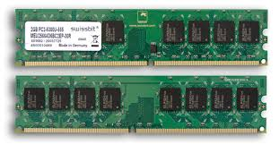Both static and dynamic RAM are considered *volatile*, as their state is lost or reset when power is removed from the system. By contrast, read-only memory (ROM) stores data by permanently enabling or disabling selected transistors, such that the memory cannot be altered. Writeable variants of ROM (such as EEPROM and flash memory) share properties of both ROM and RAM, enabling data to persist without power and to be updated without requiring special equipment. These persistent forms of semiconductor ROM include USB flash drives, memory cards for cameras and portable devices, and solid-state drives.

**Read-only memory (ROM)**

ROM is a type of non-volatile memory used in computers and other electronic devices. Data stored in ROM cannot be electronically modified after the manufacture of the memory device. Read-only memory is useful for storing software that is rarely changed during the life of the system, sometimes known as firmware. Software applications for programmable devices can be distributed as plug-in

cartridges containing read-only memory.

Erasable programmable read-only memory (EPROM) and electrically erasable programmable read-only memory (EEPROM) can be erased and re-programmed, but usually this can only be done at relatively slow speeds, may require special equipment to achieve, and is typically only possible a certain number of times.

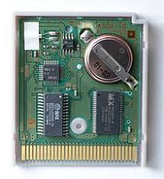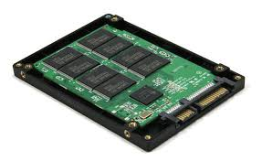

**WORKING ON CONTROL UNIT**

The **control unit** (CU) is a component of a computer's central processing unit (CPU) that directs the operation of the processor. It tells the computer's memory, arithmetic and logic unit and input and output devices how to respond to the instructions that have been sent to the processor. The Control unit (CU) is digital circuitry contained within the processor that coordinates the sequence of data movements into, out of, and between a processor's many sub-units.

The result of these routed data movements through various digital circuits (sub-units) within the processor produces the manipulated data expected by a software instruction (loaded earlier, likely from memory).

It controls (conducts) data flow inside the processor and additionally provides several external control signals to the rest of the computer to further direct data and instructions to/from processor external destinations (i.e. memory).

The Control Unit (CU) is generally a sizable collection of complex digital circuitry interconnecting and directing the many execution units (i.e. ALU, data buffers, registers) contained within a CPU.

The CU is normally the first CPU unit to accept from an externally stored computer program a single instruction (based on the CPU's instruction set).

The CU then decodes this individual instruction into several sequential steps (fetching addresses/data from registers/memory, managing execution ([i.e. data sent to the ALU or I/O]), and storing the resulting data back into registers/memory) that controls and coordinates the CPU's inner works to properly manipulate the data.

The design of these sequential steps is based on the needs of each instruction and can range in number of steps, the order of execution, and which units are enabled.

**INPUT/OUTPUT MECHANISM**

The process of giving input to computer and giving output from computer is called input/ output. The mechanism almost same for input and output. The operating system is mainly responsible for input output operating interrupt and error handling is important terms related to input/outputs.

*I/O devices are divided into two categories*:-

1. **Block devices**: -

  A block devices is one that store information in fixed-sized blocks, each one, with its own address common blocked size ranges from 512 bytes to 32768 bytes. The essential property of a block device is that it is

Their first significant effort, an attempt to import televisions, failed. The group rebuilt itself within a year by conducting quality checks on computers for new buyers. Lenovo soon started developing a circuit board that would allow IBM-compatible personal computers to process Chinese characters. This product was Lenovo's first major success. Lenovo also tried and failed to market a digital watch. Liu said, "Our management team often differed on which commercial road to travel. This led to big discussions, especially between the engineering chief and myself. He felt that if the quality of the product was good, then it would sell itself. But I knew this was not true, that marketing and other factors were part of the eventual success of a product." The fact that its staff had little business experience compounded Lenovo's early difficulties. "We were mainly scientists and didn't understand the market", Liu said. "We just learned by trial-and-error, which was very interesting—but also very dangerous", said Liu. In 1990, Lenovo started to manufacture and market computers using its own brand name. possible to read or write each block independently of all the other ones. In other word, at any instant, the program can read or write any of the blocks. The common examples of block device are disk. A disk is block addressable device because no matter where the arm currently is, it is always possible to seek to another cylinder and then wait for another block to rotate the head.

1. **Character devices**: -

  A character device is one that delivers or accepts a stream of characters, without regards to any blocks structure. It is not accessible and does not have any such operation. The examples of character devices are printers, paper tapes, network interface card, mice and most other devices that are not disk like can be seen as.

**Device controller**

I/O units typically consist of mechanical part and the electronic part. The electronic part is also called the device controller or adapter. On pc, device controller takes the form of printed circuit card that can be inserted into an expansion slots. The controller card actually has a connected on it, into which a cable leading to the device itself can be plugged many controllers can handle more than one identical devices. The standard for interface between controller and device is ANSI, ICE, IDE, SCSI, ISO etc.

**Specifications**

General

|  |  |
| --- | --- |
| Sales Package | * Laptop, Battery, Power Adaptor, User Guide, Warranty Documents |
| Model Number | * Y720 |
| Part Number | * 80VR00ESIN |
| Series | * Legion |
| Color | * Black |
| Type | * Gaming Laptop |
| Suitable For | * Gaming |
| Battery Backup | * Up to 5 hours |

Processor and Memory Features

|  |  |
| --- | --- |
| Dedicated Graphic Memory Type | * GDDR5 |
| Dedicated Graphic Memory Capacity | * 6 GB |
| Processor Brand | * Intel |
| Processor Name | * Core i7 |
| Processor Generation | * 7th Gen |
| SSD | * Yes |
| SSD Capacity | * 256 GB |
| RAM | * 16 GB |
| RAM Type | * DDR4 |
| HDD Capacity | * 2 TB |
| Processor Variant | * 7700HQ |
| Clock Speed | * 2.8 GHz with Turbo Boost Up to 3.8 GHz |
| Memory Slots | * 2 Slots |
| RAM Frequency | * 2400 MHz |
| Cache | * 6 MB |
| RPM | * 5400 |
| Graphic Processor | * NVIDIA GeForce GTX 1060 |

Operating System

|  |  |
| --- | --- |
| OS Architecture | * 64 bit |
| Operating System | * Windows 10 Home |
| System Architecture | * 64 bit |

Port and Slot Features

|  |  |
| --- | --- |
| Mic In | * Yes |
| RJ45 | * Yes |
| USB Port | * 3 x USB 3.0 |
| HDMI Port | * 1 x HDMI Port |
| Hardware Interface | * SATA |

Display and Audio Features

|  |  |
| --- | --- |
| Touchscreen | * No |
| Screen Size | * 39.62 cm (15.6 inch) |
| Screen Resolution | * 1920 x 1080 pixel |
| Screen Type | * Full HD LED Backlit Anti-glare IPS Slim Display |
| Speakers | * Built-in Dual Speakers |
| Internal Mic | * Built-in Microphone |
| Sound Properties | * 2 x 2 W JBL Speakers with Chamber |

Connectivity Features

|  |  |
| --- | --- |
| Wireless LAN | * WIFI 2x2 AC |
| Bluetooth | * v4.1 |

Dimensions

|  |  |
| --- | --- |
| Dimensions | * 380 x 277 x 29 mm |
| Weight | * 2.95 kg |

Additional Features

|  |  |
| --- | --- |
| Disk Drive | * Not Available |
| Web Camera | * HD Webcam |
| Antivirus | * McAfee LiveSafe |
| Keyboard | * Backlit Keyboard |
| Backlit Keyboard | * Yes |
| Pointer Device | * Touchpad |
| Included Software | * One Key Recovery, Lenovo Companion, Lenovo App Explorer, Lenovo Nerve Sense, Microsoft Office 2016 |
| Additional Features | * 256 GB SSD for reduced boot up time and in-game loading, NVIDIA GeForce GTX 1060 for desktop level performance, 16 GB DDR4 VRAM for lag-free performance, Full HD LED Backlit Anti-glare IPS Slim Display, i7 7th Gen with up to 3.8 GHz Turbo Boost, * 1 Year Brand Onsite Warranty |

Warranty

|  |  |
| --- | --- |
| Warranty Summary | * 1 Year Onsite Warranty |
| Warranty Service Type | * Onsite |
| Covered in Warranty | * Manufacturing Defects |
| Not Covered in Warranty | * Physical Damage |
| Domestic Warranty | * 1 Year |

More Details

* Generic Name
  + Computers
* Country of Origin
  + India

**IMAGES**

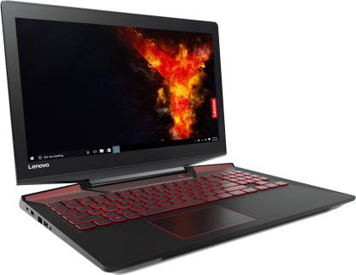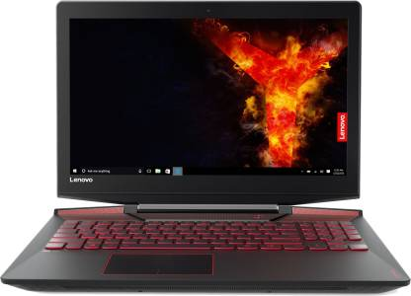

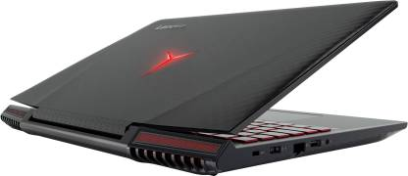

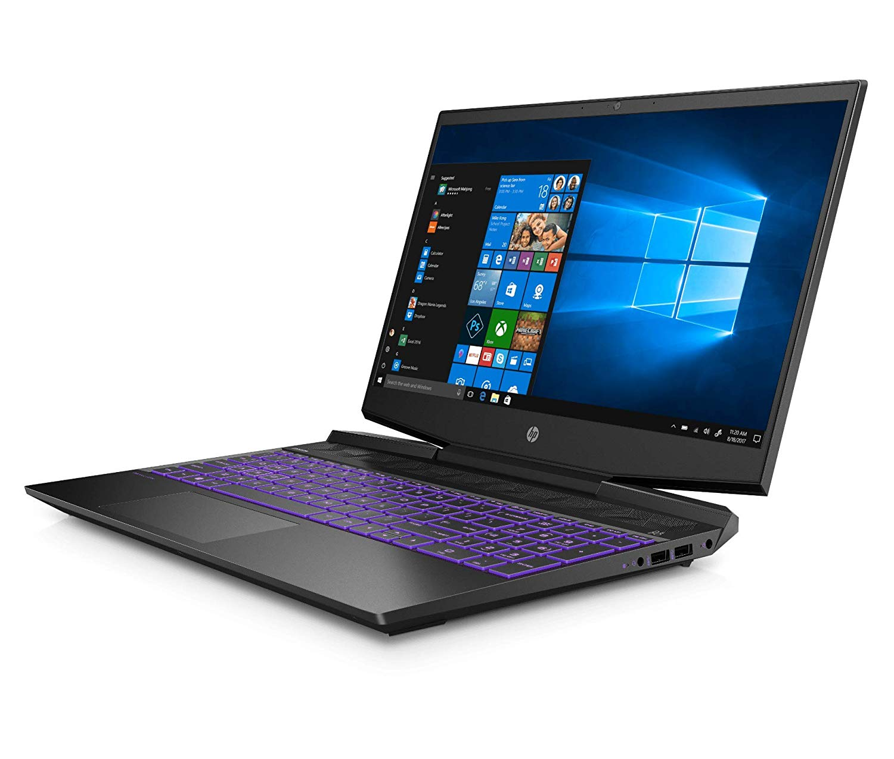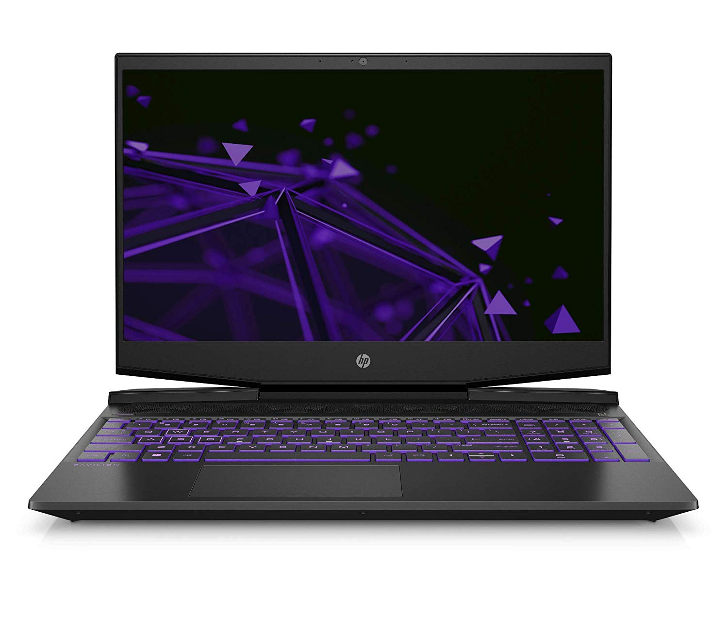HP 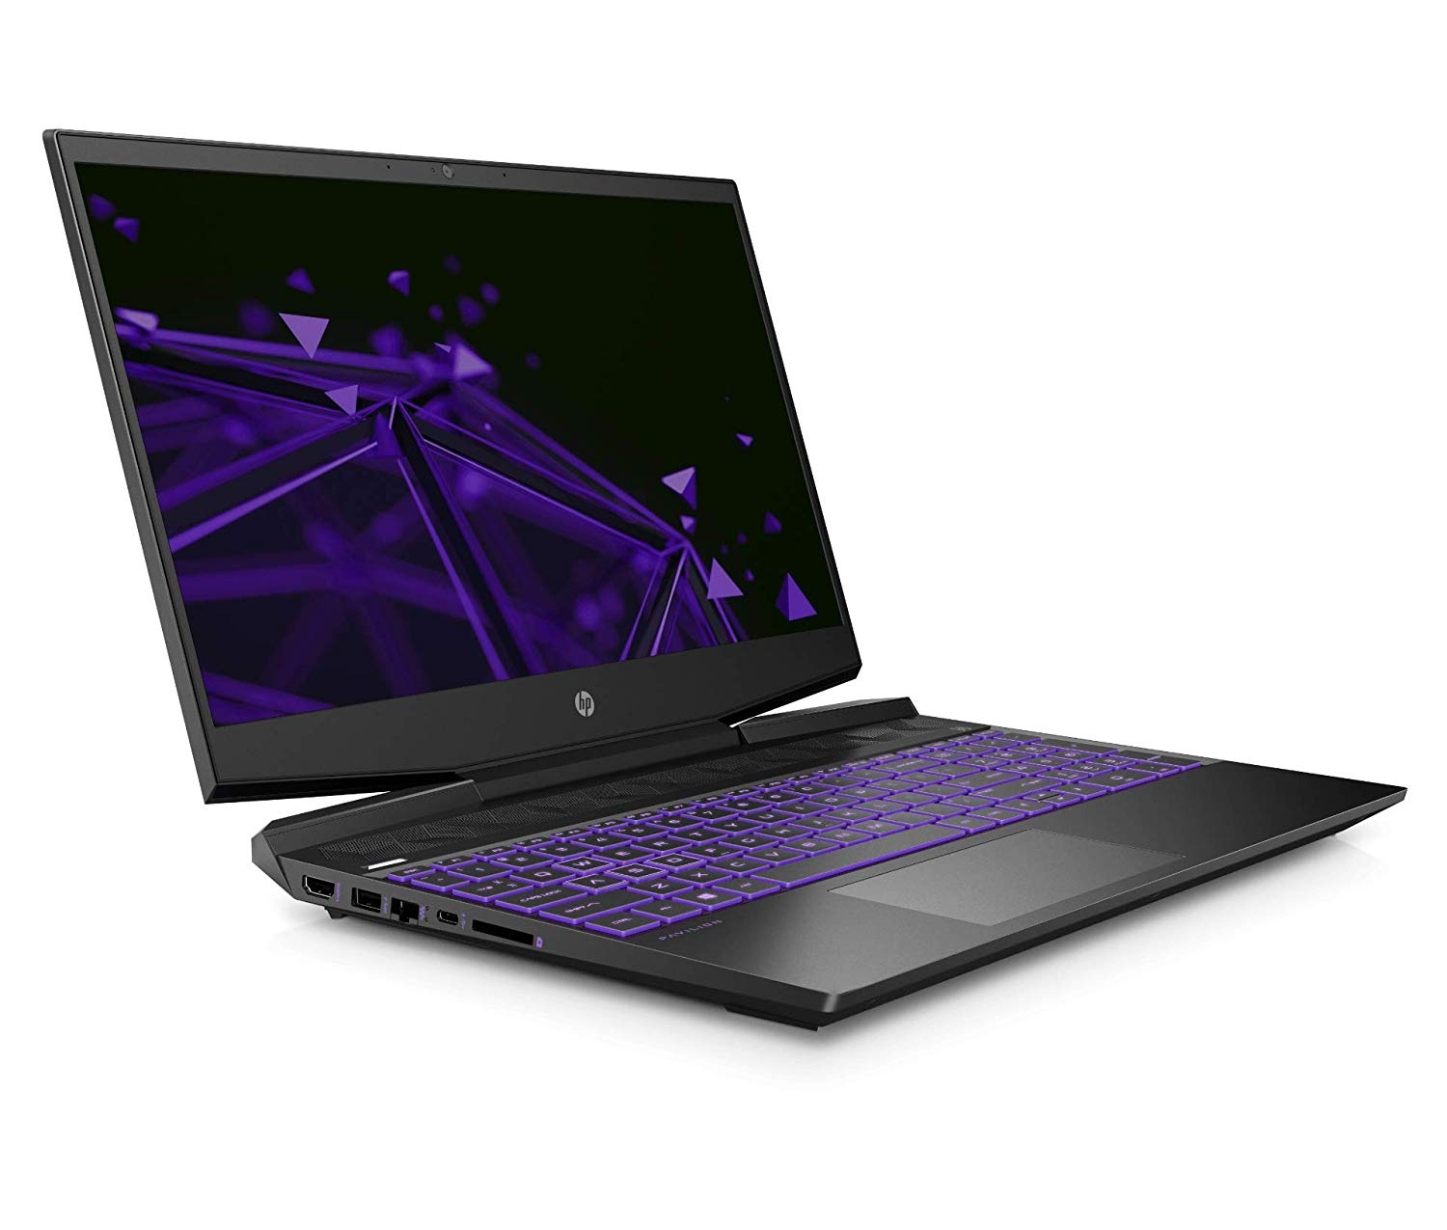

Technical Details

|  |  |
| --- | --- |
| Brand | HP |
| Model | 15-dk0047TX |
| Model Name | Pavilion |
| Model Year | 2019 |
| Item Weight | 2.25 Kg |
| Product Dimensions | 36 x 25.6 x 2.3 cm |
| Batteries: | 1 A batteries required. (included) |
| Item model number | 15-dk0047TX |
| RAM Size | 8 GB |
| Flash Memory Installed Size | 256.0 |
| Ram Memory Installed Size | 8 GB |
| Ram Memory Technology | DDR4 |
| Hard Drive Size | 1024 GB |
| Hard Disk Rotational Speed | 7200 RPM |
| Hard Disk Technology | Hybrid Drive |
| Operating System | Windows 10 |
| Processor Brand | Intel |
| Processor Speed | 2.40 GHz |
| Processor Type | Core i5 |
| Graphics Card Ram Size | 4 GB |
| Graphics Coprocessor | NVIDIA GTX 1650 |
| Included Components | Laptop, Battery, AC Adapter, User Guide, Manuals |
| Screen Size | 15.6 Inches |
| Display Type | LED-Backlit |
| Display Resolution Maximum | 1920 x 1080 (Full HD) |
| Batteries Included | Yes |
| Batteries Required | Yes |
| Battery Cell Composition | Lithium Ion |
| Connector Type | Wireless |
| Device Type | Gaming laptop |

|  |  |
| --- | --- |
|  | |
| SYSTEM FEATURES | |
| **Operating system** | **Windows 10 Home Single Language 64** |
| **Processor Name** | **Intel® Core™ i5-9300H (2.4 GHz base frequency, up to 4.1 GHz base with Intel® Turbo Boost Technology, 8 MB cache, 4 cores)** |
| **Processor footnote** | **[6] Multi-core is designed to improve performance of certain software products. Not all customers or software applications will necessarily benefit from use of this technology. Performance and clock frequency will vary depending on application workload and your hardware and software configurations. Intel’s numbering is not a measurement of higher performance. Intel, Pentium, Intel Core, Celeron, Intel logo and the Intel Inside logo are trademarks of Intel Corporation in the U.S. and other countries. [7] Intel® Turbo Boost performance varies depending on hardware, software and overall system configuration. See http://www.intel.com/technology/turboboost/ for more information.** |
| **Processor family** | **9th Generation Intel® Core™ i5 processor** |
| **Chipset** | **Intel® HM370** |
| **Form factor** | **Standard laptop** |
| MEMORY | |
| **Memory** | **8 GB DDR4-2666 SDRAM (1 x 8 GB)** |
| **Memory Note** | **Transfer rates up to 2666 MT/s.** |
| STORAGE | |
| **Hard drive description** | **1 TB 7200 rpm SATA** |
| **Hard drive (2nd)** | **256 GB PCIe® NVMe™ M.2 SSD** |
| **Storage type** | **HDD; SSD** |
| **Cloud service** | **Dropbox** |
| **Cloud service footnote** | **[2] Dropbox: 25GB of free online storage for 6 months from date of registration. For complete details and terms of use, including cancellation policies, visit the website at www.dropbox.com. Internet service required and not included.** |
| DISPLAY AND GRAPHICS | |
| **Display** | **39.62 cm(15.6) diagonal FHD 60Hz IPS anti-glare micro-edge WLED- backlit (1920 x 1080)** |
| **Graphics** | **NVIDIA® GeForce® GTX 1650 Graphics (4 GB GDDR5 dedicated)** |
| EXPANSION FEATURES | |
| **Ports** | **1 USB 3.1 Gen 2 Type-C™ (10 Gb/s signalling rate, Power Delivery 3.0, DisplayPort™ 1.4, HP Sleep and Charge); 1 USB 3.1 Gen 1 Type-A (HP Sleep and Charge); 2 USB 3.1 Gen 1 Type-A (Data Transfer Only); 1 HDMI; 1 AC smart pin; 1 RJ-45; 1 headphone/microphone combo** |
| **Expansion slots** | **1 multi-format SD media card reader** |
| MEDIA DEVICES | |
| **Audio features** | **B&O, dual speakers, HP Audio Boost** |
| **Webcam** | **HP Wide Vision HD Camera with integrated dual array digital microphone** |
| **Sensors** | **Accelerometer** |
| INPUT DEVICES | |
| **Pointing device** | **HP Image pad with multi-touch gesture support; Precision Touchpad Support** |
| **Keyboard** | **Full-size island-style ultra violet backlit keyboard with numeric keypad** |
| COMMUNICATIONS | |
| **Network interface** | **Integrated 10/100/1000 GbE LAN** |
| **Wireless** | **Intel® Wireless-AC 9560 802.11a/b/g/n/ac (2x2) Wi-Fi® and Bluetooth® 5 Combo** |
| **Wireless note** | **MU-MIMO supported; Miracast compatible** |
| POWER AND OPERATING REQUIREMENTS | |
| **Power supply type** | **150 W AC power adapter** |
| **Battery type** | **3-cell, 52.5 Wh Li-ion** |
| **Battery weight** | **210 g** |
| **Energy Efficiency Compliance** | **ENERGY STAR® certified; EPEAT® Silver registered** |
| DIMENSIONS AND WEIGHT | |
| **Dimensions without stand (W x D x H)** | **36 x 25.6 x 2.34 cm** |
| **Dimension note (metric)** | **Dimensions vary by configuration** |
| **Weight** | **Starting at 2.25 kg** |
| DESIGN | |
| **Product colour** | **Shadow black** |
| SOFTWARE | |
| **HP apps** | **HP 3D Drive Guard; HP Audio Switch; HP Documentation; HP e-Service; HP JumpStart; HP Support Assistant; HP Connection Optimizer; HP PC Hardware Diagnostics Windows; HP BIOS Recovery** |
| **HP Apps footnote** | **[8] HP 3D Drive Guard: Only on HDD configurations** |
| **Software included** | **McAfee LiveSafe™** |
| **Software footnote** | **[1] McAfee LiveSafe 30-day free trial offer (Internet access required. First 30 days included. Subscription required for live updates afterwards.)** |
| WARRANTY AND SERVICES | |
| **Warranty** | **1-year limited parts and labour** |

**REFERENCES**

* <https://www.flipkart.com/lenovo-legion-core-i7-7th-gen-16-gb-2-tb-hdd-256-gb-ssd-windows-10-home-6-graphics-y720-gaming-laptop/p/itmf3s32tyt6jg2y>
* [**https://www.lenovo.com/in/en/legion/**](https://www.lenovo.com/in/en/legion/)
* [**https://gadgets.ndtv.com/laptops/news/lenovo-legion-y730-y530-c730-t730-t530-y25f-10-laptops-pcs-towers-india-price-specifications-1914781**](https://gadgets.ndtv.com/laptops/news/lenovo-legion-y730-y530-c730-t730-t530-y25f-10-laptops-pcs-towers-india-price-specifications-1914781)
* [**https://www.amazon.in/Lenovo-Legion-Y720-GeForce-80VR0064US/dp/B074L1NK79**](https://www.amazon.in/Lenovo-Legion-Y720-GeForce-80VR0064US/dp/B074L1NK79)

**CONCLUSIONS**

The fresh design of the Legion Y730 holds promise, with a well-rounded feature set at a relatively modest price. Graphics options max out with the GeForce GTX 1050 Ti Relatively light at both screen sizes. Multiple screen refresh-rate options. Corsair keyboard with per-key RGB lighting.  glance, the Legion Y730 looks very much like the Legion Y530. Both measure 0.95 by 14.37 by 10.24 inches (HWD) and weigh 5.1 pounds. (Lenovo also offers a 17-inch version of this laptop, but our review unit is the 15-inch model.) That's a positive, as I praised the Y530's design in my review. It is especially appealing for a budget laptop.