

**MSPM’S**

**Deogiri Institute of Engineering and Management Studies, Aurangabad**

**Department of Computer Science and Engineering**

Report on

**Printer**

Submitted By

Arti Mule(26059)

Sandip Kolte (26060)

Under the Guidance of

Prof.P.H.Durole

Department of Computer Science and Engineering

(Deogiri Institute of Engineering and Management Studies)

2019-2020

**DEVICE: EPSON L3110**

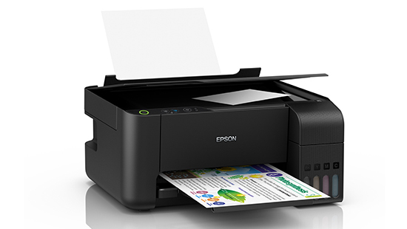

**Printer Type:**

**Printer Type:** Print, Scan, Copy

Printing Technology:

Print Method: On-demand inkjet (piezoelectric)

Minimum Ink Droplet Volume:3

printer Language’s / P-Reprint Direction: Bi-directional printing, Uni-directional printing

Nozzle Configuration:180 x 1 nozzles Black, 59 x 1 nozzles per colour (Cyan, Magenta, Yellow)

Maximum Resolution:5760 x 1440 dpi (with Variable-Sized Droplet Technology)

Automatic 2-sided Printing: No

Print Speed:

Photo Default - 10 x 15 cm / 4 x 6 Approx. 69 sec per photo (Border) / 90 sec per photo

Draft, A4 (Black / Colour): Up to 33 ppm / 15 ppm

ISO 24734, A4 Simplex (Black / Colour): Up to 10 ipm / 5.0 ipm

First Page Out Time from Ready Mode (Black / Colour): Approx. 10 sec / 16 sec

Product information

Style: **L3110**

Technical Details

|  |  |
| --- | --- |
| Brand | Epson |
| Model | L3110 |
| Model Name | Eco Tank |
| Item Weight | 4.5 Kg |
| Product Dimensions | 37.5 x 34.7 x 17.9 cm |
| Item model number | L3110 |
| Max Print speed Monochrome | 33 pages_per_minute |
| Max Print speed Colour | 15 pages_per_minute |
| Printing Technology | Inkjet |
| Printer Output Type | Colour |
| Printing Technology | Ink Tank |
| Supports Dual Sided Printing | No |
| Printer Media Size Maximum | A4, A5, A6, B5, C6, DL |
| Included Components | Printer, CD DVD Tray, Power Cable and USB Cable |
| Batteries Included | No |
| Batteries Required | No |
| Connector Type | USB |

Technology

Printing Method

Epson Micro Piezo™ print head

Nozzle Configuration

 180 Nozzles Black, 59 Nozzles per Colour

Minimum Droplet Size

3 pl, With Variable-Sized Droplet Technology

Ink Technology

Dye Ink

Printing Resolution

5,760 x 1,440 DPI

Application

Home, Home Office

All-in-One Functions

Print, Scan, Copy

Print

Printing Speed ISO/IEC 24734

10 pages/min Monochrome, 5 pages/min Colour

Printing Speed

15 pages/min Colour (plain paper 75 g/m²), 33 pages/min Monochrome (plain paper 75 g/m²), 69 Seconds per 10 x 15 cm photo (Epson Premium Glossy Photo Paper)

**Scan**

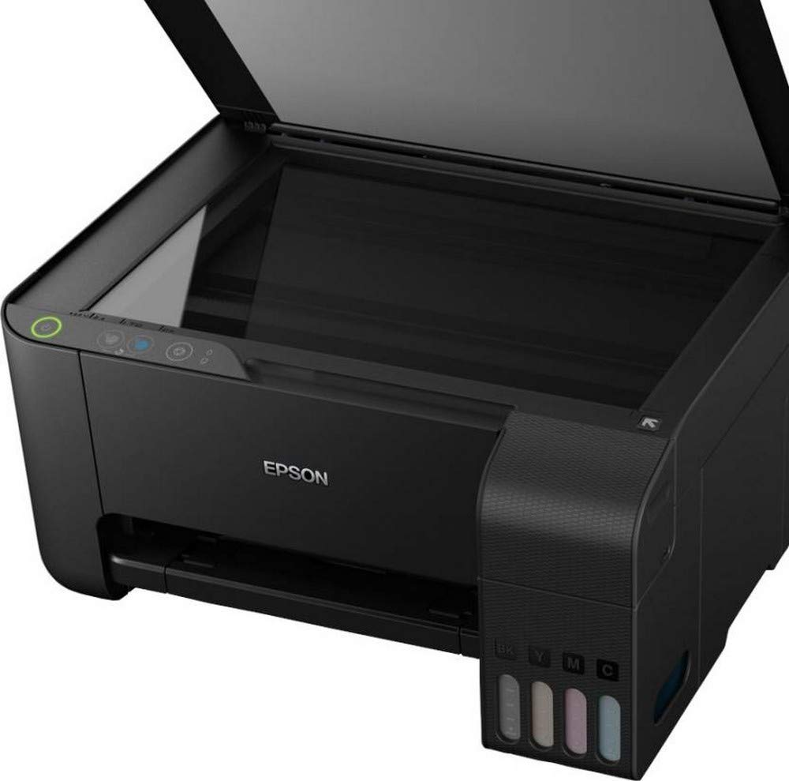Single-sided scan speed (A4 black)

200 DPI; 11 sec. with flatbed scan

Single-sided scan speed (A4 colour)

200 DPI; 32 sec. with flatbed scan

Scanning Resolution

600 DPI x 1,200 DPI (Horizontal x Vertical)

Output formats

BMP, JPEG, TIFF, PDF

Scanner type

Contact image sensor (CIS)

**Paper /Media Handling**

Number of paper trays : -1

Paper Formats

C6 (Envelope), B5, A6, A5, A4, Legal, User defined, 13 x 18 cm, 10 x 15 cm, Letter, No. 10 (Envelope), DL (Envelope), 16:9

Duplex

Manual

Output Tray Capacity

30 Sheets

multifunction

100 Sheets Standard, 100 Sheets Maximum, 20 Photo Sheets

Media Handling

Borderless print

**General**

Energy Use

12 Watt (standalone copying, ISO/IEC 24712 pattern), 0.4 Watt (sleep mode), 3.9 Watt (ready), 0.2 Watt (Power off)

Supply Voltage

AC 220 V - 240 V

Product dimensions

375‎ x 347 x 179 mm (Width x Depth x Height)

Product weight

3.9 kg

Noise Level

6.5 B (A) with Epson Premium Glossy Photo Paper / Photo RPM mode - 52 dB (A) with Epson Premium Glossy Photo Paper / Photo RPM mode

Compatible Operating Systems

Mac OS X 10.6.8 or later, Windows 10, Windows 7, Windows 8, Windows 8.1, Windows Server 2008 R2, Windows Server 2012 R2, Windows Server 2016, Windows Vista, Windows XP SP3, Windows Server 2003 R2, Windows XP Professional x64 Edition

Included Software

Epson Scan

Interfaces

USB

Power Supply

220V, 240V

What's in the box

4 x 70ml individual ink bottles (Bk, C, Y, M) + 1 extra black ink bottle, Main unit, Power cable, Setup guide, Software (CD), Warranty document

Colour

Black

Include Bottle Yield

Black yield : -8,100 pages

Colour yield : -6,500 pages

**DEVICE: CANON PIXMA G2000**

* **Product Description:**

Print out important documents, posters, or cards conveniently at home with this Canon Pixma Printer. You can use this versatile all-in-one printer to print, scan, or copy. Also, with its High Page Yield Ink Bottles, you can enjoy printing without worrying about running short of ink supplies.

* **High Page Yield Ink Bottles:**

You can print up to 7000 pages at a time with these ink bottles without worrying about the cost of ink or your ink supplies running low while printing out your favorite posters.

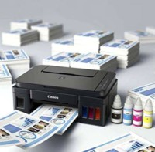

* **Integrated Ink Tank System:**

This Canon printer has a compact body, thanks to its built-in integrated ink tanks. This design of the printer also makes it easy for you to view the remaining ink levels just in a glance.

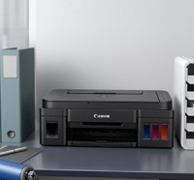

* **Quality Photo and Document Printing**

Its hybrid ink system ensures high-quality prints. It can produce crisp black text documents and stunning photos. Additionally, this printer can print out A4 size borderless photos

.

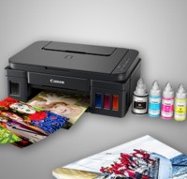

* **All-in-one for High Volume Printing**

This Canon printer can print, scan, and copy. Its refillable ink tank is designed for high volume printing at a low running cost. Its ISO Standard print speed can print A4 sheets at up to 8.8 images per minute in black-and-white and up to 5.0 images per minute in color. You can also print a 10 x 15 cm (4 x 6) borderless photo in 60 seconds.

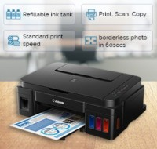

**SPECIFICATIONS:**

* **Design:**The sleek and compact Canon Pixma G2000 Multifunction Printer measures 445 × 330 × 163 (W × D × H) mm and weighs only 5.8 kg. The matte black finish makes it look very eye catching. It is equipped with four individual ink bottles with 2pl min ink droplet size and total 1472 nozzles. Its built-in integrated ink tanks create a compact printer body. You can easily fit this small sized printer in a limited space of your office. Its portable design and light weight enables you to shift it conveniently from one place to another. The ink bottles use screw down caps to prevent any ink leakage while ensuring easy ink flow during refilling. You can easily view the remaining ink levels at a glance.
* **Print Performance:**The Canon Pixma G2000 Multifunction Printer produces crisp and clear prints with a maximum resolution of 4800 × 1200 dpi. It has a high document printing speed with approx. 5 ipm for color and approx. 8.8 ipm for Black & White. Borderless photos can be printed up to A4 sizes in approx. 60 seconds. The printer provides you high volume printing at a low running cost. With its high page yield ink bottles up to 7000 pages, you can enjoy printing without having to worry about cost of ink or ink supplies running low.
* **Connectivity:**The multifunctional printer has Hi-speed USB 2.0 interface which allows you to directly print all your important documents and images from your USB flash drive with eas

|  |  |
| --- | --- |
| Ethernet Support | No |
| USB support | USB 2.0 |
| Wireless Support | No |

* **Other Features:**The energy-star qualified Canon Pixma printer saves an appreciable amount of power and comes with a 1 year manufacturer warranty to ensure you complete peace of mind.ensure you complete peace of mind.

**General:**

|  |  |
| --- | --- |
| Standby Noise Level | * 5 db |
| Active Noise Level | * 46 db |
| Printing Method | * Inkjet |
| Type | * Multi-function |
| Display | * Single Digit |
| Model Name | * Pixma G 2000 |
| Model Series | * Refillable Ink Tank All-In-One |
| Printing Output | * Color |
| Printer Languages | * English |
| Internal Memory | * 16 MB |
| Functions | * Print, Copy, Scan |
| Brand | * Canon |
| Refill Type | * Refillable Ink Tank |
| Ideal Usage | * Home & Small Office |

**Print:**

|  |  |
| --- | --- |
| Max Print Resolution (Color) | * 4800 x 1200 dpi |
| Max Print Resolution (Mono) | * 4800 x 1200 dpi |
| Duty cycle (monthly, A4) | * 10000 pages |
| First Print Out Time (Color) | * 5 sec |
| First Print Out Time (Mono) | * 8.8 sec |
| Print speed Photo (10 x 15) | * 60 sec |
| Print Speed Color | * 5 ipm |
| Print Speed Mono | * 8.8 ipm |
| Cost per Page (Color) - As per ISO Standards | * 0.21 Rs. |
| Cost per Page (Black)- As per ISO Standards | * 0.08 Rs. |
| Duplex Print | * NA |
| Other Print Features | * Refillable Ink Tank All-In-One for High Volume Printing |

**Paper Handling:**

|  |  |
| --- | --- |
| Media types supported | * Labels, Paper, Envelopes |
|  |  |
| Auto Document Feeder | * No |
| Output tray capacity | * 50 sheets |
|  |  |
| Multipurpose tray capacity | * 1 sheets |
| Input tray type | * Paper Cassette |
| Output tray type | * Face-Down |
| Input tray capacity | * 100 sheets |
| Borderless printing | * Yes |
| Media size supported | * A4, A5, B5, Letter, Legal, 4 x 6", 5 x 7", Envelopes (DL, COM10), Custom size (width 101.6 - 215.9mm, length 152.4 - 676mm) |

**Scan:**

|  |  |
| --- | --- |
| Bit depth Color | * 48-bit |
|  |  |
| Scanning Speed Color | * 19 sec |
| Scanning Speed Mono | * 19 sec |
| Bit depth Mono | * 16-bit |
| Scan area size | * 216 x 297 mm |
| Scan Method | * Contact Image Sensor (CIS) |
| Interpolated scanning resolution | * 25 x 19200 dpi |
| Optical scanning resolution | * 600 x 1200 dpi |
| Scan Type | * Flatbed |

**Fax:**

|  |  |
| --- | --- |
| Fax Retrieval | * No |
| Speed Dials Memory | * 0 numbers |
| Dual Access | * No |
| Fax delayed sending | * No |
| Broadcasting Locations | * 0 |
| Fax Forwarding | * No |
| Remote Reception | * No |
| Memory Capacity | * 0 pages |
| Resolution | * 0 dpi |
| Modem Speed | * 0 kbps |
| Auto Dial | * No |
| Group Dials | * 0 groups |

**Copy:**

|  |  |
| --- | --- |
| Copy Resolution Color | * 4800 x 1200 dpi |
| Copier resize | * 1 |
| Copy Resolution Mono | * 4800 x 1200 dpi |
| Maximum Copies | * 10 cpm |
| First Copy Out Time | * 32 sec |
| Maximum Multicopy | * 21 pages |
| Copy speed Mono | * 1.7 cpm |
| Copy Speed Color | * 1.7 cpm |

**Power and Operating Requirements:**

|  |  |
| --- | --- |
| Operating Temperature range | * 0-35 degree C |
| Power consumption (standby) | * 0.8 W |
| Operating Humidity range | * Mon Oct 01 00:00:00 IST 1990 % |
| Power requirements | * 200 to 240 V, 50/60 Hz |
| Power consumption (manual-off) | * 0.4 W |
| Power consumption (active) | * 11 W |

**Dimensions and Weight:**

|  |  |
| --- | --- |
| Height | * 20.864 cm |
| Width | * 50.285 cm |
| Weight | * 5.8 kg |
| Depth | * 39.93 cm |

**System Requirements:**

|  |  |
| --- | --- |
| Hard Drive | * 1.0 GB Free Hard Disk Space |
| Memory | * 16 MB Ram |
| Processor | * 200 MHz ARM9 Processor |
| Other System Requirements | * NA |
| Operating System | * Windows XP, Vista, 7, 8, 8.1, 10 |

**Compatible Inks/toners:**

|  |  |
| --- | --- |
| Compatible Color Cartridge | * GI-790 (Cyan, Magenta, Yellow, Black) |
| Compatible Black cartridge | * GI-790 (Cyan, Magenta, Yellow, * Black) |

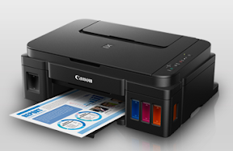

## Pros & Cons of Canon Pixma G2000 Multifunction Printer:

### Pros

* ✔ Fast print time
* ✔ Good print resolution
* ✔ Low ink consumption
* ✔ Easy to setup
* ✔ Easy to use
* ✔ Accurate colors
* ✔ Wireless printing

### Cons

* **×**Small cartridge
* **×**Scanning speed slow
* **×**High ink consumption
* **×**Poor software
* **×**Jams easily