 **MSPM'S**

**Deogiri Institute of Engineering and Management Studies ,**

**Aurangabad**

**Department of Basic Science and Engineering**

Survey Based **Project** Report on

Dell XPS 13 Laptop

**Subject : Computer Architecture and Organisation**

Submitted By

**Divya Chandrakant Samse (26062)**

Under the Guidance of

**Prof. P.H.Durole**

Asst. Prof. Department of Cse

2019-20.

This is to certify that **Ms. Divya Chandrakant Samse** have sucessfully completed their Survey Based Project on Laptop Comparison on date **26th August 2019.**

**Name of Guide**

**Prof. P.H.Durole**

INDEX

1. Introduction

* Processor
* Architecture
* Graphics Processing Unit

2.Laptop Specification

3. Computer Arithmetic

4. Memory Organization

5.Instruction Set

6.I/O component and mechanism

**INTRODUCTION**

**PROCESSOR**

* A central processing unit(CPU) is the electronic circuitry within a computer that carries out the instructions of a computer program by performing the basic arithmetic, logical, control and input/output operation specified by the instructions. The computer industry has used the term “central processing unit ”at least since the early 1960s.

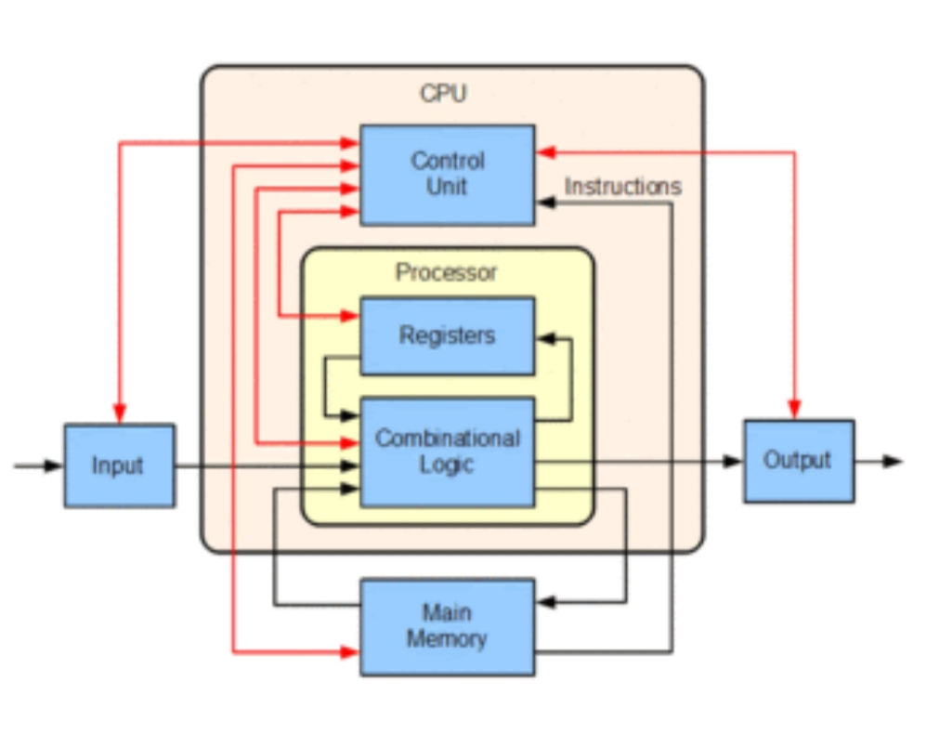

* Traditionally , the term “CPU” refers to a processor, more specifically to its processing unit and control unit(CU), distinguishing these core elements of a computer from external components such as main memory and I/O circuitry.
* The form , design, and implementation of CPUs have changed over the course of their history, but their fundamental operation remains almost unchanged . Principle components of a CPU include the arithmetic logic unit (ALU) that performs arithmetic and logic operations registers that supply operands to the ALU and store the results of ALU operations and a control unit that orchestrates the fetching( from memory ) and execution of instructions by directing the coordinated operations of the ALU , registers and other components.
* Most modern CPUs are microprocessors, meaning they are contained on a single integrated circuit (IC) chip. An IC that contains a CPU may also contain memory, peripheral interfaces, and other components of a computer; such integrated devices are variously called microcontrollers or systems on a chip (SOC). Some computers employ a multi-core processor, which is a single chip containing two or more CPUs called “cores"; in that context, one can speak of such single chip as “socke

**ARCHITECTURE**

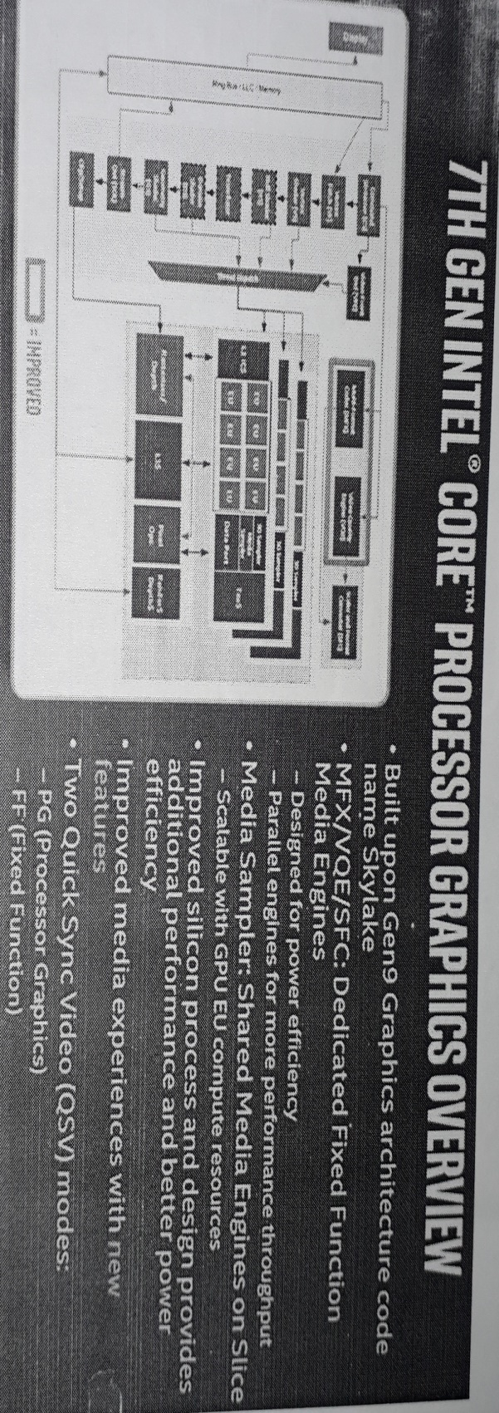 **Kaby Lake Overview.(Predecessor to Coffee Lake)**

1.**Kaby Lake** is in an intel codename for a processor microarchitecture Intel announced on August 30,2016 .Lake the preceding Sky lake ,Kaby Lake is produced using a 14 nanometer manufacturing process technology.Breaking with Intel's previous “tick-tock" manufacturing and design model , Kaby Lake represents the optimized step of the newer “process -architecture-optimization” model. Kaby Lake began shipping to manufacturers and OEMs in the second quarter of 2016, and mobile chips have started shipping while Kaby Lake (desktop) chips were officially launched in January 2017.

2.In August 2017 , Intel announced Kaby Lake Refresh (Kaby Lake R) marketed as the 8th generation mobile CPUs , breaking the long cycle where architecture matched the corresponding generation of CPUs.

3.Kaby Lake is the first Intel platform to lack official driver support for versions of Windows 10. Furthermore, Windows update is disabled under Windows 8.1 and earlier, although an enthusiast-created modification was released that disabled the check and allowed it to continue to work on the platform.

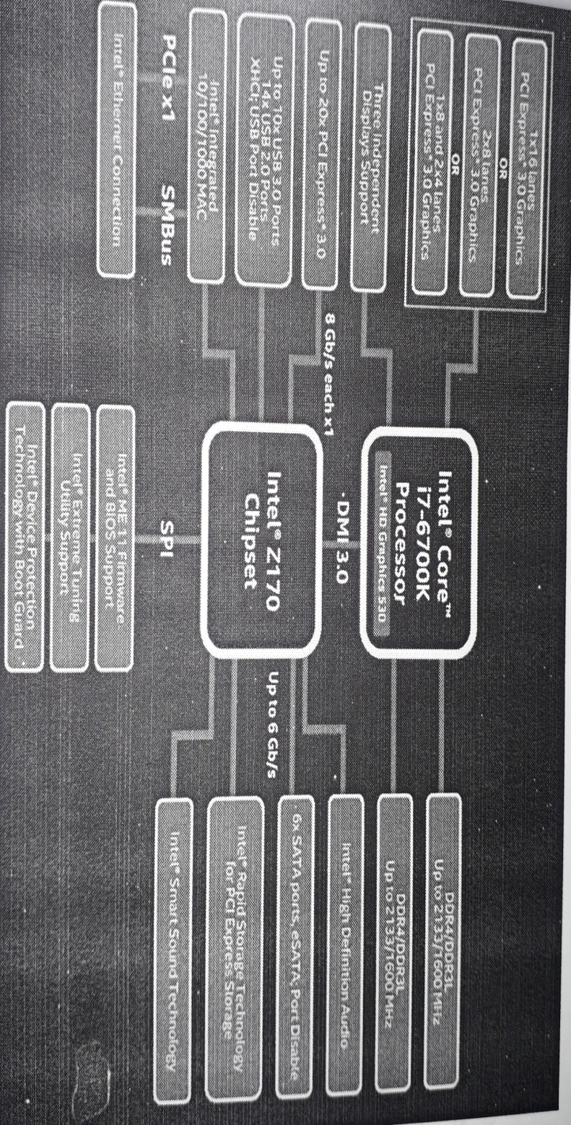**Sky Lake Architecture Overview ( Predecessor to Kaby Lake)**

-Sky Lake was anticipated to be succeeded by the 10 nano meter Cannon Lake , but it was announced in July 2015 that Cannon Lake has been delayed until the second half of 2017.In the meantime ,Intel released a fourth 14 nm generation on October 5,2017 named coffe lake.

**Coffee Lake Architecture(Latest)**

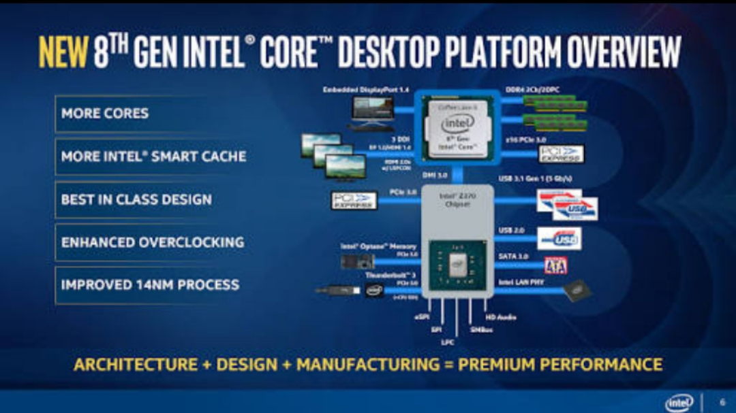

**GPU**

1. 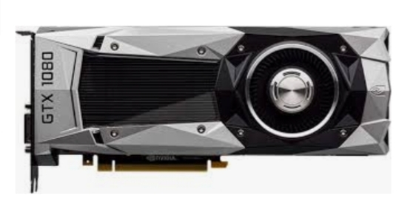A graphics processing unit(GPU) is specialised electronic circuit designed to rapidly manipulate and alter memory to accelerate to creation of image in a frame buffer intended for output to a display device. GPU is used in embedded system, mobile phones, computer etc.

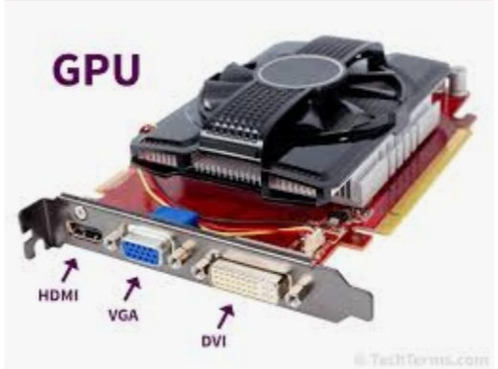

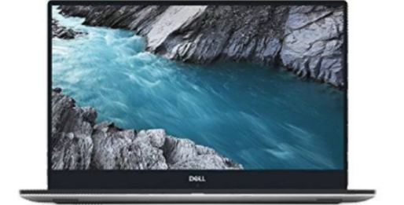 **DELL XPS 13 laptop specification**

Display: 13.6

Storage: 1TB

HDD speed :5400rpm

Ram:8GB

Ram speed:2133MHZ

Graphics memory:4GB

Processor:Intel core i5-8250 U(5th generation)

Operating system: Windows 10 Home

Price:1,17,164

**Memory Organisation**

A memory unit is the collection of storage units or devices together. The memory unit stores the binary information in the form of bits. Generally, memory/storage is classified into 2 categories:

* **Volatile Memory**: This loses its data, when power is switched off.
* **Non-Volatile Memory**: This is a permanent storage and does not lose any data when power is switched off.
* The total memory capacity of a computer can be visualized by hierarchy of components. The memory hierarchy system consists of all storage devices contained in a computer system from the slow Auxiliary Memory to fast Main Memory and to smaller Cache memory.
* **Auxiliary memory**: access time is generally 1000times that of the main memory, hence it is at the bottom of the hierarchy.
* The main memory occupies the central position because it is equipped to communicate directly with the CPU and with auxiliary memory devices through Input/output processor (I/O).

When the program not residing in main memory is needed by the CPU, they are brought in from auxiliary memory. Programs not currently needed in main memory are transferred into auxiliary memory to provide space in main memory for other programs that are currently in use.

* The cache memory is used to store program data which is currently being executed in the CPU.

## **Main Memory**

The memory unit that communicates directly within the CPU, Auxillary memory and Cache memory, is called main memory. It is the central storage unit of the computer system. Main memory is made up of RAM and ROM, with RAM integrated circuit chips holing the major share.

* RAM: Random Access Memory
  + **DRAM**: Dynamic RAM, is made of capacitors and transistors, and must be refreshed every 10~100 ms. It is slower and cheaper than SRAM.
  + **SRAM**: Static RAM, has a six transistor circuit in each cell and retains data, until powered off.
  + **NVRAM**: Non-Volatile RAM, retains its data, even when turned off. Example: Flash memory.

**ROM**: Read Only Memory, is non-volatile and is more li4ke a permanent storage for information. It also stores the bootstrap loader program, to load and start the operating system when computer is turned on.

## **Auxiliary Memory**

Devices that provide backup storage are called auxiliary memory. For example: Magnetic disks and tapes are commonly used auxiliary devices. Other devices used as auxiliary memory are magnetic drums, magnetic bubble memory and optical disks.

It is not directly accessible to the CPU, and is accessed using the Input/output channels.

### Cache Memory

The data or contents of the main memory that are used again and again by CPU, are stored in the cache memory so that we can easily access that data in shorter time.

Whenever the CPU needs to access memory, it first checks the cache memory. If the data is not found in cache memory then the CPU moves onto the main memory. It also transfers block of recent data into the cache and keeps on deleting the old data in cache to accomodate the new one.

**Instruction Set:**

Instruction set is also called as ISO(Instruction set Architecture)is a part of laptop that pertains to programing, which is basically machine language.The instruction set provide command to the processor to tell it what it needs to do. The instruction set consist of addressing mode , Instruction, native data types , registers, memory architecture, interrupt and exception handeling ,external I/O.

The example of instruction set is x86 instruction set which is common in laptops today. Different computer processer can use almost the same instruction set while still having different internal design.

Both the intel pentium and AMD Athlon processer use nearly the same x86 instruction set . The instruction set can be built into the hardware of processor or it can be emulated in software using interpreter.

**Examples of instruction set :**

* **ADD** - Add two numbers together.
* **COMPARE** - Compare numbers.
* **IN** - Input information from a device, e.g., keyboard.
* **JUMP** - Jump to designated RAM address.
* **JUMP IF** - Conditional statement that jumps to a designated RAM address.
* **LOAD** - Load information from RAM to the CPU.
* **OUT** - Output information to device, e.g., monitor.
* **STORE** - Store information to RAM.

**Input / Output Components and Mechanism:**

**Input device and it's mechanism**

In computing, an inputdevice is a piece of Computer equipment used to provide data and control signals to an information processing system such as a computer or  Information appliances. Examples of input devices include keyboard ,mouse, scanner, digital cameras, joystick, and microphone.

1. **Keyboard:**



It is standard input device is readily available for us to fill the data. A keyboard is similar to conventional type writer. Keyboard is divided into three main parts such as function keys, Numeric key and alphabetic numeric key, special key and screen navigation keys.

**2.Touch Screen:**

A touch screen is a computer display screen that serves as an input device. When a touch screen is touched by a finger or stylus, it registers the event and sends it to a controller for processing.

A touch screen may contain pictures or words that the user can touch to interact with the device.

Touch screens can be attached to computers or to networks as terminals. How a touch screen event is registered depends on the touch screen's inherent technology.

**3.Joystick :**

A joystick is an input device consisting of a stick that pivots on a base and reports its angle or direction to the device it is controlling. Joysticks are often used to control video games, and usually have one or more push-buttons whose state can also be read by the computer

**4.Webcam:**

captures a video image of the scene in front of it. It is either built in to the computer (e.g. laptop) or it is connected through an USB cable. The video signal is made up of a series of individual 'image frames' which are an instant snapshot of the scene in front of it.

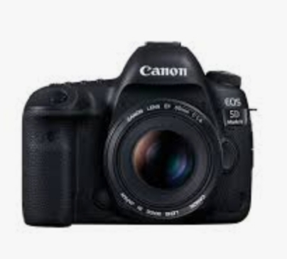**5.Camera**:

camera is also a input device because it allows you to put digital images into the laptop or computer.

**6.Microphone:**

Microphone is an input device to input sound that is then stored in a digital form

The microphone is used for various applications such as adding sound to a multimedia presentation or for mixing music.



**Output Components and it's Mechanism**

1. **Monitors**

* Monitors, commonly called as Visual Display Unit(VDU), are the main output device of a computer . It forms image from tiny dots , called pixels that are arranged in reactangular form. The sharpness of the image depends on the no of pixel .

1. 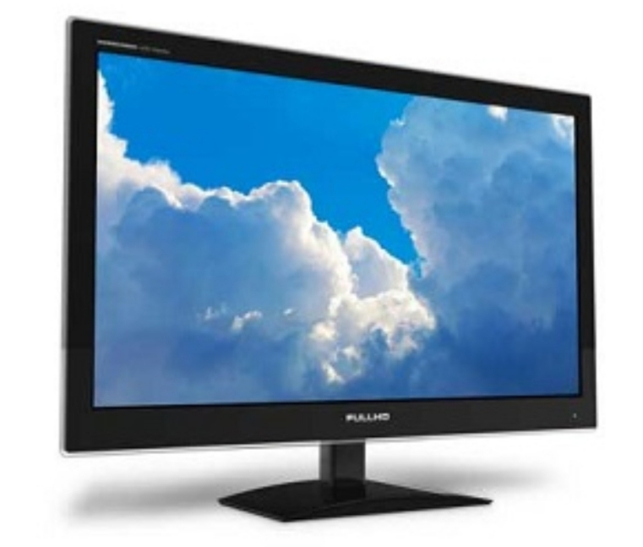**Printer:**

A printer is an external hardware Output device that takes the electronic data stored on a computer or other device and generates a Copy of it. For example, if you created a report on your computer, you could print several copies to hand out at a staff meeting. Printers are one of the most popular computer peripherals and are commonly used to print text and photos.

1. **Projector:**

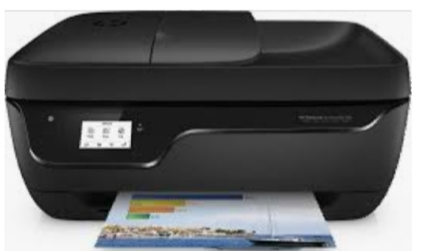 projector is an [output device](https://techterms.com/definition/outputdevice) that projects an image onto a large surface, such as a white screen or wall. It may be used an alternative to a [monitor](https://techterms.com/definition/monitor) or

television when showing video or images to a large group of people.

projectors can used wherever there is a bright surface (such as a white or light coloured wall). Most projectors have multiple [input](https://techterms.com/definition/input) sources, such as [HDMI](https://techterms.com/definition/hdmi) ports for newer equipment and [VGA](https://techterms.com/definition/vga) ports for older devices. Some projectors support Wi-Fi and Bluetooth as well.