

**MSPM’S**

**Deogiri Institute of Engineering and Management Studies, Aurangabad**

**Department of Basic Science and Humanities**

Report on

**Samsung J6 Infinity**

Submitted By

**Vaishnavi Yadav (26065)**

Under the Guidance of

**Prof. Pankaj Durole**

Department of computer science and Engineering

(Deogiri Institute of Engineering and Management Studies)

2019-2020

**Contents**

Processor Architecture

Memory

Working Control Unit

I/O Mechanisms

Other functionalities Device

**Processor Architecture** **:**

A mobile application processor is a system on a chip designed to support applications running in a [mobile operating system](https://searchmobilecomputing.techtarget.com/definition/mobile-operating-system) environment. A mobile application processor provides a self-contained operating environment that delivers all system capabilities needed to support a device's applications, including memory management, graphics processing and multimedia decoding.

*Mobile architecture* allows maintaining this connection whilst during transit. Each day the number of mobile devices is increasing, mobile architecture is the pieces of technology needed to create a rich, connected user experience. Currently there is a lack of uniform interoperability plans and implementation.

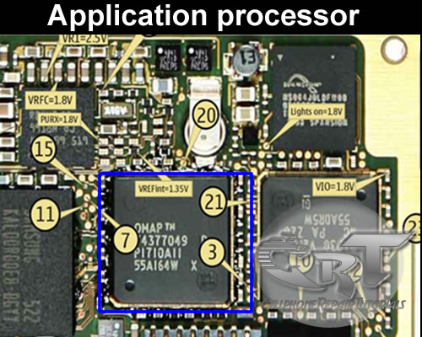

* Samsung Galaxy J6 smartphone runs on Android v8.0 (Oreo) operating system. The phone is powered by Octa core, 1.6 GHz, Cortex A53 processor. It runs on the Samsung Exynos 7 Octa 7870 Chipset. It has 3 GB RAM and 32 GB internal storage.

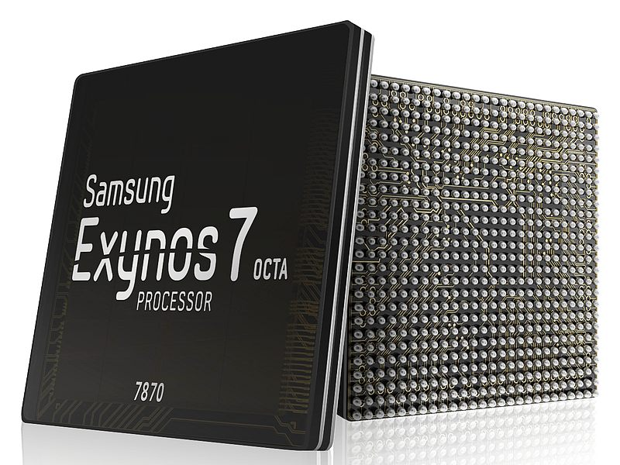

The current generations of smartphones come in a range of multi-core processors. Most commonly found are dual-core (two), quad-core (four) and octa-core (eight), with the latter being the most powerful. Some processors also come with hexa-core (six), but they are pretty rare.

* Processor is like the brain of a [smartphone](https://reliancedigital.in/smart-phones/c/S101711). Almost everything you do on your smartphone, more or less depends on it. Naturally then, the thumb rule is to pick the best of what’s available. However, getting a high-end processor, means investing in an expensive flagship smartphone. You’ll definitely get the performance you’re paying for, but it’s important to ask yourself if you really need it.

The amount of processing power you need depends on the tasks and applications you’d run on the phone. It is important to pick a smartphone with a processor that offers just the right amount of power, while still fitting comfortably in your budget. Picking a smartphone solely going by the processor is difficult for most people. There are so many jargons and technical terms to follow, which makes it a little complicated. So to help, here is a quick guide on understanding processors and picking a smartphone with the right one.

It’s not just down to crunching numbers as well. A processor also carries modules that support different hardware and features of the smartphone. This includes the camera, Wi-Fi, screen, security, graphics, Bluetooth, network connectivity and many others. A high-end processor then will support and offer the latest of features available with each of these components.

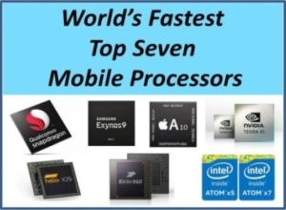

* **Memory** :

Phone's memory. Phone's memory includes RAM and ROM. RAM equals the memory (or memory bar) of the computer, while ROM is the device's internal storage, equaling the hard disk of the computer. The bigger the RAM, the more software the phone runs smoothly; While the bigger the ROM, the more data it can store.

Usually, a phone with big RAM is not easy to get stuck. So far, the RAM of the smartphones generally reaches above 2G, the major phones are equipped with 3GB / 4GB, even 6GB and 8GB this year. The Samsung j6 infinity has 32 GB ram rom is 32 GB

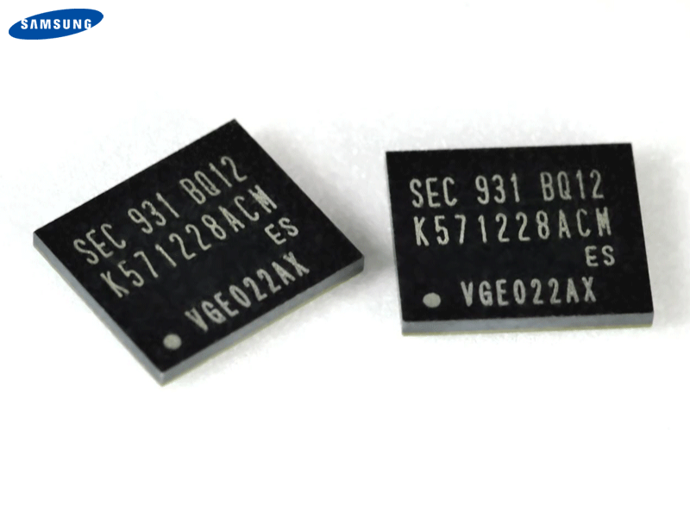

* **The ROM**

ROM (Read Only Memory) is a form of data storage. This type of memory keeps the saved data even if the device power is off. The word Read-only identifies it as "read-only memory", since the reprogramming process is generally infrequent, comparatively slow, and often does not permit random access writes to individual memory locations.

It equals a hard disk in a computer, storing several of files, including videos, songs, photos, and system software, etc. At present, most smartphones are equipped with 16GB, 32GB, 64GB, or even 128GB, 256GB large ROM. But we have to pay attention that in phones the ROM is not described with ROM but with storage. The Samsung j6 infinity is also available in 32 GB.

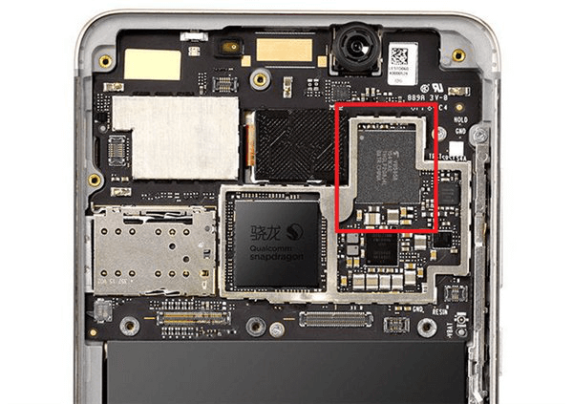

* **32GB Internal Memory Samsung j6 infinity**

Sufficient memory is essential for the urban mobile phone user so that he / she is able to have as much data as possible at their disposal. Smartphone makers such as Samsung is consistently putting out mobile phones with large internal memory to address this need. 32GB internal memory mobiles with their respective prices have been made available to you at the lowest prices from major online stores like Flipkart, Amazon, Snapdeal, Shop clues, and Paytm. We assure you that the prices of these 32GB internal memory phones as shown above are lowest across online and offline platforms in India.

# RAM

# 

RAM stands for random access memory. This tells you any part of the data it stores can be accessed directly. The phone doesn’t have to scan through sequentially-stored data as you might do with a CD, an old tape cassette or, most importantly, a hard drive. It’s effectively instant-access.

Today’s phones’ general storage is random access *too*, because it’s comprised of eMMC chips rather than little spinning disc platters, but the most important distinction remains. A phone’s RAM is going to be much, much faster than the 8GB-64GB storage you use to store apps and music.

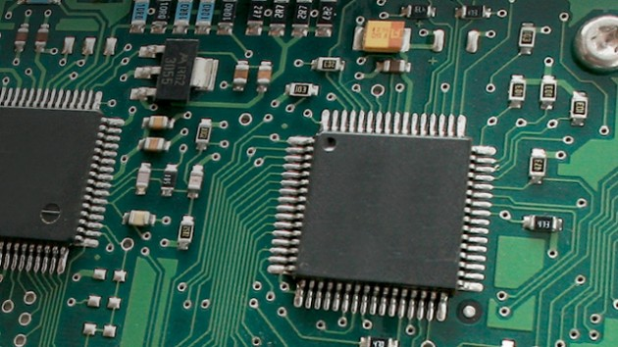

# Working Control Unit:

# 

# Basic control unit consists of mobile stations, base stations and a mobile switching center (MSC). The MSC is also known as Mobile Telephone Switching Office (MTSO). The MTSO controls 11 the cells and provides the interface between each cell and the main telephone office. Each mobile communicates via radio with one of the base stations and may be handed off (switched from one cell to another) to any other base station throughout the duration of the call.

Each mobile station consists of a transceiver, an antenna and control circuitry. The base station consists of several transmitters and receivers which simultaneously handle full duplex communication and generally have towers which support several transmitting and receiving antennas. The base station serves as a bridge between all mobile users in the cell and connects the simultaneous mobile calls via telephone lines or microwave link to the MSC. The MSC co-ordinates the activities of all the base stations and connects the entire cellular system to the PSTN, most of the cellular system also provide a service known as roaming.

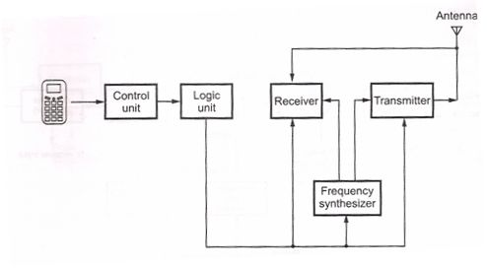

* The cellular system operates in the 800-900 MHz range. The newer digital cellular systems have even greater capacity. Some of these systems operate in 1.7-1.8 GHz bands.
* **Control channels**

These are responsible for housekeeping tasks such as telling the mobile when a call is coming in and which frequency to use. To ensure this handover works, the phone constantly monitors the broadcast control channel of up to 16 neighboring cells.

In normal operation, phones continually adjust the power of the radio waves they send out to be the minimum needed for the base station to receive a clear signal. If a phone moves far away from its base station and if the signal is weak, the network consults the list and triggers a handover to a neighboring cell with best signal.

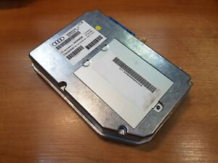

* **Input Mechanism :**

An input mechanism to allow the user to interact with the phone. The most common input mechanism is a keypad, but touch screens are also found in smartphones. Basic mobile phone services to allow users to make call sand send text messages. All GSM phones use a SIM card to allow an account to be swapped among device.

| **Samsung DeX station/pad** | **Samsung DeX HDMI adaptor** |
| --- | --- |
| To switch into Samsung DeX using the station or pad, follow these steps:   1. *1.*   Connect the DeX Station to an external monitor using a HDMI cable.   1. *2.*   Connect the DeX Station to a power source using a Samsung branded fast charger  (fast chargers have a lightning bolt symbol on them).   1. *3.*   Connect the keyboard and mouse to the mobile device through Bluetooth. Alternatively, connect the mouse and keyboard via USB.   1. *4.*   Place the mobile device on the DeX Station. | To switch into Samsung DeX using a HDMI adapter, follow these steps:   1. *1.*   Connect a Samsung Note 9 or Tab 4 to an external monitor using a HDMI to USB Type-C cable.   1. *2.*   Connect the keyboard and mouse to the mobile device through Bluetooth. Alternatively, connect the mouse and keyboard via USB dongle. |

## **Touch Screens and Virtual Data Entry:**

By default, the data-entry method on an iPhone is a touch-screen, virtual keyboard. Virtual keyboards are really interesting because they are so flexible. Input settings for each field can change the layout of the keyboard, as well as the keys it includes. On-screen keyboards can employ interesting user interfaces that range from gestural typing to virtual thumbwheels that let users provide constrained values such as dates and times.

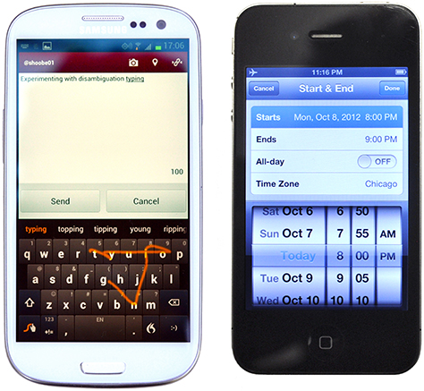

### **Pens:**

A pen, or if you prefer, stylus, provides another means of entering data. Depending on your viewpoint, pen-based systems are either having a resurgence or simply will not die. It’s best to think of pen input as analogous to a virtual keyboard. For data-entry purposes—rather than special drawing or note applications—pen input is usually a mode, and users can easily switch back to a keyboard or keypad.

### **Voice:**

I’m not talking about assistance applications like Apple’s Siri here, but voice-entry modes. [8] Such speech-to-text systems have been part of Android for a couple of years and iOS more recently. Like pen input, they have varying degrees of utility and generally provide similar methods of proposing candidate translations, which the system automatically accepts. The user may then select from among alternatives, edit values directly, or try again.

* **Output Mechanism:**
* GSM

(Global System for Mobile communications: originally from Grouped Special Mobile) is the most popular standard for mobile phones in the world. A phone standard describe how the frequency and other mechanisms on how the phones connect to the rest of the world. Therefor GSM is not an output device, it is a technical standard

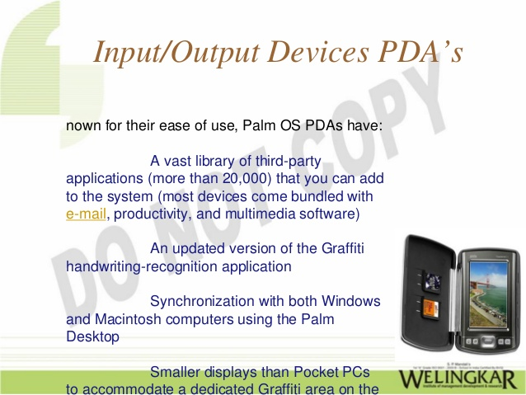

* **An output device reproduces or displays the results of that processing output devices only receive the output of data from another device.**
* Most devices are only input devices or output devices, as they can only accept data input from a user or output data generated by a computer. However, some devices can accept input and display output, and they are referred to as [I/O devices](https://www.computerhope.com/jargon/i/io.htm) (input/output devices).

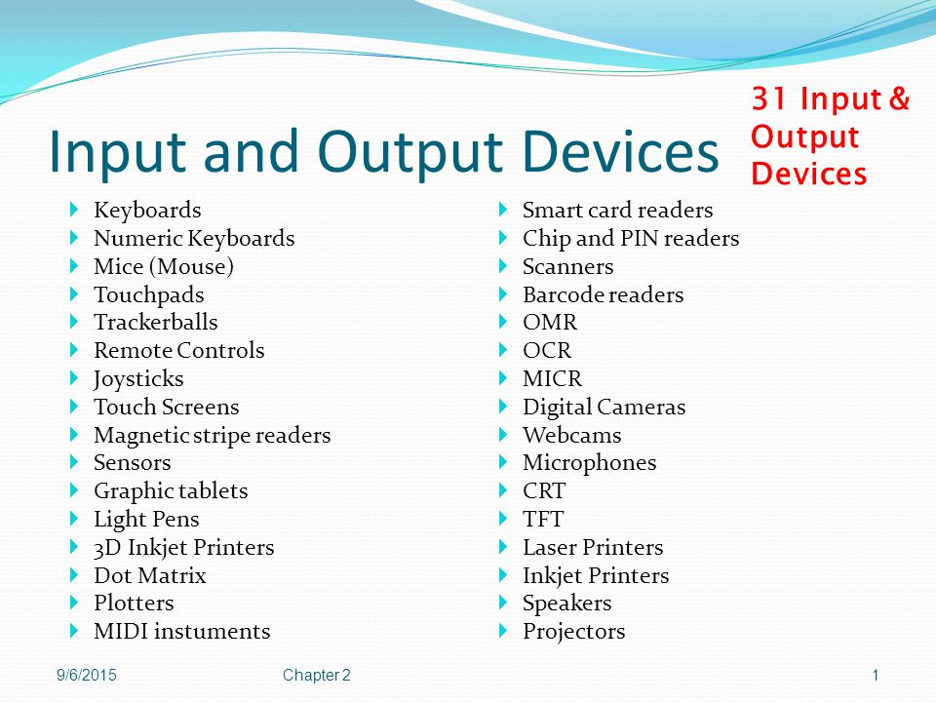

# Instruction set:

**A**n instruction set is a group of commands for mobile in [machine language](https://whatis.techtarget.com/definition/machine-code-machine-language). The term can refer to all possible instructions for a mobile or a subset of instructions to enhance its performance in certain situations.

The instruction set, also called ISA (instruction set architecture)

## Examples of instruction set

**ADD** - Add two numbers together.

**COMPARE** - Compare numbers.

**IN** - Input information from a device, e.g., keypad.

**JUMP** - Jump to designated RAM address.

**JUMP IF** - Conditional statement that jumps to a designated RAM address.

**LOAD** - Load information from RAM to the mobile .

**OUT** - Output information to device, e.g., display.

**STORE** - Store information to RAM.

**Other functionalities Device:**

* Operating System. Android v8.0 (Oreo)
* 5.6 inches (14.22 cm) bezel-less display.
* Samsung Exynos 7 Octa 7870 Tru-Octa Core Processor. 3 GB RAM. 32 GB internal storage, expandable upto 256 GB.
* 13 MP Rear Camera.
* 3000 mAh battery.
* Face Unlock.

**1. Display Manager**

This software shows the screen icon corresponding to the hot key on the keyboard when it is pressed. For example, if an external monitor is connected to a note PC and the Fn+F4 key combination is pressed, the screen is displayed on the external monitor and the corresponding function icon is displayed.

**2. Battery Manager**

Battery Manager is a management program that allows you to use the battery efficiently. You can select the optimized power mode depending on the system environment.

And it helps the note PC's power management and decreases the LCD brightness when no input from the keyboard or touchpad is detected for a pre-determined period of time.

**3. Recovery Solution**

This software enables running Samsung Recovery Solution in Windows. This function does not work when the restoration area is deleted. Using this software, you can restore the computer to the initial state just like when purchased or a previously backed-up state or back up the current state. Recovery Solution III also provides data backup and restore functions

**4. Samsung Update Plus**

This software enables to update the software and drivers installed on the system over the Internet. With Samsung Update

● Search for the latest driver and pre-installed software for your system.

● Easily download and install updates.

● Automatically search for and install new updates.

**5. Magic Keyboard**

This software enables launching a function when the corresponding hot key of the keyboard connected to the system is pressed.

**6. Easy ALS Manager**

This software detects the ambient illumination (using the Ambient Light Sensor) and automatically adjusts the brightness of the LCD.

**7. Easy Speedup Manager**

This software enables you to adjust the system performance. Speed Mode, Normal Mode and Silent Mode are supported. For example, when playing a video file while running a number of programs simultaneously, the file may be played intermittently. In this case, if Speed Mode is selected, the

**8. Samsung Magic Doctor**

Samsung Magic Doctor is troubleshooting software provided by Samsung Computer for system diagnosis, and restoring the system.

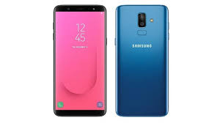

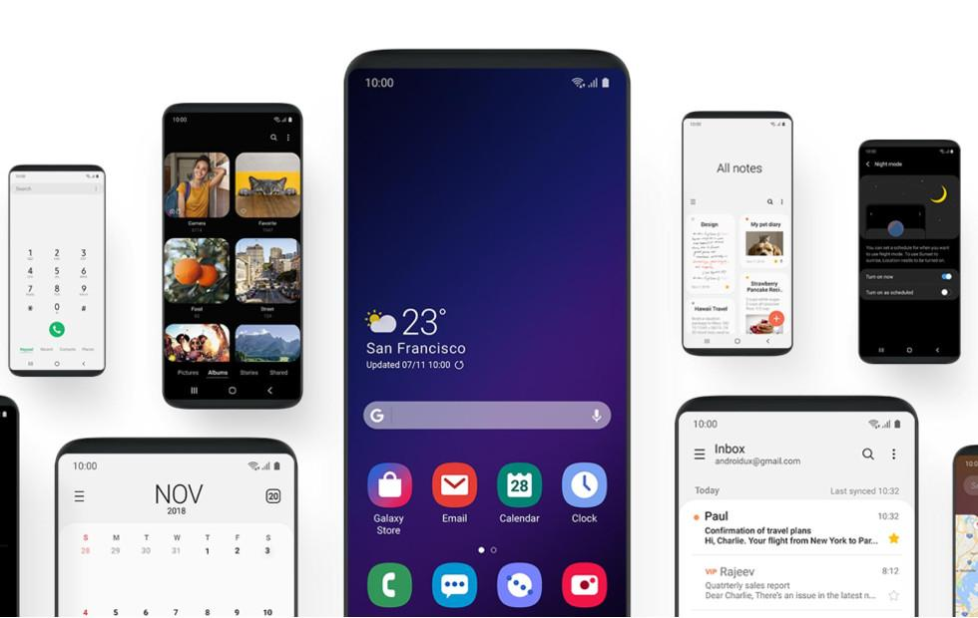

Thank you