

**MSPM’S**

**Deogiri Institute of Engineering and Management Studies, Aurangabad**

**Department of Basic Science and Humanities**

Report on

Computer Architecher & organization

Submitted By

**1)Pranav Bahekar(26066)**

**2) Om Bolenwar (26068)**

Under the Guidance of

Prof. Pankaj Durole

Department of Basic Sciences and Humanities

(Deogiri Institute of Engineering and Management Studies)

2018-2019



CERTIFICATE

This is to Certify that Mr.**Pranav Bahekar** and Mr.**Om Bolenwar** Seat No.26066 & 26068 has completed a report writing on Computer Architecher & organization.

**Pankaj Durole**  **Dr.S.Kalyankar Dr.UlhasShiukar**

**Subject Teacher H.O.D. Director**

**Dell inspiration 15 5000**

To drive the system, the **laptop** is powered by a 3.4Ghz Intel Core **i5**-8250U (**8th Gen**) processor that is paired with an AMD Radeon 530 graphics with a 4GB of dedicated memory and an 8GB of DDR4 RAM that can be expanded up to 16GB by one memory slot. Hence, the **laptop** is a great performer in gaming and multitasking.

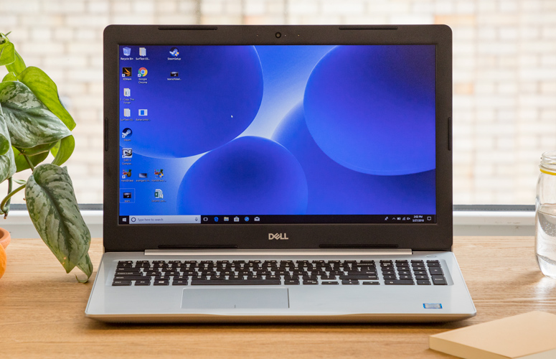

### Design

Dell's 15.6-inch, midrange notebook is a bland, chunky block. It has long been the case that the Inspiron lineup lacks any sort of aesthetic muse, and the Inspiron 15 5000 follows this trend. It's a plastic, silver slab bearing Dell's logo in a mirror sheen.

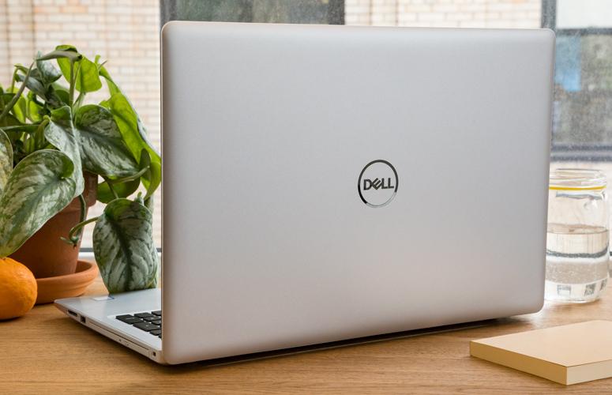

Lifting the lid reveals the 15.6-inch, 1080p screen surrounded by an almost offensively thick bezel and a plastic deck with a faux brushed-metal look. There's a fingerprint reader on the power button, and the keyboard is a black collection of island-style keys.

At 4.9 pounds and 15 x 10.2 x 0.9 inches, the Inspiron 15 5000 is just a bit slimmer than the [Acer Aspire E 15 E5-576G-5762](https://www.laptopmag.com/reviews/laptops/acer-aspire-e-15-e5-576g-5762), which is the same weight, width and height but measures 1.2 inches thick.

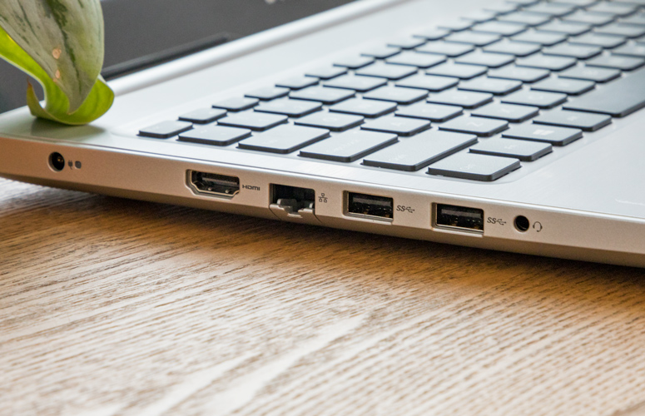

The Inspiron has its fair share of [ports](https://www.laptopmag.com/articles/port-and-adapter-guide), including an HDMI output, Ethernet jack, headphone jack and three USB 3.0 ports, as well as an SD card reader and (for those who still need one) a [disc drive](https://www.laptopmag.com/articles/laptops-with-disc-drives).

**Audio**

The speakers on the Inspiron are plenty loud and easily filled up a small conference room when I listened to Charli XCX's "Boom Clap." The song's vocals and drums were clear, though an underlying bass line didn't stand out from the rest of the mix. The preinstalled Waves MaxxAudio Pro has a bunch of preset equalizers and some dials to adjust the music, but I found that the default options were the best.

### Display

The display on the Inspiron 15 5000 is truly horrendous. Sure, it's 15.6 inches and has a 1080p resolution, but it's also blurry and [dim](https://www.laptopmag.com/benchmarks/display-brightness). When I watched the trailer for Avengers: Infinity war, Gamora's green skin had a sickly white tint, it was hard to make out the spiderweb patterns in Spider-Man's suit, and there was no hint of red in Star-Lord's jacket; instead, it appeared brown. The blue skies over Wakanda appeared gray, and Thanos had a blue tint on his purple flesh.



The screen on this laptop covers just 67 percent of the sRGB color gamut, falling below the mainstream laptop average (89 percent) and the Aspire's result (74 percent).

The Dell's panel measured an average of 175 nits, dimmer than both the Aspire (200 nits) and the average (230 nits). This Inspiron is also much dimmer than the older Inspiron 15 5000 with touch screen that we reviewed in 2017 (213 nits).

**Keyboard and Touchpad**

The keyboard on the Inspiron measures 1.4 millimeters of travel and requires 73 grams of force to press, but the keys feel cheap and loose, making them seem shallower than they are. This keyboard is just not very comfortable.

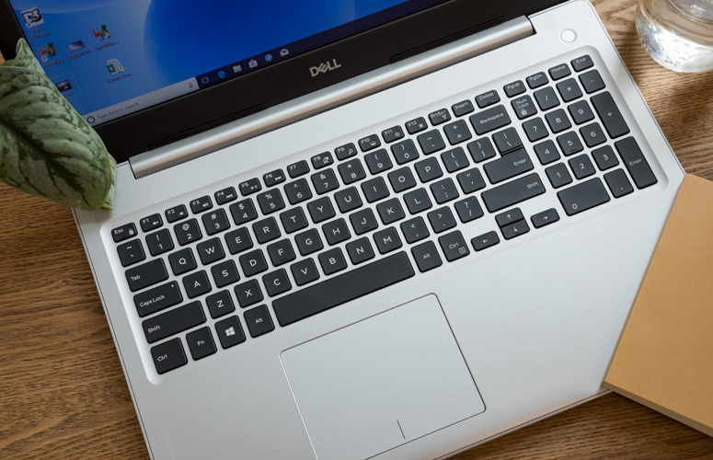

On the 10fastfingers.com typing test, I reached 104 words per minute, which is below my usual minimum of 107 words per minute; I got my usual error rate of 2 percent.

The 4.1 x 3.1-inch touchpad is nice and spacious, though the plastic is a little bouncy. I felt it quivering under my fingers when I was performing gestures like tapping three fingers to invoke Cortana quickly or two-finger scrolling (but the gestures, to Dell's credit, do work).

**Performance**

While our configuration of the Inspiron has an Intel Core i5-8250U and 8GB of [RAM](https://www.laptopmag.com/articles/how-much-ram), which are poised for multitasking, its 1TB, 5,400-rpm. HDD is slow compared to the SSDs you get in a lot of computers (you can pay extra to configure the Inspiron with an SSD). I had 15 tabs open in Google Chrome (one of which was streaming a 1080p episode of Late Night with Seth Meyers) when the laptop paused and showed the loading icon before I could open more tabs.

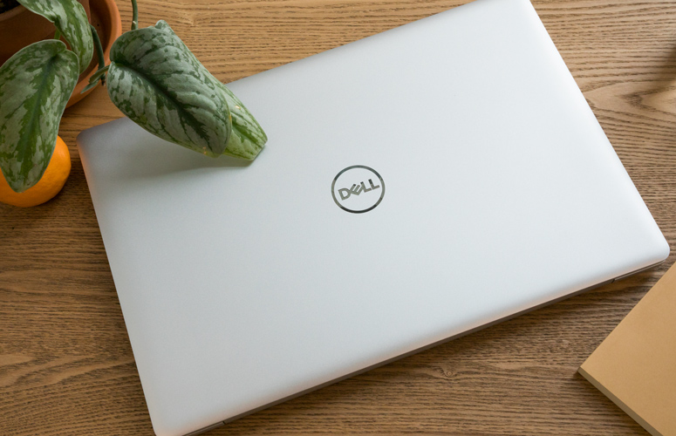

On the Geekbench 4 overall performance test, the Inspiron earned a score of 11,791, beating both the Aspire (9,278, also with a Core i5-8250U) and the mainstream laptop average (8,231).

The Inspiron took 39 seconds to duplicate 4.97GB of files (what you'd get on a full DVD), which comes out to a rate of 130.5MBps. That's slower than both the average (152.5MBps) and the Aspire (149.7Mbps).

The Inspiron took 1 minute and 11 seconds to complete our Excel spreadsheet macro, which pairs 65,000 names and addresses. That's faster than both the Aspire (1:30) and the average (1:49). The Inspiron was also faster on our HandBrake video-editing test, transcoding a 4K video to 1080p in 17 minutes and 11 seconds, beating both the Aspire (25:15) and the average (21:39).

But on the 3DMark Ice Storm Unlimited graphics benchmark, the Inspiron earned a score of 69,943, falling below both the Aspire's 122,144 and the average (72,506). While the Inspiron uses Intel's integrated UHD 620 graphics, the Aspire, which costs $50 more, has a dedicated Nvidia GeForce MX150 with 2GB of VRAM. That's nothing to game on, but it will give you a boost in Photoshop.

### Battery Life

The brief battery life on the Inspiron will basically chain you to your desk. The system ran for a paltry 5 hours and 8 minutes on [Laptop Mag Battery Test 2.0](https://www.laptopmag.com/articles/all-day-strong-longest-lasting-notebooks), which continuously browses the web, runs videos and plays through graphics benchmarks over Wi-Fi. The mainstream laptop average is 8 hours and 23 minutes, and the Aspire ran for an even-longer 9:26.

**Heat**

The Inspiron stays cool under pressure, keeping under our 95-degree Fahrenheit comfort threshold. After the Inspiron streamed 15 minutes of HD video from YouTube, our heat gun measured 81 degrees Fahrenheit on the touchpad, 94 degrees between the G and H keys, and 90.5 degrees on the laptop's bottom.

**Webcam**

Dell's 720p webcam takes dark photos that have little detail. In a selfie I took with the camera at my desk, I was covered in shadow, with my eyes darkened and my beard appearing darker than usual.

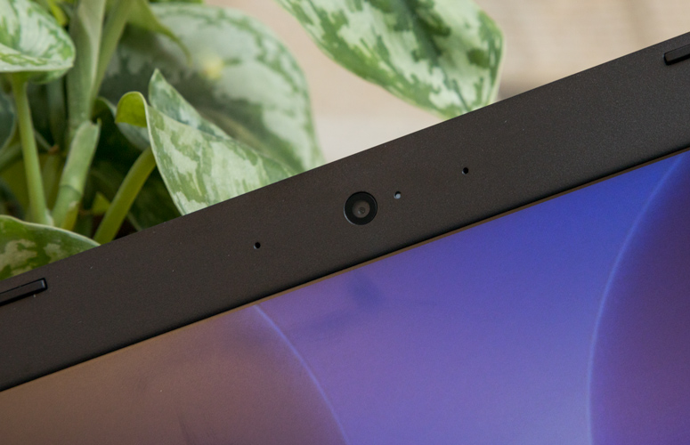

### Software and Warranty

Dell's software includes [Mobile Connect](https://www.laptopmag.com/articles/dell-mobile-connect), which lets you send texts and make calls from your iPhone or Android phone. On the latter, you can control the whole phone from your laptop. You also get Dell Power Manager, to help you manage how fast your battery drains, and Support Assist, to help with any technical issues.

Of course, you also get a bunch of junk that's built in to every copy of Windows 10, like Candy Crush Soda Saga, Bubble Witch 3 Saga, March of Empires: War of Lords and Netflix, among others.

Dell sells the Inspiron 15 50000 with a one-year warranty. See how the company performed in our [Tech Support Showdown](https://www.laptopmag.com/articles/tech-support-showdown) and [Best and Worst Brands showdown](https://www.laptopmag.com/articles/dell-brand-rating).

### What Does the Inspiration 15 5000 Cost?

The Inspiration we tested cost $549 and came with an Intel Core i5-8250U, 8GB of RAM and a 1TB, 5,400-rpm HDD.

For $649, you can keep the same specs but update the display to a touch screen or swap out the hard drive with a 256GB SSD. At $749, you move to an 8th Gen Intel Core i7 CPU, 8GB of RAM, a 128GB SSD and a 1TB HDD, but no touch screen.

Specifications

General

|  |  |
| --- | --- |
| Sales Package | * Laptop, Battery, Power Adaptor, User Guide, Warranty Documents |
| Model Number | * 5570 |
| Part Number | * A560513WIN9 |
| Series | * Inspiron 15 5000 |
| Color | * Platinum Silver |
| Type | * Laptop |
| Suitable For | * Processing & Multitasking |
| Power Supply | * 65 W AC Adapter |
| Battery Cell | * 3 cell |
| MS Office Provided | * Yes |

Processor And Memory Features

|  |  |
| --- | --- |
| Dedicated Graphic Memory Type | * GDDR5 |
| Dedicated Graphic Memory Capacity | * 2 GB |
| Processor Brand | * Intel |
| Processor Name | * Core i5 |
| Processor Generation | * 8th Gen |
| SSD | * No |
| RAM | * 8 GB |
| RAM Type | * DDR4 |
| HDD Capacity | * 1 TB |
| Processor Variant | * 8250U |
| Clock Speed | * 1.6 GHz with Turbo Boost Upto 3.4 GHz |
| Expandable Memory | * Upto 16 GB |
| RAM Frequency | * 2400 MHz |
| Cache | * 6 MB |
| RPM | * 5400 |
| Graphic Processor | * AMD Radeon 530 |

Operating System

|  |  |
| --- | --- |
| OS Architecture | * 64 bit |
| Operating System | * Windows 10 Home |
| System Architecture | * 64 bit |

Port And Slot Features

|  |  |
| --- | --- |
| Mic In | * Yes |
| HDMI Port | * 1 x HDMI Port (v1.4b) |
| Multi Card Slot | * 3-in-1 Card Reader (SD, SDHC, SDXC) |

Display And Audio Features

|  |  |
| --- | --- |
| Touchscreen | * No |
| Screen Size | * 39.62 cm (15.6 inch) |
| Screen Resolution | * 1920 x 1080 Pixel |
| Screen Type | * Full HD LED Backlit Anti-glare Display |
| Speakers | * Built-in Speaker |
| Internal Mic | * Dual Digital Microphone Array |
| Sound Properties | * Stereo Speakers Professionally Tuned with MaxxAudio Pro |

Connectivity Features

|  |  |
| --- | --- |
| Wireless LAN | * IEEE 802.11ac |
| Bluetooth | * v4.1 |

Dimensions

|  |  |
| --- | --- |
| Dimensions | * 380 x 258 x 22.7 mm |
| Weight | * 2.2 kg |

Additional Features

|  |  |
| --- | --- |
| Disk Drive | * CD/DVD writer |
| Web Camera | * HD Webcam |
| Read/Write Speed | * 8x |
| Lock Port | * Noble Lock Slot |
| Antivirus | * McAfee Multi Device 15 Months Subscription |
| Keyboard | * Standard Keyboard |
| Pointer Device | * Touchpad |
| Included Software | * Microsoft Office Home and Student 2016 |
| Additional Features | * Li-ion Battery |

Warranty

|  |  |
| --- | --- |
| Warranty Summary | * 1 Year Onsite Warranty |

On the Geekbench 4 overall performance test, the Inspiron earned a score of 11,791, beating both the Aspire (9,278, also with a Core i5-8250U) and the mainstream laptop average (8,231).

The Inspiron took 39 seconds to duplicate 4.97GB of files (what you'd get on a full DVD), which comes out to a rate of 130.5MBps. That's slower than both the average (152.5MBps) and the Aspire (149.7Mbps).

The Inspiron took 1 minute and 11 seconds to complete our Excel spreadsheet macro, which pairs 65,000 names and addresses. That's faster than both the Aspire (1:30) and the average (1:49). The Inspiron was also faster on our HandBrake video-editing test, transcoding a 4K video to 1080p in 17 minutes and 11 seconds, beating both the Aspire (25:15) and the average (21:39).

But on the 3DMark Ice Storm Unlimited graphics benchmark, the Inspiron earned a score of 69,943, falling below both the Aspire's 122,144 and the average (72,506). While the Inspiron uses Intel's integrated UHD 620 graphics, the Aspire, which costs $50 more, has a dedicated Nvidia GeForce MX150 with 2GB of VRAM. That's nothing to game on, but it will give you a boost in Photoshop.

 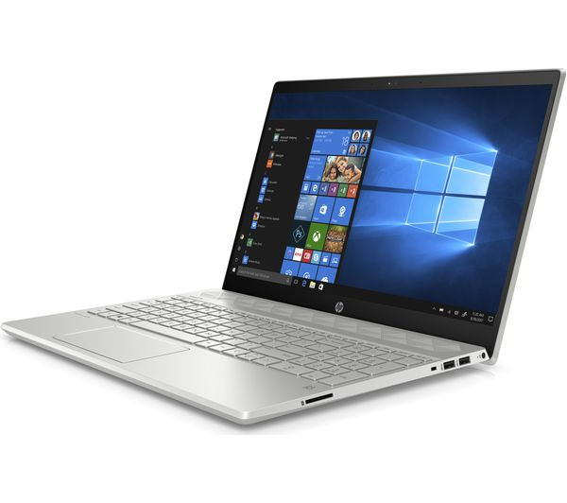

HP AMD RYZEN5

Processor: AMD Ryzen 5 2500U Quad-Core Processor, 2 GHz base processor speed, up to 3.6 GHz burst frequency, 4 cores, 6 MB L3 cache

* Operating System: Pre-loaded Windows 10 Home with lifetime validity
* Display: 15.6-inch Full HD (1920x1080) display, brightness: 220 nits | WLED backlit display | Backlit keyboard
* Memory, Graphics & Storage: 8GB DDR4 RAM, expandable to 16 GB, with AMD Radeon Vega 8 Graphics | Storage: 1TB HDD
* Design & battery: Multi-touch gesture support | Thin and light design | Laptop weight: 2.04 kg | Average battery life = 7 hours, HP Fast Charge battery
* Warranty: This genuine HP laptop comes with a 1-year domestic warranty from HP covering manufacturing defects and not covering physical damage. For more details, see Warranty section below and for any product related queries contact_us on: [1800-425-4999] [1800-108-4747].
* Preinstalled Software: Microsoft Office Home & Student 2016 | In the Box: Laptop with included battery and charger
* Ports & CD drive: 1 HDMI 1.4, 2 USB 3.1, 1 USB 2.0, 1 Audio-output | With CD drive
* Other features: Full-Size Backlit Keyboard | Dual Speakers | HP Audio Boost | Bluetooth 4.2 | Wifi ac (1x1)

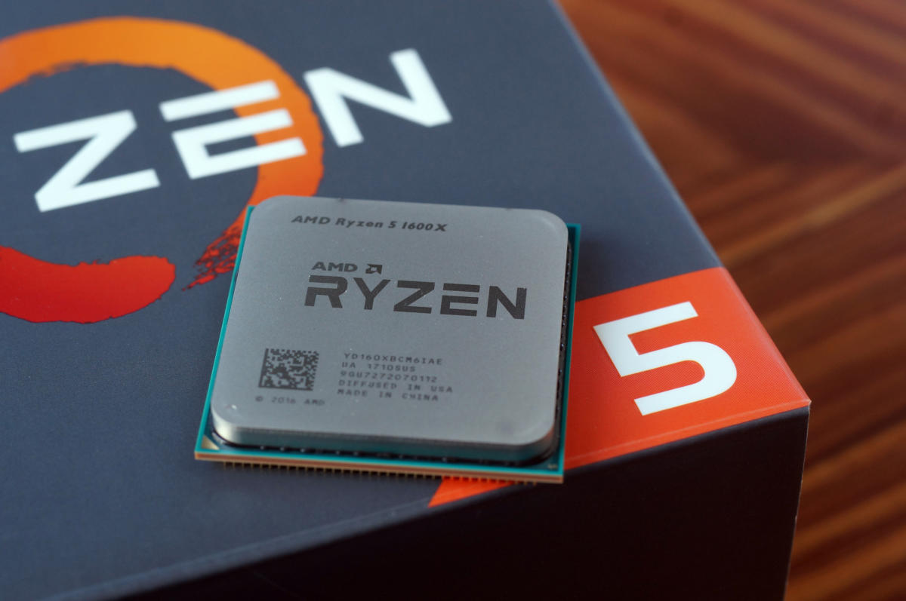

For the Core i5-7600K, testing was conducted using the same system we used for the Core i7-7700K in our Ryzen 7 [review](http://www.pcworld.com/article/3176191/computers/ryzen-review-amd-is-back.html), but with a few key changes. We updated the Asus ROG Maximus IV Code to the latest available BIOS, which basically adds Optane support. We also pulled two of four memory modules we had installed. This reduced the RAM from 32GB to 16GB of DDR4, but it also allowed us to increase the memory clock of our Corsair modules from DDR4/2133 to DDR4/2933 speeds.

IDG

Ryzen 5 1600X and Core i5-7600K compared

Note that running Kaby Lake at higher speeds with all memory slots full isn’t an issue. Not all of the CPUs we tested (*cough* Ryzen), however, will easily support high clock speeds with all DIMM slots loaded.

For the Ryzen 5 1600X, rather than re-use the previous AMD X370 build from the Ryzen 7 review, I used an MSI B350 Tomahawk motherboard. AMD provided the board, saying it had a newer BIOS that offered the best performance. A clean install of Windows 10 was loaded onto a Kingston 256GB HyperX SSD (the same model and capacity used in other test machines). For RAM, I used a pair of Geil EVO 8GB modules with the timing set to AMD’s specifications for testing on the Tomahawk board.

As with all of our builds, we used Founders Edition GeForce GTX 1080 cards. I verified clock and RAM timings on each card before I began testing.

**First up: Productivity benchmarks**

Our benchmarking begins with a battery of productivity tests. First, Cinebench for multithreaded performance, then Blender and POV-Ray for image-rendering chops. We add Handbrake and Adobe Premiere CC 2017 for video encoding.

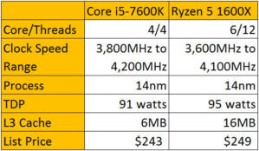

**Cinebench Performance**

Our first test is the ever-reliable Cinebench R15, which is made by Maxon and based off a real rendering engine used in its Cinema4D parts. You might recall that this benchmark was fingered by the FTC over alleged Intel benchmark improprieties, but Maxon has claimed its innocence.

The first result you see is Cinebench R15 restricted to a single thread. The Core i5-7600K comes out on top, which is to be expected given its higher clock speed and higher instructions per clock. For the most part, the Core i5-7600K sits at 4.2GHz at almost all loads all the time. The Ryzen 5 1600X bounces around, hitting 4.1GHz clock speeds only on occasion. You’re looking at maybe a 12-percent difference, which ain’t bad, but in the end, still second-best.

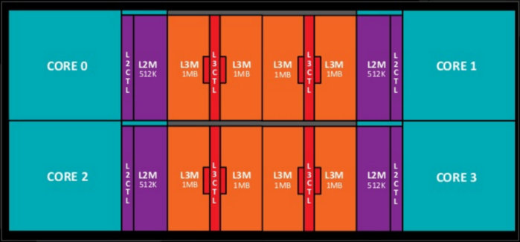

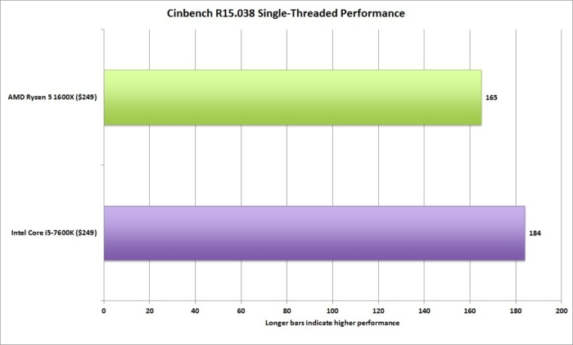

We retested on Cinebench R15, but this time with all the CPU cores and threads available. You’re seeing roughly an 80-percent difference in performance when all cores are hot on Ryzen 5 and the Core i5. Let’s say that again: An 80-percent difference. That’s just a crushing blow to Core i5 and pretty much frames how this battle is likely to shape up: Give up a little single-threaded performance for a huge bump in multi-threaded performance.

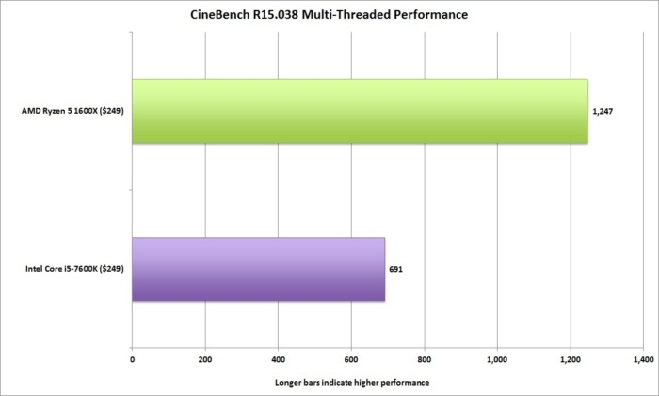

**Blender Performance**

Blender is a popular open-source 3D renderer that’s used in a lot of indie movie productions. Like most 3D production apps, it loves cores, but I’ve found it not to scale quite as well as Maxon’s rendering engine. Still, Ryzen 5 is clearly in front by a huge margin and finishes about 50 percent faster than Core i5.

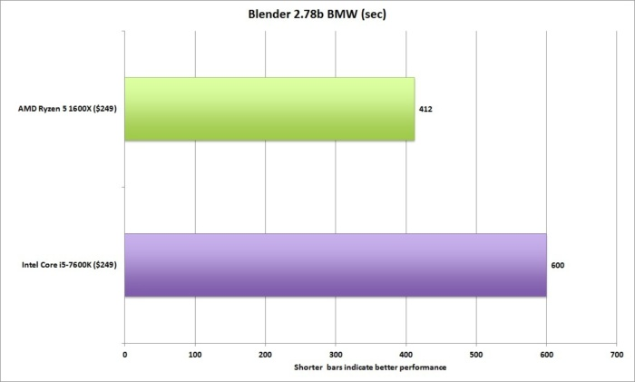

**POV Ray performance**

Our last rendering test uses a professional application called Persistence of Vision Raytracer, or POV Ray. It actually hearkens back to the days of the Amiga. Its built-in benchmark spits out a score that tells you how many pixels per second are rendered by a CPU.

First, single-threaded performance, which looks an awful lot like Cinebench R15’s single-threaded results. The Kaby Lake Core i5 has the advantage. Haters, say what you will, but those 7th-gen chips are mean little CPUs.

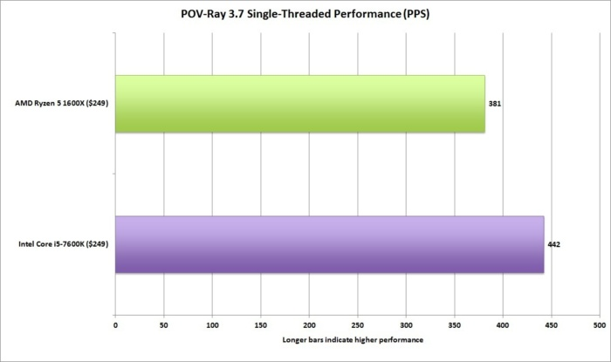

## 7-Zip Performance

If you’re like us, you immediately uninstalled the annoying brand-name Zip program on your PC and pointed your browser at the free and fast 7-Zip. The free app features a built-in benchmark that measures the speed of a machine at compressing and decompressing files. Ryzen 5 picks up Core i5, throws it into the audience, then jumps out of the ring to smash a break-away chair over its quad-core head.

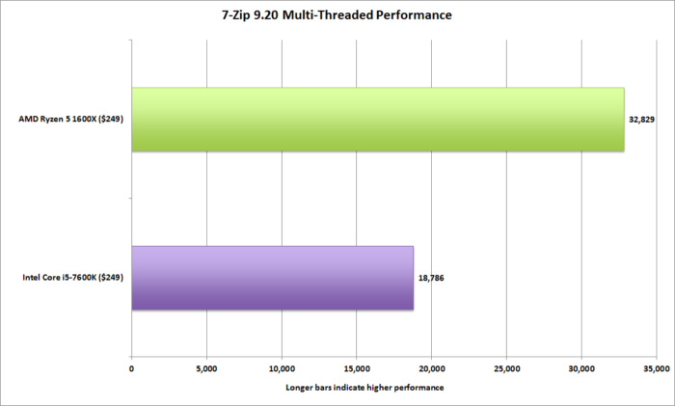

## Geekbench 4.1

I haven’t always used Geekbench in CPU reviews, as the test has been somewhat controversial in the past. The latest version still takes algorithms its creator (Primate Labs) thinks are relevant in image editing, encryption and the like, and measures how well a CPU can run them. Primate Labs has changed how the test looks at CPU performance, however, and most consider that to be an improvement.

The latest version specifically addresses Ryzen performance, so I was interested to see the results. Ryzen 5 outpaces Core i5, but even though this is a multi-threaded test, I’m not seeing the scaling result I expected. That means either the test’s algorithms don’t particular favor Ryzen, or it just doesn’t scale with the core and thread counts that well. I’m inclined to believe the latter, as the difference between a Core i5 and Core i7 (which adds Hyper-Threading) is maybe 10 percent.

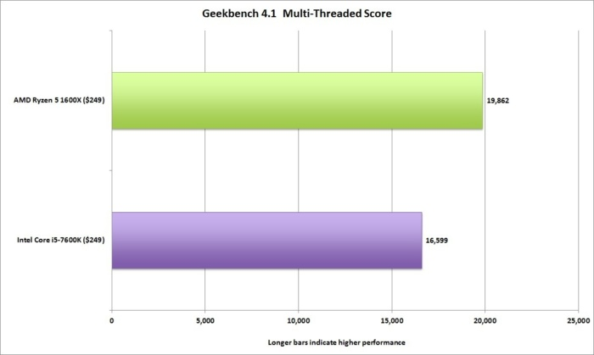

## PCMark 8 Performance

PCMark 8 tries to replicate real-world use by not just using small algorithms, but also creating small simulated applications to measure performance.

First up is the PCMark 8 Creative Conventional test, which throws various workloads at a system, including encoding, video conferencing, and photo editing. In the end, Ryzen 5 has a slight advantage. Although there is an encoding portion, I’d take that to mean the creative mode is pretty lightweight and doesn’t favor multiple cores much. The takeaway from this is, if you’re editing photos and doing quick video edits with the free software that came with Windows, both CPUs will do the job.

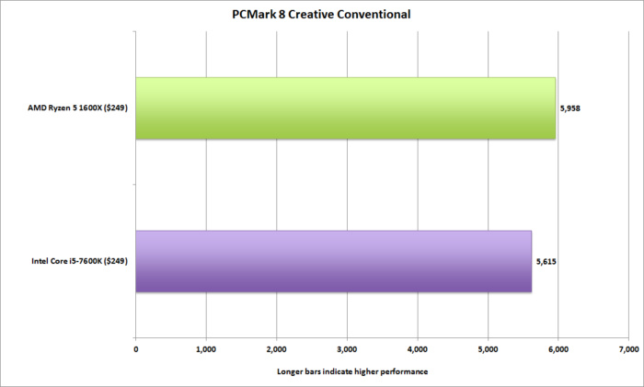

## Handbrake Performance

To measure encoding performance, we use the popular and free Handbrake to convert a 30GB 1080p MKV file using the Android Tablet preset. Handbrake loves, loves, loves CPU cores, and it shows. Ryzen 5 smokes Core i5 by about 70 percent in encoding time. Again, 12 threads vs 4 threads is not even a contest.

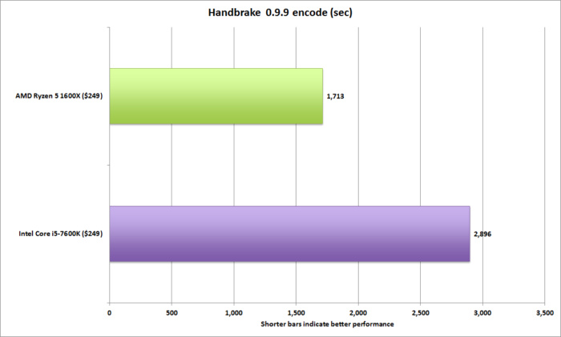

**Adobe Premiere Pro Creative Cloud 2017**

For a video test, we took an actual published project from our video colleagues at IDG.tv that was shot on a 4K Sony camera, and we tasked both machines to encode it using the Blu-ray preset in Premiere Pro CC 2017. Premiere Pro lets you encode using the GPU, which tends to offer a huge performance decrease in render time, or the CPU, which is still generally considered to offer the best visual quality. Using the CPU for this first chart, you can see the Ryzen 5 flexing its core count over Core i5, offering a massive decrease in render times. If time is money, Ryzen 5 gets you more money.

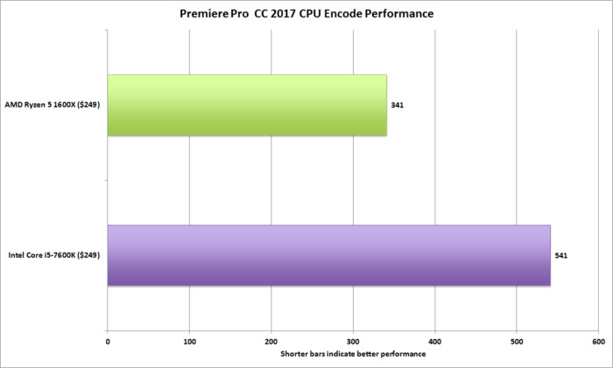

## Gaming performance: The big question

On the application side, Ryzen 5 has it handled. But how about gaming performance? That’s been the Achilles heel for Ryzen in early-days testing.

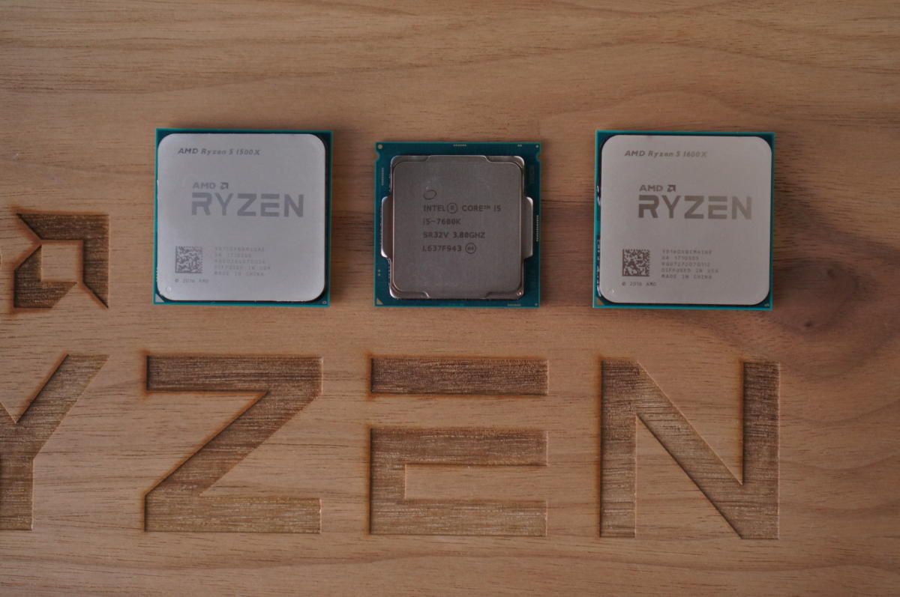

## 3DMark Performance

First up is Futuremark’s popular 3DMark test. This test is designed first and foremost as a GPU and graphics load test. Everything works as it should: Ryzen 5 gets a small advantage thanks to its additional cores, but for the most part, it’s dead-even between the pair of GeForce GTX 1080 cards we used for testing.

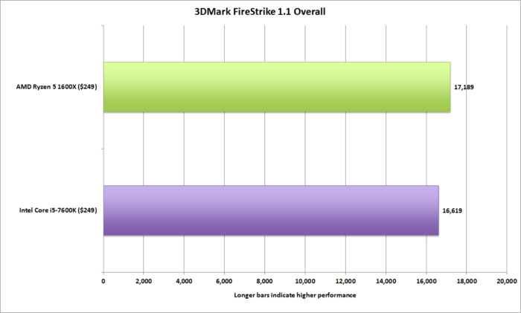

## Ashes of the Singularity: Escalation Performance

Moving on to a real game, we used Ashes of the Singularity: Escalation. Oxide, the developer of Ashes, has said much of the controversy around Ryzen 7’s gaming performance comes from the new micro-architecture. While AMD’s offerings foundered, the gaming world optimized for Intel—and it showed in our first tests out of the gate, with [Ryzen 7](http://www.pcworld.com/article/3176191/computers/ryzen-review-amd-is-back.html). The results you see here follow a few weeks of code-tweaking for Ryzen.

Ryzen 5, for the most part, is slightly faster than Core i5. When you consider the slightly higher clock speeds and improved IPC of Core i5, that’s actually a pretty significant win in this GPU-centric test mode. The results, Oxide said, are only expected to get better.

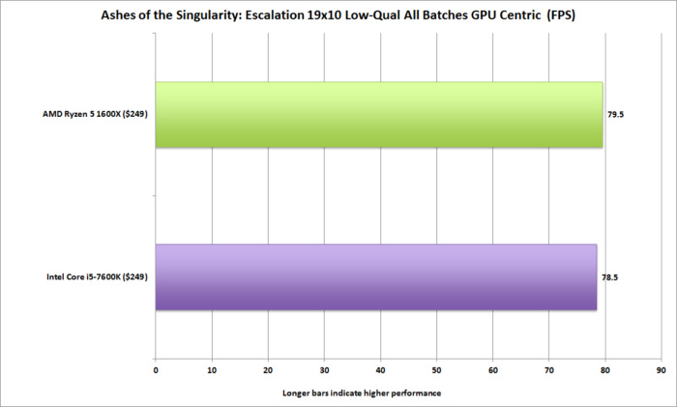

## Why you don't need to freak out

If the last four charts are enough to freak you out, don’t. We know much more about Ryzen 5 then we did about Ryzen 7 when it launched, and the lack of answers seemed to swirl around for weeks.

Although there are still some outstanding questions, it’s clear to me that there isn’t some flaw with Ryzen that makes it slow (which everyone feared). The most logical conclusion is to blame the games themselves.

I say this because If Ashes of the Singularity developer Oxide can bump performance by 20 percent or more after a couple weeks’ worth of tweaking, and in fact says it’s not fair to even compare Intel with AMD with the previous code, it stands to reason other games could do the same. Optimization may not erase the difference completely, but it should make any remaining difference insignificant.

Ryzen may still have problems with older games if only because game developers are unlikely to update code for a 2014 title. However, I’d bet few of you are having problems running a three-year-old game with your rig today. A modern GPU and modern CPU can run any older title without issues. The more important question is whether developers will support Ryzen going forward for games that come out in 2020—not 2014.

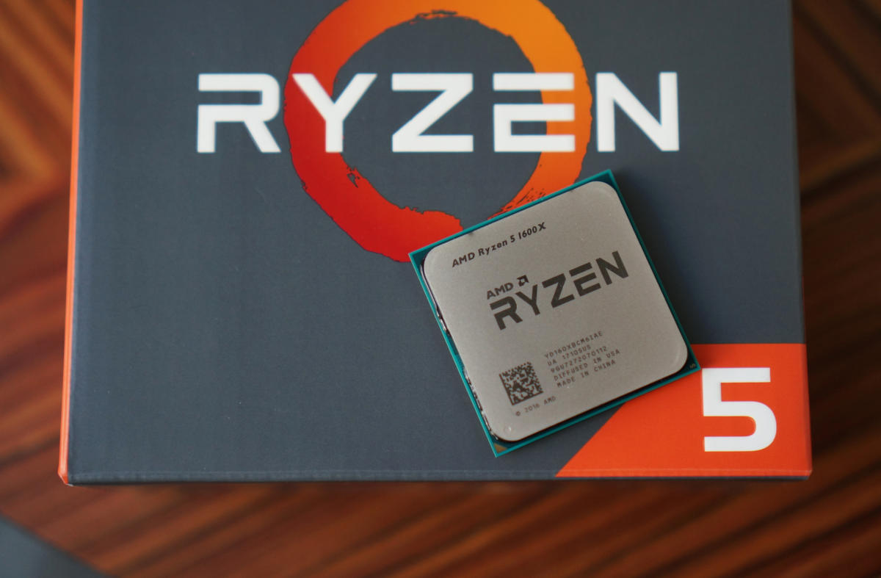

## Conclusion

After testing Ryzen 5, and especially after seeing how its performance changed with optimized games, Ryzen gaming performance is clearly not as big of a deal as it seemed when Ryzen 7 first launched. When it comes to deciding the matter at hand—which is the best $250 CPU—the complicated answer is: Match the workloads above with what you do and choose based on your needs, not what someone tells you is right.

The problem is, people don’t want complicated answers. They want simple answers and they want you to pick for them. In that case, Ryzen 5 is the way to go. It burns Core i5 to the ground in multi-threaded applications performance and doesn’t give up much in single-threaded performance.

