

**Deogiri Institute of Engineering and Management Studies, Aurangabad**

**Department of Computer Science Engineering**

Report on

Computer Architecture and Organization

**Android Phone**

Submitted By

**Shubhangi Rajesh Hiwale (26069)**

**Sanyukta Milind Ingole (26070)**

Under the Guidance of

**Prof. P. H. Durole**

Department of Computer Science Engineering

(Deogiri Institute of Engineering and Management Studies)

2018-2019

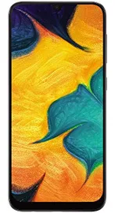

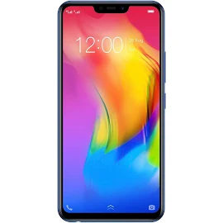

Samsung Galxcy A30 Vivo Y83 Pro

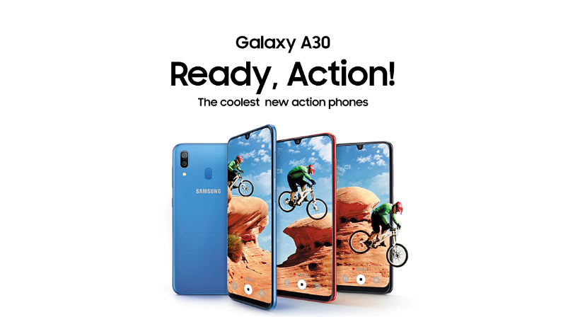

**Key Specs**

Android v9.0 (Pie)

|  |  |  |  |
| --- | --- | --- | --- |
| * Performance   Octa core (1.8 GHz, Dual Core + 1.6 GHz, Hexa Core)Samsung Exynos 7 Octa4 GB RAM | * Display   6.4 inches (16.26 cm)1080x2340 px, 403 PPISuper AMOLED | * Camera   16 MP + 5 MP Dual Primary Camera LED Flash16 MP Front Camera | * Battery   4000 mAh Fast Charging USB Type-C port |

Supports Indian bands

* VoLTE
* 64 GB + 512 GB Expandable
* Dual SIM: Nano + Nano
* Fingerprint sensor
* USB OTG Support

**Verdict**

The Samsung Galaxy A30 is a mid-range smart phone that comes with a completely bezel-less display. It covers a number of features that make it a perfect choice in this range. It comes with a slim body that sits comfortably on the palms of the handle. Provide a great performance; it is powered with a decent battery backup to keep it running. The camera performance is also very impressive and is sufficient storage to keep all the data in it.

**Display and Camera**

The Samsung Galaxy A30 comes with a 6.4-inch Super AMOLED display having a screen resolution of 1,080 x 2,340 pixels and a density of 403 PPI. The bezel-less display provides a great viewing experience and it comes with a notch on top.

For the optics, it has a dual rear camera setup, consisting of 16MP + 5MP lenses. It can capture amazing pictures and the front camera will impress the selfie lovers its 16MP resolution.

**Configuration and Battery**

The Galaxy A30 is equipped with an octa-core processor setup consisting a 2.2GHz Cortex A73 dual-core and a 1.6GHz Cortex A53 hexa-core processor. It is seated upon the Exynos 7 Octa 7904 chipset and assisted by the Mali-G71 MP2 GPU that handles the graphics. The 4GB RAM makes sure there is no lag while gaming or multitasking.

In terms of the power backup, it has been provided with a 4,000 mAh Li-ion battery that claims to provide 23 hours of backup on 3G usage. It is further equipped with Fast charging support.

**Storage and Connectivity**

The inbuilt storage capacity of the device is 64GB, which is ample to keep the files and data of the users. It also comes with an external memory slot of 256GB. For the connectivity, the dual SIM device supports 4G VoLTE. Other options include Wi-Fi 802.11, b/g/n, Mobile Hotspot, Bluetooth v5.0, GPS with A-GPS, Glonass, micro USB 2.0, etc.

Full Information about Phone:

Versions: SM-A305F/DS, SM-A305FN/DS (Global); SM-A305G/DS, SM-A305GN/DS, SM-A305YN

|  |  |  |
| --- | --- | --- |
| **NETWORK** | [**Technology**](https://www.gsmarena.com/network-bands.php3) | [GSM / HSPA / LTE](https://www.gsmarena.com/samsung_galaxy_a30-9579.php) |
|  |  |

|  |  |  |
| --- | --- | --- |
| **LAUNCH** | [**Announced**](https://www.gsmarena.com/glossary.php3?term=phone-life-cycle) | 2019, February |
| [**Status**](https://www.gsmarena.com/glossary.php3?term=phone-life-cycle) | Available. Released 2019, March |

|  |  |  |
| --- | --- | --- |
| **BODY** | [**Dimensions**](https://www.gsmarena.com/samsung_galaxy_a30-9579.php) | 158.5 x 74.7 x 7.7 mm (6.24 x 2.94 x 0.30 in) |
| [**Weight**](https://www.gsmarena.com/samsung_galaxy_a30-9579.php) | 165 g (5.82 oz) |
| [**Build**](https://www.gsmarena.com/glossary.php3?term=build) | Front glass, plastic body |
| [**SIM**](https://www.gsmarena.com/glossary.php3?term=sim) | Single SIM (Nano-SIM) or Dual SIM (Nano-SIM, dual stand-by) |

|  |  |  |
| --- | --- | --- |
| **DISPLAY** | [**Type**](https://www.gsmarena.com/glossary.php3?term=display-type) | Super AMOLED capacitive touch screen, 16M colors |
| [**Size**](https://www.gsmarena.com/samsung_galaxy_a30-9579.php) | 6.4 inches, 100.5 cm2 (~84.9% screen-to-body ratio) |
| [**Resolution**](https://www.gsmarena.com/glossary.php3?term=resolution) | 1080 x 2340 pixels, 19.5:9 ratio (~403 ppi density) |
| [**Protection**](https://www.gsmarena.com/glossary.php3?term=screen-protection) | Corning Gorilla Glass 3 |

|  |  |  |
| --- | --- | --- |
| **PLATFORM** | [**OS**](https://www.gsmarena.com/glossary.php3?term=os) | Android 9.0 (Pie) |
| [**Chipset**](https://www.gsmarena.com/glossary.php3?term=chipset) | Exynos 7904 (14 nm) |
| [**CPU**](https://www.gsmarena.com/glossary.php3?term=cpu) | Octa-core (2x1.8 GHz Cortex-A73 & 6x1.6 GHz Cortex-A53) |
| [**GPU**](https://www.gsmarena.com/glossary.php3?term=gpu) | Mali-G71 MP2 |

|  |  |  |
| --- | --- | --- |
| **MEMORY** | [**Card slot**](https://www.gsmarena.com/glossary.php3?term=memory-card-slot) | Micro SD, up to 1 TB (dedicated slot) |
| [**Internal**](https://www.gsmarena.com/glossary.php3?term=dynamic-memory) | 64 GB, 4 GB RAM or 32 GB, 3 GB RAM |

|  |  |  |
| --- | --- | --- |
| **MAIN CAMERA** | [**Dual**](https://www.gsmarena.com/glossary.php3?term=camera) | 16 MP, f/1.7, PDAF 5 MP, f/2.2, 12mm, (ultra wide) |
| [**Features**](https://www.gsmarena.com/glossary.php3?term=camera) | LED flash, panorama, HDR |
| [**Video**](https://www.gsmarena.com/glossary.php3?term=camera) | 1080p@30fps |

|  |  |  |
| --- | --- | --- |
| **SELFIE CAMERA** | [**Single**](https://www.gsmarena.com/glossary.php3?term=secondary-camera) | 16 MP, f/2.0 |
| [**Video**](https://www.gsmarena.com/glossary.php3?term=secondary-camera) | 1080p@30fps |

|  |  |  |
| --- | --- | --- |
| **SOUND** | [**Loudspeaker**](https://www.gsmarena.com/glossary.php3?term=loudspeaker) | Yes |
| [**3.5mm jack**](https://www.gsmarena.com/glossary.php3?term=audio-jack) | Yes |
|  | Active noise cancellation with dedicated mic |

|  |  |  |
| --- | --- | --- |
| **COMMS** | [**WLAN**](https://www.gsmarena.com/glossary.php3?term=wi-fi) | Wi-Fi 802.11 a/b/g/n/ac, dual-band, Wi-Fi Direct, hotspot |
| [**Bluetooth**](https://www.gsmarena.com/glossary.php3?term=bluetooth) | 5.0, A2DP, LE |
| [**GPS**](https://www.gsmarena.com/glossary.php3?term=gps) | Yes, with A-GPS, GLONASS, BDS |
| [**Radio**](https://www.gsmarena.com/glossary.php3?term=fm-radio) | FM radio |
| [**USB**](https://www.gsmarena.com/glossary.php3?term=usb) | 2.0, Type-C 1.0 reversible connector |

|  |  |  |
| --- | --- | --- |
| **FEATURES** | [**Sensors**](https://www.gsmarena.com/glossary.php3?term=sensors) | Fingerprint (rear-mounted), accelerometer, proximity, compass |
|  |  |

|  |  |  |
| --- | --- | --- |
| **BATTERY** |  | Non-removable Li-Po 4000 mAh battery |
| [**Charging**](https://www.gsmarena.com/glossary.php3?term=battery-charging) | Fast battery charging 15W |

|  |  |  |
| --- | --- | --- |
| **MISC** | [**Colors**](https://www.gsmarena.com/glossary.php3?term=build) | Black, Blue, Red |
| [**Models**](https://www.gsmarena.com/glossary.php3?term=models) | SM-A305F, SM-A305FN, SM-A305G, SM-A305GN, SM-A305YN |
| [**SAR EU**](https://www.gsmarena.com/glossary.php3?term=sar) | 0.25 W/kg (head)     1.17 W/kg (body) |
| [**Price**](https://www.gsmarena.com/glossary.php3?term=price) | About 230 EUR |

|  |  |  |
| --- | --- | --- |
| **TESTS** | [**Performance**](https://www.gsmarena.com/glossary.php3?term=benchmarking) | [Base mark OS II: 1772 / Base mark OS II 2.0: 1388 Base mark X: 11270](https://www.gsmarena.com/benchmark-test.php3?idPhone=9579#show) |
| [**Display**](https://www.gsmarena.com/gsmarena_lab_tests-review-751p2.php) | [Contrast ratio: Infinite (nominal)](https://www.gsmarena.com/samsung_galaxy_a30-9579.php) |
| [**Camera**](https://www.gsmarena.com/gsmarena_lab_tests-review-751p5.php) | [Photo](https://www.gsmarena.com/piccmp.php3?idType=1&idPhone1=9579&nSuggest=1) / [Video](https://www.gsmarena.com/vidcmp.php3?idType=3&idPhone1=9579&nSuggest=1) |
| [**Loudspeaker**](https://www.gsmarena.com/gsmarena_lab_tests-review-751p3.php) | [Voice 65dB / Noise 66dB / Ring 68dB](https://www.gsmarena.com/samsung_galaxy_a30-9579.php) |
| [**Audio quality**](https://www.gsmarena.com/gsmarena_lab_tests-review-751p4.php) | [Noise -93.3dB / Crosstalk -88.9dB](https://www.gsmarena.com/samsung_galaxy_a30-9579.php) |
| [**Battery life**](https://www.gsmarena.com/gsmarena_lab_tests-review-751p6.php) | [Endurance rating 92h](https://www.gsmarena.com/samsung_galaxy_a30-9579.php) |
|  |  |  |

**Processor Architecture:**

About Octa core (1.8 GHz, Dual Core + 1.6 GHz, Hexa Core)

As the name suggests, the Octa-core processor is made up of eight processor cores that power Galaxy smart phones. The processor enables Galaxy smart phones to carry out more advanced tasks such as handling high resolution videos and graphic-heavy games without draining the battery, making the devices capable and efficient. The Octa-core processor also gives Galaxy devices faster load times.

*Samsung’s Galaxy smart phones run on either Octa-core (2.3GHz Quad + 1.6GHz Quad) or Quad-core (2.15GHz + 1.6GHz Dual) processors, depending on the country or carrier.

### The Octa Core

In simple term, a Octa core processor have four processors and same is case with an octa-core processor. These cores may be either on same integrated circuit on the same chip package. Here are their advantage and disadvantages.

#### Advantages-

* Multitasking is the major advantages of quad or octa core processor. More cores provide more capacity to mobile performing many tasks in the single instance.
* Quad or other multi-core processors are helpful in running such apps which are rather intensive and require a lot of resources. Such apps include video editors, antivirus, graphics programs, etc.
* A new quad processor consumes less power and general less heat. That’s why they are much efficient.
* Moore’s Law says that a computer is obsolete in 2 years. Quad or octa-core is actually way ahead of current mobile application development technology  because not all the developer are able to program apps running on quad core processors. Many programmers are still written for dual or single core processors.

#### Disadvantages-

* A mobile with quad or octa core processors have been tested to drain battery rather faster.
* [Mobile developers](http://www.rapidsofttechnologies.com/mobile-app-development.php) need to program their apps to take the full advantage of quad or octa-core processors

What is core in a processor?

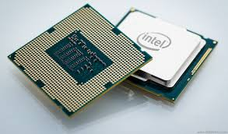

Danny Stieben on Makeuseof.com (What Is A Processor Core? [Make Use Of Explains]) Explains that, a processor core is a processing unit which read in instruction to perform specific actions. Instructions are chained together so that, when run in real time, they make up your computer experience. Literally everything you do on your computer has to be processed by your processor. Whenever you open a folder that requires your processor. When you type into a word document that also requires your processor. Things like drawing the desktop environment, the windows, and game graphics are the job of your graphics card — which contains hundreds of processors to quickly work on data simultaneously — but to some extent they still require your processor as well.

**How they Work-**

The designs of processors are extremely complex and vary widely between companies and even models. Their architectures — currently “Ivy Bridge” for [Intel](https://www.makeuseof.com/tags/intel/) and “Piledriver” for [AMD](https://www.makeuseof.com/tags/amd/) — are constantly being improved to pack in the most amount of performance in the least amount of space and energy consumption. But despite all the architectural differences, processors go through four main steps whenever they process instructions: fetch, decode, execute, and writeback.

### Fetch

The fetch step is what you expect it to be. Here, the processor core retrieves instructions that are waiting for it, usually from some sort of memory. This could include RAM, but in modern processor cores, the instructions are usually already waiting for the core inside the processor cache. The processor has an area called the program counter which essentially acts as a bookmark, letting the processor know where the last instruction ended and the next one begins.

### Decode

Once it has fetched the immediate instruction, it goes on to decode it. Instructions often involve multiple areas of the processor core — such as arithmetic — and the processor core needs to figure this out. Each part has something called an opcode which tells the processor core what should be done with the information that follows it. Once the processor core has figured this all out, the different areas of the core itself can get to work

### Execute

The execute step is where the processor knows what it needs to do, and actually goes ahead and does it. What exactly happens here varies greatly depending on which areas of the processor core are being used and what information is put in. As an example, the processor can do arithmetic inside the ALU, or Arithmetic Logic Unit. This unit can connect to different inputs and outputs to crunch numbers and get the desired result. The circuitry inside the ALU does all the magic, and it’s quite complex to explain, so I’ll leave that for your own research if you’re interested.

### Writeback

The final step, called writeback, simple places the result of what’s been worked on back into memory. Where exactly the output goes depends on the needs of the running application, but it often stays in processor registers for quick access as the following instructions often use it. From there, it’ll get taken care of until parts of that output need to be processed once again, which can mean that it goes into the RAM.

**Instruction Set**

# Android ABIs

Different Android devices use different CPUs, which in turn support different instruction sets. Each combination of CPU and instruction set has its own Application Binary Interface (ABI). An ABI includes the following information:

* The CPU instruction set (and extensions) that can be used.
* The bendiness of memory stores and loads at runtime. Android is always little-endian.
* Conventions for passing data between applications and the system, including alignment constraints, and how the system uses the stack and registers when it calls functions.
* The format of executable binaries, such as programs and shared libraries, and the types of content they support. Android always uses ELF. For more information, see ELF System V Application Binary Interface.
* How C++ names are mangled. For more information, see Generic/Itanium C++ ABI.

This page enumerates the ABIs that the NDK supports, and provides information about how each ABI works.

ABI can also refer to is the native API supported by the platform. For a list of those kinds of ABI issues affecting 32-bit systems, see 32-bit ABI bugs.

**Memory**

## What is RAM

RAM (Random Access Memory) is short-term digital storage. Computers (and yes, your phone is a computer) use RAM mostly to hold data that active applications — along with the CPU and operating system's kernel — are using because RAM is very fast when it comes to reading and writing. Even the fastest hard drive or flash storage is slow when you need to read or write something "right now", and while the CPU inside your phone has its own cache to hold data that's being used for calculations, there's not a lot of it. The Snapdragon 835 (as an example) has 2MB of cache for the high-performance cores and 1MB for the low-performance cores. 2MB of cache is only enough to hold what's being used right now, so you need somewhere to hold what's being used next.

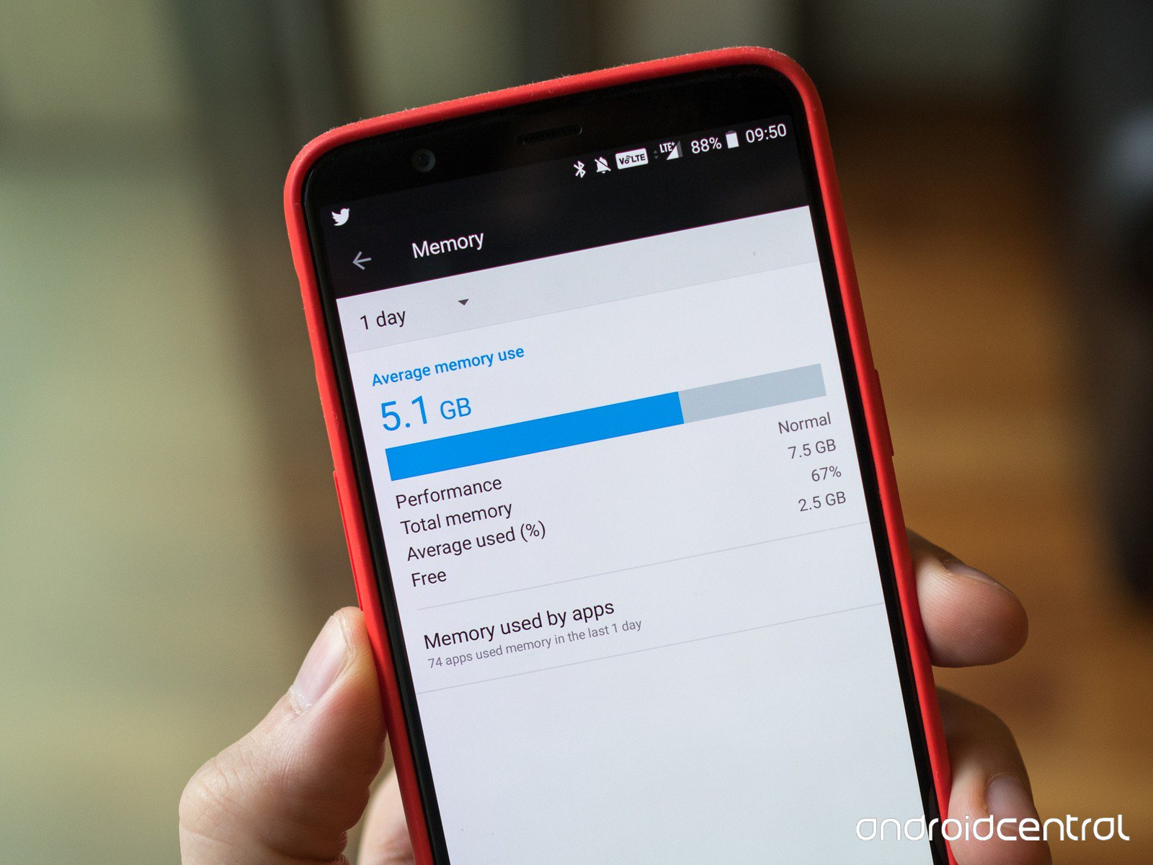

The OS kernel acts as a traffic cop for everything that goes on when it comes to using your phone's hardware. When a game or any app wants to draw a new screen, the data is created to use for it goes into the RAM where the OS can parse it, let the CPU and GPU do any processing needed, then send it off to the display, so the right color dots can be drawn in the right places.

It all sounds complicated, and it is, but all you need to understand are three basic things: RAM is a place to hold data for a short period of time, and data placed there can be read or written very fast. Data in RAM is erased when you shut your phone down. A portion of the RAM in your phone is used as soon as you turn it back on and no apps or even the OS is able to use that portion. This goes for just about any computer; they (almost) all have RAM and they use it the same way.

## What does having more RAM inside my phone do for me?

You already know the short answer because it's above — allows for more apps to run in the background. But the long answer is really interesting. The first Android phone, the T-Mobile G1, had 192MB of RAM. The Pixel 2 has about 22 times more with 4GB.

8GB or 10GB of RAM is complete overkill for a typical Android phone. Phones like a Nexus or an Android One/Android Go phone can get away with 1.5 - 2GB of free RAM after the phone is booted up. So can a Galaxy S8, but only because the min free settings are set so that the home app (the user interface) is forced to stay open, and uses a portion of the reserved RAM. The Samsung interface is more resource intensive, and Samsung did the very smart thing here starting with the Galaxy S6 and killed most of the home screen lag.

Using what that tells us, we can see that a phone like the Galaxy S8 needs more RAM installed. Since almost every phone comes with 4GB of RAM, there is no real difference here and a Nexus phone just has a little more memory to have another app or two up and running because its interface isn't using as much. It's also why Samsung, LG, HTC and others have included ways to kill running processes outside of the min free settings for the times it needs a little boost in performance. If you kill all the apps you can, apps that were not already in memory will start a little faster.

### Memory management

Since Android devices are usually battery-powered, Android is designed to manage processes to keep power consumption at a minimum. When an application is not in use the system suspends its operation so that, while available for immediate use rather than closed, it does not use battery power or CPU resources. Android manages the applications stored in memory automatically: when memory is low, the system will begin invisibly and automatically closing inactive processes, starting with those that have been inactive for the longest amount of time. Lifehacker reported in 2011 that third-party task killer applications were doing more harm than good.

**Working of Control Unit**

The **control unit** (CU) is a component of a computer's [central processing unit](https://en.wikipedia.org/wiki/Central_processing_unit) (CPU) that directs the operation of the processor. It tells the computer's memory, arithmetic and logic unit and input and output devices how to respond to the instructions that have been sent to the processor.

A CU takes its input from the instruction and status registers. Its rules of operation, or micro program, are encoded in a programmable logic array (PLA), random logic or read-only memory (ROM).

It directs the operation of the other units by providing timing and control signals. Most computer resources are managed by the CU. It directs the flow of data between the CPU and the other devices. [John von Neumann](https://en.wikipedia.org/wiki/John_von_Neumann) included the control unit as part of the [von Neumann architecture](https://en.wikipedia.org/wiki/Von_Neumann_architecture). In modern computer designs, the control unit is typically an internal part of the [CPU](https://en.wikipedia.org/wiki/Central_processing_unit) with its overall role and operation unchanged since its introduction.

The Control unit (CU) is digital circuitry contained within the processor that coordinates the sequence of data movements into, out of, and between a processor's many sub-units. The result of these routed data movements through various digital circuits (sub-units) within the processor produces the manipulated data expected by a software instruction (loaded earlier, likely from memory). It controls (conducts) data flow inside the processor and additionally provides several external control signals to the rest of the computer to further direct data and instructions to/from processor external destinations (i.e. memory).

Examples of devices that require a CU are CPUs and graphics processing units (GPUs). The CU receives external instructions or commands which it converts into a sequence of control signals that the CU applies to the data path to implement a sequence of register-transfer level operations

CU functions are as follows:

* Controls sequential instruction execution
* Interprets instructions
* Guides data flow through different computer areas
* Regulates and controls processor timing
* Sends and receives control signals from other computer devices
* Handles multiple tasks, such as fetching, decoding, execution handling and storing results

CUs are designed in two ways:  
  
Hardwired control: Design is based on a fixed architecture. The CU is made up of flip-flops, logic gates, digital circuits and encoder and decoder circuits that are wired in a specific and fixed way. When instruction set changes are required, wiring and circuit changes must be made. This is preferred in a reduced instruction set computing (RISC) architecture, which only has a small number of instructions.

* Microprogram control: Microprograms are stored in a special control memory and are based on flowcharts. They are replaceable and ideal because of their simplicity.

**Input**-**Output Mechanism**

Standard I/O*is* a standardized input/output mechanism that originates from the Unix operating system. Although this mechanism is mostly used with older non-GUI operating systems, standard I/O still plays a role in modern GUI (graphical user interface) operating systems, where people use it to debug malfunctioning programs and to teach input/output in entry-level programming courses.

As you’ve probably guessed, standard I/O uses devices for inputting and outputting data. These devices include standard input, standard output, and standard error.

## Standard input

The standard input device is that part of the operating system that controls from where a program receives its input. By default, the standard input device reads that input from a device driver attached to the keyboard. However, you can redirect, or switch, the input source to a device driver attached to a file so that input seems to be “magically” coming from a file — instead of the keyboard.

## Standard output

The standard output device is that part of the operating system that controls where a program sends its output. By default, the standard output device sends the output to a device driver attached to the screen. However, the output destination can be redirected to a device driver attached to a file or printer, which results in the same program displaying its findings on the screen, saving them in a file, or providing a hardcopy listing of the results.

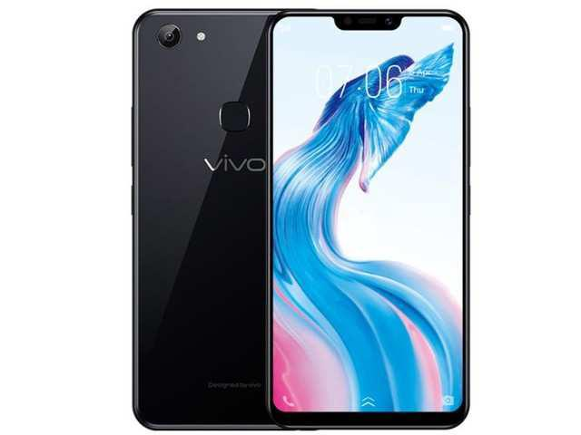**Vivo Y83 Pro**

**FRONT SIDE TOP SIDE**

Vivo Y83 pro SPECIFICATION

Vivo Y83 Pro The phone comes with a 6.22-inch touchscreen display with a resolution of 720x1520 pixels at a pixel density of 270 pixels per inch (ppi) and an aspect ratio of 19:9.

Vivo Y83 Pro is powered by a 2GHz octa-core MediaTek MT6762 processor. It comes with 4GB of RAM.

The Vivo Y83 Pro runs Android 8.1 Oreo and is powered by a 3,260mAh battery.

As far as the cameras are concerned, the Vivo Y83 Pro on the rear packs a 13-megapixel primary camera with an f/2.2 aperture and a second 2-megapixel camera with an f/2.4 aperture. The rear camera setup has phase detection autofocus. It sports a 8-megapixel camera on the front for selfies, with an f/2.2 aperture.

The Vivo Y83 Pro runs Funtouch OS 4.0 based on Android 8.1 Oreo and packs 64GB of inbuilt storage that can be expanded via microSD card.

Connectivity options on the Vivo Y83 Pro include Wi-Fi, GPS, and Micro-USB. Sensors on the phone include ambient light sensor, compass/ magnetometer, proximity sensor, and fingerprint sensor.

The Vivo Y83 Pro measures 155.20 x 75.20 x 7.70mm (height x width x thickness) and weighs 152.00 grams. It was launched in Black and Gold colours.

As of 4th August 2019, Vivo Y83 Pro price in India starts at Rs. 13,990.

**Vivo Rom Function OS-4.0**

## Remove the noise, retain the original only

With many white spaces, the visual focus becomes more prominent, and this also makes the picture more refined and wider. We attempt to reduce all obstacles in vertical visual extension to achieve a consensus with the visual perspective of a borderless full screen. At the same time, the integration of more brand colors also injects greater clarity and vitality into these pictures.

## Customization with an exquisite simplicity

Exquisite and concise icons make the whole desktop looks natural and comfortable for a more efficient experience. Smart icons that can automatically rechimognize the wallpaper colors to adapt their colors accordingly make the overall view more comfortable. Icon shapes can also be updated according to your preferences. All these are tailored to satisfy the unique requirements of different users. Customization for the one and only you.

**Processor 2.0GHz Octa-core**

As the name suggests, the Octa-core processor is made up of eight processor cores that power Galaxy smartphones. The processor enables Galaxy smartphones to carry out more advanced tasks such as handling high resolution videos and graphic-heavy games without draining the battery, making the devices capable and efficient. The Octa-core processor also gives Galaxy devices

# Android 8.1 Features and APIs

**Contents**

* Android Oreo (Go edition)
* Neural Networks API
* Autofill framework updates
* Notifications

Android 8.1 (API level 27) introduces a variety of new features and capabilities for users and developers. This document highlights what's new for developers.

**Notification**

Android 8.1 includes the following changes to notifications:

* Apps can now only make a notification alert sound once per second. Alert sounds that exceed this rate aren't queued and are lost. This change doesn't affect other aspects of notification behavior and notification messages still post as expected.
* Notification Listener Service and Condition Provider Service are not supported on low-RAM Android-powered devices that return true when Activity Mangers low drive device () is called.

## Programmatic Safe Browsing actions

By using the Web View[implementation](https://developer.android.com/reference/android/webkit/WebView.html) of the Safe Browsing API, your app can detect when an instance of Web View attempts to navigate to a URL that Google has classified as a known threat. By default, the Web View shows an interstitial that warns users of the known threat. This screen gives users the option to load the URL anyway or return to a previous page that's safe.

In Android 8.1, you can define programmatically how your app responds to a known threat:

* You can control whether your app reports known threats to Safe Browsing.
* You can have your app automatically perform a particular action—such as going back to safety—each time it encounters a URL that Safe Browsing classifies as a known threat.
* **Model number vivo 1802**
* Vivo Y83 (Black, 32 GB) (4 GB RAM)

|  |  |
| --- | --- |
| In The Box | Protective Film (Applied), Earphone, User Manual, microUSB to USB Cable, USB Power Adapter, SIM Ejector Pin, Handset, Protective Case |
| **Model Number** | **1802** / PD1803BF |
| **Model** Name | Y83 |
| Color | Black |
| Browse Type | Smartphones |

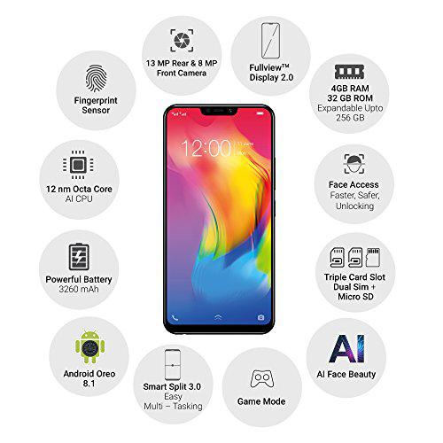

## VIVO Y83 PRO DESCRIPTION

## Vivo Y83 Pro was launched in September 2018 & runs on Android 8.1 OS. The Smartphone is available in more than three color options i.e. Gold, Black, Aurora White, Red & has a built in fingerprint sensor as the primary security feature, along with the host of connectivity options in terms of 3G, 4G, GPS, WiFi Bluetooth capabilities. Priced at Rs. 11990 the phone is available with 64 GB of internal storage.

## Vivo Y83 Pro Full Specifications

**General**

|  |  |
| --- | --- |
| Brand | Vivo |
| Model | Y83 Pro |
| Launched in India | Yes |
| Form factor | Touchscreen |
| Dimensions (mm) | 155.20 x 75.20 x 7.70 |
| Weight (g) | 152.00 |
| Battery capacity (mAh) | 3260 |
| Colours | Black, Gold |

**Display**

|  |  |
| --- | --- |
| Screen size (inches) | 6.22 |
| Touchscreen | Yes |
| Resolution | 720x1520 pixels |
| Protection type | Gorilla Glass |
| Aspect ratio | 19:9 |
| Pixels per inch (PPI) | 270 |

**Hardware**

|  |  |
| --- | --- |
| Processor | 2GHz octa-core |
| Processor make | MediaTek MT6762 |
| RAM | 4GB |
| Internal storage | 64GB |
| Expandable storage | Yes |
| Expandable storage type | microSD |

**Camera**

|  |  |
| --- | --- |
| Rear camera | 13-megapixel (f/2.2) + 2-megapixel (f/2.4) |
| Rear autofocus | Phase detection autofocus |
| Rear flash | LED |
| Front camera | 8-megapixel (f/2.2) |

**Software**

|  |  |
| --- | --- |
| Operating system | Android 8.1 Oreo |
| Skin | Funtouch OS 4.0 |

**Connectivity**

|  |  |
| --- | --- |
| Wi-Fi | Yes |
| GPS | Yes |
| Bluetooth | Yes |
| Micro-USB | Yes |

**Sensor**

Finger print sensor-yes

Compass-magnometer-yes

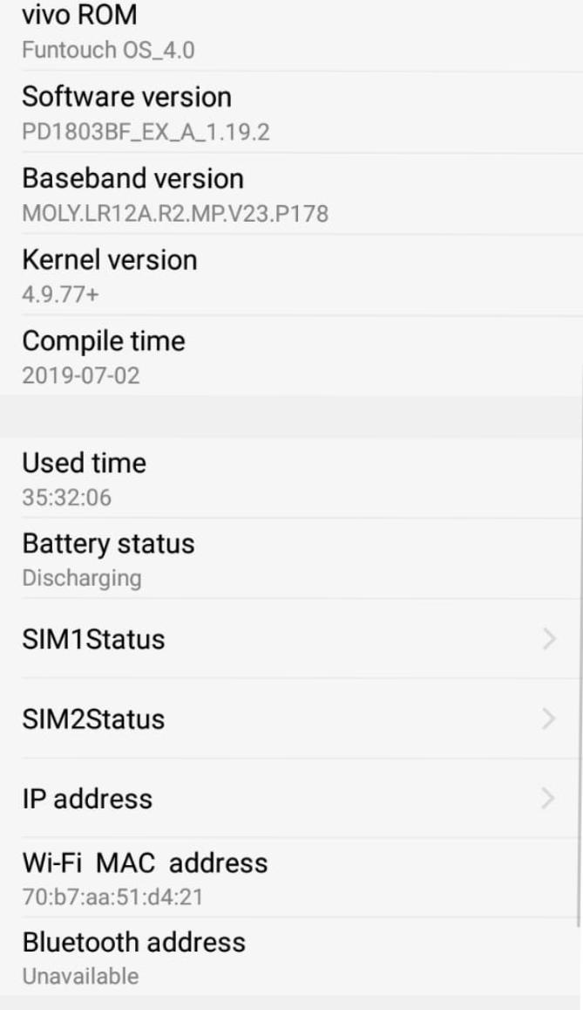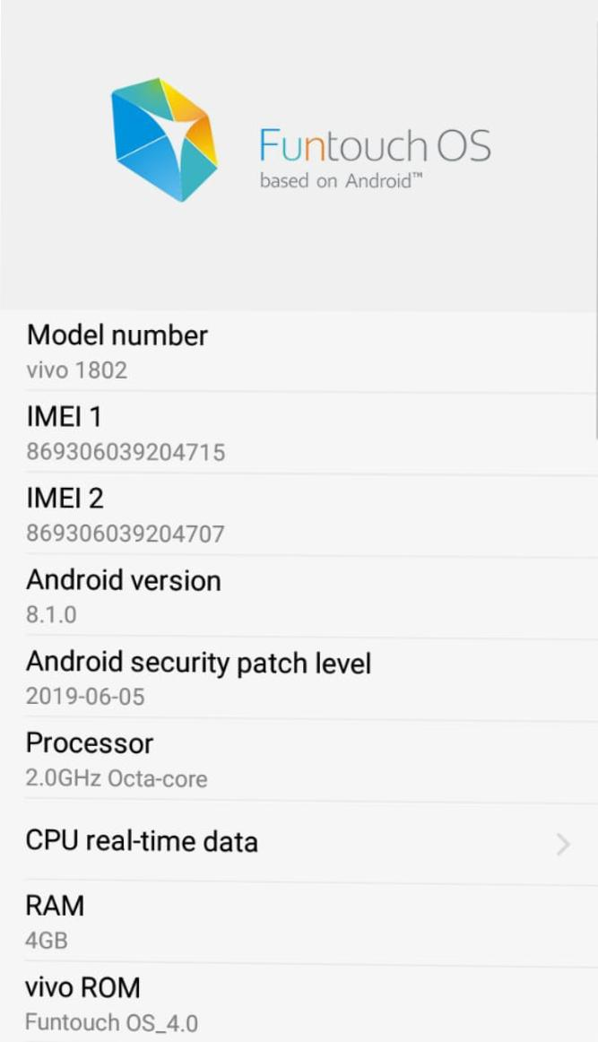

|  |  |  |  |  |  |  |  |  |  |  |  |  |  |  |  |  |  |  |  |  |  |  |  |  |  |
| --- | --- | --- | --- | --- | --- | --- | --- | --- | --- | --- | --- | --- | --- | --- | --- | --- | --- | --- | --- | --- | --- | --- | --- | --- | --- |
| **Difference of Samsung Galaxy A30 and Vivo Y83**   |  |  |  | | --- | --- | --- | | **User Rating** | **4/5*|***[**Read User Reviews**](https://www.gadgetsnow.com/mobile-phones/Samsung-Galaxy-A30#rate) | **4/5*|***[**Read User Reviews**](https://www.gadgetsnow.com/mobile-phones/Vivo-Y83#rate) | | Performance | Octa core | Octa core | | Display | 6.4" (16.26 cm) | 6.22" (15.8 cm) | | Storage | 64 GB | 32 GB | | Camera | 16 MP + 5 MP | 13 MP | | Battery | 4000 mAh | 3260 mAh | | Ram | 4 GB | 4 GB | | | | | |
|  | | | |
| **Special Feature**   |  |  |  | | --- | --- | --- | | Fingerprint Sensor Position | Rear | Rear | | Other Sensors | Light sensor, Proximity sensor, Accelerometer | Light sensor, Accelerometer, Compass, Gyroscope | | Fingerprint Sensor | https://static.toiimg.com/thumb/msid-68096475,height-23,resizemode-4/yes.jpg | https://static.toiimg.com/thumb/msid-68096475,height-23,resizemode-4/yes.jpg | | | | | |
|  | | | | |
| |  |  |  | | --- | --- | --- | | Quick Charging | https://static.toiimg.com/thumb/msid-68096475,height-23,resizemode-4/yes.jpg | https://static.toiimg.com/thumb/msid-68096496,height-23,resizemode-4/yes.jpg | | Operating System | Android v9.0 (Pie) | Android v8.1 (Oreo) | | Sim Slots | Dual SIM, GSM+GSM, Dual VoLTE | Dual SIM, GSM+GSM | | Model | Galaxy A30 | Y83 | | Launch Date | March 2, 2019 (Official) | May 31, 2018 (Official) | | Brand | Samsung | Vivo | | Sim Size | SIM1: Nano SIM2: Nano | SIM1: Nano SIM2: Nano | | Network | 4G: Available (supports Indian bands) 3G: Available, 2G: Available | 4G: Available (supports Indian bands) 3G: Available, 2G: Available | | Fingerprint Sensor | https://static.toiimg.com/thumb/msid-68096475,height-23,resizemode-4/yes.jpg | https://static.toiimg.com/thumb/msid-68096475,height-23,resizemode-4/yes.jpg | | | | | |
|  | | | | |
| |  |  |  | | --- | --- | --- | | Audio Features | Dolby Atmos | - | | Loudspeaker | https://static.toiimg.com/thumb/msid-68096475,height-23,resizemode-4/yes.jpg | https://static.toiimg.com/thumb/msid-68096475,height-23,resizemode-4/yes.jpg | | Audio Jack | 3.5 mm | 3.5 mm | | | | | |
| **PERFORMANCE** | | | | |
| |  |  |  | | --- | --- | --- | | Chipset | Samsung Exynos 7 Octa 7904 | MediaTek Helio P22 | | Graphics | Mali-G71 MP2 | PowerVR GE8320 | | Processor | Octa core (1.8 GHz, Dual core, Cortex A73 + 1.6 GHz, Hexa Core, Cortex A53) | Octa core, 2 GHz, Cortex A53 | | Architecture | 64 bit | 64 bit | | Ram | 4 GB | 4 GB | | | | | |
| **DESIGN** | | | | |
| |  |  |  | | --- | --- | --- | | Thickness | 7.7 mm | 7.7 mm | | Width | 74.7 mm | 75.2 mm | | Weight | 165 grams | 151 grams | | Height | 158.5 mm | 155.2 mm | | Colours | Black, Blue, Red | Black, Red, Aurora White | | | | | |
| **DISPLAY** | | | | |
| |  |  |  | | --- | --- | --- | | Display Type | Super AMOLED | IPS LCD | | Aspect Ratio | 19.5:9 | 19:9 | | Bezelless Display | https://static.toiimg.com/thumb/msid-68096475,height-23,resizemode-4/yes.jpg with notch | https://static.toiimg.com/thumb/msid-68096475,height-23,resizemode-4/yes.jpg with notch | | Pixel Density | 403 ppi | 270 ppi | | Screen To Body Ratio Calculated | 84.74 % | 82.33 % | | Screen Size | 6.4 inches (16.26 cm) | 6.22 inches (15.8 cm) | | Screen Resolution | 1080 x 2340 pixels | 720 x 1520 pixels | | Touch Screen | https://static.toiimg.com/thumb/msid-68096475,height-23,resizemode-4/yes.jpg Capacitive Touchscreen, Multi-touch | https://static.toiimg.com/thumb/msid-68096475,height-23,resizemode-4/yes.jpg Capacitive Touchscreen, Multi-touch | | | | | |
| **STORAGE** | | | | |
| |  |  |  | | --- | --- | --- | | Internal Memory | 64 GB | 32 GB | | Expandable Memory | https://static.toiimg.com/thumb/msid-68096475,height-23,resizemode-4/yes.jpg Up to 512 GB | https://static.toiimg.com/thumb/msid-68096475,height-23,resizemode-4/yes.jpg Up to 256 GB | | Usb Otg Support | https://static.toiimg.com/thumb/msid-68096475,height-23,resizemode-4/yes.jpg | https://static.toiimg.com/thumb/msid-68096475,height-23,resizemode-4/yes.jpg | | | | | |
| **CAMERA** | | | | |
| |  |  |  | | --- | --- | --- | | Settings | Exposure compensation, ISO control | Exposure compensation, ISO control | | Camera Features | Fixed Focus | Digital Zoom, Auto Flash, Face detection, Touch to focus | | Image Resolution | 4616 x 3464 Pixels | 4128 x 3096 Pixels | | Autofocus | https://static.toiimg.com/thumb/msid-68096475,height-23,resizemode-4/yes.jpg | https://static.toiimg.com/thumb/msid-68096475,height-23,resizemode-4/yes.jpg Phase Detection autofocus | | Shooting Modes | Continuos Shooting, High Dynamic Range mode (HDR) | Continuos Shooting, High Dynamic Range mode (HDR) | | Resolution | 16 MP Front Camera | 8 MP Front Camera | | Physical Aperture | F2.0 | F2.2 | | Flash | https://static.toiimg.com/thumb/msid-68096475,height-23,resizemode-4/yes.jpg LED Flash | https://static.toiimg.com/thumb/msid-68096475,height-23,resizemode-4/yes.jpg Screen flash | | | | | |
| **BATTERY** | | | | |
| |  |  |  | | --- | --- | --- | | User Replaceable | https://static.toiimg.com/thumb/msid-68096496,height-23,resizemode-4/yes.jpg | https://static.toiimg.com/thumb/msid-68096496,height-23,resizemode-4/yes.jpg | | Quick Charging | https://static.toiimg.com/thumb/msid-68096475,height-23,resizemode-4/yes.jpg Fast | https://static.toiimg.com/thumb/msid-68096496,height-23,resizemode-4/yes.jpg | | Type | Li-ion | Li-ion | | Capacity | 4000 mAh | 3260 mAh | | | | | |
|  | | | | |
|  |  |  |  |  |
|  | | | | |
| |  |  |  | | --- | --- | --- | | **Price** | **₹ 16,990** | **₹ 14,990** | |  |  |  | | | | | |

Reference:

* <https://www.91mobiles.com/samsung-galaxy-a30-price-in-india>
* <https://www.gsmarena.com/samsung_galaxy_a30-9579.php>
* <https://developer.android.com/ndk/guides/abis>
* <https://www.samsung.com/global/galaxy/what-is/octa-core-processor/>
* <http://www.rapidsofttechnologies.com/blog/index.php/the-smart-device-processors-single-dual-quad-and-octa-core/>
* <https://www.androidcentral.com/ram-what-it-how-its-used-and-why-you-shouldnt-care>
* <https://en.wikipedia.org/wiki/Control_unit>