# 

**MSPM’S**

**Deogiri Institute of Engineering and Management Studies, Aurangabad**

**Department of Computer Science and Engineering**

Report on

**SAMSUNG GALAXY A 50(MOBILE )**

Submitted By

**PAYAL BALASAHEB RUDRAWAR (26074)**

Under the Guidance of

**Prof. P. H. Durole**

Department of Computer Science and Engineering

(Deogiri Institute of Engineering and Management Studies)

2019-2020



CERTIFICATE

This is to certify that Miss **Payal Balasaheb Rudrawar** has completed report

writing on **SAMSUNG GALAXY A 50 (Mobile)** insubject Computer **Architecture &**

**Organization.**

**Prof. P. H. Durole Prof. Sanjay Kalyankar Dr.UlhasShiurkar**

**Subject Teacher H.O.D. Director**

# Samsung Galaxy A50

# Samsung Galaxy A50

# Samsung Galaxy A50

The Samsung Galaxy A50 is a mid-range smartphone with a premium design, Super AMOLED screen, an in-display fingerprint reader, a triple camera, and a large battery. The phone features a 6.4-inch Super AMOLED screen with Full HD+ resolution, 19.5:9 aspect ratio, and a U-shaped notch. It features a 25MP selfie camera with f/2.0 aperture. There is a triple-camera setup at the rear, which consists of a 25MP sensor, an 8MP sensor, and a 5MP sensor, can record 4K videos. There is a 25MP selfie camera at the front. The Galaxy A50 runs Android 9 Pie-based One UI and uses the Exynos 9610 chipset. The phone has GPS, a dual-SIM card slot, 4G connectivity, dual-band Wi-Fi ac/b/g/n, Bluetooth 5.0, NFC, a USB Type-C port, and a 3.5mm headphone jack. It lasts long, too, thanks to a 4000mAh battery which supports 15W fast charging.

Samsung Galaxy A50 Price in India

|  |  |
| --- | --- |
| Price: | **$349** |
| Price in India: | **Rs 24,990** |
| Storage Variant: | 4GB RAM + 64GB Internal Storage |
| Colors: | Ocean Blue and Black |

**Pros:** The A50 has a great AMOLED screen. Impressive imaging is possible in favorable lighting conditions. Gaming at high graphics settings is indeed possible. Samsung has designed One UI quite well. The phone also offers USB Type-C fast charging with decent battery life.

**Cons:** Unfortunately, the phone's in-display fingerprint scanner performance is terrible. Furthermore, usability is hampered because of intermittent lag and stutters in the UI. Imaging in low-light is poor. Also, the rear panel of the phone can be scratched easily.

Samsung Galaxy A50 Price in India

https://assets.mspimages.in/logos/store-logo/amazon_store.png

**₹17,400**

https://assets.mspimages.in/logos/store-logo/tatacliq_store.png

**₹18,490**

https://assets.mspimages.in/logos/store-logo/samsungindiaestore_store.png

**₹18,490**

https://assets.mspimages.in/logos/store-logo/flipkart_store.png

**₹18,490**

https://assets.mspimages.in/logos/store-logo/shopclues_store.png

**₹21,044**

**Samsung Galaxy A50 expert Review**

Last updated Apr 8th 2019

**7.8**

BATTERY LIFE

**8.0**

DISPLAY

**9.0**

PERFORMANCE

**7.0**

REAR CAMERA

**8.0**

SELFIE CAMERA

**8.0**

VALUE FOR MONEY

**7.0**

**Summary:**The Galaxy A50 offers some impressive features including a superb AMOLED screen, great battery life, and cameras that are capable of impressive photography. However, the phone falters in key aspects such as its inconsistent in-display fingerprint sensor and overall sluggishness, making it difficult to use the phone as a daily driver.

Samsung Galaxy A50 Key Specifications

* **4000 mAh** capacity
* **Dual, Nano-SIM** sim configuration
* **6.4 inches (15.24 cm)** screen size
* **Samsung Exynos 9 Octa** cpu
* **Android v9.0 (Pie)** operating system
* **64GB** internal
* **4GB** ram
* **Triple (25MP + 8MP + 5MP);25MP** camera

The latest *Samsung Galaxy A50* news

Samsung Galaxy A50 Camera is as Good as the Nokia 8 Sirocco According to DxOMark

The Samsung Galaxy A50 managed to get a DxOMark score of 83 in still imaging. This is around the same score achieved by smartphones such as the LG G7 ThinQ, Apple iPhone 7, and Nokia 8 Sirocco. It is also the same score as the Galaxy S6 Edge and is only three points behind last year’s Galaxy A9. Video performance on this phone fared a little worse though, as the Galaxy A50 managed to get only 79 points in this department.

Samsung Galaxy A50 Receives a Price-cut in India

Samsung Mobile has slashed the prices of the two variants of its mid-range Galaxy A50 smartphone in India. The price now starts at INR 18,490.

Dec 31, 2018 -- Samsung Galaxy A50 Specs Revealed

According to a new Dutch report, the upcoming Samsung Galaxy A50 will sport a solid 4000mAh battery. The device is also speculated to get a 24MP sensor in its rear camera, in what will probably be a dual rear camera setup. The device will be a mid-ranger but still sport an optical in-display fingerprint sensor, and will be powered by Samsung's Exynos 9610 chipset paired to 4GB of RAM.

| Store | Details | Price |
| --- | --- | --- |
| Amazon.in | Samsung Galaxy A50 (White, 4GB RAM, 64GB Storage) Without Offer | 17,400 |
| Tata CliQ | Samsung Galaxy A50 64 GB (Black) 4 GB RAM, Dual SIM 4G | 18,490 |
| Samsung Online Shop | Samsung Galaxy A50 | 18,490 |
| Flipkart | Samsung Galaxy A50 (Blue, 64 GB)(4 GB RAM) | 18,490 |
| Shopclues | Samsung Galaxy A50 64 GB, 4 GB RAM | 21,044 |

[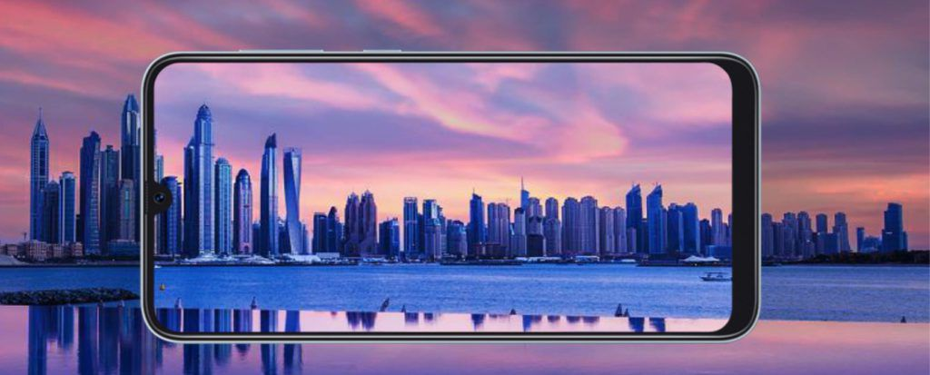](https://assets.mspimages.in/wp-content/uploads/2018/12/Samsung-Galaxy-A50-Infinity-U-Super-AMOLED-Screen.jpg)

Samsung Galaxy A50 Uses Super AMOLED Screen, In-Display Fingerprint Reader

The Samsung Galaxy A50 uses a 6.4-inch Super AMOLED screen and Samsung calls it Infinity U display due to its U-shaped notch. The screen features Full HD+ resolution (2340×1080 pixels) and 19.5:9 aspect ratio. The Galaxy A50 is also the first mid-range smartphone from Samsung to feature an in-display fingerprint reader. The phone uses an optical in-display fingerprint reader rather than the ultrasonic in-display fingerprint reader that’s used in the Galaxy S10 and the Galaxy S10 Plus. The phone is available in three colors in India: Black, Blue, and White.

[](https://assets.mspimages.in/wp-content/uploads/2018/12/Samsung-Galaxy-A50-In-Display-Fingerprint-Reader.jpg)

Samsung Galaxy A50’s Triple Camera Has 25MP Sensor

The company’s first mid-range phone to use a triple-camera setup is the Galaxy A50, bringing it in line with many other high-end phones from 2019. The triple-camera setup includes a 25MP sensor (f/1.7 aperture, PDAF) with a wide-angle lens, an 8MP sensor (f/2.2 aperture) with an ultra-wide angle lens, and a 5MP (f/2.2 aperture) depth sensor. There’s an LED flash the rear-facing camera can also record 2160p 4K UHD and 1080p Full HD videos at 30fps. At the front, the U-shaped notch hides within a 25MP selfie camera that has f/2.0 aperture and can record 1080p Full HD videos at 30fps.

[](https://assets.mspimages.in/wp-content/uploads/2018/12/Samsung-Galaxy-A50-Triple-Camera.jpg)

Samsung Galaxy A50 Features Exynos 9610 Chipset, Runs One UI

The Samsung Galaxy A50 is powered by Samsung’s mid-range Exynos 9610 chipset. Announced in March this year, the Exynos 9610 is manufactured on a 10nm FinFET process. It has four ARM Cortex-A73 cores clocked at up to 2.3 GHz and four ARM Cortex-A53 cores clocked at 1.7 GHz. The graphics are processed by Mali-G72 MP3 GPU. The chipset is good enough for a mid-range device. The phones is available in two memory configurations: 4GB RAM + 64GB storage and 6GB RAM + 64GB storage. There’s a micro SD card slot as well. On the software front, the Galaxy A50 ships with the latest Android 9 Pie operating system that’s customized with Samsung’s One UI design.

[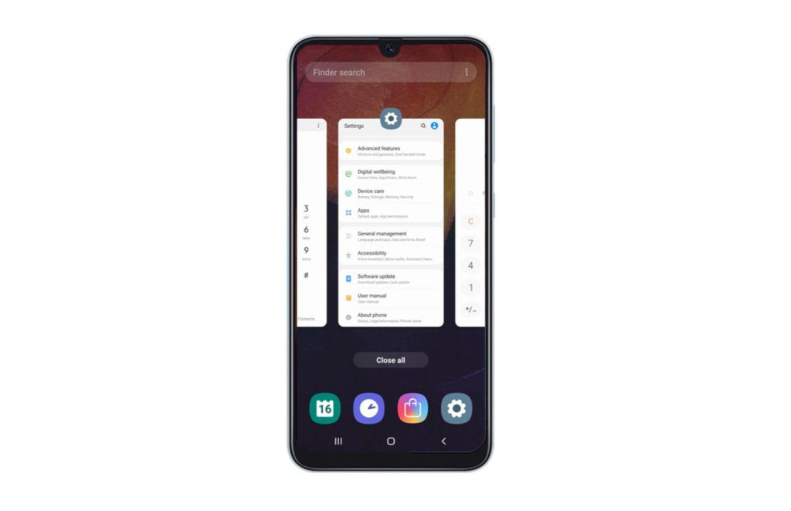](https://assets.mspimages.in/wp-content/uploads/2018/12/Samsung-Galaxy-A50-One-UI-Android-9-Pie.jpg)

**Samsung Galaxy A50 Lasts Long With 4000mAh Battery, Charges Fast**

The Galaxy A50 comes packed with a high-capacity battery. At 4000mAh, expect the phone to easily last a day even with heavy usage. Connectivity options on the Galaxy A50 include GPS with A-GPS, GLONASS, BeiDou, dual-SIM card slot with 4G LTE, Wi-Fi 802.11 a/b/g/n/ac (2.4Ghz and 5GHz), Bluetooth 5.0 (with LE), USB 2.0 Type-C port, and a 3.5mm headphone jack.

Samsung Galaxy A50 Specifications:

| **Summary** | |
| --- | --- |
| Performance | Samsung Exynos 9 Octa |
| Display | 6.4 inches (15.24 cm) |
| Storage | 64GB |
| Camera | Triple (25MP + 8MP + 5MP) |
| Battery | 4000 mAh |
| RAM | 4GB |

| **Display** | |
| --- | --- |
| Resolution | 1080 x 2340 pixels |
| Display Type | Super AMOLED |
| Screen Size | 6.4 inches (15.24 cm) |
| Pixel Density | 403 pixel per inch (ppi) |
| Touchscreen type | Capacitive, Multi-touch |

| **Storage** | |
| --- | --- |
| RAM | 4GB |
| Internal | 64GB |
| Expandable | micro SD, Up to 256GB |

| **Software** | |
| --- | --- |
| Operating System | Android v9.0 (Pie) |

| **Camera** | |
| --- | --- |
| Rear | Triple (25MP + 8MP + 5MP) |
| Selfie | 25MP |
| Rear Camera Features | LED Flash, Digital Zoom, Auto Flash, Face detection, Touch to focus |
| Other Features | Exposure compensation, High Dynamic Range mode (HDR) |

| **Battery** | |
| --- | --- |
| Removable Battery | No |
| Type | Li-ion |
| Wireless Charging | No |
| Capacity | 4000 mAh |
| Fast Charging | Yes |

| **Connectivity** | |
| --- | --- |
| GPS | Yes, with A-GPS, GLONASS, GALILEO, BDS |
| Wi-Fi | Yes, with Hotspot |
| Bluetooth | v5.0, A2DP, LE |
| Network | 4G VoLTE, 4G |
| USB | microUSB 2.0 Type-C 1.0 reversible connector |
| Voice Over LTE (VoLTE) | Yes |
| SIM Configuration | Dual, Nano-SIM |
| NFC Chipset | Yes |
| Infrared | No |

| **Processor** | |
| --- | --- |
| Chipset | Samsung Exynos 9 Octa |
| CPU | 2.3 GHz, Quad core, Cortex A73 + 1.6 GHz, Quad core, Cortex A53 |
| Graphics | Mali-G72 MP3 |
| Architecture | 64 bit |
| No of Cores | 8 (Octa Core) |

| **Sensors** | |
| --- | --- |
| Accelerometer | Yes |
| Gyroscope | Yes |
| Fingerprint sensor | Yes |
| Other Sensors | Proximity |

| **Sound** | |
| --- | --- |
| Speaker | Yes |
| Audio Jack | Yes, 3.5mm |

Samsung Galaxy A50₹ 17,690 is in the news once again, this time, thanks to the leak of a user manual that tips some interesting details, such as the presence of an in-display fingerprint sensor, a triple rear camera, as well as a list of specifications that include a massive 4,000mAh battery. The Samsung Galaxy A50 is expected to be part of the company's revamped Galaxy A-Series of devices, which are said to bring more premium features this year.

As per the leaked user manual and specifications sheet on SlashLeaks, an in-display fingerprint sensor is clearly visible in the Samsung Galaxy A50 schematics, while other interesting titbits include the triple rear camera setup, and the presence of a 3.5mm earphone jack at the bottom of the phone. An Infinity-U Display is also visible, Samsung's terminology for what is normally called the waterdrop-shaped display notch in the industry. To recall, Samsung had introduced its new display types at its developer conference in November last year.

The leaked schematics from the user manual also show the presence of a dedicated micro SD card slot on the Samsung Galaxy A50, as well as the presence of a USB Type-C port. A single rear-firing speaker is also visible, though the earpiece may also double up as one.

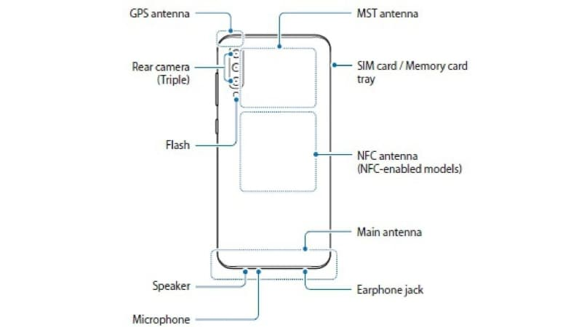

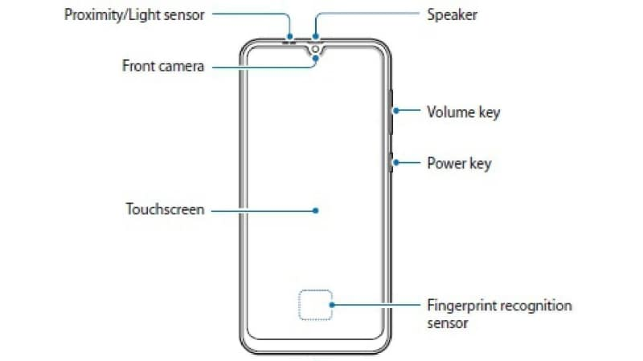

Coming to the leaked Samsung Galaxy A50 specifications, the dual-SIM smartphone with model number SM-A505F is seen to run Android 9.0 Pie, and sport a 6.4-inch Super AMOLED display with a full-HD+ (1080x2340 pixels) resolution. Unfortunately, no processor, RAM, or storage details were tipped, though earlier leaks had tipped an unnamed octa-core processor, 4GB of RAM, and 64GB of storage, on at least one of the variants.

The leaked specifications sheet doesn't detail the triple rear camera setup entirely, but does mention a 25-megapixel 1/2.8-inch sensor with a 0.9-micron pixel size, an f/1.7 aperture, and OIS - this matches a previous leak as well. SlashLeaks however adds that the other two sensors will be an 8-megapixel (f/2.4) sensor and a 5-megapixel (f/2.2) sensor - all this is paired with an LED flash module. No information is available about the front camera.

Other leaked Galaxy A50 specifications include dimensions of 158.6x74.7x7.7mm and a weight of 166 grams. Connectivity options include 4G VoLTE, Wi-Fi 802.11ac, Bluetooth v4.0, FM radio, a USB Type-C (v2.0) port, and a 3.5mm headphone jack. As we mentioned, a 4,000mAh battery was also tipped - something that matches an earlier leak.

**Design**

Picking up the Galaxy A50 in hand, it immediately feels very polished. The phone has a sandwich-type chassis design with polycarbonate edges that joins the screen and the back panel. While the company has gone with a notched display that should effectively narrow-down bezels, they are fairly noticeable, especially at the chin.

The rear panel is where Samsung has done some real magic. There’s a reflective coating that scatters the light through the plastic shell and makes for some really appealing hues. This is something that we haven't seen much before, and the colors reflected by the back of the Galaxy A50 do make it stand out from the general league of other phones.

Having said that, the back of the phone is a fingerprint and lint magnet, and we found ourselves cleaning the back of the phone very often. Samsung provides a silicone case in-the-box but given the lustrous finish on the back, we were reluctant to apply it on the A50.

The phone is sleek at 7.7mm with 3.5mm headphone jack and USB-C on the rear of the device joined by power and volume buttons on the side. There’s a speaker grille on the bottom edge which is fairly loud.

On the back, the vertical three camera module is positioned on the top-left corner with an LED flash below. Samsung’s logo combined with the reflective nature of the back panel makes for some very eye-pleasing rainbow hues. As a matter of fact, we got our hands on the Black colour model of the Galaxy A50 and not once has it given us the impression of being even close to a darker shade. Even though the phone is mostly plastic except for the front screen, the back of the phone doesn’t look and feel like plastic which is where Samsung scores some additional points from us.

Overall, the Galaxy A50 has a solid built, is sleek and we’re impressed by how Samsung has gone about with the rear panel design.

**Display:**

At 6.4 inches across, the Super AMOLED panel used by the Galaxy A50 looks tall and beautiful. The display’s got a Full HD+ (2340 x 1080 pixels) resolution, a pixel ratio density of 404 ppi and 19.5:9 aspect ratio. It has the U-shaped notch on the front which allows a screen-to-body ratio of 91.6%, making it one of the better phones to consume content on.

The front screen is topped with an additional layer of Gorilla Glass 3 to prevent it from scratches and scuff marks.

Samsung’s Infinity-U display is the least intrusive kind of notch design which allows more screen estate than the regular notch. This is especially useful for users who consume a lot of content on their smartphones primarily.

Due to the use of an AMOLED panel, the colors look vibrant with good contrast and saturation. The display is bright but has a bit of a warmer tone, but it’s nothing that will hamper the viewing experience.

We faced some initial hiccups with the auto-brightness where it would get activated even after being disabled manually. This is something that can be fixed via a software update, which we hope to see in the future.

Considering its price, the Galaxy A50 brings in a new AMOLED flavor to the budget phone market and further elevates the visual experience offered by

**Camera:**

Samsung deploys a tri-camera setup on the A50 which consists of a primary 25MP camera with an f/1.7 aperture, a 5MP depth-sensing camera with f/2.2 aperture and an 8MP ultra-wide angle lens with 123-degree field of view.

Samsung has also included features likes AR Emoji and Hyperlapsem, and the cameras on Galaxy A50 can also recognize different scenes and optimize the picture accordingly. There’s a hit and miss situation with Live Focus, as the cameras often failed to 'see' depth in an image. It took some time but we did manage to grab some good shots eventually.

Testing the camera, we took pictures in a range of environments and settings to see how it really performs. The A50 takes better photos during daylight and performs poorly at night. During daytime or in well-lit environments, the cameras were able to pick up fine details with accurate colors and dynamic ratio. However, in low-lit conditions, the sensor fails to capture details at all.

The third ultra-wide angle sensor gives a different perspective to the frame and should be a point of interest for enthusiasts. Samsung has made a good decision to go with an ultra-wide camera as it opens up new possibilities towards more advanced mobile photography. It’s commendable and we expect the company to develop on it.

A couple of pictures we took in a low-lit environment came out to be full of grains and little detail. There’s too much over-processing happening over here which is why it’s a dud in low-light photography. Our daylight shots were full of detail, identifiable texture, accurate colours and contrast.

We’ll say that the camera is capable enough to pull out some Instagram worthy pictures, and that’s going to take some practice, but looking for anything more than that would be expecting too much.

**Hardware:**

|  |  |
| --- | --- |
|  | |
| RAM | 4GB | |
| Internal storage | 64GB | |
| Expandable storage | Yes | |
| Expandable storage type | micro SD | |
| Expandable storage up to (GB) | 512 | |
| Dedicated micro SD slot | Yes | |

Samsung Galaxy A50 specifications and features

It's a little difficult to differentiate all the Galaxy M-series and A-series models and variants. The Galaxy A50 has a 6.4-inch full-HD+ 1080x2340-pixel Super AMOLED panel which is shared with some of its siblings, as we've pointed out, but its octa-core Samsung Exynos 9610 SoC is a cut above the Exynos 7904 that the others use.

This chip has four ARM Cortex-A73 and four Cortex A-53 CPU cores running at up to 2.3GHz and 1.6GHz respectively, to balance processing power and battery efficiency, along with a modern ARM Mali-G72 MP3 GPU. Samsung touts this SoC's image signal processor and support for deep learning algorithms to power features like single-camera depth sensing and face recognition.

There are two variants of the Galaxy A50, and the only difference between them is RAM. You can choose between 4GB and 6GB, but storage is the same at 64GB between the two, at least for the options launched in India as of now. This is a bit of a surprise, especially considering that the less expensive Galaxy M30 has a 128GB option (and both models have the same price gap of Rs.3,000 between variants).

Incidentally, 128GB was listed as an option when the Galaxy A50 was first unveiled at MWC 2019, so other countries might still get better specs. The 4000mAh battery is smaller than the 5000mAh unit that the Galaxy M30 has. These factors might confuse buyers a bit. You also get Bluetooth, Wi-Fi, FM radio, LTE and VoLTE on both SIMs, and the usual sensors.

It's very interesting that while the Galaxy M-series ships with Android 8.1 and Samsung's older Experience UI skin, the very similar Galaxy A50 runs Android 9 with the new One UI. This is good news, since users won't have to wait an unknown amount of time to get a major update. During our review period, we received an update to the February 2019 Android security patch.

One UI is generally an improvement in terms of design, and it does look quite modern. Samsung says it has focused on usability on phones with large screens, but what that means is it has reduced information density throughout and made text and icons everywhere enormous, with loads of padding between elements.

Some things, such as the quick settings panel, are now oversized so that icons are closer to the bottom of the screen where your thumbs are likely to be. It takes a bit of time to get used to. In some instances, it can feel as though screen space is being wasted, but on the other hand there are super useful touches like the Back button in the Settings app coming down within reach as you scroll rather than being anchored to the top-left corner of the screen.

We found that we were happier increasing the density of the icon grids for the home screens and the app drawer and reducing the default text size. You can disable the app drawer and also choose whether to open it with a swipe or by tapping an icon. An optional swipe downwards anywhere on the home screen can pull down the notifications shade. There are several customization options within various sub-menus of the Settings app that are well worth.

**Verdict**

Unfortunately for Samsung, the Galaxy A50 with its starting price of Rs.19,990 competes with Xiaomi's PocoF1 (Review) which features the top-end Qualcomm Snapdragon 845 processor. That's obviously the better choice of phone if you're a gamer or want the smoothest possible experience, but it doesn't have three rear cameras or a modern all-screen design.

As aggressive as Samsung is, it has been rather upstaged by the brand new Xiaomi Redmi Note 7 Pro with its Qualcomm Snapdragon 675 SoC, 48-megapixel primary camera, Gorilla Glass 5, and other impressive specifications. The Redmi Note 7 Pro has a starting price of Rs13,999 and even the higher-end variant at Rs.16,999 (with 128GB of storage) undercuts Samsung dramatically.

Another big competitor to the Samsung Galaxy A50 will be the company's own Galaxy M30, which has the same screen and a larger battery, but a weaker processor, standard fingerprint sensor, and a less flashy rear panel. If you aren't too fussed about camera quality, the Galaxy M30 starts for Rs.5, 000 less.

Even with these alternatives in the market, we think a lot of people will find the Galaxy A50interesting enough to consider seriously. It has all the current-day features that you'd want to show off, and there are no major problems. We think there's scope for improvement with the cameras and software, but overall, Samsung is really showing that it knows how to bring the fight back.

**Samsung Galaxy A50 Review Verdict with Pros and Cons**

The Galaxy A50 seems to be a well thought out mid-range offering. The phone seems to be ticking a lot of right boxes. The design is cool, AMOLED display is good quality, One UI software is better than what most other Android brands have to offer, and battery backup is excellent. The day-to-day performance should be good enough for average users over a longer period of time. Overall, the Galaxy A50 practical experience is much better than what its spec-sheet implies.

The Galaxy A50 will face a stiff challenge from Xiaomi’s PocoF1 (review) and Redmi K20, which offer more raw power. Having said that, If you are not an avid gamer, the Galaxy A50 should serve you better.

**Pros**

* Excellent display
* Premium look and feel
* Good battery mileage
* One UI interface
* Supports HD streaming on Netflix and Prime

**Cons**

* Average low light photography
* Average gaming performance