

MSPM’S

Deogiri Institute of Engineering and Management Studies, Aurangabad

Department of Computer Science and Engineering

Survey Based On

Acer Predator Helios 300

Report Based On:

Laptop Specification and components

Subject:

Computer Architecture and Organization

Submitted by

KrushnaKulkarni

(26116)

CSE B

Under the Guidance of

Prof.: P. H. Durole

Asst. prof. Department of CSE

(Deogiri Institute of Engineering and Management Studies)

2019-2020



**CERTIFICATE**

This is certifying that Mr. Krushna Kulkarni had successfully completed survey-based report on

Acer Predator Helios 300

Date ………

Name of Guide

Prof. P. H. Durole

Asst. Prof. Department of CSE

Acer Predator Helios 300

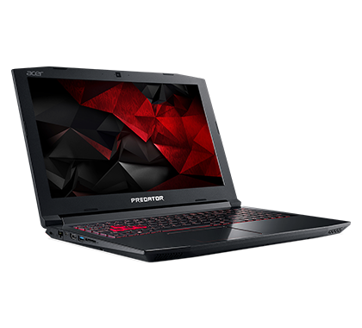

Acer Predator Helios 300 PH315-51 (NH. Q3HSI.005) Laptop (Core i5 8th Gen/8 GB/1 TB 128 GB SSD/Windows 10/4 GB) laptop has a 15.6 Inches (39.62 cm) display for your daily needs. This laptop is powered by Intel Core i5-8300H (8th Gen) processor, coupled with 8 GB of RAM and has 1 TB HDD storage at this price point. It runs on Windows 10 Home Basic operating system. As far as the graphics card is concerned this notebook has a 4 GB NVIDIA Geforce GTX 1050Ti graphics card to manage the graphical functions. To keep it alive, it has a 4 Cell Li-Ion battery and weighs 2.7 Kg.

**Design**

The Predator's aluminium-and-plastic design doesn't stray far from the look of Acer's other budget gaming notebooks; its black, metal lid has two red stripes flanking the Predator logo. There's a small plastic bumper on the top of the lid that feels far cheaper than the aluminium that surrounds it.

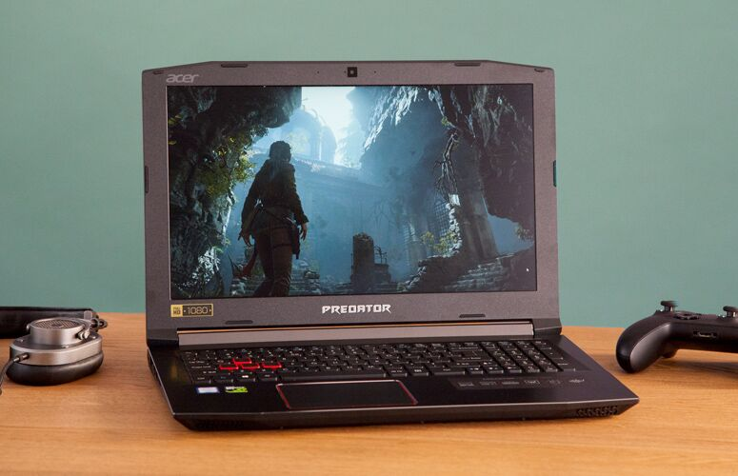

When you lift the lid, you'll find the 15.6-inch, 1080p display, surrounded by a bezel that has the Predator logo on the bottom and the Acer logo on the top-left corner. That second logo is distracting, and I wish Acer had the confidence to let the Predator brand stand on its own, the way Dell does with Alienware and Asus does with its Republic of Gamers line. There's also a full keyboard with a number pad utilizing red backlighting and red WASD keys, as well as a black, metal deck.

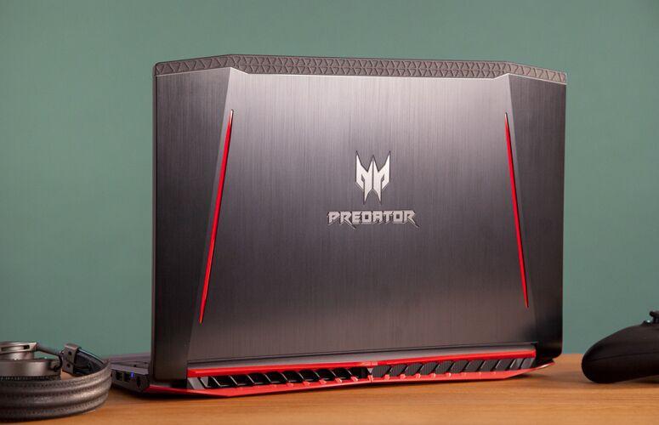

At 5.5 pounds and 15.4 x 10.5 x 1.5 inches, the Predator Helios 300 is a little larger than other mainstream gaming notebooks but also just a tad lighter. The Asus ROG Strix GP72VR GL553VD (15.1 x 10 x 1.2 inches, 5.6 pounds) and the Lenovo Legion Y520 (15 x 10.4 x 1 inches, 5.6 pounds) are slightly smaller. The 17-inch MSI 7RFX Leopard Pro is, unsurprisingly, bigger and heavier (16.5 x 10.6 x 1.5 inches, 6.4 pounds).

As any good gaming notebook should, the Predator has plenty of ports. On the left side are an Ethernet jack, a USB Type-C port, HDMI output, a USB 3.0 port and an SD card slot. A headphone jack and a pair of USB 2.0 ports are located on the right side of the laptop.

**Display**

The 15.6-inch, 1080p display on the Predator is sharp but otherwise lacklustre. When I watched the trailer for Marvel's Inhumans, Medusa's red hair didn't pop against her lavender dress, and bright lights overpowered both Black Bolt and Medusa in a scene together. It wasn't as bright as I would have liked, but it was perfectly usable.

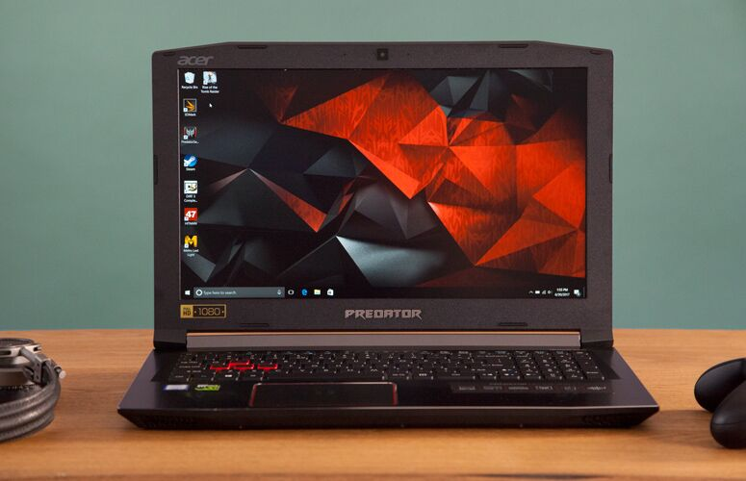

I had a similar experience in Mass Effect: Andromeda. In dark areas, I wished I could bump up the brightness, but in lighter parts of the game, I could see fine. Some fires during a space battle looked more orange than red, but it otherwise looked accurate.

The Predator's display covers 81 percent of the sRGB color gamut, surpassing the Legion (68 percent) but falling below the 15-inch laptop average (94 percent), the Strix (122 percent) and the Leopard Pro (165 percent).

The colors aren't the most accurate, either. The Predator's Delta-E score of 4.7 (0 is ideal) is worse than the average (2.2), as well as the scores for the Strix (1.6), the Leopard Pro (0.3) and the Legion (0.2)

The screen measured 226 nits of average brightness on our light meter, which is dimmer than the average (274 nits), the Strix (269 nits) and the Leopard Pro (245 nits), but brighter than the Legion (220 nits).

**Keyboard and Touchpad**

The Predator's keyboard is comfortable, but I wish it felt more responsive. The keys have 1.6 millimetres of vertical travel, so I never felt as if I were bottoming out. But the keys require 79 grams of pressure to actuate, which kept them from feeling light and clicky. It didn't take long to get used to the extra pressure, though, and I typed at 109 words per minute (within my usual 107-115-wpm range) with my standard 2 percent error rate).

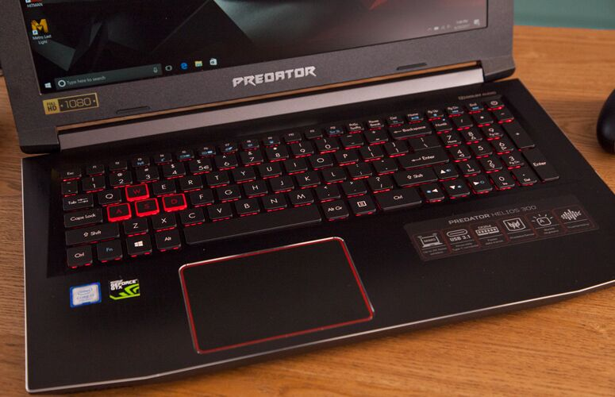

There are a few oddities on the keyboard. The Shift key and the top arrow key are very close together -- far closer than any other two keys on the keyboard -- and the right arrow key takes up some space in the number pad. Unlike the keyboard on the similarly priced Strix, the Predator's keyboard is backlit only in red; it doesn't have full RGB lighting.

The 4.1 x 3-inch touchpad is spacious, accurate and responsive to Windows 10 gestures; I had no problem pinching to zoom or swiping my Windows away. I had to click a bit harder than I usually expect to, though for games, most players use a dedicated gaming mouse anyway.

**Audio**

Acer's True Harmony speakers are nice and loud, just how I like them. When I listened to Zed and Alessia Cara's "Stay," the computer pumped the song from wall to wall of our midsize meeting room, producing clear vocals, synths and drums. The bass wasn't as strong as I would have liked, though.

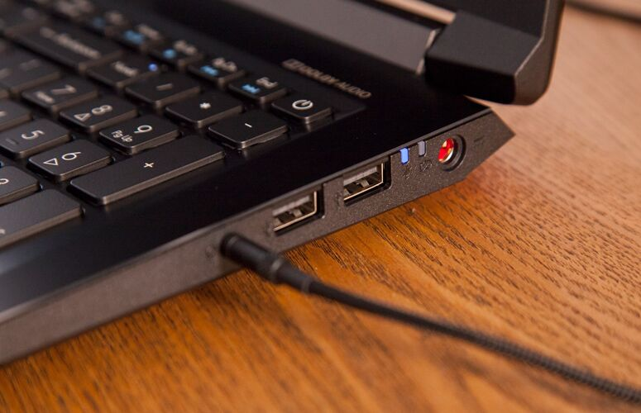

When I played Mass Effect: Andromeda, I could clearly hear the lasers in the middle of a space battle, and chatter with teammates was loud and clear.

Acer's True Harmony speakers are nice and loud, just how I like them.

The preinstalled Dolby Audio app offers a series of profiles, including Music, Movie and Game modes. Movie mode made it slightly louder, and Game mode focused on the drums. I found that the default Music setting was a fine balance.

**Gaming, Graphics and VR**

The Predator's Nvidia GeForce GTX 1060 GPU with 6GB of VRAM is a great value, and it showed its might in our performance testing. When I played Mass Effect: Andromeda on ultra-settings at 1080p with FXAA anti-aliasing, the game ran between 70 and 80 frames per second during battle and occasionally dropped down to 64 fps during interactive cutscenes.

On the Rise of the Tomb Raider benchmark (1080p, very high settings), the Predator ran the game at 67 fps, surpassing the mainstream notebook average (36 fps), the Strix (18 fps, GTX 1050), the Leopard Pro (33 fps, GTX 1060) and the Legion (46 fps, GTX 1050 Ti).

The Hitman benchmark (1080p, very high settings) rendered at 67 fps on the Helios 300, falling behind the Leopard Pro (78 fps) but ahead of the average (44 fps), the Strix (30 fps) and the Legion (60 fps).

Grand Theft Auto V (1080p, ultra-settings) played at 49 fps, which is slightly better than the average (47 fps) and the Leopard Pro (48 fps) and much smoother than the Strix (23 fps). We consider anything over 30 fps to be playable.

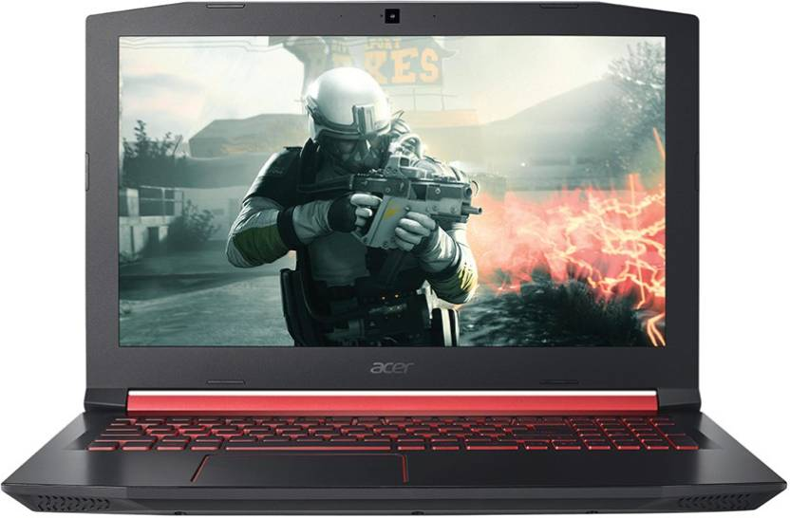The Predator achieved a score of 7.1 on the SteamVR Performance Test, surpassing the average of 5.6 and tying the Leopard Pro.

**Performance**

The Predator is armed with a 2.8-GHz Intel Core i7-7700HQ CPU, 16GB of RAM and a 256GB solid-state drive, which is more than enough for some serious multitasking. I had 30 tabs open in Chrome while I watched a 1080p stream on Twitch, and didn't see any lag.

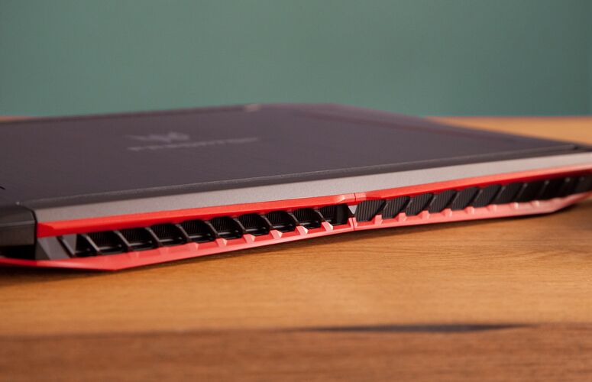

On the Geekbench 4 overall performance test, the Predator notched a score of 13,587, overcoming the mainstream average (10,675) and the rest of the pack. The Legion earned a score of 13,037, the Strix reached 12,253 and the Leopard Pro achieved 12,147.

The Predator's Nvidia GeForce GTX 1060 GPU with 6GB of VRAM is a great value, and it showed its might in our performance testing.

It took the Predator 27 seconds to copy 4.97GB of mixed media files, resulting in a rate of 188.5 megabytes per second. The average is 207.6 MBps, while the Legion (363.5 MBps) and the Leopard Pro (565.5 MBps) were both quicker. The Strix (94.2 MBps) came in a distant last place.

The Predator took 3 minutes and 22 seconds to pair 20,000 names and addresses in our OpenOffice Spreadsheet Macro, handily beating the average of 4:12. The Legion (3:19) was quicker, and the Strix (3:31) and the Leopard Pro (3:24) were a little slower.

**Battery Life**

This is a gaming laptop that lasted far longer than we expected. It ran for 6 hours and 48 minutes on the Laptop Mag Battery Test, which browses the web continuously over Wi-Fi. That's lower than the mainstream average (7:00), but gaming notebooks tend to not even come close to that.

The Leopard Pro, for instance, endured for only 2:32, while the Legion (3:39) and the Strix (3:41) also died out much sooner than the Predator.

**Heat**

When it's not gaming, the Predator stays nice and cool under simple workloads. After we streamed HD video from YouTube for 15 minutes, the bottom of the notebook reached just 88 degrees Fahrenheit; the keyboard between the G and H keys measured 84.5 degrees; and the touchpad was 79.5 degrees. All of these temperatures are below our 95-degree comfort threshold.

But things heat up when you start to play: The bottom climbed to 113.5 degrees, and the keyboard reached 104.5 degrees. However, the touchpad stayed cool, at 83.5 degrees.

**Webcam**

The 720p webcam on the Predator is nice and sharp, but its colors aren't accurate. While I could make out individual hairs and see the creases in a colleague's jacket behind me, my navy-blue shirt appeared black.

**Software and Warranty**

Acer's biggest addition to the Predator is its Predator Sense app, which lets you monitor CPU and GPU speeds and fine-tune fan control for optimal performance.

You'll also find all the bloat usually packed into Windows 10, including Sling, Facebook, Twitter, Candy Crush Soda Saga and Royal Revolt 2.

Acer sells the Predator Helios 300 with a two-year warranty. See how the company did on our Tech Support Showdown and Best and Worst Brands report.

Specifications

General

|  |  |
| --- | --- |
| Sales Package | * Laptop, Battery, Power Adaptor, User Guide, Warranty Documents |
| Model Number | * PH315-51 / PH315-51-51V7/ph315 51 55xx |
| Part Number | * NH. Q3HSI.014 / NH. Q3HSI.007 |
| Series | * Predator Helios 300 |
| Color | * Obsidian Black |
| Type | * Gaming Laptop |
| Suitable For | * Gaming, Processing & Multitasking |
| Battery Backup | * Up to 7 hours |
| Power Supply | * 135 W AC Adapter |
| Battery Cell | * 4 cells |
| MS Office Provided | * No |

Processor and Memory Features

|  |  |
| --- | --- |
| Dedicated Graphic Memory Type | * GDDR5 |
| Dedicated Graphic Memory Capacity | * 4 GB |
| Processor Brand | * Intel |
| Processor Name | * Core i5 |
| Processor Generation | * 8th Gen |
| SSD | * Yes |
| SSD Capacity | * 128 GB |
| RAM | * 8 GB |
| RAM Type | * DDR4 |
| HDD Capacity | * 1 TB |
| Processor Variant | * 8300H |
| Chipset | * Intel HM370 |
| Clock Speed | * 2.3 GHz with Turbo Boost Up to 4 GHz |
| Memory Slots | * 2 Slots |
| Expandable Memory | * Up to 32 GB |
| Cache | * 8 MB |
| Graphic Processor | * NVIDIA Geforce GTX 1050Ti |

Operating System

|  |  |
| --- | --- |
| OS Architecture | * 64 bits |
| Operating System | * Windows 10 Home |
| System Architecture | * 64 bits |

Port and Slot Features

|  |  |
| --- | --- |
| Mic In | * Yes |
| RJ45 | * Yes |
| USB Port | * 2 x USB 2.0, 1 x USB 3.0, 1 x USB 3.1 (1st Gen) Type C |
| HDMI Port | * 1 x HDMI Port (v2.0) |
| Multi Card Slot | * SD Card Reader |

Display and Audio Features

|  |  |
| --- | --- |
| Touchscreen | * No |
| Screen Size | * 39.62 cm (15.6 inch) |
| Screen Resolution | * 1920 x 1080 Pixel |
| Screen Type | * Full HD LED Backlit IPS Display |
| Speakers | * Built-in Dual Speakers |
| Internal Mic | * Built-in Dual Digital Microphone |
| Sound Properties | * Stereo Speakers, Acer True Harmony Plus Technology, Optimized Dolby Audio Premium Sound Enhancement |

Connectivity Features

|  |  |
| --- | --- |
| Wireless LAN | * IEEE 802.11a/b/g/n/ac |
| Bluetooth | * v5.0 |
| Ethernet | * Gigabit Ethernet, Wake-on-LAN Ready |

Dimensions

|  |  |
| --- | --- |
| Dimensions | * 390 x 266 x 26.75 mm |
| Weight | * 2.5 kg |

Additional Features

|  |  |
| --- | --- |
| Disk Drive | * Not Available |
| Web Camera | * HD Webcam |
| Lock Port | * Kensington Lock Slot |
| Keyboard | * Fine Tip Backlit Keyboard with Independent Standard Numeric Keypad (International Language Support) |
| Backlit Keyboard | * Yes |
| Pointer Device | * Multi Gesture Touchpad |
| Included Software | * Acer Care Centre, Acer Portal, Acer Quick Access, Acer Configuration Manager |
| Additional Features | * 3220 mA Li-ion Battery, Dual Fan Cooling with Metal Aero Blade 3D, Metal Form Factor Designed |

Quotation:

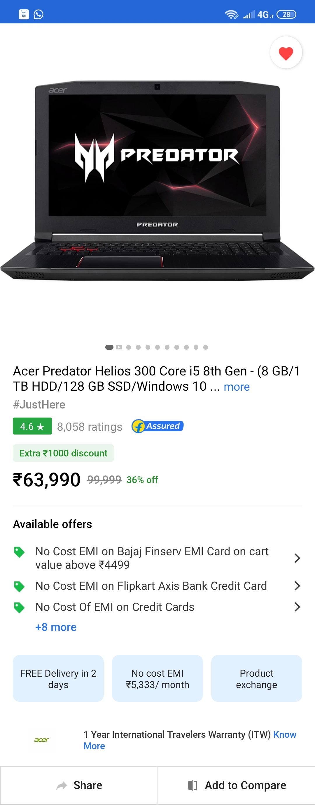

References:

* www.google.in
* https://www.laptopmag.com/reviews/laptops/acer-predator-helios300
* www.flipkart.com