

**Deogiri Institute of Engineering and Mangement Studies**

**Aurangabad**

Report on

LENOVO 330S

BY

Anshul Saboo (26118)

Under the Guidance of

Prof. Pankaj Durole

(Asst prof./Prof. Deogiri Institute of Engineering and Management Studies Aurangabad )

**LENOVO 33OS**

**INTRODUCTION**

Featuring a streamlined chassis with a polished aluminum cover, the Ideapad 330S is designed to make an impression. Choose from four sophisticated tone-on-tone color options to make it yours.

With up to seven hours* of battery life, the Ideapad 330S will easily go wherever your day takes you.

*Based on testing with MobileMark 2014. Battery life varies significantly with settings, usage, & other factors.

The latest generation of Intel® Core™ i7 processing offers up to a 40 percent improvement in performance,* with unprecedented gaming capabilities, theater-like entertainment, faster boot-ups, and seamless multi-tasking.

*Software and workloads used in performance tests may have been optimized for performance only on Intel® microprocessors. Performance tests are measured using specific computer systems, components, software, operations, and functions. Any change to any of those factors may cause the results to vary.

Running out of battery and short on time? The Ideapad 330S supports Rapid Charge—15 minutes plugged in will give you up to 2 hours of use.* You’ll also be able to charge your phone and other devices via USB 3.0 port, even when your laptop is powered off. Make the most of your time.

*In power-off mode. 65 W power supply required.

Leverage the best of Windows 10, with a new update packed with exciting features. The powerfully reimagined Photos app makes it easier–and more fun—to tell your story in video: add a soundtrack, use transitions, deploy 3D effects, and more. And sharing is quicker than ever, with intuitive settings that make it easier to instantly connect with the people you care about most.

graphics cards rely on their own processing power, so you'll experience smoother graphics, less screen tearing, and better gaming performance without compromising overall speed and responsiveness. Whether you're playing a game or creating or editing content, you'll enjoy crisp visuals.

We are committed to providing an uncluttered desktop and a safer PC experience out of the box. Our preload contains just five hand-selected applications designed to increase your productivity.

Featuring up to FHD resolution on a wide-angle display edged with razor-thin 5.7 mm bezels, the Ideapad 330S offers the dynamic experience of a portable home theater.

The Ideapad 330S can be customized to fit all your storage needs: Up to 2 TB SATA HDD stores thousands of videos, photos, and files. A responsive SATA or PCIe SSD – up to 256 GB – features shorter boot-up times and faster data-transfer speeds. And 128 GB PCIe SSD + 1 TB SATA HDD hybrid storage gives you a good mix of both.

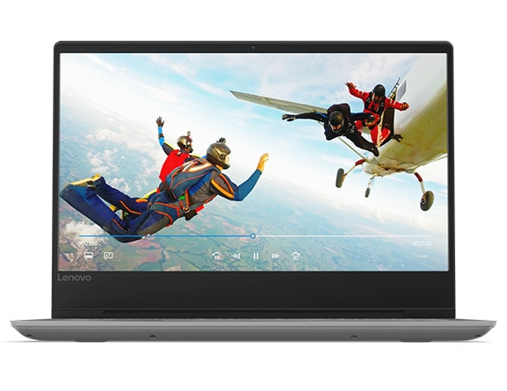

**SPECIFICATIONS**

General

|  |  |
| --- | --- |
| Sales Package | * Laptop, Battery, Power Adaptor, User Guide, Warranty Documents |
| Model Number | * 330-15IKB |
| Part Number | * 81DE01K0IN |
| Series | * Ideapad 330 |
| Color | * Onyx Black |
| Type | * Laptop |
| Suitable For | * Processing & Multitasking |
| Battery Backup | * Upto 6 hours |
| Power Supply | * 65 W AC Adapter |
| Battery Cell | * 2 cell |
| MS Office Provided | * No |

Processor And Memory Features

|  |  |
| --- | --- |
| Dedicated Graphic Memory Type | * GDDR5 |
| Dedicated Graphic Memory Capacity | * 2 GB |
| Processor Brand | * Intel |
| Processor Name | * Core i5 |
| Processor Generation | * 8th Gen |
| SSD | * No |
| RAM | * 8 GB |
| RAM Type | * DDR4 |
| HDD Capacity | * 1 TB |
| Processor Variant | * 8250U |
| Clock Speed | * 1.6 GHz with Turbo Boost Upto 3.4 GHz |
| Memory Slots | * 2 Slots |
| Expandable Memory | * Upto 8 GB |
| RAM Frequency | * 2133 MHz |
| Cache | * 6 MB |
| RPM | * 5400 |
| Graphic Processor | * NVIDIA Geforce MX150 |
| Number of Cores | * 4 |

Operating System

|  |  |
| --- | --- |
| OS Architecture | * 64 bit |
| Operating System | * Windows 10 Home |
| System Architecture | * 64 bit |

Port And Slot Features

|  |  |
| --- | --- |
| Mic In | * Yes |
| RJ45 | * Yes |
| USB Port | * 2 x USB 3.0, 1 x USB 3.0 Type C |
| HDMI Port | * 1 x HDMI Port |
| Multi Card Slot | * 4-in-1 Card Reader (SD, SDHC, SDXC, MMC) |

Display And Audio Features

|  |  |
| --- | --- |
| Touchscreen | * No |
| Screen Size | * 39.62 cm (15.6 inch) |
| Screen Resolution | * 1366 x 768 Pixel |
| Screen Type | * HD LED Backlit Anti-glare TN Display |
| Speakers | * Built-in Dual Speakers |
| Internal Mic | * Single Microphone |
| Sound Properties | * 2 x 1.5 W Speakers with Dolby Audio |

Connectivity Features

|  |  |
| --- | --- |
| Wireless LAN | * WIFI 1x1 AC |
| Bluetooth | * v4.1 |
| Ethernet | * 100/1000 Mbps |

Dimensions

|  |  |
| --- | --- |
| Dimensions | * 378 x 260 x 22.9 mm |
| Weight | * 2.2 kg |

Additional Features

|  |  |
| --- | --- |
| Disk Drive | * Not Available |
| Web Camera | * HD 720P Webcam |
| Antivirus | * McAfee LiveSafe 12 Months Subscription |
| Keyboard | * Island Style Keyboard |
| Pointer Device | * Touchpad |
| Included Software | * Lenovo App Explorer, Lenovo Companion 3.0 |
| Additional Features | * Li-ion Battery, NVIDIA Geforce MX150 for Supreme Graphics Performance |
|  |  |

**PROCESSOR**

**Core i5-8250U** is a 64 bit quad- core performance x 86 mobile microprocessor introduced by Intel in mid- 2017. This processor, which is based on an enhanced version of the Kaby Lake micro architecture, is manufactured on Intel's 2nd generation enhanced 14nm + process. The i5-8250U operates at 1.6 GHz with a TDP of 15 W and Turbo Boost frequency of up to 3.4 GHz. This MPU supports up to 32 GiB of dual-channel DDR4-2400 memory and incorporates Intel's UHD Graphics 620 IGP operating at 300 MHz with a burst frequency of 1.15 GHz.

This model has a configurable TDP-down of 10 W at 800 MHz and a TDP-up of 25 W at 1.8 GHz.

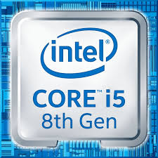

**GRAPHIC PROCESSOR (NVIDIA GeForce MX150 )-**

The GeForce MX150 is a graphics card by NVIDIA, launched in May 2017. Built on the 14 nm process, and based on the GP108 graphics processor, in its N17S-G1-A1 variant, the card supports DirectX 12.0. The GP108 graphics processor is a relatively small chip with a die area of only 74 mm² and 1,800 million transistors. It features 384 shading units, 24 texture mapping units and 16 ROPs. NVIDIA has placed 2,048 MB GDDR5 memory on the card, which are connected using a 64-bit memory interface. The GPU is operating at a frequency of 1227 MHz, which can be boosted up to 1468 MHz, memory is running at 1502 MHz.  
Being a igp card, the NVIDIA GeForce MX150 does not require any additional power connector, its power draw is rated at 25 W maximum. This device has no display connectivity, as it is not designed to have monitors connected to it. GeForce MX150 is connected to the rest of the system using a PCI-Express 3.0 x16 interface.

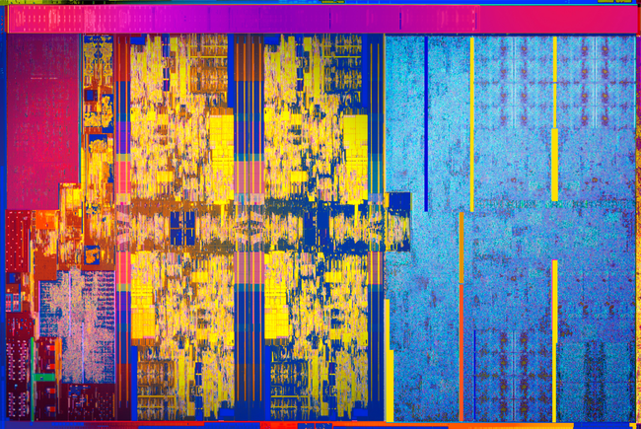

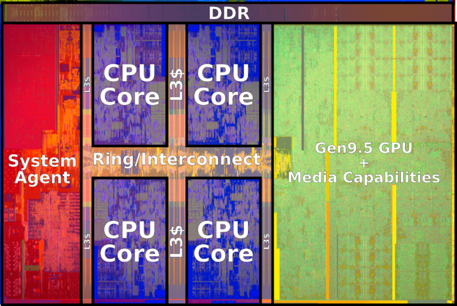

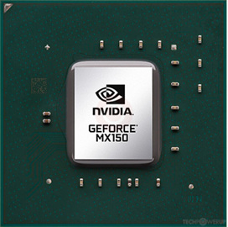

**PORTS AND CONNECTIVITY**

1. **RJ45 Port** - RJ45 is a type of connector commonly used for Ethernet networking. It looks similar to a telephone jack, but is slightly wider. Since Ethernet cables have an RJ45 connector on each end, Ethernet cables are sometimes also called RJ45 cables.

The "RJ" in RJ45 stands for "registered jack," since it is a standardized networking interface. The "45" simply refers to the number of the interface standard. Each RJ45 connector has eight pins, which means an RJ45 cable contains eight separate wires. If you look closely at the end of an Ethernet cable, you can actually see the eight wires, which are each a different color. Four of them are solid colors, while the other four are striped.

RJ45 cables can be wired in two different ways. One version is called T-568A and the other is T-568B.

1. **MIC in Port** - Sometimes abbreviated as **mic**, a **microphone** is a [hardware](https://www.computerhope.com/jargon/h/hardware.htm) [peripheral](https://www.computerhope.com/jargon/p/peripher.htm) and [input device](https://www.computerhope.com/jargon/i/inputdev.htm) originally invented by [Emile Berliner](https://www.computerhope.com/people/emile_berliner.htm) in [1877](https://www.computerhope.com/history/1800.htm). A microphone allows computer users to [input](https://www.computerhope.com/jargon/i/input.htm) audio into their computers. The picture is an example of *Blue Microphone's Yeti USB microphone - silver edition* and an example of a high-quality computer microphone.\
2. **TYPE C USB Port** - **USB-C**, formally known as **USB Type-C**, is a 24-pin USB connector system, which is distinguished by its two-fold rotationally-symmetrical connector.

The USB Type-C Specification 1.0 was published by the USB IMPLEMENTERS FORM  (USB-IF) and was finalized in August 2014. It was developed at roughly the same time as the USB 3.1 specification. In July 2016, it was adopted by the IEC as "IEC 62680-1-3".

A device with a Type-C connector does not necessarily implement USB .31, USB POWER DELIVERY , or any Alternate mode: the Type-C connector is common to several technologies while mandating only a few of them.

USB 3.2, released in September 2017, replaces the USB 3.1 standard. It preserves existing USB 3.1 *SuperSpeed* and *SuperSpeed+* data modes and introduces two new *SuperSpeed+* transfer modes over the USB-C connector using two-lane operation, with data rates of 10 and 20 Gbit/s (1 and ~2.4 GB/s).

1. **HDMI Port -** Short for High Definition Multimedia Interface, HDMI is a connector and cable capable of transmitting high-quality and high-bandwidth streams of audio and video between devices. The HDMI technology is used with devices such as an HDTV, Projector, DVD player, or Blu-ray player.
2. **ETHERNET Port -** Ethernet connections are found on the back of a computer or the back or side of a laptop. A router may have several Ethernet ports to accommodate multiple wired devices on a network. The same is true for other network hardware like hubs and modems.

An Ethernet port accepts a cable that has an RJ-45 connector. The alternative to using such a cable with an Ethernet port is Wi-fi, which eliminates the need for both the cable and the port.

An Ethernet port is a little wider than a phone jack. Because of this shape, it's impossible to neatly fit an Ethernet cable into a phone jack, which makes it a little easier when plugging in cables.

**PORTS OF IDEAPAD 330S**

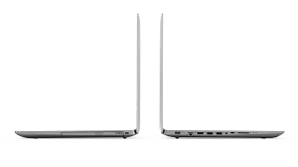

**RANDOM ACCESS MEMORY (DDR4 SDDRAM)**

What is DDR4 RAM?

DDR4 SDRAM is the abbreviation for "double data rate fourth generation synchronous dynamic random-access memory", the latest variant of memory in computing. DDR4 is able to achieve higher speed and efficiency thanks to increased transfer rates and decreased voltage. The last dynamic random-access memory update, DDR3, came out in 2007, but developers began working on DDR4 back in 2005. Samsung manufactured the first DDR4 memory console in 2011 and this technology is expected to hit the consumer market sometime in 2014. External hardware receives more hype, but this new memory technology is one example of the internal developments that enable computing advancements.

DDR4 chips are expected to support transfer rates between 2133 MT/s (million transfers per second) and 4266 MT/s. By comparison, DDR3 technology supports only up to 800 to 2133 MT/s. This significant memory transfer boost will enable hardware developers to produce DDR4 chips with more powerful processors and more capable devices. This new memory also uses less power -- 1.2 Volts compared to 1.65 Volts of DDR3 chips. This reduced power consumption should lead to better battery life in portable devices such as phones and tablets. DDR4 doesn't fundamentally change the way memory operates, but it features a new command signal to indicate the active command. The /ACT command consolidates the previous process, which demanded three separate commands when an active command is in use.

Major technology manufacturers have already started integrating DDR4 chips into their lines of products. AMD has been sampling DDR4 in its latest chip sets. Intel also announced that it would use DDR4 technology in an upcoming computing product. Consumers may not celebrate this significant advance in memory technology, but they will appreciate the performance it provides and new features it enables. Under-the-hood technology is the engine that drives computers, and DDR4 is compact piece of muscle.

What are the benefits of DDR4?

DDR4, the latest generation of RAM, offers increased speed and efficiency for computing devices. Short for "double data rate fourth generation", DDR4 is set to makes its debut on the smartphone, tablet, and desktop computer, market in 2014. Developers began drawing up the plans for DDR4 in 2005, two years before its predecessor, DDR3, hit the market. This new memory chip technology boasts increased transfer speeds that will boost performance of your favorite devices. The previous generation of dynamic RAM offered speeds between 800 and 2133 MT/s (million transfers per second), but DDR4 supports speeds of between 2133 and 4266 MT/s. Along with its increased speed, DDR4 also is more efficient, using a maximum of 1.2 Volts compared to DDR3's maximum 1.65 Volts.

This cutting-edge memory is the foundation for the next-generation of devices. DDR4 enables developers to add more powerful processors to their hardware. For consumers, that means advanced computing capabilities on all platforms, whether it's a smartphone, tablet or desktop computer. DDR4 also will enable hardware manufacturers to boost the battery life on their mobile devices, a major concern for millions of smartphone users. Consumers might not celebrate this internal hardware development, but we rely on it to run the systems and applications we love.