 **MSPM'S**

**DEOGIRI INSTITUTE OF ENGINEERING AND MANAGEMENT STUDIES, AURANGABAD**

Department of Computer science and Engineering

Survey Based Project **Report** on

Hp (pavilion 14 ce-1003tx) & Hp (pavilion x360-14-cd0087tu

**Subject: Computer architecture and Organization**

Submitted By

**Harman Hora (26023)**

**Yash sonnawane (26024)**

Under the guidance of

**Prof. P. H. Durole**

Asst. Prof. Department of CSE

(Deogiri Institute of Engineering and Management Studies)

2019-2020



CERTIFICATE

This is to certify that Mr. Harman Hora & Mr. Yash Sonawane had

Successfully completely his/her Survey Based Project on Comparison of laptops on date 17/08/2019

**Hp pavilion-14ce-1003tx:**

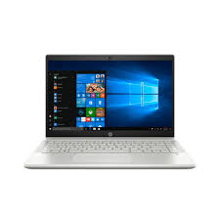 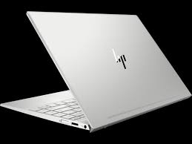

**Specifications:**

**Processor**

Intel core i7 8th Generation:

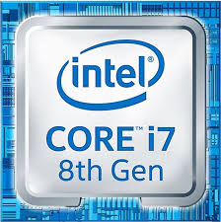

The **Intel Core i7-8565U** is a power efficient quad-core SoC for notebooks and Ultrabooks based on the Whiskey Lake generation that was announced in August 2018 (IFA). Compared to the similar named Kaby Lake-R processors (e.g. Core i7-8550U), the Whiskey Lake CPUs are now produced in a further improved 14nm process (14nm++) and offer higher clock speeds. The architecture and features are the same. The i7-8565U offers e.g. high Turbo clock speeds of 4,6 GHz (versus 4 GHz of the i7-8550U) for a single core and 4.1 GHz (versus 3.7 GHz) of all cores (4.1 GHz for 2 cores). The integrated GPU is still named Intel UHD Graphics 620 and the dual-channel memory controller still supports the same RAM speeds as Kaby-Lake-R (DDR4-2400 / LPDDR3-2133). Compared to the slower Core i5-8265U and i3-8145U, the i7 supports **Thermal Velocity Boost**.

The Whiskey Lake SoCs are used with a new PCH produced in 14nm that supports USB 3.1 Gen 2 (10 Gbps) and CNVi WiFi/BT parts.

**Architecture**

Intel basically uses the same microarchitecture compared to Skylake and Kaby Lake, so the per-MHz performance does not differ. That means Whiskey Lake is a Kaby Lake chip manufactured in the improved 14nm++ process.

**Performance**

The performance of the i7-8565U depends on the cooling solution of the laptop and the defined TDP limits for short and long term performance. We already saw big differences for Kaby Lake-R (e.g., i7-8550U benchmarks), especially for long term (sustained) performance. Therefore, it will be interesting to see how the additional Turbo  clock speed can be made use of. It looks like Intel is promoting the i7 to be 3 - 11% faster than the previous i7-8550U, with Cinebench R15 Multi reaching 5% gains.

**Graphics**

The integrated Intel UHD Graphics 620 (Intel Gen 9.5) is untouched from the 8th Gen Kaby Lake chips. With fast dual-channel memory, it can reach the performance of a dedicated GeForce 920M.

Contrary to Skylake, Kaby Lake and Whiskey Lake now also supports H.265/HEVC Main 10 with a 10-bit color depth as well as Google's VP9 codec. The dual-core Kaby Lake processors announced in January should also support HDCP 2.2.

**Power Consumption**

The chip is manufactured in a further improved 14nm process with FinFET transistors (14nm++), the same as the 8th Gen Coffee Lake processors. Intel still specifies the TDP with 15 Watts, which is typical for ULV chips. Depending on the usage scenario, the TDP can vary between 7.5 (cTDP Down) and 25 Watts.

**Essentials**

* Product Collection [8th Generation Intel® Core™ i7 Processors](https://ark.intel.com/content/www/us/en/ark/products/series/122593/8th-generation-intel-core-i7-processors.html)
* Code Name [Products formerly Whiskey Lake](https://ark.intel.com/content/www/us/en/ark/products/codename/135883/whiskey-lake.html)
* Vertical Segment Mobile
* Processor Number i7-8565U
* Status Launched
* Launch Date Q3'18
* Lithography 14 nm
* Recommended Customer Price $409.00

**Performance**

* # of Cores 4
* # of Threads 8
* Processor Base Frequency 1.80 GHz
* Max Turbo Frequency 4.60 GHz
* Cache 8 MB Smart Cache
* Bus Speed 4 GT/s OPI
* TDP 15 W
* Configurable TDP-up Frequency 2.00 GHz
* Configurable TDP-up 25 W
* Configurable TDP-down Frequency 800 MHz
* Configurable TDP-down 10 W

**Supplemental Information**

* Embedded Options Available No

**Memory Specifications**

* Max Memory Size (dependent on memory type) 64 GB
* Memory Types DDR4-2400, LPDDR3-2133
* Max # of Memory Channels 2
* Max Memory Bandwidth 37.5 GB/s
* ECC Memory Supported  No

**Processor Graphics**

* Processor Graphics ‡ Intel® UHD Graphics 620
* Graphics Base Frequency 300 MHz
* Graphics Max Dynamic Frequency 1.15 GHz
* Graphics Video Max Memory 32 GB
* Graphics Output DP/HDMI/DVI
* 4K Support Yes, at 60Hz
* Max Resolution (HDMI 1.4)4096x2304@24Hz
* Max Resolution (DP) 4096x2304@60Hz
* Max Resolution (eDP - Integrated Flat Panel) 4096x2304@60Hz
* DirectX* Support 12
* OpenGL* Support 4.5
* Intel® Quick Sync Video Yes
* Intel® Clear Video HD Technology Yes
* Intel® Clear Video Technology Yes
* # of Displays Supported  ‡3
* Device ID 0x3EA0

**Expansion Options**

* PCI Express Revision 3.0
* PCI Express Configurations  ‡1x4, 2x2, 1x2+2x1 and 4x1
* Max # of PCI Express Lanes 16

**Package Specifications**

* Sockets Supported FCBGA1528
* Max CPU Configuration1
* TJUNCTION 100°C
* Package Size 46x24

**Advanced Technologies**

* Intel® Optane™ Memory Supported ‡ Yes
* Intel® Speed Shift Technology Yes
* Intel® Thermal Velocity Boost Yes
* Intel® Turbo Boost Technology ‡  2.0
* Intel® vPro™ Platform Eligibility ‡ No
* Intel® Hyper-Threading Technology ‡ Yes
* Intel® Virtualization Technology (VT-x) ‡ Yes
* Intel® Virtualization Technology for Directed I/O (VT-d)‡ Yes
* Intel® VT-x with Extended Page Tables (EPT) ‡ Yes
* Intel® TSX-NI No
* Intel® 64 ‡ Yes
* Instruction Set 64-bit
* Instruction Set Extensions Intel® SSE4.1, Intel® SSE4.2, Intel® AVX2
* Intel® My WiFi Technology Yes
* Idle States Yes
* Enhanced Intel Speed Step® Technology Yes
* Thermal Monitoring Technologies Yes
* Intel® Flex Memory Access Yes
* Intel® Identity Protection Technology ‡ Yes
* Intel® Smart Response Technology Yes

**Security & Reliability**

* Intel® AES New Instructions Yes
* Secure Key Yes
* Intel® Software Guard Extensions (Intel® SGX)Yes with Intel® ME
* Intel® OS Guard Yes
* Intel® Trusted Execution Technology  ‡No

**CPU Benchmarks (8565-u)**

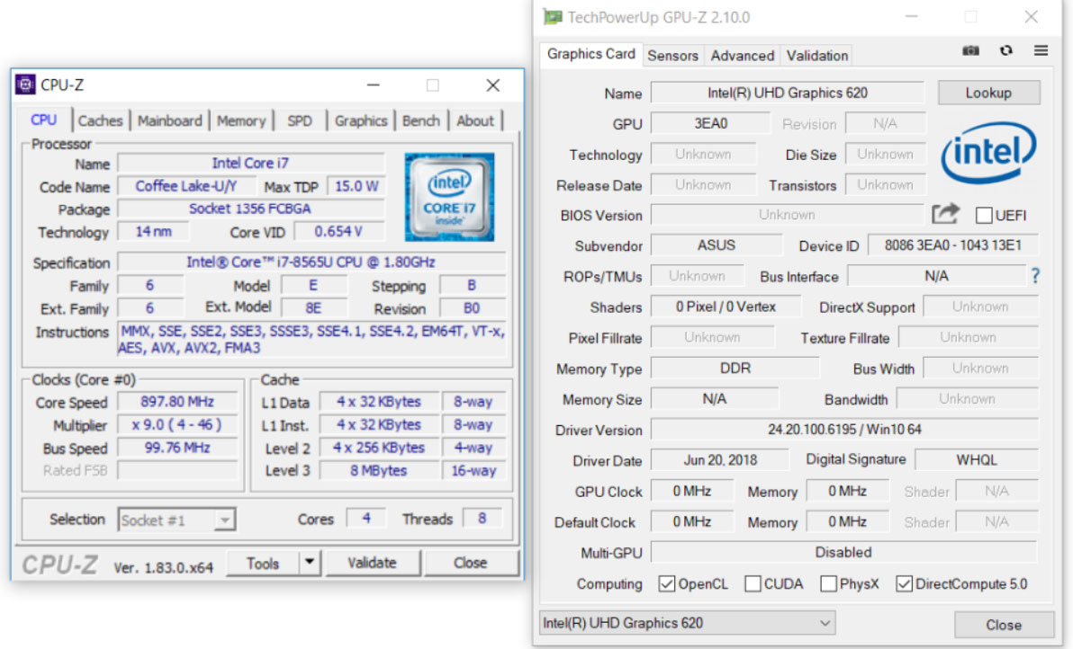

**Ram (hp 1003tx)**

* **Capacity – 16gb**
* **Type -DDR4**
* **Frequency-2400Mhz**
* **SODIMM (soldered directly into the circuit)**

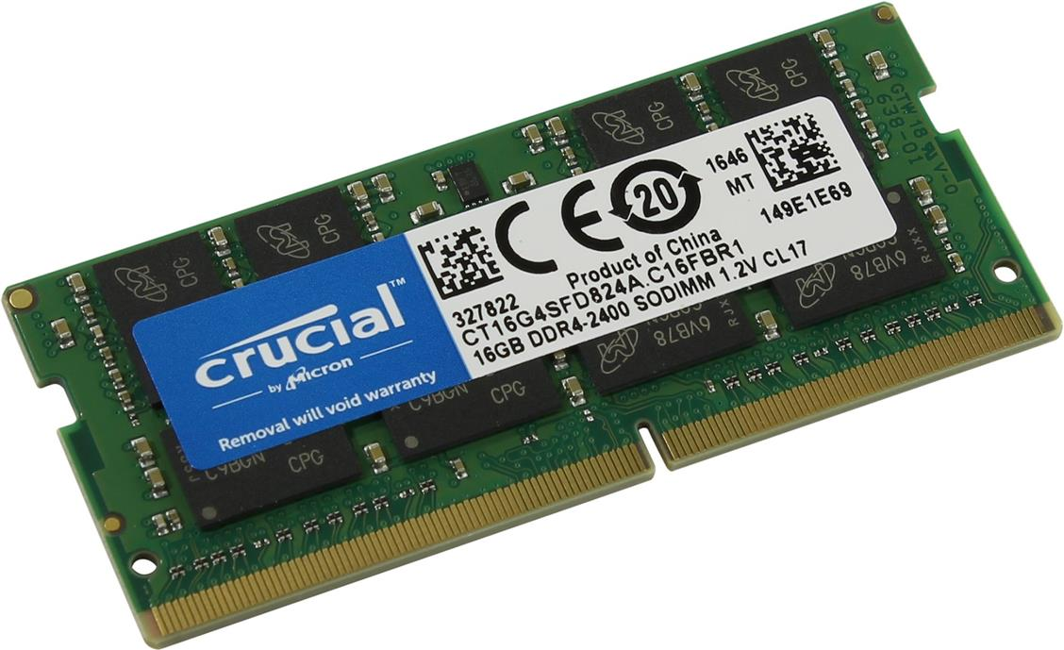

Features

the primary advantages of DDR4 over its predecessor, DDR3, include higher module density and lower voltage requirements, coupled with higher [data rate transfer](https://en.wikipedia.org/wiki/Bit_rate#Goodput_(data_transfer_rate)) speeds. The DDR4 standard allows for [DIMMs](https://en.wikipedia.org/wiki/DIMM) of up to 64 [GB](https://en.wikipedia.org/wiki/Gibibyte) in capacity, compared to DDR3's maximum of 16 GB per DIMM.[[7]](https://en.wikipedia.org/wiki/DDR4_SDRAM#cite_note-7)

Unlike previous generations of DDR memory, [prefetch](https://en.wikipedia.org/wiki/Prefetch_buffer) has *not* been increased above the 8n used in DDR3;[[8]](https://en.wikipedia.org/wiki/DDR4_SDRAM#cite_note-SamsungIDF-8):16 the basic burst size is eight words, and higher bandwidths are achieved by sending more read/write commands per second. To allow this, the standard divides the DRAM banks into two or four selectable bank groups,[[9]](https://en.wikipedia.org/wiki/DDR4_SDRAM#cite_note-JEDEC-9) where transfers to different bank groups may be done more rapidly.

Because power consumption increases with speed, the reduced voltage allows higher speed operation without unreasonable power and cooling requirements.

DDR4 operates at a voltage between 1.2 V and 1.4 V with a frequency between 800 and 2133 MHz (DDR4-1600 through DDR4-4266), compared to frequencies between 400 and 1067 MHz and voltage requirements of 1.5 or 1.65 V of DDR3. Due to the nature of DDR, speeds are typically advertised as doubles of these numbers (DDR3-1600 and DDR4-2400 are common, with DDR4-3200 and DDR4-4800 available at high cost). Although a low-voltage standard has yet to be finalized (as of August 2014), it is anticipated that low-voltage DDR4 will run at a voltage of 1.05 V, compared to DDR3's low-voltage standard ([DDR3L](https://en.wikipedia.org/wiki/DDR3L)) which requires 1.35 V to operate.

**Command encoding**

though it still operates in fundamentally the same way, DDR4 makes one major change to the [command formats used by previous SDRAM generations](https://en.wikipedia.org/wiki/SDRAM#Commands). A new command signal, ACT, is low to indicate the activate (open row) command.

The activate command requires more address bits than any other (18 row address bits in an 16 Gb part), so the standard RAS, CAS, and WE [active low](https://en.wikipedia.org/wiki/Active_low) signals are shared with high-order address bits that are not used when ACT is high. The combination of RAS=L and CAS=WE=H that previously encoded an activate command is unused.

As in previous SDRAM encodings, A10 is used to select command variants: auto-precharge on read and write commands, and one bank vs. all banks for the precharge command. It also selects two variants of the ZQ calibration command.

As in DDR3, A12 is used to request *burst chop*: truncation of an 8-transfer burst after four transfers. Although the bank is still busy and unavailable for other commands until eight transfer times have elapsed, a different bank can be accessed.

Also, the number of bank addresses has been increased greatly. There are four bank select bits to select up to 16 banks within each DRAM: two bank address bits (BA0, BA1), and two bank group bits (BG0, BG1). There are additional timing restrictions when accessing banks within the same bank group; it is faster to access a bank in a different bank group.

In addition, there are three chip select signals (C0, C1, C2), allowing up to eight [stacked chips](https://en.wikipedia.org/wiki/Multi-Chip_Module#Chip_stack_MCMs) to be placed inside a single DRAM package. These effectively act as three more banks select bits, bringing the total to seven (128 possible banks).

Standard transfer rates are 1600, 1866, 2133, 2400, 2666, 2933, and 3200 MT/s (​12⁄15, ​14⁄15, ​16⁄15, ​18⁄15, ​20⁄15, ​22⁄15, and ​24⁄15 GHz clock frequencies, double data rate), with speeds up to DDR4-4800 (2400 MHz clock) commercially available.

**Design considerations**

The DDR4 team at [Micron Technology](https://en.wikipedia.org/wiki/Micron_Technology) identified some key points for IC and PCB design:

IC design:

* VrefDQ calibration (DDR4 "requires that VrefDQ calibration be performed by the controller");
* New addressing schemes ("bank grouping", ACT to replace RAS, CAS, and WE command, PAR and Alert for error checking and DBI for data bus inversion);
* New power saving features (low-power auto self-refresh, temperature-controlled refresh, fine-granularity refresh, data-bus inversion, and CMD/ADDR latency).

Circuit board design:[[53]](https://en.wikipedia.org/wiki/DDR4_SDRAM#cite_note-Denali-55)

* New power supplies (VDD/VDDQ at 1.2 V and wordline boost, known as VPP, at 2.5 V);
* VrefDQ must be supplied internal to the DRAM while VrefCA is supplied externally from the board;
* DQ pins terminate high using pseudo-open-drain I/O (this differs from the CA pins in DDR3 which are centre-tapped to VTT)

[Row hammer](https://en.wikipedia.org/wiki/Rowhammer) mitigation techniques include larger storage capacitors, modifying the address lines to use [address space layout randomization](https://en.wikipedia.org/wiki/Address_space_layout_randomization) and dual-voltage I/O lines that further isolate potential boundary conditions that might result in instability at high write/read speeds.

**Storage: 512 GB NVMe ,1TB sshd (hard drive)**

NVMe is no longer a nice-to-have storage technology. If you’re shopping for a new PC, it’s a feature you should actively seek out. Moreover, if your PC is of fairly recent vintage, you should upgrade

T

 to NVMe.

**What it is**

NVMe is a communications standard developed specially for SSDs by a consortium of vendors including Intel, Samsung, SanDisk, Dell, and Seagate. It operates across the PCIe bus (hence the ‘Express’ in the name), which allows the drives to act more like the fast memory that they are, rather than the hard disks they imitate. Bottom line: NVMe is fast. Really fast. Like never-have-to-wait-again-for-your-computer fast.

The approximate performance ceilings for the three mainstream storage technologies as things now stand are:

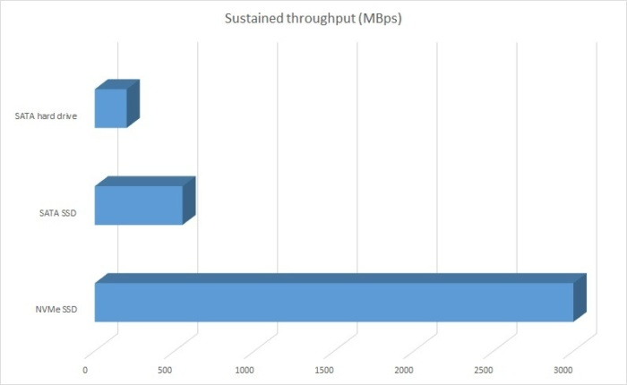

Not that you need sustained throughput like this very often, but NVMe makes short work of transferring files of any size. HDD = 200MBps, SATA SSD = 550MBps, NVMe SSD = 3GBps. Longer bars are better.

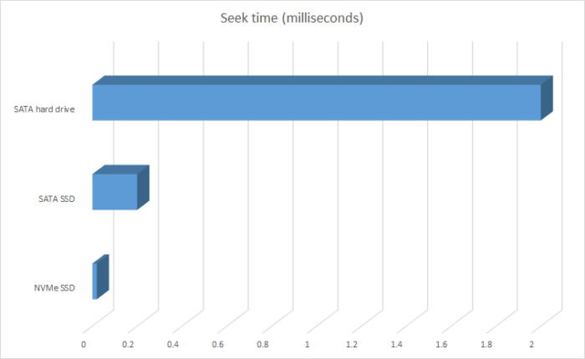

The CPU and GPU development curve pales in comparison to that of storage over the last 10 years. HD = 2-5 ms seek, SATA SSD = 0.2 ms seek, NVMe SSD = 0.02 ms seek. Shorter bars are better, but this is an overall average. Some drives in each category might do better, some will do worse.

Quotation**:**

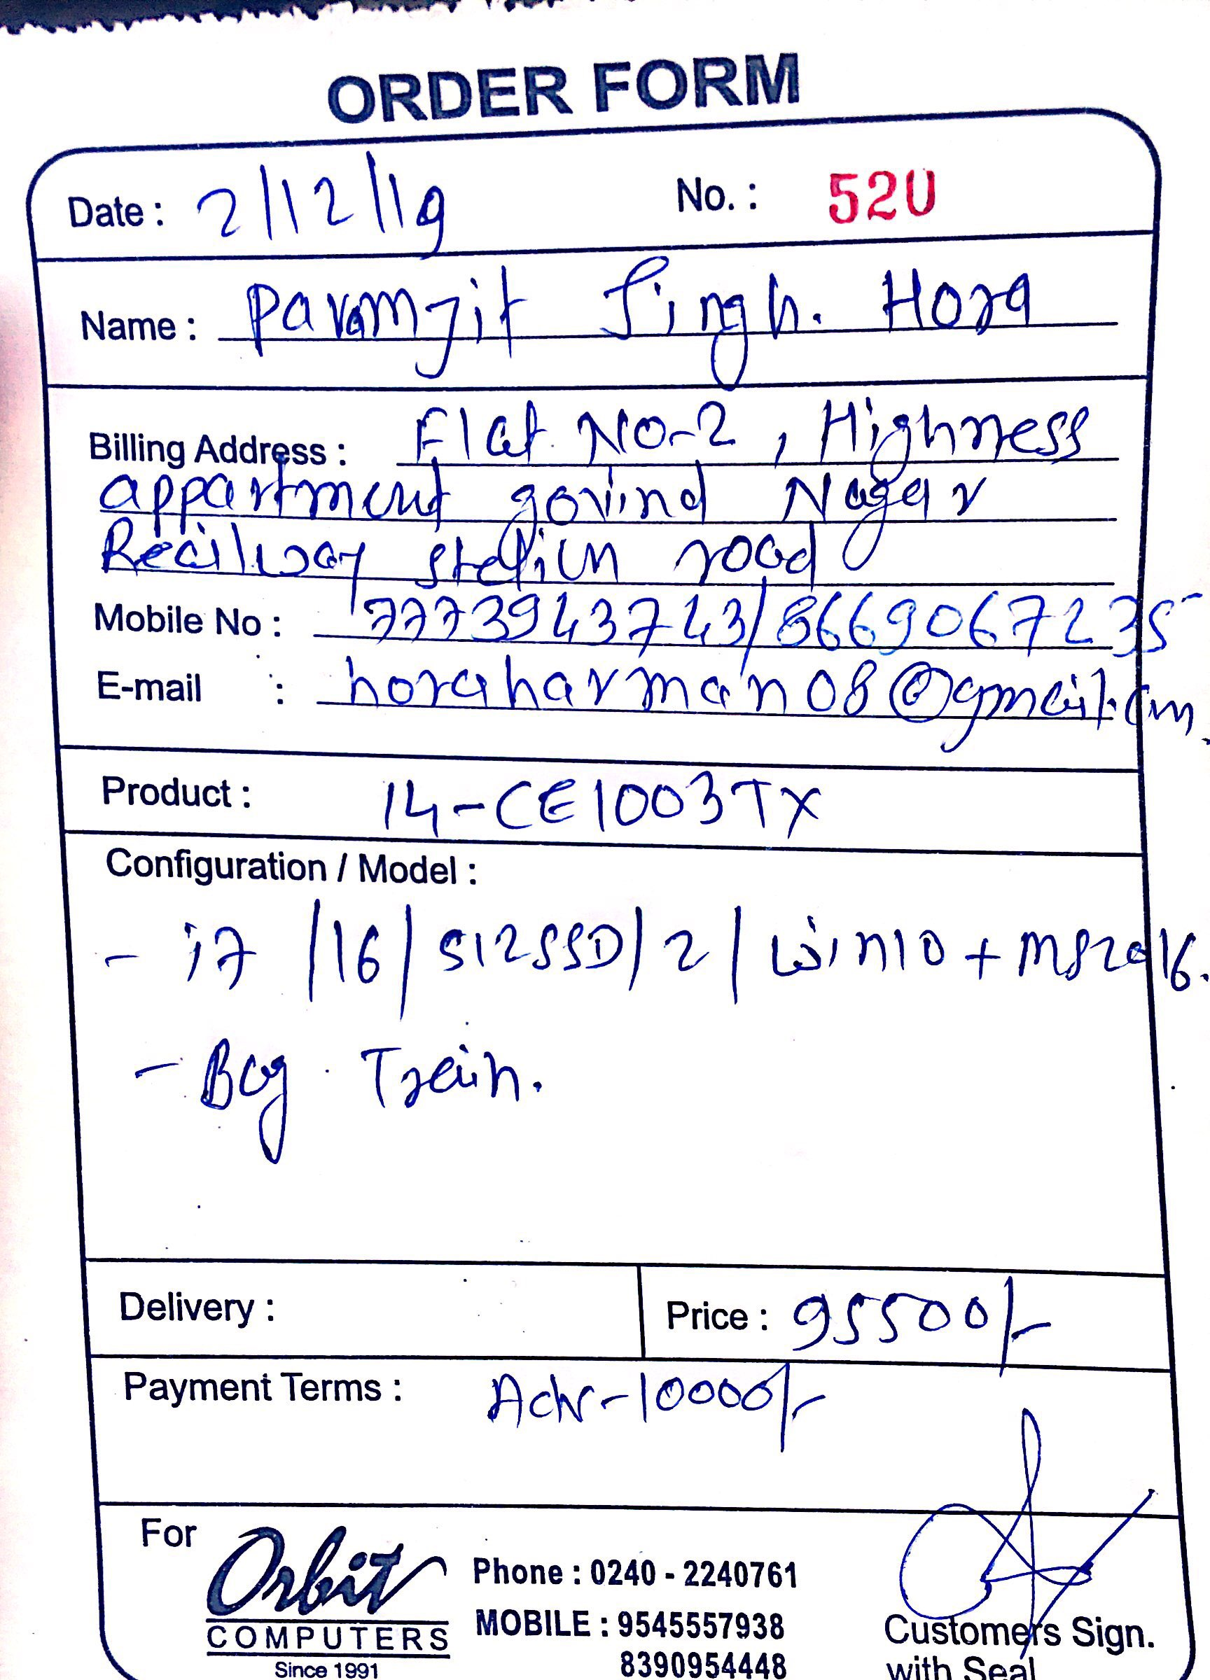

HP Pavilion x360 14 cd0087TU Laptop

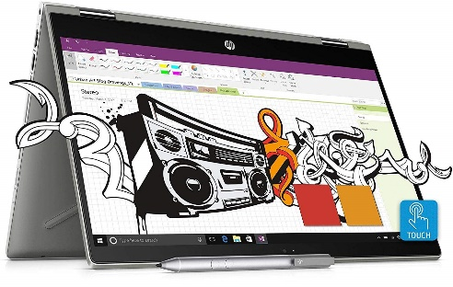

Processor:

* Product Collection[8th Generation Intel® Core™ i5 Processors](https://ark.intel.com/content/www/us/en/ark/products/series/122597/8th-generation-intel-core-i5-processors.html)
* Code Name [Products formerly Kaby Lake R](https://ark.intel.com/content/www/us/en/ark/products/codename/126287/kaby-lake-r.html)
* Vertical Segment Mobile
* Processor Number i5-8250U
* Status launched
* Launch DateQ3'17
* Lithography 14 nm
* Recommended Customer Price$297.00

## Performance

* # of Cores4
* # of Threads8
* Processor Base Frequency1.60 GHz
* Max Turbo Frequency3.40 GHz
* Cache 6 MB Smart Cache
* Bus Speed 4 GT/s OPI
* TDP 15 W
* Configurable TDP-up Frequency 1.80 GHz
* Configurable TDP-up 25 W
* Configurable TDP-down Frequency 800 MHz
* Configurable TDP-down 10 W

## Supplemental Information

* Embedded Options Available No
* Data-sheet [View now](https://www.intel.com/content/www/us/en/processors/core/core-technical-resources.html)

## Memory Specifications

* Max Memory Size (dependent on memory type) 32 GB
* Memory Types DDR4-2400, LPDDR3-2133
* Max # of Memory Channels 2
* Max Memory Bandwidth 37.5 GB/s
* ECC Memory Supported ‡No

## Processor Graphics

* Processor Graphics ‡Intel® UHD Graphics 620
* Graphics Base Frequency300 MHz
* Graphics Max Dynamic Frequency1.10 GHz
* Graphics Video Max Memory 32 GB
* Graphics Output eDP /DP/HDMI/DVI
* 4K Support Yes, at 60Hz
* Max Resolution (HDMI 1.4) ‡ 4096x2304@24Hz
* Max Resolution (DP)‡4096x2304@60Hz
* Max Resolution (eDP - Integrated Flat Panel) ‡4096x2304@60Hz
* DirectX* Support12
* OpenGL* Support4.4
* Intel® Quick Sync Video Yes
* Intel® Clear Video HD Technology Yes
* Intel® Clear Video Technology Yes
* # of Displays Supported ‡3
* Device ID0x5917

## Expansion Options

* PCI Express Revision3.0
* PCI Express Configurations ‡1x4, 2x2, 1x2+2x1 and 4x1
* Max # of PCI Express Lanes12

## Package Specifications

* Sockets SupportedFC-BGA1356
* Max CPU Configuration1
* TJUNCTION100°C
* Package Size42mm X 24mm

## Advanced Technologies

* Intel® Optane™ Memory Supported ‡Yes
* Intel® Speed Shift Technology Yes
* Intel® Turbo Boost Technology ‡2.0
* Intel® v Pro™ Platform Eligibility ‡No
* Intel® Hyper-Threading Technology ‡Yes
* Intel® Virtualization Technology (VT-x) ‡Yes
* Intel® Virtualization Technology for Directed I/O (VT-d) ‡Yes
* Intel® VT-x with Extended Page Tables (EPT) ‡Yes
* Intel® TSX-NI No
* Intel® 64 ‡Yes
* Instruction Set64-bit
* Instruction Set Extensions Intel® SSE4.1, Intel® SSE4.2, Intel® AVX2
* Intel® My Wi-Fi Technology Yes
* Idle States Yes
* Enhanced Intel Speed Step® Technology Yes
* Thermal Monitoring Technologies Yes
* Intel® Flex Memory access Yes
* Intel® Identity Protection Technology ‡Yes
* Intel® Stable Image Platform Program (SIPP)No
* Intel® Smart Response Technology Yes

## Security & Reliability

* Intel® AES New Instructions Yes
* Secure key Yes
* Intel® Software Guard Extensions (Intel® SGX) Yes with Intel® ME
* Intel® OS Guard Yes
* Intel® Trusted Execution Technology ‡No
* Execute Disable Bit ‡Yes

Ram: 8gb ddr4 2400mhz



Features

the primary advantages of DDR4 over its predecessor, DDR3, include higher module density and lower voltage requirements, coupled with higher [data rate transfer](https://en.wikipedia.org/wiki/Bit_rate#Goodput_(data_transfer_rate)) speeds. The DDR4 standard allows for [DIMMs](https://en.wikipedia.org/wiki/DIMM) of up to 64 [GB](https://en.wikipedia.org/wiki/Gibibyte) in capacity, compared to DDR3's maximum of 16 GB per DIMM.[[7]](https://en.wikipedia.org/wiki/DDR4_SDRAM#cite_note-7)

Unlike previous generations of DDR memory, [prefetch](https://en.wikipedia.org/wiki/Prefetch_buffer) has *not* been increased above the 8n used in DDR3;[[8]](https://en.wikipedia.org/wiki/DDR4_SDRAM#cite_note-SamsungIDF-8):16 the basic burst size is eight words, and higher bandwidths are achieved by sending more read/write commands per second. To allow this, the standard divides the DRAM banks into two or four selectable bank groups,[[9]](https://en.wikipedia.org/wiki/DDR4_SDRAM#cite_note-JEDEC-9) where transfers to different bank groups may be done more rapidly.

Because power consumption increases with speed, the reduced voltage allows higher speed operation without unreasonable power and cooling requirements.

DDR4 operates at a voltage between 1.2 V and 1.4 V with a frequency between 800 and 2133 MHz (DDR4-1600 through DDR4-4266), compared to frequencies between 400 and 1067 MHz and voltage requirements of 1.5 or 1.65 V of DDR3. Due to the nature of DDR, speeds are typically advertised as doubles of these numbers (DDR3-1600 and DDR4-2400 are common, with DDR4-3200 and DDR4-4800 available at high cost). Although a low-voltage standard has yet to be finalized (as of August 2014), it is anticipated that low-voltage DDR4 will run at a voltage of 1.05 V, compared to DDR3's low-voltage standard ([DDR3L](https://en.wikipedia.org/wiki/DDR3L)) which requires 1.35 V to operate.

**Command encoding**

though it still operates in fundamentally the same way, DDR4 makes one major change to the [command formats used by previous SDRAM generations](https://en.wikipedia.org/wiki/SDRAM#Commands). A new command signal, ACT, is low to indicate the activate (open row) command.

The activate command requires more address bits than any other (18 row address bits in an 16 Gb part), so the standard RAS, CAS, and WE [active low](https://en.wikipedia.org/wiki/Active_low) signals are shared with high-order address bits that are not used when ACT is high. The combination of RAS=L and CAS=WE=H that previously encoded an activate command is unused.

As in previous SDRAM encodings, A10 is used to select command variants: auto-precharge on read and write commands, and one bank vs. all banks for the precharge command. It also selects two variants of the ZQ calibration command.

As in DDR3, A12 is used to request *burst chop*: truncation of an 8-transfer burst after four transfers. Although the bank is still busy and unavailable for other commands until eight transfer times have elapsed, a different bank can be accessed.

Also, the number of bank addresses has been increased greatly. There are four bank select bits to select up to 16 banks within each DRAM: two bank address bits (BA0, BA1), and two bank group bits (BG0, BG1). There are additional timing restrictions when accessing banks within the same bank group; it is faster to access a bank in a different bank group.

In addition, there are three chip select signals (C0, C1, C2), allowing up to eight [stacked chips](https://en.wikipedia.org/wiki/Multi-Chip_Module#Chip_stack_MCMs) to be placed inside a single DRAM package. These effectively act as three more banks select bits, bringing the total to seven (128 possible banks).

Standard transfer rates are 1600, 1866, 2133, 2400, 2666, 2933, and 3200 MT/s (​12⁄15, ​14⁄15, ​16⁄15, ​18⁄15, ​20⁄15, ​22⁄15, and ​24⁄15 GHz clock frequencies, double data rate), with speeds up to DDR4-4800 (2400 MHz clock) commercially available.

**Design considerations**

The DDR4 team at [Micron Technology](https://en.wikipedia.org/wiki/Micron_Technology) identified some key points for IC and PCB design:

IC design:

* VrefDQ calibration (DDR4 "requires that VrefDQ calibration be performed by the controller");
* New addressing schemes ("bank grouping", ACT to replace RAS, CAS, and WE command, PAR and Alert for error checking and DBI for data bus inversion);
* New power saving features (low-power auto self-refresh, temperature-controlled refresh, fine-granularity refresh, data-bus inversion, and CMD/ADDR latency).

Circuit board design:[[53]](https://en.wikipedia.org/wiki/DDR4_SDRAM#cite_note-Denali-55)

* New power supplies (VDD/VDDQ at 1.2 V and wordline boost, known as VPP, at 2.5 V);
* VrefDQ must be supplied internal to the DRAM while VrefCA is supplied externally from the board;
* DQ pins terminate high using pseudo-open-drain I/O (this differs from the CA pins in DDR3 which are centre-tapped to VTT)

[Row hammer](https://en.wikipedia.org/wiki/Rowhammer) mitigation techniques include larger storage capacitors, modifying the address lines to use [address space layout randomization](https://en.wikipedia.org/wiki/Address_space_layout_randomization) and dual-voltage I/O lines that further isolate potential boundary conditions that might result in instability at high write/read speeds.

Storage:

128 gb (SSD) + 1 tb (hdd)

Quotation:

