Xiaomi redmi note 7 pro design

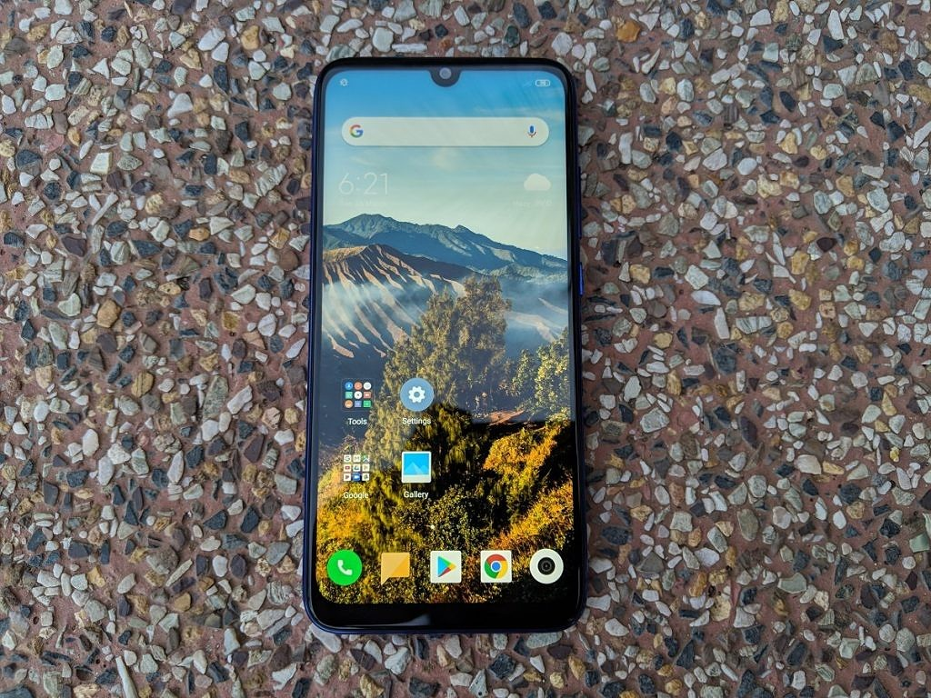

With the Redmi Note 7 Pro, Xiaomi finally embarks on a new design. Ever since the [Xiaomi Redmi Note 3](https://forum.xda-developers.com/redmi-note-3), Redmi Note phones had mostly the same construction with minor variations in the form of a metal body with plastic caps at the top and bottom. Even as competitors moved to glass backs with gradient color finishes or glossy plastic construction, Xiaomi was content with its metal + plastic construction combo. The Redmi Note 7 and the Redmi Note 7 Pro break away from the metal back construction for a new design that Xiaomi calls “Aurora Glass.”

In terms of build quality, the Redmi Note 7 Pro has a plastic frame that provides rigidity for Corning’s Gorilla Glass 5 on the front and back. This can arguably be seen as a downgrade in terms of construction, considering phones like the [Xiaomi Redmi Note 4](https://forum.xda-developers.com/redmi-note-4) had near all-metal designs. The [Xiaomi Mi A2](https://www.xda-developers.com/xiaomi-mi-a2-review/) was constructed from a single piece of unibody aluminum, thereby establishing itself as the benchmark in build quality. The Redmi Note 7 Pro fails to live up to that high standard, but as I have noted earlier, [the time for metal-built phones is passing away fast](https://www.xda-developers.com/glass-aluminum-flagship-plastic-wrong/), even in the budget and mid-range price segments.

The Redmi Note 7 Pro still feels like a well-built phone despite its plastic frame. In the future, it would be good to see Xiaomi adopt a metal frame to make the phone on par with flagships in this area. The plastic frame remains the weak spot in terms of durability, but in terms of day-to-day use, it should hold up fine.

The Redmi Note 7 Pro’s design is special even if its build quality isn’t class-leading. On the front, we have a 6.3-inch Full HD+ 19.5:9 IPS display with a U-shaped notch that Xiaomi refers to as the “Dot Notch.” The U-shaped notch contains the 13MP front camera and the proximity / ambient light sensors. The top and side bezels are still a bit bigger than they should be, and there is a sizable chin as well. Competing phones like the [Samsung Galaxy M30](https://www.xda-developers.com/samsung-galaxy-m30-india-launch-specifications/) are clearly ahead here as Xiaomi hasn’t effectively utilized the space on the front. Despite this, the Redmi Note 7 Pro still has a decent screen-to-body ratio of 81.4%. With flagships now breaking the 90% screen-to-body ratio barrier, there is room for improvement here.On the top, we find the secondary microphone, an IR blaster, and a 3.5mm headphone jack. The IR blaster + 3.5mm headphone jack combination is becoming increasingly rare, and the Redmi Note 7 Pro is a positive outlier in this aspect. The power and volume buttons are located on the right-hand side. While the stiffness and actuation force of the buttons aren’t quite as good as on the Mi A2, they still present no issues. Their placement is also optimal.

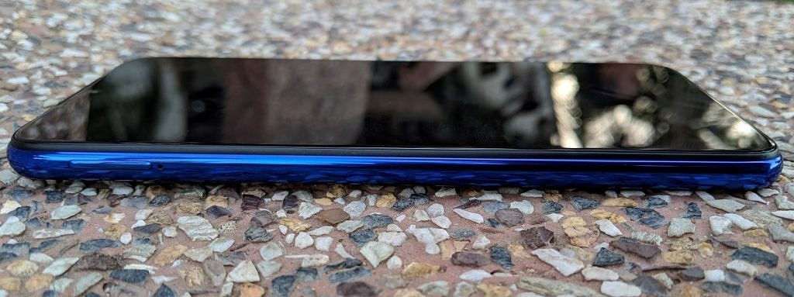

The SIM tray is placed on the left-hand side of the phone. It’s a hybrid solution that can either take dual nano-SIMs or a nano-SIM + a microSD card, forcing users to choose between expandable storage and dual-SIM functionality. Competing phones in this price range (such as the [Asus ZenFone Max Pro M2](https://www.xda-developers.com/asus-zenfone-max-pro-m2-android-pie-beta-india/) and the [Realme 2 Pro)](https://www.xda-developers.com/realme-2-realme-2-pro-realme-c1-malaysia-launch/)have moved toward triple slots containing a dedicated slot for the microSD card, and Xiaomi itself uses a triple slot in phones like the Xiaomi Redmi 6 Pro. Not including it in the Redmi Note 7 Pro, therefore, feels like a missed opportunity and a poor decision in the context of the Indian smartphone market. In India, the Redmi Note 7 Pro is sold in two configurations: 4GB RAM with 64GB storage and 6GB RAM with 128GB storage. In China, Xiaomi currently sells only the higher-end variant.

On the bottom of the Redmi Note 7 Pro, we find the USB Type-C port and dual speaker grilles. As expected, only the right grille contains the speaker, while left grille is the primary microphone.The USB Type-C port is a welcome sight as Xiaomi has *finally*dropped the outdated microUSB port that was found in earlier Redmi Note phones. It supports USB 2.0 speeds, but that drawback is shared with plenty of higher-priced phones as well.

**[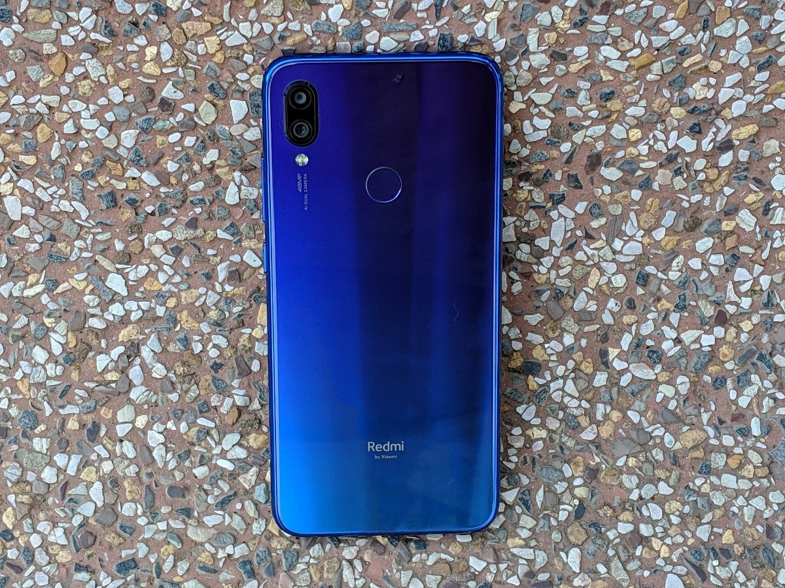](https://www.xda-developers.com/files/2019/03/Xiaomi-Redmi-Note-7-Pro-Review-Back-2.jpg)**

The star of the Redmi Note 7 Pro’s design is undoubtedly the back design, which Xiaomi terms “Aurora Glass.” Xiaomi uses nano-texturing underneath the layer of Gorilla Glass 5 on the back to create a look reminiscent of premium phones. The phone is sold in Neptune Blue, Nebula Red, and Black. While Black is a standard black finish for users interested in a more understated color option, the other two colors are gradient color finishes that are executed very well. I have the Neptune Blue color variant for review, and it looks amazing. Light reflections are great to look at, and the phone does a great job of looking like a well-designed, premium phone.

The biggest plus point with the glass back is that Xiaomi has used a fingerprint-resistant coating, which means it collects fingerprints in a restrained manner. This is great to see considering that plenty of flagship phones lack such a coating. The glossy finish of the glass does mean that the phone is quite slippery, though.

The 48MP + 5MP rear cameras are placed at the top left on the back. The camera bump here is significant, but that’s expected considering the 1/2″ sensor size of the 48MP primary sensor. The “48MP AI Dual Camera” branding gives away the fact that Xiaomi is heavily promoting the phone’s camera. The capacitive fingerprint sensor is placed at the center on the back, and it’s followed by “Redmi by Xiaomi” branding at the bottom, reflecting Redmi’s status as a [newly formed sub-brand of the company](https://www.xda-developers.com/xiaomi-spins-redmi-sub-brand/).

The Redmi Note 7 Pro uses a p2i water-repellent nanocoating for splash resistance, and there are rubber gaskets around the ports. It does *not* claim to be water resistant, but it should be able to resist rainwater and minor splashes well. In the future, we would prefer to see this be upgraded to an IP67 or IP68 rating for a higher level of certified water resistance.

In terms of ergonomics, the Redmi Note 7 Pro isn’t an especially thin phone, but that’s not necessarily a bad thing. The phone has flat sides and a flat glass back, contributing to its slab-like feeling. This does have a negative impact on ergonomics. The size of the phone may also be off-putting for users interested in smaller phones, but I had no issues with it. Ergonomics are still good thanks to the relatively narrow side bezels and thick, glossy plastic frame. Overall, the Redmi Note 7 Pro has a great design. If it had a metal frame, it would have achieved top marks in build quality, and that remains an area of improvement for Xiaomi.

In the box, Xiaomi bundles a 10W charger and a transparent glossy TPU case. We will have more to say on the phone’s charging capabilities in the Battery Life and Charging section.

Xiaomi Redmi Note 7 Pro Display

The Xiaomi Redmi Note 7 Pro has a 6.3-inch Full HD+ (2340×1080) IPS LCD with a 19.5:9 aspect ratio and 409 PPI. The display’s dimensions are 145 mm x 67 mm, which means that it’s actually narrower than one would expect. The Redmi Note 6 Pro had a slightly wider display, and any 5.5-inch (16:9), 6-inch (18:9), 6.18-inch (18.7:9), and 6.28-inch (19:9) display will measure 68 mm in width. In general, when it comes to the 19.5:9 aspect ratio, it would have been better for Xiaomi to have included a 6.4-inch display in the Redmi Note 7 Pro. (The increased length of the display does come in useful when compared to a notch-less 6-inch 18:9 display.)

The Redmi Note 7 Pro’s Full HD+ display leaves me no complaints with respect to resolution and pixel density. 409 PPI is fine for general use, especially considering the fact that the IPS LCD uses an RGB matrix. Text is sharp, and in general, there is little need for Quad HD+ displays to arrive in this price segment, unless they move significantly downward in terms of pricing.

The display of the Redmi Note 7 Pro can go as bright as 450 nits. It has Xiaomi’s Sunlight Display technology which boosts contrast in sunlight for better readability. This is a separate feature from a High Brightness Mode (HBM) which seems to be inactive or not present on the Redmi Note 7 Pro’s display. The sunlight legibility of the display, therefore, is good without being outstanding.

The Redmi Note 7 Pro’s display has a rated contrast ratio of 1,500:1. Subjectively, the display’s black levels are *okay*. The contrast is still on par with—or slightly better than—the Xiaomi Mi A2’s display. However, AMOLED displays are now starting to arrive in this price segment, led by the Samsung Galaxy M30 and the [OPPO K1](https://www.xda-developers.com/oppo-k1-india-launch/). [AMOLED displays can’t be matched with respect to contrast](https://www.xda-developers.com/smartphone-display-terminology-explained/), and I believe it’s time for Xiaomi to take a serious look at moving the Redmi Note series to AMOLED displays.

On the other hand, the display’s viewing angles are great. There is negligible angular color shift across viewing angles. The loss of brightness and contrast across angle changes are also kept under control, although the display won’t compete with AMOLED displays in this particular aspect.

Xiaomi states that the Redmi Note 7 Pro’s display supports 84% of the NTSC gamut. This means that the display’s native color gamut is wider than the sRGB gamut. The Redmi Note 7 Pro doesn’t support Android’s native color management system, though no phone in this price segment supports it, so this is expected. What we get are three display modes, one of which has three color temperature presets.

Out of the box, the Redmi Note 7 Pro’s display shows inaccurate colors with respect to the sRGB gamut. The “Automatic Contrast” default mode targets the DCI-P3 color gamut, but in terms of calibration, it deviates from the color space because of the overly bluish white point.  The white point can be brought closer to 6504K by choosing the “Warm” color temperature preset. Due to the lack of support for Android’s color management system, the “Automatic Contrast” mode is inaccurate with respect to the sRGB gamut. It should, therefore, be used for watching DCI-P3 content or for getting a more saturated display with a colder white point. The “Increased Contrast” mode is very similar to the “Automatic Contrast” mode, but it does slightly increase display contrast. With regards to color accuracy, the aforementioned caveats apply to this mode as well.

The “Standard” color mode, on the other hand, is calibrated to the sRGB gamut. This mode satisfies color accuracy demands as its white point, grayscale, saturation, and gamut coverage are all on the mark. The display of the Redmi Note 7 Pro is noticeably better than the [Xiaomi POCO F1](https://forum.xda-developers.com/poco-f1)‘s display in this respect. This is because Xiaomi has *finally* fixed the pink tint grayscale issue that affected its budget and mid-range smartphone displays. The Redmi Note 7 Pro’s display has slightly greenish grays but the sRGB calibration is still excellent. The display also features Reading mode with scheduling options to cut down on blue light.

The display doesn’t support HDR content, but again, that drawback is shared by all other phones in this price range. On the other hand, Widevine L1 certification is included.

The Redmi Note 7 Pro’s waterdrop “dot notch” is a significant improvement over wide display notches in phones like the POCO F1. However, the hide notch option is strangely missing. Unfortunately, in the current MIUI Global Stable software, the small notch doesn’t result in any improvements with respect to the display notification icons. This is because, despite the increase in space for the status bar, MIUI doesn’t display *any*notification icons by default. Users can enable an option to display incoming notification icons which will result in new

Xiaomi Redmi Note 7 Pro Camera Performance

### Camera specifications

The Xiaomi Redmi Note 7 Pro has a dual rear camera setup. Its primary 48MP camera features the [Sony IMX586](https://www.xda-developers.com/sonys-imx586-48mp-smartphone-camera/)sensor, 1/2″ sensor size, 0.8μm pixel size f/1.8 aperture, and 25.7mm equivalent focal length. It does not have optical image stabilization (OIS). The secondary camera is a 5MP depth sensor with an f/2.4 aperture. It is used for the purpose of generating a depth map in Xiaomi’s implementation of portrait mode. The Redmi Note 7 Pro does not feature a telephoto lens or an ultra-wide angle camera. While no phone in this price range has a telephoto camera, Samsung has introduced ultra-wide-angle cameras in this price segment with the Galaxy M30 and the [Galaxy A50](https://www.xda-developers.com/samsung-galaxy-a10-galaxy-a30-galaxy-a50-india-launch/).

Xiaomi is strongly promoting the Redmi Note 7 Pro’s 48MP primary camera, so let’s delve deeper into that. The IMX586 sensor was announced by Sony in July last year. To achieve the 48MP resolution, it has a Quad Bayer color filter instead of a standard Bayer filter. What this means is that just like the Sony IMX600 in the Huawei P20 Pro and Huawei Mate 20 Pro, the 48MP sensor has less color resolution than a camera with a standard Bayer filter.

The IMX586 camera sensor is a lot bigger than 12MP flagship sensors such as the IMX363 in the Google [Pixel 3](https://www.xda-developers.com/tag/google-pixel-3/), which has a 1/2.55″ sensor size. Similar to the IMX600, the IMX586 on the Redmi Note 7 Pro uses 4-in-1 pixel binning to achieve 1.6μm “super pixels” from the 0.8μm pixel size. Pixel binning is used to reduce noise, improve per-pixel detail, and improve dynamic range. The sensor is found in the [Honor View20](https://www.xda-developers.com/honor-view-20-camera-review/) and the [Xiaomi Mi 9](https://www.xda-developers.com/hands-on-xiaomi-mi-9-transparent-violet/) as well.

The [Chinese/Global Xiaomi Redmi Note 7](https://www.xda-developers.com/redmi-note-7-launch-specifications-pricing-availability/) has a 48MP primary camera, but it doesn’t use the IMX586. Instead, it uses [Samsung’s ISOCELL GM1 sensor](https://www.xda-developers.com/samsung-32mp-48mp-isocell-camera-sensors/), which is also used in the [Vivo V15 Pro](https://www.xda-developers.com/vivo-v15-pro-hands-on-first-impressions-review/). The key difference between the two is that the IMX586 can take photos natively at 48MP resolution, while the Samsung GM1 uses upscaling and interpolation (resulting in the lack of Zero Shutter Lag) to achieve a photo resolution of 48MP.

The Redmi Note 7 Pro, therefore, is prepared when it comes to camera hardware. It’s the cheapest phone to use the IMX586, but as we have mentioned before, the choice of a camera sensor is not the only factor in determining image quality. In this age of computational photography, image processing is equally important, and Xiaomi has been steadily stepping forward in this area.

### Camera app and user experience

#### Camera app

The Xiaomi Redmi Note 7 Pro’s MIUI Camera app offers the following camera modes: **Photo, Video, Portrait, Night, Short video, Square, Panorama, and Pro**. On top of the camera app, users can toggle flash, HDR (auto/on/off), AI, and filters. The menu button contains options for Settings, Timer, Tilt-shift, Straighten, Group Selfie, [Google Lens](https://www.xda-developers.com/tag/google-lens/), and 48MP. Google Lens, therefore, can be accessed directly from the camera app.At launch, Xiaomi stated that users would be able to take 48MP photos using Pro mode. However, the company then rolled out an update to enable users to take 48MP photos in Photo (auto) mode. In 48MP mode, HDR and AI are both disabled. By default, the camera takes photos in 12.0MP resolution (4000×3000). The 48MP (8000×6000) mode can be set as the default mode by enabling the option to save the previous mode in the camera settings.

The Redmi Note 7 Pro’s Night mode is the same as the night modes of the POCO F1, [Xiaomi Mi Mix 3](https://www.xda-developers.com/xiaomi-mi-mix-3-review-proof-that-xiaomi-can-do-premium-too/), [Xiaomi Mi 8](https://forum.xda-developers.com/mi-8), and [Xiaomi Mi Mix 2S](https://forum.xda-developers.com/xiaomi-mi-mix-2s). It takes a few exposures and then stacks them together, applying exposure compensation and heavy use of noise reduction. The Pro mode is the usual full-featured mode that users have come to expect, and it’s nice to see it on the Redmi Note 7 Pro as earlier Redmi series phones lacked such camera modes. The Portrait mode has become a mainstay even on budget devices, and it works well enough in daylight. It requires a lot of light to work well, though. If it’s too dark, the camera will be unable to apply a depth effect.

In the camera app settings, users can choose to disable camera sounds, add time stamp on photos, disable the photo watermark, show grid lines, scan QR codes, add an option to take a photo by tapping anywhere on the camera preview after focusing, choose whether to mirror the front camera’s photos, and choose camera frame aspect ratio and picture quality. In terms of video settings, users can choose to disable video stabilization (which is active only in the 1080p@30fps mode), video resolution, video encoder (H264 or H265), video HFR (slow motion) resolution (720p@120fps or 1080p@120fps), and the time lapse interval.

Additional settings include an option to enable fingerprint shutter for photos, define actions for a volume button press, and choose settings for auto exposure, contrast, saturation, and sharpness.

#### Camera user experience

For the most part, the Redmi Note 7 Pro’s camera user experience is fast and smooth, but there are some caveats. There is zero shutter lag when taking 12MP pixel binned photos in daylight, and phase detection autofocus (PDAF) works well. 48MP full-resolution shots in Photo mode have significant processing lag in the order of multiple seconds, however. Users can still take 48MP photos quickly as the processing happens in the background, but the [Qualcomm Snapdragon 675 simply doesn’t support ZSL with a 48MP camera](https://www.qualcomm.com/products/snapdragon-675-mobile-platform). This means image stacking in a way similar to [Google Camera](https://www.xda-developers.com/tag/google-camera/)‘s HDR+ mode is impossible with the Redmi Note 7 Pro’s 48MP photos.

Interestingly, the processing lag when taking 48MP photos is significantly lesser than the processing lag of 48MP photos in Photo mode. The story gets more complicated as both 48MP modes are not the same. The 48MP Photo mode takes photos with significantly less noise, especially indoors. This means that the noise reduction of the Pro mode’s 48MP option is a lot weaker.

The Redmi Note 7 Pro features AI scene recognition to fall in line with the popular camera trends of 2018 and 2019. This feature only works in 12MP mode, and the differences it makes to image quality are marginal, unlike Huawei’s Master AI. As there are only marginal differences in output, there is no harm in leaving it switched on.

In daylight, when taking photos at its default 12MP resolution that employs pixel binning, the Redmi Note 7 Pro’s camera is impressive. It can be easily compared with flagships on a level playing field, and that itself is no small achievement. In general, the camera handles exposure and dynamic range well, with HDR auto doing its bit to help. Some samples suffer from underexposure in high-contrast scenes, but this issue is minor in scale. As expected, dynamic range is not on the same level as top-tier flagship phones such as the [Huawei Mate 20 Pro](https://www.xda-developers.com/huawei-mate-20-pro-review/)and the [Google Pixel 3 XL](https://www.xda-developers.com/google-pixel-3-xl-camera-software-design-pixel-stand/). However, it nearly matches the OnePlus 6T and is on par with the POCO F1.

Colors are also accurate, and over-saturation isn’t an issue. In terms of detail, the Redmi Note 7 Pro’s samples are pleasantly good as they avoid falling into obvious pitfalls. Plenty of fine texture detail is retained, to the point where the camera is a best-in-class camera at its price point. The camera performs admirably when it comes to resolving natural detail such as trees, plants, grass, etc., at 100% resolution. The starting ISO level is still ISO 100, which is an area where Xiaomi needs to improve to push the ISO level to ISO 50 or beyond. Despite this, noise reduction is handled well, with luminance noise being sparingly found in 12MP pixel binned photos. The photos also show no obvious signs of artificial sharpening, image processing artifacts, or corner softness, which are three big plus points.

Therefore, when taking 12MP photos in consideration, the Redmi Note 7 Pro’s camera is more impressive in terms of exposure and dynamic range than the Xiaomi Mi A2 (the previous image quality champion at this price point), and it manages to tie with the POCO F1 while slightly trailing the OnePlus 6T. In terms of detail, its samples have less detail than flagship cameras like the Google Pixel 3, Huawei Mate 20 Pro, and the Samsung Galaxy S10, while being better than nearly all lower mid-range competitors.

To answer the detail deficit to flagship phones, the Redmi Note 7 Pro has a trick up its sleeve: its 48MP resolution option in Photo mode.

The 48MP mode comes with a lot of expectations, and thankfully, it mostly lives up to its expectations, at least in daylight. Although it’s not the default resolution option, taking 48MP photos is relatively painless as long as the camera app works well. A single 48MP photo is about 15-24MB in size while a 12MP daylight photo is about 6-8MB. The camera surely captures a lot of information, but does it actually perform well?

The answer: Yes, it does. 48MP photos suffer from the issues of underexposure and relatively weak dynamic range when compared with top-tier flagship cameras (the 12MP pixel binned photos also have slightly better exposure). However, top-tier flagship smartphones also cost 4-5x the price of the Redmi Note 7 Pro. Barring phones like the Huawei Mate 20 Pro and the Google Pixel 3, the Redmi Note 7 Pro’s 48MP mode can legitimately be compared with flagships.**In terms of detail retention, its performance is phenomenal for the price point.** Taking aside the price point, the 48MP photos have more detail than most flagships like the POCO F1, OnePlus 6T, [LG V40 ThinQ](https://www.xda-developers.com/lg-v40-thinq-mini-review/), and Vivo NEX S. The 48MP daylight photos can actually be compared with the Google Pixel 3’s HDR+ photos in terms of detail. **The Redmi Note 7 Pro, therefore, becomes the new benchmark for daylight image quality in a lower mid-range phone.**

The downsides for the 48MP mode are that it chooses to apply less noise reduction and sharpening, which means some samples can look soft at 100% resolution (this issue does not exist in the 12MP default resolution option). Processing lag and huge file sizes can also become issues depending on the subject and phone’s storage. Even after taking these factors into consideration, the Redmi Note 7 Pro’s 48MP mode is a winner, at least in daylight. The amount of detail it provides enables flexibility in cropping, and detail can be resolved even in far-off objects.

Overall, the Redmi Note 7 Pro’s camera exceeds expectations in daylight. Its negatives are few, while its list of positives challenges that of affordable flagships. The camera can be legitimately compared with the OnePlus 6T’s camera. This time around, Xiaomi was not wrong in making that particular comparison.

Unfortunately, the situation drastically changes as we head indoors. The Redmi Note 7 Pro’s image quality rapidly degrades as light levels fall, similar to the POCO F1, OnePlus 6T, and the Xiaomi Mi A2. Definition and fine texture detail are degraded, and the sharpness of image samples is reduced significantly. Photos taken of people under artificial lighting are artificially processed with aggressive noise reduction, which has a negative impact on detail. Using the 48MP mode indoors presents only marginal improvements in image quality.

The lack of OIS also means that the camera is highly susceptible to camera shake and motion blur. The Redmi Note 7 Pro’s camera is, therefore, on par with most of its competitors indoors. The indoor image quality from any phone with a properly working [Google Camera port](https://www.xda-developers.com/google-camera-port-hub/) will turn out much, much better (for example, the [POCO F1’s Google Camera port](https://www.xda-developers.com/google-camera-night-sight-xiaomi-poco-f1-mi-8/) transforms its indoor image quality). **When comparing stock vs. stock, the Redmi Note 7 Pro still manages to tie with the POCO F1 and the OnePlus 6T, especially as it doesn’t share the OnePlus 6T’s issue of having too many processing artifacts in indoor photos.**

### Image quality assessment – Low light

A few years ago, [Xiaomi’s budget Redmi Note series was not known for offering great low light camera quality](https://www.xda-developers.com/google-camera-hdr-xiaomi-redmi-note-3/). This began to change last year with the [Xiaomi Redmi Note 5 Pro](https://forum.xda-developers.com/redmi-note-5-pro)/Xiaomi Redmi Note 5 AI Dual Camera, and Xiaomi continued to make improvements with the Xiaomi Redmi Note 6 Pro. With the Redmi Note 7 Pro, the company makes another set of significant advancements with a pixel binned 12MP default mode, bright f/1.8 aperture, and a Night Mode that aims to take brighter, less noisy photos in low light.

The Redmi Note 7 Pro has to deal with a basic fact: Most budget and lower mid-range smartphone cameras don’t tend to do well in low light. Even keeping this in mind, the Redmi Note 7 Pro becomes an outlier as it has surprisingly good image quality in low light.

The Redmi Note 7 Pro’s low light 12MP photo samples taken in Photo mode show accurate colors, decent exposure, and more fine detail than the competition. The 4-in-1 pixel binning proves its worth here as the Redmi Note 7 Pro’s low light samples are slightly superior to the OnePlus 6T’s samples, while also being better than the POCO F1 and the Xiaomi Mi A2. Luminance noise does become a significant issue, but thankfully, chromatic noise is not found in all but the most extreme low light samples. Camera shake and motion blur remain constraints, and OIS could have done a lot to help here.

In terms of detail, the Redmi Note 7 Pro’s low light samples are not able to match flagships like the Huawei Mate 20 Pro, Google Pixel 3, Samsung Galaxy S10, and the LG V40 ThinQ. However, it’s able to compete with most other upper mid-range phones as well as affordable flagships. In its particular price segment, no other phone can even come close, as the Redmi Note 7 Pro currently enjoys a significant advantage in terms of image quality.

Xiaomi lets go of all the aforementioned advantages in Night Mode, however. Unfortunately, Night Mode (which is limited to 12MP resolution) shares a lot of similarities with OnePlus’ Nightscape mode, [which itself doesn’t do a great job](https://www.xda-developers.com/oneplus-6t-camera-review/). Although Night Mode samples are brighter than Photo (auto) mode samples, they have enormous downsides elsewhere. Noise reduction is done extremely aggressively in Night Mode to the point where photos have no detail to speak of. Xiaomi also applies artificial sharpening and adjusts photo contrast to the point where photos lose their authentic integrity. At 100% resolution, the photos contain a high number of artifacts.

Therefore, Photo mode is superior to Night mode in almost all cases except for extreme low light where it would be hard to even see the object. Even then, I can’t help but feel disappointed by Xiaomi’s Night Mode. The heavy use of the noise reduction/blur effect should be reduced as the first step in future phones. When detail is retained instead of being destroyed, Xiaomi can then think of catching up with [Google’s Night Sight](https://www.xda-developers.com/google-pixel-night-sight-google-camera-review/) and Huawei’s Night Mode, which remain the industry leaders in computational photography-powered night modes.

Overall, the Redmi Note 7 Pro’s low light image quality is still a strength, but there is significant room for improvement with Night Mode. Photo mode samples have a lot more detail, and in most cases, the Redmi Note 7 Pro’s camera manages to tie with or even beat the OnePlus 6T’s camera in low light.

### Video recording evaluation

The Xiaomi Redmi Note 7 Pro can record videos in 4K@30fps, 1080p@60fps, and 1080p@30fps. Unfortunately, EIS is enabled only in the 1080p@30fps video mode. Xiaomi provides an option to record videos in the H265 encoder to save space, but the default video encoder remains H264 for better compatibility.

Let’s start off with 4K@30fps videos in daylight. The Redmi Note 7 Pro can actually record 4K videos with the MIUI Camera app unlike the Redmi Note 5 Pro and the Redmi Note 6 Pro. The videos have enough resolved detail along with having accurate colors and exposure. Audio is recorded in stereo, and audio recording is pretty good. While dynamic range isn’t a strong point, the autofocus is reliable. The real flaw with 4K videos is that they have no stabilization. The camera’s lack of OIS combined with disabled EIS in 4K means that videos are highly affected by camera shake. Any video containing movement can be so shaky that it’s better to use 1080p@30fps instead. In low light, the videos are affected by the same flaws that affect low light photos. Such videos are still usable for detail, but ultimately, external stabilization is required to make any use of this mode.

Unfortunately, 1080p@60fps videos also have disabled EIS, [unlike the Xiaomi Mi A2](https://www.xda-developers.com/xiaomi-mi-a2-review/). 1080p@60fps videos do have a constant frame rate of 60fps, but they are hampered by underexposure. This mode would have been useful for capturing fast moving objects, but the lack of EIS along with the 60fps frame rate exacerbates the camera shake issue. Xiaomi is advised to look towards providing EIS support in the 1080p@60fps mode in a software update.

The 1080p@30fps video recording mode is the preferred mode with the Redmi Note 7 Pro. EIS works well during walking, but there is a distracting stutter effect while panning during recording. Exposure is on point. Detail levels are slightly lower than 4K videos, but the enabled EIS makes up for that. PDAF continues to work well here. In low light, noise levels are kept under control, and the detail is quite good. However, there is a drastic decrease in the amount of light being captured. Thanks to EIS, recording videos in low light with the Redmi Note 7 Pro is actually a plausible option.

Overall, video recording isn’t a great strength of the Redmi Note 7 Pro’s camera, because of the fact that EIS is disabled in two of the three video resolution options. The video quality itself is still quite good, and users should have minimal complaints. EIS support in 1080p@60fps videos would significantly improve the rating here.

## Xiaomi Redmi Note 7 Pro Audio

The Xiaomi Redmi Note 7 Pro’s mono loudspeaker is good when it comes to loudness and clarity. I didn’t have any issues here. Speaker loudness is easily on par with the Xiaomi Mi A2, and in general, most phones don’t stumble in this area.

The Redmi Note 7 Pro has a 3.5mm headphone jack. Even three years ago it would have been surprising to mention this, but I am glad that Xiaomi has opted to keep the headphone jack in its Redmi Note series. Nearly all lower mid-range phones still have the headphone jack, so its absence would have been a major flaw for the Redmi Note 7 Pro (as it was for the Xiaomi Mi A2). As it is, there is nothing to complain about here. The Snapdragon 675 features Qualcomm’s Aqstic audio codec, which means that audio quality when using 3.5mm earphones is remarkably good. There are no 3.5mm to USB Type-C adapters to worry about here (!).

The Redmi Note 7 Pro’s USB Type-C port also supports audio output, which means that earphones such as the [OnePlus Type-C Bullets](https://www.xda-developers.com/oneplus-6t-no-headphone-jack-type-c-bullets/) are supported out of the box. Lastly, Bluetooth audio shouldn’t an issue here as the Snapdragon 675 features support for aptX Classic, aptX HD, and [aptX Adaptive](https://www.xda-developers.com/qualcomm-aptx-adaptive-bluetooth-audio-codec/).

Overall, the Redmi Note 7 Pro’s audio quality leaves me with no complaints. It works, and it works well.

Xiaomi Redmi Note 7 Pro Software

The Xiaomi Redmi Note 7 Pro is powered by MIUI 10 on top of Android Pie. My unit is currently running MIUI Global Stable 10.2.7.0 with the February 1, 2019 security patch. We have covered most of MIUI 10’s new features separately, so readers should check that out.

On the Redmi Note 7 Pro, MIUI 10 is more of a Xiaomi experience than ever. While Huawei’s [EMUI](https://www.xda-developers.com/tag/emui/) is inching closer and closer to stock Android with each new version, it seems that MIUI steps farther and farther away from stock Android with each new iteration. Its feature set is broad. It heavily promotes Xiaomi services and acts as a monetization platform for the company. Finally, it has its own design identity. Let’s take a quick look through different aspects of MIUI.

Firstly, the design language of MIUI doesn’t adhere to Material Design principles. Its UI is a hybrid of iOS and Android, with abundant use of the blur effect. The notification panel, in particular, looks highly inspired by iOS. Functionally, there is nothing wrong with it, except for the fact that the brightness slider can’t be adjusted with a simple tap, unlike stock Android. Xiaomi should fix this for a quality of life improvement.As expected, MIUI’s system launcher doesn’t come with an app drawer by default. This can be easily fixed by downloading a third-party launcher, and Xiaomi’s own [POCO Launcher](https://www.xda-developers.com/poco-launcher-customize-desktop-grid-icon-size/) comes with an app drawer. POCO Launcher has more customization options, and it’s only a download away on the Play Store.

The recent apps menu is another big divergence from Android. It contains two vertically scrolling columns of stacked cards unlike stock Android Pie, which features horizontally scrolling cards. This can be thought of as an upgrade or downgrade, depending on user opinion. By default, the recent apps view contains recommendations for Cleaner, Security scan, Find apps (Xiaomi’s Mi Apps store), and Manage apps. These recommendations can be switched off in the settings app.

Lock screen notifications on MIUI still aren’t handled properly, much to our disappointment. Notifications can’t be expanded on the lock screen (they can be swiped away), and they won’t show there after the phone has been unlocked once, even if the notification itself hasn’t been viewed. While I didn’t have any issues with MIUI’s notification management for apps in general, it’s worth noting that MIUI’s autostart feature disables third-party apps from automatically starting on boot. Users have to manually white-list such apps. Similarly, MIUI’s Battery Saver feature could be disabled in past MIUI versions, but I was unable to find such an option in the current MIUI 10 stable build.

Both the MIUI system launcher and POCO Launcher contain App Vault with shortcuts for Ola Cabs booking, notes, calendar events, and more. It’s Xiaomi’s take on OnePlus’ Shelf. It’s not the fastest panel to open, and Xiaomi uses the panel to showcase recommendations too, but thankfully, this feature can be disabled as well.Let’s move on to the gestures. They are one of the best features of MIUI as the company has chosen to forgo stock Android Pie’s navigation system in favor of its own full-screen gesture navigation system. MIUI’s gesture navigation has smooth finger tracking and nice animations, but the user experience of gestures on the Redmi Note 7 Pro is not as good as it is on the POCO F1, because the gestures themselves aren’t as fast and responsive. The gestures are: Swipe from the bottom of the display to go home, swipe from either edge of the display to go back, and swipe up and hold to access recent apps.

Users can quickly switch to the previous app by swiping from the edge of the screen and then holding. For [Google Assistant](https://www.xda-developers.com/tag/google-assistant/), Xiaomi has a gesture to long press the power button for 0.5 seconds. To trigger an app’s edge swipe action, users can swipe from the edge of the screen in the top area. Ultimately, the only gesture missing is an easy way to enter Xiaomi’s [one-handed mode](https://play.google.com/store/apps/details?id=com.xda.onehandedmode)—users will have to enable quick ball (pie gestures) or three-button navigation for that.

MIUI doesn’t handle full-screen apps as nicely as stock Android. If an app wasn’t built for tall display aspect ratios, it will be shown with a thick black bar at the bottom, and users will have to manually allow full-screen mode for it.

MIUI’s expanded feature set relative to stock Android can come in useful. Features like dual apps, connection speed indicator in the status bar, scheduled power on/off, one-handed mode, caller ID, quick ball, and more are simply not found in stock Android, and some of this functionality can’t even be downloaded from the Google Play Store. MIUI also features customizable button and gesture shortcuts to launch the camera, take a screenshot with three fingers, turn off the display, and more.

On the other hand, MIUI’s list of bloatware (especially in the Indian region) is egregious. Users will get Amazon Shopping, Facebook, Dailyhunt, Opera News, and Opera Mini installed out of the box. Thankfully, these apps can be completely uninstalled, but they shouldn’t have been installed by default in the first place.Finally, we come to the most controversial part of MIUI: the ads. As can be seen in the screenshots above, they have become a serious problem. Over the last year, Xiaomi has started showing ads in MIUI more frequently for some regions, especially in India. Ads and promotional notifications will inundate the phone unless the user nips them in the bud. Ads are shown in the MIUI Security app when installing any app, which is scanned before they can be opened, even though Google Play Protect negates the usefulness of this “feature.” The “Glance” feature on the lock screen is thankfully disabled by default, but enabling it will result in “news updates” being shown on the lock screen. Many of Xiaomi’s system apps such as the File Manager, Mi Apps, Themes, and others contain ads. The Mi Store app sends notifications for upcoming flash sales. **All of this is completely unnecessary, and in the worst case, it amounts to a violation of user privacy.**

Thankfully, disabling ads in MIUI is easy to do. As part of the first boot, users should disable personalized ad recommendations. They can choose to revoke authorization for the MSA system component and for Xiaomi’s system apps. For apps like the Security app and File manager, users should enter the settings menu and then disable the “Show recommendations” option. I would also recommend switching off notifications for most Xiaomi system apps for a less intrusive user experience. To entirely disable ads in MIUI, [follow these instructions](https://forum.xda-developers.com/redmi-note-5-pro/how-to/tutorial-how-to-remove-ads-redmi-note-5-t3842425).

Disabling ads on MIUI is relatively painless, but that doesn’t mean that they should exist in the first place.**I strongly disagree with the proposition that it is acceptable for Xiaomi to earn money by showing ads on a user’s phone.** This sort of approach is unfortunately now being followed by Samsung with the Galaxy A series, and it has the potential to become a dangerous trend. I hope that Xiaomi listens to user feedback regarding this issue.

Overall, MIUI is a very polarizing user interface that has quite a few benefits and flaws. The overall UX is still *okay*for the most part, but Xiaomi can make many improvements. Currently, it’s hard to deny that stock-based user interfaces such as OnePlus’ [OxygenOS](https://www.xda-developers.com/tag/oxygenos/) and [Android One](https://www.xda-developers.com/tag/android-one/) make for a cleaner, less intrusive user experience as compared to MIUI, and Huawei’s EMUI is also arguably ahead of MIUI. With respect to the Redmi Note 7 Pro, I can’t quite give MIUI a free pass, but the overall package *just about*passes the acceptability test.

## Xiaomi Redmi Note 7 Pro Battery Life and Charging

The Xiaomi Redmi Note 7 Pro is powered by a 4,000mAh battery. The battery capacity in the Redmi Note series has stayed constant since the Redmi Note 5 Pro, although it’s worth noting that phones like the Redmi Note 4 featured bigger 4,100mAh batteries in the past. When taking into consideration the efficient 11nm Snapdragon 675 chipset and MIUI’s aggressive memory management, the Redmi Note 7 Pro should have great battery life.

The Redmi Note 7 Pro does indeed get great battery life, helping prolong the fine legacy of great battery life in the Redmi Note series. In my usage, I could get roughly 6.5-7 hours of screen-on time on Wi-Fi, with unplugged time varying from 48-60 hours. Standby drain is low, and it’s really hard to drain the battery quickly. For comparison, the POCO F1’s battery life is noticeably less, while the OnePlus 6T tries hard to keep up with the Redmi Note 7 Pro but ultimately falls behind. Users with light usage, therefore, should be able to get 2-3 days of battery life, while moderate use can easily get 2 days. Heavy usage will result in the battery being drained in 24-36 hours.

The Redmi Note 7 Pro supports Qualcomm Quick Charge 4, but sadly, Xiaomi continues to cut corners by bundling a 10W charger in the box. Officially, Qualcomm Quick Charge 4 chargers are not even available in India, and Xiaomi doesn’t sell them on its Indian website. The company does sell a Quick Charge 3.0 compatible charger on [Mi.com](http://mi.com/" \t "_blank)for ₹449. Using a third-party Quick Charge 3.0 charger, it takes 1.5 hours for the battery to be charged from 20% to 100%.

## Xiaomi Redmi Note 7 Pro Odds & Ends

The Xiaomi Redmi Note 7 Pro supports dual 4G VoLTE on both SIMs, and I had no issues with call quality and cellular reception. In India, the phone supports VoLTE on all the major networks. The phone has limited LTE bands, which means importers in Western markets probably won’t get LTE coverage.  The phone supports Cat.12 LTE downlink (600Mbps) and Cat.13 LTE uplink. Wi-Fi 802.11ac support is also present.

The Redmi Note 7 Pro doesn’t have NFC, but because the phone will be [sold only in China and India](https://www.xda-developers.com/redmi-note-7-pro-india-china-restrict/), the lack of NFC does not make a major difference. Importers in markets where NFC is widespread should be aware of this, though.

Finally, the Redmi Note 7 Pro’s vibration motor is par for the course in this price segment. The Xiaomi Mi A2 does feature a noticeably stronger vibration motor, but the Redmi Note 7 Pro’s motor is nearly on par with the POCO F1.