

**MSPM’S**

**Deogiri Institute of Engineering and Management Studies, Aurangabad**

**Project Topic**

LAPTOP :

Dell xps 13

Submitted By

**Akanksha Sanjay Lodhe**

**CSE Branch, SE-2 and Roll No-26132**

Under the Guidance of

**Prof. Pankaj Durole**

(Deogiri Institute of Engineering and Management Studies)

2018-2019

CERTIFICATE

This is to Certify that Akanksha Sanjay Lodhe has Completed Word Document Presentation of Computer Architecture and Organization on Survey of Dell xps 13 laptop. For the partial fulfillment of Continuous Assessment on date 05/09/19.

**Name and Signature of Student Name and Signature of Subject Teacher**

**CONTENTS:**

|  |  |
| --- | --- |
| **Sr No.** | **Title** |
| **1** | **Introduction of Dell xps 13**  **a. Processor.**  **b. Archietecture.**  **c. Graphics processing unit.** |
| **2** | **Laptop specification .** |
| **3** | **Computer arithematic.** |
| **4** | **Memory organization.** |
| **5** | **Instruction set.** |
| **6** | **I/O components and mechanism** |

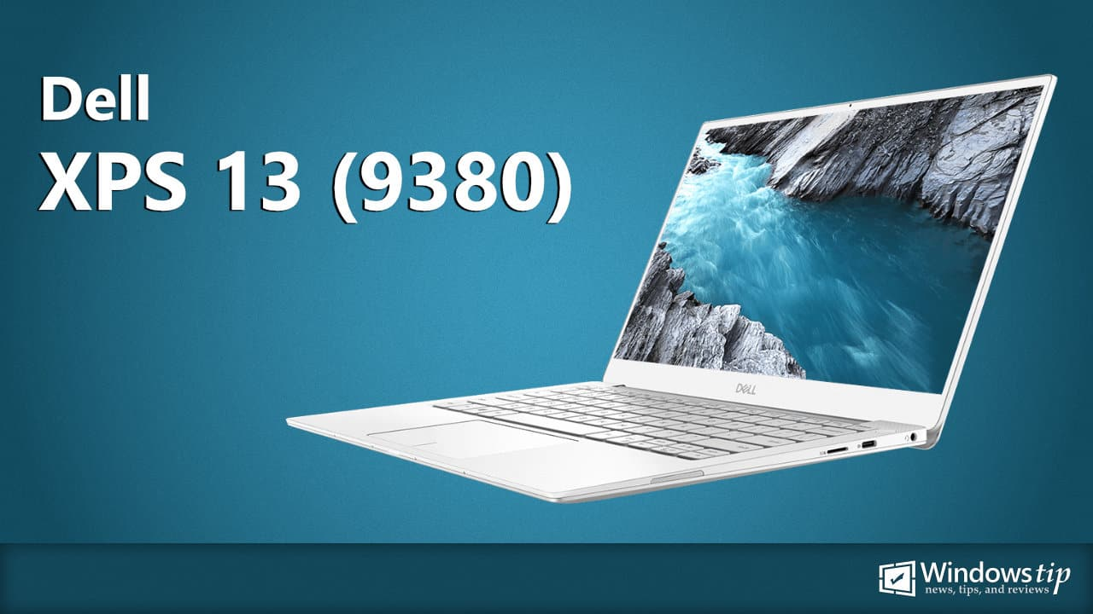

The Dell XPS 13 9380 features the latest Whiskey lake processor 8th Gen dual-core Intel Core i3-8145U, quad-core Intel Core i5-8265U, or quad-core Intel Core i7-8565U. It offers options of a 13.3-inch InfinityEdge FHD non-touch, FHD with touch support, and UltraSharp 4K UHD with touch support. It’s available in 4 GB, 8 GB, and 16 GB of 2133 MHz dual-channel LPDDR3 SDRAM with the PCIe 3×4 NVME SSD storage up to 2TB.

The laptop weight at 1.27 kb with a dimension of 301.76mm x 199.24mm x 7.80-11.63mm. It also has a nice range of ports including two Thunderbolt 3 port, one USB-C 3.1 Gen 2 port, one headset port, one microSD card reader, and a wedge-shaped lock. Read on to see the Dell XPS 13 9380 full spec sheet.

**INTRODUCTION**

**PROCESSOR:**

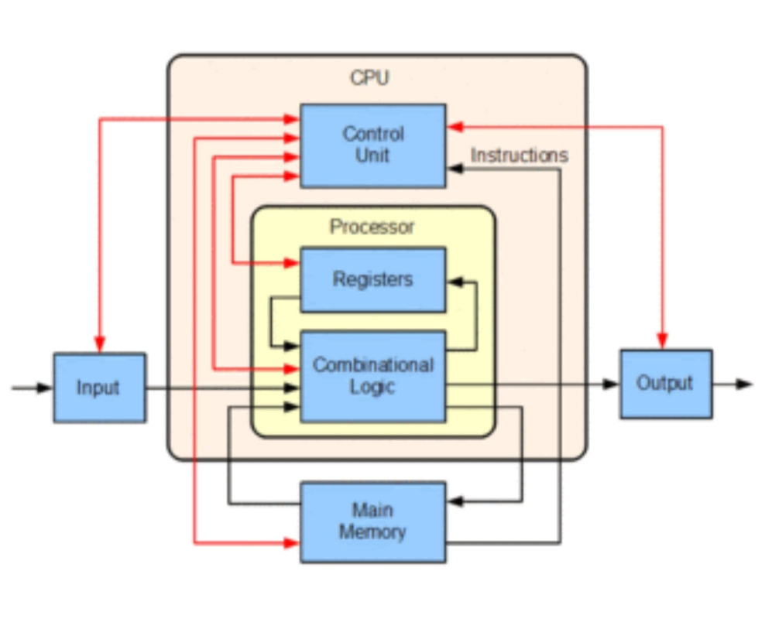

* A central processing unit(CPU) is the electronic circuitry within a computer that carries out the instructions of a computer program by performing the basic arithmetic, logical, control and input/output operation specified by the instructions. The computer industry has used the term “central processing unit ”at least since the early 1960s.

* Traditionally , the term “CPU” refers to a processor, more specifically to its processing unit and control unit(CU), distinguishing these core elements of a computer from external components such as main memory and I/O circuitry.

* The form , design, and implementation of CPUs have changed over the course of their history, but their fundamental operation remains almost unchanged . Principle components of a CPU include the arithmetic logic unit (ALU) that performs arithmetic and logic operations registers that supply operands to the ALU and store the results of ALU operations and a control unit that orchestrates the fetching( from memory ) and execution of instructions by directing the coordinated operations of the ALU , registers and other components.Most modern CPUs are microprocessors, meaning they are contained on a single integrated circuit (IC) chip. An IC that contains a CPU may also contain memory, peripheral interfaces, and other components of a computer; such integrated devices are variously called microcontrollers or systems on a chip (SOC). Some computers employ a multi-core processor, which is a single chip containing two or more CPUs called “cores"; in that context, one can speak of such single chip as “sockets”.

# Key Features:

* Model: Dell XPS 13 9380
* Processor: Core i7 8th Gen QuadeCore.
* RAM: 16GB
* SSD: 512GB
* Fingerprint Redar.

**GPU**

|  |
| --- |
|  |
|  |  |

1. A graphics processing unit(GPU) is specialised electronic circuit designed to rapidly manipulate and alter memory to accelerate to creation of image in a frame buffer intended for output to a display device. GPU is used in embedded system, mobile phones, computer etc.

|  |
| --- |
|  |
|  |  |

Modern GPUs are very efficient at manipulating computer graphics and image processing , and their highly parallel structure make them more efficient than general purpose CPUs for algorithm where the processing of large blocks of data id done in parallel.

# Dell XPS 13 9380 Technical Specifications

|  |  |
| --- | --- |
|  | Dell XPS 13 9380 |
| **Availability** | |
| **Released** | 2019 |
| **Software** | |
| **Pre-Installed OS** | • Windows 10 Home 64-bit • Windows 10 Pro 64-bit • Ubuntu |
| **Built-in Apps** | • Microsoft Office 30-days trial • McAfee LiveSafe™ 12 Month Subscription |
| **Display** | |
| **Size** | 13.3 inches |
| **Info** | **13.3-inch FHD touchscreen** 1920 x 1080, 166 PPI, 60 Hz, 1500:1 contrast ratio, 400 nits luminance, 2.90 W power consumption, Anti-reflective, Touch support.  **13.3-inch FHD non-touchscreen** 1920 x 1080, 166 PPI, 60 Hz, 1500:1 contrast ratio, 400 nits luminance, 2.90 W power consumption, Anti-glare, Non-touch support.  **13.3-inch UHD touchscreen** 3840 x 2160, 331 PPI, 60 Hz, 1500:1 contrast ratio, 400 nits luminance, 5.41 W power consumption, Anti-reflective, Touch support. |
| **Internal Specs** | |
| **CPU** | **8th Gen Intel® Core™ i3-8145U** 2 cores, 4 threads, 4MB SmartCache, 2.10 GHz up to 3.90 GHz.  **8th Gen Intel® Core™ i5-8265U** 4 cores, 8 threads, 6MB SmartCache, 1.60 GHz up to 3.90 GHz.  **8th Gen Intel® Core™ i7-8565U** 4 cores, 8 threads, 8MB SmartCache, 1.80 GHz up to 4.60 GHz. |
| **Graphics** | Intel® UHD Graphics 620 |
| **Memory** | 4 GB8 GB16 GB  2133 MHz Dual-channel LPDDR3 SDRAM |
| **Storage** | 128 GB256 GB 512 GB 1 TB2 TB  PCIe® 3x4 NVMe™ SSD, Up to 32 Gbps |
| **Network** | • Killer 1435-S WiFi: Up to 867 Mbps, Dual band 2.4 GHz/5 GHz, 802.11 a/b/g/n/ac • Bluetooth 4.2 |
| **Battery** | |
| **Size** | 4-cell smart lithium-ion (52 WHr) |
| **Battery Life** | Up to 21 hours (FHD panel) |
| **Power Supply** | 45 W USB (Type-C) power adapter 20 VDC/2.25A, 15 VDC/3A, 9 VDC/3A, 5VDC/3A |
| **Exterior** | |
| **Dimensions** | **Rear** 11.88 x 7.84 x 0.46 in (301.76 x 199.24 x 11.63 mm) **Front** 11.88 x 7.84 x 0.31 in (301.76 x 199.24 x 7.80 mm) |
| **Weight** | 2.81 lb (1.27 kg) |
| **Colors** | • Frost with Arctic white woven glass. • Rose Gold with Arctic white woven glass. • Platinum silver with black carbon fiber interior. |
| **Keyboard and Trackpad** | • Full-size backlit keyboard. • 4.13 x 2.36 in (105 mm x 60 mm) touchpad with multi-touch gesture support. |
| **Ports** | • 2 x Thunderbolt™ 3 with Power Delivery & DisplayPort (4 lanes of PCI Express Gen 3)  • 1 x USB-C 3.1 with Power Delivery & DisplayPort • 1 x headset jack • 1 x microSD card reader • 1 x Wedge-shaped lock |
| **Camera & Audio** | |
| **Camera** | **Front facing camera** Top-mount front camera with fixed focus lens, 0.9 Megapixels (1280 x 720 HD) at 30 fps. |
| **Audio** | • Realtek ALC3271-CG with Waves MaxxAudio Pro • Two speakers (2W x 2 = 4W total) • Dual-array microphones |
| **Misc** | |
| **Sensors** | • Windows Hello compliant fingerprint reader in the power button​​ • Ambient light sensor |
| **Security** | • Windows Hello with Fingerprint Sign in • Wedge-shaped lock |

# Computer arithematic

Data is manipulated by using the arithmetic instructions in digital computers. Data is manipulated to produce results necessary to give solution for the computation problems. The Addition, subtraction, multiplication and division are the four basic arithmetic operations. If we want then we can derive other operations by using these four operations.

To execute arithmetic operations there is a separate section called arithmetic processing unit in central processing unit. The arithmetic instructions are performed generally on binary or decimal data. Fixed-point numbers are used to represent integers or fractions. We can have signed or unsigned negative numbers. Fixed-point addition is the simplest arithmetic operation.

If we want to solve a problem then we use a sequence of well-defined steps. These steps are collectively called algorithm. To solve various problems we give algorithms.

In order to solve the computational problems, arithmetic instructions are used in digital computers that manipulate data. These instructions perform arithmetic calculations.

And these instructions perform a great activity in processing data in a digital computer. As we already stated that with the four basic arithmetic operations addition, subtraction, multiplication and division, it is possible to derive other arithmetic operations and solve scientific problems by means of numerical analysis methods.

A processor has an arithmetic processor(as a sub part of it) that executes arithmetic operations. The data type, assumed to reside in processor, registers during the execution of an arithmetic instruction. Negative numbers may be in a signed magnitude or signed complement representation. There are three ways of representing negative fixed point - binary numbers signed magnitude, signed 1’s complement or signed 2’s complement. Most computers use the signed magnitude representation for the mantissa.

**Memory Organisation :**

A memory unit is the collection of storage units or devices together. The memory unit stores the binary information in the form of bits. Generally, memory/storage is classified into 2 categories:

* **Volatile Memory**: This loses its data, when power is switched off.
* **Non-Volatile Memory**: This is a permanent storage and does not lose any data when power is switched off.
* The total memory capacity of a computer can be visualized by hierarchy of components. The memory hierarchy system consists of all storage devices contained in a computer system from the slow Auxiliary Memory to fast Main Memory and to smaller Cache memory.
* **Auxiliary memory**: access time is generally 1000times that of the main memory, hence it is at the bottom of the hierarchy.
* The main memory occupies the central position because it is equipped to communicate directly with the CPU and with auxiliary memory devices through Input/output processor (I/O).
* When the program not residing in main memory is needed by the CPU, they are brought in from auxiliary memory. Programs not currently needed in main memory are transferred into auxiliary memory to provide space in main memory for other programs that are currently in use. The cache memory is used to store program data which is currently being executed in the CPU.

## Main Memory

The memory unit that communicates directly within the CPU, Auxillary memory and Cache memory, is called main memory. It is the central storage unit of the computer system. Main memory is made up of RAM and ROM, with RAM integrated circuit chips holing the major share.

* RAM: Random Access Memory
  + **DRAM**: Dynamic RAM, is made of capacitors and transistors, and must be refreshed every 10~100 ms. It is slower and cheaper than SRAM.
  + **SRAM**: Static RAM, has a six transistor circuit in each cell and retains data, until powered off.
  + **NVRAM**: Non-Volatile RAM, retains its data, even when turned off. Example: Flash memory.

**ROM**: Read Only Memory, is non-volatile and is more li4ke a permanent storage for information. It also stores the bootstrap loader program, to load and start the operating system when computer is turned on.

## Auxiliary Memory

Devices that provide backup storage are called auxiliary memory. For example: Magnetic disks and tapes are commonly used auxiliary devices. Other devices used as auxiliary memory are magnetic drums, magnetic bubble memory and optical disks.

It is not directly accessible to the CPU, and is accessed using the Input/output channels.

### Cache Memory

The data or contents of the main memory that are used again and again by CPU, are stored in the cache memory so that we can easily access that data in shorter time.

Whenever the CPU needs to access memory, it first checks the cache memory. If the data is not found in cache memory then the CPU moves onto the main memory. It also transfers block of recent data into the cache and keeps on deleting the old data in cache to accomodate the new one.

**Instruction Set:**

Instruction set is also called as ISO(Instruction set Architecture)is a part of laptop that pertains to programing, which is basically machine language.The instruction set provide command to the processor to tell it what it needs to do. The instruction set consist of addressing mode , Instruction, native data types , registers, memory architecture, interrupt and exception handeling ,external I/O.

The example of instruction set is x86 instruction set which is common in laptops today. Different computer processer can use almost the same instruction set while still having different internal design.

Both the intel pentium and AMD Athlon processer use nearly the same x86 instruction set . The instruction set can be built into the hardware of processor or it can be emulated in software using interpreter.

**Examples of instruction set :**

* **ADD** - Add two numbers together.
* **COMPARE** - Compare numbers.
* **IN** - Input information from a device, e.g., keyboard.
* **JUMP** - Jump to designated RAM address.
* **JUMP IF** - Conditional statement that jumps to a designated RAM address.
* **LOAD** - Load information from RAM to the CPU.
* **OUT** - Output information to device, e.g., monitor.
* **STORE** - Store information to RAM.

**Input device and it's mechanism:**

In computing, an inputdevice is a piece of Computer equipment used to provide data and control signals to an information processing system such as a computer or Information appliances. Examples of input devices include keyboard ,mouse, scanner, digital cameras, joystick, and microphone.

1. **Keyboard:**

|  |
| --- |
|  |
|  |  |

It is standard input device is readily available for us to fill the data. A keyboard is similar to conventional type writer. Keyboard is divided into three main parts such as function keys, Numeric key and alphabetic numeric key, special key and screen navigation keys.

**2.Touch Screen:**

A touch screen is a computer display screen that serves as an input device. When a touch screen is touched by a finger or stylus, it registers the event and sends it to a controller for processing.

A touch screen may contain pictures or words that the user can touch to interact with the device.

Touch screens can be attached to computers or to networks as terminals. They also play a prominent role in the design of digital appliances such as the personal digital assistant (PDAs), satellite navigation devices, mobile phones and video games.

How a touch screen event is registered depends on the touch screen's inherent technology.

**3.Joystick :**

A joystick is an input device consisting of a stick that pivots on a base and reports its angle or direction to the device it is controlling. Joysticks are often used to control video games, and usually have one or more push-buttons whose state can also be read by the computer.

**4.Webcam:**

captures a video image of the scene in front of it. It is either built in to the computer (e.g. laptop) or it is connected through an USB cable. The video signal is made up of a series of individual 'image frames' which are an instant snapshot of the scene in front of it.

|  |
| --- |
|  |
|  |  |

**5.Camera**:

camera is also a input device because it allows you to put digital images into the laptop or computer.

**6.Microphone:**

Microphone is an input device to input sound that is then stored in a digital form.

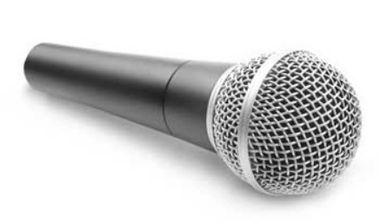The microphone is used for various applications such as adding sound to a multimedia presentation or for mixing music.

## 7. Digitizer

Digitizer is an input device which converts analog information into digital form. Digitizer can convert a signal from the television or camera into a series of numbers that could be stored in a computer. Digitizer is also known as Tablet or Graphics Tablet as it converts graphics and pictorial data into binary inputs. A graphic tablet as digitizer is used for fine works of drawing and image manipulation applications.

**Output Components and it's Mechanism**

1. **Monitors**

|  |
| --- |
|  |
|  |  |

* Monitors, commonly called as Visual Display Unit(VDU), are the main output device of a computer. It forms images from tiny dots, called pixels that are arranged in a rectangular form. The sharpness of the image depends upon the number of pixels.

|  |
| --- |
|  |
|  |  |

1. **Printer:**

A printer is an external hardware Output device that takes the electronic data stored on a computer or other device and generates a Copy of it. For example, if you created a report on your computer, you could print several copies to hand out at a staff meeting. Printers are one of the most popular computer peripherals and are commonly used to print text and photos.

1. **Projector:**

projector is an [output device](https://techterms.com/definition/outputdevice) that projects an image onto a large surface, such as a white screen or wall. It may be used an alternative to a [monitor](https://techterms.com/definition/monitor) or television when showing video or images to a large group of people.

projectors can used wherever there is a bright surface (such as a white or light coloured wall). Most projectors have multiple [input](https://techterms.com/definition/input) sources, such as [HDMI](https://techterms.com/definition/hdmi) ports for newer equipment and [VGA](https://techterms.com/definition/vga) ports for older devices. Some projectors support Wi-Fi and Bluetooth as well.

