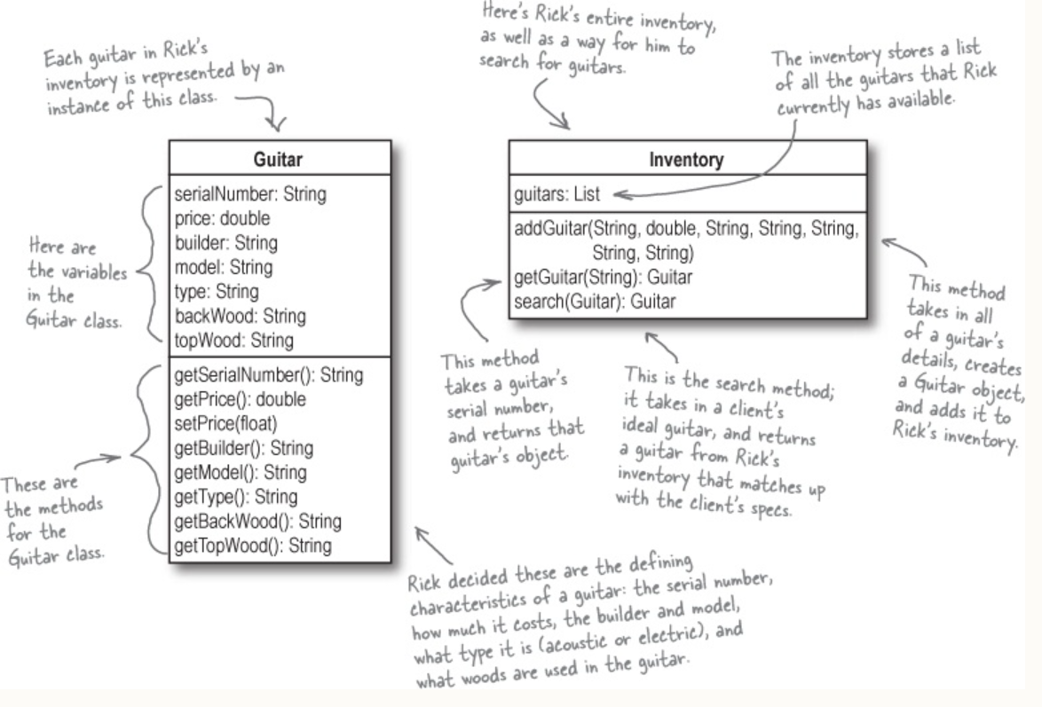

**Replaced String With Enum for few parameters which will provide compile-time type checking, reducing errors from passing invalid strings.**

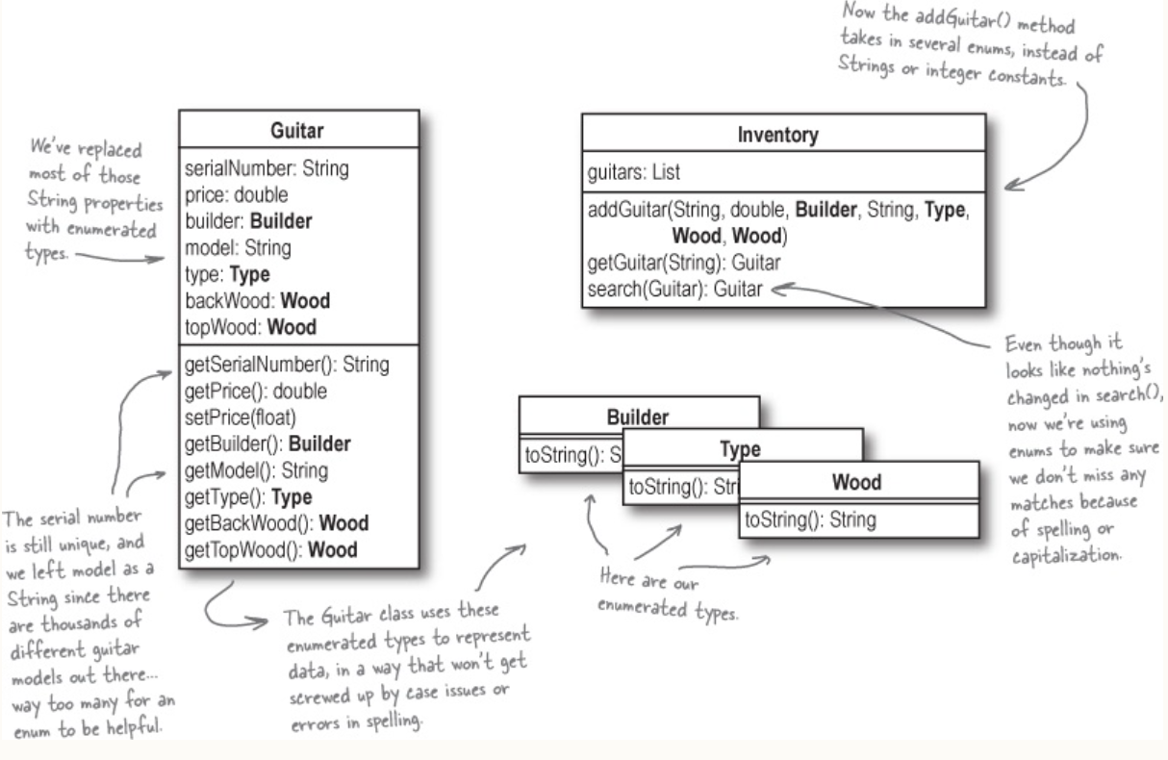

**Encapsulated the guitar properties out of Guitar, and put them in their own separate object**

