Azure Cloud Fundamentals and Data Pipeline Implementation using ADF
Week 4 Assignment

Objective
The objective of this assignment was to understand core Azure cloud concepts and build an end-to-end data pipeline using an Azure Storage Account and Azure Data Factory (ADF). The work involved exploring the Azure Portal, provisioning storage and Data Factory resources, configuring linked services and datasets, building a pipeline with metadata validation and a copy data activity, executing and monitoring the pipeline, and configuring role-based access control (IAM) for the resources involved.

1. Explore Azure Portal and Create a Resource Group
A resource group named “rg-superstore-pipeline” was created. A resource group acts as a logical container that groups related Azure resources together, making it easier to manage, monitor, and delete them as a single unit.
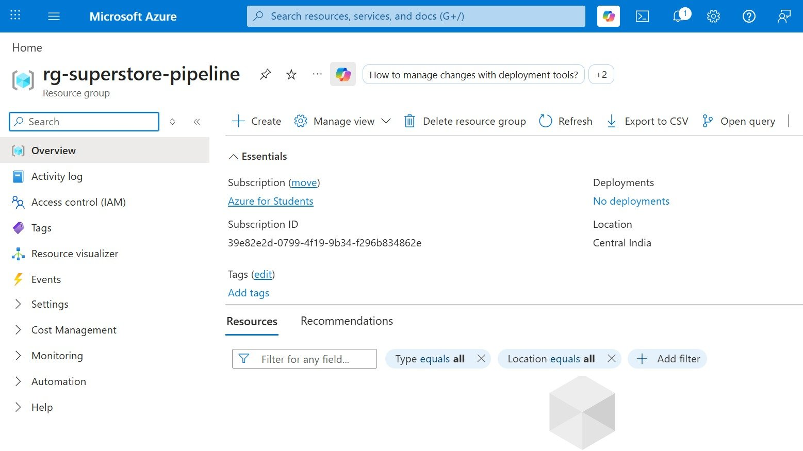
Figure 1: Resource group overview (rg-superstore-pipeline)

2. Create a Storage Account, Blob Container, and Upload a CSV File
A storage account named “stsuperstoreak55” was created within the resource group, using the Standard performance tier and locally redundant storage (LRS). Inside the storage account, a blob container named “superstore-data” was created, and the Superstore sales dataset (Sample - Superstore.csv), sourced from Kaggle, was uploaded to this container.
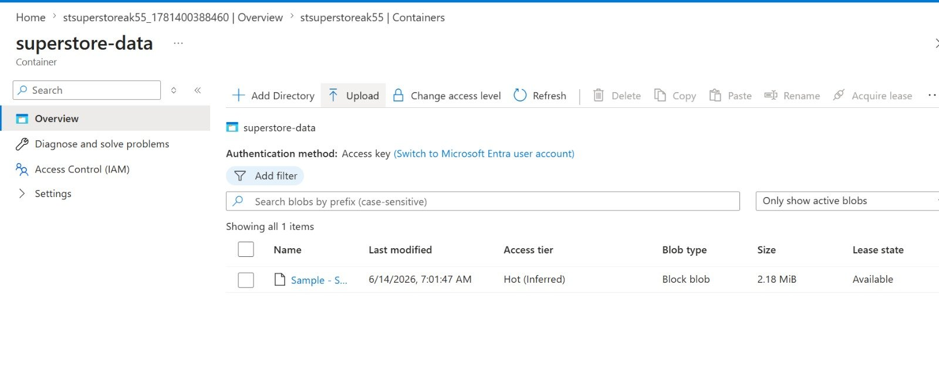
Figure 2: Blob container superstore-data with the uploaded CSV file

3. Create Azure Data Factory and Explore the ADF UI
An Azure Data Factory (V2) instance named “adf-superstoreak” was created within the same resource group and region, alongside the storage account.
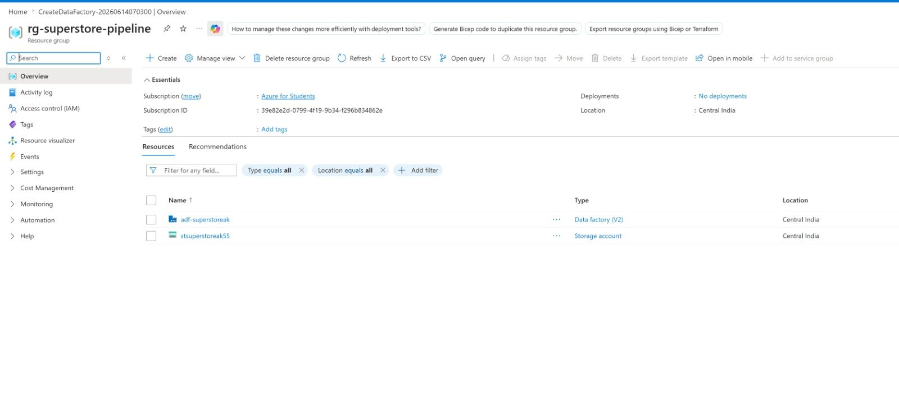
Figure 3: Resource group showing the Data Factory and Storage Account resources
The Data Factory overview page provides access to Azure Data Factory Studio, the web-based authoring and monitoring interface.
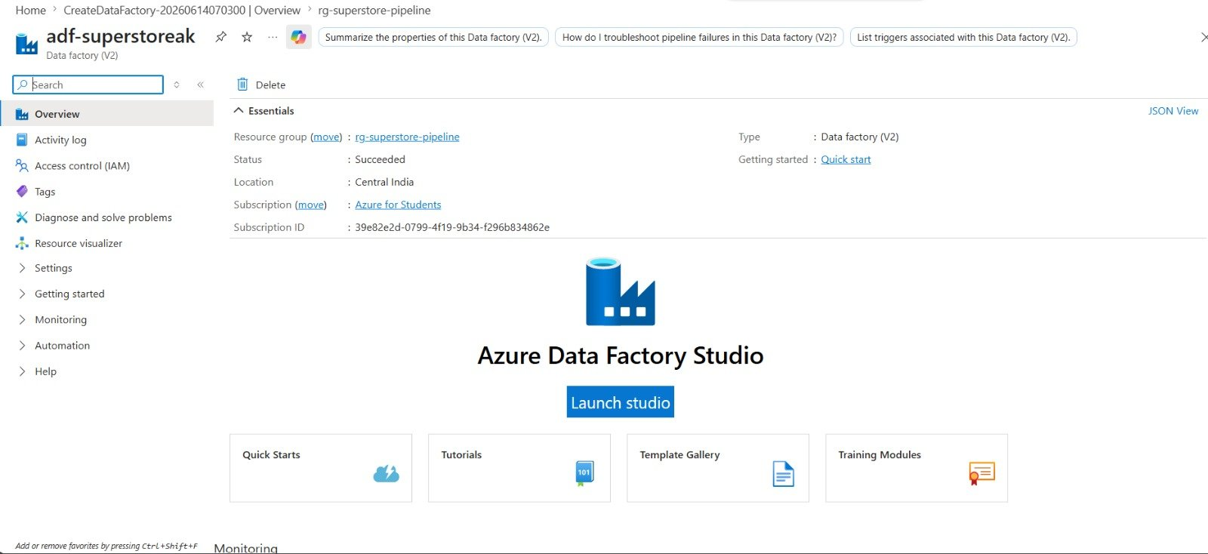
Figure 4: Azure Data Factory overview page with the Launch Studio option
Within ADF Studio, the three main areas of the interface were explored. The Author pane is used to create and manage pipelines, datasets, and data flows.
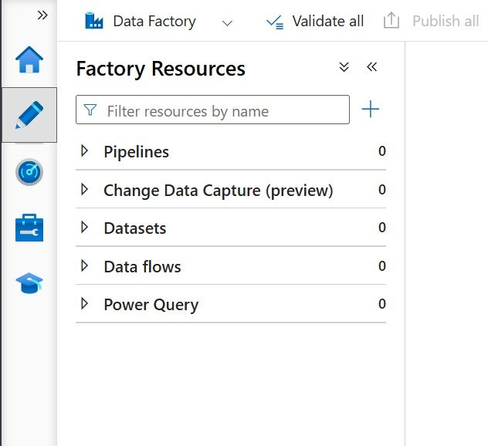
Figure 5: Author pane - Factory Resources
The Monitor pane displays the history and status of pipeline runs, both triggered and debug runs.
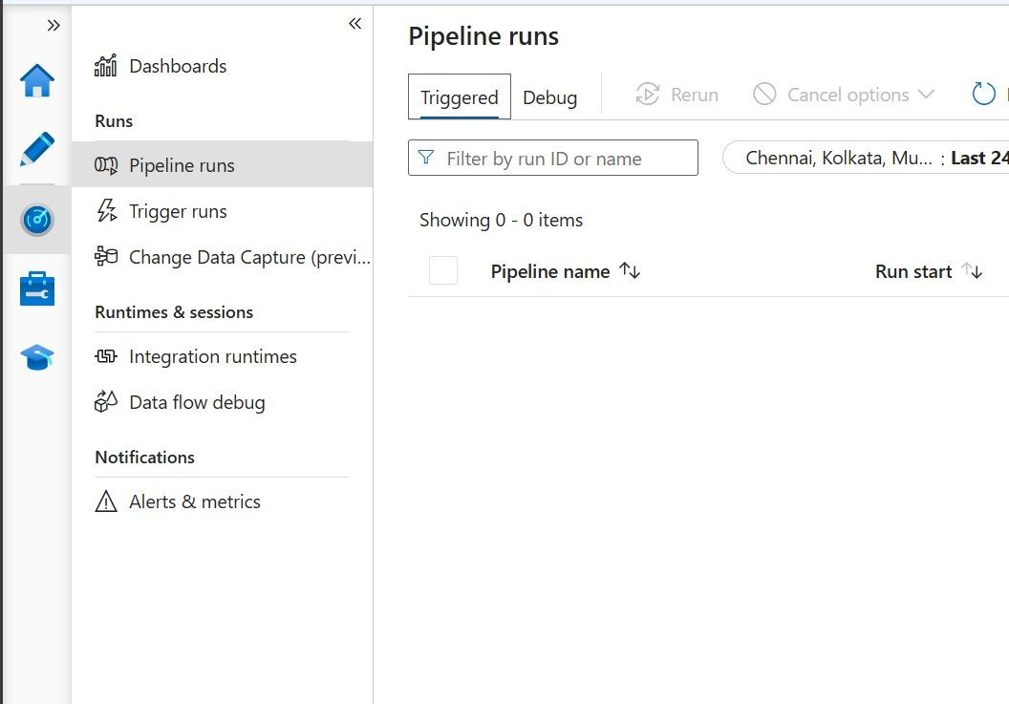
Figure 6: Monitor pane - Pipeline runs
The Manage pane is used to configure linked services, integration runtimes, and other factory-level settings.
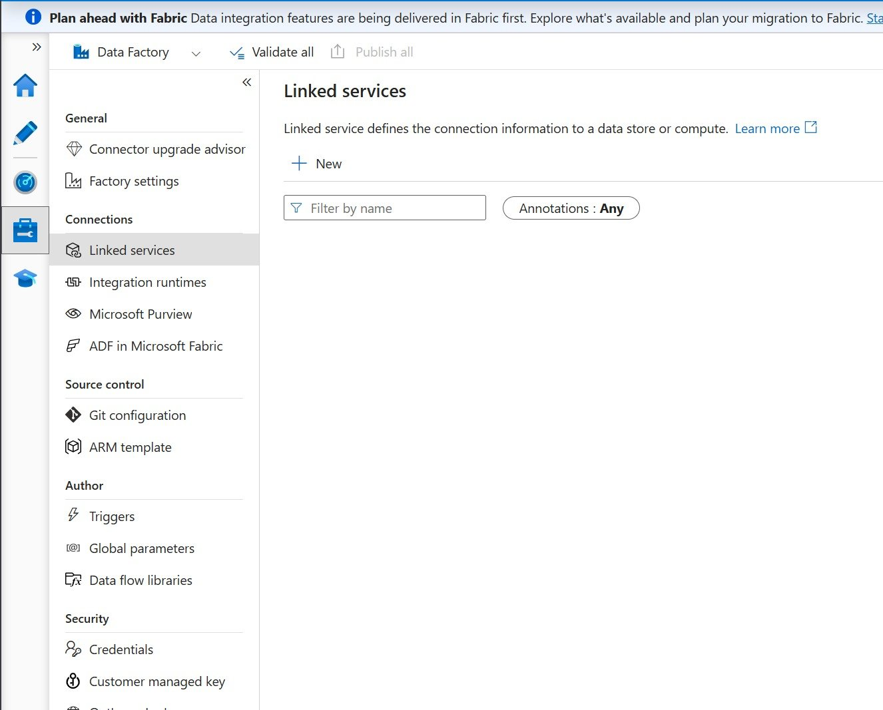
Figure 7: Manage pane - Linked services

4. Create Linked Service (Blob Storage) and Datasets
A linked service named “ls_blobstorage_superstore” was created to establish a connection between Azure Data Factory and the Blob Storage account, using account key authentication.
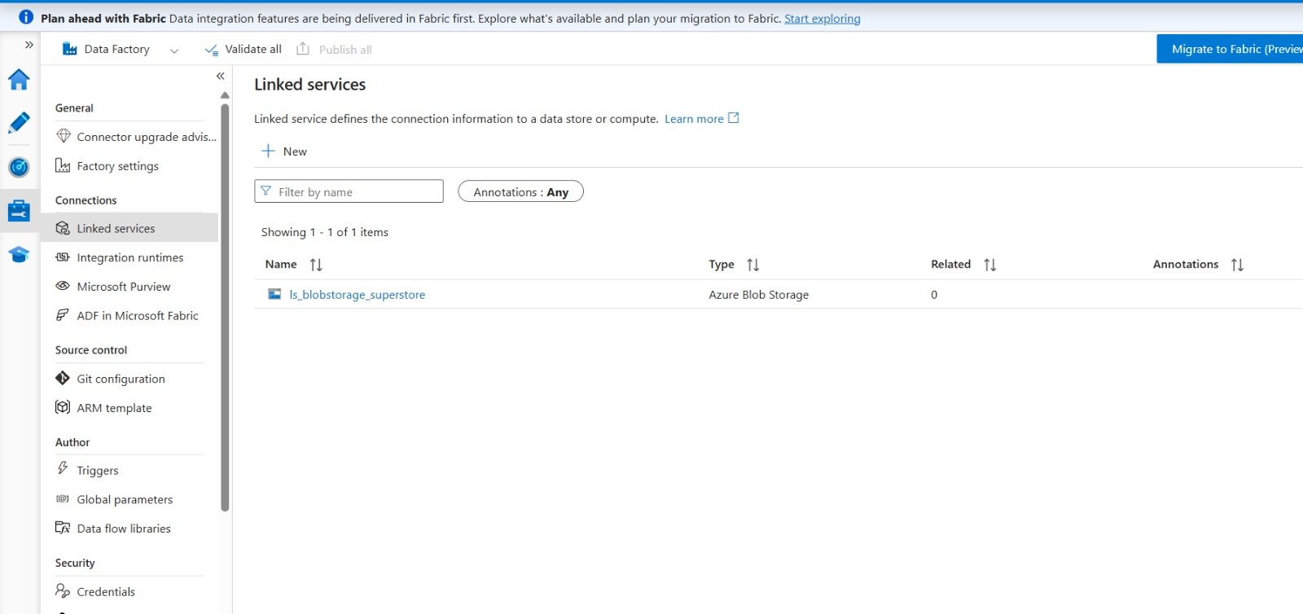
Figure 8: Linked service ls_blobstorage_superstore configured for Azure Blob Storage
A source dataset named “ds_superstore_source” was created, pointing to the uploaded CSV file. The connection was verified using the Preview Data option, which displayed sample rows from the Superstore dataset.
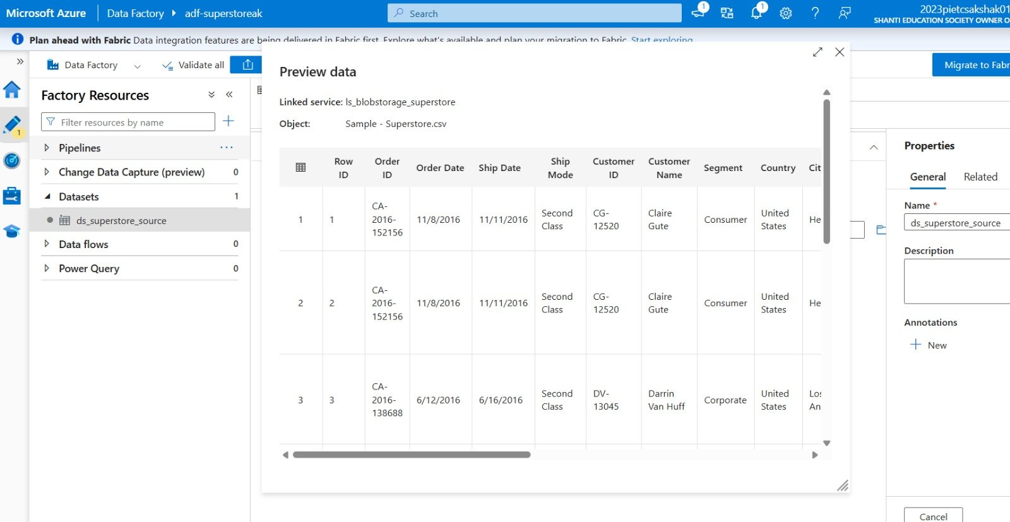
Figure 9: Preview of source dataset ds_superstore_source
A destination dataset named “ds_superstore_destination” was also created, pointing to an output folder within the same blob container, where the copied data would be written by the pipeline.
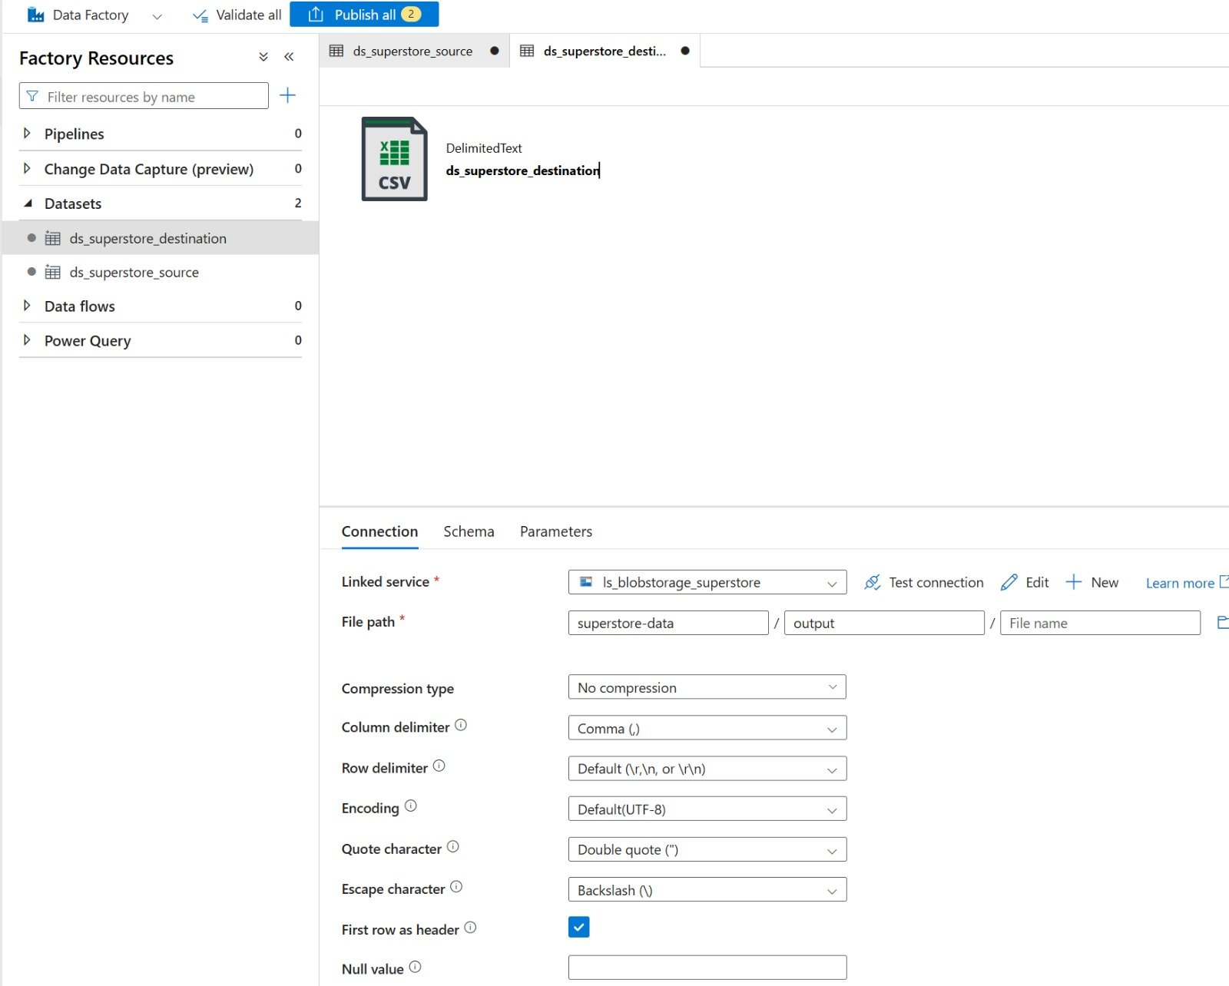
Figure 10: Destination dataset ds_superstore_destination configuration

5. Use Get Metadata Activity to Retrieve File Information
A pipeline named “pl_superstore_pipeline” was created. The first activity added was a Get Metadata activity, named “GetMetadata_SourceFile”, configured against the source dataset. This activity was set up to retrieve the item name, size, last modified timestamp, existence status, and column count of the source file, allowing the file to be validated before further processing.
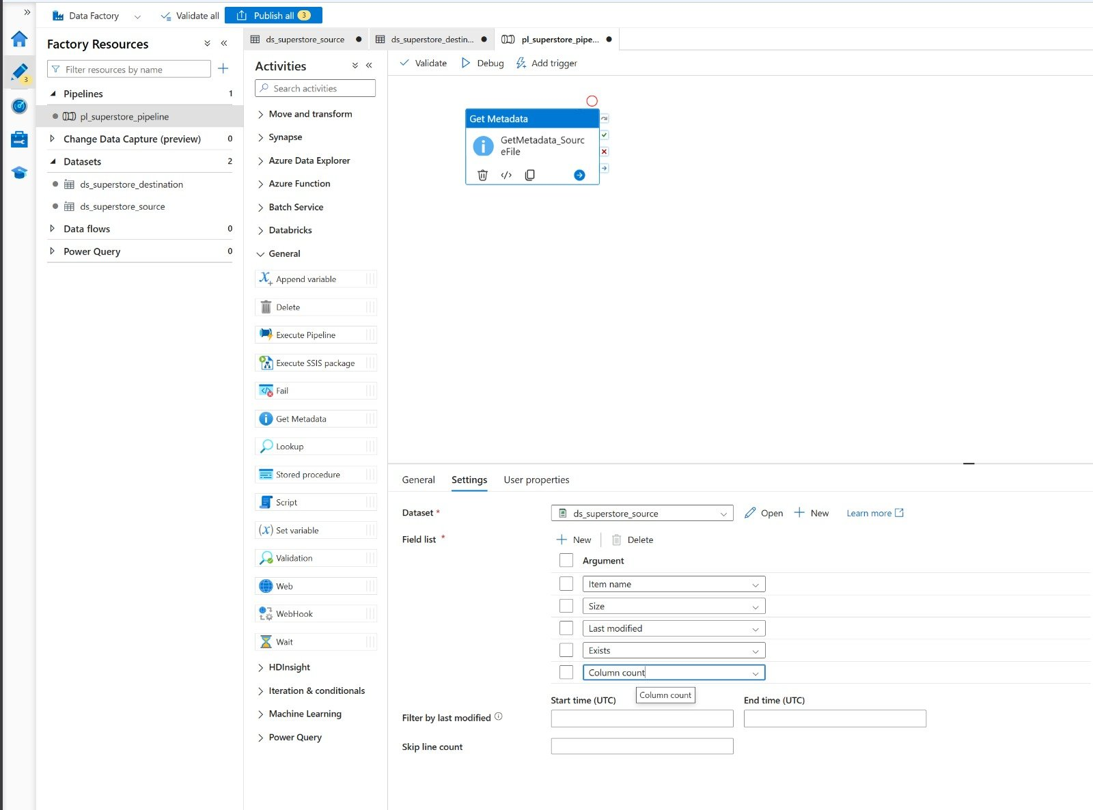
Figure 11: Get Metadata activity configuration

6. Build a Pipeline Using Copy Data Activity
A Copy Data activity, named “CopyData_BlobToBlob”, was added to the pipeline and connected to run only after the Get Metadata activity completed successfully. The source of the Copy Data activity was set to the “ds_superstore_source” dataset.
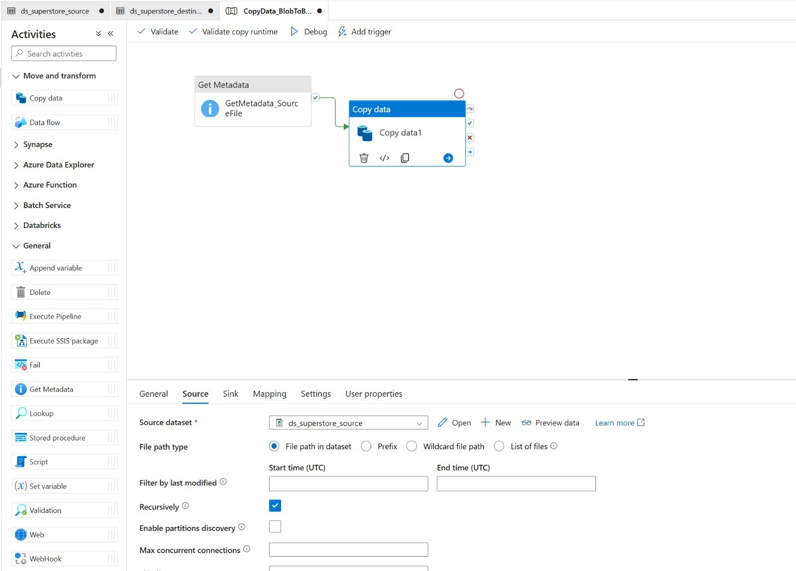
Figure 12: Copy Data activity - Source configuration
The sink (destination) of the Copy Data activity was set to the “ds_superstore_destination” dataset, so that a copy of the source data would be written to the output folder in the blob container.
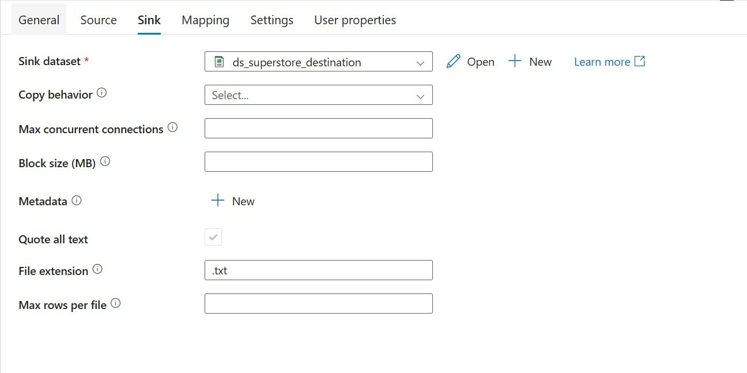
Figure 13: Copy Data activity - Sink configuration

7. Execute the Pipeline and Monitor Execution
The pipeline was executed using the Debug option. Both activities completed successfully, as shown by the status indicators on the pipeline canvas and in the output table, which lists each activity's status, run start time, duration, and integration runtime.
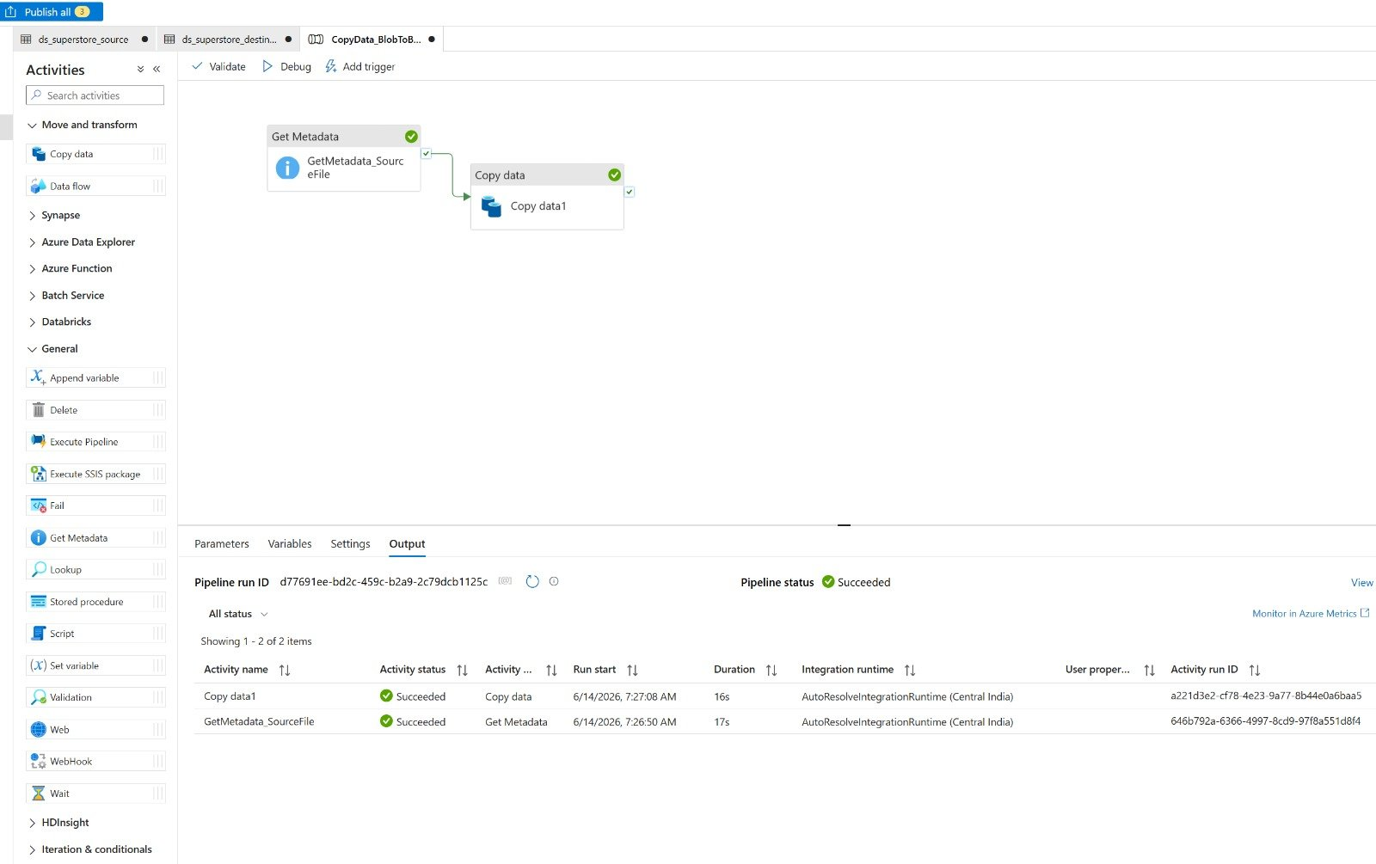
Figure 14: Pipeline debug run output - both activities succeeded
The output of the Get Metadata activity confirmed the details of the source file: item name “Sample - Superstore.csv”, last modified on 14 June 2026.
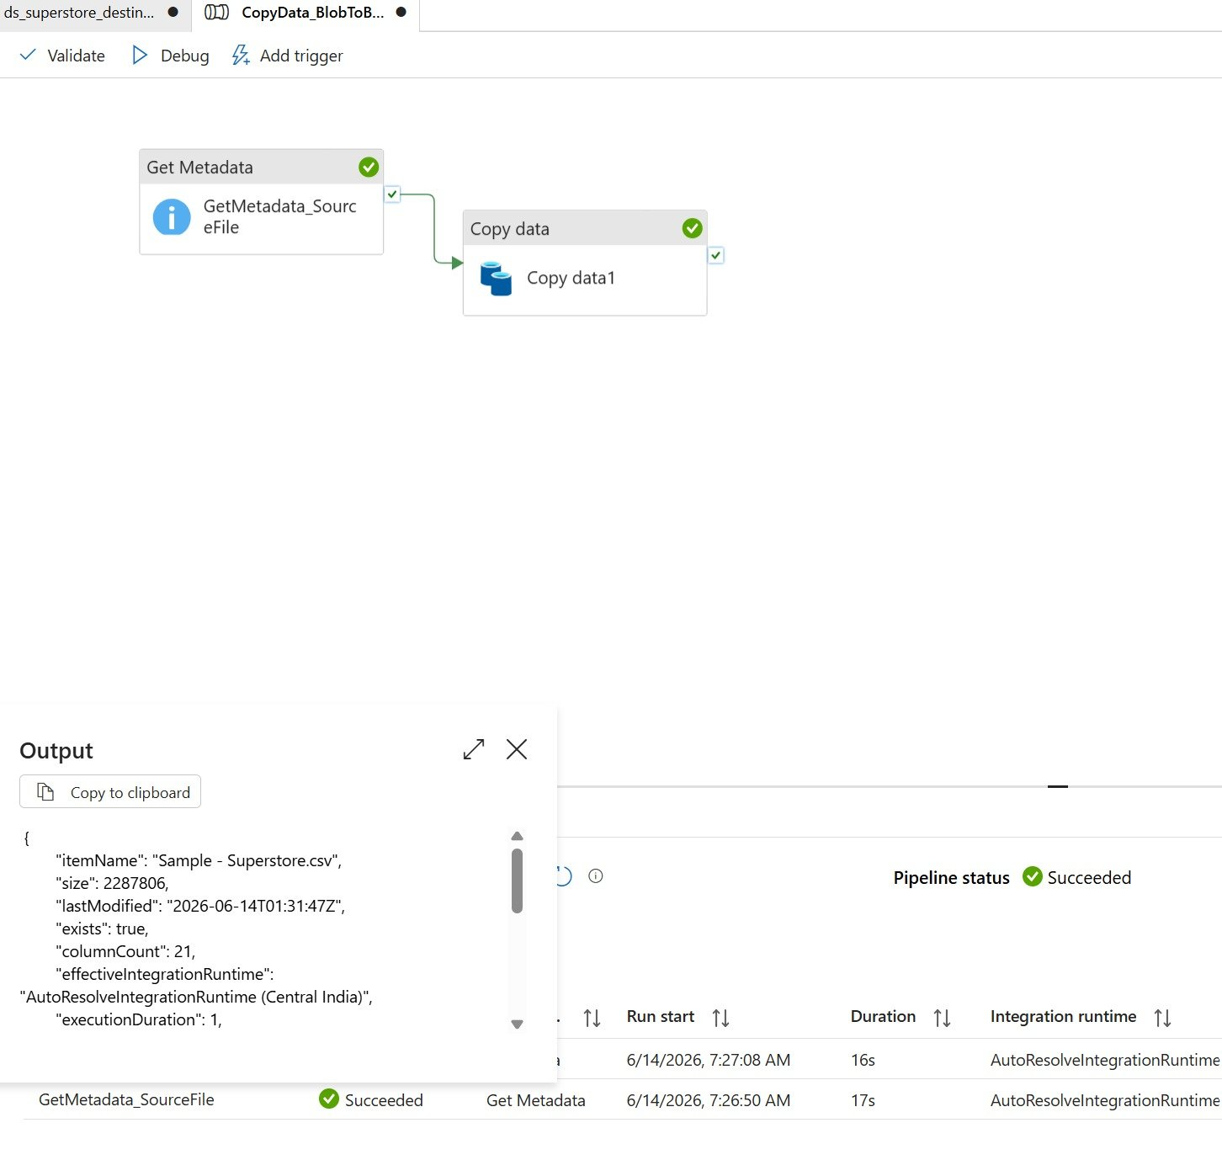
Figure 15: Get Metadata activity output (JSON)
The pipeline run was also reviewed under the Monitor section's Debug tab, which showed the pipeline “CopyData_BlobToBlob” completing successfully with a total duration of 43 seconds, triggered manually.
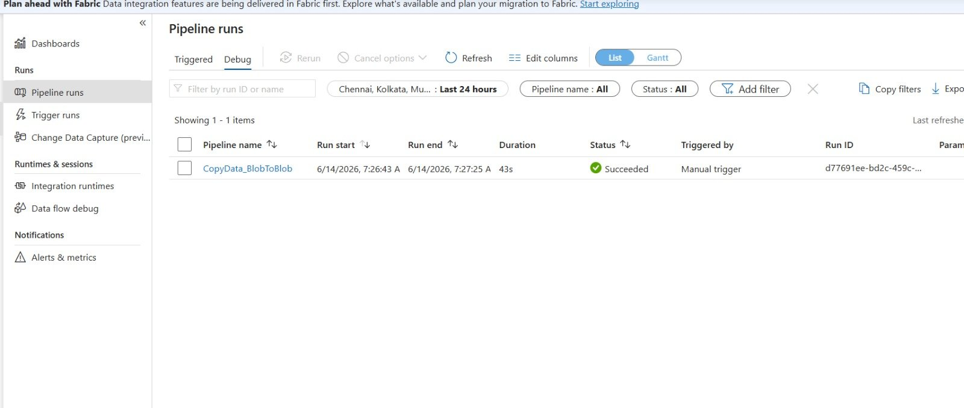
Figure 16: Pipeline run history under Monitor (Debug tab)

8. Assign IAM Roles (Reader, Contributor)
Role-based access control was configured at the resource group level through the Access Control (IAM) blade. Reader and Contributor roles were assigned to the user account, in addition to the Owner role that was automatically assigned at the subscription level. The Reader role grants read-only access to view resources, while the Contributor role allows full management of resources without the ability to grant access to others.
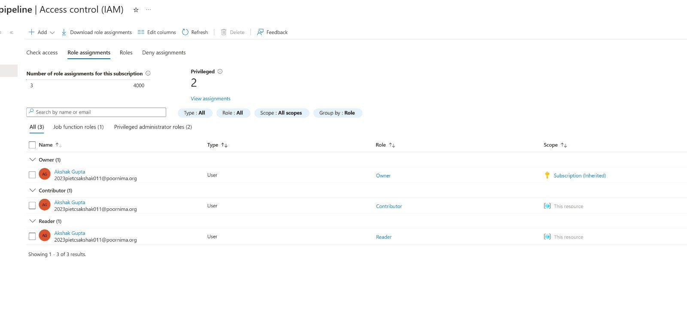
Figure 17: IAM role assignments at the resource group level

9. End-to-End Pipeline with Metadata Validation
Overall, this assignment implemented a complete end-to-end pipeline: the source CSV file was stored in Azure Blob Storage, validated and processed through Azure Data Factory using a Get Metadata activity followed by a Copy Data activity, and written to a destination location within the same storage account. Metadata validation confirmed the existence, size, and structure of the source file before the copy operation was executed, and the successful pipeline run confirmed that the data was copied as expected.

Summary
This assignment provided practical exposure to fundamental Azure cloud concepts and the Azure Data Factory service. Key concepts covered included the Azure resource hierarchy (resource group, storage account, container, and blob), the differences between Infrastructure-as-a-Service, Platform-as-a-Service, and Software-as-a-Service offerings, and the role of Azure Data Factory as an orchestration tool for data movement. The pipeline built in this assignment followed an ETL-style pattern, where the Get Metadata activity acted as a validation step before the Copy Data activity transferred data from a source to a destination location in Blob Storage. The assignment also covered access management through Azure RBAC, demonstrating how Reader and Contributor roles can be assigned at the resource group level to control access to resources such as Storage Accounts and Data Factory. Overall, the exercise resulted in a working end-to-end cloud data pipeline, from data ingestion to validated data movement, monitored and managed through the Azure Portal and ADF Studio.

