Week 3 SQL Assignment
Superstore Sales Analysis using Subqueries, CTEs, and Window Functions

Objective
The goal of this assignment is to analyze sales data from the Superstore dataset by applying SQL concepts like Subqueries, CTEs (Common Table Expressions), and Window Functions. The data is structured into three dimensional tables customers, orders, and products and then queried to extract business insights.

Step 1 – Load Superstore Dataset into a Table
The first step is creating the raw table structure in MySQL that will hold all the data from the Superstore CSV file. This table acts as the staging area from which all other tables are built.
Output:
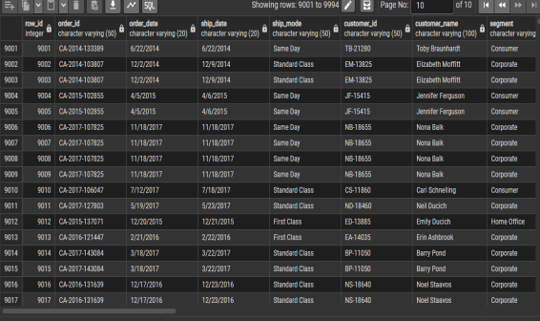

Step 2 – Create Dimensional Tables
From the raw staging table, we extract and create three separate normalized tables: customers, products, and orders. SELECT DISTINCT is used to avoid duplicate entries when inserting data.

1. Customers Table
Stores unique customer information such as name, segment, location, and region.
Output:
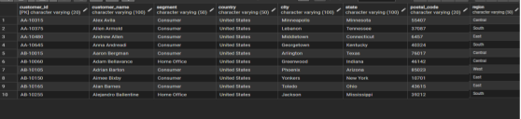


2. Products Table
Stores unique product details including category and sub-category.
Output:
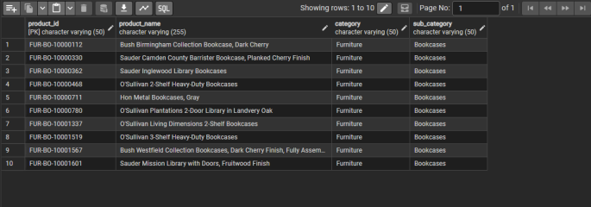


3. Orders Table
Stores all transactional data and connects customers and products together through foreign keys.
Output:
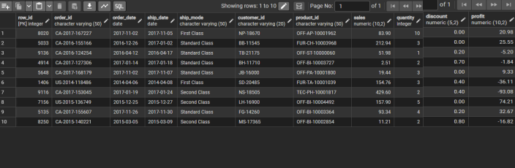


Step 3 – Apply Subqueries
Subqueries are nested SELECT statements used inside another query. Here we use them to filter data dynamically based on calculated values.

1. Orders with Above Average Sales
This query returns all order rows where the sales value is greater than the overall average sales across the entire orders table.
Output:
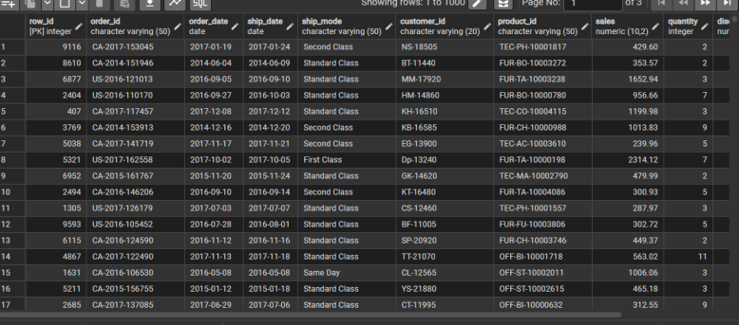

2. Highest Order Per Customer
This query returns the single highest-value order for each customer. A correlated subquery is used for every row, it checks whether the sales value equals the maximum sales for that specific customer.
Output:
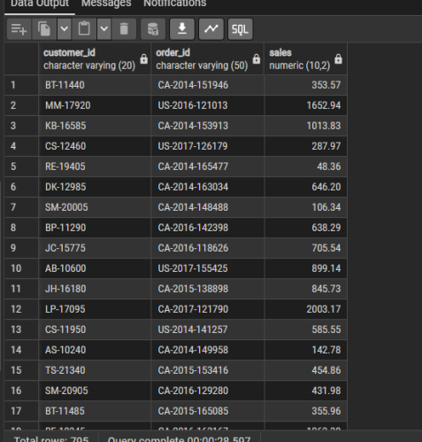

Step 4 – Apply CTE (Common Table Expressions)
A CTE is a temporary named result set defined with the WITH keyword. It makes complex queries easier to read and reuse. Here we compute aggregated values per customer.

1. Total Sales Per Customer
Calculates the total sales amount generated by each customer and orders them from highest to lowest.
Output:
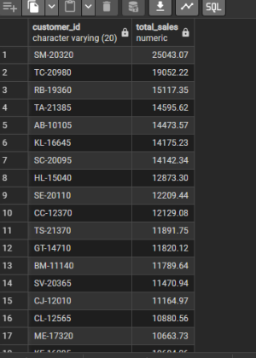

2. Total Profit Per Customer
Similar to the above query but aggregates profit instead of sales, giving a view of how much each customer contributes to overall profitability.
Output:
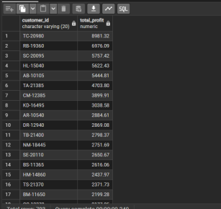

Step 5 – Window Functions
Window functions perform calculations across a set of rows that are related to the current row, without collapsing the rows into a single grouped result. This is different from GROUP BY, all individual rows are still returned.

1. ROW_NUMBER()
Assigns a unique sequential number to each row based on sales in descending order. No two rows get the same number, even if they have equal sales values.
Output:
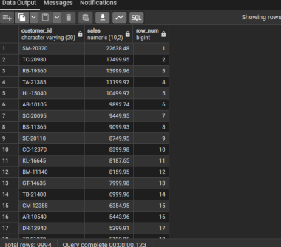

2. RANK()
Assigns a rank to each row. If two rows have the same sales value, they get the same rank. The next rank is then skipped (e.g., 1, 2, 2, 4).
Output:
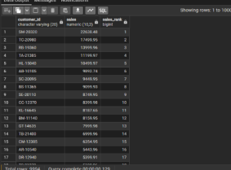

3. DENSE_RANK()
Similar to RANK() but does not skip rank numbers after a tie. For example, if two rows tie at rank 2, the next row gets rank 3 instead of 4.
Output:
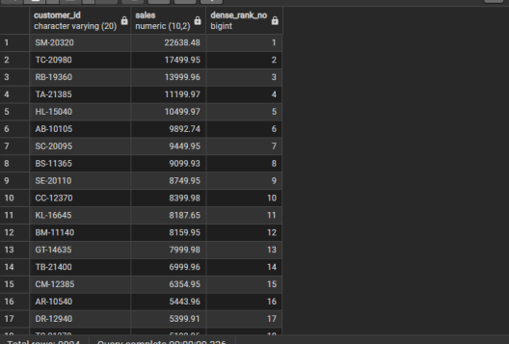

Step 6 – Combining JOIN + CTE + Window Functions
This query brings everything together. A CTE calculates total sales per customer, a JOIN adds the customer name from the customers table, and a RANK window function ranks customers based on their total sales contribution. This helps identify the highest-value customers and is useful for segmentation and targeted business decisions.
Output:
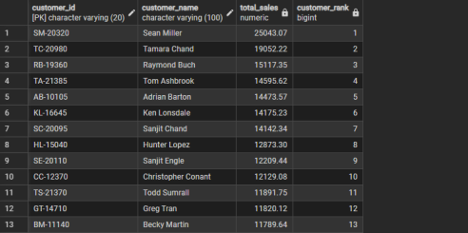

Step 7 – Business Queries
These queries answer specific business questions using a combination of the techniques covered above.

1. Top 10 Customers by Sales
Returns the 10 customers who have generated the highest total sales. These are the most valuable customers for the business.
Output:
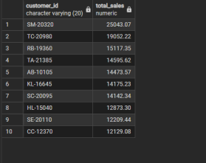

2. Bottom 10 Customers by Sales
Returns the 10 customers with the lowest total sales. These could be customers who purchased very little or only once with a low-value order.
Output:
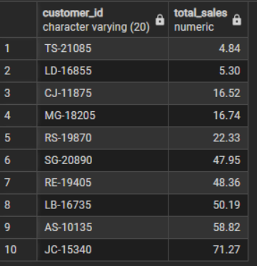

3. Single-Order Customers
Finds customers who have placed exactly one order. These are one-time buyers and could be targeted with retention campaigns.
Output:
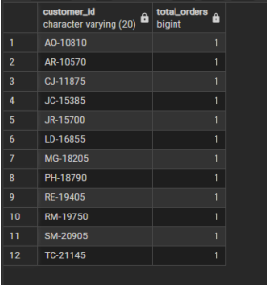

4. Customers Above Average Total Sales
Returns customers whose total sales are higher than the average total sales across all customers. These are the high-value customers who contribute more than the typical customer.
Output:
