IPL Data Analysis
Authors: Akshansh Bakshi, Arjit Jain, Maulik Awasthi
Affiliation: Bennet University, Department of Computer Science

Abstract

The Indian Premier League (IPL) is one of the highest-watched T20 cricket leagues globally, with huge public interest and analytical interest each season. Its worldwide popularity, in addition to a humongous fantasy sports environment, creates a great need for tidy, readable, and aggregated performance data. Now, audience members, pundits, and fantasy league players are overwhelmed by scattered statistics on multiple media platforms. This fragmentation makes it nearly impossible to find a single source of truth, complicating a quick and comparative view of player and team performance. This wastes time and makes it hard to conduct easy and fruitful analysis, which in turn infuriates fans. This study aims to close this gap immediately by reporting a merged analysis of the IPL 2025 season, using a dataset downloaded from Kaggle. We made use of a data pipeline based on Python, largely making use of Pandas for the important steps of data cleaning and aggregation, and Plotly.Express for graphics. All analysis is hosted on an interactive dashboard developed with Streamlit. In this study, we focused on graphing the season's key performance criteria. This effort provides one cohesive, centralized, and intuitive tool from which anyone can find and comprehend the season's key figures. It delivers all the insights you'll require without the need to drill through a series of complex sources, effectively lowering the barrier for fans and analysts to engage with the data.
Keywords: IPL, Cricket Analytics, Data Visualization, Sports Statistics, Python

Introduction

The Indian Premier League, or the IPL, is more than a domestic cricket league in India; it's a mammoth for the international entertainment industry. The stakes and rapidness of the 20-20 format have transformed the game, making it the most consumable form of cricket globally. Since its launch, it has become a multi-million-dollar market that not only attracts international players but also generates huge amounts of money through its sponsorships, media rights, and high-value auctions of players.

Such sheer popularity ensures that each season, there is a huge public demand for information. And talking about this need, it literally comes from everywhere. From casual fans seeking to resolve an argument to the hard-core analysts who write columns. But most important of all, it affects millions of fantasy league participants whose livelihoods rely on making information-driven judgments and decisions. To this new generation of enthusiasts, monitoring the performance of players isn't simply a side-interest thing, but rather its their mind that is constantly attached to the activity, making it more than just a simple interest. Aside from the fans alone, managers, coaches, and even auction tacticians use statistics to make important economic decisions.
Discussing our study and the project it is based on, we aimed to provide these enthusiasts with insights into everything happening in the league. Using powerful tools for data cleaning, aggregation, and visualization, we achieved it through the simplest of methods. Many studies have been written around the same topic, but the methods are different. Some compare team data over the past 10 years, while others just compare player performances. All this using the basic yet high-end tools of Python [1]-[2] or the powerful Microsoft BI tool [3]. While we can't underestimate the heights it can achieve, these studies inspired us to work on all aspects of the sport. To include player performance while also keeping in mind the team analysis.
Going a bit out of the topic, but diving deep into analysis, we also found our way into the lane of Machine Learning and AI. Some studies have been made on predictive analysis of match outcomes and player performances. The basis of which is, gathering data from past matches or years and plotting them for the players as well as the teams [4]-[7]. The team winning analysis is done keeping in mind the enthusiasts who are much more involved in the world of fantasy sports, betting their lives onto it. These people rely completely on such sort of working models as it brings them the relief and satisfaction they want. Along with this, we kept another study in mind where fuzzy clustering was used to particularly put the playing styles of different players into perspective. How they fire the ball away from the bat and how they keep their firm in the field [8].
It's actually frustrating when you simply just want a quick, comparative summary of who's on top, but get a page saying this and that kind of rubbish all over. That makes it very hard for someone without the technical expertise or time to manually compile these kinds of sources. This project was born directly out of that idea, driven by our own personal passion for the sport. We wanted to pierce through the noise and be the final solution to all that frustration of looking everywhere. Our approach was to create a clean, centralized, and interactive application centered on the latest IPL 2025 season data.
Our methodology wasn't to chart every individual ball or catch taken. Instead, we examined the three most important performance indicators of the tournament that tell the story of it all themselves. By obtaining a full dataset and using Python to analyze and perfectly visualize it, we've built a dynamic and open dashboard. The following report outlines our ideas and approach, along with the basic workflow. From taking up raw data to the interactive graphs and graphics. We harness the muscle of the Pandas library for cleaning and aggregating the data, Plotly.Express for graphing, and Streamlit to host the final product, providing an easy-to-understand and not-so-sophisticated statistical snapshot of the season.

Methodology

Our process was pretty straightforward {as shown in Fig.1} and to the point with the problem. What we did was to break it down into a couple of necessary key steps, all of which were handled by Python and its main libraries. This greatly helped us with our work and paved the correct path for the approach. This methodology follows a progressive style layout from sourcing the data to building the final tool.
1. Data and Tools
Searching up Kaggle we sourced an IPL dataset from this year to get things started with. Python was the backbone of the whole project and was literally used to create everything up from scratch. Talking about specifics, we used modern-day libraries like Pandas, Plotlib.Express, Regex and Streamlit. All of which aided the project in a well-rounded way.
2. Data Cleaning
Now, to begin with the main execution, we had to clean the data. That’s how we could move to analyse it anyhow. For this, we used the Pandas library. The first step involved using the library to load the dataset and address any problems in it. We checked the data for any missing values and checked for duplicate entries as well. All that could give an error or lead to one in our results was completely eliminated in this step. This process ensured our final calculations would be accurate.
3. Data Aggregation
After cleaning the dataset, our next step was to transform the data from a long list of individual match events into the summaries we needed. This is where we got the numbers for our charts and graphs that the project displays. To put it into words for better understanding, imagine you need to find the purple cap holder. For this, we combined the data for wickets taken in matches played and summed them all up to the result.
4. Data Visualization
Once we had our processed data, we needed to graph it for a better visual (Nobody likes to see just a boring table on sites). We used Plotly.Express to create the bar charts. It’s reliable and gives you a lot of control over the final look, which is indeed very important for a clean presentation. The bar chart was the perfect match for our study as it allows you to compare statistics between other players in real time.
5. Creating The Web App
Just some messed up yet neatly put graphs are fine on paper or for a random look, but what we wanted was for people to use our work. Streamlit was the perfect tool for this. This Python library lets you build simple web apps really quickly and from nothing but just your imagination. We used it to create an interactive dashboard where a user can view the graphs in a web browser, making the data easier to access.
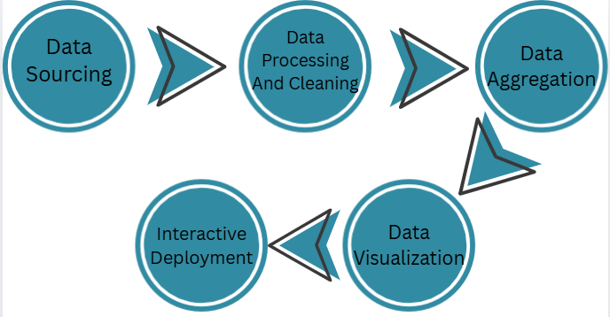
Fig.1 The Flow of The Project

Results and Discussion

Player Analysis
The first section of our project works on player analysis. We worked on three major factors that come with it.
- Top Run Scorers
- Top Wicket Takers
- Best All-Rounder
These sections help in overall analysis of all the 3 major types of players in the tournament.
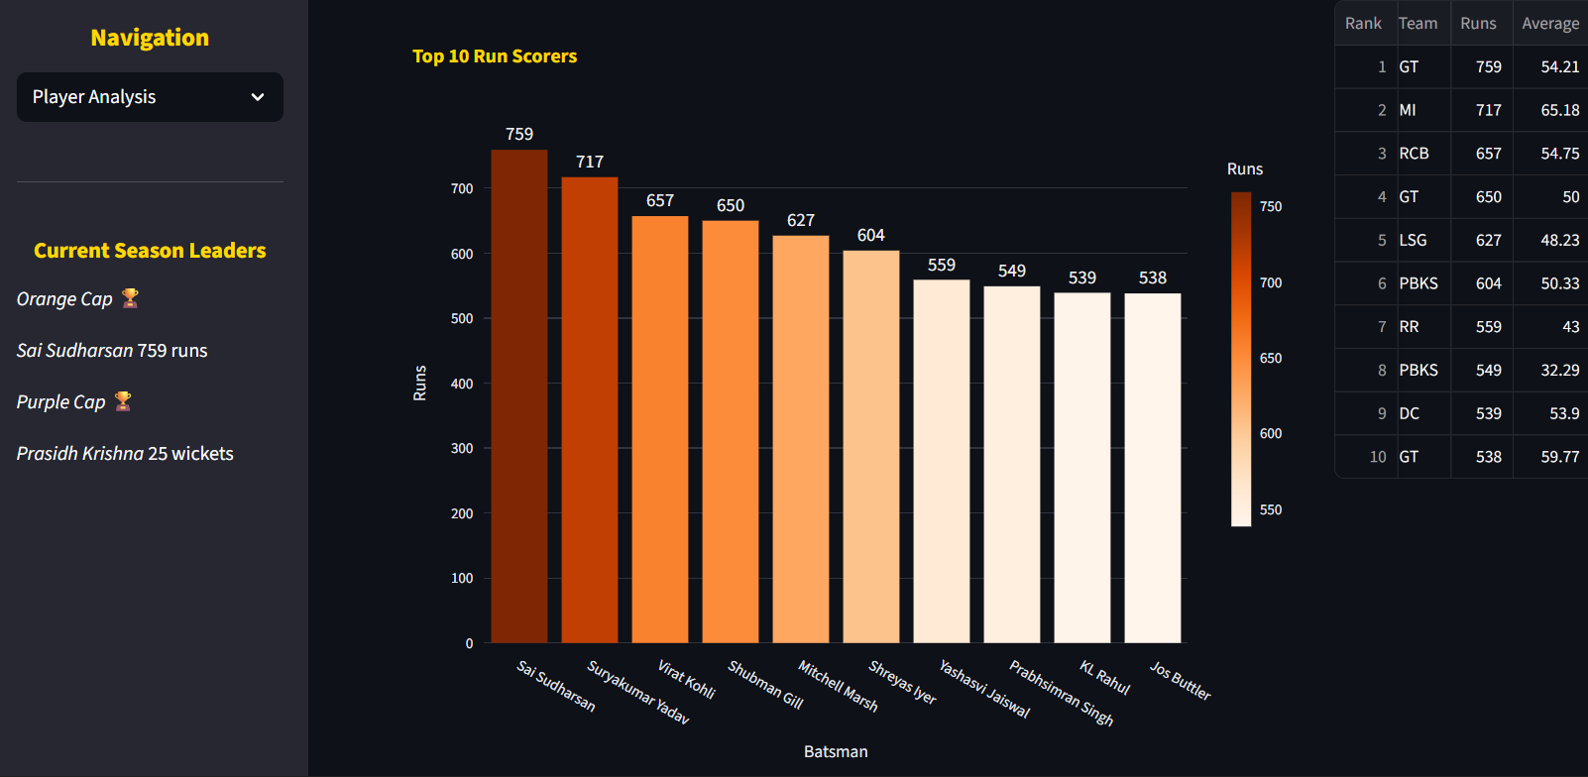
Fig. 2 {Dashboard of Top Run Scorers}
Going through all of them, we take up the top 10 run scorers from the tournament {Shown in Fig. 2} and visualize them using graphs to help users get a clean and precise view of their requirements. We also display a table to have a more concise and detailed view of each player and their performance. The same has been done with the Top Wicket Takers section as well. The All-rounder section on the other hand just displays the table with highlighted values that separate out the best from the rest. Evey dashboard has its own top performer highlighted at the bottom of the table and at the sidebar as well. The colors are used to make the site look more dynamic and user-friendly.

Team Analysis
The second section comprised of Team Analysis. This section works on a lot of major factors regarding team analysis. For example :- How a team did in its auctions, how well their players performed in the tournament, what was the average age distribution of the team and much more. All this was visualized in visual factors like bar-graphs and histograms {As shown in Fig. 3}
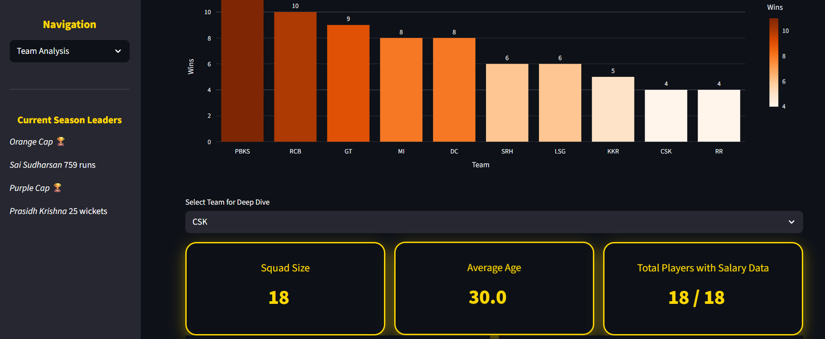
Fig. 3{Team Analysis Dashboard)
This section helps users to get all the info they need just from a single page. All team dashboards put up in a single place is the best way to do it as the users want to save as much time as they want going through things they love. This section provides information on not just one team, but about every team that participated in tournament. All major conclusions were highlighted in big boxes to make it easier to get major info without the effort to find it elsewhere.

Conclusion and Future Work
Concluding the study, the project can do wonders if kept working upon. Analysing players and teams through different aspects of the game gives enthusiasts all over the globe something to talk about. The project aims to reduce and almost diminish the hassle that comes with looking for the right data. Displaying charts, tables, and graphs along with great-looking graphics isn’t everyone’s forte of work. This project worked on this issue and was successful in its task. We displayed player analysis of top run scorers, wicket takers. and even the top all-rounders of the tournament. Along with this, we worked on team analysis where we inspected the top countries from which players are selected and the highest paid genre of each team.
As part of our never-ending journey on this project, we look forward to adding new features, one of which is pitch and ground analysis.This will help enthusiasts know the pitch conditions thoroughly and much more detailed view of the venue. Along with this it would give insights into how teams perform batting/bowling first on that kind of pitch and what are the probable types of wins in coin tosses at that venue. Adding this would make the analysis complete as most viewers of the sport around the world are concerned only on these three factors.

References
[1] Saranya, G., Swaminathan, A., Surendran, R., & Nelson, L. (2023, February). Ipl data analysis and visualization for team selection and profit strategy. In 2023 7th International Conference on Computing Methodologies and Communication (ICCMC) (pp. 592-598). IEEE.
[2] Birunda, S. S., Nagaraj, P., Jebamani, B. J. A., Revathi, B., & Muneeswaran, V. (2023, January). A Structured Analysis on IPL 2022 matches by approaching various Data Visualization and Analytics. In 2023 International Conference on Computer Communication and Informatics (ICCCI) (pp. 1-9). IEEE.
[3] Jaipurkar, M., Ragit, N., Tambuskar, C., & Saraf, P. D. (2023, July). Ipl data analysis and visualization using microsoft power bi tool. In 2023 14th International Conference on Computing Communication and Networking Technologies (ICCCNT) (pp. 1-6). IEEE.
[4] Manju, M. K., Philip, A. O., & Sreeja, M. U. (2023, May). Exploratory data analysis of Indian Premier League (IPL). In INTERNATIONAL CONFERENCE ON HUMANS AND TECHNOLOGY: A HOLISTIC AND SYMBIOTIC APPROACH TO SUSTAINABLE DEVELOPMENT: ICHT 2022 (Vol. 2773, No. 1, p. 020005). AIP Publishing LLC.
[5] Mohapatra, S., Goswami, A., Singh, A., Singh, V. K., Sen, B., & Sharma, K. (2021). Exploratory Data Analysis on IPL Data. In Contemporary Issues in Communication, Cloud and Big Data Analytics: Proceedings of CCB 2020 (pp. 315-325). Singapore: Springer Singapore.
[6] Sudhamathy, G., & Meenakshi, G. R. (2020). PREDICTION ON IPL DATA USING MACHINE LEARNING TECHNIQUES IN R PACKAGE. ICTACT Journal on Soft Computing, 11(1).
[7] Ramalingam, M., Gokul, S., Mythravarshini, L. S., & Harine, K. S. (2022, March). Efficient player prediction and suggestion using machine learning for IPL tournament. In 2022 International Mobile and Embedded Technology Conference (MECON) (pp. 162-167). IEEE.
[8] Dey, P. K., Chakraborty, G., Ruj, P., & Sarkar, S. (2012). A data mining approach on cluster analysis of ipl. International Journal of Machine Learning and Computing, 2(4), 351.

