EXPT-7

AIM: Design a sketch to interface IR sensor with ARDUINO/ESP-32 board

**ESP32 and Infrared receiver**

To connect an IR Reciever. It requires Vcc(5v), GND and there is a data out which you connect to your Arduino. IR showing the pinout.3.3v from the ESP32 board

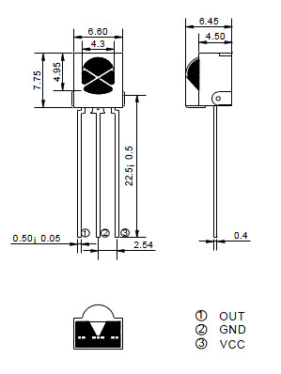

Remote control used for testing,

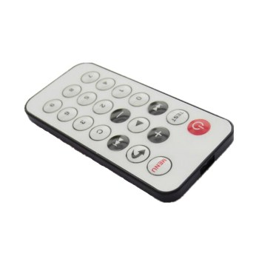

Layout

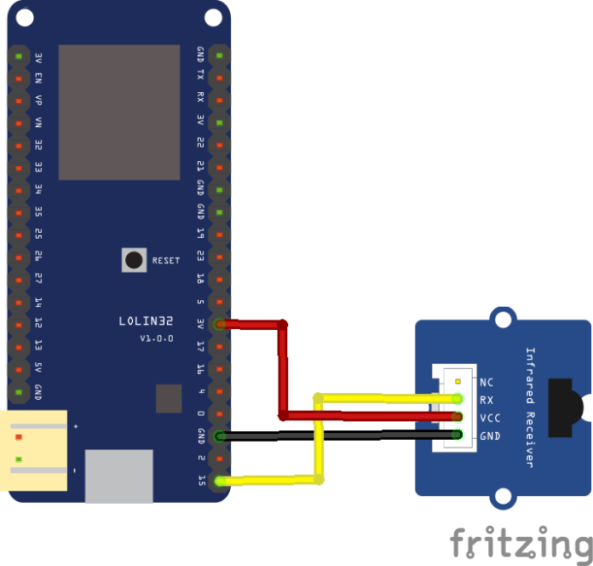

**Code**

You’ll need the IR Remote library, you can get this from

<https://github.com/shirriff/Arduino-IRremote>

Download and import or copy into your Arduino -> Library folder.

#include <IRremote.h>

int RECV_PIN = 15;

IRrecv irrecv(RECV_PIN);

decode_results results;

**void setup()**

{

Serial.begin(9600);

irrecv.enableIRIn(); // Start the receiver

}

**void loop()**

{

if (irrecv.decode(&results))

{

Serial.println(results.value, HEX);

irrecv.resume();

}

}

**Testing**

Opened the serial monitor and pressed various keys on my remote here is what was displayed

FFA25D

FFFFFFFF

FFE21D

FF22DD

FFFFFFFF

FF02FD

FFFFFFFF

FFC23D

F076C13B

FFFFFFFF

FFA857

FF906F

FFFFFFFF

FF6897

FFFFFFFF

FFFFFFFF

FF9867

FFFFFFFF

FFB04F

FFFFFFFF

FF30CF

As you can see with a bit of programming we can take these values and put them to use.