**EXPT-8**

**AIM : Design a sketch to interface ESP32 with HC-SR04 Ultrasonic Sensor with Arduino IDE**

**Components Required:-**

* **ESP32 DOIT DEVKIT V1 Board**
* **HC-SR04 Ultrasonic Sensor**
* **Breadboard**
* **Jumper wires**

**Here we are using I2C LCD display or serial monitor to monitor the Ultrasonic sensor distance data** Interfacing the HC-SR04 Ultrasonic Sensor with the ESP32 board using the Arduino IDE. **HC-SR04 Ultrasonic Distance Sensor** that can report the range of objects up to 13 feet away

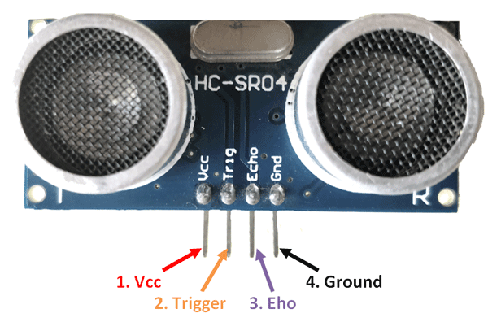

* VCC is the power supply for HC-SR04 Ultrasonic distance sensor which we connect the 5V pin on the Arduino.
* Trig (Trigger) pin is used to trigger the ultrasonic sound pulses.
* Echo pin produces a pulse when the reflected signal is received. The length of the pulse is proportional to the time it took for the transmitted signal to be detected.
* GND should be connected to the ground of Arduino.

**Features:**

Here’s a list of some of the HC-SR04 ultrasonic sensor features and specs:

* Power Supply :+5V DC
* Quiescent Current : 2mA
* Working Current: 15mA
* Effectual Angle: 15°
* Ranging Distance : 2cm – 400 cm/1″ – 13ft
* Resolution : 0.3 cm
* Measuring Angle: 30 degree
* Trigger Input Pulse width: 10uS

Whenever any object come ahead of the ultrasonic module it calculates the time taken from sending the signals to receiving them since time and distance are related for sound waves passing through air medium at 343.2m/sec. the distance can be calculated using the TRD (time/rate/distance) measurement formula.

Distance L = 1/2 × T

where L is the distance, T is the time between the emission and reception, and C is the sonic speed. (The value is multiplied by 1/2 because T is the time for go-and-return distance.

**HC-SR04 Ultrasonic Sensor Pinout**

Here’s the pinout of the HC-SR04 Ultrasonic Sensor.

|  |  |
| --- | --- |
| VCC | Powers the sensor (5V) |
| Trig | Trigger Input Pin |
| Echo | Echo Output Pin |
| GND | Common GND |

**SKETCH OF ESP32 WITH ULTRASONIC SENSOR INTERFACE**

#define TRIG_PIN 23 // ESP32 pin GIOP23 connected to Ultrasonic Sensor's TRIG pin

#define ECHO_PIN 22 // ESP32 pin GIOP22 connected to Ultrasonic Sensor's ECHO pin

float duration_us, distance_cm;

void setup() {

// begin serial port

Serial.begin (9600);

// configure the trigger pin to output mode

pinMode(TRIG_PIN, OUTPUT);

// configure the echo pin to input mode

pinMode(ECHO_PIN, INPUT);

}

void loop() {

// generate 10-microsecond pulse to TRIG pin

digitalWrite(TRIG_PIN, HIGH);

delayMicroseconds(10);

digitalWrite(TRIG_PIN, LOW);

// measure duration of pulse from ECHO pin

duration_us = pulseIn(ECHO_PIN, HIGH);

// calculate the distance

distance_cm = 0.017 * duration_us;

// print the value to Serial Monitor

Serial.print("distance: ");

Serial.print(distance_cm);

Serial.println(" cm");

delay(500);

}