

ADA PROJECT
Name: Akshansh Pundir
School: SOET
Programme: BTECH CSE AI & ML
Section: C
Roll No: 2401730010
Date: 03/02/26
Course Code – ENCS256

Faculty Name: Mrs. Vandana Mam

Question 1: Fibonacci’s Series
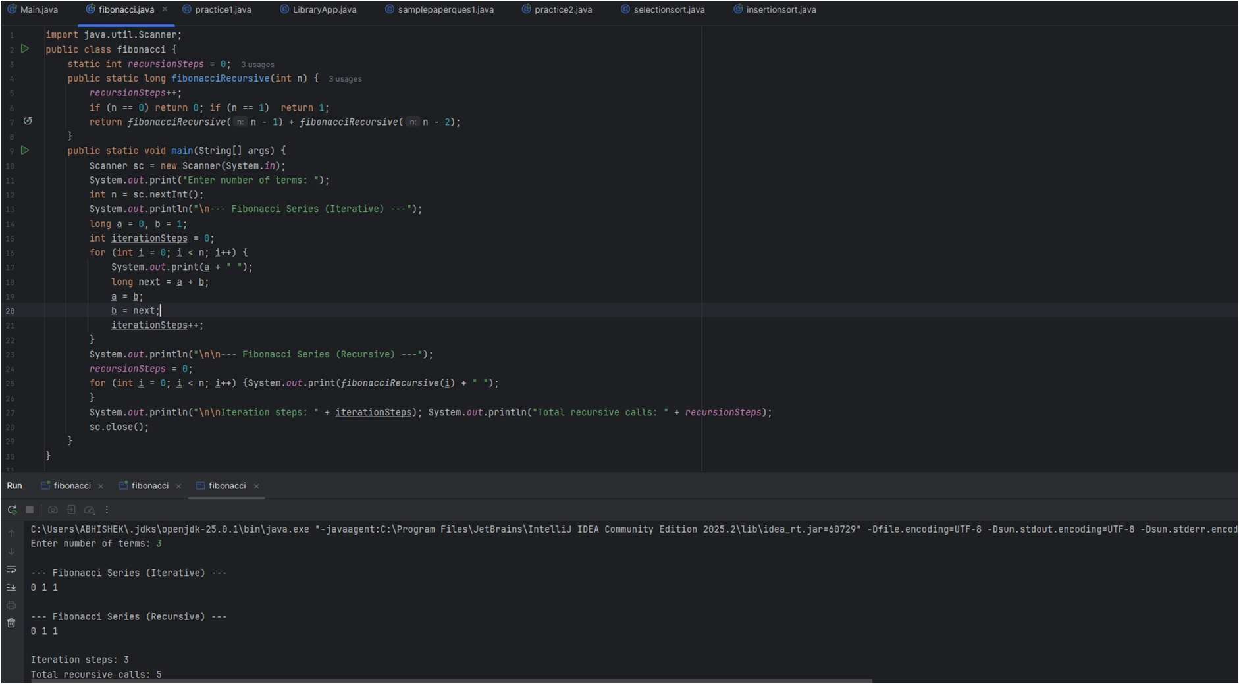

Question 2: Factorial Number:
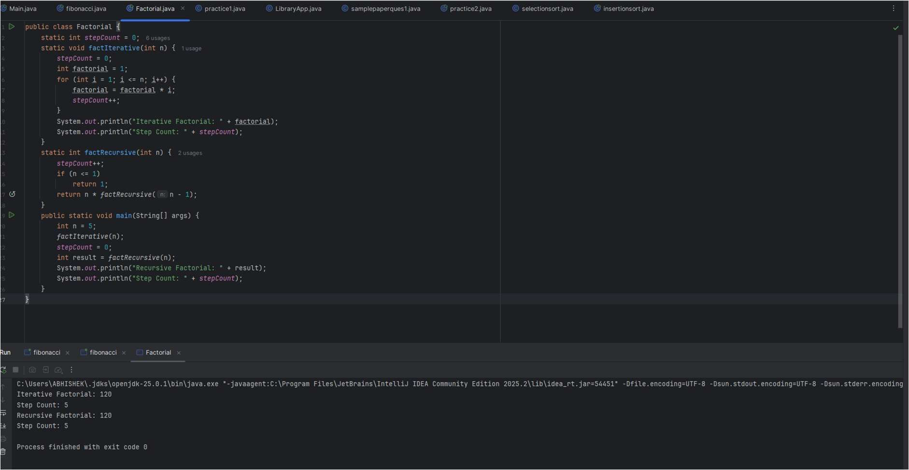
Graph:
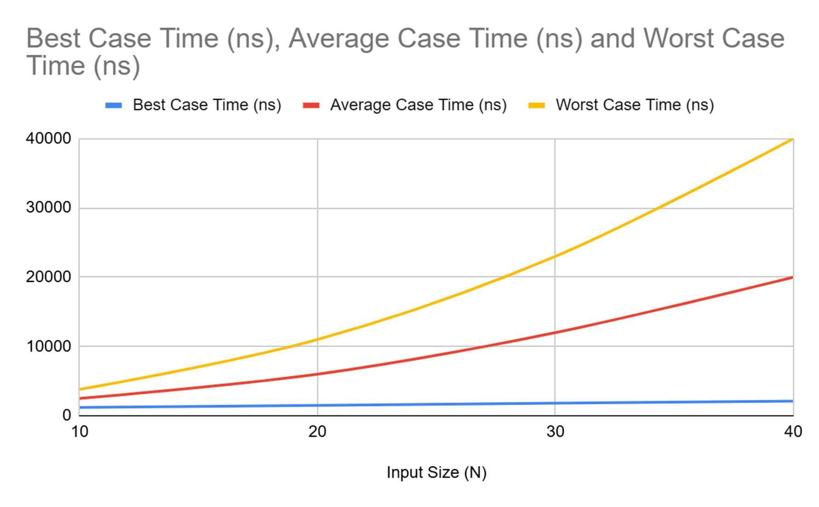
Question 3: Insertion Sort
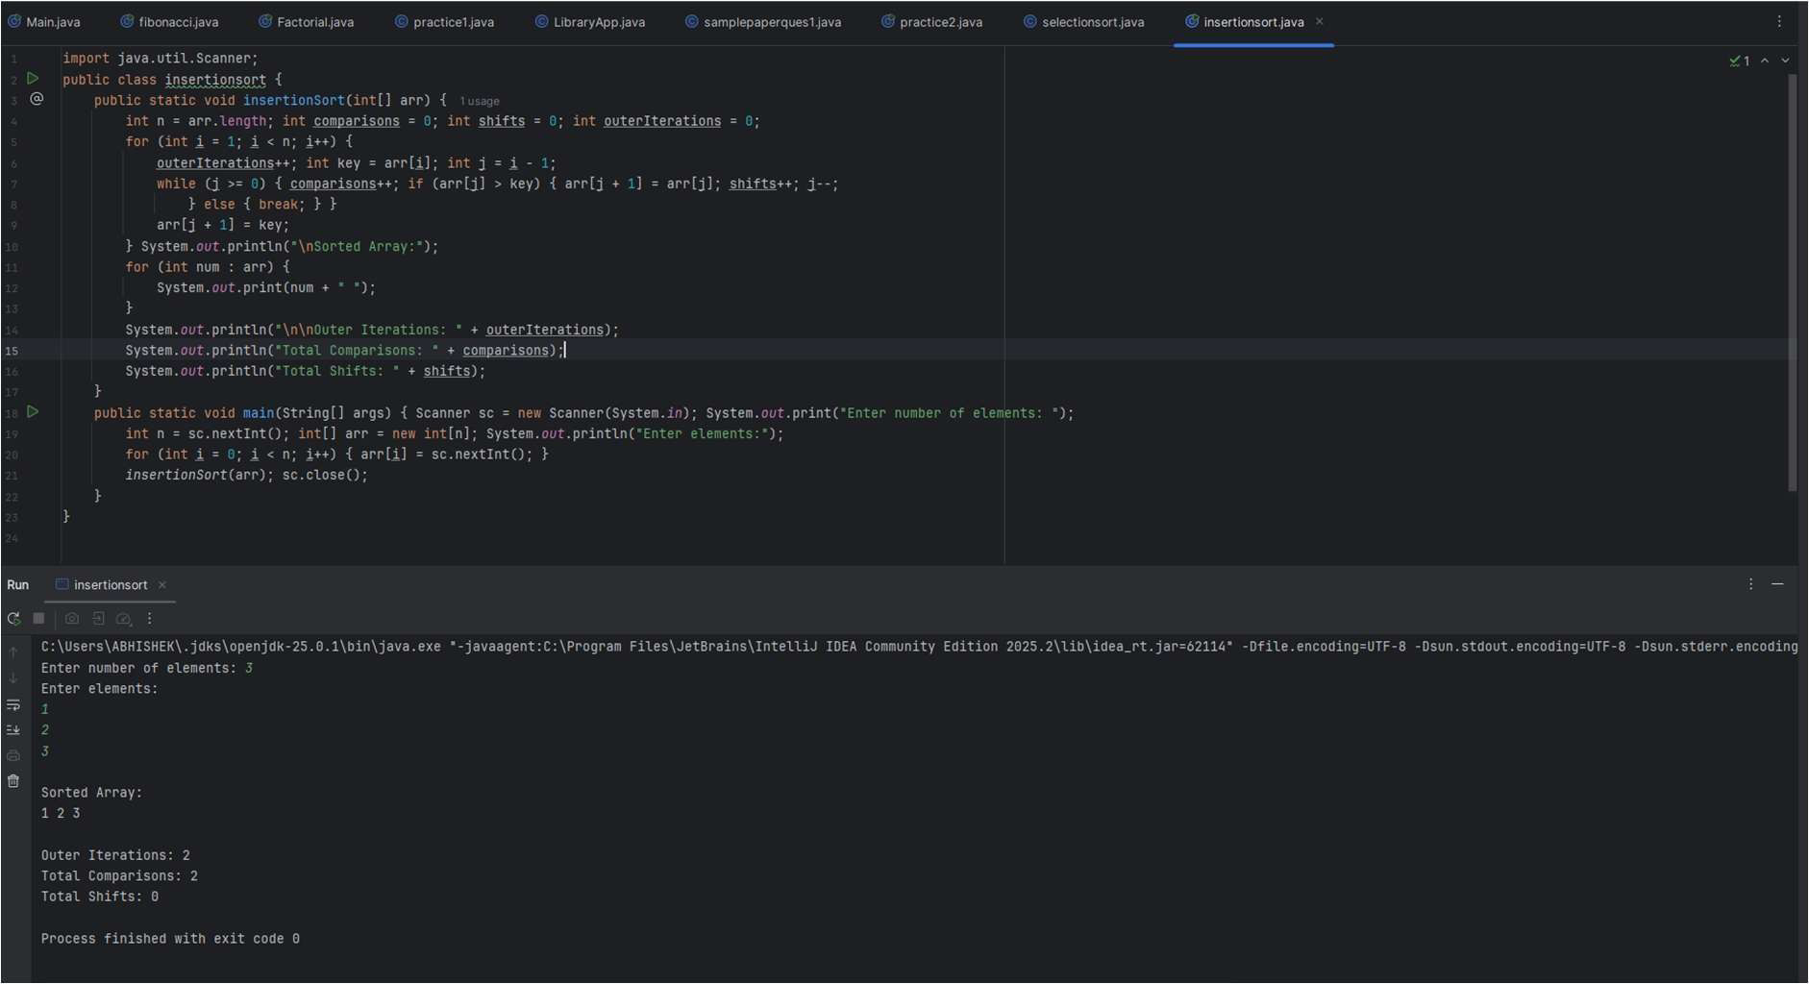
Graph :
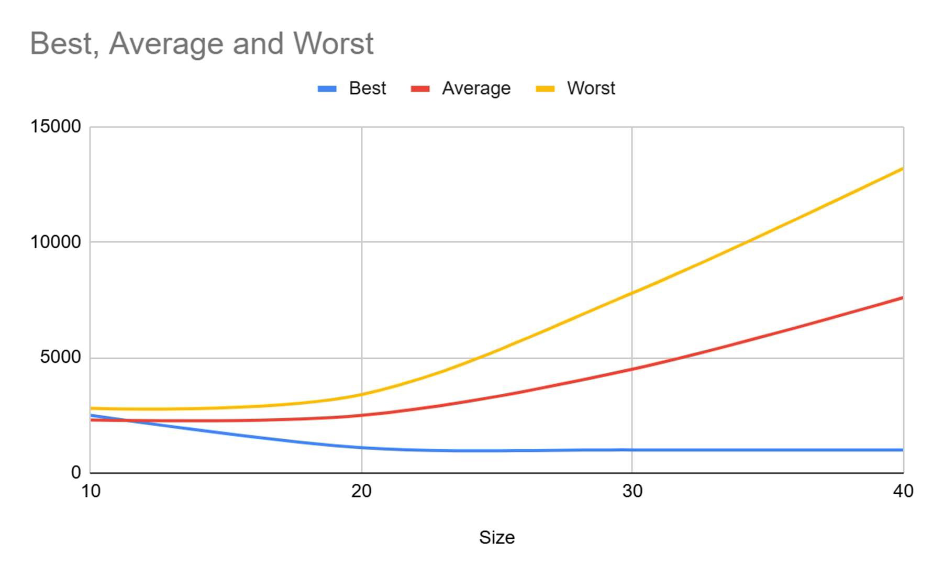

Question 4: Merge Sort
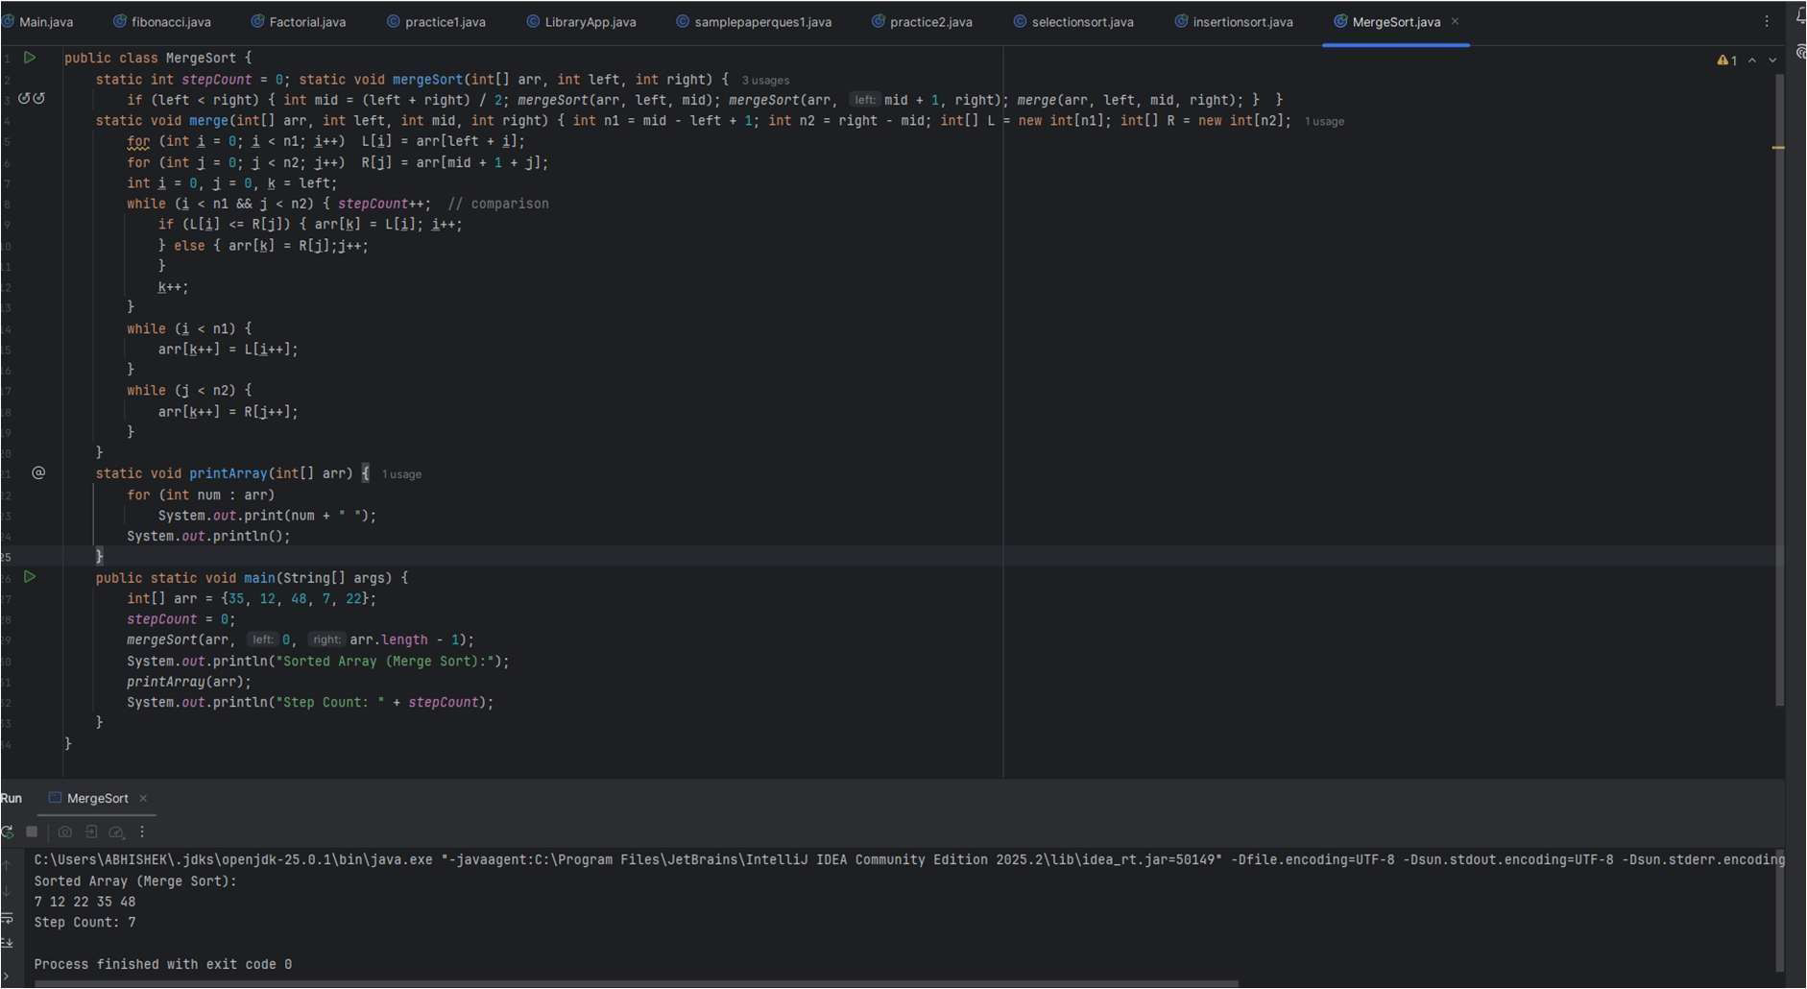
Graph:
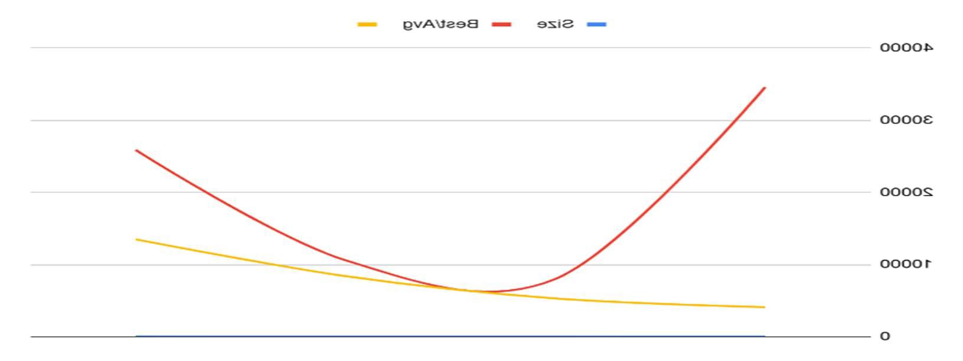
Question 5: Quick Sort
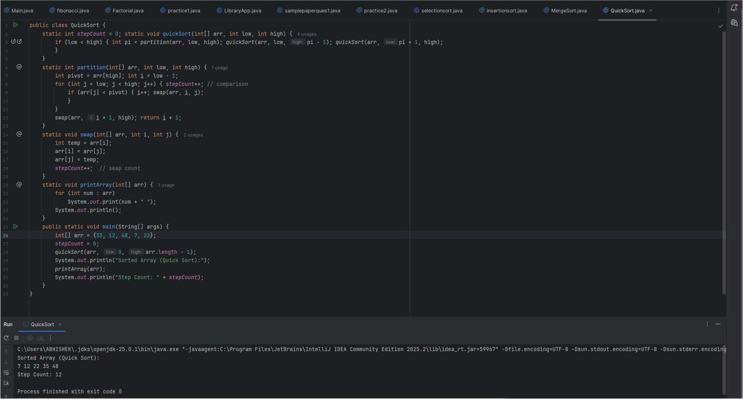
Graph:

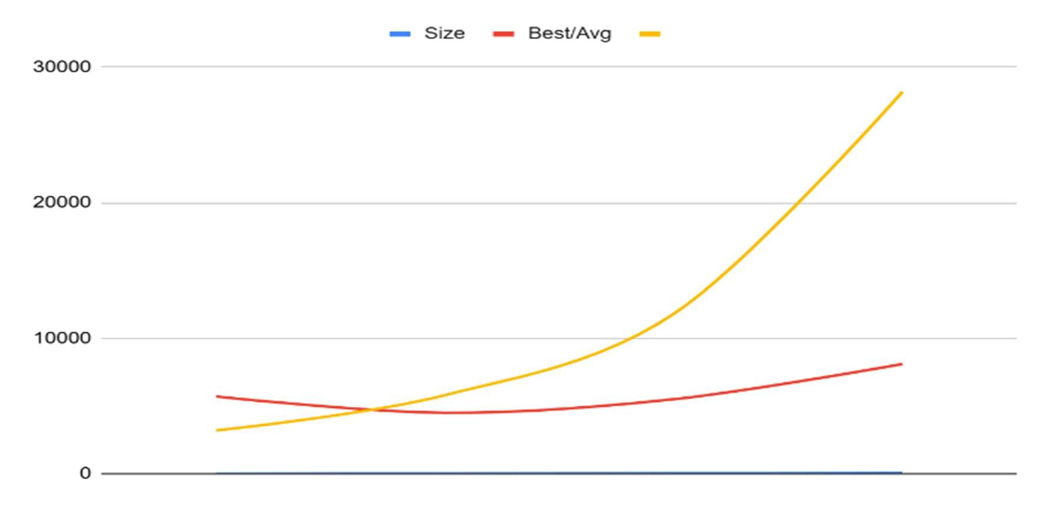
Question 6: Selection Sort
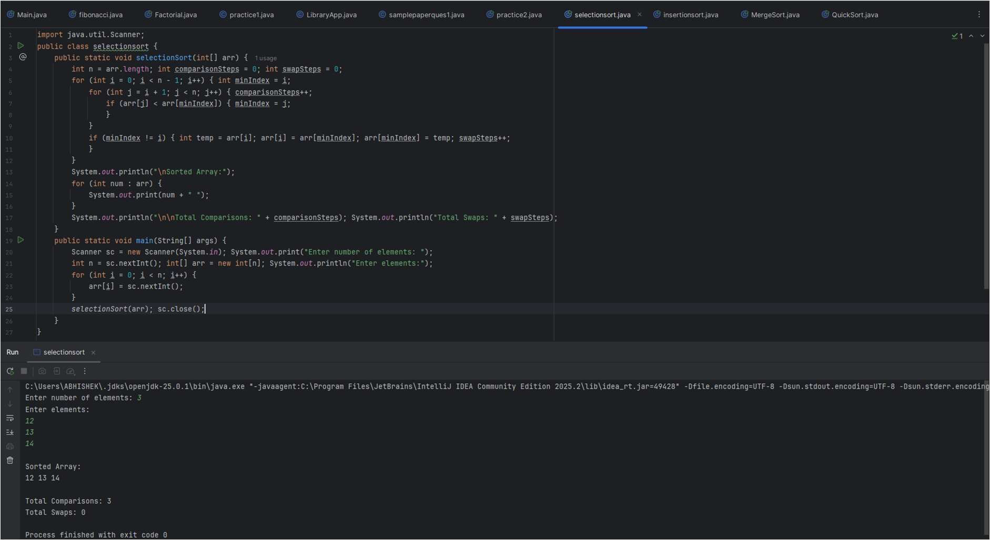
Graph:
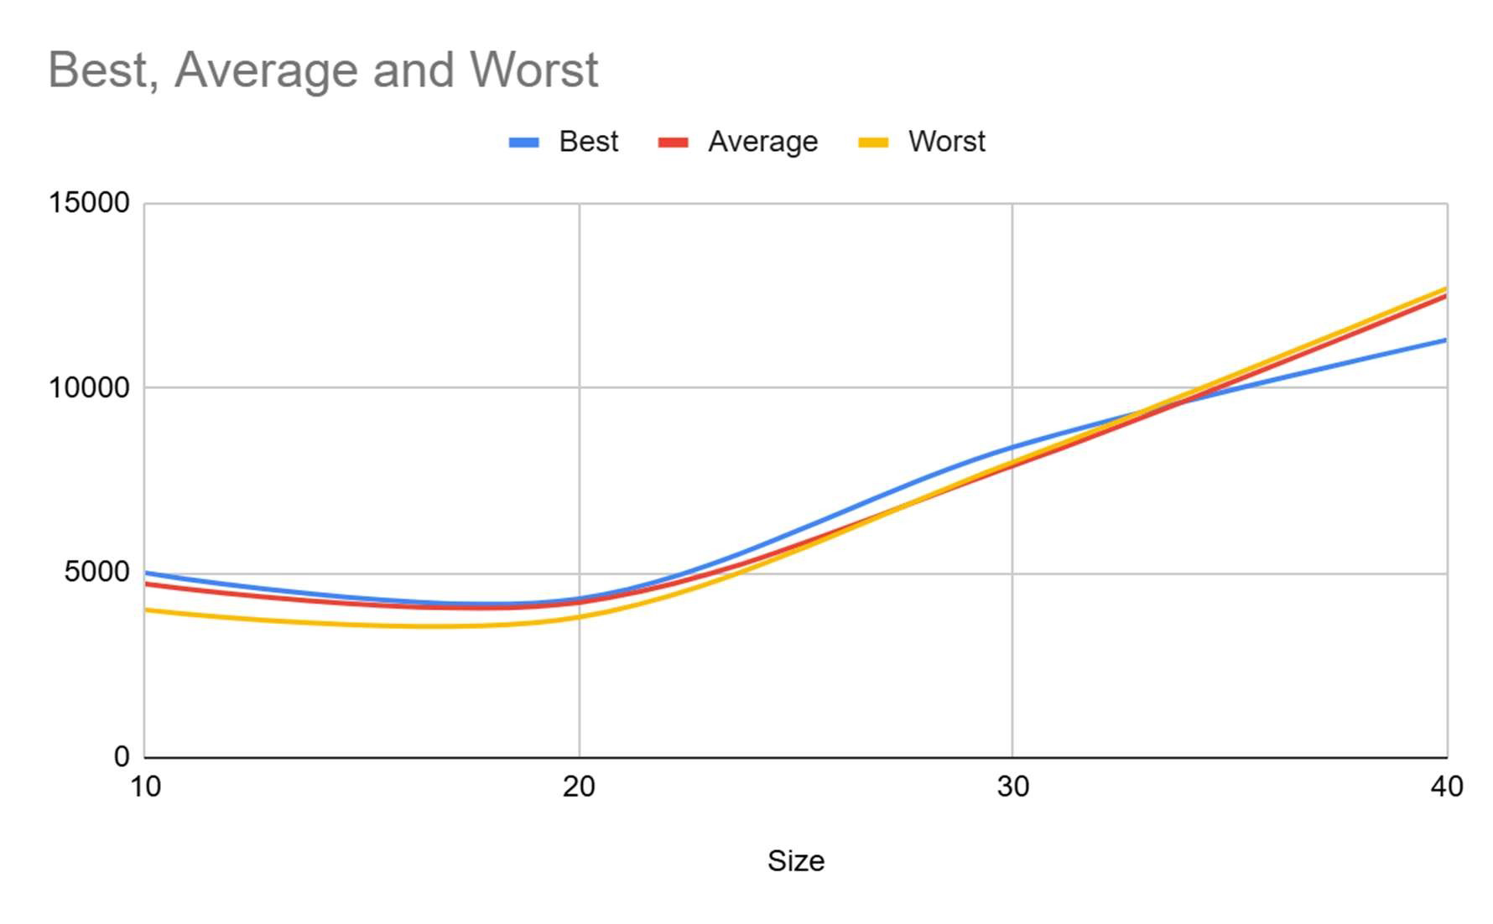

Question 7: Bubble Sort

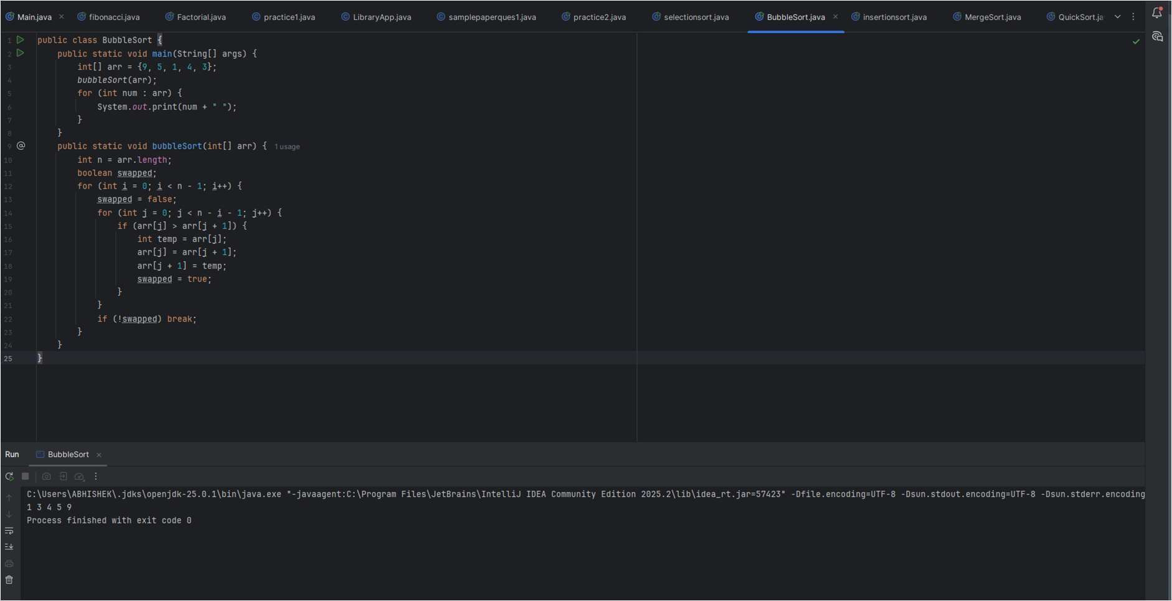
Graph:
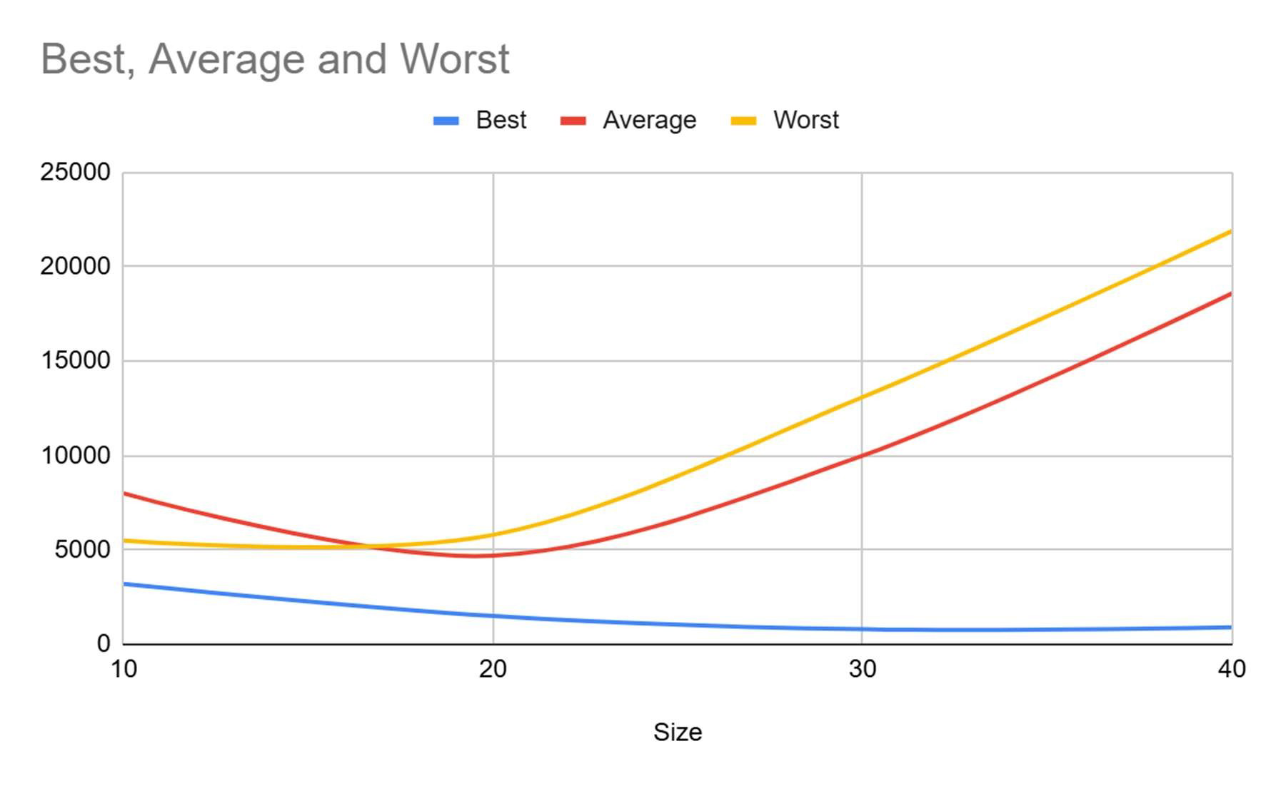

Question 8: Linear Search
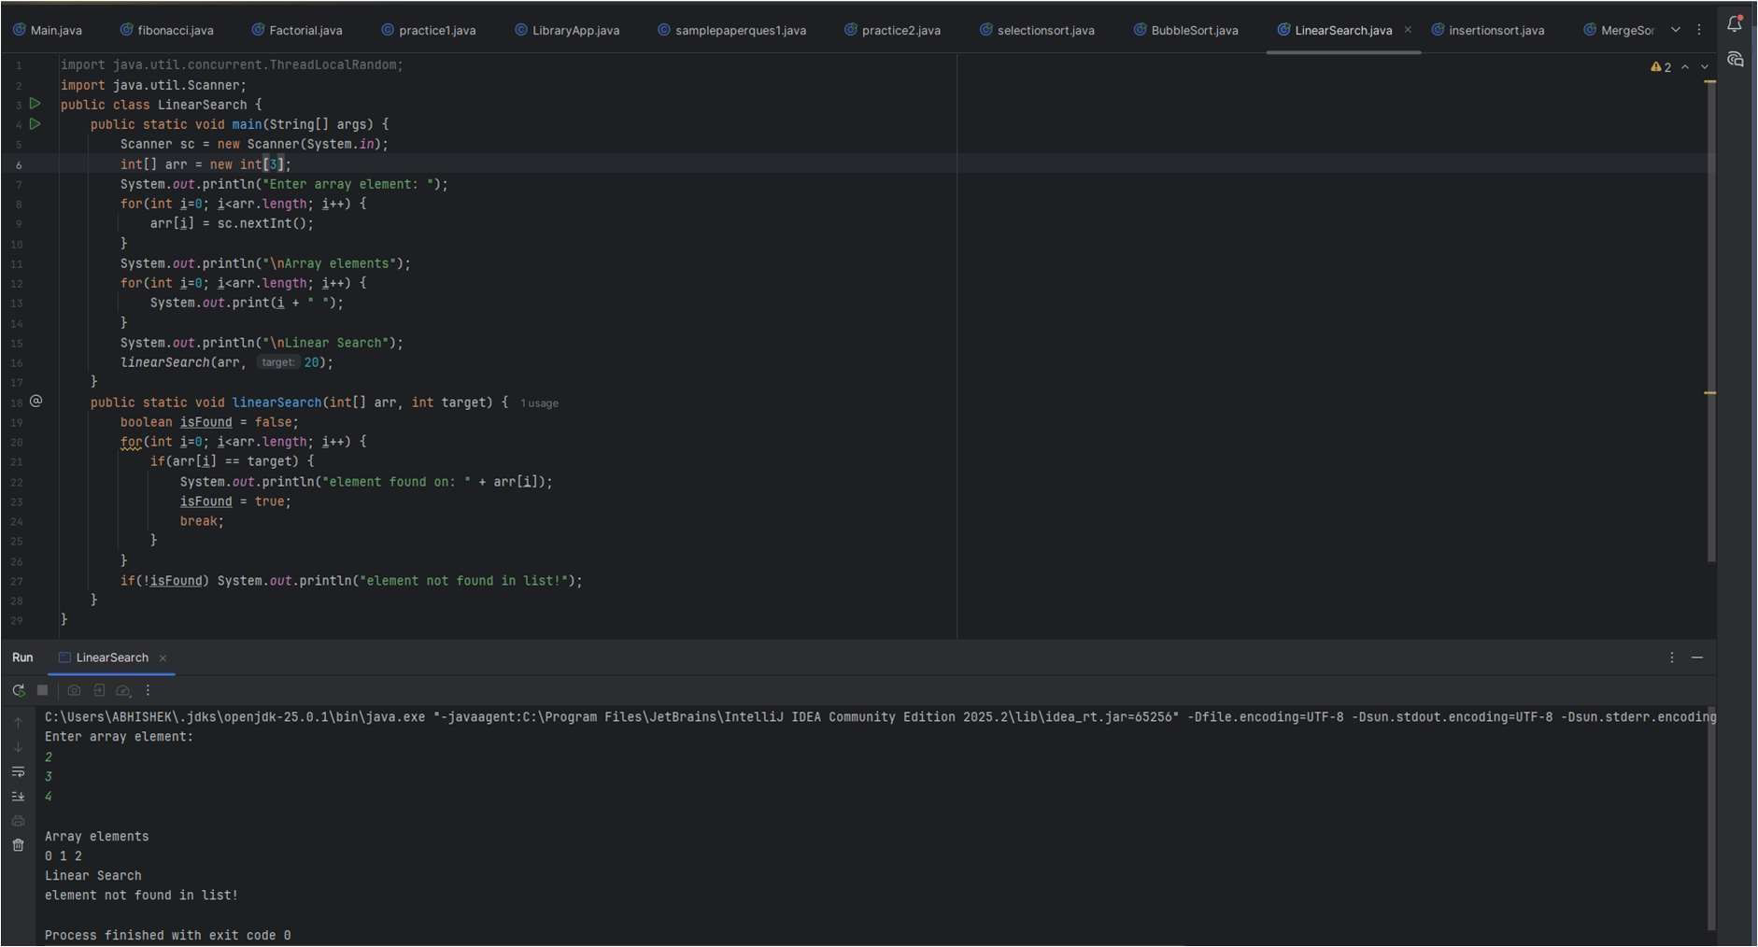
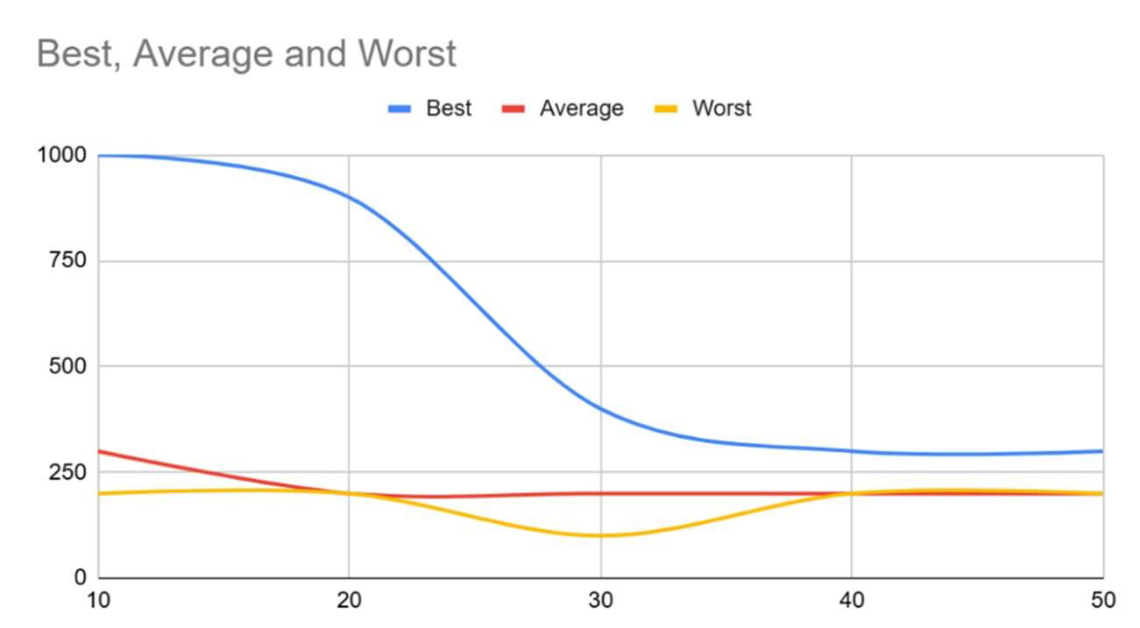
Question 9: Binary Search
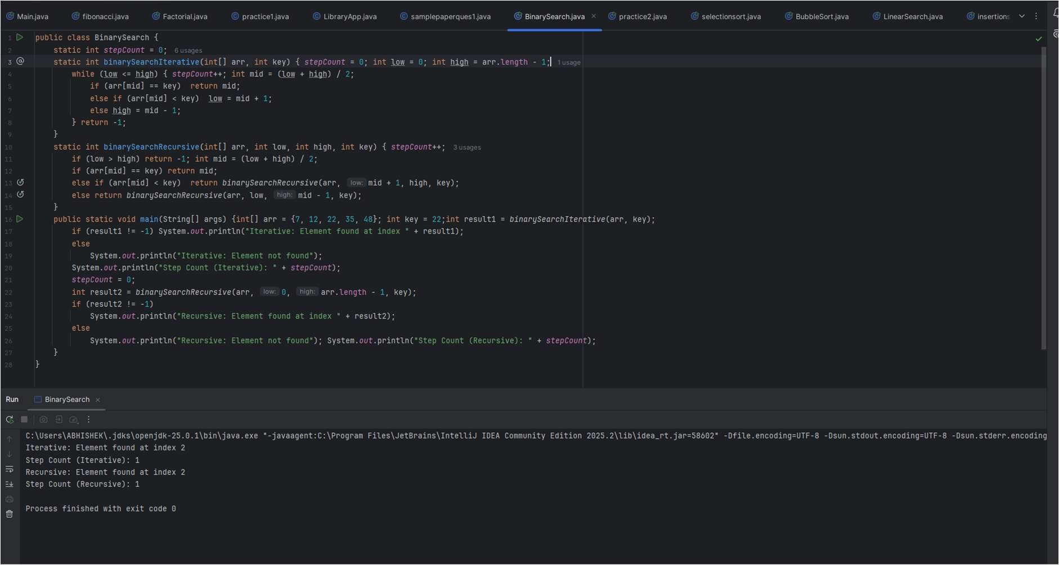
Graph:

Question 10 : Bellman-Ford
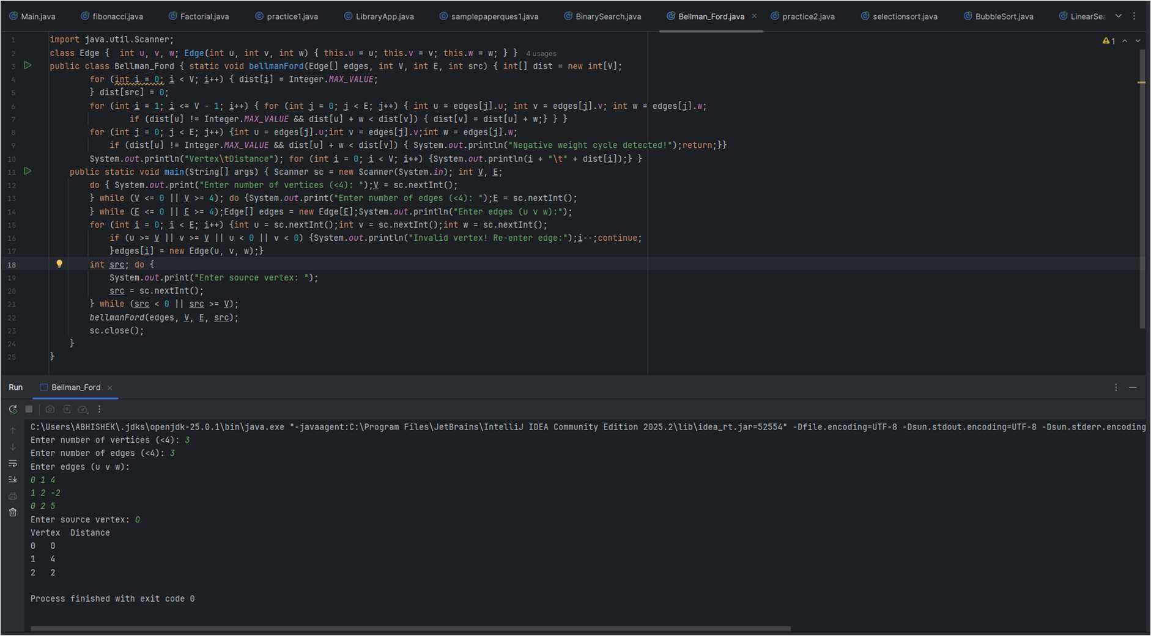
Question 11: Dijkstra Algorithm
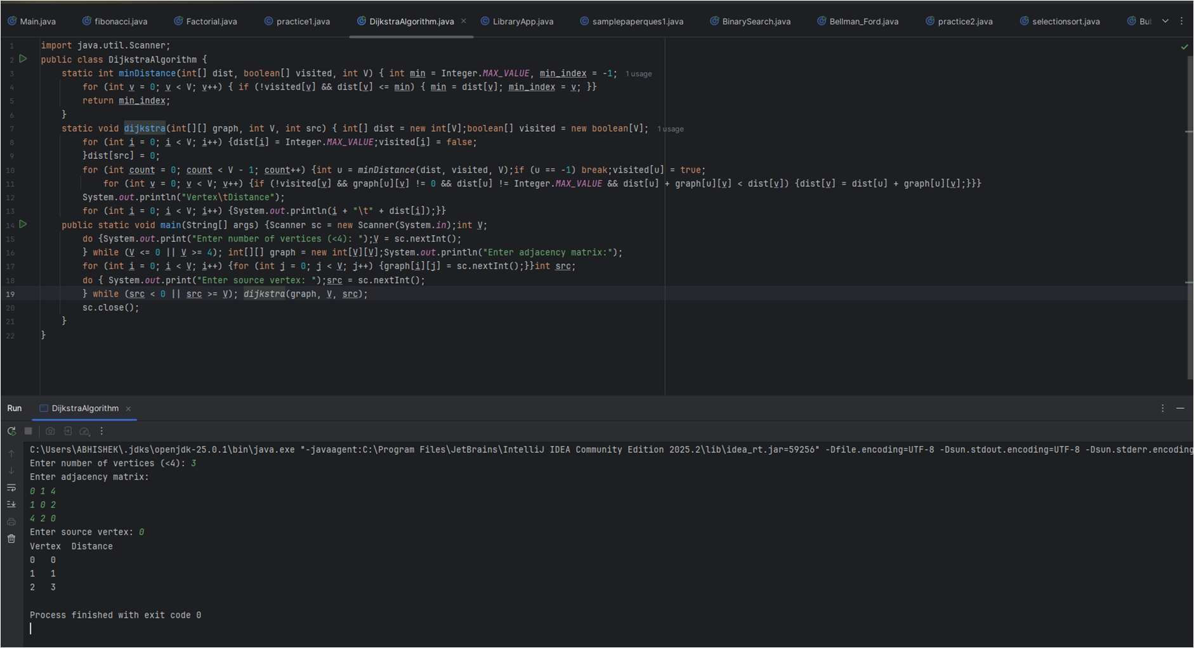

Question 12: Fractional Knapsack
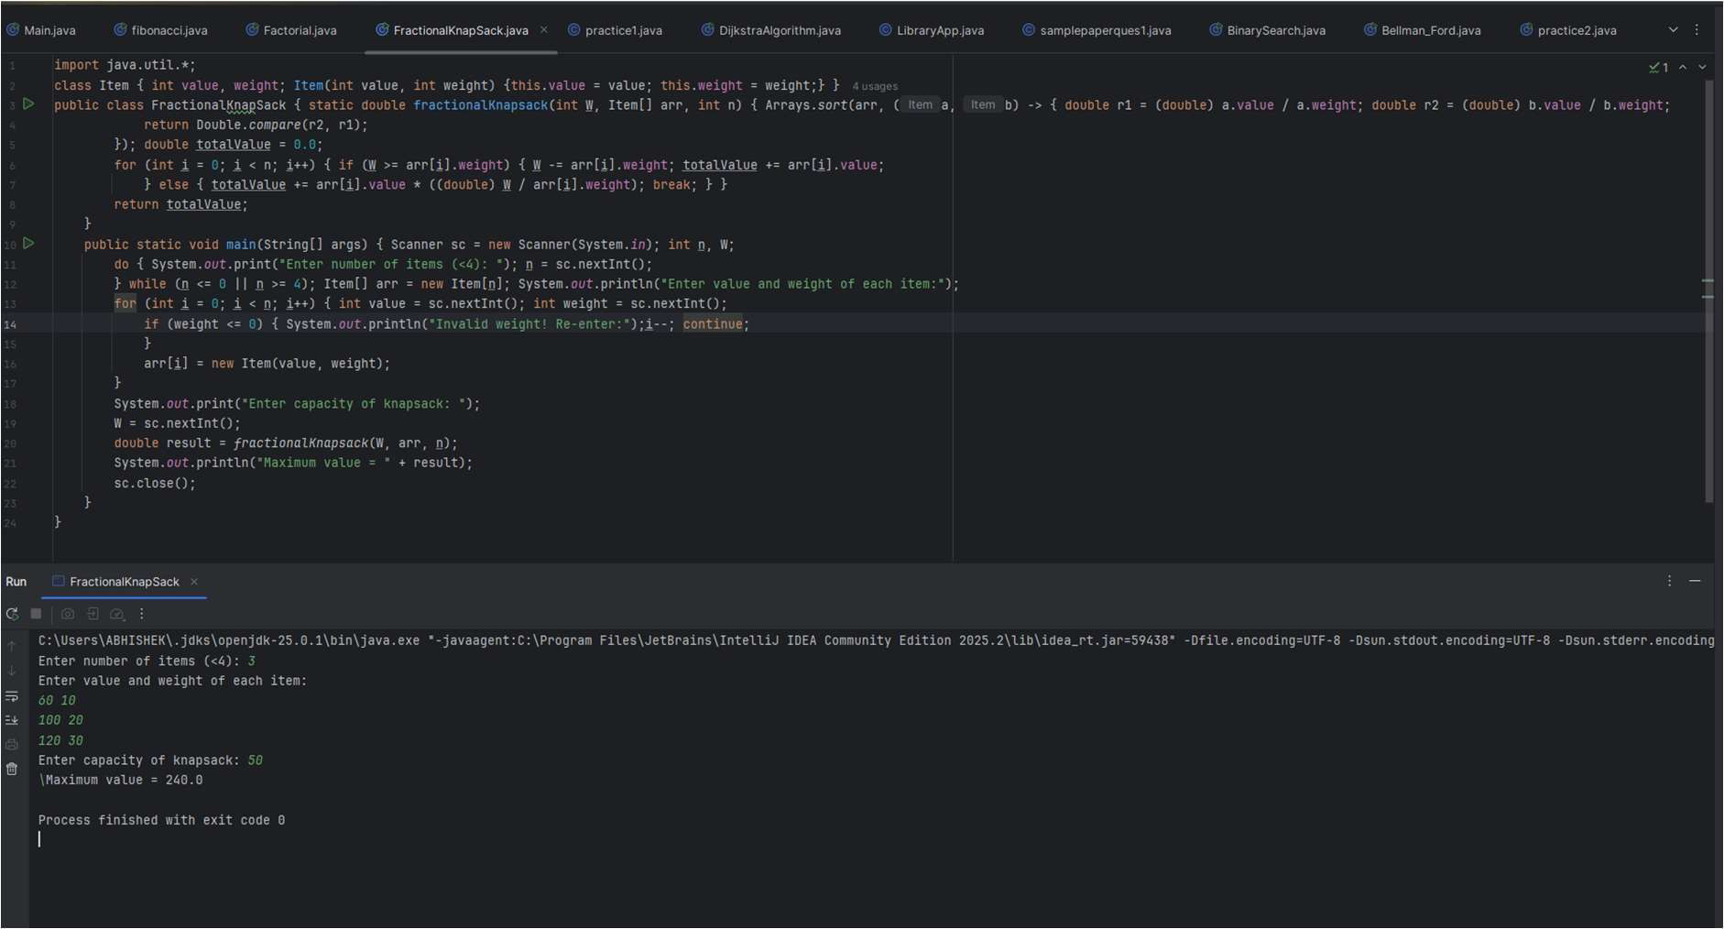
Question 13: Matrix Chain Multiplication
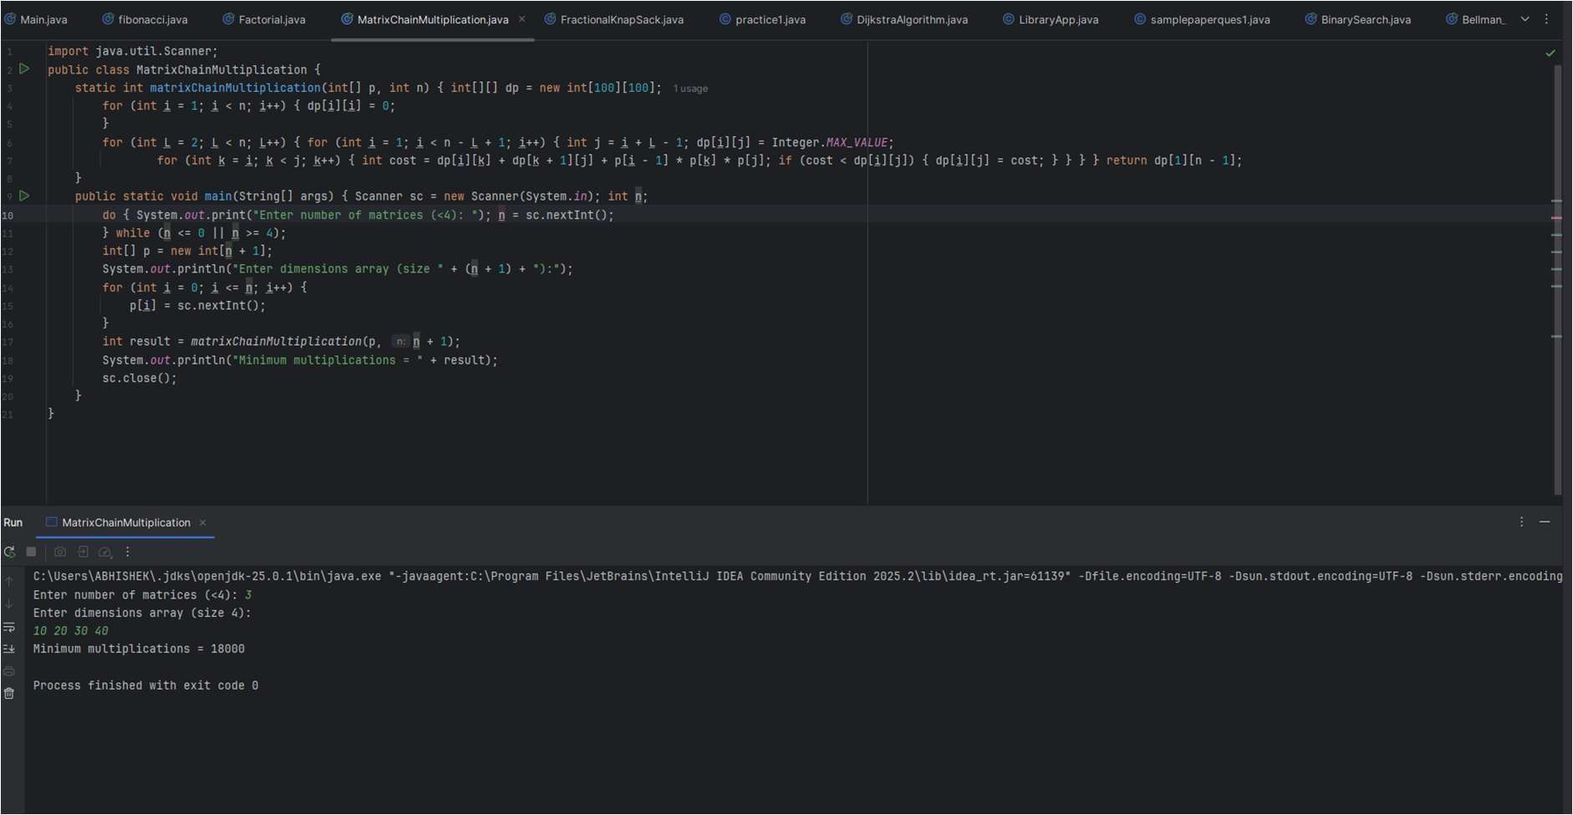

Question 14: Largest Common Subsequence
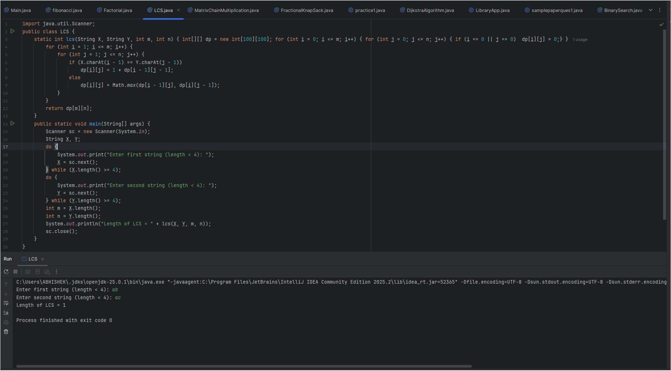
Question 15: 0/1 Fractional Knapsack
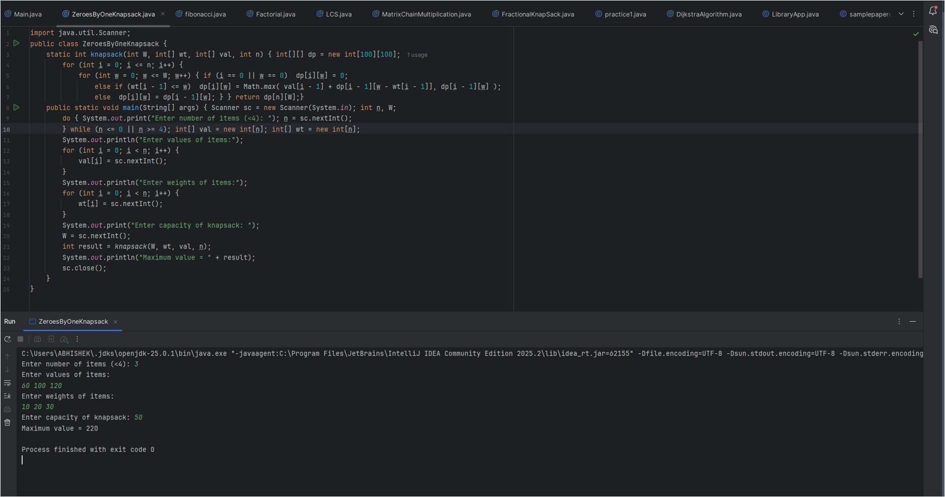

Question 16: BFS
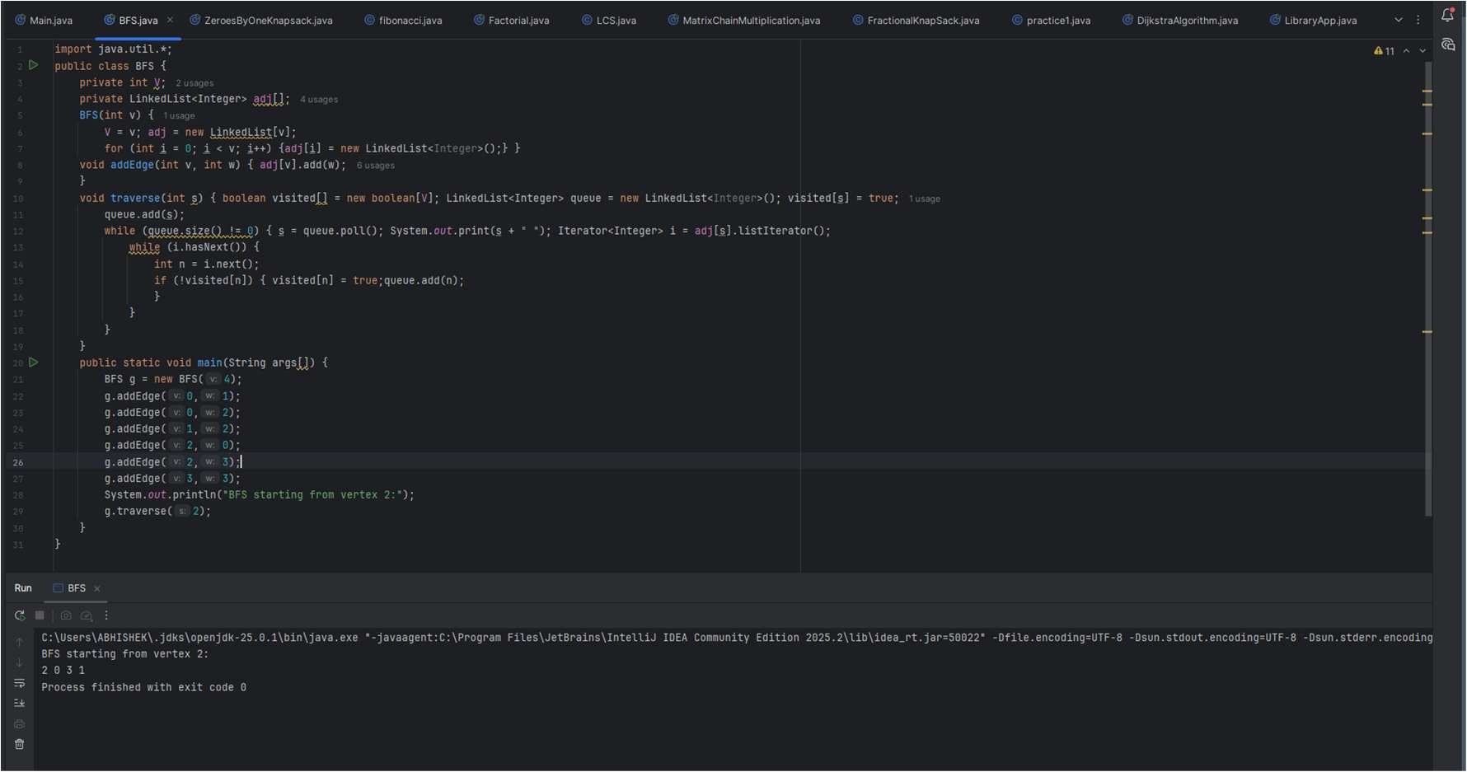
Question 17: DFS
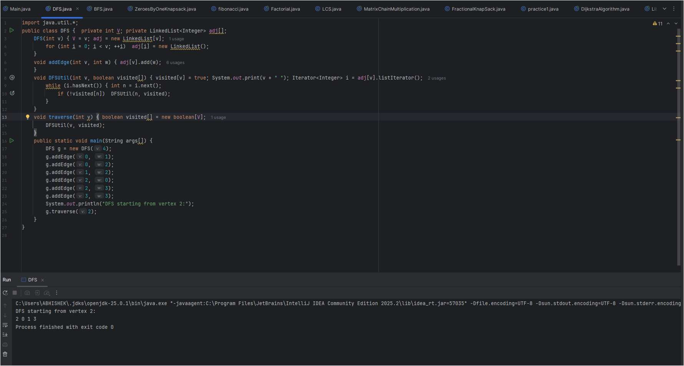

Question 18: N Queens
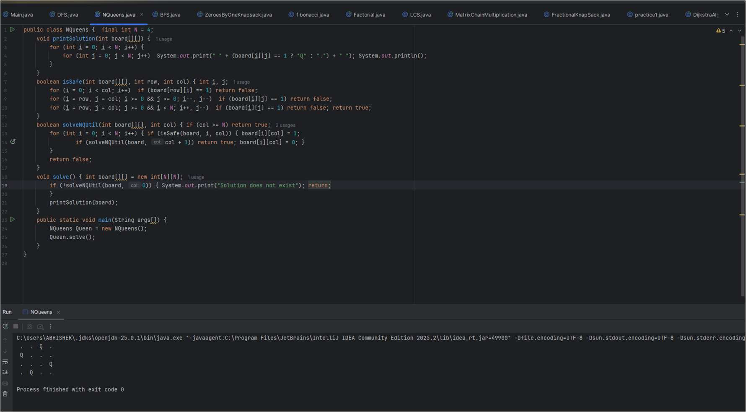
Question 19: Sum of Subsets
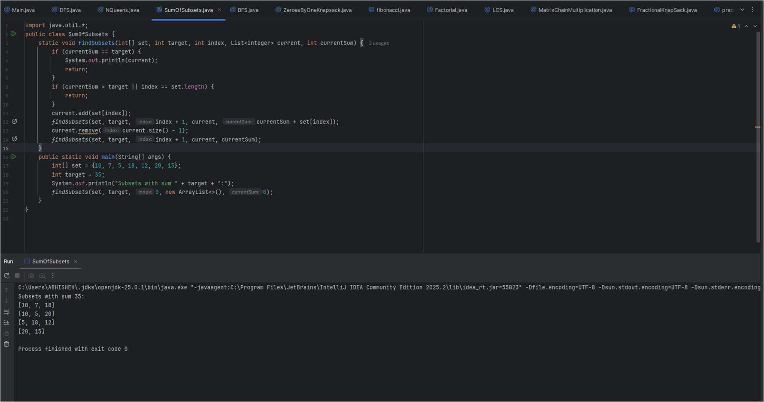

Question 20: Naïve String Matching
