1. Company Profile

1. About Viva Solutions

Amobile application development industry is growing at a tremendous pace to accommodate rise in demand of custom mobile applications. Viva Solutions is an Indian offshore Mobile application development company that provides comprehensive mobile application solutions to worldwide clients.
Viva Solutions has the specialist mobile app developers, who are proficiently utilize various mobile app development platforms like Android, IPhone, Blackberry, Symbian and Brew and Windows Mobile to create exceptional applications that serve wide range of consumer interests from entertainment to business.
Viva Solutions has a full-fledged offshore development center with state-of-the-art IT infrastructure and other amenities. It has rich pool of talented mobile app developers who have technical acumen to engineer customer-specific applications.
As a professional mobile application development company, we value our clients and ensure that they get excellent mobile applications, which make their money go further. We are quality conscious and ensure that our developers follow international software/web development standards. Constant innovation is our buzzword and as part of this tactic, our managers conduct in-house training sessions so that developer remains in touch with latest mobile technology to improve the mobile application development cycle.
We explore latest mobile technology offerings so that your mobile apps are packed with advanced features, which give you sensational user experience. By outsourcing your mobile application development to us you get cutting-edge mobile apps development service at affordable price and within stipulated time.

Services
Viva Solutions is a Mobile application development company that provides customized mobile apps development services to its global clientele. We have profound knowledge of the latest mobile application development trends and customer requirements.
Our technical excellence in this field and resolute commitment to deliver pioneering services has become our guiding force that propels us ahead, of our rivals. The developers at Viva Solutions pour all their expertise in mobile apps development to deliver you, unparallel mobile application development service in areas like:
- iPhone application development
- iPad application development
- Window mobile apps development
- Android application development
- Blackberry Application Development
- Symbian application development services
- J2ME mobile application development
- Mobile web development
- Brew Apps development

The Viva Solutions Advantage
Viva Solutions brings to you, its rich experience in mobile Android apps development. You can count on our technical acumen to deliver you innovative mobile apps, which add value to your business or organization. The benefits of hiring Viva Solutions as your mobile application developer are:
- One-stop complete mobile application development solutions
- Superior development platform
- More functional features in mobile applications for greater user experience
- Customer oriented development
- Flawless development and web integration of mobile apps
- Full-Fledged offshore development center that provides world class mobile application development services at very affordable rates.
If you are not happy with performance your mobile apps or want more inventive and cost –effective mobile applications, then pick up your phone and call us. We will take care of all your worries and ensure that you enjoy world-class mobile application development services in a cost-effective manner. So, if you do not have the Viva Solutions advantage, then you are surely missing something.

Solutions
The mobile application development industry has registered tremendous growth after successful launch of iPhone. The next generation Smart phones like Android, Blackberry and iPhone have taken the user experience to higher levels and opened new avenues. They have placed web world in the hands of users and given them freedom to enjoy its various offerings- anywhere, anytime.
As mobile technology evolves to meet new challenges on consumer front, it becomes primary responsibility of the mobile development companies develop innovative mobile application solutions that provide leverage to the users on business, commercial and personal fronts.
Viva Solutions understands its responsibility well and delivers world class mobile solutions for wide ranging fields. It has specialist teams of Android, iPhone, Blackberry, Symbian and Windows mobile developers who create custom mobile applications that transcend end-user expectations.

Our Mobile Solutions
What We Do?
We provide comprehensive mobile solutions through different mobile development platforms like Android, MAC, Blackberry, Symbian and Windows Mobile. We offer expert mobile application solutions for following areas of mobile development.
- Device optimized mobile applications
- Custom web apps development
- Third party apps customization and integration on clients’ device
- Mobile apps porting/migration
- Mobile apps development/customization/deployment/maintenance
How We Do? – Our Methodology
Apps Analytics and Brainstorming
We value our clients and hence our mobile development efforts are client-need- driven. Our development teams minutely scrutinize clients’ mobile apps needs, identify their goals/objective and understand the scope of application before beginning the brainstorming session, the most critical part mobile solution development process.
During this phase features of new mobile apps are planned, discussed and finalized, to improve on the shortcomings of the existing applications. The best available development platform is selected, keeping in mind the, need to develop application at very competitive rates.
Development and Testing
In this phase the ideas are given shape, through prototyping development and testing to create applications in cost-effective way and at same keep the development risks to the minimum levels. The debugging and stimulation tools used help in creating flawless applications in minimum time, because time is of an essence in apps development process.
Deployment and Maintenance
Once the application is trial run satisfactorily and load tested it is integrated by submitting it device application distributor so that it gets the required acceptance support on the mobile device to function satisfactorily. Our experts provide complete technical support/backup for applications developed by us, in-case you face any performance issues.

Mobile Solutions – Why Us?
Our mobile application solutions give you the leverage in following ways:
- Mobile service providers, especially the new entrants find our mobile solutions indispensable at it gives them price advantage needed to penetrate the competitive market
- Scalable solutions, especially for online business to accommodate seamlessly, future changes in business
- Precise mobile apps solutions that augment business and personal development
- Mobile solutions that empower apps to perform brilliantly across different platforms to deliver great user experience.

Mobile Solutions- Our Area of Expertise
The mobile environment is expanding quickly and getting more sophisticated with passage of time because of development and integration of mobile applications that cater to different application needs of the clients or end users.
We provide precise mobile application solutions that give your online business the competitive edge and clearly distinguish you from the pack. With upward pointing ROI graph you can clearly feel the difference that our cutting-edge mobile solutions bring to you business. Our expertise in Mobile application solutions development extends to the following areas:
- Multimedia
- Enterprise level applications- CRM , CMS and ERP
- Social Media and Community Networking
- Mobile e-commerce
- Mobile e-Learning and Trading
- Travel/Tourism
- Business/Finance
- Audio and Video streaming for mobile
- Personal Utilities

Contact:
Viva Solutions
A-15 Rudrax Complex,
Opp. Naroda Lake,
Naroda, Ahmedabad.

2. Project Profile

2.1 Project Details

Title | Media Player
Aim | To play different audio and video files in the android operating system based mobiles.
Project Category | Mobile Application
Front End | Java with Android SDK libraries
Team Size | Two member
Team Members | Patel Akshar Babulal (07DCE060)  Pancholi Maharshi Jayendra (07DCE053)
Internal Project Guide | Prof. Rahul Shrimali  (Professor, IDS,NU)
External Project Guide | Mr. Prakash V. Iyer  Manager, Viva Solutions
Location | Viva Solutions  A-15 Rudrax complex,  Opp. Naroda Lake,  Naroda, Ahmadabad  Gujarat, India.  E-mail : vivasolutionsno1@gmail.com

Project Definition:
Media Player is android application that can play various audio and video files.

2.1 Project Details
2.1 Project Details
2.1 Project Details
2.2 Project Objectives

The aim of the project is to design and develop an application for Google Android operating system. The application should be able to play audio and video files and with best play in options and have high impact Graphical User Interface and user friendly hand on options.
Specific objectives are as follows:
- Easy to use interface
- Application will be written using Android SDK in Java and should run on all
Android-powered devices with appropriate system version.
- It should support Vertical and Horizontal orientation.
- The application will play audio files with format of MP3, AAC, 3GP, M4A, MIDI, RTX, OGG, and WAV.
- The application will play video files with format of 3GP, MP4, WEBM.
- Background playing options.
- Notification on the home screen.
- Design and documentation for this project are crucial and are also success indicators. Design should be sufficiently documented and carried out in a well structured way, following best software development practices.

Requirements
Below is the list of requirements for the application, documented by the author after a discussion and an agreement with the customer on the application’s features and behaviour.
The requirements were revised, according to the iterative development model, after creating a design and doing some development. The changes were then approved by the customer. The following is essentially a more detailed description of the application that follows from the objectives noted in the second chapter. It also forms the basis for the tests that shall be conducted after development.

ID Func1: Ability to play Audio file
Area: Functional
Description: The application will get the audio file from the play list and start playing that file.

ID Func2: Ability to play Video File
Area: Functional
Description: The application will get the audio file from the play list and start playing that file.

ID UI1: Welcome Screen
Area: UI
Description: After the application is initialised user will be presented with a welcome screen. By default, it would be title of the application and developer information.

ID UI2: Main Screen
Area: UI
Description: Following options will be presented in the main menu
o Tab of Audio /Video
o Default play list

ID UI3: Player Screen
Area UI
Description It will consist of following things
o Play , Pause, Next, Previous, Shuffle buttons
o Album image
o Album name, Artist name

2.3 Similar Projects

We were unable to find Android projects that would be useful for this topic described in any publication such as a journal or a book. This is probably due to the fact that Android is still a young platform and also because it is far easier to distribute such projects electronically, for instance via an Internet website. Therefore, the following projects all come from various referenced websites and while some of them (like Google’s API Demos) are very well documented, others only include the source code with no documentation at all. All of them, however, proved useful in illustrating how to achieve some of the tasks needed for this project.

3.3.1 API Demos
This Google-developed project acts as a sample of all the basic operations on Android. It is having Demonstrating media player application

3.3.2 Kino Media Player
Kino media player was developed by individual persons. It was developed to help them selves.

3.3.3 Cube
Cube was developed with high impact on visualization of different visualizer in it with no extra features.

3. Tools and Technology
2.1 Project Details

3.1 Android

Android is a software stack for mobile devices that includes an operating system, middleware and key applications. Google Inc. purchased the initial developer of the software, Android Inc., in 2005. Android's mobile operating system is based on a modified version of the Linux kernel. Google and other members of the Open Handset Alliance collaborated on Android's development and release. The Android Open Source Project (AOSP) is tasked with the maintenance and further development of Android. The Android operating system is the world's best-selling Smartphone platform.
Android has a large community of developers writing applications that extend the functionality of the devices. There are currently over 150,000 apps available for Android. Android Market is the online app store run by Google, though apps can also be downloaded from third-party sites. Developers write primarily in the Java language, controlling the device via Google-developed Java libraries.
The unveiling of the Android distribution on 5 November 2007 was announced with the founding of the Open Handset Alliance, a consortium of 80 hardware, software, and telecom companies devoted to advancing open standards for mobile devices. Google released most of the Android code under the Apache License, a free software and open source license.
The Android open-source software stack consists of Java applications running on a Java-based, object-oriented application framework on top of Java core libraries running on a Dalvik virtual machine featuring JIT compilation. Libraries written in C include the surface manager, OpenCore media framework, SQLite relational database management system, OpenGL ES 2.0 3D graphics API, WebKit layout engine, SGL graphics engine, SSL, and Bionic libc. The Android operating system, including the Linux kernel, consists of roughly 12 million lines of code including 3 million lines of XML, 2.8 million lines of C, 2.1 million lines of Java, and 1.75 million lines of C++.

Features

Handset layouts | The platform is adaptable to larger, VGA, 2D graphics library, 3D graphics library based on OpenGL ES 2.0 specifications, and traditional smart phone layouts.
Storage | SQLite, a lightweight relational database, is used for data storage purposes
Connectivity | Android supports connectivity technologies including GSM/EDGE, IDEN, CDMA, EV-DO, UMTS, Bluetooth, Wi-Fi, LTE, and WiMAX.
Messaging | SMS and MMS are available forms of messaging, including threaded text messaging and now Android Cloud to Device Messaging Framework (C2DM) is also a part of Android Push Messaging service.
Web browser | The web browser available in Android is based on the open-source WebKit layout engine, coupled with Chrome's V8 JavaScript engine. The browser scores a 93/100 on the Acid3 Test.
Java support | While most Android applications are written in Java, there is no Java Virtual Machine in the platform and Java byte code is not executed. Java classes are compiled into Dalvik executables and run on the Dalvik virtual machine. Dalvik is a specialized virtual machine designed specifically for Android and optimized for battery-powered mobile devices with limited memory and CPU. J2ME support can be provided via third-party-applications.
Media support | Android supports the following audio/video/still media formats: WebM, H.263, H.264 (in 3GP or MP4 container), MPEG-4 SP, AMR, AMR-WB (in 3GP container), AAC, HE-AAC (in MP4 or 3GP container), MP3, MIDI, Ogg Vorbis, WAV, JPEG, PNG, GIF, BMP.
Streaming media support | RTP/RTSP streaming (3GPP PSS, ISMA), HTML progressive download (HTML5 <video> tag). Adobe Flash Streaming (RTMP) and HTTP Dynamic Streaming are supported by the Flash 10.1 plugin. Apple HTTP Live Streaming is supported by RealPlayer for Mobile and planned to be supported by the operating system in Android 3.0 (Honeycomb). Microsoft Smooth Streaming is planned to be supported through the awaited port of Silverlight plugin to Android.
Additional hardware support | Android can use video/still cameras, touchscreens, GPS, accelerometers, gyroscopes, magnetometers, proximity and pressure sensors, thermometers, accelerated 2D bit blits (with hardware orientation, scaling, pixel format conversion) and accelerated 3D graphics.
Development environment | Includes a device emulator, tools for debugging, memory and performance profiling. The integrated development environment (IDE) is Eclipse (currently 3.4 or greater) using the Android Development Tools (ADT) Plugin. The programming languages are Java and C/C++.
Market | The Android Market is a catalog of applications that can be downloaded and installed to Android devices over-the-air, without the use of a PC.
Multi-touch | Android has native support for multi-touch which was initially made available in handsets such as the HTC Hero. The feature was originally disabled at the kernel level (possibly to avoid infringing Apple's patents on touch-screen technology at the time). Google has since released an update for the Nexus One and the Motorola Droid which enables multi-touch natively.
Bluetooth | Supports A2DP, AVRCP, sending files (OPP), accessing the phone book (PBAP), voice dialing and sending contacts between phones. Keyboard, mouse and joystick (HID) support is available through manufacturer customizations and third-party applications. Full HID support is planned for Android 3.0 (Honeycomb).
Video calling | The mainstream Android version does not support video calling, but some handsets have a customized version of the operating system which supports it, either via UMTS network (like the Samsung Galaxy S) or over IP. Video calling through Google Talk is planned for Android 3.0 (Honeycomb).
Multitasking | Multitasking of applications is available.
Voice based features | Google search through Voice has been available since initial release. Voice actions for calling, texting, navigation etc. are supported on Android 2.2 onwards.
Tethering | Android supports tethering, which allows a phone to be used as a wireless/wired hotspot. Prior to Android 2.2 this was supported by third-party applications or manufacturer customizations.

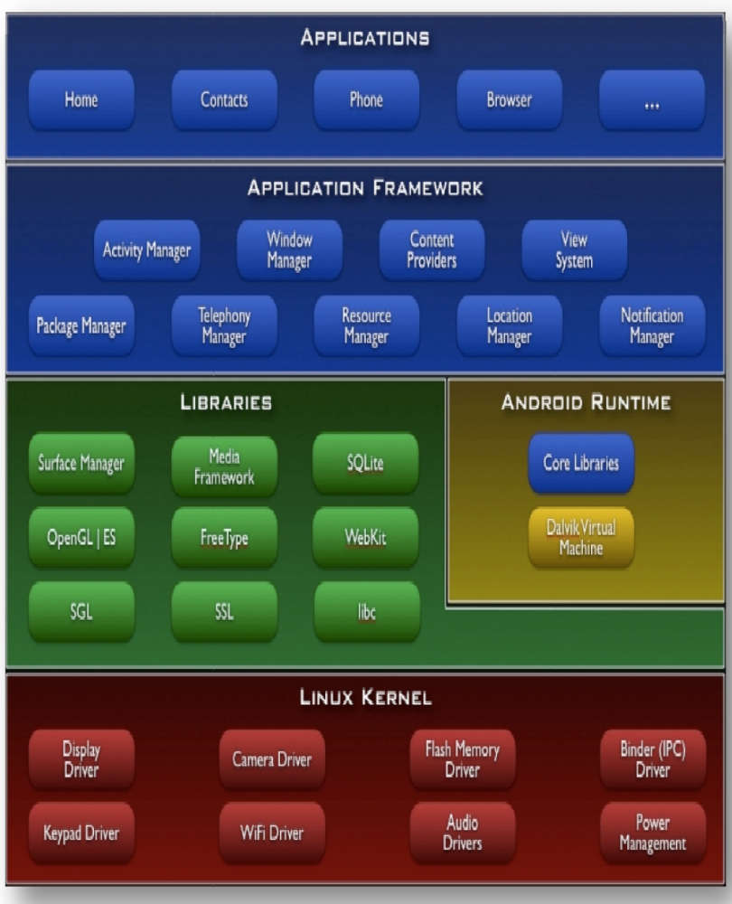

Android Architecture

3.2 Java

Java is a programming language originally developed by James Gosling at Sun Microsystems (which is now a subsidiary of Oracle Corporation) and released in 1995 as a core component of Sun Microsystems' Java platform. The language derives much of its syntax from C and C++ but has a simpler object model and fewer low-level facilities. Java applications are typically compiled to bytecode (class file) that can run on any Java Virtual Machine (JVM) regardless of computer architecture. Java is a general-purpose, concurrent, class-based, object-oriented language that is specifically designed to have as few implementation dependencies as possible. It is intended to let application developers "write once, run anywhere". Java is currently one of the most popular programming languages in use, and is widely used from application software to web applications.
The original and reference implementation Java compilers, virtual machines, and class libraries were developed by Sun from 1995. As of May 2007, in compliance with the specifications of the Java Community Process, Sun relicensed most of its Java technologies under the GNU General Public License. Others have also developed alternative implementations of these Sun technologies, such as the GNU Compiler for Java, GNU Classpath, and Dalvik.

Principles
There were five primary goals in the creation of the Java language:
- It should be "simple, object oriented and familiar".
- It should be "robust and secure".
- It should have "an architecture-neutral and portable environment".
- It should execute with "high performance".
- It should be "interpreted, threaded, and dynamic".

Java Platform
Main articles: Java (software platform) and Java Virtual Machine
One characteristic of Java is portability, which means that computer programs written in the Java language must run similarly on any supported hardware/operating-system platform. This is achieved by compiling the Java language code to an intermediate representation called Java bytecode, instead of directly to platform-specific machine code. Java bytecode instructions are analogous to machine code, but are intended to be interpreted by a virtual machine (VM) written specifically for the host hardware. End-users commonly use a Java Runtime Environment (JRE) installed on their own machine for standalone Java applications, or in a Web browser for Java applets.
Standardized libraries provide a generic way to access host-specific features such as graphics, threading, and networking.
A major benefit of using bytecode is porting. However, the overhead of interpretation means that interpreted programs almost always run more slowly than programs compiled to native executables would. Just-in-Time compilers were introduced from an early stage that compiles bytecodes to machine code during runtime.

Implementations
Sun Microsystems officially licenses the Java Standard Edition platform for Linux, Mac OS X, and Solaris. Although in the past Sun has licensed Java to Microsoft, the license has expired and has not been renewed. Through a network of third-party vendors and licensees, alternative Java environments are available for these and other platforms.
Sun's trademark license for usage of the Java brand insists that all implementations be "compatible". This resulted in a legal dispute with Microsoft after Sun claimed that the Microsoft implementation did not support RMI or JNI and had added platform-specific features of their own. Sun sued in 1997 and in 2001 won a settlement of US$20 million, as well as a court order enforcing the terms of the license from Sun.[25] As a result, Microsoft no longer ships Java with Windows, and in recent versions of Windows, Internet Explorer cannot support Java applets without a third-party plug-in. Sun, and others, has made available free Java run-time systems for those and other versions of Windows.
Platform-independent Java is essential to the Java EE strategy, and an even more rigorous validation is required to certify an implementation. This environment enables portable server-side applications, such as Web services, Java Servlets, and Enterprise JavaBeans, as well as with embedded systems based on OSGi, using Embedded Java environments. Through the new GlassFish project, Sun is working to create a fully functional, unified open source implementation of the Java EE technologies.
Sun also distributes a superset of the JRE called the Java Development Kit (commonly known as the JDK), which includes development tools such as the Java compiler, Javadoc, Jar, and debugger.

Performance
Main article: Java performance
Programs written in Java have a reputation for being slower and requiring more memory than those written in C. However, Java programs' execution speed improved significantly with the introduction of Just-in-time compilation in 1997/1998 for Java 1.1, the addition of language features supporting better code analysis (such as inner classes, StringBuffer class, optional assertions, etc.), and optimizations in the Java Virtual Machine itself, such as HotSpot becoming the default for Sun's JVM in 2000. Currently, Java code has approximately half the performance of C code.
Some platforms offer direct hardware support for Java; there are microcontrollers that can run java in hardware instead of a software JVM, and ARM based processors can have hardware support for executing Java bytecode through its Jazelle option.

Automatic memory management
Java uses an automatic garbage collector to manage memory in the object lifecycle. The programmer determines when objects are created, and the Java runtime is responsible for recovering the memory once objects are no longer in use. Once no references to an object remain, the unreachable memory becomes eligible to be freed automatically by the garbage collector. Something similar to a memory leak may still occur if a programmer's code holds a reference to an object that is no longer needed, typically when objects that are no longer needed are stored in containers that are still in use. If methods for a nonexistent object are called, a "null pointer exception" is thrown.
One of the ideas behind Java's automatic memory management model is that programmers can be spared the burden of having to perform manual memory management. In some languages, memory for the creation of objects is implicitly allocated on the stack, or explicitly allocated and deallocated from the heap. In the latter case the responsibility of managing memory resides with the programmer. If the program does not deallocate an object, a memory leak occurs. If the program attempts to access or deallocate memory that has already been deallocated, the result is undefined and difficult to predict, and the program is likely to become unstable and/or crash. This can be partially remedied by the use of smart pointers, but these add overhead and complexity. Note that garbage collection does not prevent "logical" memory leaks, i.e. those where the memory is still referenced but never used.
Garbage collection may happen at any time. Ideally, it will occur when a program is idle. It is guaranteed to be triggered if there is insufficient free memory on the heap to allocate a new object; this can cause a program to stall momentarily. Explicit memory management is not possible in Java.
Java does not support C/C++ style pointer arithmetic, where object addresses and unsigned integers (usually long integers) can be used interchangeably. This allows the garbage collector to relocate referenced objects and ensures type safety and security.
As in C++ and some other object-oriented languages, variables of Java's primitive data types are not objects. Values of primitive types are either stored directly in fields (for objects) or on the stack (for methods) rather than on the heap, as commonly true for objects (but see Escape analysis). This was a conscious decision by Java's designers for performance reasons. Because of this, Java was not considered to be a pure object-oriented programming language. However, as of Java 5.0, autoboxing enables programmers to proceed as if primitive types were instances of their wrapper class.
Java contains multiple types of garbage collectors. By default, HotSpot uses the Concurrent Mark Sweep collector, also known as the CMS Garbage Collector. However, there are also several other garbage collectors that can be used to manage the Heap. For 90% of applications in Java, the CMS Garbage Collector is good enough.

3.3 XML

Extensible Markup Language (XML) is a set of rules for encoding documents in machine-readable form. It is defined in the XML 1.0 Specification produced by the W3C, and several other related specifications, all gratis open standards.
XML's design goals emphasize simplicity, generality, and usability over the Internet. It is a textual data format with strong support via Unicode for the languages of the world. Although the design of XML focuses on documents, it is widely used for the representation of arbitrary data structures, for example in web services.
Many application programming interfaces (APIs) have been developed that software developers use to process XML data, and several schema systems exist to aid in the definition of XML-based languages.
As of 2009[update], hundreds of XML-based languages have been developed, including RSS, Atom, SOAP, and XHTML. XML-based formats have become the default for most office-productivity tools, including Microsoft Office (Office Open XML), OpenOffice.org (OpenDocument), and Apple's iWork.

Key terminology
The material in this section is based on the XML Specification. This is not an exhaustive list of all the constructs which appear in XML; it provides an introduction to the key constructs most often encountered in day-to-day use.
(Unicode) Character
By definition, an XML document is a string of characters. Almost every legal Unicode character may appear in an XML document.
Processor and Application
The processor analyzes the markup and passes structured information to an application. The specification places requirements on what an XML processor must do and not do, but the application is outside its scope. The processor (as the specification calls it) is often referred to colloquially as an XML parser.
Markup and Content
The characters which make up an XML document are divided into markup and content. Markup and content may be distinguished by the application of simple syntactic rules. All strings which constitute markup either begin with the character "<" and end with a ">", or begin with the character "&" and end with a ";". Strings of characters which are not markup are content.
Tag
A markup construct that begins with "<" and ends with ">". Tags come in three flavors: start-tags, for example <section>, end-tags, for example </section>, and empty-element tags, for example <line-break />.
Element
A logical component of a document which either begins with a start-tag and ends with a matching end-tag, or consists only of an empty-element tag. The characters between the start- and end-tags, if any, are the element's content, and may contain markup, including other elements, which are called child elements. An example of an element is <Greeting>Hello, world.</Greeting> (see hello world). Another is <line-break />.
Attribute
A markup construct consisting of a name/value pair that exists within a start-tag or empty-element tag. In the example (below) the element img has two attributes, src and alt: <img src="madonna.jpg" alt='Foligno Madonna, by Raphael' />. Another example would be <step number="3">Connect A to B.</step> where the name of the attribute is "number" and the value is "3".
XML Declaration
XML documents may begin by declaring some information about themselves, as in the following example.
<?xml version="1.0" encoding="UTF-8" ?>

Characters and escaping
XML documents consist entirely of characters from the Unicode repertoire. Except for a small number of specifically excluded control characters, any character defined by Unicode may appear within the content of an XML document. The selection of characters which may appear within markup is somewhat more limited but still large.
XML includes facilities for identifying the encoding of the Unicode characters which make up the document, and for expressing characters which, for one reason or another, cannot be used directly.

Valid characters
Main article: Valid characters in XML
Unicode code points in the following ranges are valid in XML 1.0 documents:[9]
- U+0009, U+000A, U+000D: these are the only C0 controls accepted in XML 1.0;
- U+0020–U+D7FF, U+E000–U+FFFD: this excludes some (not all) non-characters in the BMP (all surrogates, U+FFFE and U+FFFF are forbidden);
- U+10000–U+10FFFF: this includes all code points in supplementary planes, including non-characters.
XML 1.1[10] extends the set of allowed characters to include all the above, plus the remaining characters in the range U+0001–U+001F. At the same time, however, it restricts the use of C0 and C1 control characters other than U+0009, U+000A, U+000D, and U+0085 by requiring them to be written in escaped form (for example U+0001 must be written as &#x01; or its equivalent). In the case of C1 characters, this restriction is a backwards incompatibility; it was introduced to allow common encoding errors to be detected.
The code point U+0000 is the only character that is not permitted in any XML 1.0 or 1.1 document.

Encoding detection
The Unicode character set can be encoded into bytes for storage or transmission in a variety of different ways, called "encodings". Unicode itself defines encodings which cover the entire repertoire; well-known ones include UTF-8 and UTF-16. There are many other text encodings which pre-date Unicode, such as ASCII and ISO/IEC 8859; their character repertoires in almost every case are subsets of the Unicode character set.
XML allows the use of any of the Unicode-defined encodings, and any other encodings whose characters also appear in Unicode. XML also provides a mechanism whereby an XML processor can reliably, without any prior knowledge, determine which encoding is being used. Encodings other than UTF-8 and UTF-16 will not necessarily be recognized by every XML parser.

Escaping
XML provides escape facilities for including characters which are problematic to include directly. For example:
- The characters "<" and "&" are key syntax markers and may never appear in content outside of a CDATA section.[13]
- Some character encodings support only a subset of Unicode: for example, it is legal to encode an XML document in ASCII, but ASCII lacks code points for Unicode characters such as "é".
- It might not be possible to type the character on the author's machine.
- Some characters have glyphs that cannot be visually distinguished from other characters: examples are non-breaking-space (&#xa0;) and Cyrillic Capital Letter A (&#x410;).
There are five predefined entities: &lt; represents "<", &gt; represents ">", &amp; represents "&", &apos; represents ', and &quot; represents ". All permitted Unicode characters may be represented with a numeric character reference. Consider the Chinese character "中", whose numeric code in Unicode is hexadecimal 4E2D, or decimal 20,013. A user whose keyboard offers no method for entering this character could still insert it in an XML document encoded either as &#20013; or &#x4e2d;. Similarly, the string "I <3 Jörg" could be encoded for inclusion in an XML document as "I &lt;3 J&#xF6;rg".
"&#0;" is not permitted, however, as the null character is one of the control characters excluded from XML, even when using a numeric character reference.[14] An alternative encoding mechanism such as Base64 is needed to represent such characters.

Comments
Comments may appear anywhere in a document outside other markup. Comments cannot appear before the XML declaration. The string "--" (double-hyphen) is not allowed (as it is used to delimit comments). The ampersand has no special significance within comments, so entity and character references are not recognized as such, and there is no way to represent characters outside the character set of the document encoding.
An example of a valid comment: "<!-- no need to escape <code> & such in comments -->"

Well-formedness and error-handling
The XML specification defines an XML document as a text which is well-formed, i.e. it satisfies a list of syntax rules provided in the specification. The list is fairly lengthy; some key points are:
- It contains only properly encoded legal Unicode characters.
- None of the special syntax characters such as "<" and "&" appear except when performing their markup-delineation roles.
- The begin, end, and empty-element tags which delimit the elements are correctly nested, with none missing and none overlapping.
- The element tags are case-sensitive; the beginning and end tags must match exactly.
- There is a single "root" element which contains all the other elements.
The definition of an XML document excludes texts which contain violations of well-formedness rules; they are simply not XML. An XML processor which encounters such a violation is required to report such errors and to cease normal processing. This policy, occasionally referred to as draconian, stands in notable contrast to the behavior of programs which process HTML, which are designed to produce a reasonable result even in the presence of severe markup errors. XML's policy in this area has been criticized as a violation of Postel's law.[15]

Schemas and validation
In addition to being well-formed, an XML document may be valid. This means that it contains a reference to a Document Type Definition (DTD), and that its elements and attributes are declared in that DTD and follow the grammatical rules for them that the DTD specifies.
XML processors are classified as validating or non-validating depending on whether or not they check XML documents for validity. A processor which discovers a validity error must be able to report it, but may continue normal processing.
A DTD is an example of a schema or grammar. Since the initial publication of XML 1.0, there has been substantial work in the area of schema languages for XML. Such schema languages typically constrain the set of elements that may be used in a document, which attributes may be applied to them, the order in which they may appear, and the allowable parent/child relationships.

DTD
Main article: Document Type Definition
The oldest schema language for XML is the Document Type Definition (DTD), inherited from SGML.
DTDs have the following benefits:
- DTD support is ubiquitous due to its inclusion in the XML 1.0 standard.
- DTDs are terse compared to element-based schema languages and consequently present more information in a single screen.
- DTDs allow the declaration of standard public entity sets for publishing characters.
- DTDs define a document type rather than the types used by a namespace, thus grouping all constraints for a document in a single collection.
DTDs have the following limitations:
- They have no explicit support for newer features of XML, most importantly namespaces.
- They lack expressiveness. XML DTDs are simpler than SGML DTDs and there are certain structures that cannot be expressed with regular grammars. DTDs only support rudimentary datatypes.
- They lack readability. DTD designers typically make heavy use of parameter entities (which behave essentially as textual macros), which make it easier to define complex grammars, but at the expense of clarity.
- They use a syntax based on regular expression syntax, inherited from SGML, to describe the schema. Typical XML APIs such as SAX do not attempt to offer applications a structured representation of the syntax, so it is less accessible to programmers than an element-based syntax may be.
Two peculiar features that distinguish DTDs from other schema types are the syntactic support for embedding a DTD within XML documents and for defining entities, which are arbitrary fragments of text and/or markup that the XML processor inserts in the DTD itself and in the XML document wherever they are referenced, like character escapes.
DTD technology is still used in many applications because of its ubiquity.

XML Schema
Main article: XML Schema (W3C)
A newer schema language, described by the W3C as the successor of DTDs, is XML Schema, often referred to by the initialism for XML Schema instances, XSD (XML Schema Definition). XSDs are far more powerful than DTDs in describing XML languages. They use a rich datatyping system and allow for more detailed constraints on an XML document's logical structure. XSDs also use an XML-based format, which makes it possible to use ordinary XML tools to help process them.

Schematron
Main article: Schematron
Schematron is a language for making assertions about the presence or absence of patterns in an XML document. It typically uses XPath expressions.

3.4 Ubuntu

Ubuntu is a computer operating system based on the Debian GNU/Linux distribution and distributed as free and open source software. It is named after the Southern African philosophy of Ubuntu ("humanity towards others").
With an estimated global usage of more than 12 million users, Ubuntu is designed primarily for desktop use, although netbook and server editions exist as well. Web statistics suggest that Ubuntu's share of Linux desktop usage is about 50%, and indicate upward-trending usage as a web server.
Ubuntu is sponsored by the UK-based company Canonical Ltd., owned by South African entrepreneur Mark Shuttleworth. Canonical generates revenue by selling technical support and services tied to Ubuntu, while the operating system itself is entirely free of charge.

Features
Ubuntu is composed of many software packages, the vast majority of which are distributed under a free software license. The only exceptions are some proprietary hardware drivers. The main license used is the GNU General Public License (GNU GPL) which, along with the GNU Lesser General Public License (GNU LGPL), explicitly declares that users are free to run, copy, distribute, study, change, develop and improve the software. On the other hand, there is also proprietary software available that can run on Ubuntu. Ubuntu focuses on usability, security and stability. The Ubiquity installer allows Ubuntu to be installed to the hard disk from within the Live CD environment, without the need for restarting the computer prior to installation. Ubuntu also emphasizes accessibility and internationalization to reach as many people as possible. Beginning with 5.04, UTF-8 became the default character encoding, which allows for support of a variety of non-Roman scripts. As a security feature, the sudo tool is used to assign temporary privileges for performing administrative tasks, allowing the root account to remain locked, and preventing inexperienced users from inadvertently making catastrophic system changes or opening security holes. PolicyKit is also being widely implemented into the desktop to further harden[jargon] the system through the principle of least privilege.
Ubuntu comes installed with a wide range of software that includes OpenOffice, Firefox, Empathy (Pidgin in versions before 9.10), Transmission, GIMP (in versions prior to 10.04), and several lightweight games (such as Sudoku and chess). Additional software that is not installed by default can be downloaded and installed using the Ubuntu Software Center or the package manager Synaptic, which come pre-installed. Ubuntu allows networking ports to be closed using its firewall, with customized port selection available. End-users can install Gufw (GUI for Uncomplicated Firewall) and keep it enabled. GNOME (the current default desktop) offers support for more than 46 languages. Ubuntu can also run many programs designed for Microsoft Windows (such as Microsoft Office), through Wine or using a Virtual Machine (such as VMware Workstation or VirtualBox). For the upcoming 11.04 release, Canonical intends to drop the GNOME Shell as the default desktop environment in favor of Unity, a graphical interface it first developed for the netbook edition of Ubuntu.
Ubuntu, unlike Debian, compiles their packages using gcc features such as PIE and Buffer overflow protection to harden their software. These extra features greatly increase security at the performance expense of 1% in 32 bit and 0.01% in 64 bit.

4.0 System Study

4.1 System Feasibility
System Feasibility is the tool or stage for determining whether to proceed with the project or to beneficial to the company or yahoo store clients.
Technical Feasibility: Can the work for the store be done with current equipment, existing software technology and available personnel? If new technology is needed, what is the likelihood that it can be developed?
Development tools chosen for this store is Media Player, Eclipse 3.6, Android SDK 10r, Android 2.3.3 lib & ADT plug-in and we expertise to use these tool to develop this kind of application. So the Media Player is technically feasible.
Operational Feasibility: Will the system be used if it is developed and implemented? Will there be resistance from users that will undermine the possible application benefits?
Once the application is developed, the work does not get over here. It should be easy to operate by customers for whom the application is developed. This demands a very good user interface to be implemented. Keeping in mind this issue, the app is designed so that it will be very user friendly and the users won’t require extensive training to use the system. It has got a very user friendly and an easy interface so that it can also be used by any new user. It is totally feasible to operation our application with great ease.
Economical Feasibility: Are there sufficient benefits in creating the system to make the costs acceptable? Or, are the costs of not creating the system so great that it is advisable to undertake the project?
The development tools for this application are freely available so this way the cost of development decreases vastly. And now a days operating mobile phones with Android OS is coming at very little price so we can say that the project is Economical Feasible.

4.2 Waterfall Model
D
uring any software development project it is essential to collect the requirement before designing the software, to have a design before implementation etc, - namely to follow a structured software development lifecycle. As circumstances vary, different lifecycles have been developed and described over the years to accommodate different needs of different projects. In this section, several main methodologies are presented and are followed by a short discussion on why they are suitable for this project.

Below is only a summary of common methodology followed by a discussion, which methodology is best suited for this project.

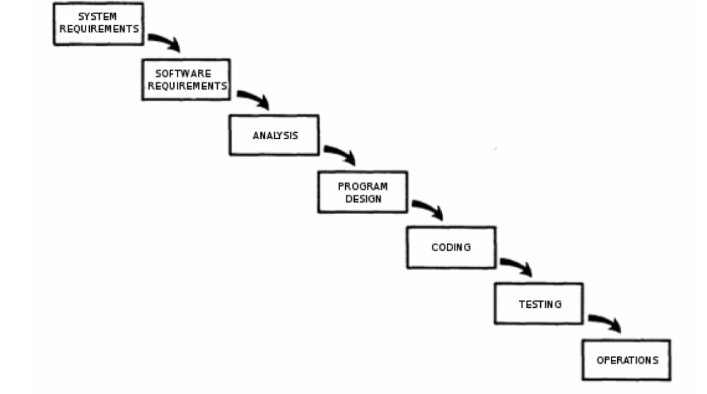

1: Pure Waterfall model

4.2.1 Pure Waterfall

Waterfall model is the oldest and the most well-known of all described here. It is probably the most intuitive one and it serves as the basis for most other models, even though many problems have been recognised since its introduction. The basic idea of this model is to divide development into few separate stages (like requirements analysis, design, coding, testing) and go through them in order. Each stage can only be started if the previous one is
completed, i.e. coding would not start before the design is finished and approved. Because of the rigid structure this model is often used in formal projects that carry a high risk (for instance military projects) and carries a lot of documentation. In order for pure waterfall model to be suitable, requirements need to be well-understood and stable throughout the
whole cycle.

4.2.2 Modified Waterfalls

Despite its advantages it is usually better to use a variation of the pure waterfall model to address some of the major flaws. Described below are two changes that address its inflexibility and that will be adopted in this project.
“Sashimi” i.e. overlapping phases is a model similar to the pure waterfall, with the exception of starting time of each stage. In sashimi model phases overlap slightly, so the design is started before the requirements are finalised, coding before the design is completed etc. That accommodates situations, where it is difficult to predict various problems, for instance when during coding it becomes apparent that a design decision was wrong. The name “sashimi”
comes from the fact that the graph representing this particular model resembles the Japanese dish.

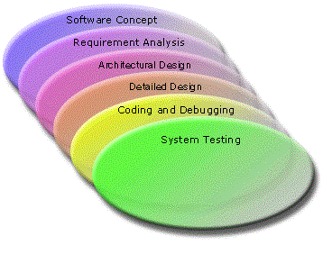

Figure 2: Sashimi model
Allowing for more regression (coming back to stages that have already been gone through), which is called “risk reduction”, allows to revise the stages that have been already gone through, taking into consideration how some of the later stages progressed.

4.2.3 Design-to-Schedule

This model is suitable for projects, where delivering a product by the given deadline is the critical success factor – even if the product doesn’t have all of the specified features. It is based on several releases, each one with lesser priority features than the previous one, so that the most important requirements are satisfied first. Subsequent releases are made until all features are included, or until the time runs out in which case only the low-priority characteristics are missing.
Design-to-Schedule model is best suited for situations, where the deadline is unmovable and it is hard to predict, whether all the work will be completed by then, making it a good choice for this project.
To summarise, this project will use:
- waterfall model as a base for the development methodology
- overlapping stages to enable working on two different stages simultaneously
- iterating over stages that were already gone through to enable refining design and coding decisions based on knowledge acquired at later stages
- planning for few releases, each adding functionality to the previous one, to
ensure that at least some version of the software is ready by the deadline

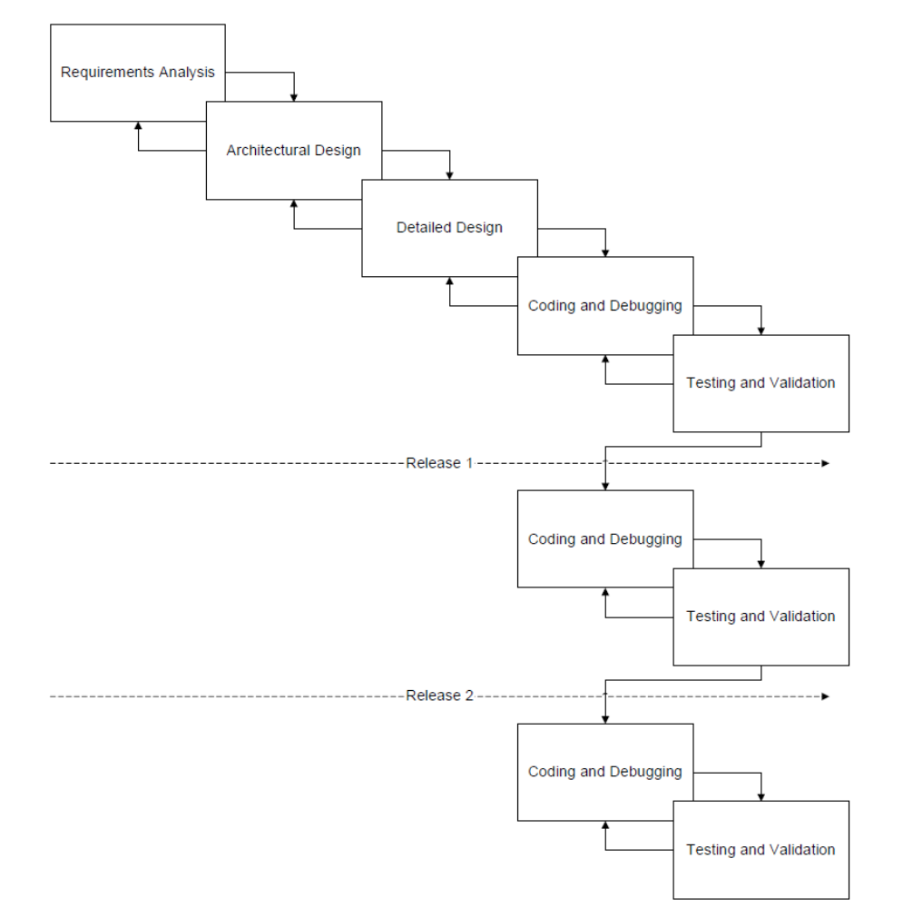
Figure change: Adopted Development Model

5.0 System Design

5.1 System Flow Diagram
Flow chart, or flow diagram, is a graphical representation of a process or system that details the sequencing of steps required to create output.
A system flowchart explains how a system works using a diagram. The diagram shows the flow of data through a system.
A flowchart is a common type of chart that represents an algorithm or process, showing the steps as boxes of various kinds, and their order by connecting these with arrows.
A flowchart is an analytical technique used to describe some aspect of an information system in a clear, concise, and logical manner. Flowcharts use a standard set of symbols to pictorially describe transaction-processing procedures.
Flowcharts are used in analyzing, designing, documenting or managing a process or program in various fields.
Difference between Data Flow Diagram and Flow Chart - First, DFD Emphasizes the flow of data and what is happening in a system while Flow Chart emphasizes the flow of documents or records containing data. And Second, DFD represents the logical flow of data while Flow Chart represents the physical flow of data.

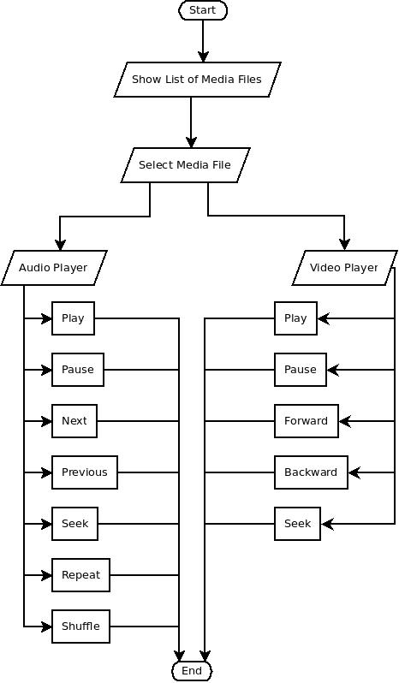
5.1 System Flow Diagram

5.2 System Chart
S
ystem chart represent different modules exist in the Media Player application. It represent main module and sub module of the system.

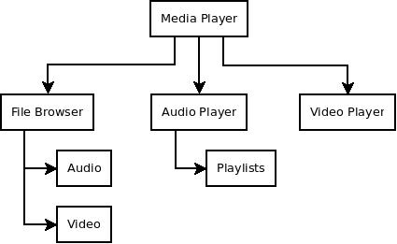

5.0 User Manual

Media Files Browser
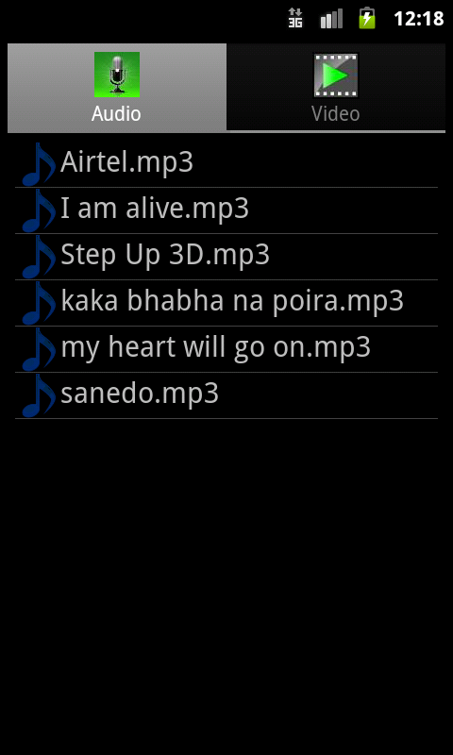

Audio Player
