1. Project Profile
1.1 Introduction
Project Title | Social Networking Website
Project Name | eNetwork
Front End | JSP 2.0
Back End | MySQL 5.5
Web and Scripting | HTML , CSS, JavaScript, AJAX
Application Server | GlassFish 3.0.1
Integrated Development Environment(IDE) | NetBeans 6.9.1
Operating System | Fedora 14

1.2 Project Definition:
Social Networking Website is a website in which people can share information and build social relations.
1.3 Major Objectives:
- Easy to use User Interface
- Share Profile Information
- Profile Privacy
- Share Content
- Content Privacy
1.4 Requirement Analysis:
1.4.1 Functional Requirements:
eNetwork will allow user to perform following functions:

- Create and manage profile having social, professional, and personal information.
- Search people by name, email, location.
- Add or remove friends.
- Send/Receive messages.
- Send/Receive posts.
- Upload and share photos.
- Upload and share videos.
- Add videos from YouTube.
- Add privacy to photos, videos, posts, and profile.
- Comment on photo, video, posts.

1.4.2 Requirement Gathering:
Types of Modules:

  - Profile
  - Friends
  - Posts
  - Messages
  - Photos
  - Videos
  - Privacy
  - Search

1.4.2 Requirement Specification:
Home Page
Login
Register
User Home Page
Read Posts.
Publish posts.
Account settings.
Photos
Upload new photos.
Add photos.
View photos.
Delete photos.
Edit photos.
Videos
Upload new videos.
Add videos.
View videos.
Delete videos.
Edit videos.
Add video from YouTube.
Profile
Add profile information.
Edit profile information.
Delete profile information.
View profile information.
Privacy
Set privacy on photos.
Set privacy on posts.
Set privacy on videos.
Set privacy on profile.
Search
Search people by name, email, location.

2. Tools and Technology
2.1 JSP
Java Server Pages (JSP) is a Java technology that helps software developers serve dynamically generated web pages based on HTML, XML, or other document types. Released in 1999 as Sun's answer to ASP and PHP, JSP was designed to address the perception that the Java programming environment didn't provide developers with enough support for the Web.
Architecturally, JSP may be viewed as a high-level abstraction of Java servlets. JSP pages are loaded in the server and operated from a structured special installed Java server packet called a Java EE Web Application, often packaged as a .war or .ear file archive.
JSP allows Java code and certain pre-defined actions to be interleaved with static web markup content, with the resulting page being compiled and executed on the server to deliver an HTML or XML document. The compiled pages and any dependent Java libraries use Java bytecode rather than a native software format, and must therefore be executed within a Java virtual machine (JVM) that integrates with the host operating system to provide an abstract platform-neutral environment.
JSP syntax is a fluid mix of two basic content forms: scriptlet elements and markup. Markup is typically standard HTML or XML, while scriptlet elements are delimited blocks of Java code which may be intermixed with the markup. When the page is requested the Java code is executed and its output is added, in situ, with the surrounding markup to create the final page. Because Java is a compiled language, not a scripting language, JSP pages must be compiled to Java bytecode classes before they can be executed, but such compilation is needed only when a change to the source JSP file has occurred.
Java code is not required to be complete (self contained) within its scriptlet element block, but can straddle markup content providing the page as a whole is syntactically correct (for example, any Java if/for/while blocks opened in one scriptlet element must be correctly closed in a later element for the page to successfully compile). This system of split inline coding sections is called step over scripting because it can wrap around the static markup by stepping over it. Markup which falls inside a split block of code is subject to that code, so markup inside an if block will only appear in the output when the if condition evaluates to true; likewise markup inside a loop construct may appear multiple times in the output depending upon how many times the loop body runs.
The JSP syntax adds additional XML-like tags, called JSP actions, to invoke built-in functionality. Additionally, the technology allows for the creation of JSP tag libraries that act as extensions to the standard HTML or XML tags. JVM operated tag libraries provide a platform independent way of extending the capabilities of a web server. Note that not all commercial Java servers are Java EE specification compliant.

JSP 2.0
The new version of the JSP specification includes new features meant to improve programmer productivity. Namely:
- An Expression Language (EL) which allows developers to create Velocity-style templates (among other things).
- A faster/easier way to display parameter values.
- A clear way to navigate nested beans.
The Java EE 5 Platform has focused on easing development by making use of Java language annotations that were introduced by J2SE 5.0. JSP 2.1 supports this goal by defining annotations for dependency injection on JSP tag handlers and context listeners.
Another key concern of the Java EE 5 specification has been the alignment of its web tier technologies, namely JavaServer Pages (JSP), JavaServer Faces (JSF), and the JavaServer Pages Standard Tag Library (JSTL).
The outcome of this effort has been the Unified Expression Language (EL), which integrates the expression languages defined by JSP 2.0 and JSF 1.1.
JSP 2.0 introduced a problem in the tag library section on how the JSP version information was represented. The specification itself is inconsistent, sometimes referring to a jsp-version element, and at other times a version attribute on the root element. JSF specifications have gone with the later interpretation; however some JSP implementations still expect the jsp-version element.
JSP 2.1 leverages the Servlet 2.5 specification for its web semantics.
2.2 MySQL
MySQL is a relational database management system (RDBMS) that runs as a server providing multi-user access to a number of databases. MySQL is officially pronounced /maɪˌɛskjuːˈɛl/ ("My S-Q-L"),but is often also pronounced /maɪˈsiːkwəl/ ("My Sequel"). It is named after developer Michael Widenius' daughter, My. The SQL phrase stands for Structured Query Language.
The MySQL development project has made its source code available under the terms of the GNU General Public License, as well as under a variety of proprietary agreements. MySQL was owned and sponsored by a single for-profit firm, the Swedish company MySQL AB, now owned by Oracle Corporation.
Free-software projects that require a full-featured database management system often use MySQL. Where the project may lead to something in commercial use, the license terms need careful study. Some free software project examples: Joomla, WordPress, phpBB, Drupal and other software built on the LAMP software stack. MySQL is also used in many high-profile, large-scale World Wide Web products, including Wikipedia, Google (though not for searches) and Facebook.
MySQL is used in some of the most frequently visited web sites on the Internet, including Flickr, Nokia.com, YouTube and as previously mentioned; Wikipedia, Google and Facebook.

Features
As of April 2009, MySQL offers MySQL 5.1 in two different variants: the open source MySQL Community Server and the commercial Enterprise Server. They have a common code base and include the following features:
- A broad subset of ANSI SQL 99, as well as extensions
- Cross-platform support
- Stored procedures
- Triggers
- Cursors
- Updatable Views
- True Varchar support
- Information schema
- Strict mode
- X/Open XA distributed transaction processing (DTP) support; two phase commit as part of this, using Oracle's InnoDB engine
- Independent storage engines (MyISAM for read speed, InnoDB for transactions and referential integrity, MySQL Archive for storing historical data in little space)
- Transactions with the InnoDB, BDB and Cluster storage engines; savepoints with InnoDB
- SSL support
- Query caching
- Sub-SELECTs (i.e. nested SELECTs)
- Replication support (i.e. Master-Master Replication & Master-Slave Replication) with one master per slave, many slaves per master, no automatic support for multiple masters per slave.
- Full-text indexing and searching using MyISAM engine
- Embedded database library
- Partial Unicode support (UTF-8 and UCS-2 encoded strings are limited to the BMP)
- Partial ACID compliance (full compliance only when using the non-default storage engines InnoDB, BDB and Cluster)
- Partititoned tables with pruning of partitions in optimiser
- Shared-nothing clustering through MySQL Cluster
- Hot backup (via mysqlhotcopy) under certain conditions^{[21]}

Distinguishing features
MySQL implements the following features, which some other RDBMS systems may not:
- Multiple storage engines, allowing one to choose the one that is most effective for each table in the application (in MySQL 5.0, storage engines must be compiled in; in MySQL 5.1, storage engines can be dynamically loaded at run time):
  - Native storage engines (MyISAM, Falcon, Merge, Memory (heap), Federated, Archive, CSV, Blackhole, Cluster, Berkeley DB, EXAMPLE, Maria, and InnoDB, which was made the default as of 5.5)
  - Partner-developed storage engines (solidDB, NitroEDB, Infobright (formerly Brighthouse), Kickfire, XtraDB, IBM DB2^{[22]}). InnoDB used to be a partner-developed storage engine, but with recent acquisitions, Oracle now owns both MySQL core and InnoDB.
  - Community-developed storage engines (memcache engine, httpd, PBXT, Revision Engine)
  - Custom storage engines
- Commit grouping, gathering multiple transactions from multiple connections together to increase the number of commits per second.
2.3 AJAX
Ajax (pronounced /ˈeɪdʒæks/; shorthand for Asynchronous JavaScript and XML)^{[1]} is a group of interrelated web development methods used on the client-side to create interactive web applications. With Ajax, web applications can retrieve data from the server asynchronously in the background without interfering with the display and behavior of the existing page. Data is usually retrieved using the XMLHttpRequest object. Despite the name, the use of XML is not needed, and the requests need not be asynchronous.^{[2]}
Like DHTML and LAMP, Ajax is not one technology, but a group of technologies. Ajax uses a combination of HTML and CSS to mark up and style information. The DOM is accessed with JavaScript to dynamically display, and to allow the user to interact with the information presented. JavaScript and the XMLHttpRequest object provide a method for exchanging data asynchronously between browser and server to avoid full page reloads.
The term Ajax has come to represent a broad group of web technologies that can be used to implement a web application that communicates with a server in the background, without interfering with the current state of the page. In the article that coined the term Ajax,^{[1]} Jesse James Garrett explained that the following technologies are incorporated:
- HTML or XHTML and CSS for presentation
- the Document Object Model (DOM) for dynamic display of and interaction with data
- XML for the interchange of data, and XSLT for its manipulation
- the XMLHttpRequest object for asynchronous communication
- JavaScript to bring these technologies together
Since then, however, there have been a number of developments in the technologies used in an Ajax application, and the definition of the term Ajax. In particular, it has been noted that JavaScript is not the only client-side scripting language that can be used for implementing an Ajax application; other languages such as VBScript are also capable of the required functionality. (However, JavaScript is the most popular language for Ajax programming due to its inclusion in and compatibility with the majority of modern web browsers.) Also, XML is not required for data interchange and therefore XSLT is not required for the manipulation of data. JavaScript Object Notation (JSON) is often used as an alternative format for data interchange, although other formats such as preformatted HTML or plain text can also be used.
2.4 GlassFish
GlassFish is an open source application server project led by Sun Microsystems for the Java EE platform. The proprietary version is called Sun GlassFish Enterprise Server. GlassFish is free software, dual-licensed under two free software licences: the Common Development and Distribution License (CDDL) and the GNU General Public License (GPL) with the classpath exception.
GlassFish is based on source code released by Sun and Oracle Corporation's TopLink persistence system. It uses a derivative of Apache Tomcat as the servlet container for serving Web content, with an added component called Grizzly which uses Java New I/O (NIO) for scalability and speed.
2.5 NetBeans IDE
The NetBeans IDE is an open-source integrated development environment. NetBeans IDE supports development of all Java application types (Java SE including JavaFX, (Java ME, web, EJB and mobile applications) out of the box. Among other features are an Ant-based project system, Maven support, refactorings, version control (supporting CVS, Subversion, Mercurial and Clearcase).
Modularity: All the functions of the IDE are provided by modules. Each module provides a well defined function, such as support for the Java language, editing, or support for the CVS versioning system, and SVN. NetBeans contains all the modules needed for Java development in a single download, allowing the user to start working immediately. Modules also allow NetBeans to be extended. New features, such as support for other programming languages, can be added by installing additional modules. For instance, Sun Studio, Sun Java Studio Enterprise, and Sun Java Studio Creator from Sun Microsystems are all based on the NetBeans IDE.
License: From July 2006 through 2007, NetBeans IDE was licensed under Sun's Common Development and Distribution License (CDDL), a license based on the Mozilla Public License (MPL). In October 2007, Sun announced that NetBeans would henceforth be offered under a dual license of the CDDL and the GPL version 2 licenses, with the GPL linking exception for GNU Classpath.

Integrated modules
These modules are part of the NetBeans IDE.

NetBeans Profiler
The NetBeans Profiler is a tool for the monitoring of Java applications: It helps developers find memory leaks and optimize speed. Formerly downloaded separately, it is integrated into the core IDE since version 6.0.
The Profiler is based on a Sun Laboratories research project that was named JFluid. That research uncovered specific techniques that can be used to lower the overhead of profiling a Java application. One of those techniques is dynamic bytecode instrumentation, which is particularly useful for profiling large Java applications. Using dynamic bytecode instrumentation and additional algorithms, the NetBeans Profiler is able to obtain runtime information on applications that are too large or complex for other profilers. NetBeans also support Profiling Points that let you profile precise points of execution and measure execution time.

GUI design tool
Formerly known as project Matisse, the GUI design-tool enables developers to prototype and design Swing GUIs by dragging and positioning GUI components.^{[8]}
The GUI builder also has built-in support for JSR 296 (Swing Application Framework), and JSR 295 (Beans Binding technology).

NetBeans JavaScript editor
The NetBeans JavaScript editor provides extended support for JavaScript, Ajax, and CSS.
JavaScript editor features comprise syntax highlighting, refactoring, code completion for native objects and functions, generation of JavaScript class skeletons, generation of Ajax callbacks from a template; and automatic browser compatibility checks.
CSS editor features comprise code completion for styles names, quick navigation through the navigator panel, displaying the CSS rule declaration in a List View and file structure in a Tree View, sorting the outline view by name, type or declaration order (List & Tree), creating rule declarations (Tree only), refactoring a part of a rule name (Tree only).
2.6 Fedora
Fedora (pronounced /fəˈdɔrə/) is an RPM-based, general purpose collection of software, including an operating system based on the Linux kernel, developed by the community-supported Fedora Project and sponsored by Red Hat. The Fedora Project's mission is to lead the advancement of free and open source software and content as a collaborative community.^{[2]}
One of Fedora's main objectives is not only to contain software distributed under a free and open source license, but also to be on the leading edge of such technologies.^{[3][4]} Fedora developers prefer to make upstream changes instead of applying fixes specifically for Fedora—this ensures that their updates are available to all Linux distributions.^{[5]}
Fedora has a comparatively short life cycle: version X is maintained until one month after version X+2 is released. With 6 months between releases, the maintenance period is a very short 13 months for each version.^{[6]} This can lead to trouble should one wish to use a particular version of Fedora for product development (i.e., embedded systems) where long term support is more important than maintaining leading edge revisions of software.
In 2008, Linus Torvalds, author of the Linux kernel, stated that he used Fedora because it had fairly good support for the PowerPC processor architecture, which he favored at the time.^{[7]}
According to DistroWatch, Fedora is the third most popular Linux-based operating system as of December 2010, behind Ubuntu and Mint.^{[8]}

3. System Analysis
3.1 Flow Chart
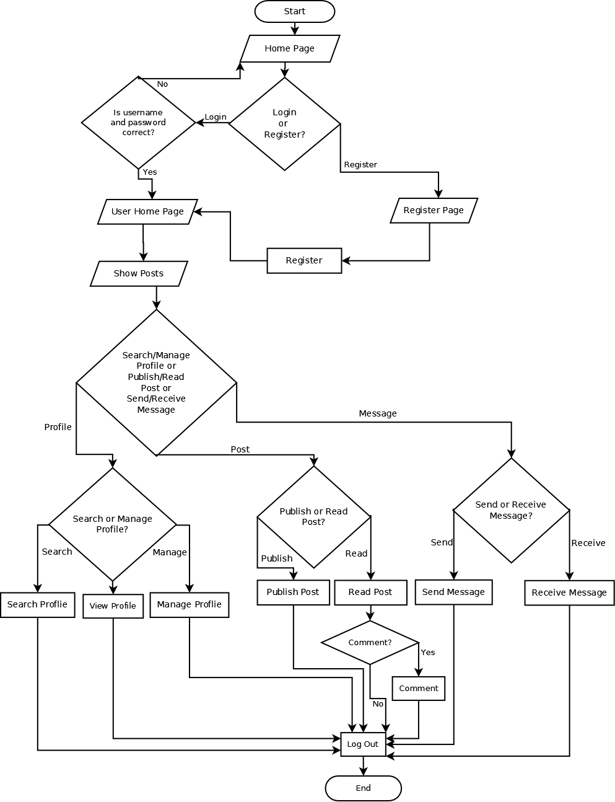
3.2 System Chart
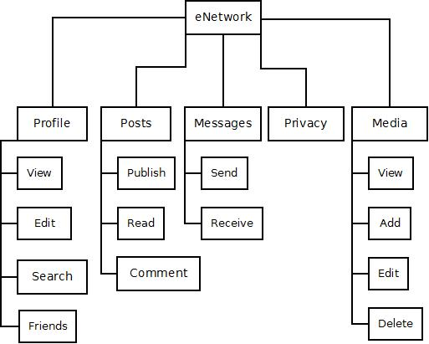
3.3 Data Flow Diagrams (DFDs)
Context Level DFD
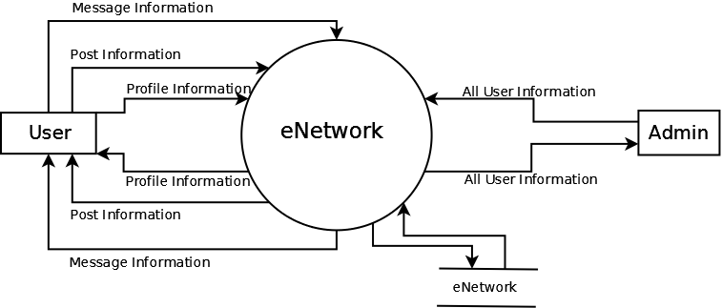
First Level DFD
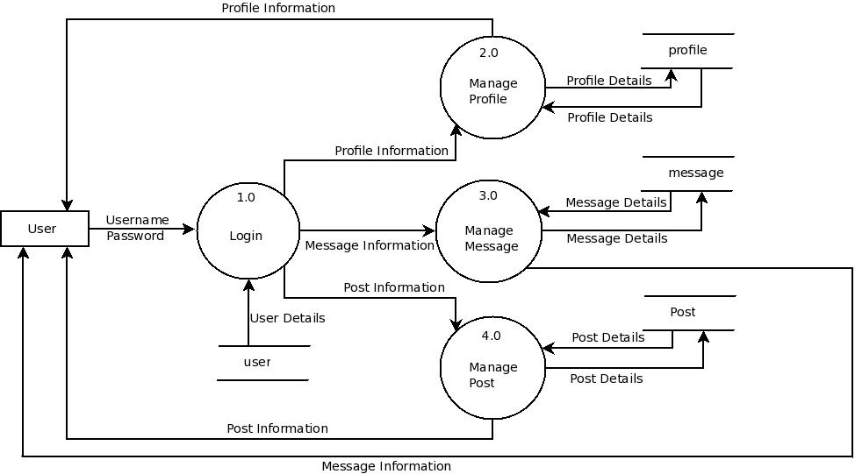
Second Level DFD of Manage Profile Process:
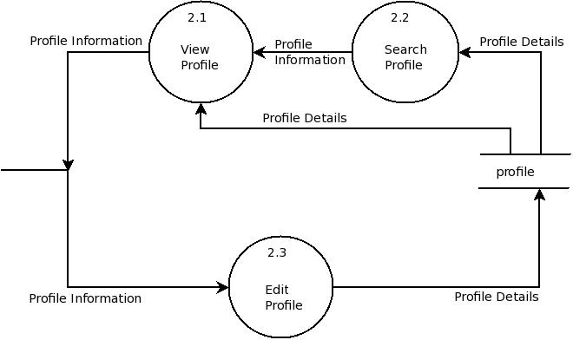
Second Level DFD of Manage Message Process:

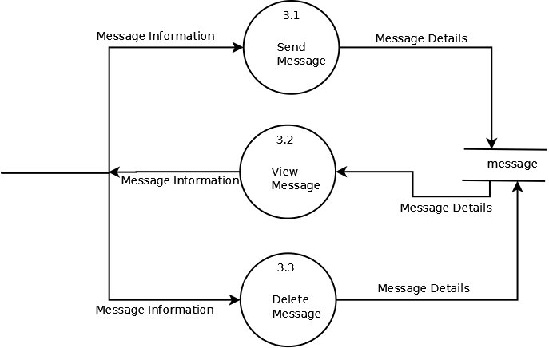
Second Level DFD of Manage Post Process
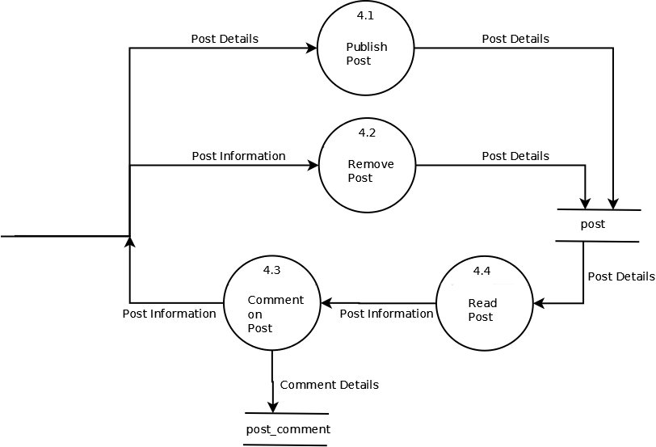

3.4 E-R Diagram:
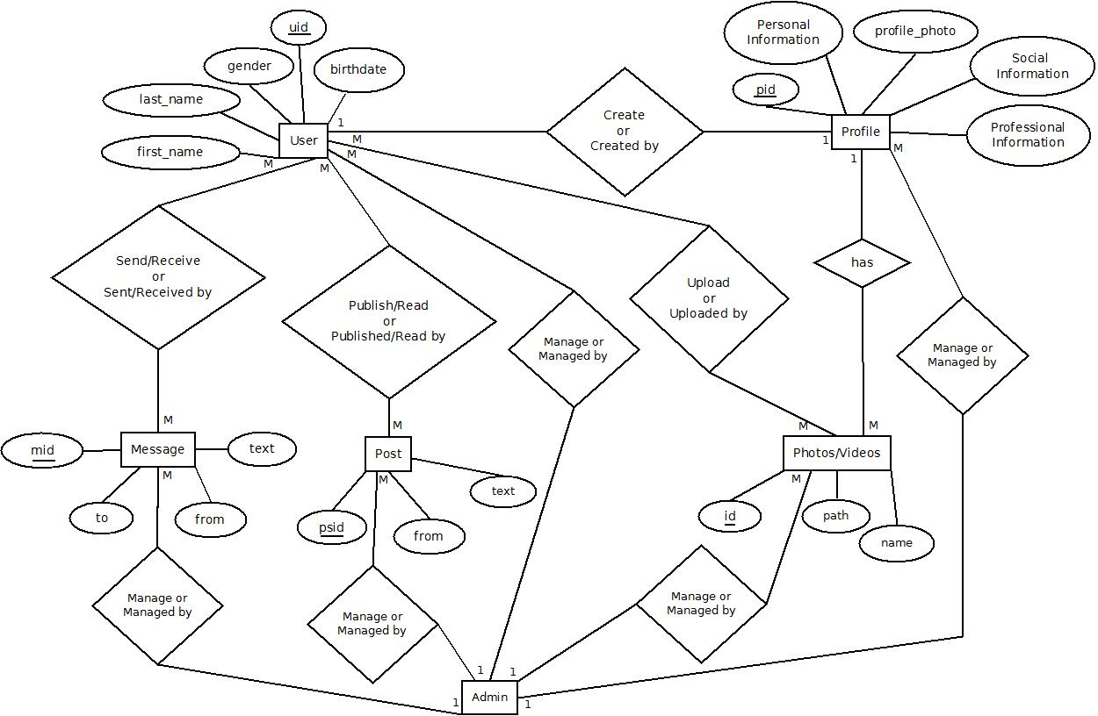
3.5 Data Dictionary:
Table: user
Description: This table is used to store essential information of user.
Field Name | Data Type | Length | Not Null? | P.K? | F.K? | Reference Table | Description
uid | INT | 11 | Y | Y | N | - | Unique ID of User
username | VARCHAR | 45 | Y | N | N | - | Username
password | VARCHAR | 45 | Y | N | N | - | Password
email | VARCHAR | 45 | Y | N | N | - | Email ID
first_name | VARCHAR | 45 | Y | N | N | - | First Name
last_name | VARCHAR | 45 | Y | N | N | - | Last Name
gender | VARCHAR | 6 | Y | N | N | - | Gender
birthdate | DATE | - | Y | N | N | - | Birthdate

Table: profile
Description: table is used to store profile of user.
Field Name | Data Type | Length | Not Null? | P.K? | F.K? | Reference Table | Description
pid | INT | 11 | Y | Y | N | - | Unique ID of Profile
uid | INT | 11 | Y | N | Y | user | Unique ID of User
photo | BOOL | - | N | N | N | - | Profile Photo of User
city | VARCHAR | 45 | N | N | N | - | City
hometown | VARCHAR | 45 | N | N | N | - | Hometown
languages | TEXT | - | N | N | N | - | Languages
aboutme | TEXT | - | N | N | N | - | About User
rl_status | VARCHAR | 45 | N | N | N | - | Relationship Status
employer | VARCHAR | 45 | N | N | N | - | Employer
college | VARCHAR | 45 | N | N | N | - | College/University
high_school | VARCHAR | 45 | N | N | N | - | High School
religion | VARCHAR | 45 | N | N | N | - | Religion
activities | VARCHAR | 45 | N | N | N | - | Activities
interests | TEXT | - | N | N | N | - | Interests

Table: message
Description: This table is used to store messages.
Field Name | Data Type | Length | Not Null? | P.K? | F.K? | Reference Table | Description
mid | INT | 11 | Y | Y | N | - | Unique ID of Message
uid_from | INT | 11 | Y | N | Y | user | Unique ID of User who sent message.
uid_to | IN | 11 | Y | N | Y | user | Unique ID of User whom message has been sent.
text | TEXT | - | - | N | N | - | Content of Message

Table: post
Description: This table is used to store posts published by any user.
Field Name | Data Type | Length | Not Null? | P.K? | F.K? | Reference Table | Description
psid | INT | 11 | Y | Y | N | - | Unique ID of Post
uid | INT | 11 | Y | N | Y | user | Unique ID of User who published the post.
text | TEXT | - | Y | N | N | - | Content of Post

Table: post_comment
Description: This table is used to store comments on post.
Field Name | Data Type | Length | Not Null? | P.K? | F.K? | Reference Table | Description
pscid | INT | 11 | Y | Y | N | - | Unique ID of Comment
psid | INT | 11 | Y | N | Y | post | Unique ID of Post
uid | INT | 11 | Y | N | Y | user | Unique ID of User
text | TEXT | - | Y | N | N | - | Content of Post

Table: media_album
Description: sThis table is used to store albums of photos.
Field Name | Data Type | Length | Not Null? | P.K? | F.K? | Reference Table | Description
mdaid | INT | 11 | Y | Y | N | - | Uniqu Album ID
uid | INT | 11 | Y | N | Y | user | Unique ID of User
name | VARCHAR | 45 | Y | N | N | - | Name of Album
cover | INT | 11 | N | N | Y | photo | Cover Photo of Album

Table: media
Description: This table is used to store videos.
Field Name | Data Type | Length | Not Null? | P.K? | F.K? | Reference Table | Description
mdid | INT | 11 | Y | Y | N | - | Unique ID of Video
mdaid | INT | 11 | Y | N | Y | video_album | Video Album ID
name | VARCHAR | 45 | N | N | N | - | Name of Video
path | VARCHAR | 100 | Y | N | N | - | Path of Video
type | CHAR | 1 | Y | N | N | - | Type of Media either Photo or Video

Table: media_comment
Description: This table is used to store comments on photo.
Field Name | Data Type | Length | Not Null? | P.K? | F.K? | Reference Table | Description
mdcid | INT | 11 | Y | Y | N | - | Unique ID of Comment
mdid | INT | 11 | Y | N | Y | media | Unique ID of Media
uid | INT | 11 | Y | N | Y | user | Unique ID of User
text | TEXT | - | Y | N | N | - | Content of Comment

Table: friendship
Description: This table is used to store friendship relation of users.
Field Name | Data Type | Length | Not Null? | P.K? | F.K? | Reference Table | Description
fid | INT | 11 | Y | Y | N | - | Unique Friendship ID
uid1 | INT | 11 | Y | N | Y | user | Unique ID of User
uid2 | INT | 11 | Y | N | Y | user | Unique ID of User

Table: friend_request
Description: This table is used to store friends requests.
Field Name | Data Type | Length | Not Null? | P.K? | F.K? | Reference Table | Description
frid | INT | 11 | Y | Y | N | - | Unique ID of Friend Request
uid_from | INT | 11 | Y | N | Y | user | Unique ID of User
uid_to | INT | 11 | Y | N | Y | user | Unique ID of User

Table: privacy
Description:This table is used to store privacy settings for user.
Field Name | Data Type | Length | Not Null? | P.K? | F.K? | Reference Table | Description
prid | INT | 11 | Y | Y | N | - | Unique Privacy ID
uid | INT | 11 | Y | N | Y | user | Unique ID of User
photos | VARCHAR | 45 | N | N | N | - | Photo Privacy
videos | VARCHAR | 45 | N | N | N | - | Video Privacy
posts | VARCHAR | 45 | N | N | N | - | Post Privacy
profile | VARCHAR | 45 | N | N | N | - | Profile Privacy
comments | VARCHAR | 45 | N | N | N | - | Comment Privacy
birthdate | VARCHAR | 45 | N | N | N | - | Birthdate Privacy
gender | VARCHAR | 45 | N | N | N | - | Gender Privacy

4. System Design
Index Page
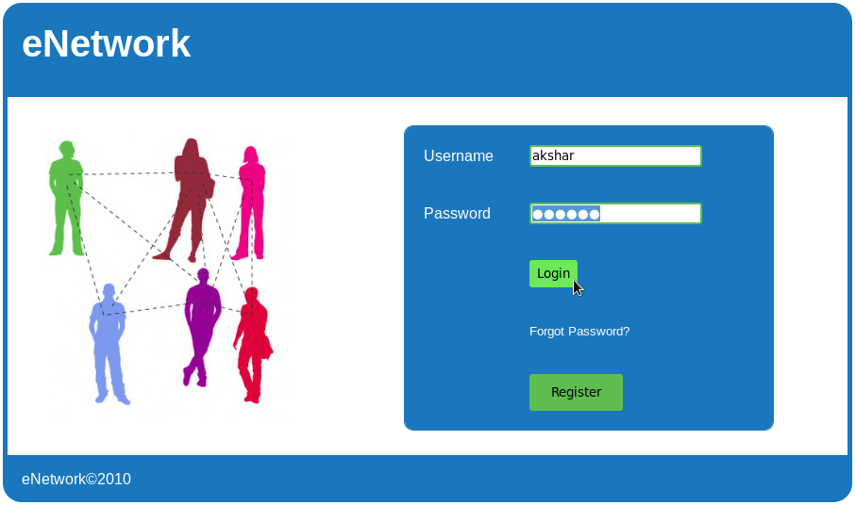
This is home page of eNetwork. Here user can enter username and password to login and register with eNetwork. Server side validation is performed on username and password.
Register Page
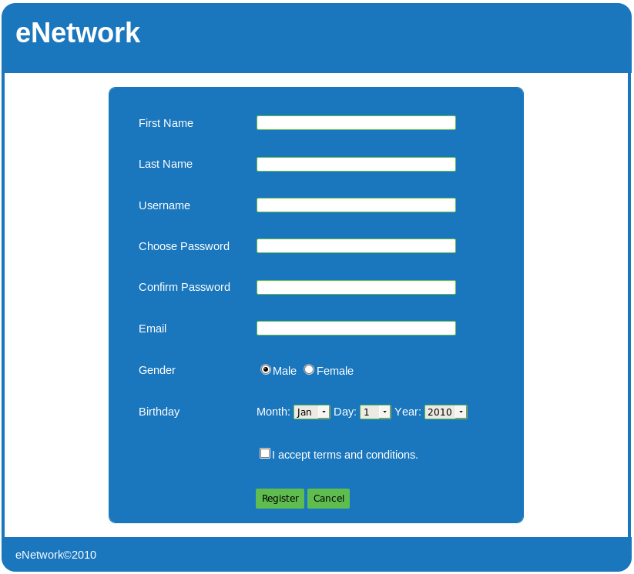
This page is used to register a user with eNetwork. Here username availability will be checked using AJAX.
Profile Photo Upload Page
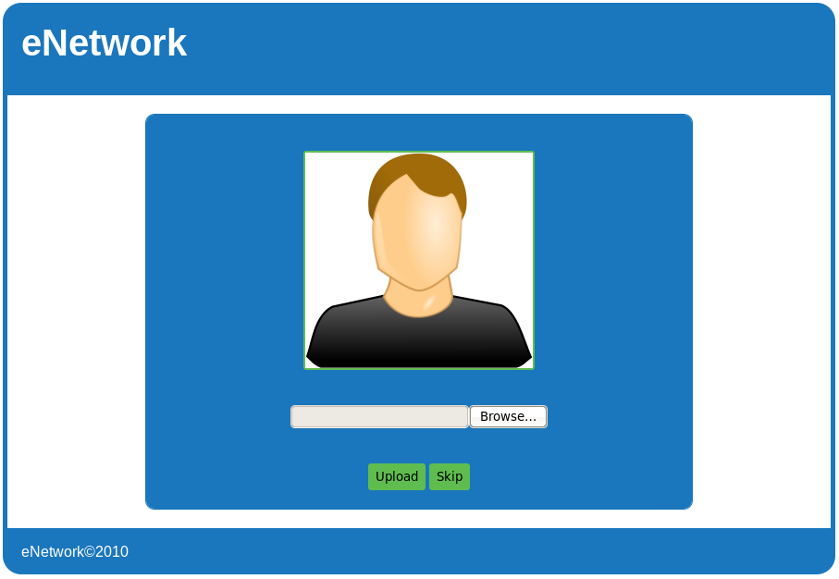
In this page user can upload a profile photo or skip this step and later, user can upload profile photo.
Add Profile Information Page
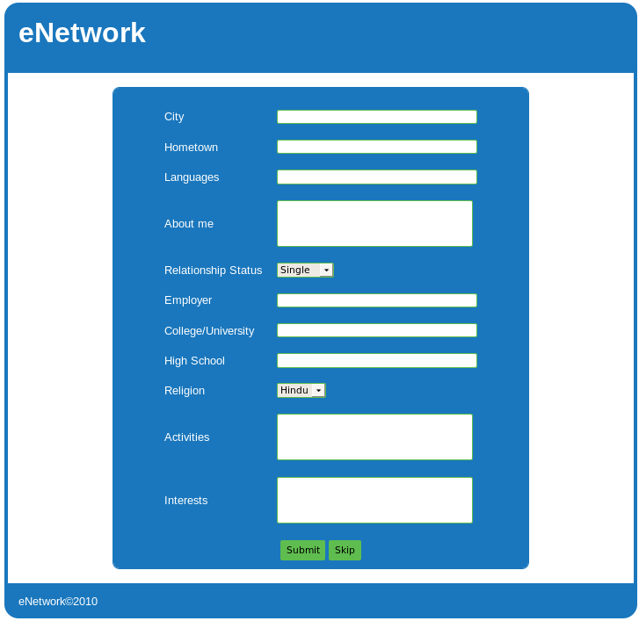
In this page user can enter profile information or skip this step and late can edit profile information.
Forgot Password Page
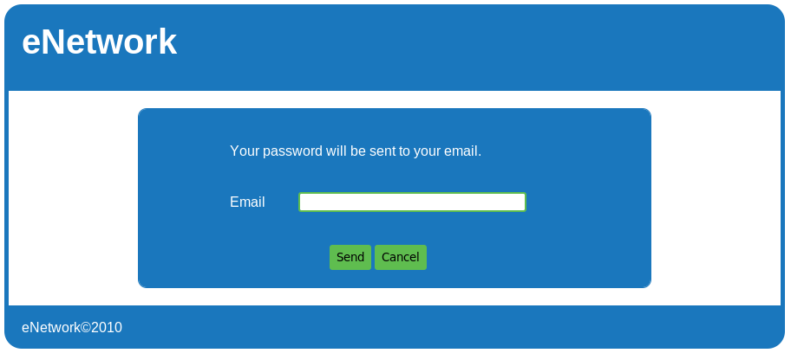
Here user has to enter valid email id and then user will have to reset password.
Home Page
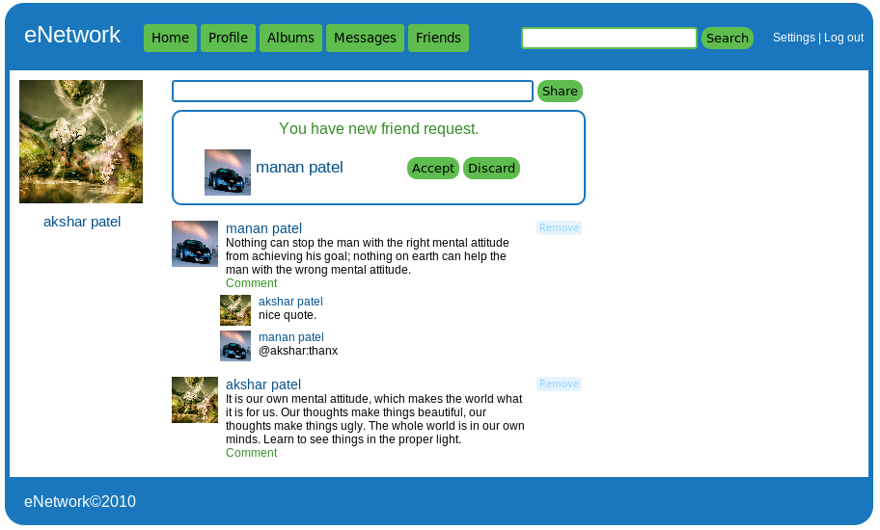
This is the home page after logging in into eNetwork. In this page user get notification about new friend requests and can accept or discard requests. Here, user can publish posts and can read posts published by friends. User can navigate among home, profile, albums, messsages, and friends. Here user can also search people by name and email id.
Profile Page
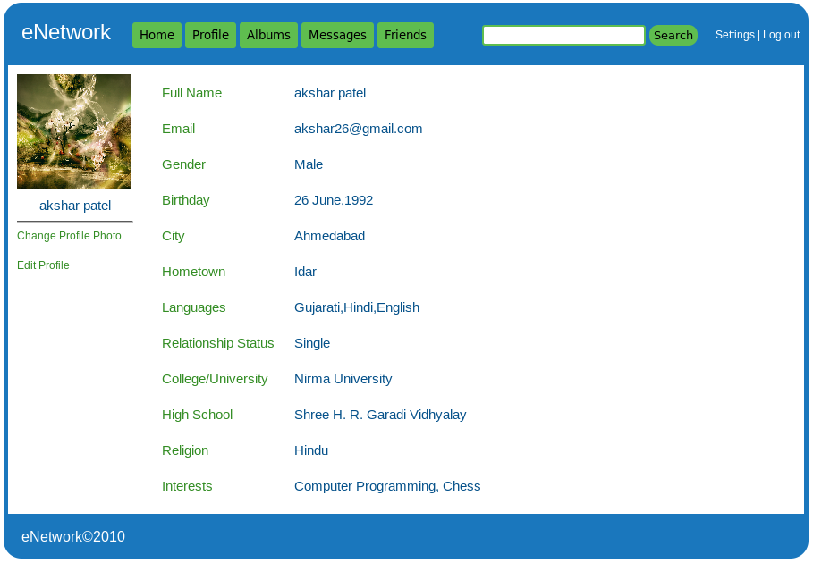
Here, user can see his/her profile information. User can edit profile photo. User can edit profile information.
Albums Page
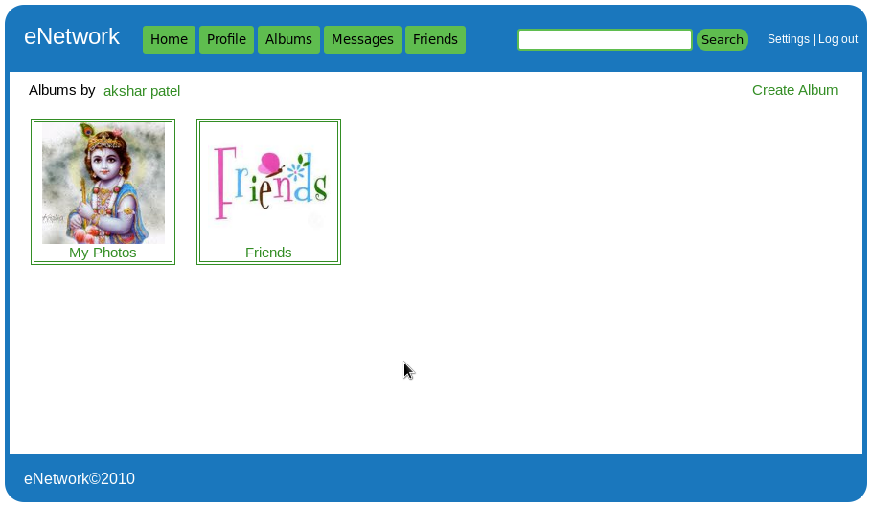
In this page, user can create new albums or see albums created by him/her. User can click on specific album and then photos/videos will be appeared to user.

5. Bibliography
Websites:
www.wikipedia.org
www.roseindia.net
www.stackoverflow.com
www.w3schools.com
www.jsptut.com
www.jsptutorial.net
Books:
Head First Servelets and JSP by O’REILLY Publication
Beginning with Java Sever Pages by WROX Publication

