CHAPTER - 4

SYSTEM ANALYSIS

4.1 STUDY OF CURRENT SYSTEM:

As current systems we studied following systems:

- Pen and Paper:
Most people use pen and paper for designing their schedules and goal setting. It is very easy but very inefficient too.

- To-do Application:
This is one of the most popular productivity application out there. It is simple and easy to use for most people, but it provides too basic functionalities.

- Calendar Application:
This is very popular for spanning the schedule over several but it cannot be used effectively for designing the routine for single day.

- Project Management System:
This is very heavy on features and resources. It is mainly focused on team work for large projects and cannot used for designing routines.

4.2 PROBLEMS AND WEAKNESSES OF CURRENT SYSTEM

Limitations of Pen and Paper:

- It cannot provide the recommendation to user.
- Modifying the information is not easy.
- It is not easy to manage.
- It does not remind about anything.
- It is not able to track the progress.
- All the work have to be performed manually.
- It is not environment friendly option.

Limitations of To-do Application:

- It cannot provide the recommendation to user.
- It has not direct feature to create routine.
- It cannot track the progress of any task.
- It cannot review the completed work daily.
- It provides only very basic features.
- It does not impose any time limit on any task.
- It does not provide any visual information.

Limitations of Calendar Application:

- It cannot provide the recommendation to user.
- Copying a routine is not easy.
- It cannot track the progress.
- It does not provide day review feature.
- It is not focused on a single day.
- It is little complex for novice user.
- It does not provide the functionality of templates.

Limitations of Project Management Application:

- It cannot provide the recommendation to user.
- It does not have functionality of managing the routines.
- It is not focused on single day.
- It is generally not used for personal productivity.
- It is generally focused on team productivity.
- It is very much complex for beginners.
- It is less flexible.

4.3 REQUIREMENTS FOR NEW SYSTEM:

This application is targeted any user who wants to improve the personal productivity by making better use of time and setting effective goals. The application intends to provide easy to use functionality even for beginners. To improve the personal productivity, the application is considering four aspects: routines, goals, progress, review.

Functional Requirements:

- Create routine easily.
- Create new routine by modifying the existing one.
- Associate activities of routine to goals to be achieved.
- Track the work progress.
- Review the completed work.

Non-functional requirements:

- Privacy of user's data
- Memory and Space efficiency
- Free and open source database management system suitable for mobile apps
- Mobile and tablet support
- Old version support (Android 2.3 or later)
- The system must be scalable enough to be able to add any additional functionality even after the application is developed once
- An error message is a control to make you aware that security has been circumvented or controls have been broken.

4.4 FEASIBILITY STUDY

- Technical Feasibility
This project is implemented using Android SDK that provided by Google. As it was easily available in any smart phone (featured android OS). It is very popular technology used by smart phones.

- Schedule Feasibility
Another important feature to be considered during the feasibility study was the time limit: 8 months. The main concern during the schedule feasibility was to cover the wide range of applications and facilities to be provided with the Application during such a short period of time.

- Operational Feasibility
This application may also be used by persons who don’t have in depth knowledge of the application developed. Care was taken so that the application is user-friendly to the maximum.

- Economic Feasibility
This feasibility is of the utmost importance when implementing or developing website. As Android SDK and SQLite Server are very easy for implementation, definitely project is economic.

- Implementation Feasibility
This application is developed in Eclipse (with Android SDK) /SQLite and is to be implemented in the same environment only. However to implement the application the user doesn’t need to have a complete knowledge of the technical features of this android OS. As a result the implementation of the software won’t pose any serious problems.

4.5 REQUIREMENT VALIDATION

- Requirements validation is concerned with showing that the requirements actually define the system which the user wants
- If any filed is compulsory and if that one is left blank then an error message will be displayed on that field.
- The system validate the all standard input form validations required to be done in name, date, time , etc.

Some of them described here:
1. Required data filed can’t filled blank there is an alert for it.
2. Display date and time must be in specific format.
3. Task must be written in specific formats.
4. User must select only one routine.
5. Name must be character not in digits.

4.6 FUNCTIONS OF SYSTEM

4.6.1 Use Case Diagram:
- Represent overall Scenario of the system.
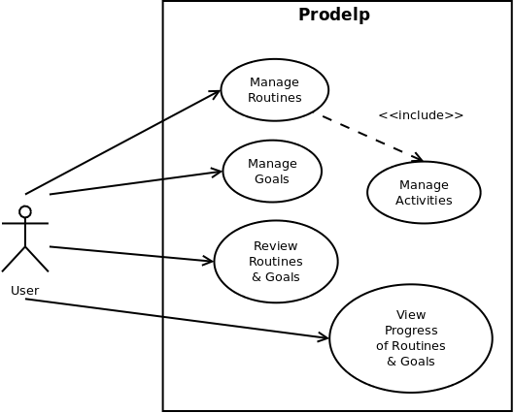
- A scenario is nothing but a sequence Steps declaring an interaction between User and System.

Fig. 4.1 Use Case Diagram

4.6.2 Sequence Diagram:

- It shows how to object interact with the other objects.

Sequence Diagram for Manage Routines:

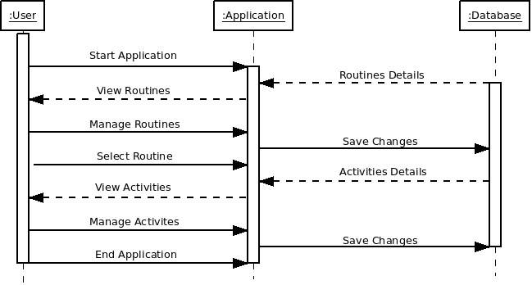
Fig. 4.2 Sequence Diagram for Manage Routines

Sequence Diagram for Manage Goals:

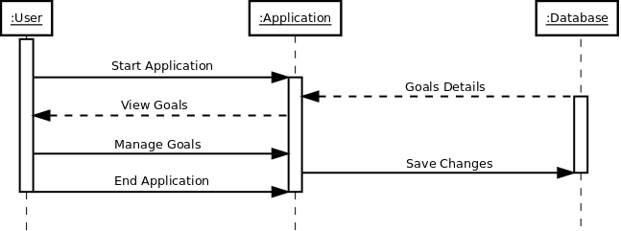
Fig. 4.3 Sequence Diagram for Manage Goals

Sequence Diagram for Review Routines and Goals:

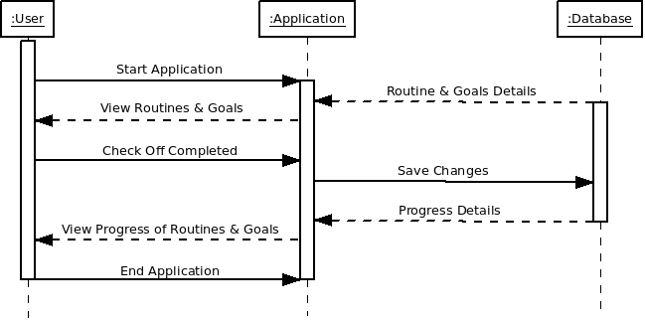
Fig. 4.4 Sequence Diagram for Review Routines and Goals

Sequence Diagram for View Progress of Routines and Goals:

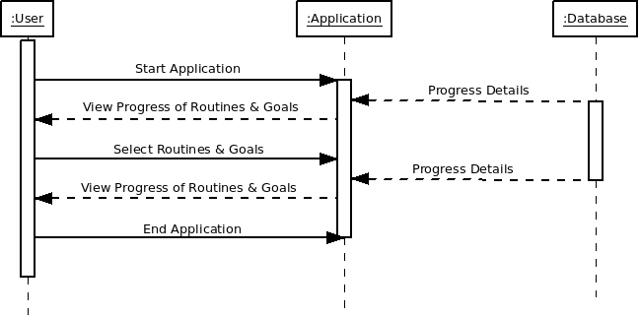
Fig. 4.5 Sequence Diagram for View Progress of Routines and Goals
4.7 DATA MODELLING

4.7.1 Class Diagram:
- Used to capture a Static view of system.
- Represent how to put various objects together.

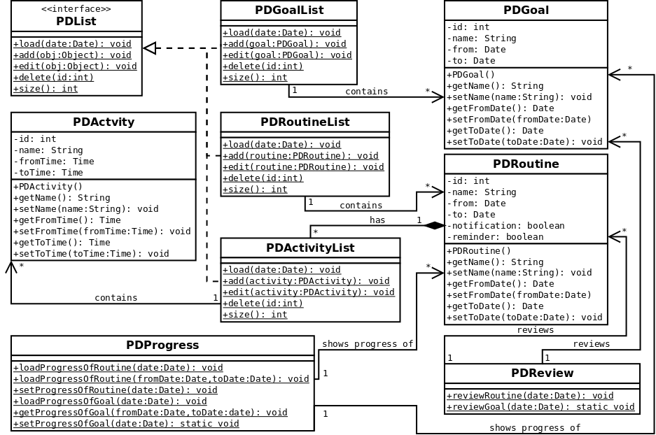
Fig. 4.6 Class Diagram
4.7.2 Activity Diagram:
Activity diagrams are graphical representations of work flows of stepwise activities and actions with support for choice, iteration and concurrency. In the Unified Modeling Language, activity diagrams can be used to describe the business and operational step-by- step work flows of components in a system. An activity diagram shows the overall flow of control.
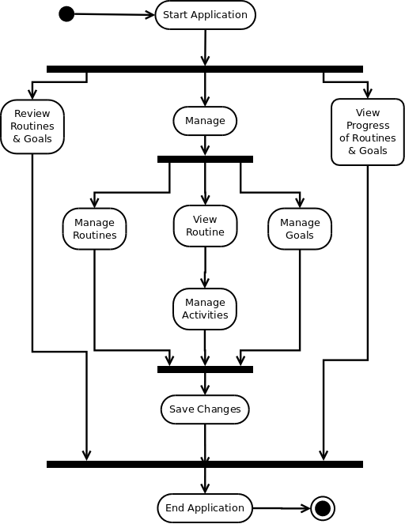
Fig. 4.7 Activity Diagram

4.8 FUNCTION AND BEHAVIOUR MODELLING

DFD Diagram:
• Used to model the information and function domain.
• Grater level helps the analyst to perform functional decomposition.

4.8.1 Data Flow Diagrams:

Contex Level DFD
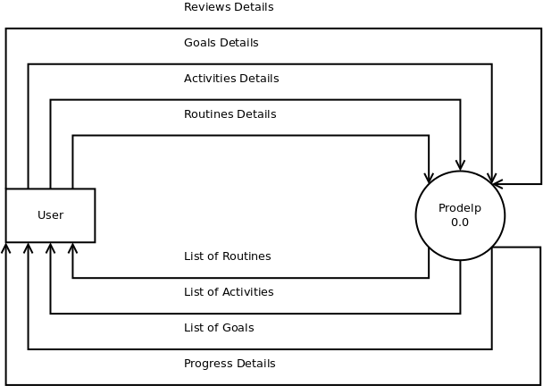
Fig. 4.8 Context Level DFD
First Level DFD

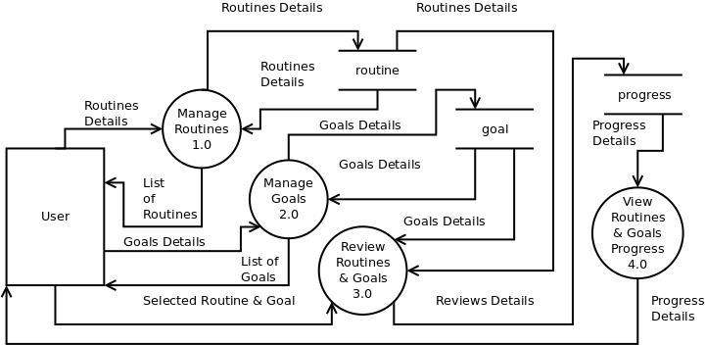
Fig. 4.9 First Level DFD
Second Level DFD of Manage Routines

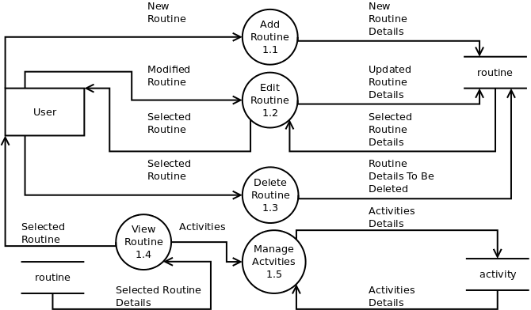
Fig. 4.10 Second Level DFD of Manage Routines
Second Level DFD of Manage Goals
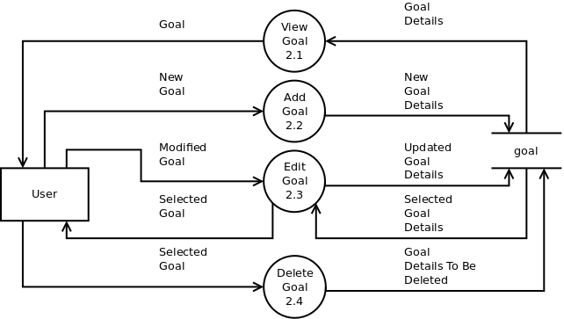
Fig. 4.11 Second Level DFD of Manage Goals

Third Level DFD of Manage Activities
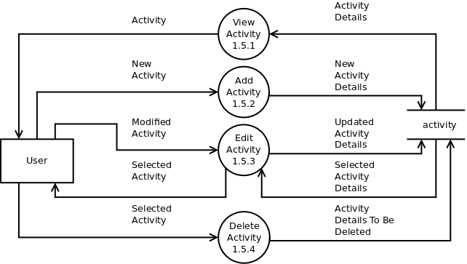
Fig. 4.12 Third Level DFD of Manage Activities
4.9 MAIN FUNCTIONS OF NEW SYSTEM

- Routines:
This module allows the user to view, add, edit and delete the routine. The user can create multiple routines for different days.
- Activities:
This module allows the user to view, add, edit and delete the activities of selected routine. Activities cannot exist without the routine.
- Goals:
This module allows the user to view, add, edit and delete the goals that need to be achieved by following defined routine.
- Review
This module is used for reviewing the day's work and user can check off what has been completed in specific routine for specific day.
- Progress
This module can be used for view the user's progress of efficiency for a day or over a period of several days.

4.10 SELECTION OF HARDWARE AND SOFTWARE JUSTIFICATION
_________________________________________________________________________________________________________________________________________________
- Hardware:
Hardware | Requirement | Justification
Android-based Mobile Phone | Android 4.0.3 or higher | Android 4.0.3 is an incremental release of the Android 4.x (Ice Cream Sandwich) platform family. This release includes new features for users and developers, API changes, and various bug fixes. There are only 6.8% device running older releases than 4.0.3. So we are targeting to support around 93% android mobile phones around the world.

- Software
Software | Requirement | Justification
Frond End | Java and XML | Java is used for writing the logic and XML is used for designing the user interface for the application in android.
Back End | SQLite | SQLite is lightweight database suitable for small application such as mobile application.

Table 4.1 Selection of Hardware and Software Justification

