CHAPTER - 5

SYSTEM DESIGN

5.1 DATABASE DESIGN

5.1.1 Table and Relationship:
- Data Dictionary
Routine Table:

Field Name | Data Type | Not  Null | Primary  Key | Foreign  Key | Reference  Table | Description
r_id | INTEGER | Y | Y | -- | -- | Unique ID  of Routine
r_name | TEXT | N | N | -- | -- | Name of Routine
r_fromDate | TEXT | N | N | -- | -- | Routine Start Date
r_toDate | TEXT | N | N | -- | -- | Routine End Date

Table 5.1 Routine Table
Activity Table:

Field Name | Data Type | Not  Null | Primary  Key | Foreign  Key | Reference  Table | Description
a_id | INTEGER | Y | Y | -- | -- | Unique ID  of Activity
a_name | TEXT | N | N | -- | -- | Name of Activity
a_fromTime | TEXT | N | N | -- | -- | Activity Start Time
a_toTime | TEXT | N | N | -- | -- | Activity End Time
r_id | INTEGER | Y | N | Y | routine | Routine ID

Table 5.2 Activity Table

Goal Table:

Field Name | Data Type | Not  Null | Primary  Key | Foreign  Key | Reference  Table | Description
g_id | INTEGER | Y | Y | -- | -- | Unique ID  of Goal
g_name | TEXT | N | N | -- | -- | Name of Goal
g_fromDate | TEXT | N | N | -- | -- | Goal Start Date
g_toDate | TEXT | N | N | -- | -- | Goal End Date

Table 5.3 Goal Table

Progress Table:

Field Name | Data Type | Not  Null | Primary  Key | Foreign  Key | Reference  Table | Description
p_id | INTEGER | Y | Y | -- | -- | Unique ID  of Progress
p_date | TEXT | N | N | -- | -- | Date of Review
p_rate | TEXT | N | N | -- | -- | Calculated  Progress Percentage

Table 5.4 Progress Table
5.1.2 Logical Description of Data:

5.1.2.1 E-R Diagrams:

- Used to Relationship pair can represented by graphically.
- Used in Database application but most commonly used in Data Design.

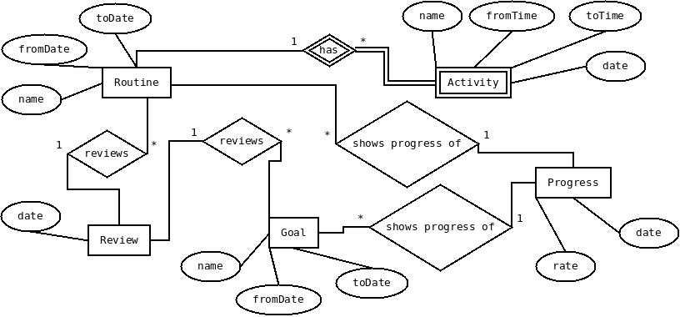

Fig. 5.1 E-R Diagram
5.2 ACCESS CONTROL AND SECURITY

The user is only one who uses the application on his mobile for his personal purpose. The application does not require user to log into system. Therefore, there are no any access control mechanisms are defined in the application.

The application provides the adequate level of security to make sure that user's private date is not compromised by means of network operations in the application. The application takes the advantage of security features already available in Android Platform.

5.3 SYSTEM ARCHITECTURE DESIGN

Model-View-Controller (MVC) is a software architecture architectural pattern. The model is the data, the view is the window on the screen, and the controller is the glue between the two taking the data and presenting that to the view .

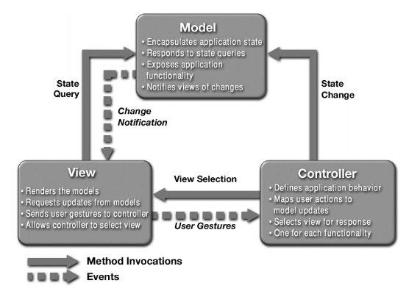
Fig. 5.2 MVC Architecture

- Model

  - Manages the app data and state
  - Not concerned with UI or presentation
  - Often persists somewhere
  - Same model should be reusable, unchanged in different interfaces

- View

  - Present the Model to the user in an appropriate interface
  - Allows user to manipulate data
  - Does not store any data except to cache state
  - Easily reusable & configurable to display different data

- Controller

  - Intermediary between Model & View
  - Updates the view when the model changes
  - Updates the model when the user manipulates the view
  - Typically where the app logic lives

Model View Controller (MVC) Pattern in Android architecture

Models: Content Providers.
Data Managers that are the recommended form of inter-application data sharing.
Views: Activities.
This is the application's primary user interface component. Every individual screen of an Android application is derived from the Activity Java class (android.app.Activity).
They are containers for Views (android.view.View).
Controllers: Services.
These are background components that behave like UNIX daemons and Windows services. They run invisibly and perform ongoing unattended processing.

5.4 OBSERVATION MATRIX CANVAS

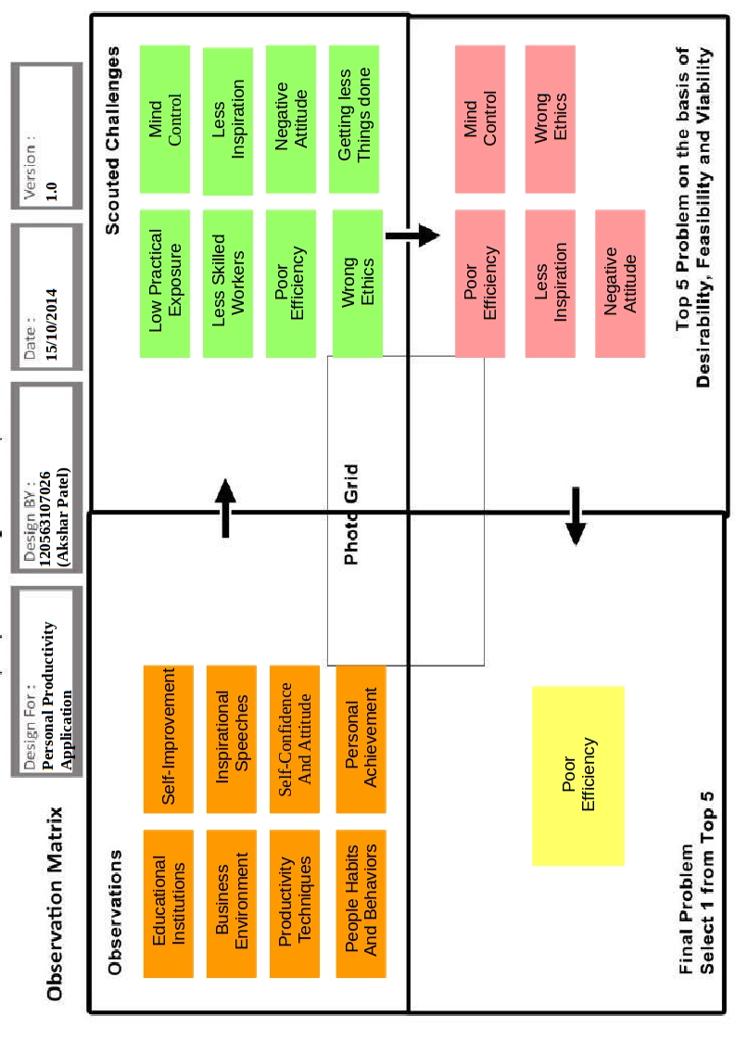
Fig. 5.3 Observation Matrix Canvas
Observations:

In observations part, we have to view users and their behavior in the context of their lives.

In our project we took observation from the followings:

- Educational Institutions
- Business Environment
- Productivity Techniques
- People Habits and Behaviors
- Self-Improvement
- Inspirational Speeches
- Self-Confidence and Attitude
- Personal Achievements

Scouted Challenges:

By making the observation as in Observations part, we can identify what are the challenges users are facing.

In our project we listed our following challenges:

- Low Practical Exposure
- Less-skilled Workers
- Poor Efficiency
- Wrong Ethics
- Mind Control
- Less Inspiration
- Negative Attitude
- Getting less things done

Top 5 Problems:

In this part, from the listed challenges we identify the top 5 important problems to be solved.

In our project, we identified top 5 problems which are as follows:

- Poor Efficiency
- Wrong Ethics
- Mind Control
- Less Inspiration
- Negative Attitude

Final Problem:

In this part, from the top 5 problems, we identify the most important problem to be solved first.

In our project, we identified the most important problem to be Poor Efficiency.

As poor efficiency of any person can lead to many different problems such as low self-esteem , poor performance, less desire for work, less inspiration, getting less things done and many other problems. So solving this problem is very important. Although, the problem of poor efficiency seems very small but if it can be solved in a proper way, it can make dramatic changes in personal life of any person.
5.5 IDEATION CANVAS

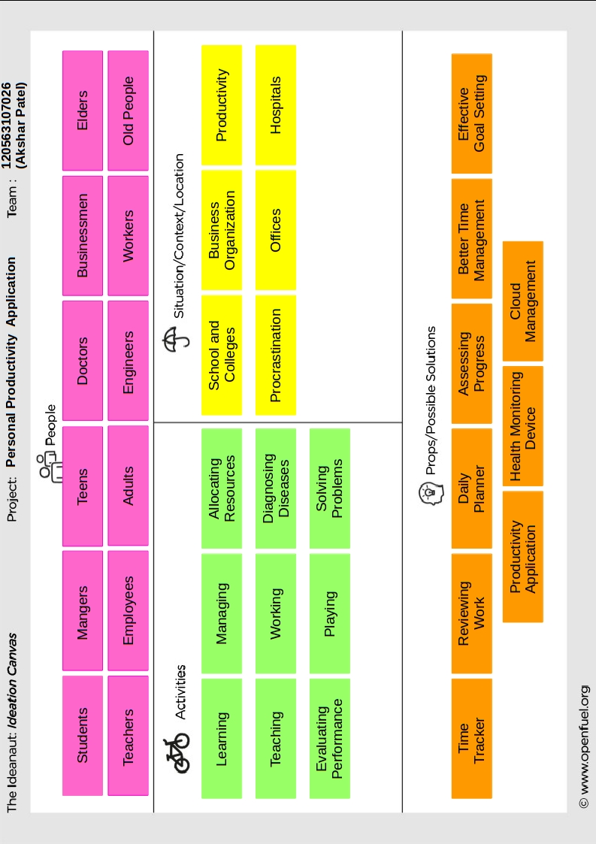
Fig. 5.4 Ideation Canvas
People:
In this part, we define the different people for whom we are interested to solve the problems. We can segment them into various groups on the basis of their profession e.g. Teachers, doctors, athletes. Similarly segment them on the basis of their age, income and other characteristics.
In our project, we have considered following people:
- Students | - Doctors
- Teachers | - Engineers
- Managers | - Businessmen
- Employees | - Workers
- Teens | - Elders
- Adults | - Old People

Activities:
In this part, we write down whatever every segment of people do. We make the list, as long as possible- for example teachers: teach, take attendance, prepare class notes, prepare presentations, grade students, evaluate answer sheets and prepare question papers. Similarly; Shoppers, window shop, compare prices, visit stores, return defective goods, claim warranty etc.
In our project, we defined following activities:
- Learning | - Allocating Resources
- Teaching | - Diagnosing Diseases
- Working | - Solving Problems
- Playing | - Managing

Situation/Context/Location:
Every above mentioned activity can be done in a different situation, location or context. For shopping- prices can be compared online or offline. The location for shopping can be a mall with many available brands or a street shop. Sometimes we could be buying clothes for ourself and at times for gifting – which depicts different contexts. For a teacher – evaluation can be of either subjective or objective papers. At other times it could be of project reports. Evaluation can be either paper/document based or for continuous class behavior which depicts different contexts.
In our project, we considered following situations/contexts/locations:
- School and Colleges | - Procrastination
- Business Organization | - Offices
- Productivity | - Hospitals
Props/Possible Solutions:
In this part we note down the objects, technologies or solutions which may be possible outcomes to our idea/challenge. The prop need not be related as it’s always randomness that helps in finding new ideas. Consider an example where we are thinking about teachers and throw in a random solution like chemical reagent. Here as mentioned above the randomness in ideas can be implemented. Adding up People: Teacher > Activity: Evaluation > Situation: Subjective answer sheets; to the chemical reagent gives us a special pen based on acidity that makes the teacher comments tamper proof.
In our project, we identified following props:
- Time Tracker | - Better Time Management
- Reviewing Work | - Effective Goal Setting
- Daily Planner | - Cloud Management
- Assessing Progress | - Health Monitoring Device

5.6 PRODUCT DEVELOPMENT CANVAS

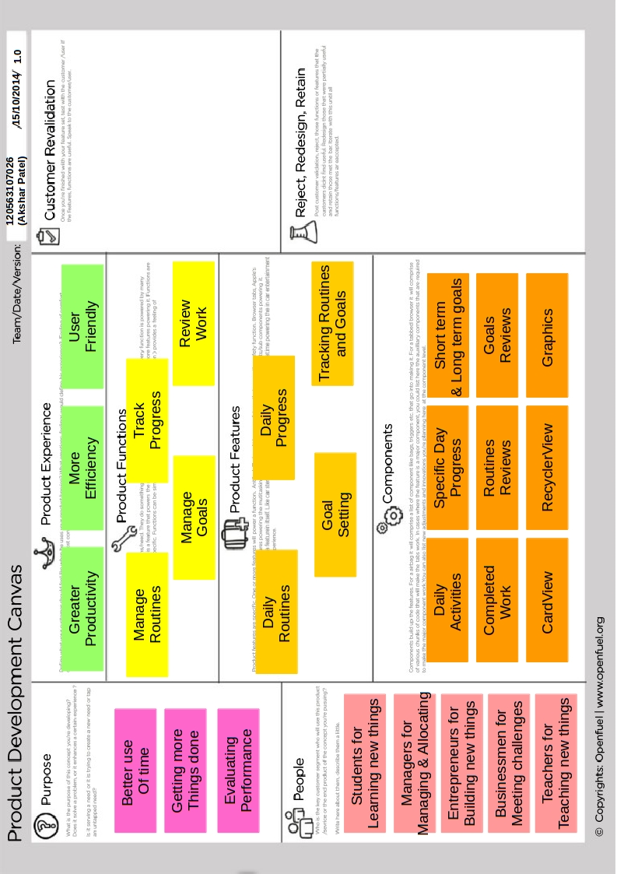
Fig. 5.5 Product Development Canvas
Purpose:
The section would answer the following questions: What is the broad purpose of our product? What problem sector we want to target broadly or specifically? For e.g. we may want to target transport sector or we may want to come up with options for Healthier foods. If we already have a specific purpose, then go ahead with it. Like solving the problem of measuring footfalls in a retail store or measuring consumer interest in specific products on retail shelves.
The main purposes of our project are as follows:
- Better use of Time
- Getting More Things Done
- Evaluating Performance
People:
In this part, we make the segment more focused. We note down the kind of people we have in mind while developing the product and also the people for whom we are resolving the problem.
In our project, we focused on following people:
- Students for Learning new things
- Managers for Managing and Allocating
- Entrepreneurs for Building new things
- Businessmen for Meeting challenges
- Teachers for Teaching new things
Product Experience:
In this part, we focus in depth on how the customer feels for our product/service concept. We mention every kind of experience we would want our user to feel, enjoy or avail. we also make a list of all user problems you want to address and how user feels about each of his problems.
In our project, we want the user have following experiences:
- Greater Productivity
- More Efficiency
- User Friendly
Product Functions:
In this part, we define the product functions deliver the product experience. We convert the product experience into functions for our product/service. What functions our product should perform to meet the customer experience we have just identified in product experience? Mostly the user experience/needs will be our product functions. e.g. if we want our users to feel comfortable & maintain right body posture while sitting on a chair, function provided must be comfortable sitting and healthy posture. If we are developing software, user requirement for faster experience would mean that faster working will be a function of our product.
In our project, we have identified following major product functions:
- Manage Routines
- Track Progress
- Manage Goals
- Review Work
Product Features/Components:
Features power the product functions. We find product features that will deliver the product functions we have identified. For a comfortable chair, ergonomic design would be one feature; footrest or armrest could be more. And how about a mobile or a cup holder? Multiple product features could lead to the same function. Features could also be components. Like arm-rest, neck rest or footrest. A faster algorithm could be a feature powering the speed performance of software.
In our project, we have found out following features:
- Daily Routines
- Goal Setting
- Daily Progress
- Tracking Routines and Goals
In our project, we have following major components:
- Daily Activities
- Completed Work
- CardView
- RecyclerView
- Graphics
- Specific Day Progress
- Routines Reviews
- Goals Reviews
- Short term and long term goals

