CHAPTER - 6

IMPLEMENTATION AND TESTING

6.1 IMPLEMENTATION ENVIRONMENT

The application is a mobile application for android. So it does not require any specific implementation environment. It requires only android operating system based mobile phone with android version 4.0.3 or higher. The Internet connectivity is optional and application works just fine even without the Internet. Internet is required only if the user wants to have the feature of auto recommendations.

6.2 SECURITY FEATURES

There are not any special security required for application. The application accesses Internet only after having the permission from user while installing the application and it does not violet any security rules as defined Google for Android Platform application development.

6.3 CODING STANDARDS

Where coding conventions have been specifically designed to produce high-quality code, and have then been formally adopted, they then become coding standards. Specific styles, irrespective of whether they are commonly adopted, do not automatically produce good quality code. It is only if they are designed to produce good quality code that they actually result in good quality code being produced, i.e., they must be very logical in every aspect of their design - every aspect justified and resulting in quality code being produced.
Good procedures, good methodology and good coding standards can be used to drive a project such that the quality is maximized and the overall development time and development and maintenance cost is minimized.

6.3 TESTING

Testing involves operation of a system or application under controlled conditions and evaluating the results. The controlled conditions should include both normal and abnormal conditions. Testing should intentionally attempt to make things go wrong to determine if things happen when they don’t happen when they should. It is oriented to “detection‟.
When a system is developed, it hopes that it performs properly. In practice, however some errors always occur. The main purpose of testing an information system is to find the errors and correct them.
- To ensure system will perform as per specification
- Ensure system meets the user requirement
- Verify if control function as intended
- To make sure incorrect inputs, incorrect processing and incorrect outputs (if any)
- will be detected during operation
- Should include both computer based and manual operation
The different types of testing are.
1. Unit Testing
The first level of testing is called as Unit testing. Here the different modules are tested and the specifications produced during design for the modules .Unit Testing is essential for verification of the goal and to test the internal logic of the modules .Unit testing was conducted to the different modules of the project. Errors were noted down and corrected down immediately and the program clarity as increased. The testing was carried out during the programming stage itself. In this step each module is found to be working satisfactory as regard to the expected output from the module.
2. Integration Testing
The second level of testing includes integration testing. It is a systematic testing of constructing structure. At the same time tests are conducted to uncover errors associated with the interface. It need not be the case, that software whose modules when run individually and showing perfect results will also perfect results when run as a whole. The individual modules are tested again and the results are verified. The goal is to see if the modules can be integrated between modules. Poor interfacing may result in data being lost across an interface causing serious problems. This testing activity can be considered as testing the design and emphasizes on testing modules interactions.
3. Validation Testing
The next level of testing is validation testing. Here the entire software is tested. The reference document for this process is the requirement and the goal is to see if the software meets its requirements. The requirement document reflects and determines whether the software functions the user expected. At the culmination of the integration testing, software is completely assembled as a package, interfacing and corrected and a final series of software test and validation test begins. The proposed system under construction has been tested by Using validation testing and found to be working satisfactory.
4. Output testing
The output of the software should be acceptable to the system user. The output requirements are defined during the system analysis .Testing of the software system id done against the output requirements and the output testing was completed with success.
5. User acceptance system
An acceptance test has the objective of selling the user on the validity and reliability of the system. It verifies that the systems procedures operate to system specification and make the integrity of vital data is maintained.
6. Performance Testing
This project is a system-based project, and the modules are interdependent with the other modules, so the testing cannot be done module by module. So the unit testing is not possible in the case of this driver. So this system is checked only with their performance to check their quality. In case of the Unit testing the initialization module is first tested. Since read module and the write module is interdependent the performance testing is done only after the final phase of coding.
6.1 USER INTERFACE DESING

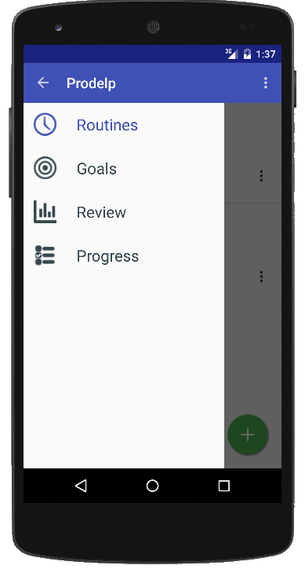

Fig. 6.1 Navigation Drawer Screen

Description: It is used to navigate through different modules.

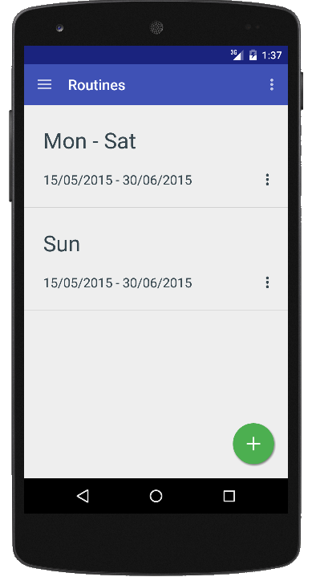

Fig. 6.2 Routines Screen

Description: It is used to view and manage routines.

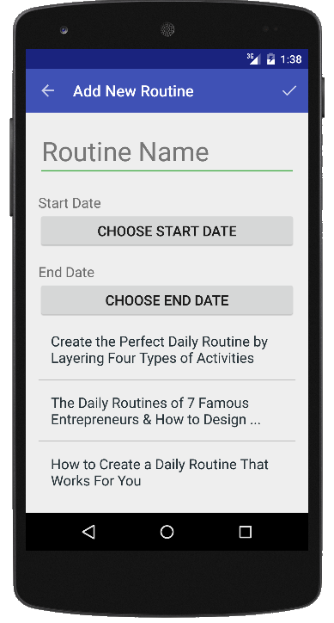

Fig. 6.3 Add New Routine Screen

Description: It is used to add new routine

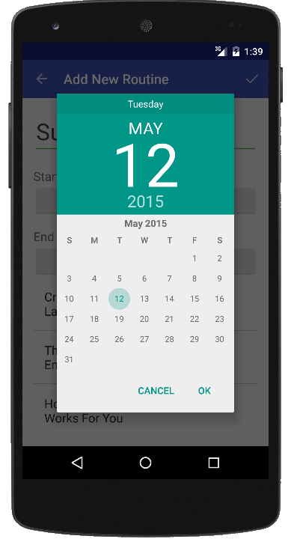

Fig. 6.4 Add New Routine Date Picker Screen

Description: It is used to pick the dates for routine.

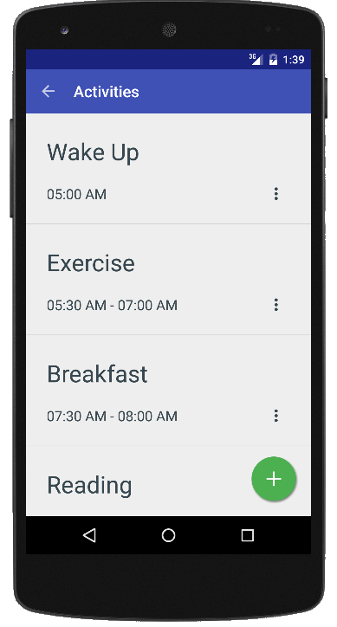

Fig. 6.5 Activities Screen

Description: It is used to view and manage activities.

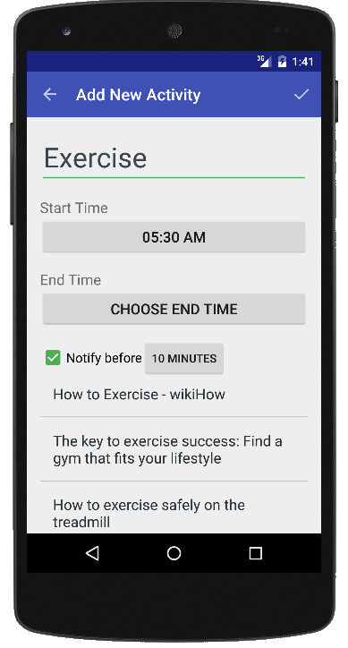

Fig. 6.6 Add New Activity Screen

Description: It is used to add new activity.

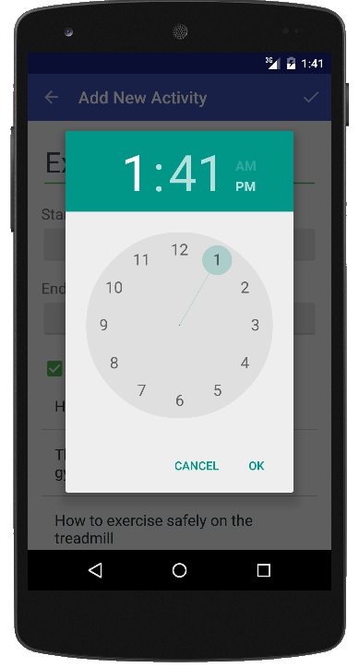

Fig. 6.7 Add New Activity Time Picker Screen

Description: It is used to pick time for activity.

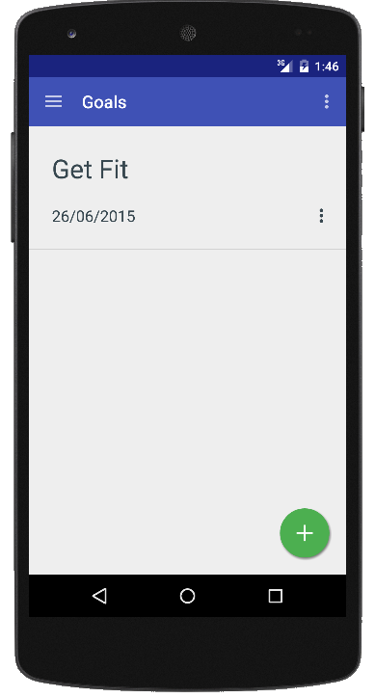

Fig. 6.8 Goals Screen

Description: It is used to view and manage goals.

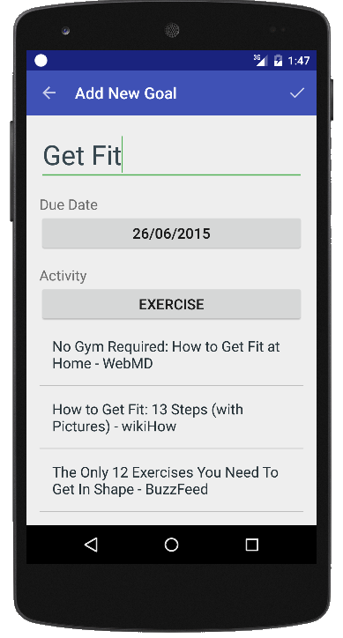

Fig. 6.9 Add Goal Screen

Description: It is used to add new goal.

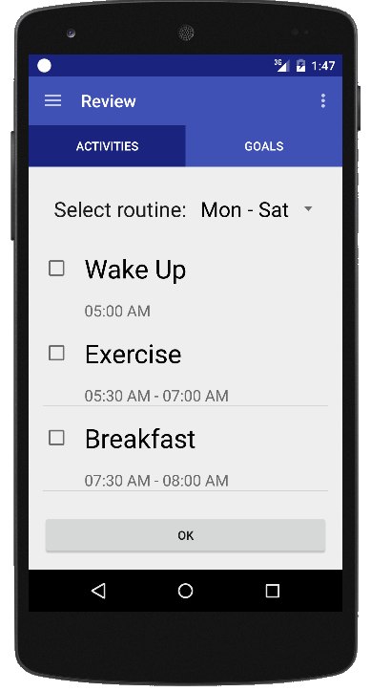

Fig. 6.10 Review

Description: It is used to review the activities.

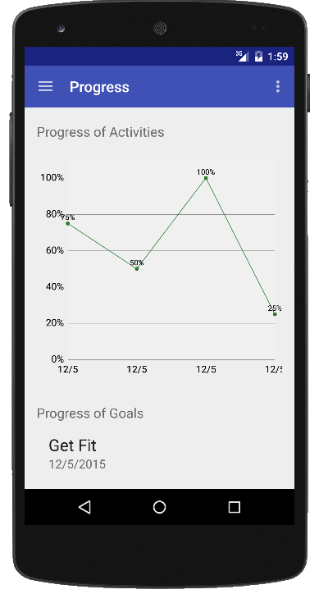

Fig. 6.11 Progress Screen

Description: It is used to view the progress.

