WAVELET AND HILBERT TRANSFORM BASED FEATURE EXTRACTION AND CLASSIFICATION

Gopal Krishan Goyal, B.E CSE (AIML) Chandigarh University [Gopalgoyal770@gmail.com](mailto:Gopalgoyal770@gmail.com)

Chandraksh Narayan, B.E CSE (AIML) Chandigarh University [Chandraksh03@gmail.com](mailto:Chandraksh03@gmail.com)

Aryan Bharat Kumar, BE CSE (AIML) Chandigarh University [ar22073yan@gmail.com](mailto:ar22073yan@gmail.com)

Deshaveni Akshar Rao, B.E CSE (AIML) Chandigarh University [**aksharraodeshaveni2004@gmail.com**](mailto:aksharraodeshaveni2004@gmail.com)

# **ABSTRACT**

**This study investigated the efficacy of machine learning models in classifying human emotions (positive, neutral, negative) using EEG brainwave data. An openly available dataset containing EEG recordings from two individuals was employed. The data underwent signal transformation methods like Wavelet and Hilbert transforms. Different machine learning models were then trained and tested on the pre-processed data to classify emotions. The classification accuracy of 95.04% was achieved using Light Gradient Boosting Machine on the approximation coefficients obtained through Wavelet transformation. Similarly, employing a K-Nearest Neighbors Classifier on Hilbert transformed data yielded an accuracy of 95.44%. Combining both Wavelet and Hilbert transformations with K-Nearest Neighbors Classifier resulted in an accuracy of 95.31%. These findings suggest the potential of machine learning coupled with appropriate signal processing techniques for emotion recognition using EEG data.**

*Keywords— EEG (Electroencephalography) Signal, Sentiment Analysis, Feature Extraction, Wavelet Transformation, Hilbert Transformation.*

# **INTRODUCTION**

In the field of Sentiment analysis, automated processes of understanding and classifying emotions and opinions are used. It has become a cornerstone of modern data analysis. It plays an important role in a way to gauge public opinion, understanding human emotion, and even monitoring mental health. Traditionally, sentiment analysis has made use of modalities such as text, voice, and facial expressions with the help of techniques like Natural Language Processing (NLP) that analyse textual data to understand and extract sentiments, Facial Recognition that involve reading and analysing facial expressions and patterns[1][2]. However, these methods are susceptible to conscious manipulation or misinterpretation thus reducing the accuracy of deductions made. The main focus of sentiment analysis has been on identifying emotions in written form, spoken language or from facial expressions, which are subjective person to person thus prone to bias[3]. However, recent advancements in research and technology have paved the

way for more objective and scientific emotion detection methods. One promising approach involves studying and analysing electrical and magnetic signals generated within the brain itself, such as electroencephalography (EEG) signals [4]. Unlike traditional methods that rely on subjective interpretations, EEG offers a more direct and objective way by studying brain activity, supported by mathematical methods. EEG measures the electrical activity of the brain by using non-invasive electrodes placed on the scalp. These electrodes detect even the tiny voltage fluctuations produced by the synchronized electrical signal firing of large groups of neurons. Then these EEG signal data is analysed to identify patterns and measure frequencies changes, these results can be further used to study cognitive activity including the emotion that person may be experiencing at that point of time. For instance, specific EEG signal patterns have been associated with distinct emotional states. For example, increased activity in the frontal lobe is often associated with positive emotions like happiness, on the other hand, activity in the amygdala is linked to negative emotions like fear.

By analysing EEG signals, this paper aims to understand and classify positive and negative emotional experiences, such as happiness, sadness, stress, or excitement. While other physiological signals like heart rate and skin conductance can also indicate emotional arousal, EEG offers a more direct window into brain activity, potentially revealing nuanced emotional states. However, analysing EEG signals presents challenges due to their inherit complexity, randomness, noise due to passive brain signals and non-stationary nature EEG signals. Therefore, we require advance signal processing techniques such as mathematical wave transformation that are well-suited for analysing non-stationary data and capturing the subtle and dynamic features associated with emotional responses. Fourier, Hilbert and Wavelet based transformation are few to name. Traditional methods like Fourier Transform struggle with these characteristics, often missing important dynamic features while performing wave transformation [5]. To address these limitations, this research explores the use of wavelet and Hilbert transforms for feature extraction from EEG signals. The wavelet transform excels at capturing both global and local changes in frequency by analysing the signal at multiple resolutions, by virtue of decomposing a signal into its constituent constituents and scrutinizing its time-frequency attributes, these transforms facilitate the extraction of pertinent features encapsulating salient signal characteristics. The Hilbert transform, on the other hand, facilitates the extraction of the instantaneous frequency of a signal, rendering it apt for analysing non-stationary signals. By applying these advanced techniques of Hilbert and Wavelet based transformation, this study aims to classify emotional experiences based on EEG data. The extracted features will be used to train and evaluate various classification algorithms and compare their accuracies for better sentiment analysis.

# **BACKGROUND**

Traditionally, the focus of sentiment analysis has been on identifying emotions in written or spoken language. However, a brand-new area of research in the study of emotions is emerging: the examination of physiological signals like the Electrocardiogram (EEG) [4]. This technique holds great potential for a variety of applications, including human-computer interaction, healthcare monitoring, and marketing research. However, there are a number of challenges to be solved before it is possible to accurately extract emotional signals from EEG data.

Modest Emotional Impact: Emotions can influence EEG characteristics subtly, even when they obviously affect brain nerves. Variables like brain nerve variability (BNV) [4], amplitude variations, and certain waveform patterns can all be indicators of emotional states. However, in order to obtain these tiny hints [7], complex signal-processing techniques are required.

Examining EEG-based sentiment analysis with HT and WT offers fascinating chances to get knowledge about emotions [3]. Following are the benefits in this research field:

* Proof of Concept: Previous studies have demonstrated that sentiment categorization tasks may be achieved using HT and WT parameters extracted from EEG signals. It is feasible to discern between basic emotional states like positive, negative, and neutral, as research has shown.
* Methods for Features Extraction: Scholars have explored a range of feature extraction methods with HT and WT [8]. This entails taking instantaneous information (such as phase and amplitude) from HT and using WT to assess wavelet coefficients at certain decomposition stages. These methods provide valuable insights into the relationship between emotional states and EEG characteristics.
* Combining HT and WT with Machine Learning Algorithms Features: The results of integration can be promising. Practical applications can be made feasible by training models on features extracted from EEG signals, which enables automated emotion classification.

There have been researches made in this sector, i.e., analysing EEG signals. In 2014, research paper named ‘Human Emotion Recognition using EEG signal’ got 94.7% accuracy by using Signal decomposition by Empirical mode decomposition, Feature vector composed using Hilbert- Huang transform, classification by multi class SVM. Similar Research was published in 2018 named ‘Empirical mode decomposition (EMD) and discrete Fourier transform’ got accuracy of 87.5% by Signal decomposition using digital filters, feature extraction with methods like EMD, Hilbert Transform, or Discrete Wavelet Transform (DWT), classification with SVMs.

**Table 1: Related works in Sentiment analysis using EEG signals. Ref. [9] – [15]**

|  |  |  |  |
| --- | --- | --- | --- |
| **S. No** | **Name of the Method** | **Author(s)** | **Recognition Rate** |
| 1. | Empirical mode decomposition (EMD) and discrete Fourier transform (2013) | Paithane | 52% |
| 2. | Supervised dimensionality reduction (2017) | Minigmin Zhao, Fadell Adib, Dina Katabi | 66.1(arousal) 64.1(valence) |
| 3. | Frequency Domain Features and Support Vector Machines (2011) | Ferdinando, Hany Se”anen, Tapio Alasaarela, Esko | 66.51 % |
| 4. | Combination of Spatial Filtering and Wavelet (2010) | Y. Liu, C. Wu, Y. Kao, Y. Chen | 83.04 % |
| 5. | Kernel Eigen-Emotion Pattern and Adaptive Support Vector Machine (2013) | Suwicha Jirayucharoensak, Setha Pan-Ngum, and Pasin Israsena | 73.42-80 % |
| 6. | Higher order Crossings method (2010) | Tauseef Sohaib, Ahmad Qureshi, Shahnawaz Hagelb¨ack, Johan Hilborn, Olle Jerˇci´c, Petar | 83.3% |
| 7. | Human Emotion Recognition using Electro-cardiogram Signals (2014) | M, Muruga an Khairunizam, Wan Yaacob, Sazali Selvaraj, Jerritta | 57.5% |
| 8. | Support Vector Machine and Linear Dynamic System (2012) | Duan RN., Wang XW., Lu BL | 83.01% |

# **METHODOLIGY**

In this study, we propose a methodology for detecting emotions from EEG signals using wavelet and Hilbert transforms. Wavelet and Hilbert transforms are powerful mathematical tools for signal analysis, offering unique capabilities for capturing both frequency and time information simultaneously, as well as providing insights into the signal's phase dynamics and temporal variations. While wavelet transform decomposes the signal into different frequency components akin to the Fourier transform, it does so with the added advantage of time localization. Raw EEG wave dataset will go through Wavelet and Hilbert based transformation individually, Wavelet Transformation classifies new transformed signal dataset into Detail coefficient and Approx coefficient dataset. Then these acquired dataset from both Hilbert and Wavelet transformation will be fed to different machine learning models to find the highest accuracies that can be achieved. Lastly, the detail coefficient Wavelet transformed dataset will go through Hilbert transformation, thus feeding the same to different learning models to find their accuracies. However, one challenge associated with Hilbert transform is Edge effect. It is the distortion that can occur at the boundaries or edges of a signal or data set during processing or analysis. In this paper, we address this challenge to ensure the accuracy and reliability of our emotion detection methodology.

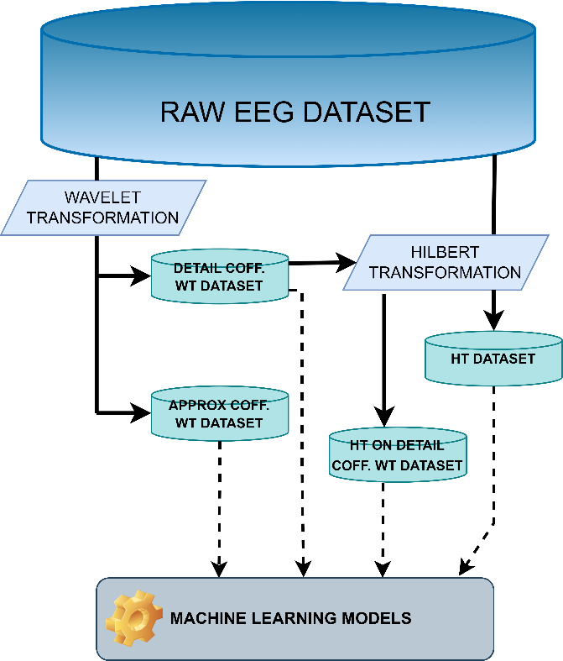

**Figure 2: Methodology followed during implementation.**

The proposed framework comprises of these steps-

## DATA ACQUISITION

The data have been collected from Kaggle form the publisher [18]. As stated, the data contains EEG signals recorded by Electroencephalography a typical non-invasive method, in which EEG electrodes are placed along the scalp using the International 10-20 system on two persons. 4 dry extra cranial electrodes were used. The voltages were recorded form the TP10, AF8, AF7, TP9 points as shown in fig [4]. As for the dataset and procedure to how it was collected it can be found in [17].

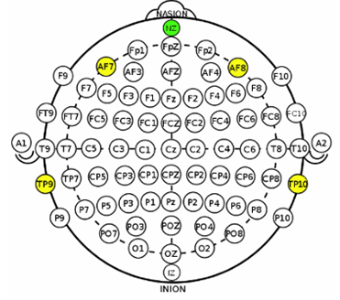

**Figure 1: EEG sensors TP9, AF7, AF8 and TP10 of the Muse headband on the international standard EEG placement system. Ref- [3].**

## WAVELET TRANSFORM

The wavelet transform is a mathematical technique used analysis of signals and data in both time and frequency domains simultaneously. It decomposes a signal into a series of wavelets, which are small waves of varying frequencies and durations. Unlike Fourier transforms, wavelet transforms use wavelets that are localized in both time and frequency. Wavelet transform is useful for analysing signals with non-stationary characteristics and are widely used in signal processing, image and data compression, and feature extraction.

Mathematically, Discrete wavelet transformed is given by

Detail coefficients 𝑐 $D_{j}$ [𝑛],



Approximation coefficients 𝑐 $A_{j}$ [𝑛],



Here, *f*[*n*] represents input signal, ℎ[𝑘] represents the high-pass filter coefficients (wavelet coefficients) and *g*[*k*] represents the low-pass filter coefficients (scaling coefficients), summation is done on the filter taps. The factor ${\left|2j\right|}^{-1}$ is due to for the normalization due to scaling at each level of the transform.

are complex and non-stationary, whose frequency content changes over time and are well-suited for wavelet transform which have both time and space localization. The wavelet transform decompose the signals into two coefficients, Detail Coefficient: In wavelet decomposition, the signal is passed through a series of low-pass and high-pass filters. The high-pass filter extracts the detail coefficients. The detail coefficients represent the high-frequency components of the signal. They highlight the changes in the signal at a certain level of resolution. They give information about the sharp transition or the fast-changing aspects of the signal. Approximation Coefficient: When the signal is passed through a low-pass filter and the resulting output represents the approximation coefficients. The approximation coefficient provides a coarse approximation of the original signal at a certain level of resolution. The objective of this step is to use the multi-resolution analysis of wavelet transform to decompose the input signals based on frequency to capture to both high and low-frequency components of the signal at different resolutions. This allows for the detection of fine details at high frequencies while preserving global trends at lower frequencies. In the level 1 decomposition, the signal is converted into approximation coefficients (cA) and level 1 detail coefficients(cD). The approximation coefficient captures the low frequency components. The detail coefficients capture the high frequency. They represent the transient details, rapid changes, or fluctuations within the signal.

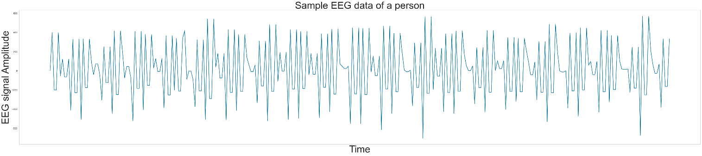

**Figure 3: Snippet of EEG activity of a person recorded over certain time-period.**

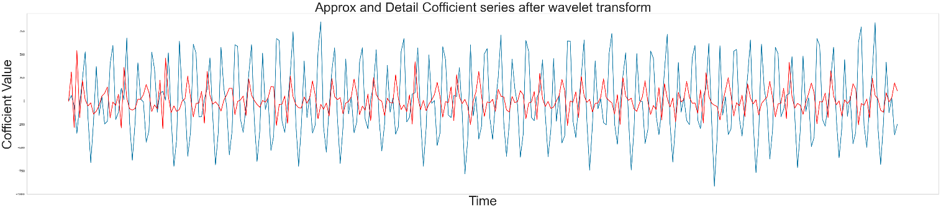

**Figure 4: Snippet of time dependent variation of coefficient values of a person recorded over certain time-period. Detail coefficient (Blue) and Approx coefficient (Red), gained after Wavelet transformation of raw EEG signal. Wavelet transformation reduced dataset into two new datasets, Detail coefficient and Approx coefficient dataset.**

## HILBERT TRANSFORM

Hilbert transform is a mathematical concept used in the field signal processing to modulate the phase data of a real-valued signal. Unlike traditional Fourier transforms, that decompose a signal into its constituent frequencies but discard phase data, the Hilbert transform compose a new signal that preserves the original signal's frequency content while making a specific phase shift. Mathematically, this phase shift is π/2 for all the frequency components.

Discrete Hilbert Transform is typically implemented using the discrete Fourier transform. Let $( x\left[n\right])$ be EEG signal aswhere $( n )$ is discrete time index. First Discrete Fourier Transform of $( x\left[n\right])$ is calculated given by $( X\left[k\right]), where k$ represents the frequency index. Here, $N$ is length of signal and $i$ is the imaginary unit.



Then a frequency response function $H\left[k\right]$ is created for DHT. Given by,

$$H\left[k\right]=\left\{\begin{aligned} 1 if k=0 \\ {2 if<k≤N}/2 \\ 0 otherwise\end{aligned}\right.$$

$H\left[k\right]$ corresponds to a phase shift of $( -π/2 )$ for positive frequencies and $( π/2 )$ for negative frequencies.

Then, DHT, given by $Y\left[k\right]$ is obtained,



Finally, Inverse Discrete Fourier Transform of $Y\left[k\right]$ is calculated to get DHT of original signal.



Hilbert Transform is applied to EEG data to get information like instantaneous phase and amplitude envelope. Instantaneous information provides insights about different emotional states as they are linked to specific patterns in frequency bands. Amplitude envelope represents magnitude of signal over time. Emotional arousal may increase amplitude in certain group frequencies, indicating certain emotional behavior.

# **RESULT AND DISCUSSIONS**

The dataset used was openly available on Kaggle [18]. It contains the EEG brain wave data collected from two people (1 male, 1 female) for 3 minutes per state - positive, neutral, negative by placing electrodes on their scalp.

From the EEG brain and wave dataset necessary features were extracted, specifically time varying EEG signal. Dataset was split into training and testing set and accuracies of various models on raw dataset were recorded. This raw data was Wavelet transformed successfully decomposing the EEG data into time-frequency components and extracting features form both approximation (low-frequency) and detail (high-frequency) coefficients, by this new data we acquired 94.23% accuracy with K-Neighbors Classifier on Detail coefficient wavelet transformed dataset and 95.04% with Light Gradient Boosting Machine on Approx coefficient wavelet transformed dataset. Accuracy was measured for different models classifying emotions as Positive, Negative and Neutral.

Highest accuracy of 95.44% was acquired by K-Neighbors Classifier and Light Gradient Boosting Machine when different models were fed Hilbert transformed dataset, followed by Extra Trees Classifier with 95.04% accuracy. Additionally, detail coefficient wavelet transformed dataset was further made to go through Hilbert transformation, then the resulting datasets was fed to different models and following results were acquired.

**Table 2: Highest model accuracies on Detail coefficient(cD) Hilbert Transform dataset.**

|  |  |
| --- | --- |
| **MODEL** | **ACCUARACY** |
| K Neighbors Classifier | 94.23% |
| Extra Trees Classifier | 94.23% |
| Light Gradient Boosting Machine | 93.36% |

**Table 3: Highest model accuracies on Approx coefficient(cA) Hilbert Transform dataset.**

|  |  |
| --- | --- |
| **MODEL** | **ACCUARACY** |
| Light Gradient Boosting Machine | 95.04% |
| Gradient Boosting Classifier | 94.77% |
| Extra Trees Classifier | 93.84% |

**Table 4: Highest model accuracies on dataset of Hilbert Transformed DWT (Discreate Wavelet Transform) dataset.**

|  |  |
| --- | --- |
| **MODEL** | **ACCUARACY** |
| K Neighbors Classifier | 95.31% |
| Extra Trees Classifier | 94.77% |
| Light Gradient Boosting Machine | 94.70% |

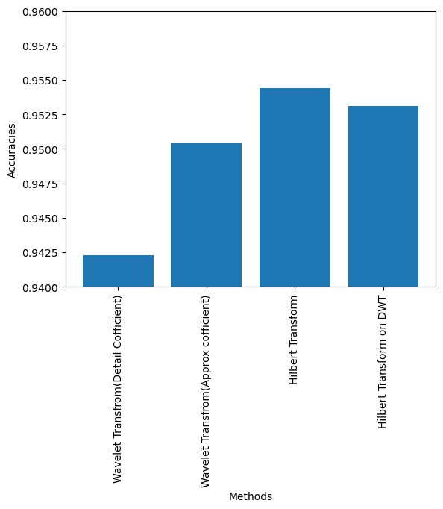

**Figure 5: Highest accuracies achieved by different methods.**

In summary, the highest classification accuracy of 95.04% was achieved using Light Gradient Boosting Machine on the approximation coefficients obtained through Wavelet transformation. Similarly, employing a K-Nearest Neighbors Classifier on Hilbert transformed data yielded an accuracy of 95.44%. Combining both Wavelet and Hilbert transformations with K-Nearest Neighbors Classifier resulted in an accuracy of 95.31%. These findings demonstrate the potential of machine learning coupled with appropriate signal processing techniques, particularly Wavelet Transform, for accurate emotion recognition using EEG data.

# **CONCLUSION**

This research researched the effectiveness of various machine learning for classifying human emotions (positive, neutral, negative) using EEG brainwave data. Feature extraction from the raw signal and application of transformation methods like Wavelet and Hilbert transforms were used. Different machine learning models were trained and tested on the pre-processed data for emotion classification.

# **REFERENCES**

[1] J. J. Bird, L. J. Manso, E. P. Ribiero, A. Ekart, and D. R. Faria, A study on mental state classifi- cation using eeg-based brain-machine interface, in 9th International Conference on Intelligent Systems, IEEE(2018).

[2]M. Gargesha, P. Kuchi, Facial expression recognition using a neural network, Artificial Neural Computation Systems, 31 (2002). 709-724.

[3] Ashraf Kiyani, I., & Razaq, A. (2022). A comprehensive review on sentiment perception using electroencephalography (EEG). SN Computer Science, 3(3), 245. [19] Choubey, H., & Pandey, A. (2019). A new feature extraction and classification mechanisms For EEG signal processing. Multidimensional Systems and Signal Processing, 30, 1793-1809.

[4] Bhattacharyya, Abhijit, et al. "A novel approach for automated detection of focal EEG signals using empirical wavelet transform." Neural Computing and Applications 29 (2018): 47-57.

[5] M, Muruga an Khairunizam, Wan Yaacob, Sazali Selvaraj, Jerritta, Electrocardiogram-based emotion recognition system using empirical mode decomposition and discrete Fourier transform. Expert Systems. 31 (2013). 10.1111/exsy.12014.

[6] Kalra, Diksha. EEG based mental workload classification using Hilbert Huang transform. Diss. 2020.

[7] Oweis, Rami J., and Enas W. Abdulhay. "Seizure classification in EEG signals utilizing Hilbert-Huang transform." Biomedical engineering online 10 (2011): 1-15.

[8] Sahoo, S., Mohanty, M., & Sabut, S. (2020). Automated EEG beat classification using DWT and Hilbert transform-based PCA-SVM classifier. International Journal of Biomedical Engineering and Technology, 32(3), 287-303.

[9] Paithane, A. N. Human Emotion Recognition using Electrocardiogram Signals, International Confer- ence on Pervasive Computing (ICPC). (2014). 10.1109/PERVASIVE.2015.7087042.

[10] By Mingmin Zhao, Fadel Adib, Dina Katabi, Communications of the ACM, 61 No. 9(2018). 91-100. :10.1145/3236621 59. 2017, Enhanc-ing Emotion Recognition from ECG Signals using Supervised Dimensionality Reduction. 112-118. 10.5220/0006147801120118.

[11] Ferdinando, Hany Se ¨anen, Tapio Alasaarela, Esko, 2017, Enhancing Emotion Recognition from ECG Signals using Supervised Dimensionality Reduction. 112-118. 10.5220/0006147801120118.

[12] Y. Liu, C. Wu, Y. Kao and Y. Chen, Single-trial EEG-based emotion recognition using kernel Eigen-emotion pattern and adaptive support vector machine, 2013 35th Annual International Conference of the IEEE Engineering in Medicine and Biology Society (EMBC), Osaka. (2013).10.1109/EMBC.2013.6610498.

[13] Suwicha Jirayucharoensak, Setha Pan-Ngum, and Pasin Israsena 2014. EEG Based Emotion Recognition Using Deep Learning Network with Principal Component Based Covariate Shift Adaptation, The Scientific World Journal,627892. https:// .org/10.1155/2014/627892.

[14] Tauseef Sohaib, Ahmad Qureshi, Shahnawaz Hagelb¨ack, Johan Hilborn, Olle Jerˇci´c, Petar. Evaluating Classifiers for Emotion Recognition Using EEG. Found. Augment. Cognit. Lecture Notes Comput. Sci. 8027(2013). 492-501.

10.1007/978-3-642-39454-6 53.

[15] Duan RN., Wang XW., Lu BL, EEG-Based Emotion Recognition in Listening Music by Using Su ort Vector Machine and Linear Dynamic System. In: Huang T., Zeng Z., Li C., Leung C.S. (eds) Neural Information Processing,Lecture Notes in Computer Science. (2012). 7666. Springer, Berlin, Heidelberg.

[16] Bird, Jordan & Ekart, Aniko & Buckingham, Christopher & Faria, Diego, Mental Emotional Sentiment Classification with an EEG-based Brain-machine Interface. (2019).

[17] https://www.kaggle.com/datasets/birdy654/eeg-brainwave-dataset-feeling-emotions