Practical – 2
AIM: 1. Create Basic Calculator using prompt
Source Code:
<!DOCTYPE html>
<html lang="en">
<head>
<style>
body{
background: rgb(132, 206, 236);
}
p{
background: rgb(251, 251, 251);
align-items: center;
align-content: center;
text-align: center;
text-decoration: double;
border:2px solid black;
border-radius: 10px;
height: fit-content+20;
width: fit-content+15;
}
button{

background-color: rgb(165, 138, 190);
align-items: center;
align-content: center;
text-align: center;
margin-left:45vw;
padding: 7px;
height: 7vh;
border-radius: 7px;
}
</style>
<script>
function func()
{
let a=parseFloat(prompt("Number 1:"));
let op=prompt("Operation: + - * / %");
let b=parseFloat(prompt("Number 2:"));
if(op==='+')
{
console.log(a+b);
document.getElementById("output").innerText=(a+b);
}
else if(op==='-')
{
document.getElementById("output").innerText=(a-b);
}
else if(op==='/')
{
document.getElementById("output").innerText=(a/b);
}
else if(op==='*')
{
document.getElementById("output").innerText=(a*b);
}
else if(op==='%')
{
document.getElementById("output").innerText=(a%b);
}
else
{
alert("Operation not allowed");
}
}
</script>
<meta charset="UTF-8">
<meta http-equiv="X-UA-Compatible" content="IE=edge">
<meta name="viewport" content="width=device-width, initial-scale=1.0">
<title>Simple calculator using prompt</title>
</head>
<body>
<p id="output">Here will be the output of your operation </p>
<button onclick="func()"><b>click here to begin</b></button>
</body>
</html>

Output: 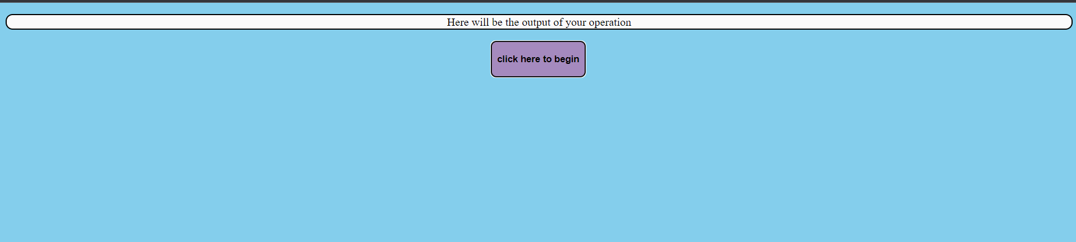
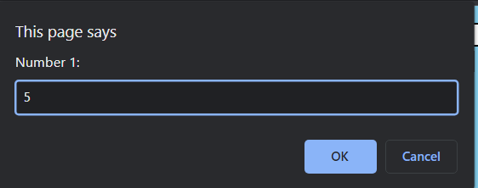
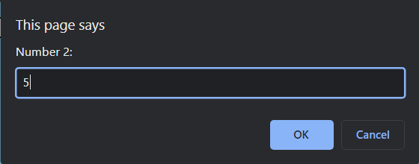
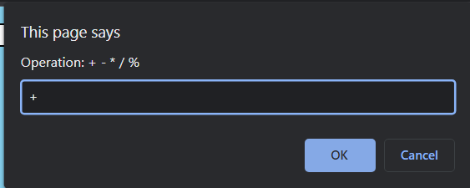
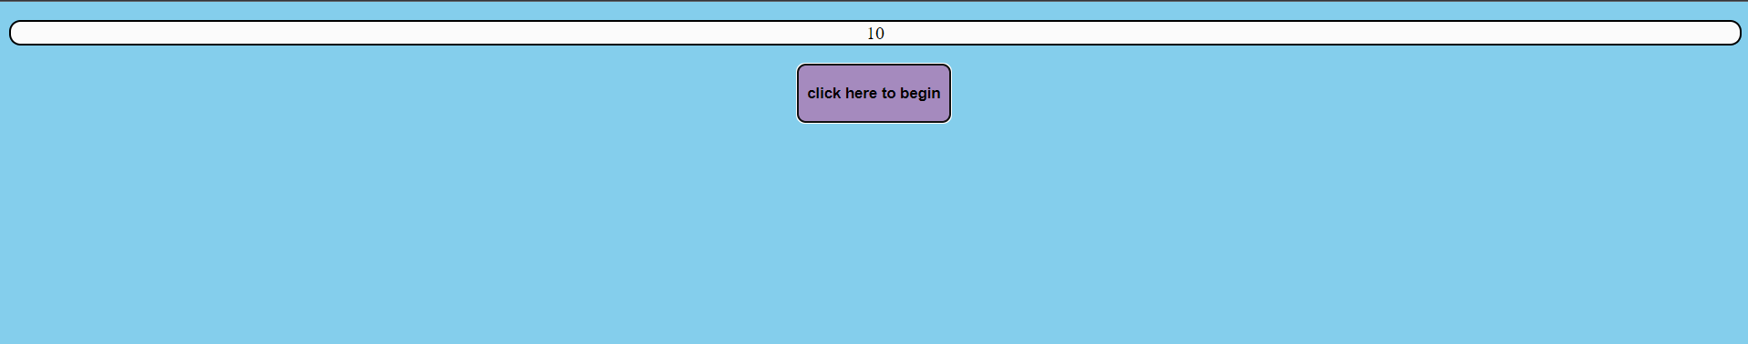

2. Create Basic Calculator using inputbox
Source Code:
<!DOCTYPE html>
<html lang="en">
<head>
<style>
body{
background: rgb(122, 228, 236);
}
p{
background-color: rgb(253, 254, 254);
align-items: center;
align-content: center;
text-align: center;
border:2px solid black;
border-radius: 10px;
height: fit-content+20;
width: fit-content+15;
}
button{
align-items: center;
align-content: center;
text-align: center;
}
</style>
<script>
function func(){
let a=parseFloat(document.getElementById("n1").value);
let b=parseFloat(document.getElementById("n2").value);
//console.log(typeof a1)
let op=document.getElementById("oper").value;
//console.log(typeof op);
if(op==='+')
{
console.log(a+b);
document.getElementById("output").innerText=(a+b);
}
else if(op==='-')
{
document.getElementById("output").innerText=(a-b);
}
else if(op==='/')
{
document.getElementById("output").innerText=(a/b);
}
else if(op==='*')
{
document.getElementById("output").innerText=(a*b);
}
else if(op==='%')
{
document.getElementById("output").innerText=(a%b);
}
else
{
alert("Operation not allowed");
}
}
</script>
<meta charset="UTF-8">
<meta http-equiv="X-UA-Compatible" content="IE=edge">
<meta name="viewport" content="width=device-width, initial-scale=1.0">
<title>Calculator using text input</title>
</head>
<body>
<p id="output">Here will be your output</p>
<label for="">Number 1:</label>
<input type="text" id="n1">
<label for="">Number 2:</label>
<input type="text" id="n2">
<br>
<select name="operation" id="oper" >
<option value="+">+</option>
<option value="-">-</option>
<option value="*">*</option>
<option value="/">/</option>
<option value="%">%</option>
</select>
<br>
<br>
<button onclick="func()">Click Here to Begin</button>
</body>
</html>

Output:
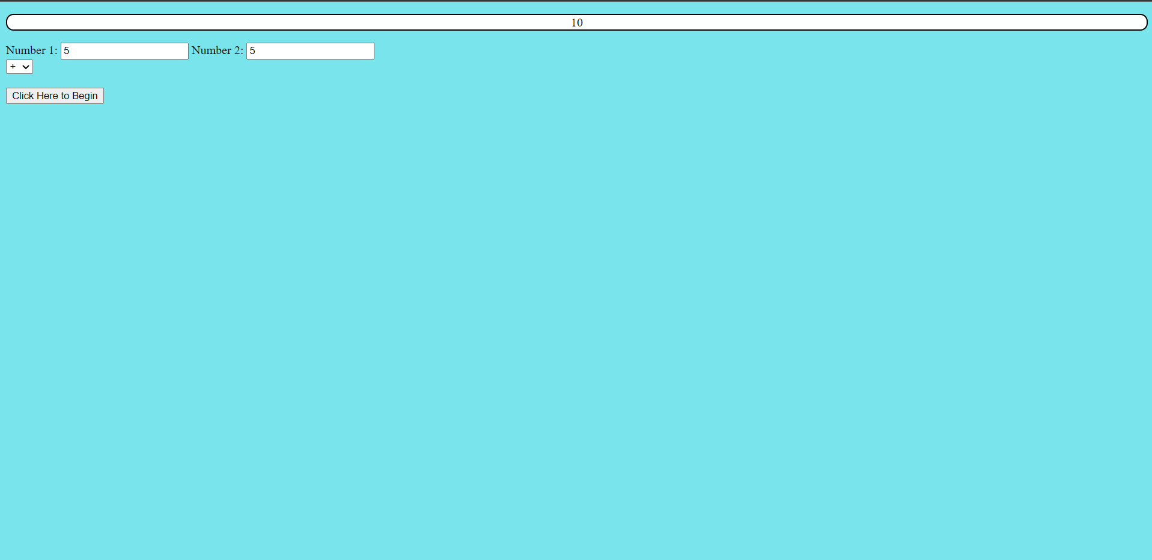

3. Do temperature Conversion using the input box and display the result on the Web Page. (Celsius to Fahrenheit)
Source Code:
<!DOCTYPE html>
<html>
<head>
<title>Temperature Converter</title>
<style>
form {
margin: 0 auto;
width: 240px;
text-align: center;
}
input[type="text"] {
width: 60px;
border: 1px solid #ccc;
border-radius: 4px;
font-size: 16px;
padding: 12px 20px;
}
select {
width: 100px;
border: 1px solid rgb(168, 168, 168);
border-radius: 4px;
font-size: 16px;
padding: 12px 20px;
margin-left: 10px;
}
input[type="button"] {
width: 100px;
background-color: #53c654;
color: rgb(14, 26, 8);
border: none;
border-radius: 4px;
font-size: 16px;
cursor: pointer;
padding: 12px 20px;
margin-left: 10px;
}
div{
background-color: rgb(253, 254, 254);
align-items: center;
align-content: center;
text-align: center;
border:2px solid black;
border-radius: 10px;
height: fit-content+20;
width: fit-content+15;
}
</style>
</head>
<body>
<div id="result">Here will be your result</div>
<br>
<form>
<input type="text" id="temp" placeholder="Enter temperature">
<br><br>
<select id="conversion-type">
<option value="celsius-to-fahrenheit">Celsius to Fahrenheit</option>
<option value="fahrenheit-to-celsius">Fahrenheit to Celsius</option>
</select>
<input type="button" value="Convert" onclick="convertTemp()">
</form>

<script>
function convertTemp() {
var temp = document.getElementById("temp").value;
var conversionType = document.getElementById("conversion-type").value;
if (conversionType == "celsius-to-fahrenheit") {
var result = (temp * 9 / 5) + 32;
} else if (conversionType == "fahrenheit-to-celsius") {
var result = (temp - 32) * 5 / 9;
}
document.getElementById("result").innerHTML = result + " &deg;F";
}
</script>
</body>
</html>

Output:
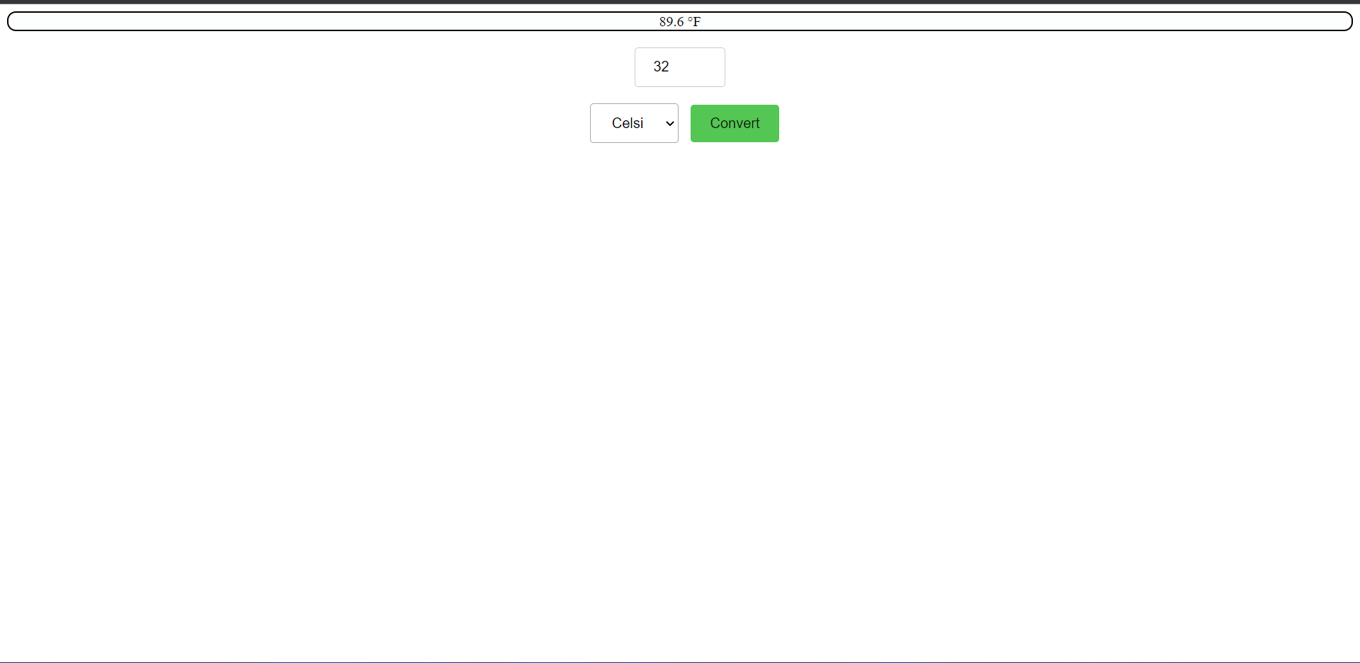

Conclusion:
From this practical I learned various HTML tags, CSS tags and usage of Javascript for creation of calculator, and convertors.
Course Outcome:
Student should able to understand the tools and technologies to design &amp; develop static and dynamic webpages/apps.
Student should able to select appropriate hosting environment.

