**FILE DISPATCH MANAGEMENT SYSTEM**

A Mini-Project submitted for the partial fulfillment of Database Management System Laboratory (CS15203)

by

Anmol Kumar Sharma

Roll Number: B210007CS

3rd Year B. Tech (CSE)

Under the Supervision of

Dr. Sangram Ray

Associate Professor



Department of Computer Science and Engineering

National Institute of Technology Sikkim

Ravangla-737139, Sikkim

December 2023

CERTIFICATE

This is to certify that the project report entitled “**FILE DISPATCH MANAGEMENT SYSTEM**” submitted by **Anmol Kumar Sharma** bearing Roll No. **B210007CS** is an authentic report for the work carried out under my supervision as a part of Database Management System Laboratory during the Odd Semester, 2023-24 at National Institute of Technology Sikkim, Ravangla-737139, Sikkim.

**Dr. Sangram Ray**

Associate Professor

Department of Computer Science and Engineering

National Institute of Technology Sikkim

Ravangla-737139, Sikkim, India

# ACKNOWLEDGEMENT

Foremost, I extend my heartfelt appreciation to my supervisor, Dr. Sangram Ray. Working on this project under his guidance has been an immense honor, and I am sincerely thankful for his outstanding mentorship, unwavering support, and motivational insights throughout the entire project duration.

I extend my special thanks to everyone who contributed their invaluable support, demonstrated patience, provided critical feedback, and conducted meticulous reviews during the project's development. Their constant inspiration, willingness to assist, and thoughtful suggestions have played a pivotal role in shaping the project.

I express my gratitude to all the faculty members, Ph.D. scholars, and staff of NIT Sikkim for fostering an environment conducive to the successful completion of my project.

Lastly, I extend my thanks to the almighty for granting me the strength, knowledge, abilities, and the opportunity to undertake and successfully complete this project study.

**Anmol Kumar Sharma**

Roll No.: B210007CS

5th Semester, B. Tech (CSE)

Department of Computer Science and Engineering

# ABSTRACT

This project introduces a File Dispatch Management System designed and implemented using PHP and MySQL technologies. The system encompasses a robust database structure with various tables tailored to efficiently manage and organize critical data related to file dispatch processes. The utilization of PHP ensures dynamic and interactive functionality, while MySQL serves as a reliable and scalable database management system. The project focuses on optimizing file dispatch procedures, offering a seamless user experience through an intuitive interface. By employing multiple tables, the system streamlines the storage and retrieval of diverse information, including file categories, user details, dispatch records, and status updates. This abstract encapsulates a comprehensive solution for organizations seeking a reliable and scalable file dispatch management system to enhance efficiency and streamline document-related workflows.

**TABLE OF CONTENTS**

|  |  |  |
| --- | --- | --- |
| **Chapter No.** | **Chapter Name** | **Page No.** |
| 1 | Introduction | 1 |
| 2 | Problem Description | 2 |
| 3 | System Specifications | 3 |
| 4 | Problem Formulation | 4-23 |
|  | 4.1 Existing System | 4 |
| 4.2 Objective | 5 |
| 4.3 Proposed System | 6 |
| 4.4 Entity-Relationship Diagram | 7 |
| 4.5 Database Schema | 8-11 |
| 4.6 Implementation | 12 |
| 4.7 Description of Modules | 13 |
| 4.8 Execution Snapshots | 14-23 |
| 5 | Applications | 24 |
| 6 | Conclusion and Future Scope | 25 |
| 7 | References | 26 |

# CHAPTER - 01

# INTRODUCTION

File Dispatch Management System is a sophisticated solution meticulously developed using PHP and MySQL technologies. In the contemporary business landscape, the efficient management of document dispatch processes stands as a critical imperative. This project emerges in response to the pressing need for a systematic and streamlined approach to file dispatch, driven by the implementation of a robust database system.

Harnessing the dynamic functionality of PHP and the reliability of MySQL for data management, this system presents a comprehensive platform for the creation, storage, and meticulous administration of vital information pertaining to file dispatch. With a dedicated focus on enhancing both user experience and operational efficiency, the system integrates various tables, each meticulously tailored to address specific facets of file dispatch—ranging from file categories and user details to dispatch records and status updates.

Our goal with the File Dispatch Management System is to transform how organizations handle document workflows. By providing an intuitive interface and automated processes, the system aims to streamline document-related procedures, enhance collaboration, and contribute to a more efficient and organized work environment.

# CHAPTER - 02

# PROBLEM DESCRIPTION

The problem stated in the project is to manage the contact information of NIT Sikkim employees using a database management system. This work is expected to emphasize the usage of a database system to manage the data. The project must involve both front-end and back-end so that we will be able to display the contact information of each employee. The front-end will be of HTML type consisting of Bootstrap to give good visual effects. The administrator should manage the information of employee and perform data manipulation operations like insertion, deletion, and updation.

The data in the back-end will be managed by the tables in MySQL. An employee has various attributes like first name, last name, contact number, email address, department, and research interest / job-type for non-academic employees.

The administrators should only be able to perform any changes in the database and other users should only be able to view the directory of employees and view the profile of each employee. Others should not be given any access to make any changes in the database rather should only be allowed to see the records.

# CHAPTER - 03

# SYSTEM SPECIFICATIONS

A robust file dispatch management system leverages modern technologies to ensure seamless functionality and an optimal user experience. The system's foundation includes:

* **Server Environment** –
  + Web Server– Apache
  + Database Management System: MySQL
  + Server-Side Scripting Language: PHP
* **Client Environment** -
  + Web Browsers: Compatible with major browsers (Google Chrome, Mozilla Firefox, Safari, Microsoft Edge)
  + JavaScript: Enabled in the client's browser for dynamic functionality
* **Database Specifications:**
  + MySQL Database: Configured and accessible
  + Database Tables: Created for storing user details, file information, and other relevant data
  + Relationships: Established between tables to reflect the project's data model
* **Programming and Markup Languages:**
  + PHP: Server-side scripting for dynamic content generation
  + HTML: Front-end structure and user interface.
  + CSS: Styling for a visually appealing and responsive layout.
  + SCSS: a preprocessor scripting language that is compiled into CSS.
  + JavaScript: Client-side scripting for enhanced interactivity
* **Frameworks / Libraries:**
  + jQuery: An open-source JavaScript library that simplifies the interactions between DOM and JavaScript.
  + TailwindCSS: An open source CSS framework for quick and better styling.
* **Text Editors:** 
  + VS Code: A simple source-code editor that makes programming easy.

# CHAPTER - 04

# PROBLEM FORMULATION

**4.1 EXISTING SYSTEM**

The existing file dispatch management systems play a pivotal role in modern organizational workflows, offering solutions to streamline the handling, sharing, and tracking of files. Existing file management systems typically provide centralized repositories for files, allowing users to upload, share, and collaborate on documents in real-time. They often incorporate version control mechanisms, ensuring that users can access the latest iteration of a file. Collaboration features, such as commenting and editing in real-time, facilitate seamless teamwork. However, challenges persist, including limited file-type support, limited offline access, and complexities in managing large-scale file structures. The ongoing evolution of these systems reflects a continual effort to address these challenges and cater to the ever-changing needs of organizations seeking effective and secure file dispatch management.

After studying existing system, we found following problems and weaknesses in the system:

* **Complex Folder Structures:** As the number of files grows, maintaining an organized folder structure becomes challenging. Users may find it difficult to navigate through complex directory trees, impacting overall user experience.
* **Limited File Type Support:** Some file management apps may have limitations in supporting specific file types or might lack robust preview capabilities for certain formats, impacting the user's ability to review files without downloading them.
* **Security and Privacy Concerns:** Security and privacy are critical considerations. Users may be concerned about the security of their files, especially when dealing with sensitive information.
* **Storage Limitations:** Free or basic plans often come with storage limitations. Users may need to manage their storage space actively or upgrade to premium plans to accommodate a growing volume of files.

**4.2 OBJECTIVE**

The primary objective of the File Dispatch Management System is to allow users to easily manage and share their files to other users. This system enables users to easily create folders, and store their files in these folders by uploading them. Moreover, this system allows users to share their files to other users. By other users, we mean users who are friends of the current logged in user. This is done to ensure authenticity of the files received, and enhanced security. Users can send friend requests to other users, which on getting accepted, files can be shared between them.

The system also allow review their file dispatch status through a user-friendly web interface, ensuring effortless navigation for all visitors, including those with limited internet browsing knowledge. The administration can efficiently register and manage details related to file dispatch, allowing for dynamic adjustments to proposed dispatch plans.

Thus, the various objectives of this system are:

* **Efficient Registration:** Enable administrative staff to register individuals accurately, capturing essential details for file dispatch.
* **User-Friendly Interface:** Provide a user-friendly web interface, allowing easy access for all users, including those with limited internet browsing knowledge.
* **Dynamic System:** Facilitate dynamic adjustments to file dispatch plans, ensuring adaptability for both members and management staff.
* **Efficient Data Management:** Streamline data management by allowing the administration to register, modify, and delete file dispatch details as needed.
* **Transparent Communication:** Empower users to check their file dispatch status on the history, fostering transparent communication with the dispatching entity.
* **Data Privacy and Security:** Provide assurance to policyholders regarding robust data privacy and security measures.

## 4.3 PROPOSED SYSTEM

In the envisioned File Dispatch Management System, all operations will be seamlessly executed through computer systems and the Internet. User registrations, file dispatch plans, and associated details will be inputted via computers, and the information will be securely stored on the server, ensuring comprehensive backups to prevent data loss.

The proposed system aims to significantly reduce time-consuming processes, offering users an efficient means to access their file dispatch information and stay updated on new programs. With a simple button click, users can swiftly retrieve their file dispatch details, streamlining the overall user experience.

This system is specifically designed to support the management of crucial details, including file dispatch records, user information, file and folder details, and friends of users. Its purpose is to overcome the limitations of the current system, offering permanent solutions to existing challenges. The primary goal is to enhance user experience, enhance security, and efficient file storage and management. This report is meticulously prepared to guide the planning and implementation phases, ensuring seamless integration by the relevant staff.

## 4.4 ENTITY - RELATIONSHIP DIAGRAM

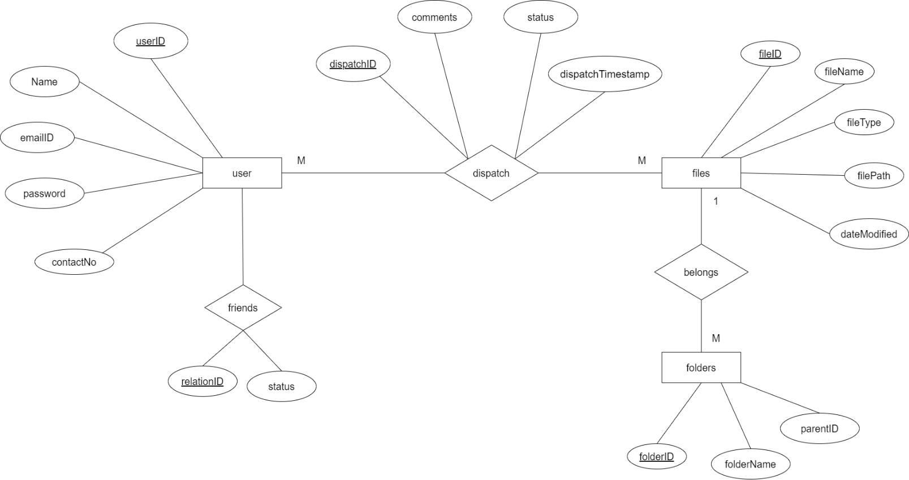

***Fig 4.4 (a): Proposed Entity-Relationship Diagram***

### 4.5 DATABASE SCHEMA

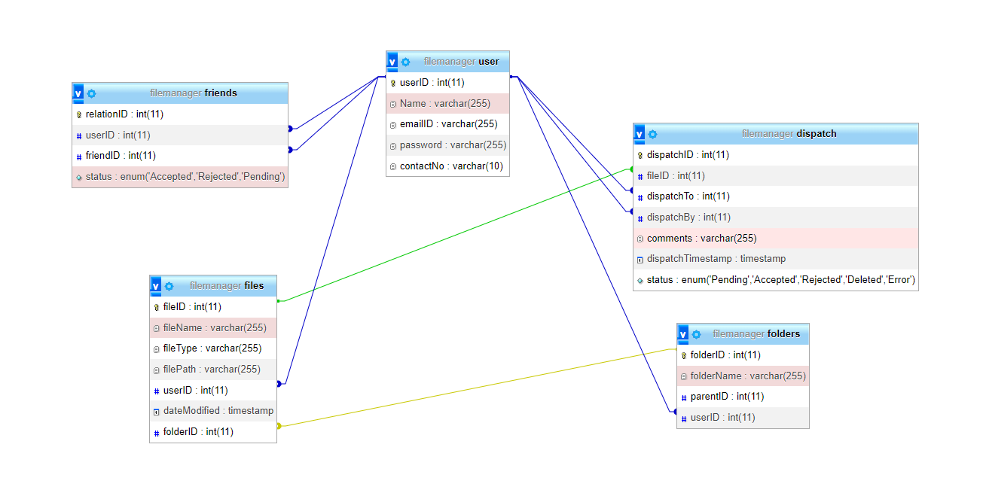

***Figure 4.5 (a): Relational Database***

### 4.5.1 RELATION SCHEMA

###### The relation schema for the given tables can be summarized as follows: user Table:- Columns: userID (Primary Key), Name, emailID, password, contactNo Primary Key: userID

###### folder Table:- Columns: folderID(Primary Key), folderName, parentID, userID

###### Primary Key: folderID

###### Foreign Key: userID (References user.userID) files Table:- Columns: fileID(Primary Key), fileName, fileType, filePath, userID, dateModified, folderID

###### Primary Key: fileID

###### Foreign Key: userID (References user.userID), folderID (References folder.folderID)

###### friends Table:- Columns: relationID(Primary Key), userID, friendID, status,

###### Primary Key: relationID

###### Foreign Key: userID (References user.userID), friendID (References user.userID)

###### dispatch Table:- Columns: dispatchID(Primary Key), fileID, dispatchTo, dispatchBy, comments, dispatchTimestamp, status

###### Primary Key: relationID

###### Foreign Key: fileID(References file.fileID), dispatchTo (References user.userID), dispatchBy (References user.userID)

###### Relationships:-

###### Many-to-Many Relationship (friends) between user (Many) and user (Many) based on the userID key in the user table.

###### Many-to-Many Relationship (dispatch) between user (Many) and files (Many) based on the userID foreign key in the files table.

###### One-to-Many Relationship (belongs) between files (1) and folders (Many) based on the folderID foreign key in the files table.

***Table 4.5 (a): user Table***

|  |  |  |  |
| --- | --- | --- | --- |
| **Serial No.** | **Column Name** | **Data-type** | **Length/Values** |
| 1 | userID | int | 11 |
| 2 | Name | varchar | 255 |
| 3 | emailID | varchar | 255 |
| 4 | password | varchar | 255 |
| 5 | contactNo | varchar | 10 |

***Table 4.5 (b): folders Table***

|  |  |  |  |
| --- | --- | --- | --- |
| **Serial No.** | **Column Name** | **Data-type** | **Length/Values** |
| 1 | folderID | int | 11 |
| 2 | folderName | varchar | 255 |
| 3 | parentID | int | 11 |
| 4 | userID | int | 11 |

***Table 4.5 (c): files Table***

|  |  |  |  |
| --- | --- | --- | --- |
| **Serial No.** | **Column Name** | **Data-type** | **Length/Values** |
| 1 | fileID | int | 11 |
| 2 | fileName | varchar | 255 |
| 3 | fileType | varchar | 255 |
| 4 | filePath | varchar | 255 |
| 5 | userID | int | 11 |
| 6 | dateModified | timestamp |  |
| 7 | folderID | int | 11 |

***Table 4.5 (e): friends Table***

|  |  |  |  |
| --- | --- | --- | --- |
| **Serial No.** | **Column Name** | **Data-type** | **Length/Values** |
| 1 | relationID | int | 11 |
| 2 | userID | int | 11 |
| 3 | friendID | int | 11 |
| 4 | status | enum | ‘Accepted’, ‘Rejected’, ‘Pending’ |

***Table 4.5 (d): dispatch Table***

|  |  |  |  |
| --- | --- | --- | --- |
| **Serial No.** | **Column Name** | **Data-type** | **Length/Values** |
| 1 | dispatchID | int | 11 |
| 2 | fileID | varchar | 255 |
| 3 | dispatchTo | int | 11 |
| 4 | dispatchBy | int | 11 |
| 5 | comments | varchar | 255 |
| 6 | dispatchTimestamp | timestamp |  |
| 7 | status | enum | ‘Pending’, ‘Accepted’, ‘Rejected’, ’Deleted’, ’Error’ |

### 4.6 IMPLEMENTATION

#### Home Page:

#### The home page serves as the initial point of interaction for users upon opening the website. It features convenient navigation links in the navbar, prompting users to either log in to access their files or, for new users, seamlessly navigate to the Sign-Up page for registration.

#### About Page:

This page consists of the basic details about the website, including its features, and advantages. It allows the users to familiarize themselves with the website,

#### Login Page

This page takes the details of an already registered user, redirects him/her to his dashboard page, if the login credentials are correct.

#### Sign Up Page

This page takes the details of a new user, and stores it in the database. It also creates a folder for the user on the server, to store his files.

#### Dashboard Page

The dashboard page is the main page, where user can navigate through his files and folders, and perform various actions such as creating or deleting folder, and uploading, downloading, deleting or sharing files.

#### Friends Page

The list of all users are displayed on this page. Any logged in user can send a friend request to another user. Friends who accept requests, can share files to the user. Requests sent can also be withdrawn, and friends can also be deleted.

#### Received Files Page

This page shows the list of files that have been shared to the user. Files shared can be accepted or rejected. The accepted files can be downloaded as well.

#### History Page

History page consists of the history of files shared with the user, or by the user, along with the user with whom the file was shared.

## 4.7 DESCRIPTION OF MODULES

There are 3 base modules used in this project:

* **Users Module**  
  This module is responsible for handling the user related database calls, and operations on user data. It includes the files for manipulation of user data. The files that are included in Users module are: loginSubmit.php, signupSubmit.php
* **Folders Module**

This module handles the folder related operations, such as creating a folder, and deleting a folder, and traversing to next and previous folder. The files that are included in Folders module are:

addFolder.php, deleteFolder.php, nextFolder.php, prevFolder.php .

* **Files Module**

**The** files module handles the operations related to files, such as uploading, downloading, and deleting files. The files that are included in Files module are: addFile.php, deleteFile.php, downloadFile.php.

* **Dispatch Module**

The dispatch module is responsible for file dispatching to another user, based om his UserID. It includes operations, such as accepting, rejecting or deleting shared files. The files that are included with this model are:

acceptSharedFile.php, deleteSharedFile.php, rejectSharedFile.php, downloadFile.php

* **Friends Module**

This module is associated to share files only to authentic users. Thus, to share a file to any user, the sender should always send a friend request the recipient, which on getting accepted, allows file sharing between the two. The files that are included with this model are:

acceptFriend.php, rejectFriend.php, deleteFriend.php, requestFriend.php, withdrawRequest.php

## 4.8 EXECUTION SNAPSHOTS

#### 4.8.1 FRONTEND

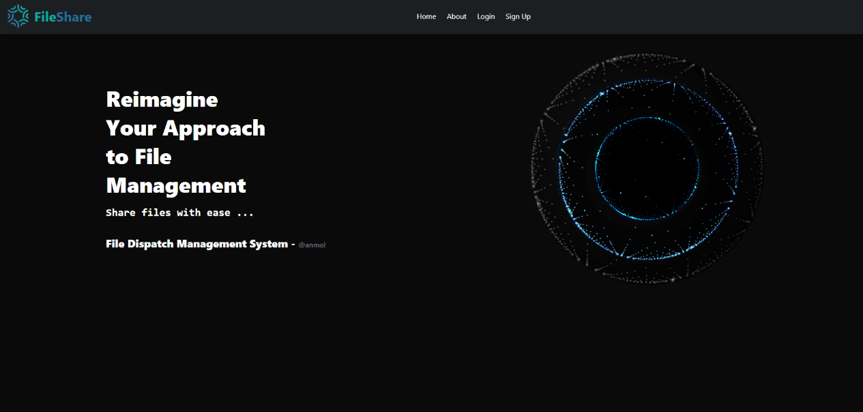

***Figure 4.8 (a): Homepage***

The home page serves as the initial point of interaction for users upon opening the website. It features convenient navigation links in the navbar, prompting users to either log in to access their files or, for new users, seamlessly navigate to the Sign-Up page for registration.

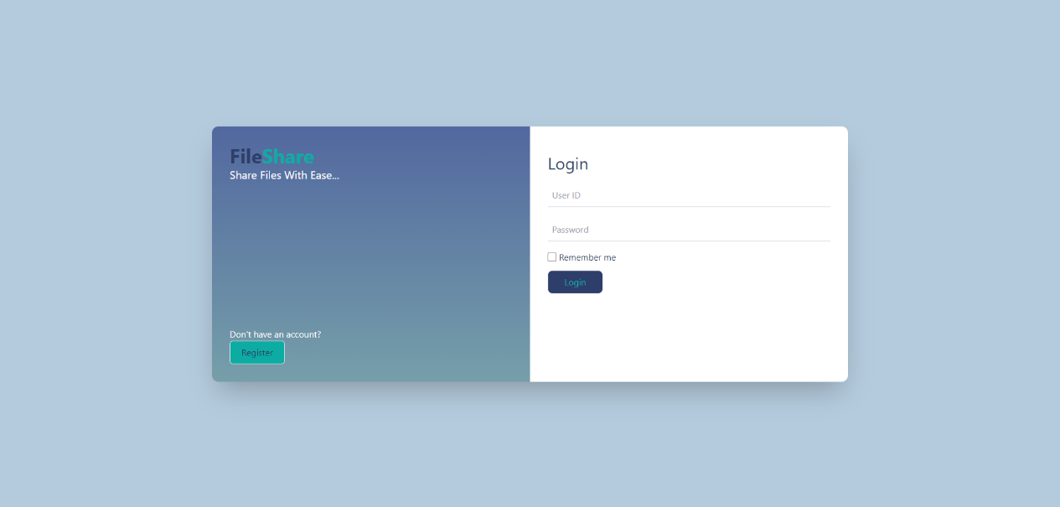

***Figure 4.8 (b): Login Page***

This page takes the details of an already registered user, redirects him/her to his dashboard page, if the login credentials are correct.

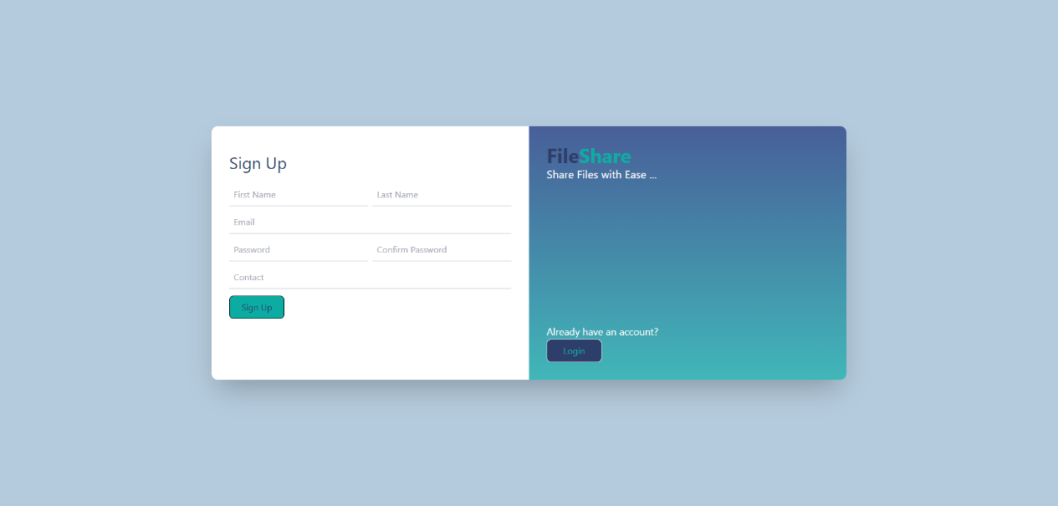

***Figure 4.8 (c): Sign Up Page***

This page takes the details of a new user, and stores it in the database. It also creates a folder for the user on the server, to store his files.

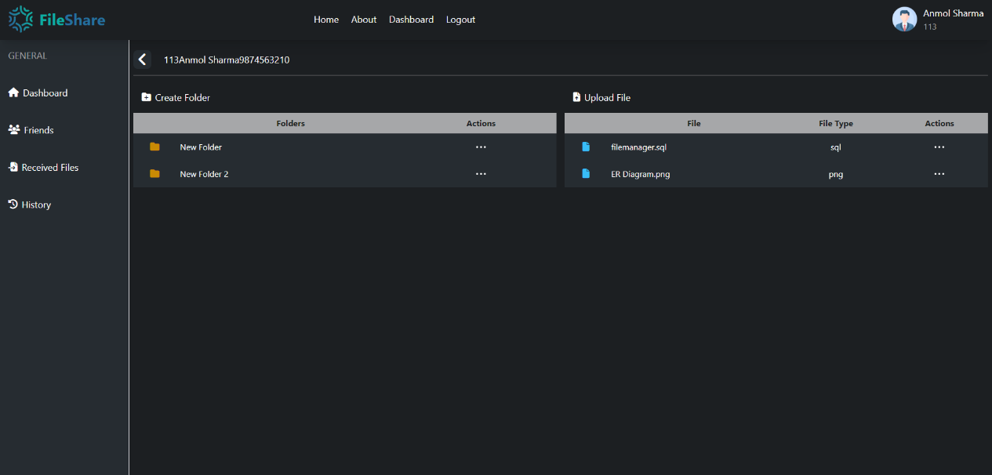

***Figure 4.8 (d): Dashboard Page***

The dashboard page is the main page, where user can navigate through his files and folders, and perform various actions such as creating or deleting folder, and uploading, downloading, deleting or sharing files.

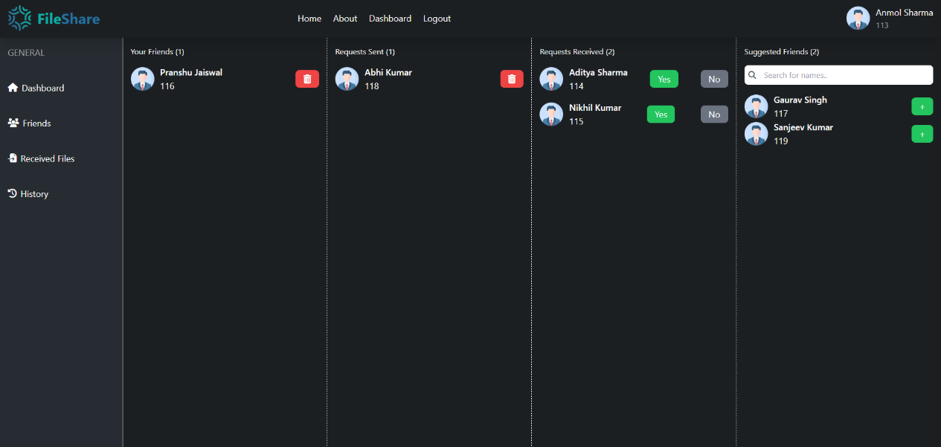

***Figure 4.8 (e): Friends Page***

The list of all users is displayed on this page. Any logged in user can send a friend request to another user. Friends who accept requests, can share files to the user. Requests sent can also be withdrawn, and friends can also be deleted.

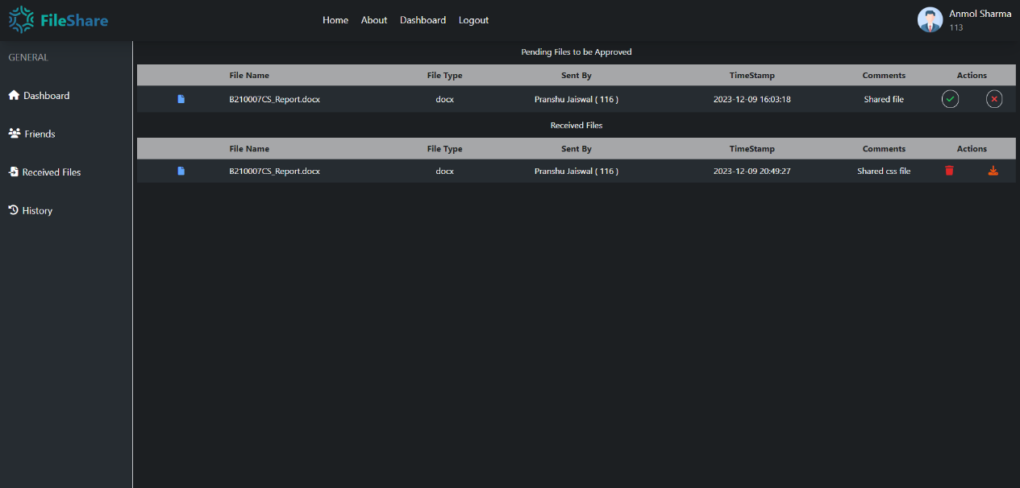

***Figure 4.8 (f): Received Files Page***

This page shows the list of files that have been shared to the user. Files shared can be accepted or rejected. The accepted files can be downloaded as well.

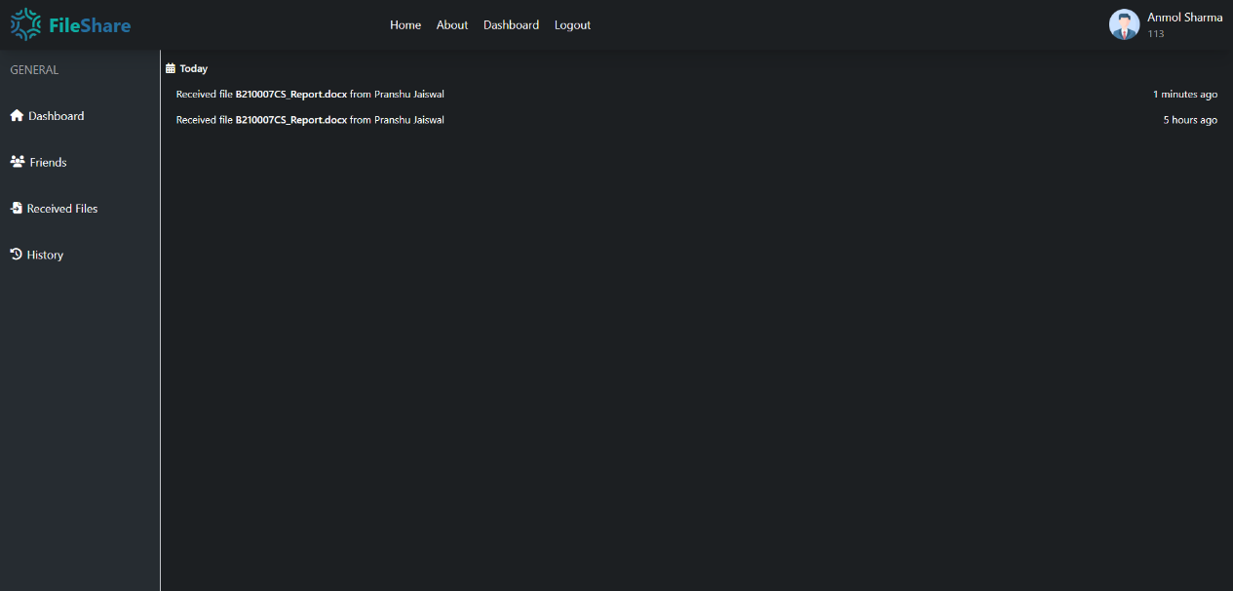

***Figure 4.8 (g): History Page***

#### History page consists of the history of files shared with the user, or by the user, along with the user with whom the file was shared.

#### 4.8.2 BACKEND

***Table 4.8 (a): filemanager Database***

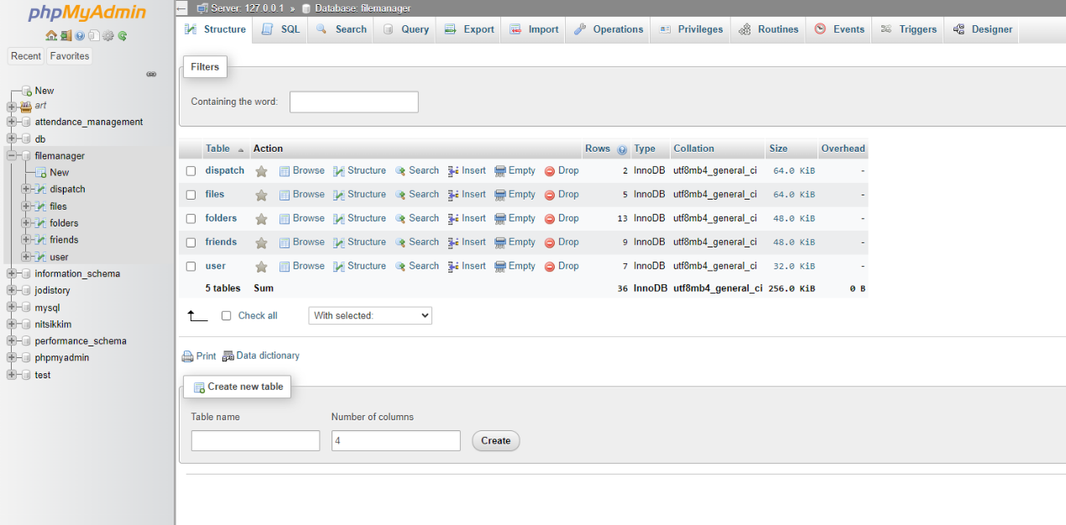

***Table 4.8 (b): users Table***

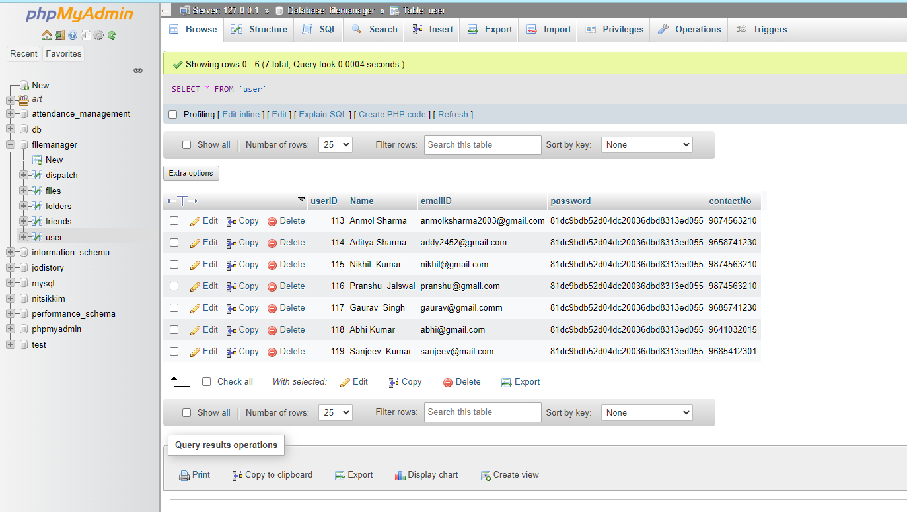

***Table 4.8 (c): folders Table***

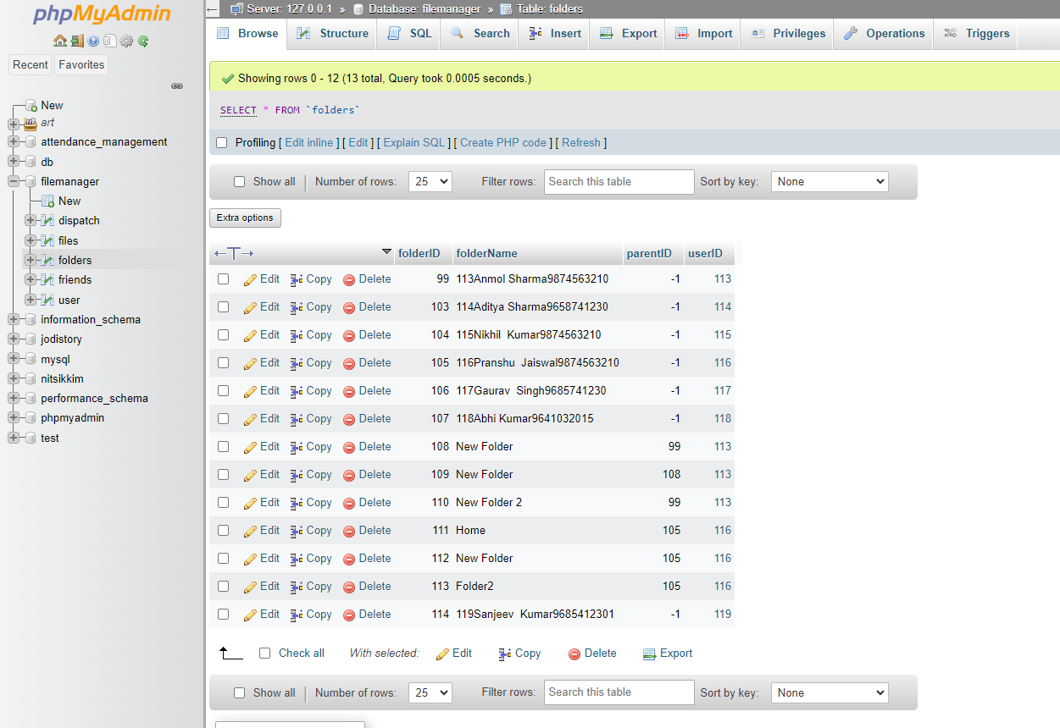

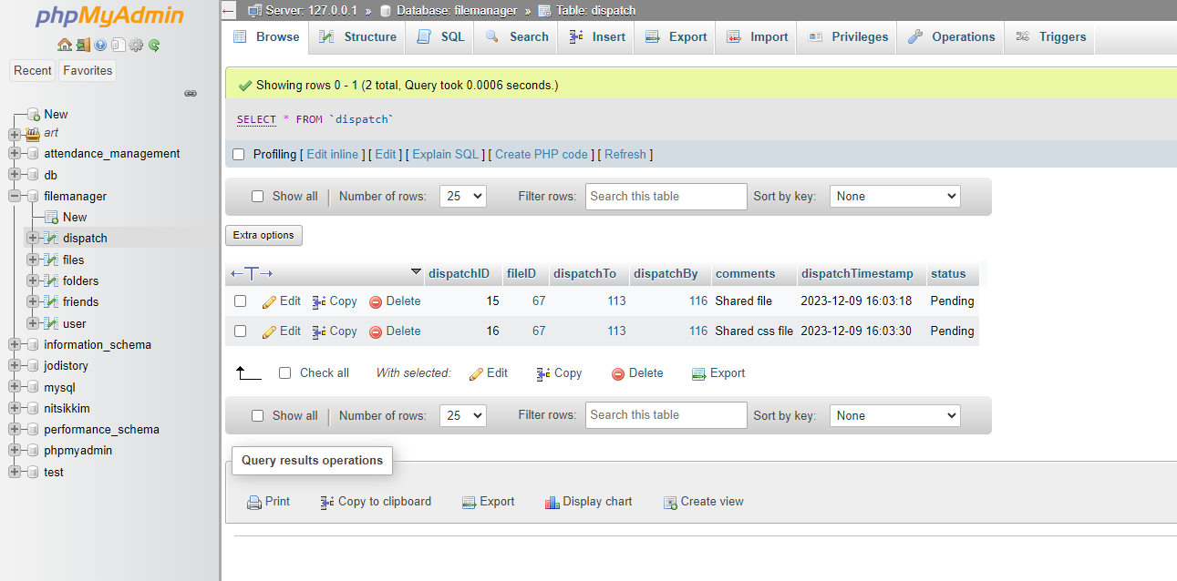***Table 4.8 (d): dispatch Table***

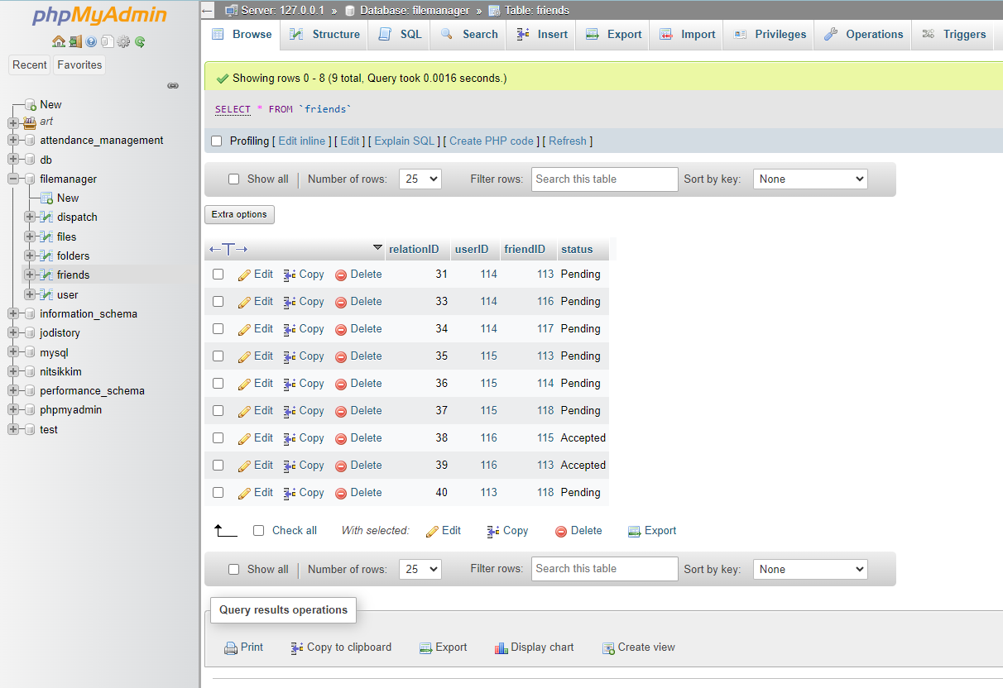***Table 4.8 (e): friends Table***

# CHAPTER - 05

# APPLICATIONS

A File Dispatch Management System (FDMS) can be a valuable tool in various industries and organizations for efficient handling and tracking of files and documents. Here are some common applications of a file dispatch management system:

* **Government Offices:** Government agencies often deal with a large volume of paperwork. An FDMS can help streamline the dispatch of files between different departments and ensure that documents reach the right personnel in a timely manner.
* **Corporate Environments:** Large corporations with multiple departments and branches can use FDMS to manage the flow of documents such as contracts, reports, and proposals. This helps in maintaining organized records and ensures that information is shared efficiently among various teams.
* **Educational Institutions:** Schools, colleges, and universities can benefit from an FDMS to manage student records, faculty documents, and administrative files. This can simplify tasks like admission processes, grading, and communication between different departments.
* **Healthcare Organizations:** Hospitals and clinics deal with a significant amount of patient records, medical reports, and administrative documents. An FDMS can help in organizing and dispatching these files to the relevant departments, improving overall patient care and administrative efficiency.
* **Legal Firms:** Law firms handle numerous legal documents, case files, and correspondence. A file dispatch management system can assist in managing and tracking the movement of legal documents among lawyers, paralegals, and support staff.

# CHAPTER - 06

# CONCLUSION & FUTURE SCOPE

# In conclusion, a File Dispatch Management System (FDMS) represents a vital tool for organizations, offering a systematic and efficient approach to handling, tracking, and managing documents. Across diverse industries, FDMS contributes to improved organizational efficiency, streamlined workflows, enhanced collaboration, and reduced risks associated with document loss or misplacement.

# Looking ahead, the future of File Dispatch Management Systems (FDMS) is marked by innovation and adaptation to meet the evolving needs of digital workplaces. Through the integration of technologies like AI, machine learning, and blockchain, FDMS is poised to provide intelligent document management, heightened security, and decentralized record-keeping. Mobile accessibility, seamless cloud integration, and user-friendly interfaces will address the requirements of remote and flexible work environments.

# Moreover, compliance features, collaborative capabilities with other enterprise systems, and customization options will enhance FDMS versatility for diverse organizational needs. The incorporation of data analytics will offer valuable insights for performance optimization. A growing emphasis on sustainability may also drive initiatives toward a paperless environment. In essence, the future of FDMS lies in its capacity to embrace cutting-edge technologies and contribute significantly to more efficient, secure, and sustainable document management practices across various industries.

# CHAPTER - 07

# REFERENCES

***Table 7 (a): References***

|  |  |  |
| --- | --- | --- |
| **SerialNo.** | **Links** | **Access Date** |
| 1 | https://levelup.gitconnected.com/basic-frontend-knowledge-737702051bd8 | 10.08.2023 |
| 2 | https://releases.jquery.com/ | 10.08.2023 |
| 3 | https://www.w3schools.com/MySQL/default.asp | 15.09.2023 |
| 4 | https://tailwindcss.com/docs/ | 15.10.2023 |
| 5 | https://kit.fontawesome.com/ | 20.10.2023 |
| 6 | https://www.youtube.com/watch?v=nP-MvFoDVZE | 01.11.2023 |
| 7 | https://www.tutorialrepublic.com/php-tutorial/php-mysql-select-query.php | 11.11.2023 |
| 8 | https://www.php.net/manual/en/ | 19.11.2023 |