Inclass Assignment

Akshar Patel

3/23/2022

# Handling Date & Time w/ lubridate Package

# Run these lines first

if (!require('tidyverse')) install.packages('tidyverse'); library('tidyverse')

## Loading required package: tidyverse

## Warning: package 'tidyverse' was built under R version 4.1.3

## -- Attaching packages --------------------------------------- tidyverse 1.3.1 --

## v ggplot2 3.3.5 v purrr 0.3.4  
## v tibble 3.1.6 v dplyr 1.0.8  
## v tidyr 1.2.0 v stringr 1.4.0  
## v readr 2.1.2 v forcats 0.5.1

## Warning: package 'tidyr' was built under R version 4.1.3

## Warning: package 'readr' was built under R version 4.1.3

## Warning: package 'forcats' was built under R version 4.1.3

## -- Conflicts ------------------------------------------ tidyverse_conflicts() --  
## x dplyr::filter() masks stats::filter()  
## x dplyr::lag() masks stats::lag()

if (!require('lubridate')) install.packages('lubridate'); library('lubridate')

## Loading required package: lubridate

## Warning: package 'lubridate' was built under R version 4.1.3

##   
## Attaching package: 'lubridate'

## The following objects are masked from 'package:base':  
##   
## date, intersect, setdiff, union

if (!require('nycflights13')) install.packages('nycflights13'); library('nycflights13')

## Loading required package: nycflights13

Q1. Update the author name and date in YAML part above

Q2. A line of code to output current year, date, and time

now()

## [1] "2022-04-04 01:12:30 EDT"

Q3. A line of code to parse date from “March 23rd 2022”

mdy("March 23rd 2022")

## [1] "2022-03-23"

Q4. A line of code to parse date from “23rd March 2022 05:23:34”

dmy_hms("23rd March 2022 05:23:34")

## [1] "2022-03-23 05:23:34 UTC"

Q5. A line of code to return flights data column names

colnames(flights)

## [1] "year" "month" "day" "dep_time"   
## [5] "sched_dep_time" "dep_delay" "arr_time" "sched_arr_time"  
## [9] "arr_delay" "carrier" "flight" "tailnum"   
## [13] "origin" "dest" "air_time" "distance"   
## [17] "hour" "minute" "time_hour"

Q6. Three lines of code to select year, month, day, hour, minute columns from flights data and then create a new column called reservation using make_datetime() function

flights %>%  
 select(year, month, day, hour, minute)%>%  
 mutate(reservation = make_datetime(year, month, day, hour, minute))

## # A tibble: 336,776 x 6  
## year month day hour minute reservation   
## <int> <int> <int> <dbl> <dbl> <dttm>   
## 1 2013 1 1 5 15 2013-01-01 05:15:00  
## 2 2013 1 1 5 29 2013-01-01 05:29:00  
## 3 2013 1 1 5 40 2013-01-01 05:40:00  
## 4 2013 1 1 5 45 2013-01-01 05:45:00  
## 5 2013 1 1 6 0 2013-01-01 06:00:00  
## 6 2013 1 1 5 58 2013-01-01 05:58:00  
## 7 2013 1 1 6 0 2013-01-01 06:00:00  
## 8 2013 1 1 6 0 2013-01-01 06:00:00  
## 9 2013 1 1 6 0 2013-01-01 06:00:00  
## 10 2013 1 1 6 0 2013-01-01 06:00:00  
## # ... with 336,766 more rows

Q7. Using three lines of code for Q6, please add two additional codes to visualize the count of reservation column using ggplot() and geom_freqploly(binwidth = 86400) functions (*1 day = 86400 seconds)

flights %>%  
 select(year, month, day, hour, minute)%>%  
 mutate(reservation = make_datetime(year, month, day, hour, minute))%>%  
 ggplot(aes(reservation)) +  
 geom_freqpoly(binwidth = 86400)

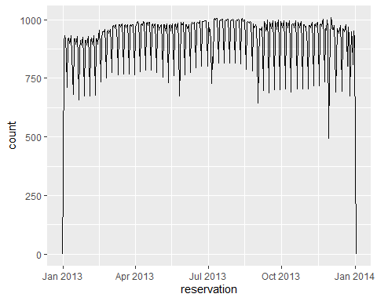

Q8. Using three lines of code for Q6, please add three additional codes to make a new column called w_reservation that contains days of the week for reservation column and its label and then a bar plot of w_reservation applying ggplot() and geom_bar() functions

flights %>%  
 select(year, month, day, hour, minute)%>%  
 mutate(reservation = make_datetime(year, month, day, hour, minute))%>%  
 mutate(w_reservation = wday(reservation, label = TRUE)) %>%  
 ggplot(aes(x = w_reservation)) +  
 geom_bar()

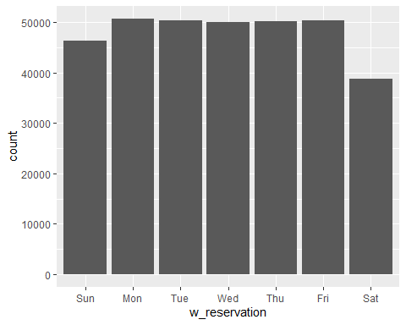

Q9. Bill Gates was born in Seattle on October 28, 1955. What day of the week was he born? Provide two lines of code for this question and exact answer.

thatday <- mdy("october 28th 1955")  
wday(thatday, label = TRUE, abbr = FALSE)

## [1] Friday  
## 7 Levels: Sunday < Monday < Tuesday < Wednesday < Thursday < ... < Saturday

"He was born on Friday"

## [1] "He was born on Friday"

Q10. What is the time difference (as days) between today and Bill Gates birthday? Provide a line of code for this question and exact answer.

today() - mdy("october 28th 1955")

## Time difference of 24265 days