Inclass Assignment (2)

Akshar Patel

1/26/2022

# Data visualization using ggplot2 package

install.packages("ggplot2")

## Error in contrib.url(repos, "source"): trying to use CRAN without setting a mirror

library("ggplot2")

## Warning in register(): Can't find generic `scale_type` in package ggplot2 to  
## register S3 method.

Q1. Replace the current author name with your name in YAML part above.

Q2. What are three components for a single plot of ggplot2?

#Data  
#geom  
#mapping  
Q3. A line of code that shows a help page for ggplot2

## Error: <text>:4:5: unexpected symbol  
## 3: #mapping  
## 4: Q3. A  
## ^

help("ggplot2")

## starting httpd help server ... done

## 2) Data preview

Q4. A line of code that shows midwest data as a table

View(midwest)

Q5. A line of code that shows midwest data summary

summary(midwest)

## PID county state area   
## Min. : 561 Length:437 Length:437 Min. :0.00500   
## 1st Qu.: 670 Class :character Class :character 1st Qu.:0.02400   
## Median :1221 Mode :character Mode :character Median :0.03000   
## Mean :1437 Mean :0.03317   
## 3rd Qu.:2059 3rd Qu.:0.03800   
## Max. :3052 Max. :0.11000   
## poptotal popdensity popwhite popblack   
## Min. : 1701 Min. : 85.05 Min. : 416 Min. : 0   
## 1st Qu.: 18840 1st Qu.: 622.41 1st Qu.: 18630 1st Qu.: 29   
## Median : 35324 Median : 1156.21 Median : 34471 Median : 201   
## Mean : 96130 Mean : 3097.74 Mean : 81840 Mean : 11024   
## 3rd Qu.: 75651 3rd Qu.: 2330.00 3rd Qu.: 72968 3rd Qu.: 1291   
## Max. :5105067 Max. :88018.40 Max. :3204947 Max. :1317147   
## popamerindian popasian popother percwhite   
## Min. : 4.0 Min. : 0 Min. : 0 Min. :10.69   
## 1st Qu.: 44.0 1st Qu.: 35 1st Qu.: 20 1st Qu.:94.89   
## Median : 94.0 Median : 102 Median : 66 Median :98.03   
## Mean : 343.1 Mean : 1310 Mean : 1613 Mean :95.56   
## 3rd Qu.: 288.0 3rd Qu.: 401 3rd Qu.: 345 3rd Qu.:99.07   
## Max. :10289.0 Max. :188565 Max. :384119 Max. :99.82   
## percblack percamerindan percasian percother   
## Min. : 0.0000 Min. : 0.05623 Min. :0.0000 Min. :0.00000   
## 1st Qu.: 0.1157 1st Qu.: 0.15793 1st Qu.:0.1737 1st Qu.:0.09102   
## Median : 0.5390 Median : 0.21502 Median :0.2972 Median :0.17844   
## Mean : 2.6763 Mean : 0.79894 Mean :0.4872 Mean :0.47906   
## 3rd Qu.: 2.6014 3rd Qu.: 0.38362 3rd Qu.:0.5212 3rd Qu.:0.48050   
## Max. :40.2100 Max. :89.17738 Max. :5.0705 Max. :7.52427   
## popadults perchsd percollege percprof   
## Min. : 1287 Min. :46.91 Min. : 7.336 Min. : 0.5203   
## 1st Qu.: 12271 1st Qu.:71.33 1st Qu.:14.114 1st Qu.: 2.9980   
## Median : 22188 Median :74.25 Median :16.798 Median : 3.8142   
## Mean : 60973 Mean :73.97 Mean :18.273 Mean : 4.4473   
## 3rd Qu.: 47541 3rd Qu.:77.20 3rd Qu.:20.550 3rd Qu.: 4.9493   
## Max. :3291995 Max. :88.90 Max. :48.079 Max. :20.7913   
## poppovertyknown percpovertyknown percbelowpoverty percchildbelowpovert  
## Min. : 1696 Min. :80.90 Min. : 2.180 Min. : 1.919   
## 1st Qu.: 18364 1st Qu.:96.89 1st Qu.: 9.199 1st Qu.:11.624   
## Median : 33788 Median :98.17 Median :11.822 Median :15.270   
## Mean : 93642 Mean :97.11 Mean :12.511 Mean :16.447   
## 3rd Qu.: 72840 3rd Qu.:98.60 3rd Qu.:15.133 3rd Qu.:20.352   
## Max. :5023523 Max. :99.86 Max. :48.691 Max. :64.308   
## percadultpoverty percelderlypoverty inmetro category   
## Min. : 1.938 Min. : 3.547 Min. :0.0000 Length:437   
## 1st Qu.: 7.668 1st Qu.: 8.912 1st Qu.:0.0000 Class :character   
## Median :10.008 Median :10.869 Median :0.0000 Mode :character   
## Mean :10.919 Mean :11.389 Mean :0.3432   
## 3rd Qu.:13.182 3rd Qu.:13.412 3rd Qu.:1.0000   
## Max. :43.312 Max. :31.162 Max. :1.0000

Q6. A line of code that shows midwest data column name

colnames(midwest)

## [1] "PID" "county" "state"   
## [4] "area" "poptotal" "popdensity"   
## [7] "popwhite" "popblack" "popamerindian"   
## [10] "popasian" "popother" "percwhite"   
## [13] "percblack" "percamerindan" "percasian"   
## [16] "percother" "popadults" "perchsd"   
## [19] "percollege" "percprof" "poppovertyknown"   
## [22] "percpovertyknown" "percbelowpoverty" "percchildbelowpovert"  
## [25] "percadultpoverty" "percelderlypoverty" "inmetro"   
## [28] "category"

Q7 A line of code that shows unique values in state column of midwest data

unique(midwest$state)

## [1] "IL" "IN" "MI" "OH" "WI"

Q8. A line of code that assigns popamerindian column as x position and popasian column as y position of midwest data to a variable myplot using ggplot function

myplot <- ggplot(data = midwest, aes(x = popamerindian, y = popasian))

Q9. Two lines of code that create a scatter plot of a variable myplot that you have made in Q8

myplot +  
 geom_point()

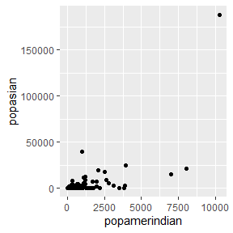

Q10. Three lines of code that create subplots (three rows) by state column using two lines of code for Q9.

myplot <- ggplot(data = midwest, aes(x = popamerindian, y = popasian))   
myplot +  
 geom_point()

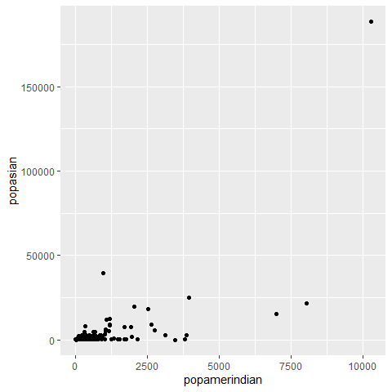

#### End of document