Inclass Assignment (3)

Akshar Patel

2/2/2022

# Data visualization using ggplot2 package (2)

### If you want to make a presentation to review this assignment next Monday, please reach me at [jlim13@uncc.edu](mailto:jlim13@uncc.edu)

### If you don’t know the answer, leave it blank. If you are caught cheating, you will be given minus 50 points.

Q1. Replace the author name with your name in YAML part above.

Q2. The first method for a quick overview of msleep data

summary(msleep)

## name genus vore order   
## Length:83 Length:83 Length:83 Length:83   
## Class :character Class :character Class :character Class :character   
## Mode :character Mode :character Mode :character Mode :character   
##   
##   
##   
##   
## conservation sleep_total sleep_rem sleep_cycle   
## Length:83 Min. : 1.90 Min. :0.100 Min. :0.1167   
## Class :character 1st Qu.: 7.85 1st Qu.:0.900 1st Qu.:0.1833   
## Mode :character Median :10.10 Median :1.500 Median :0.3333   
## Mean :10.43 Mean :1.875 Mean :0.4396   
## 3rd Qu.:13.75 3rd Qu.:2.400 3rd Qu.:0.5792   
## Max. :19.90 Max. :6.600 Max. :1.5000   
## NA's :22 NA's :51   
## awake brainwt bodywt   
## Min. : 4.10 Min. :0.00014 Min. : 0.005   
## 1st Qu.:10.25 1st Qu.:0.00290 1st Qu.: 0.174   
## Median :13.90 Median :0.01240 Median : 1.670   
## Mean :13.57 Mean :0.28158 Mean : 166.136   
## 3rd Qu.:16.15 3rd Qu.:0.12550 3rd Qu.: 41.750   
## Max. :22.10 Max. :5.71200 Max. :6654.000   
## NA's :27

Q3. The second method for a quick overview of msleep data

str(msleep)

## tibble [83 x 11] (S3: tbl_df/tbl/data.frame)  
## $ name : chr [1:83] "Cheetah" "Owl monkey" "Mountain beaver" "Greater short-tailed shrew" ...  
## $ genus : chr [1:83] "Acinonyx" "Aotus" "Aplodontia" "Blarina" ...  
## $ vore : chr [1:83] "carni" "omni" "herbi" "omni" ...  
## $ order : chr [1:83] "Carnivora" "Primates" "Rodentia" "Soricomorpha" ...  
## $ conservation: chr [1:83] "lc" NA "nt" "lc" ...  
## $ sleep_total : num [1:83] 12.1 17 14.4 14.9 4 14.4 8.7 7 10.1 3 ...  
## $ sleep_rem : num [1:83] NA 1.8 2.4 2.3 0.7 2.2 1.4 NA 2.9 NA ...  
## $ sleep_cycle : num [1:83] NA NA NA 0.133 0.667 ...  
## $ awake : num [1:83] 11.9 7 9.6 9.1 20 9.6 15.3 17 13.9 21 ...  
## $ brainwt : num [1:83] NA 0.0155 NA 0.00029 0.423 NA NA NA 0.07 0.0982 ...  
## $ bodywt : num [1:83] 50 0.48 1.35 0.019 600 ...

Q4. A line of code that returns unique values in vore column of msleep

unique(msleep$vore)

## [1] "carni" "omni" "herbi" NA "insecti"

Q5. A line of code that assigns vore column as x position of msleep data to a variable msleep_plot using ggplot function

msleep_plot <- ggplot(data = msleep, aes (x = vore))

Q6. Two lines of code that will return a bar plot of the msleep_plot variable

msleep_plot <- ggplot(data = msleep, aes(x = vore))  
  
msleep_plot +   
 geom_bar()

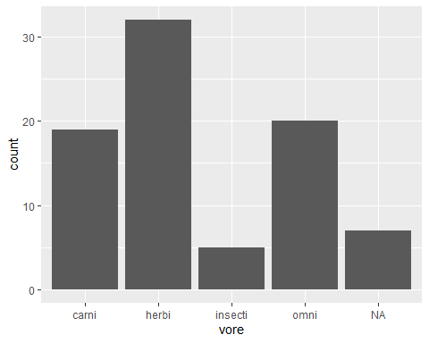

Q7. Five lines of code that will return a bar plot of the msleep_plot variable with a title Plot of count by vore. X-axis is labeled as vore and y-axis as count.

msleep_plot +   
 geom_bar() +  
 ggtitle("Plot of count by vore") +  
 xlab("Vore") +   
 ylab("count")

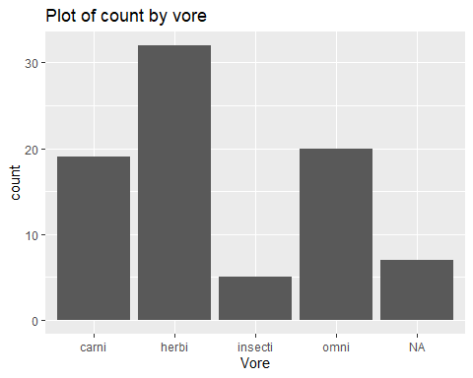

Q8. A line of code that assigns vore column as x position, proportion as “y” column of msleep data to a variable `msleep_prop’

msleep_prop <- ggplot(data = msleep, aes(x = vore, y = ..prop.., group = 1))

Q9. Five lines of code that will return a bar plot of the msleep_prop variable with a title Plot of proportion by vore. X-axis is labeled as vore and y-axis as proportion.

msleep_prop+  
 geom_bar()+  
 ggtitle("Plot of proportion by vore")+  
 xlab("vore")+  
 ylab("proportion")

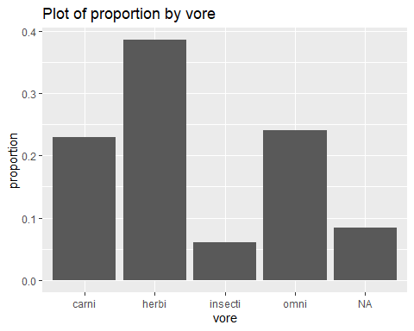

Q10. Two lines of code that will directly create a simple stacked bar plot that shows the count by vore column of msleep data with filling color by conservation column

ggplot(data =msleep, aes(x = vore, fill = conservation)) +   
 geom_bar()

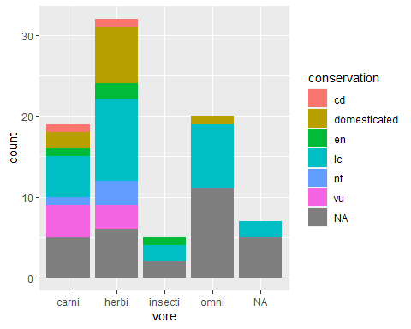

### *End of document*