1. Setting Up The Application

First add the certificate present at the following location

https://github.com/AksharTechnologies/PoojansTask/blob/master/ssl/ca.crt

in Authorities of Certificate Manager of your browser . Below is the image of the certificate that was added by me in firefox . The certificate gets added as Test CA.

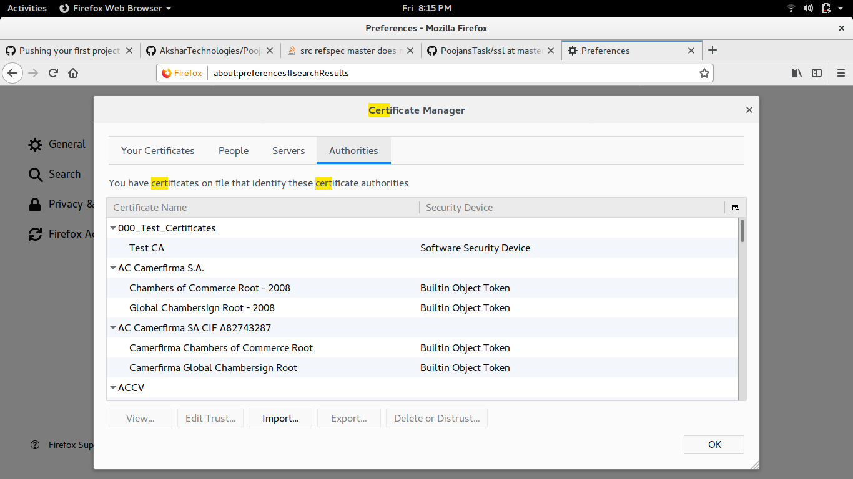
This should be done to ensure your application runs as a https application . Google Map API supports only https application and hence I had to make my application a https application .

2.Running The Application

Once this is done we can run the application . The url by which the application can be accessed is

https://localhost:3443/login/loginview . This can be seen in the image below
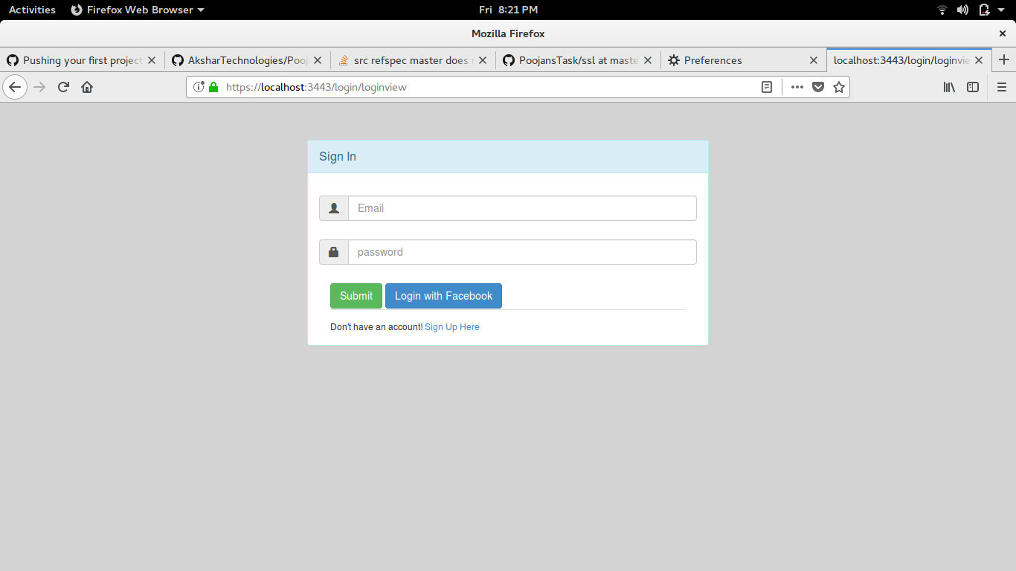

3. Signing Up

To sign up user should click the “sign up here “ link present at the bottom of the login form as seen in the image above. The sign up page can be seen in the image below .

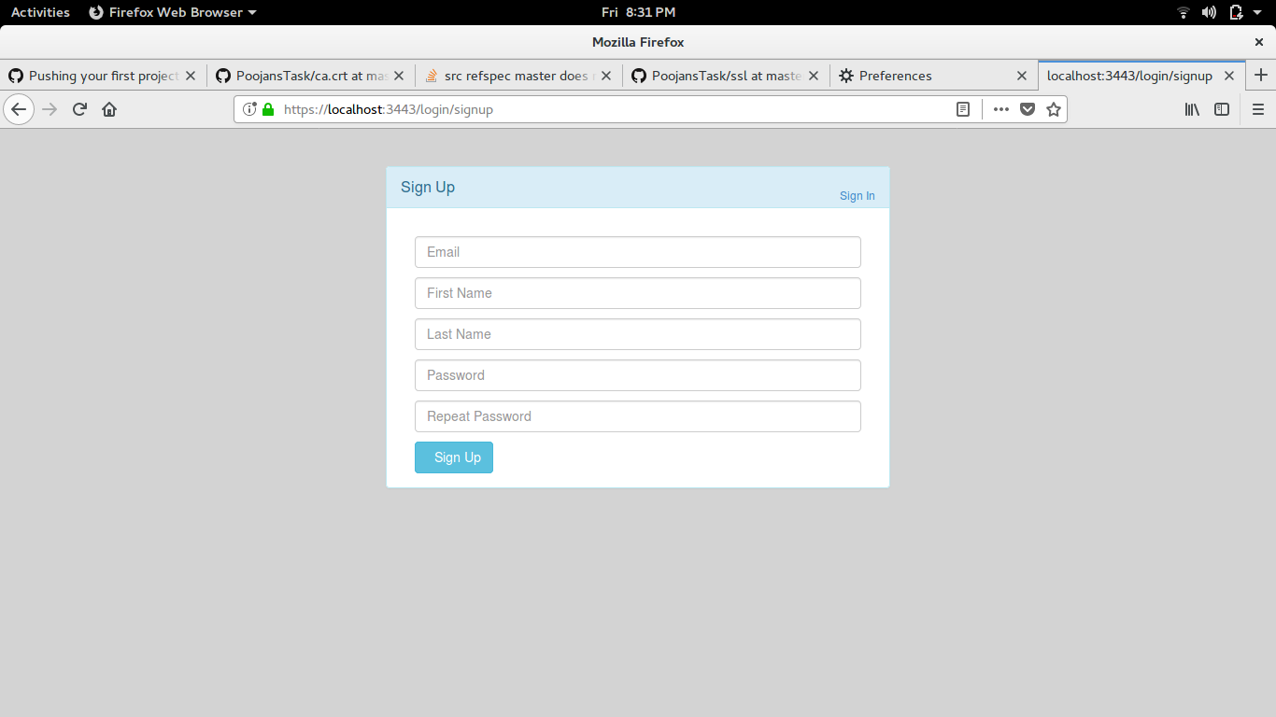

User can fill the form and can register him self . Once the user gets registered the user is navigated back to the login page where the user can login into the application with his credentials as shown in the image below .

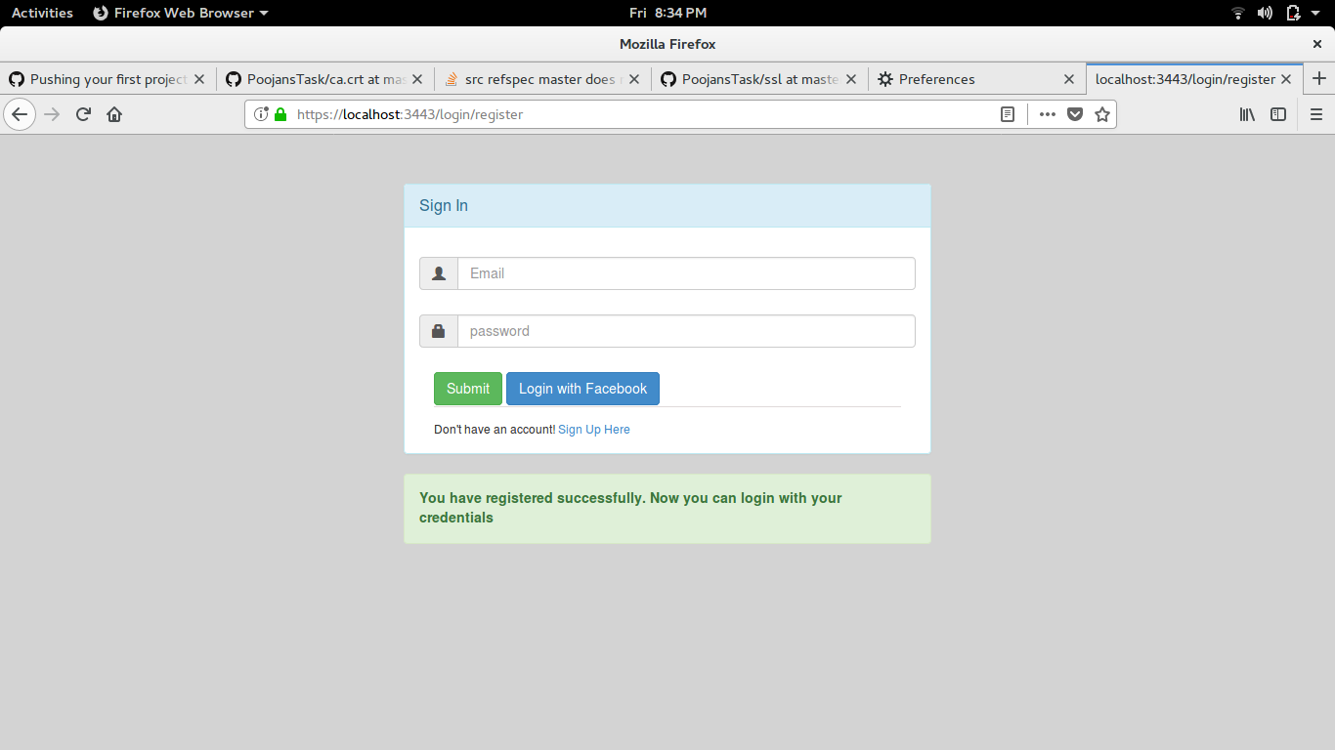
4.Login

User can log into the application by his credentials .

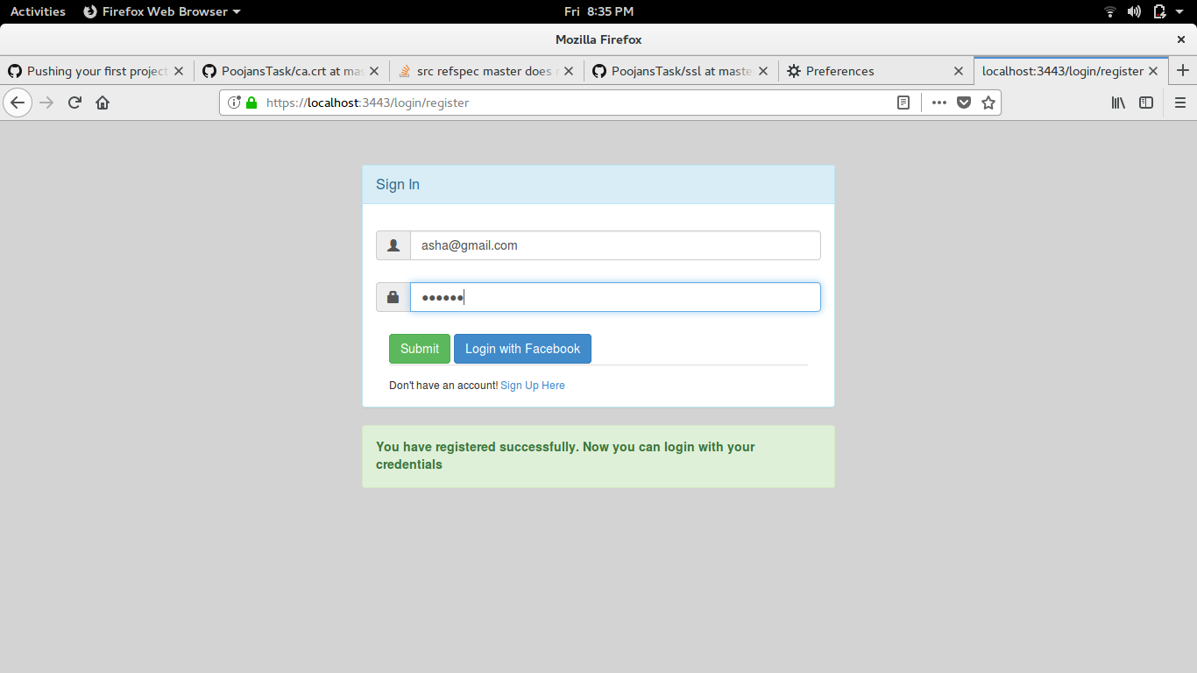

Once the user logs into the application he can see his current location on google map along with his details as shown in the below image

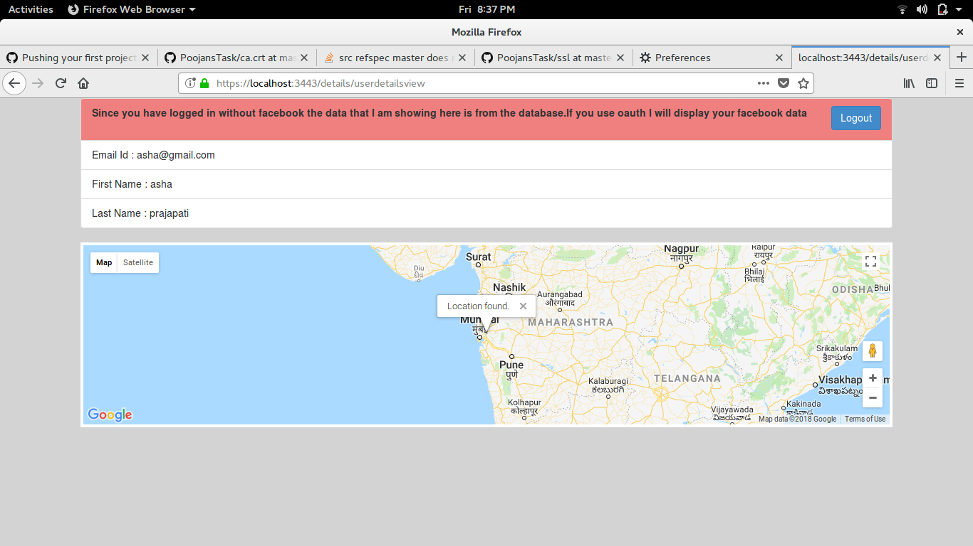

Since the user has not used facebook oauth his face book details are not shown . Details of the user which are saved in the mongodb database are shown .

5. Users Who Log Through Facebook Oauth

When the user clicks on “Login with Facebook” button user gets directed towards
Facebook login page as shown in the image below

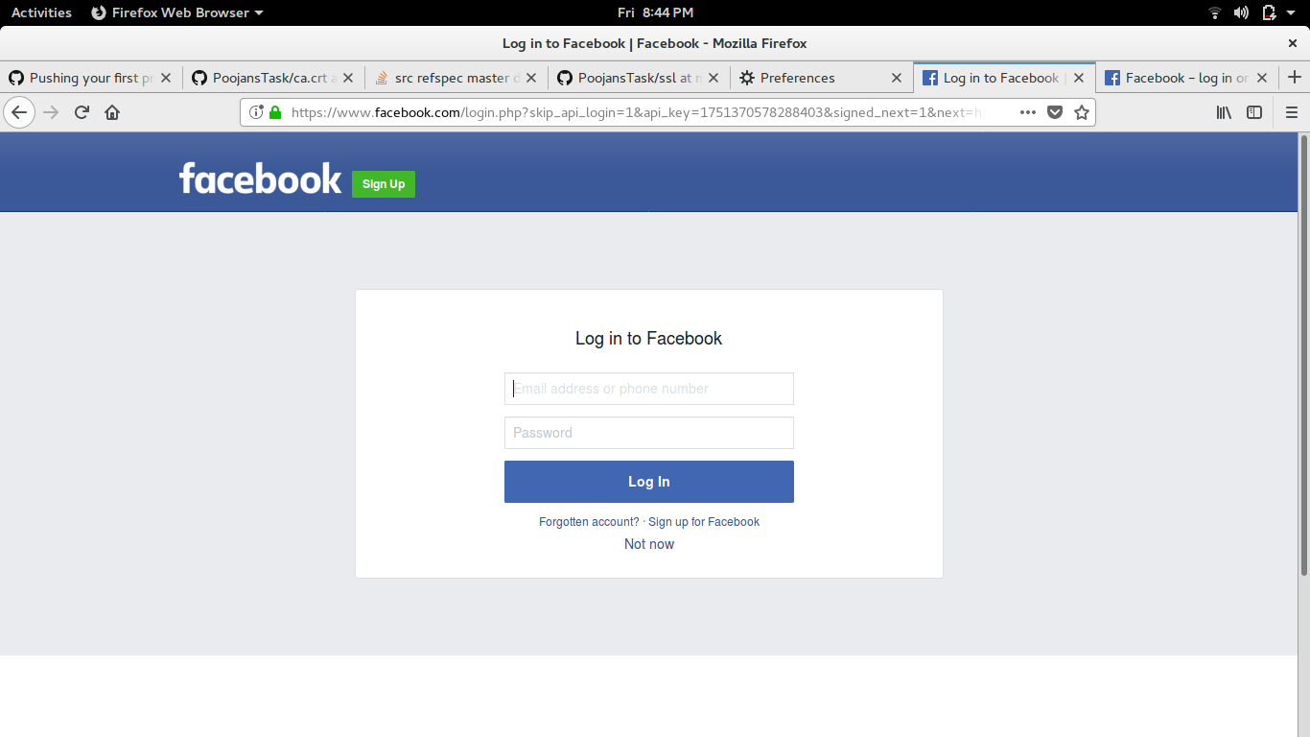
User then can fill his credentials and after that the users image and likes are fetched from facebook and are displayed on the next page which can be seen in the below two images .

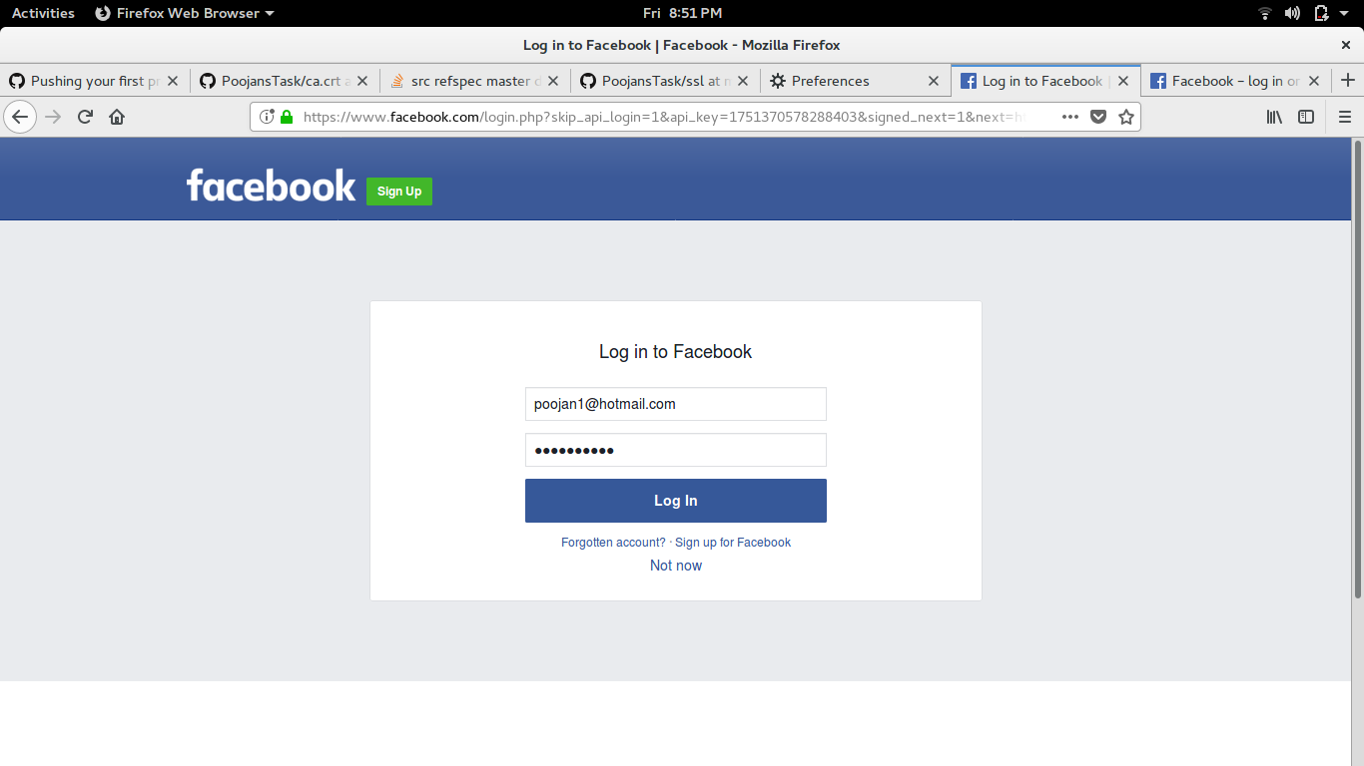

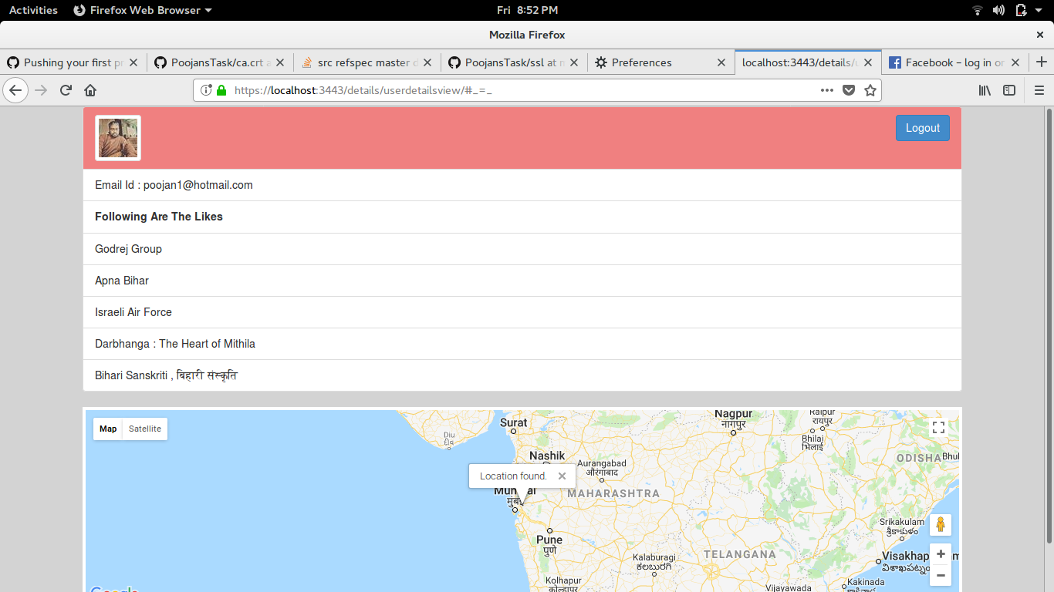
The logout button seen in the above image is used to logout from the application .

