|  |  |
| --- | --- |
| **Ex. 2** | **EXPLORING OPERATORS AND EXPRESSIONS** |
| **Date: 29.01.24** | |

# Aim:

To explore the use of operators and expressions in Python by writing programs for the

following and executing them:

1. Get the dimensions (floating point values) of a triangle, parallelogram, cylinder, cone, sphere, and rectangular prism, calculate each of their areas and display the result as a floating-point number approximated to 2 decimal places.
2. Calculate the simple interest and compound interest, given the principal amount (P), rate of interest (R), term of deposit (T) (in years), and number of times interest is compounded in a year (n) from the user. Display the result rounded off to 4 decimal places.
3. Calculate the salary of an employee of a company in terms of the basic pay, dearness allowance (DA), and house rent allowance (HRA). The DA and HRA are set as a certain percentage of the basic pay. Further, the company deducts 12% of the basic pay for PF. Compute the salary that would be received by an employee given the basic pay, percentage of basic pay for DA, and percentage of basic pay for HRA and print it, rounded off to the nearest integer. (Salary = Basic Pay + DA + HRA - PF)
4. Implement the following using functions from the math module and print the results in the scientific notation, approximated to 2 decimal places. Get the values for the variables involved from the user:

(i) 𝐴𝑐𝑜𝑠𝜃 − 𝐵𝑠𝑖𝑛(𝜃)

(ii) 𝐴𝑐𝑜𝑠(2𝜋𝑛)

* 1. 𝑒𝑎𝑛
  2. Euclidean distance between two points (x1, x2) and (y1, y2) (Use the formula for Euclidean distance - √(𝑥1 − 𝑥2)2 + (𝑦1 − 𝑦2)2)
  3. Convert an angle theta from radians to degrees.
  4. Find the base 10 and base 2 logarithm of a floating-point number x.

1. Obtain 2 decimal numbers from the user, display them in binary, octal, and hexadecimal forms, perform the logical operations (and, or, not, left and right shift) and print the results in binary and decimal forms.

# Algorithm: (a)

Step 1:Get the input from the user

Step 2: Substitute in the necessary formula

Step 3:Display the output

# (b)

Step 1:Get the input from the user

Step 2:Substitute in the formula

Step 3:Display the output

# (c)

Step 1:Collect the salary details of the employee as input

Step 2:Calculate the total salary

Step 3:Display the output

# (d)

Step 1:Get the input from the user

Step 2:Perform necessary operations

Step 3:Display the output

# (e)

Step 1:Get the input the from the user in decimal

Step 2:Convert to other forms using functions like hec(),bin(),oct()

Step 3:Display the output

(f)

Step 1: Get the values of a,b and c from the user

Step 2: Import cmath module and calculate discriminant

Step 3:Display the output

# Program:

(a)

print("Enter the dimensions of TRIANGLE:")

b1=float(input("h:"))

h1=float(input("b:"))

a1=0.5*b1*h1

print("Area of triangle:",round(a1,2))

print("Enter the dimensions of PARALLELOGRAM:")

b2=float(input("b:"))

h2=float(input("h:"))

a2=b2*h2

print(“Area of parallelogram:”,round(a2,2))

print("Enter the dimensions of cylinder:") r3=float(input("r:"))

h3=float(input("h:")) a3=2*3.14*r3*(r3+h3)

print("Area of Cylinder:",round(a3,2)) print("Enter the dimensions of Cone:") r4=float(input("r:"))

l4=float(input("l:")) a4=3.14*r4*(r4+l4)

print("Area of cone:",round(a4,2)) print("Enter the dimensions of sphere:") r5=float(input("r:"))

a5=4*3.14*r5*r5

print("Area of sphere:",round(a5,2))

print("Enter the dimensions of rectangular prism:") w6=float(input("W:"))

l6=float(input("L:"))

h6=float(input("H:")) a6=2*(w6*l6+h6*l6+h6*w6)

print("Area of Rectangular prism:",round(a6,2))

(b)

p=int(input("Enter the principal amount:"))

r=int(input("Enter the Rate of interest:"))

t=int(input("Enter the term of deposit:"))

n=int(input("Enter the number of times interest is compounded in a year:"))

si=(p*r*t)/100

ci=p*(1+r/n)**(n*t)-p

print("SIMPLE INTEREST:",si)

print("COMPOUND INTEREST:",ci)

(c)

basic_pay=float(input("Enter the basic pay of the employee:"))

da_p=float(input("Enter the percentage of dearness allowance:"))

hra_p=float(input("Enter the percentage of house rent allowance:"))

pf=0.12*basic_pay

da=da_p/100*basic_pay

hra=hra_p/100*basic_pay

salary=basic_pay+da+hra-pf

print("Salary of the employee:",salary)

(d)

import math

a=int(input("Enter the value of A:"))

b=int(input("Enter the value of B:"))

pi=3.14

print('a')

theta=int(input("Enter the angle:"))

c=a*(math.cos(theta))-b*math.sin(theta)

print(c)

print('b')

n=int(input("Enter the value of n:"))

d=a*math.cos(2*pi*n)

print(d)

print('c')

print(math.exp(a*n))

print('d')

x1=int(input("Enter the x coordinate of point 1:"))

y1=int(input("Enter the y coordinate of point 1:"))

x2=int(input("Enter the x coordinate of point 2:"))

y2=int(input("Enter the y coordinate of point 2:"))

print("Euclidean Distance:",math.dist((x1,y1),(x2,y2)))

print('e')

theta1=int(input("Enter the angle in radians:"))

print("Angle in degrees:",math.degrees(theta1))

print('f')

x=int(input("Enter the value of x:"))

print(math.log(x,10))

print(math.log(x,10))

(e)

x1=int(input("Enter the first decimal number:"))

x2=int(input("Enter the second decimal number:"))

print("DISPLAYTING:")

print("Binary form:",bin(x1),bin(x2))

print("Octal form:",oct(x1),oct(x2))

print("Hexadecimal form:",hex(x1),hex(x2))

and_op= x1 and x2

or_op=x1 or x2

not_op1=not x1

not_op2=not x2

left=x1<<1

right=x2>>1

print("RESULT IN BINARY:")

print("AND:",bin(and_op))

print("OR:",bin(or_op))

print("NOT of X1:",bin(not_op1))

print("NOT of X2:",bin(not_op2))

print("LEFT SHIFT:",bin(left))

print("RIGHT SHIFT:",bin(right))

print("RESULT IN DECIMAL")

print("AND:",and_op)

print("OR:",or_op)

print("NOT of X1:",not_op1)

print("NOT of X2:",not_op2)

print("LEFT SHIFT:",left)

print("RIGHT SHIFT:",right)

(f)

import cmath

print("ax^2+bx+c")

a=int(input("Enter the value of a:"))

b=int(input("Enter the value of b:"))

c=int(input("Enter the value of c:"))

discri=b*b -4*a*c

dis=cmath.sqrt(discri)

if discri==0:

  print("It has a single solution:",-b/(2*a))

elif discri>0:

  print("It has 2 unique solutions:",-b+dis/(2*a),-b-dis/(2*a))

elif discri<0:

  print("It has conjugate roots")

print("First solution:",-b/(2*a),dis/(2*a))

print("second solution:",-b/(2*a),-dis/(2*a))

# Screenshot of Output:(a)

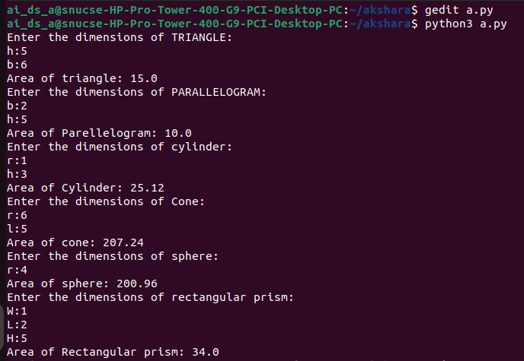

**(b)**

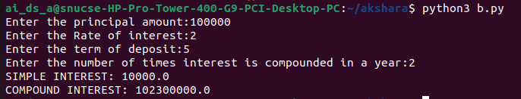

# (c)

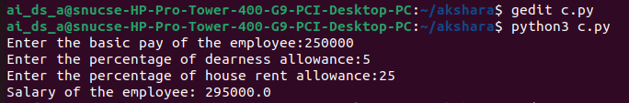

**(d)**

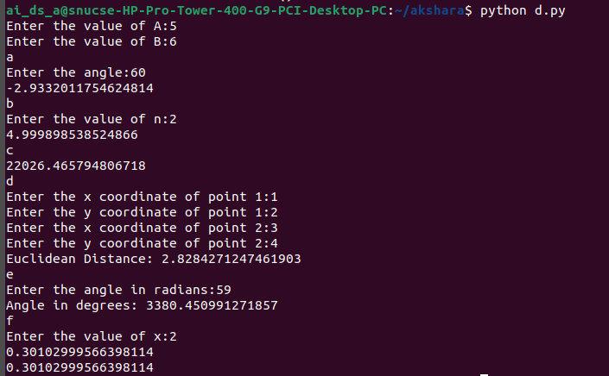

# (e)

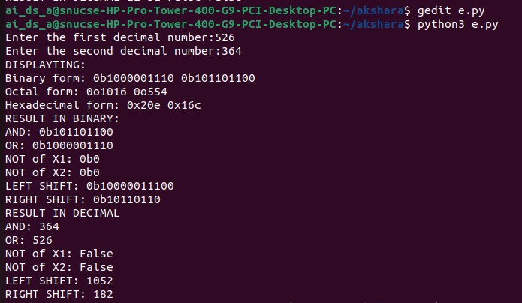

**(f)**

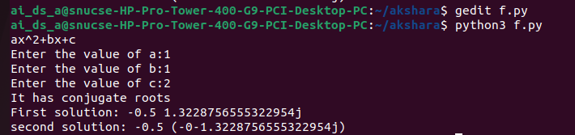

# Result:

Thus, programs have been written and executed to explore the use of operators and expressions in Python.