PROGRAM-1

AIM: Define a class ‘product’ with data members pcode, pname and price. Create 3 objects of the class and find the product having the lowest price.

class product{
int pcode;
String name;
double price;

public product (int pcode,String name,double price){
this.pcode=pcode;
this.name=name;
this.price=price;
}}
public class product{
public static void main(String[] args){
System.out.println("Akshara Anilkumar\n23mca009\n13-FEB-2024");
product p1=new product(1,"Apple",230);
product p2=new product(2,"Orange",150);
product p3=new product(3,"Grape",180);
product lowest=p1;

if(p2.price<lowest.price){
lowest=p2;
}
else if (p3.price<lowest.price){
lowest=p3;
}

System.out.println("\n The product having the lowest price is " +lowest.name+ " with price " +lowest.price);
}}

Output

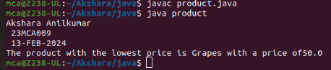

PROGRAM-2

AIM: Read 2 matrices from the console and perform matrix addition.
import java.util.Scanner;
public class MatrixAdd{
public static void main(String[] args) {
System.out.println("Akshara Anilkumar \n 23MCA009 \n 13-FEB-2024");
Scanner scanner = new Scanner(System.in);
System.out.print("Enter the number of rows: ");
int rows = scanner.nextInt();
System.out.print("Enter the number of columns: ");
int cols = scanner.nextInt();
int[][] matrix1 = new int[rows][cols];
System.out.println("Enter the values for matrix 1:");
for (int i = 0; i < rows; i++) {
for (int j = 0; j < cols; j++) {
matrix1[i][j] = scanner.nextInt();
}
}
int[][] matrix2 = new int[rows][cols];
System.out.println("Enter the values for matrix 2:");
for (int i = 0; i < rows; i++) {
for (int j = 0; j < cols; j++) {
matrix2[i][j] = scanner.nextInt();
}
}
int[][] result = new int[rows][cols];
for (int i = 0; i < rows; i++) {
for (int j = 0; j < cols; j++) {
result[i][j] = matrix1[i][j] + matrix2[i][j];
}
}
System.out.println("Results:");
for (int i = 0; i < rows; i++) {
for (int j = 0; j < cols; j++) {
System.out.print(result[i][j] + " ");
}
System.out.println();
}
scanner.close();
}
}

Output

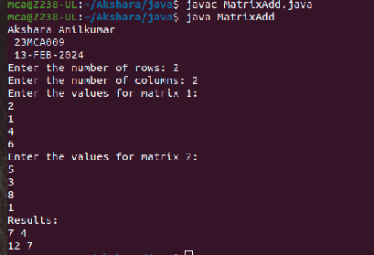

PROGRAM-3

AIM: Add complex numbers

public class ComplexNumber {
private double real;
private double imaginary;
public ComplexNumber(double real, double imaginary) {
this.real = real;
this.imaginary = imaginary;
}
public ComplexNumber add(ComplexNumber other) {
double newReal = this.real + other.real;
double newImaginary = this.imaginary + other.imaginary;
return new ComplexNumber(newReal, newImaginary);
}
public String toString() {
if (imaginary >= 0) {
return real + " + " + imaginary + "i";
} else {
return real + " - " + (-imaginary) + "i";
}
}
public static void main(String[] args) {
System.out.println("Akshara Anilkumar \n 23MCA009 \n 13-FEB-2024");
ComplexNumber num1 = new ComplexNumber(2, 3);
ComplexNumber num2 = new ComplexNumber(4, -1);
ComplexNumber sum = num1.add(num2);
System.out.println(num1 + " + " + num2 + " = " + sum);
}
}

Output
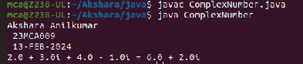

PROGRAM-4
AIM: Read a matrix from the console and check whether it is symmetric or not.

import java.util.Scanner;
public class MatrixSymmetryChecker {
public static void main(String[] args) {
System.out.println("Abin Joseph \n 22MCA002 \n 28-MARCH-2023");
Scanner input = new Scanner(System.in);
System.out.print("Enter the number of rows in the matrix: ");
int rows = input.nextInt();
System.out.print("Enter the number of columns in the matrix: ");
int cols = input.nextInt();
int[][] matrix = new int[rows][cols];
System.out.println("Enter the elements of the matrix:");
for (int i = 0; i < rows; i++) {
for (int j = 0; j < cols; j++) {
matrix[i][j] = input.nextInt();
}
}
boolean isSymmetric = true;
for (int i = 0; i < rows; i++) {
for (int j = 0; j < cols; j++) {
if (matrix[i][j] != matrix[j][i]) {
isSymmetric = false;
break;
}
}
if (!isSymmetric) {
break;
}
}
if (isSymmetric) {
System.out.println("The matrix is symmetric.");
} else {
System.out.println("The matrix is not symmetric.");
}
}
}
Output

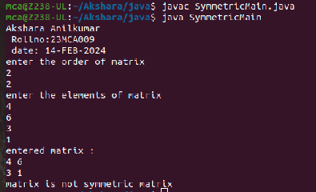
PROGRAM-5
AIM: Create CPU with attribute price. Create inner class Processor (no. of cores,
manufacturer) and static nested class RAM (memory, manufacturer). Create an object of CPU and print information of Processor and RAM.

public class CPU {
private double price;
private Processor processor;
private RAM ram;
public CPU(double price, Processor processor, RAM ram) {
this.price = price;
this.processor = processor;
this.ram = ram;
}
public double getPrice() {
return price;
}
public Processor getProcessor() {
return processor;
}
public RAM getRam() {
return ram;
}
public static class Processor {
private int numberOfCores;
private String manufacturer;
public Processor(int numberOfCores, String manufacturer) {
this.numberOfCores = numberOfCores;
this.manufacturer = manufacturer;
}
public int getNumberOfCores() {
return numberOfCores;
}
public String getManufacturer() {
return manufacturer;
}
}
public static class RAM {
private int memory;
private String manufacturer;
public RAM(int memory, String manufacturer) {
this.memory = memory;
this.manufacturer = manufacturer;
}
public int getMemory() {
return memory;
}
public String getManufacturer() {
return manufacturer;
}
}
public static void main(String[] args) {
System.out.println("Abin Joseph \n 22MCA002 \n 28-MARCH-2023");
Processor processor = new Processor(4, "Intel");
RAM ram = new RAM(8, "Kingston");
CPU cpu = new CPU(500.0, processor, ram);
System.out.println("CPU Price: " + cpu.getPrice());
System.out.println("Processor: " + cpu.getProcessor().getManufacturer() + " " +
cpu.getProcessor().getNumberOfCores() + " cores");
System.out.println("RAM: " + cpu.getRam().getManufacturer() + " " + cpu.getRam().getMemory() + "
GB");
}
}

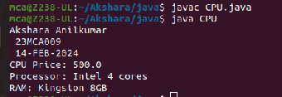
Output

