Escape Room Puzzle Game
User Flow Diagram
Based strictly on the Software Requirements Specification (SRS) and Project Synopsis

Submitted in partial fulfilment of the requirements for the award of the degree of
BACHELOR OF TECHNOLOGY
in COMPUTER SCIENCE AND ENGINEERING
Submitted by
Akshara Kamboj | 22515000014
2nd Year, B.Tech (Computer Science & Engineering)
Under the Guidance of
Mr. Gautam Mukherjee
DEPARTMENT OF COMPUTER SCIENCE AND ENGINEERING
GLA University
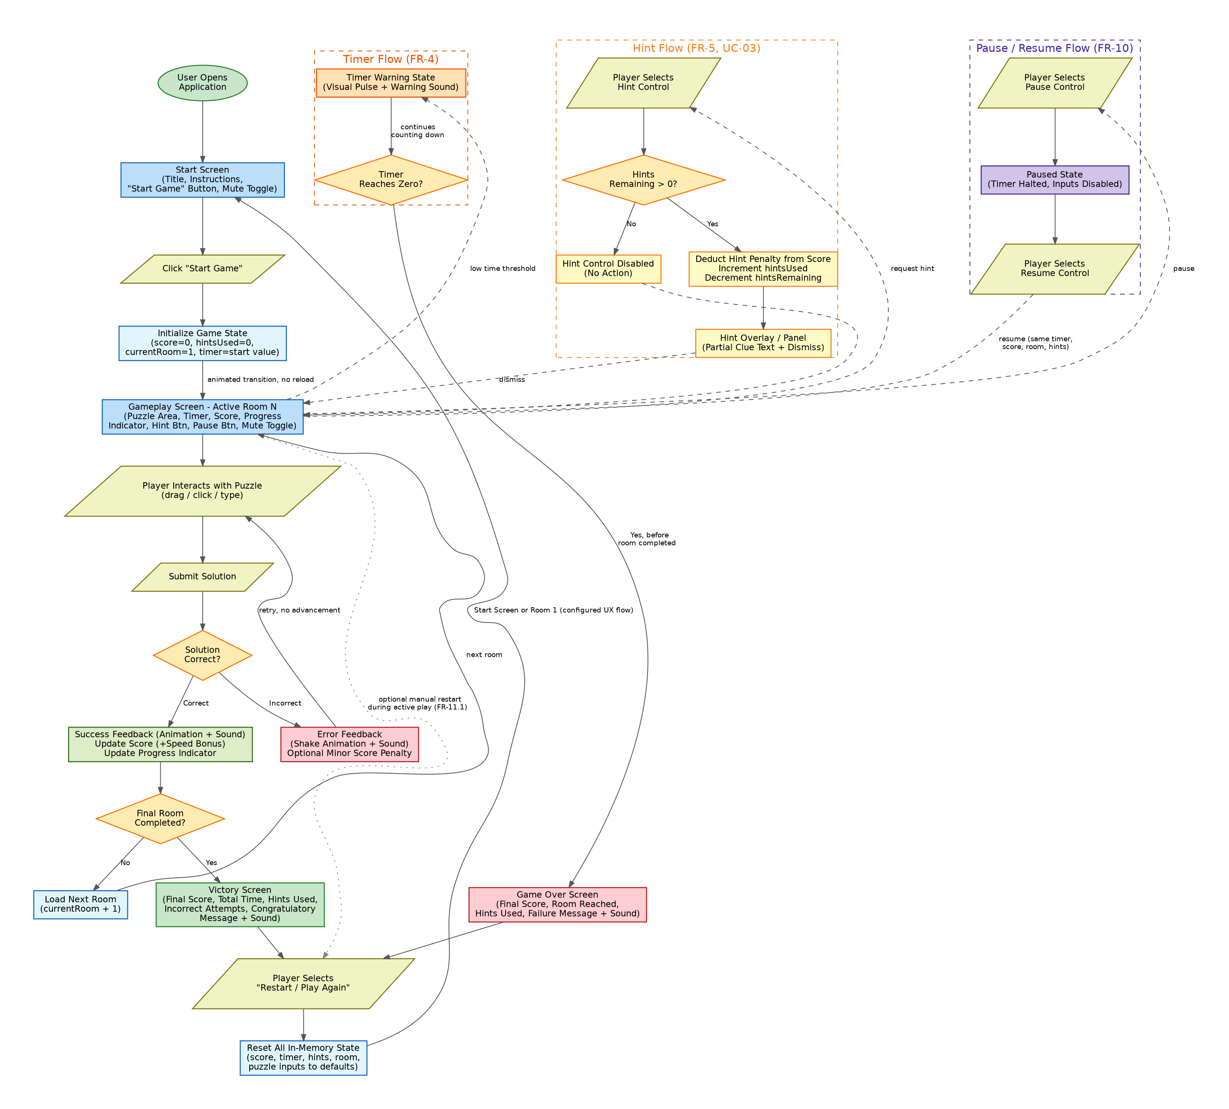
Figure 1: Complete player journey through the Escape Room Puzzle Game (client-side SPA, no backend/database/login).

1. Explanation of the Flow
The application is a single-page, client-side game (HTML5, CSS3, vanilla JavaScript) with all game state held in browser memory for the duration of a session (SRS Sections 1.2, 2.1, 6.1). The user flow below reflects the game state machine defined in SRS Section 6.4: IDLE → PLAYING → (PAUSED) → VICTORY / GAME_OVER → IDLE/PLAYING on restart.
On opening the application, the player lands on the Start Screen (FR-1.1). Selecting "Start Game" initializes all in-memory state — score, hints used, current room, and timer — and transitions to Room 1 via an animated, reload-free transition (FR-1.2–FR-1.3).
Each active room presents exactly one puzzle at a time (FR-2.2), which may be a Pattern Matching, Code-Cracking, Sequence Solving, or Riddle/Object-Based challenge (FR-3, Section 3.3). The player interacts with the puzzle UI and submits a solution, which the system validates against the room's configured answer (FR-2.3, UC-02). A correct submission triggers success feedback, a score update (including a possible speed bonus), and an update to the progress indicator (FR-2.4, FR-6.2, FR-7.2); the player then advances to the next room in the fixed sequence, or — if the final room was just solved — proceeds to the Victory Screen (FR-2.6). An incorrect submission produces non-blocking error feedback and, optionally, a minor score penalty, without losing progress; the player may retry (FR-2.5, UC-02 Alternate Flow).
At any point during an active room, the player may request a Hint. If hints remain, a score penalty is deducted, a partial (non-obvious) clue is shown in the Hint Overlay/Panel, and the hint counters are updated; if no hints remain, the Hint control is disabled and no clue is shown (FR-5, UC-03).
The player may also Pause active gameplay at any time, which halts the timer and disables puzzle inputs until Resume is selected, at which point the exact prior state (timer, score, room, hints) continues (FR-10).
The countdown timer runs continuously during active gameplay, displayed in MM:SS format. As it crosses a low-time threshold, a visual/audio warning state is applied (FR-4.4). If the timer reaches zero before the player completes the current objective, the system transitions directly to the Game Over Screen (FR-4.5, FR-9.1).
The Victory Screen (reached after the final room is solved) and the Game Over Screen (reached on timer expiry) each summarise the session — final score, time/room reached, and hints used — and both provide a "Restart / Play Again" control (FR-8, FR-9). Restart is also optionally available during active gameplay (FR-11.1). Selecting Restart resets all in-memory state to its initial defaults and returns the player to the Start Screen or directly to Room 1, per the configured UX flow (FR-11.2–FR-11.3, UC-04), re-entering the same flow described above.

2. Screens / Pages Represented in the Diagram
# | Screen / Page | Key Elements (per SRS)
1 | Start Screen | Game title, brief instructions/narrative, "Start Game" button, mute toggle (FR-1.1; Section 4.1)
2 | Gameplay Screen (per active Room) | Active puzzle area, countdown timer display (MM:SS), live score display, progress indicator, Hint button, Pause button, mute toggle (Section 4.1; FR-2, FR-4, FR-7)
3 | Hint Overlay / Panel | Non-blocking display of partial hint text with a close/dismiss control (Section 4.1; FR-5)
4 | Paused State | Gameplay screen with timer halted and puzzle inputs disabled, shown while paused (FR-10)
5 | Victory Screen | Congratulatory message/animation, celebratory sound, final score, total time taken, hints used, incorrect attempts (if tracked), Restart/Play Again control (FR-8)
6 | Game Over Screen | Failure message/animation and sound distinct from Victory, final score at failure, room reached, hints used, Restart/Play Again control (FR-9)

3. Decision Points and Possible Outcomes
Decision Point | Outcomes | Source
Solution Correct? | Correct -> success feedback, score update, progress indicator update, advance toward next room. Incorrect -> non-blocking error feedback (shake animation/sound), optional minor score penalty, player retries without losing progress. | FR-2.3–FR-2.5, UC-02
Final Room Completed? | No -> load next room in the fixed sequence. Yes -> transition to the Victory Screen. | FR-2.6, UC-02
Hints Remaining > 0? | Yes -> hint penalty deducted from score, partial clue displayed in the Hint Overlay, hintsUsed incremented / hintsRemaining decremented. No -> Hint control is disabled and shows no action; no clue is given. | FR-5.3–FR-5.6, UC-03
Player Pauses Game? | Yes -> timer halts and puzzle inputs are disabled (Paused State) until the player resumes. No -> gameplay continues uninterrupted. | FR-10.1–FR-10.3
Timer Reaches Zero? | Yes (before the active objective is completed) -> Game Over Screen is triggered. No -> countdown continues; a visual/audio warning state is applied once the timer crosses the low-time threshold. | FR-4.4–FR-4.5

4. Scope Notes
- The application is strictly front-end (HTML5, CSS3, vanilla JavaScript ES6+) with no backend server, REST API, database, or user login/authentication, consistent with SRS Sections 1.2, 2.4–2.5, 4.4, and 5.4, and Synopsis Sections 6 and 9.
- All game state (score, timer, hints, current room) exists only in browser memory for the session and is not persisted across page reloads (SRS Section 1.2, 2.5, 7.1).
- Backend/database integration, accounts, leaderboards, a level editor, multiplayer mode, and PWA packaging are explicitly listed as future enhancements and are out of scope for this flow (SRS Section 11; Synopsis Section 13).

