Advisor List Task Process Documentation
Prepared by Akshara Sarode
Project Schwab Independent Advisor Directory

Purpose and final output
This document records the steps used to turn the submitted advisor workbook into an interactive Power BI directory. It covers source preparation, the report layout, filter behavior, validation, export, and publication. The completed report supports firm-name and geographic selection, live summary counts, a sortable advisor table, and state and city comparisons.

Inputs and scope
Item | Role in the project
Submission File (Akshara).xlsx | Part 1 source workbook; the populated Schwab database sheet supplies advisor records.
Advisor Locations | Prepared Power BI table used by the dashboard visuals.
Advisor List Task - Power BI Dashboard.pbix | Editable Power BI report with imported data and two report pages.
Advisor List Task - Power BI Dashboard.pdf | Static two-page export for review and submission.

Result at the unfiltered view
The final report shows 2,570 distinct advisor firms, 51 state-level codes including DC, 1,314 displayed city names, and 2,133 ZIP codes. The imported Advisor Locations table has 4,397 location rows. A firm can appear at more than one location, so location rows and firm counts are different measures.

Report pages
- Advisor Directory is the main dashboard with the search dropdown, five KPI cards, four location slicers, advisor details, and two horizontal charts.
- Geographic Analysis provides a larger view of advisor firms by state and the top ten cities.

Part 1 source workflow
The supplied task brief and earlier process document describe a ZIP-based collection workflow from the public Find Your Independent Advisor directory: review each listing, record the firm name and CRD, capture available contact details, preserve the source ZIP and URL, and check records for duplicate CRDs and malformed fields. The submitted Excel workbook is the Part 1 output used here; this dashboard work did not repeat the scraping step.

Workflow at a glance
The work moved through five stages: review the submitted workbook, prepare the Advisor Locations model, assemble the report visuals, test linked firm and location selections, and export the final files. Each stage is described on the following pages with screenshots from the completed report.
The source workbook and the older Word documentation provide background for the task. Counts and page names in this document follow the final submitted report.

Data preparation and model

1 Import the Part 1 workbook
The submitted Excel workbook was brought into Power BI Service. The populated Schwab database sheet was used as the source. The first workbook row was not the final field-name row, so the import query promoted the actual headers and assigned usable data types before building visuals.

2 Prepare location fields
- A dedicated Advisor Locations table was used for the report visuals. The raw Schwab database query was retained in the model for traceability.
- Country was added as United States because the supplied records are U.S. advisor listings and the dashboard requires a Country filter.
- ZIP values were handled as five-character text, preserving leading zeros such as 07701.
- Firm ID was retained as the firm identifier; name, state, city, address, phone, email, website, and profile link support filtering and the details table.

3 Define count logic
Distinct firm counting is essential: the 4,397 rows describe locations, while the unfiltered directory contains 2,570 distinct firm IDs. The filtered firm card and state/city charts count unique firm IDs in the current selection. State, city, and ZIP cards count distinct values in the current filter context.
Metric | Unfiltered value | Behavior
Total Advisor Firms | 2,570 | Fixed baseline label for this imported snapshot
Filtered Advisor Count | 2,570 | Updates when slicers are applied
Unique States | 51 | Updates with filters
Unique Cities | 1,314 | Updates with filters
Unique ZIP Codes | 2,133 | Updates with filters

The total-firms label is a snapshot value. If the source is replaced or refreshed with a different population, that label should be checked and updated along with the model.

Data interpretation
The Part 1 task brief calls for one firm per CRD in a contact list. This report uses a location-level table so users can filter by each office ZIP and city. Multiple office rows for the same firm are therefore expected in the detail table; the distinct firm ID count prevents those rows from inflating the firm KPI. Missing contact fields should be left blank rather than inferred.

Dashboard design and interactions

4 Build the Advisor Directory page
The page follows the supplied layout reference: a navy report title and author subtitle across the top; five summary cards underneath; a company dropdown at the upper right; Country, State, City, and ZIP dropdowns; a wide details table on the left; and two horizontal bar charts on the right. Light orange, blue, baby pink, lavender, pink, and burgundy make the sections easy to distinguish.
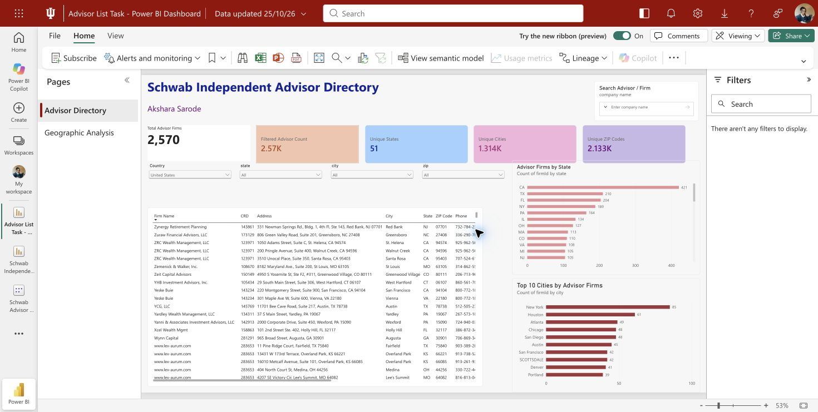
Figure 1 Advisor Directory at the unfiltered view

5 Configure the controls
All five dropdowns use fields from Advisor Locations. Country, State, City, and ZIP narrow the results progressively. The Search Advisor / Firm control was changed to a populated company-name dropdown, so users can browse and select available names. Selecting a value filters the dynamic KPI cards, advisor table, and charts.
The details table includes Firm Name, CRD, Address, City, State, ZIP Code, Phone, Email, Website, and SEC Profile. Users can sort by a column heading, scroll horizontally for right-hand fields, and export filtered rows through the table visual when Power BI permissions allow.

Validation and evidence

6 Test linked filters
The dashboard was checked at the full-data view and with linked selections. Selecting Alabama changed the filtered firm count to 25, with 10 cities and 23 ZIP codes. Narrowing further to Birmingham showed 12 firms and 8 ZIP codes. These checks confirmed that location slicers update the summary and details together.
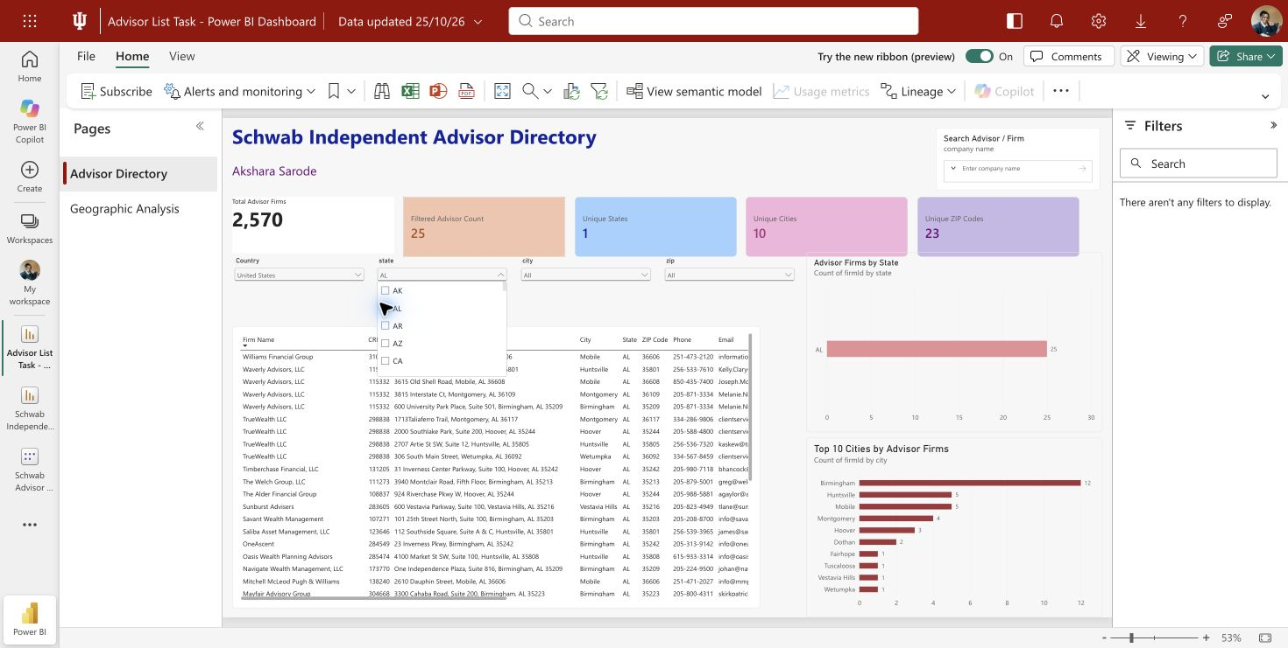
Figure 2 Alabama selection updates the report

7 Test the company dropdown
The company control was opened to confirm that firm names appear. Selecting &Wealth Partners narrowed the advisor table to its two location rows, showed one distinct firm, and updated the state and city charts. The selection was cleared before the final report was saved and exported.
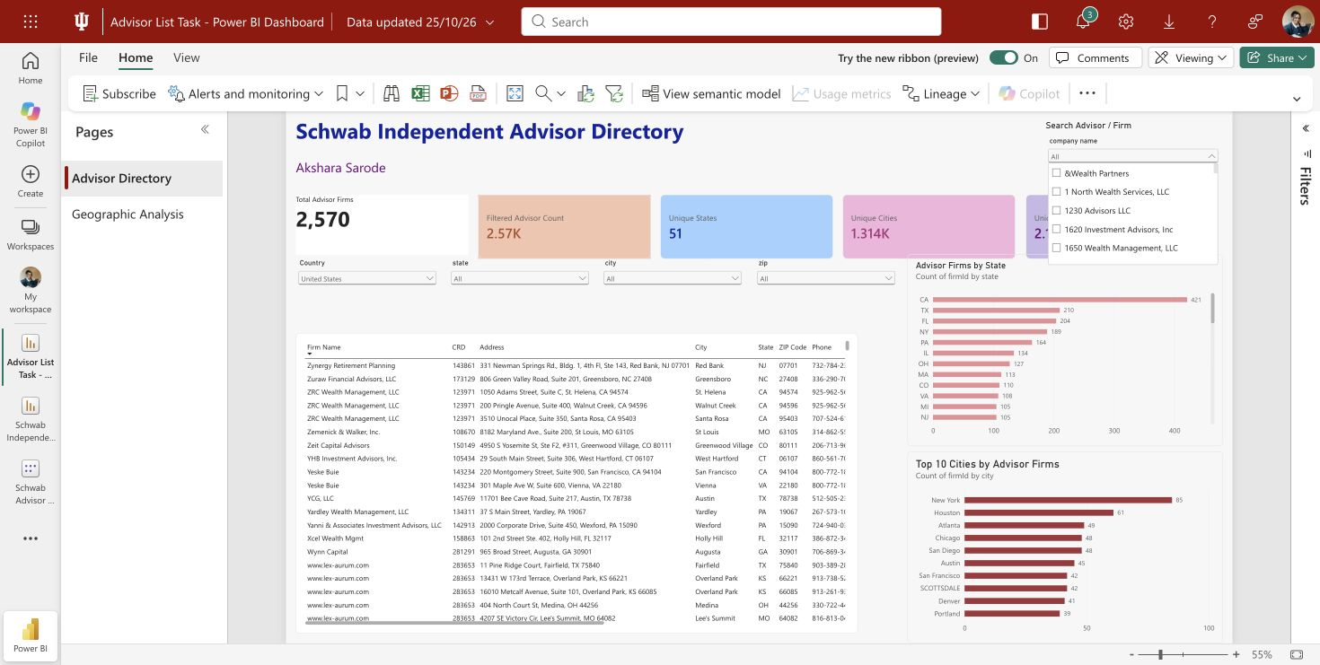
Figure 3 Company names are available in the dropdown

Export, publication, and handoff

8 Save and export
- Saved the report in Power BI as Advisor List Task - Power BI Dashboard, separate from the older Schwab Independent Advisor Directory report.
- Downloaded a PBIX copy containing the report and imported data. The PBIX archive passed an integrity check.
- Exported both report pages to PDF using the unfiltered view. The final PDF was checked to contain two pages.
- Saved screenshots of the default page, the populated company dropdown, linked Alabama filters, and the geographic analysis page.

9 Package the deliverables
File | Use
Advisor List Task - Power BI Dashboard.pbix | Interactive report for Power BI Desktop
Advisor List Task - Power BI Dashboard.pdf | Static report review copy
Submission File (Akshara).xlsx | Submitted Part 1 dataset
advisor_locations.csv | Portable location-row export
powerbi_*.png | Visual evidence of layout and filter behavior
README.md | Repository setup and usage guide

10 Publish and use
The deliverable folder was published to the public GitHub repository at github.com/Akshara-sarode/Advisor-List-Task. The live Power BI report is available through the link in the repository README. In the live report, open a dropdown, select a firm or location, review the updated cards and table, then use Reset to default to return to the full directory.

Important interpretation
The PDF and screenshots capture particular report states and are not interactive. For live filtering, use the Power BI Service report or open the PBIX in Power BI Desktop. The details table can contain multiple office rows for one firm; the firm KPI uses distinct firm IDs so the summary is not inflated by those offices.

Maintenance notes
- Refresh the imported model when the source workbook changes, then verify the row count, distinct firm count, and all four dynamic KPI cards.
- Review the fixed Total Advisor Firms label after each data refresh and update it if the firm population changes.
- Clear test selections before exporting the default PDF and screenshots, then confirm the PDF still contains both report pages.

