  
  
  
Selected_image :

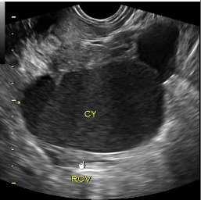

  
  
Preprocessed Image :  
  
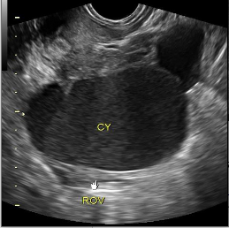  
  
  
  
Segmented Image:  
  
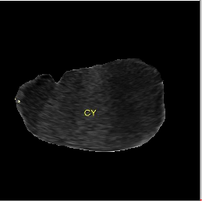  
  
  
  
  
  
Classified Out Come :  
  
  
  
  
Segmentation model performance :  
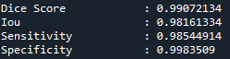  
  
  
Classification Model Performance:

