ACKNOWLEDGEMENT
We would like to express our sincere gratitude to our project guide for the guidance, constructive feedback, and encouragement provided throughout this project. We thank the faculty members and the Department for their academic support and for providing the resources needed to complete the work. We also acknowledge the authors and maintainers of the datasets, software libraries, and technical references used in this project. Finally, we are grateful to our classmates, friends, and family for their encouragement during the project.

TABLE OF CONTENTS
ACKNOWLEDGEMENT
ABSTRACT
CHAPTER 1 INTRODUCTION
1.1 Background and Context
1.2 Problem Statement and Objectives
1.3 Scope and Project Outcomes
CHAPTER 2 LITERATURE REVIEW
2.1 Crop Yield Estimation
2.2 Remote Sensing and Vegetation Indices
2.3 Regression and Feature Fusion
CHAPTER 3 SYSTEM ANALYSIS
3.1 Existing System and Problem Analysis
3.2 Requirements and Feasibility
3.3 Data Sources and Extraction
CHAPTER 4 TECHNOLOGY STACK
4.1 Languages and Libraries
4.2 Data and Model Artifacts
CHAPTER 5 SYSTEM DESIGN
5.1 Architecture and Data Flow
5.2 State-Level Data and Image Samples
5.3 Modeling Tracks
5.4 Dashboard Design and Use Cases
CHAPTER 6 TESTING
6.1 Validation Strategy
6.2 Functional Checks
CHAPTER 7 RESULTS
7.1 Tabular Baseline
7.2 Image-Only Experiment
7.3 Paired Feature-Fusion Evaluation
7.4 Interpretation and Limitations
CHAPTER 8 CHALLENGES FACED
CHAPTER 9 CONCLUSION AND FUTURE SCOPE
REFERENCES
APPENDICES

ABSTRACT
Crop yield prediction can support historical analysis and exploratory planning when agricultural records are combined with information about soil, geography and vegetation. This completed project prepares a modeling table and Streamlit prototype for four crops: Rice, Maize, Moong (Green Gram), and Urad. The original agricultural source contains a broader range of crops; the application and prepared modeling dataset focus on these four. The report distinguishes three experiments: chronological tabular regression; a separate image-only CNN; and feature-level fusion using cached EfficientNetV2 RGB and NDVI embeddings, scaling, 10-component PCA per image modality, tabular features and a Gradient Boosting estimator. On the 203-record four-crop tabular test set, Gradient Boosting achieved R2 0.8302; HistGradientBoosting was selected using validation data and achieved R2 0.8263 on test. The image-only CNN test comprised 15 pairs and achieved R2 -0.0503. A distinct 13-pair image-summary test contains only Rice and Maize. In a separate paired comparison, feature fusion increased R2 from 0.8232 to 0.8304, a modest gain of 0.0072. The dashboard is an academic prototype for historical exploration and yield estimation; cohort size and image coverage limit generalization.
Keywords: crop yield prediction; remote sensing; NDVI; Gradient Boosting; feature fusion; India

CHAPTER 1 INTRODUCTION

BACKGROUND AND CONTEXT
Crop yield depends on interactions among crop type, season, soil, rainfall, management practices and changing crop condition. Historical agricultural records provide broad coverage of production outcomes, while remotely sensed observations can summarize vegetation and surface reflectance. The project studies how these sources can be organized for crop-yield estimation across Indian states and how an interactive prototype can make the data and model outputs easier to inspect.

PROBLEM STATEMENT AND OBJECTIVES
A structured yield model may omit spatial crop-condition information, while image-only learning may lack management and climate context. The project therefore addresses data alignment, leakage-controlled modeling and a bounded evaluation of complementary inputs. The objectives were to prepare agricultural and reference data; compare tabular regression approaches; evaluate image-only learning on available aligned pairs; compare tabular-only and image-augmented models on their paired cohort; and implement a dashboard for academic exploration and prediction.

SCOPE AND PROJECT OUTCOMES
The completed implementation covers data preparation, model artifacts, saved metrics and a Streamlit interface. Its dashboard supports historical exploration, maps, inspection of stored imagery and selected yield estimates. It is an academic prototype, not field-level monitoring. Weather forecasting, live satellite monitoring, fertilizer recommendations and farmer login are not implemented features and are treated only as future possibilities. The main outcome is a reproducible applied comparison with explicit cohort limitations, rather than a new learning algorithm.
From a user perspective, the prototype has two complementary roles. The Home page helps a reader inspect patterns already present in the project records, while the Crop Prediction page turns a selected set of scenario inputs into an estimated yield. This distinction matters because a historical summary describes the stored dataset and its filters; it does not describe a newly observed field or a live crop condition. The intended audience is a student, evaluator or analyst exploring the project and its model behavior.

REPORT ORGANIZATION
Chapter 2 reviews the relevant modeling concepts. Chapter 3 analyzes the system, requirements and source data. Chapter 4 documents the technology stack. Chapter 5 explains system and model design. Chapter 6 describes validation and functional checks. Chapter 7 reports results. Chapter 8 discusses challenges. Chapter 9 concludes and lists future scope.

CHAPTER 2 LITERATURE REVIEW

CROP YIELD ESTIMATION
Yield estimation commonly uses historical crop statistics together with weather, soil and management information. Tree ensembles are useful for tabular data because they represent nonlinear relationships and interactions without requiring a strictly linear response. Random Forests average randomized trees [1], while Gradient Boosting builds an additive model by fitting successive learners to residual structure [3]. These methods provide established baselines for the project’s structured predictors.

REMOTE SENSING AND VEGETATION INDICES
Multispectral imagery observes reflected energy in several wavelength bands. Sentinel-2 provides multispectral observations suitable for land and vegetation analysis [2]. NDVI is computed from near-infrared and red reflectance and is commonly used as a vegetation greenness indicator [5]. Such measures are indirect and depend on acquisition timing, cloud filtering, spatial aggregation and preprocessing. They can complement agricultural records but do not directly encode all management conditions.

REGRESSION AND FEATURE FUSION
Feature fusion combines representations from multiple modalities before prediction. In this project, cached image embeddings are reduced with PCA and concatenated with structured variables for a tree estimator. This differs from a jointly trained CNN and tabular neural network. The design follows the broader multisensor-fusion principle that sources with different characteristics require alignment and explicit representation choices [4]. The project tests a limited paired comparison and does not treat a small metric increase as universal evidence of improvement.

PROJECT POSITIONING
The project applies established methods to a specific data pipeline. The literature supports the choice of tree regressors and vegetation indicators, while the implementation evaluates whether a reduced image representation adds predictive value to tabular inputs. It does not claim causal effects of vegetation indices, novel model architecture or operational readiness.

CHAPTER 3 SYSTEM ANALYSIS

EXISTING SYSTEM AND PROBLEM ANALYSIS
The repository contains historical crop statistics, engineering scripts, satellite-derived features and sample images. Without consistent keys and leakage checks, these sources cannot be compared reliably. In particular, production divided by area defines yield; therefore production must not be included as a predictor when yield is the target. Image availability is also sparse for the aligned CNN evaluation, requiring separate cohort reporting.

REQUIREMENTS AND FEASIBILITY
The system requires local data files, preprocessing and inference libraries, saved estimator artifacts, and a browser-based Streamlit interface. The academic scope is feasible using the repository’s historical data and local computation. The dashboard supports exploration and prediction using implemented artifacts; it does not require a live data service. The study’s research feasibility is bounded by state-level aggregation and the small image-only test cohort.
The non-functional requirements are modest and appropriate to an academic prototype. The interface should remain understandable on a standard desktop browser, present units beside numeric outputs, and load saved artifacts without requiring model training during each interaction. Results should be reproducible from the checked-in data and model files when compatible dependencies are installed. The project is not sized or evaluated as a production service: uptime, concurrent-user capacity, security hardening and operational support have not been established.
Table 3.1 Functional requirements
ID | Requirement | Implementation evidence
FR1 | Prepare and join agricultural, soil, geographic and satellite-derived records | CSV data and preprocessing pipeline
FR2 | Compare tabular regression models using chronological partitions | Saved model metrics and predictions
FR3 | Evaluate image-only prediction using aligned RGB and NDVI pairs | CNN model artifact and image test metrics
FR4 | Evaluate feature-level fusion against paired tabular inputs | Cached embeddings, PCA and Gradient Boosting artifact
FR5 | Explore data and request yield estimates in the application | Streamlit dashboard in app.py

DATA SOURCES AND EXTRACTION
The source crop_yield.csv contains 19,689 historical records and 54 distinct crop labels after whitespace normalization. The application and prepared modeling_dataset.csv focus on four target crops: Rice, Maize, Moong (Green Gram), and Urad. The prepared table contains 3,602 rows before the documented outlier filter and 3,595 after seven rows are removed. The helper shown in Figure 3.1 is narrower: it filters Rice and Maize only to prepare state-level reference lookup keys. It does not retrieve satellite imagery. Stored image examples are shown in Figure 3.2.
The state-selection helper shown in Figure 3.1 is a preprocessing utility that extracts a Rice and Maize subset for a reference lookup workflow. Its narrower crop list is not the crop list of the completed application or full modeling benchmark. The broader application and tabular results support Rice, Maize, Moong (Green Gram) and Urad. Keeping that distinction explicit prevents a data-preparation screenshot from being mistaken for the project-wide supported-crop scope.
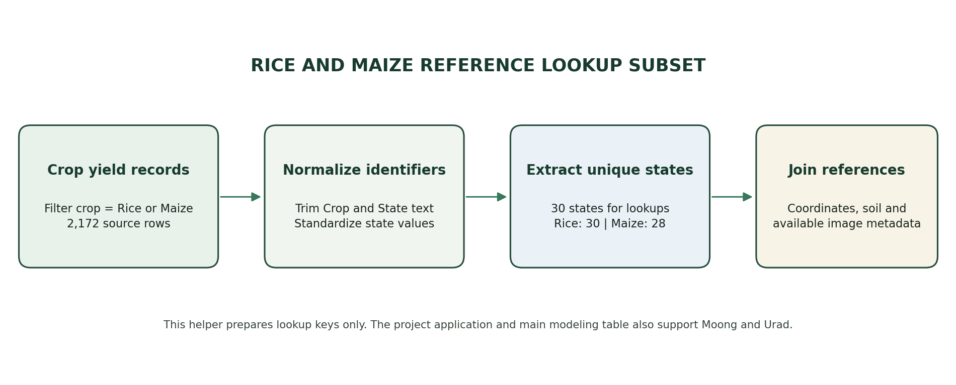
Fig. 3.1 State Selection for Rice and Maize Reference Lookup
Source: preprocessing/extract_rice_maize_locations.py. This lookup helper covers only its Rice/Maize subset; the main modeling table and application also include Moong (Green Gram) and Urad.
Table 3.2 Data modalities and project role
Data modality | Repository artifact | Role in the project
Agricultural | crop_yield.csv; modeling_dataset.csv | Crop, state, year, season, area, production, rainfall, inputs and yield
Geographic | state_coordinates.csv | Latitude and longitude for state-level display
Soil | state_soil_lookup.csv | State-linked soil profile reference values
Satellite summaries | harmonized_satellite_features.csv; sentinel2_features.csv | Spectral bands and vegetation-index summaries
Images | test_images/; CNN manifests | Stored RGB and rendered NDVI image pairs
Embeddings | embeddings/*.npy | Cached RGB and NDVI representations for fusion

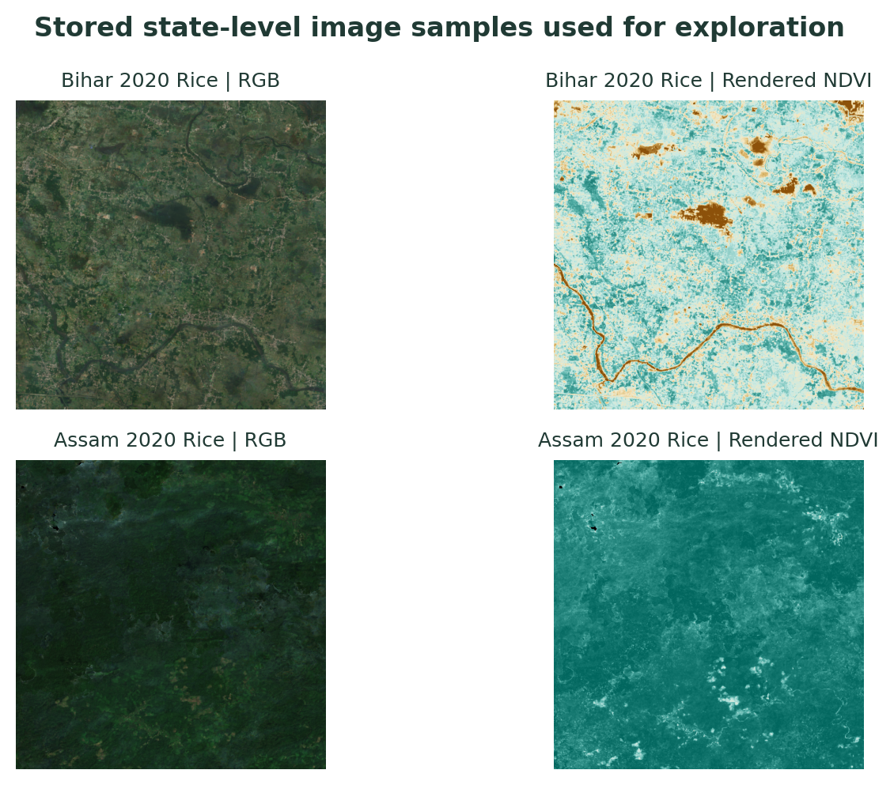
Fig. 3.2 Stored State-Level RGB and Rendered NDVI Samples
Examples from the local image archive for Bihar and Assam, 2020 rice records; shown for inspection, not live monitoring.

DATA QUALITY AND LEAKAGE CONTROLS
The documented modeling workflow removes seven implausible target rows above 15 tonnes per hectare from the 3,602-row four-crop modeling table, leaving 3,595 records. The main tabular test set contains 203 later-year records across Rice, Maize, Moong (Green Gram) and Urad. Production is excluded from predictor inputs because it is mathematically tied to yield and area. Chronological splits reduce the risk of using later-year information to predict earlier observations.
Before modeling, identifiers and field names must be normalized so joins do not silently fail because of spacing or spelling differences. The working tables are checked for missing target values, duplicate keys and implausible numeric entries. Yield is treated as the response variable, and production is excluded from predictor features because yield is calculated from production and area. A feature that directly reconstructs the target would inflate evaluation scores without representing a valid forecast input.

CHAPTER 4 TECHNOLOGY STACK

LANGUAGES AND LIBRARIES
Python is used for data preparation, model training and the application. Pandas and NumPy support tabular and numerical operations; scikit-learn provides preprocessing, regression and evaluation tools [6]. TensorFlow/Keras supports the independent image-only CNN [8]. Streamlit provides the interactive interface [7], and Plotly supports charts and spatial visualizations. Matplotlib and Pillow are used for saved diagnostic figures and image handling. Joblib persists scikit-learn estimators.
The implementation is organized around reusable artifacts rather than a training action inside the interface. Preprocessing and experiment scripts prepare features and partitions; evaluation scripts save predictions and metric summaries; and app.py loads the required data and estimators for interactive use. This separation shortens dashboard response time and makes the reported experiment outputs traceable to repository files. Reproduction still depends on using a compatible Python environment and retaining the referenced datasets, image files and serialized models.
Table 4.1 Technology components
Component | Technology | Project use
Data processing | Python, pandas, NumPy | Cleaning, joining, feature preparation
Tabular and fusion models | scikit-learn | Transformations, regression, PCA and metrics
Image-only experiment | TensorFlow / Keras | Six-channel CNN training and evaluation
Dashboard | Streamlit, Plotly | Exploratory views, maps and prediction forms
Image and report figures | Pillow, Matplotlib | Image inspection and diagnostic visualizations
Model persistence | Joblib, Keras formats | Load saved estimators and CNN artifact

DATA AND MODEL ARTIFACTS
The project stores intermediate CSV files, image manifests, model objects, metric JSON files, prediction CSVs and plots under datasets/ and models/. The saved assets allow the dashboard and report to refer to completed work. Reproduction requires the corresponding compatible dependencies and repository data files.

CHAPTER 5 SYSTEM DESIGN

ARCHITECTURE AND DATA FLOW
The pipeline begins with agricultural records and reference sources, then normalizes identifiers, joins available features and constructs modeling partitions. After preparation, three modeling tracks remain distinct. The tabular track uses structured variables. The image-only track trains a CNN on paired RGB and rendered NDVI channels. The feature-fusion track loads cached EfficientNetV2 embeddings, scales them, applies separate PCA transforms with 10 components per modality, joins the resulting 20 image features with tabular inputs and fits Gradient Boosting. The dashboard presents supported exploration and prediction workflows.
At inference time, the tabular path assembles a row from the selected state, crop, season, year and numeric scenario values, applies the saved preprocessing/model path, and returns a yield estimate. The model output is an estimate in tonnes per hectare, conditioned on the trained model and available feature representation. It should be interpreted alongside the input assumptions, rather than as a guaranteed harvest or a prescriptive action. The project does not provide confidence intervals or an automated agronomic decision.
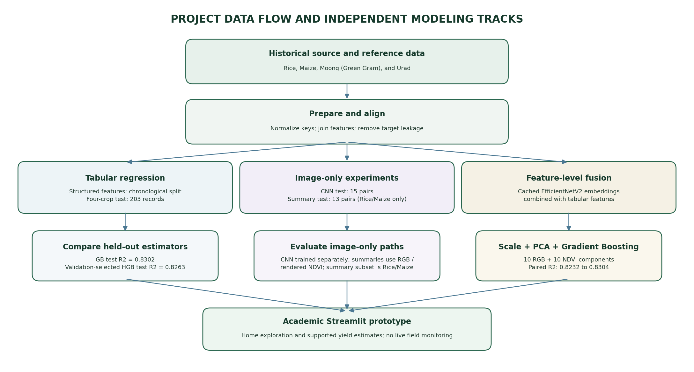
Fig. 5.1 Project Data Flow and Independent Modeling Tracks

STATE-LEVEL DATA AND IMAGE SAMPLES
State coordinates support map displays in the application. State-level image samples in Figure 3.2 allow users to inspect stored imagery alongside historical records. The interface displays archived samples and metadata; it does not fetch new scenes continuously. Consequently, a displayed image should be interpreted as a project dataset example with its associated state, crop and year, not as a current field condition.

MODELING TRACKS
Table 5.1 Implemented modeling tracks
Track | Inputs | Processing and estimator | Evaluation role
Tabular baseline | Agricultural, soil, geographic and spectral variables | Structured feature preprocessing; Gradient Boosting among compared models | Chronological four-crop baseline; 203 test records
Image-only CNN | Aligned RGB and rendered NDVI pairs | Six-channel 96×96 image input; CNN trained from scratch | CNN test n=15; separate image-summary test n=13 (Rice/Maize only)
Feature-level fusion | Cached EfficientNetV2 RGB and NDVI embeddings plus tabular features | Scaling; PCA 10+10 components; concatenated features; Gradient Boosting | Paired tabular-versus-fusion evaluation; summary omits test count

DASHBOARD DESIGN AND USE CASES
The current Streamlit sidebar exposes two pages: Home (Dashboard) and Crop Prediction (Yield Forecast). Home provides year, state, crop, metric and trend controls; summary cards; a state-coordinate plot; top-state and historical-trend charts; and a crop-area chart for the four supported crops. The Crop Prediction page accepts state, crop, season, year, area, rainfall, fertilizer and pesticide inputs, then displays a yield estimate and model name. Its feature-fusion path uses cached image embeddings with PCA and Gradient Boosting, not a jointly trained CNN and tabular neural network. Stored image previews and an optional uploaded image can be displayed; the uploaded image is not passed into the prediction call. Figure 5.2 is a recreation of the implemented Home page layout, not a browser screenshot.
The dashboard’s Home view is arranged for quick exploration: filters sit above four summary cards, followed by a compact data-context strip. Below it, the application places the state distribution map above the top-states chart in the left column, and the selected-metric trend above crop-area distribution in the right column. The metric selector changes which stored measure is emphasized, while year, state and crop controls narrow the displayed records. Figure 5.2 follows this arrangement; chart values in the live application are calculated from the active filters.
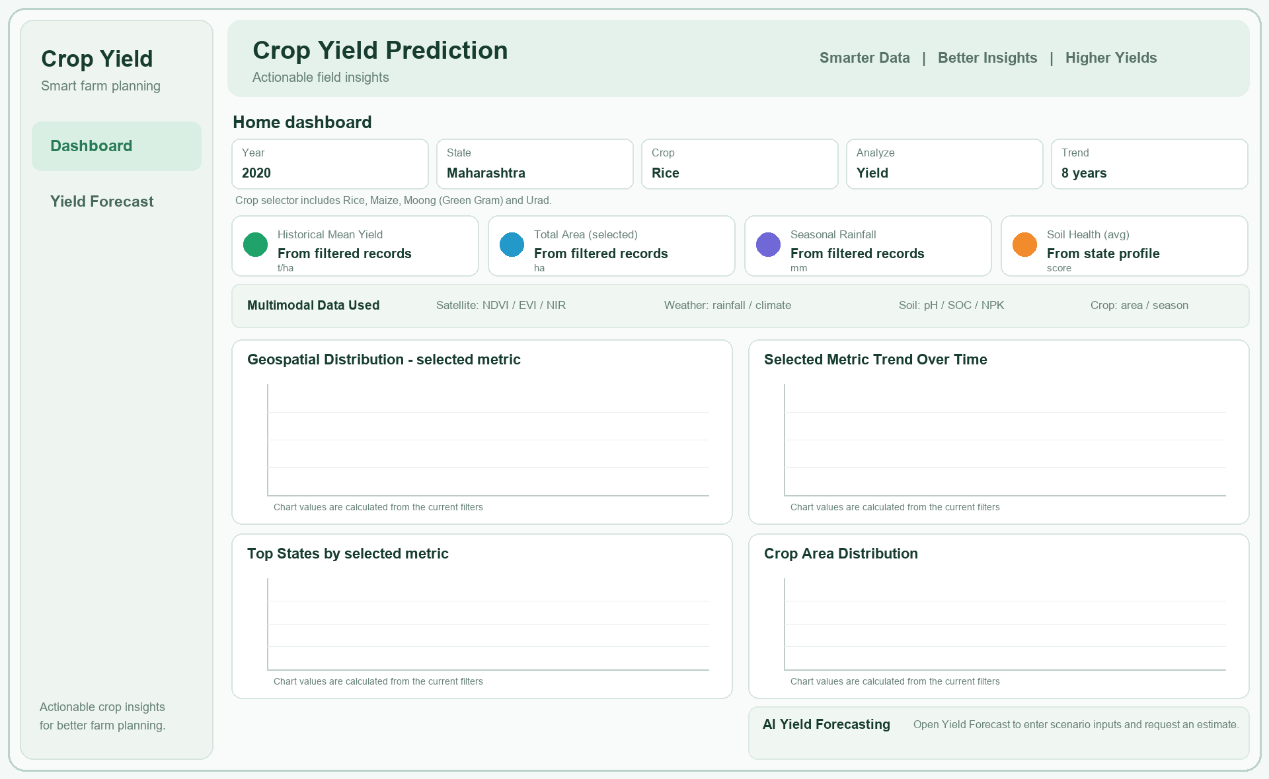
Fig. 5.2 Dashboard Layout Recreated from app.py
Layout recreation based on the current app.py Home page. This is not a captured browser screenshot; the app calculates chart values from the active filters, and the illustration omits those data values.
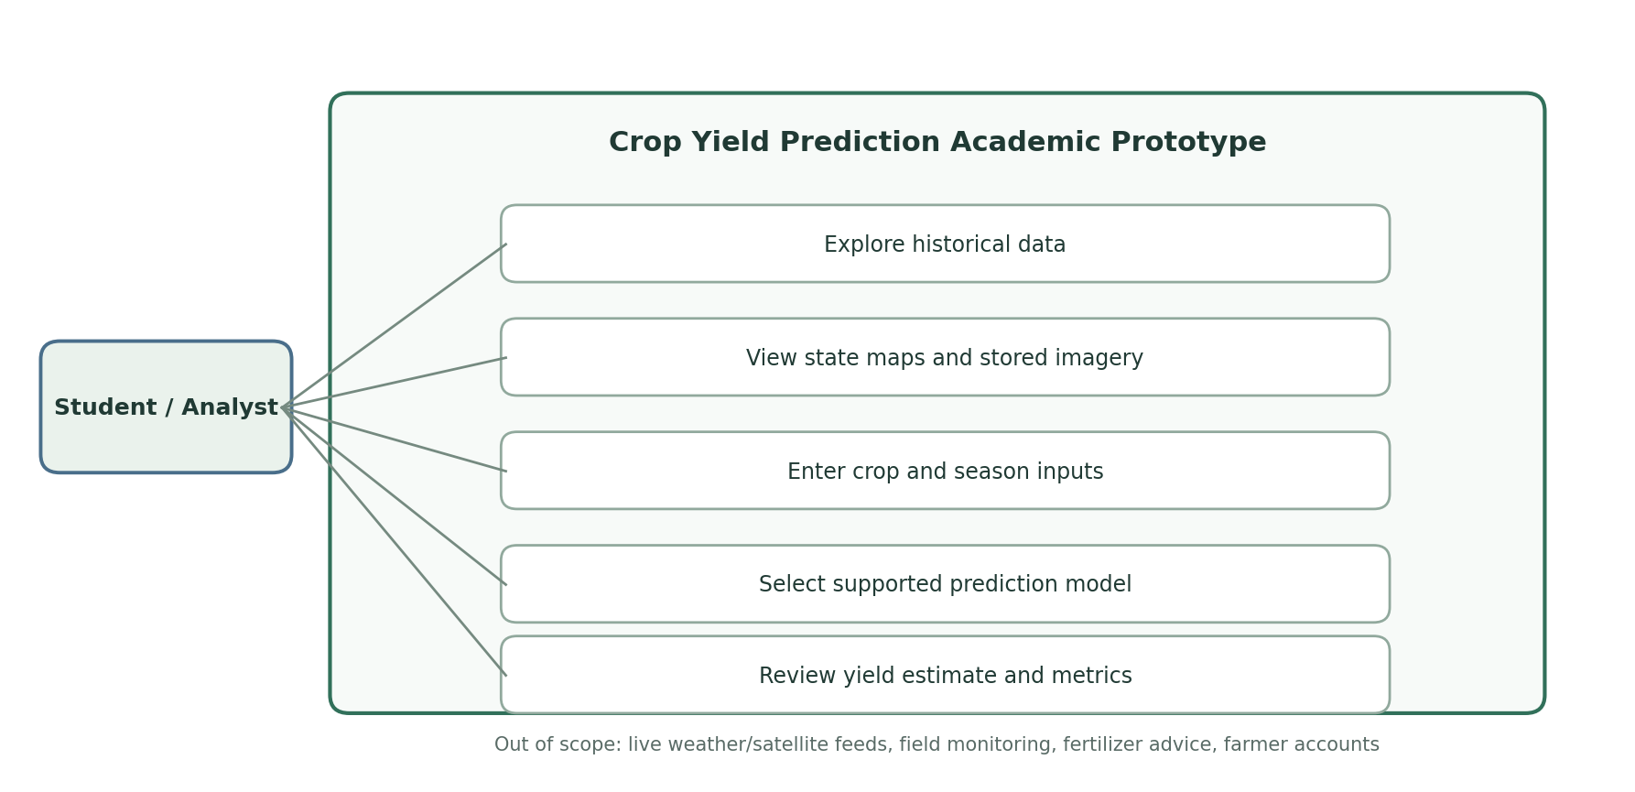
Fig. 5.3 Use Case Diagram for the Academic Prototype
Table 5.2 Dashboard use cases
Actor action | System response | Boundary
Explore historical records | Shows filtered summaries and trends | Historical project data
Inspect state and image examples | Displays state views and stored RGB/NDVI samples | No live satellite feed
Enter crop and scenario inputs | Provides supported input fields | Only implemented controls
Choose a prediction engine | Runs the selected saved model path | Tabular or implemented feature-fusion option
Review estimated yield | Shows estimate and explanatory output | Not a field-level decision or guarantee

CHAPTER 6 TESTING

VALIDATION STRATEGY
The main tabular evaluation uses a chronological split: training through 2016, validation in 2017-2018 and test in 2019-2020, with 203 test records across four crops. The separate image-only CNN test contains 15 aligned pairs; the image-summary test contains 13 pairs from Rice and Maize only. The paired feature-fusion score is compared with its own tabular arm. These populations differ and are not a single controlled three-way benchmark.
Table 6.1 Evaluation Cohorts by Experiment
Experiment | Training / validation | Test cohort | Comparison boundary
Tabular baseline | Train through 2016; validate 2017-2018 | 203 records in 2019-2020; all four target crops | Chronological four-crop baseline
Image-only CNN | Aligned image pairs; chronological holdout | 15 aligned pairs in saved CNN metrics | Independent image-only model
Image-summary models | 228 train; 33 validation | 13 aligned pairs in 2019; 8 Maize, 5 Rice | No Moong or Urad test images
Feature-level fusion | Cached embeddings joined with tabular inputs | Test count absent from tuned summary | Paired tabular R2 0.8232 vs fusion R2 0.8304

FUNCTIONAL CHECKS
The completed artifacts show that the application filters the broad historical source to its four configured target crops and provides Home and Crop Prediction pages. The Home page supports historical summaries and visual exploration; the prediction page accepts crop and scenario inputs and displays a yield estimate. Stored imagery is used for preview where available. The report does not claim automated end-to-end test coverage beyond the evidence present in the repository.
The available evidence supports a focused set of functional checks: the configured target list contains the four intended crops; dashboard filters are populated from project records; the prediction form collects the documented scenario fields; and saved estimators and metric files are present for the experiments described. Data integrity review also confirms that the target is kept separate from model predictors and that image experiments use aligned RGB/NDVI pairs. These checks document observed project behavior; they are not a claim of a formal automated test suite or production acceptance testing.
Leakage review confirms that production is removed from the tabular predictor set. Cohort review confirms that the image-only CNN and paired fusion experiments use distinct data and pipelines. The dashboard description is limited to historical exploration, stored imagery and supported model inference.

CHAPTER 7 RESULTS

TABULAR BASELINE
The modeling table covers Rice, Maize, Moong (Green Gram), and Urad. Its chronological test split contains 203 records from 2019-2020. The four compared regressors and held-out scores are listed in Table 7.1. HistGradientBoosting was selected using validation performance (validation R2 0.8385) and achieved test RMSE 0.5841 tonnes per hectare, MAE 0.3672 tonnes per hectare and R2 0.8263. Gradient Boosting had a slightly higher test R2 of 0.8302; test results were not used to select the model. For the validation-selected model, crop-level test counts and R2 were Maize (52, 0.6513), Moong (44, 0.3716), Rice (63, 0.5332), and Urad (44, 0.0374). The feature-importance plot is descriptive and should not be interpreted as causal evidence.
Crop-wise R² is uneven: the highest value among the four crops is for Maize (0.6513), followed by Rice (0.5332) and Moong (0.3716), while Urad is much lower (0.0374). Each crop has between 44 and 63 test records. This variation is a reason to report per-crop behavior alongside the aggregate score: a strong pooled result can hide weaker performance for a particular target crop. The values are specific to the available 2019–2020 test records.
The four-crop comparison shows that both boosting models substantially outperform the dummy-mean reference on this split. The validation-selected HistGradientBoosting model has a slightly lower test R² than Gradient Boosting, but a lower test MAE; model selection remains tied to validation performance to avoid choosing a model after inspecting the held-out test score. The difference between the two boosting test scores is small, so the report does not claim a universal winner beyond the selected validation protocol.
Table 7.1 Four-Crop Tabular Model Comparison on the Test Set
Model | Test n | RMSE (t/ha) | MAE (t/ha) | R2
Dummy mean | 203 | 1.4506 | 1.1008 | -0.0712
Random Forest | 203 | 0.7983 | 0.4856 | 0.6756
Gradient Boosting | 203 | 0.5776 | 0.3933 | 0.8302
HistGradientBoosting (selected on validation) | 203 | 0.5841 | 0.3672 | 0.8263

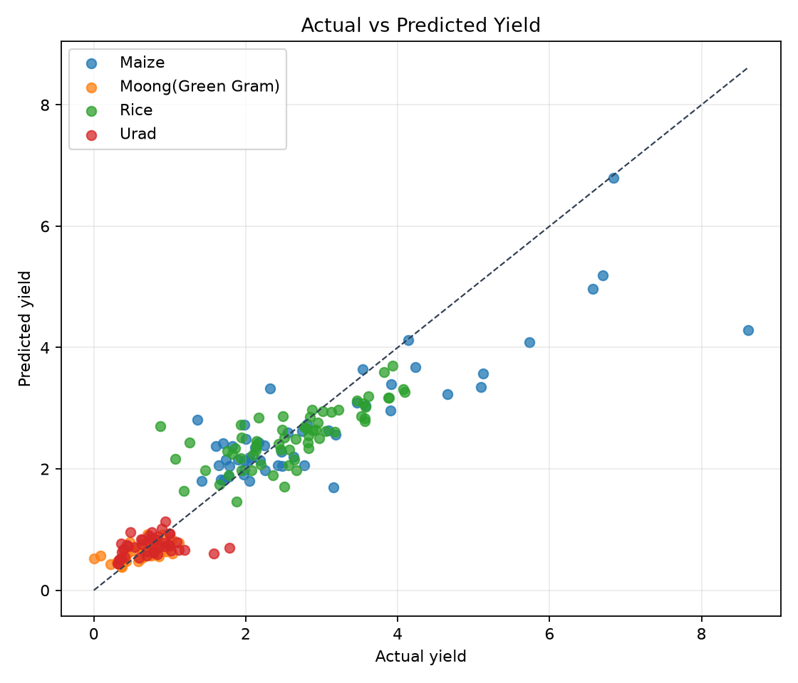
Fig. 7.1 Actual Versus Predicted Yield for the Tabular Test Set
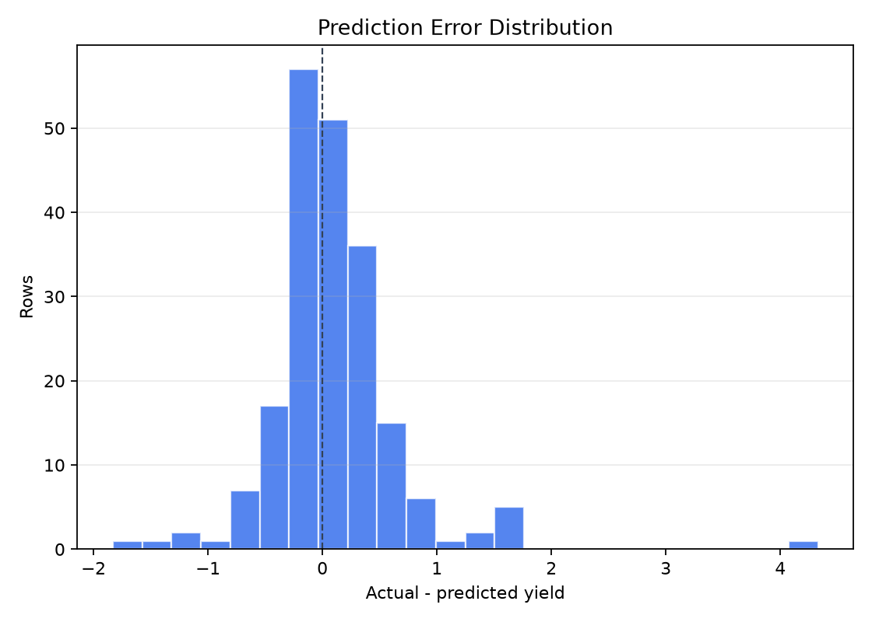
Fig. 7.2 Prediction Error Distribution for the Tabular Test Set
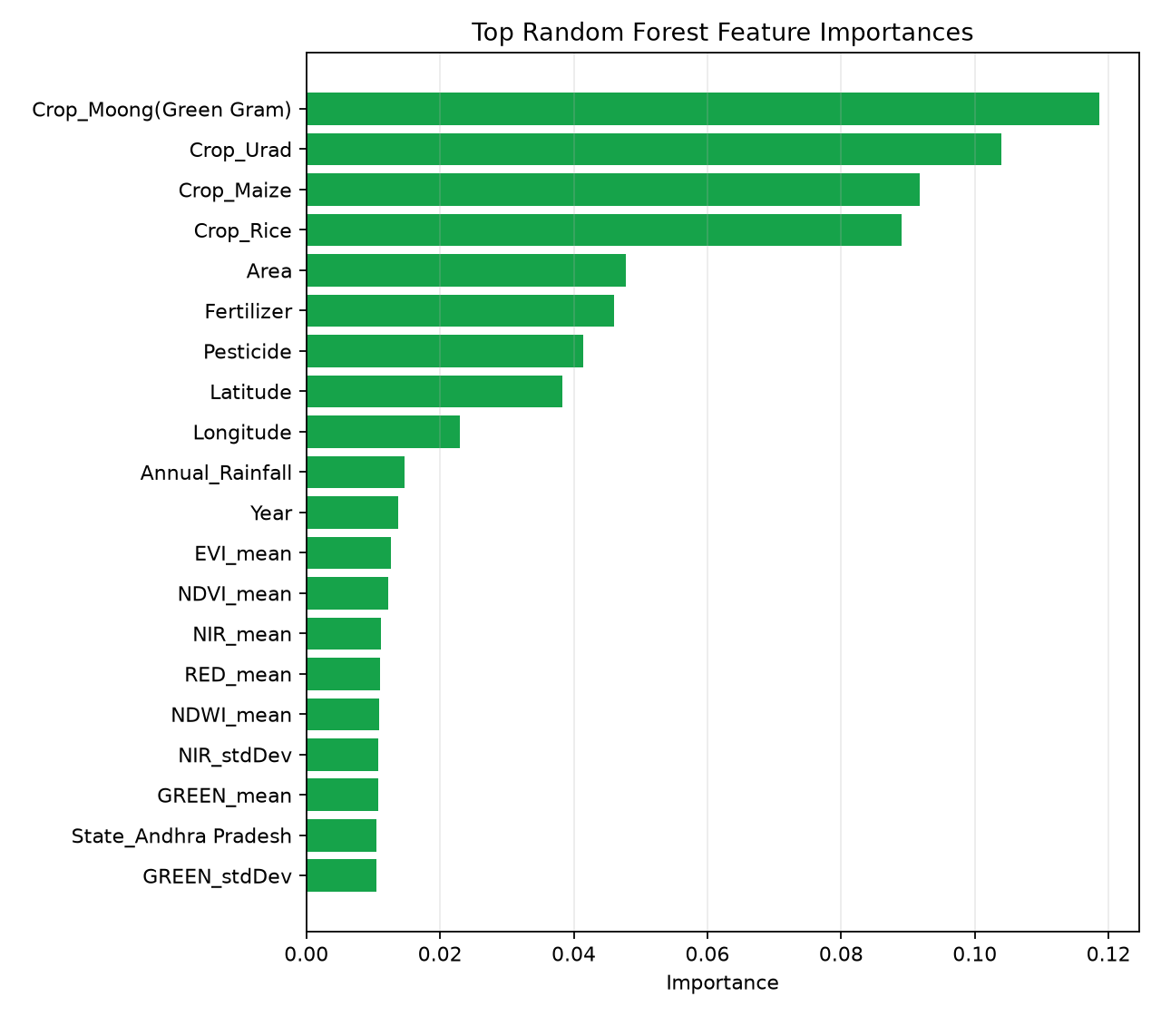
Fig. 7.3 Feature Importance for the Tabular Gradient Boosting Model

IMAGE-ONLY EXPERIMENT
The image-only experiments are narrower than the four-crop modeling table. The separate six-channel CNN uses RGB and rendered NDVI images alone; its saved test summary contains 15 aligned pairs and reports RMSE 1.6061 tonnes per hectare, MAE 1.2205 tonnes per hectare and R2 -0.0503. A distinct image-summary comparison uses 13 aligned 2019 pairs, comprising 8 Maize and 5 Rice examples, with no Moong or Urad test pairs. The image-summary metrics are listed separately in Table 7.2. These small image cohorts are exploratory and should not be generalized to the complete four-crop project.
Table 7.2 Image-Only CNN and Image-Summary Test Metrics
Model and inputs | Test n | RMSE (t/ha) | MAE (t/ha) | R²
RGB + rendered NDVI CNN | 15 | 1.6061 | 1.2205 | -0.0503
RGB summary; Extra Trees | 13 | 1.1762 | 0.7446 | 0.2935
NDVI image summary; Extra Trees | 13 | 1.0987 | 0.7723 | 0.3836
RGB + NDVI summaries; Ridge | 13 | 1.1226 | 0.7639 | 0.3565

PAIRED FEATURE-FUSION EVALUATION
The fusion artifact uses 20 PCA-reduced image features (10 RGB and 10 NDVI) combined with tabular variables and a Gradient Boosting estimator. In the paired comparison, R² increased from 0.8232 for the tabular arm to 0.8304 for the feature-fusion arm, a difference of 0.0072. This is a modest improvement. The saved fusion metric summary does not report the test count, so precision and generalization cannot be inferred from the R² difference alone.
Table 7.3 Paired feature-fusion comparison
Model arm | Image representation | Estimator | Test R²
Paired tabular | None | Gradient Boosting | 0.8232
Feature fusion | Cached EfficientNetV2 embeddings; PCA 10 RGB + 10 NDVI components | Gradient Boosting | 0.8304
Difference | 20 reduced image features added | — | +0.0072

INTERPRETATION AND LIMITATIONS
The four-crop tabular model shows useful predictive signal on its 203-record chronological test set. Image-only results are weak and cohort-limited: the CNN evaluation has 15 pairs, while the image-summary evaluation has 13 pairs from Rice and Maize only. In a third, distinct paired comparison, adding reduced image embeddings raises R2 from 0.8232 to 0.8304. The fusion summary does not report its test count, so the gain cannot be treated as conclusive evidence that imagery improves prediction across all four crops.
Table 7.4 Results and evidence limitations
Finding | Evidence | Interpretive limit
Tabular model has useful signal | Four-crop test, n=203; validation-selected HGB R2 0.8263 | Specific cohort and split
Image-only learning is exploratory | CNN test n=15; separate image-summary test n=13 (5 Rice, 8 Maize) | Small image cohort; 2019 only
Fusion improves paired R² modestly | 0.8232 to 0.8304 | Test count absent; gain is +0.0072
Dashboard supports academic exploration | Implemented Streamlit app | Not live monitoring or field advice

CHAPTER 8 CHALLENGES FACED

DATA ALIGNMENT AND COVERAGE
The main engineering challenge was aligning heterogeneous sources with different identifiers, years, seasons and spatial support. The modeling and application cover four crops, while image-only tests contain fewer examples and, for the 13-pair image-summary experiment, only Rice and Maize. State-level records do not perfectly describe field-level variation. Some source periods and imagery products also differ in sensor and processing characteristics.
A further limitation is that state-level aggregation cannot resolve within-state differences in irrigation, soil management, cultivar, planting date or local weather. Likewise, a stored state-level image sample may not correspond to the same plot, season or exact observation date as a yield record. The report therefore describes the imagery as aligned experiment input where the repository manifest defines a pair, and as stored preview material in the dashboard. Neither use supports field-level diagnosis.

LEAKAGE AND EVALUATION DESIGN
Yield is derived from production and cultivated area, making production an invalid predictor for a yield target. The workflow excludes it to avoid target leakage. A second challenge was keeping experimental cohorts distinct: the tabular benchmark, image-only CNN and fusion comparison use different evaluation populations. The fusion artifact’s missing test count is an additional reporting limitation.

MODEL AND INTERFACE BOUNDARIES
The image-only CNN is trained from scratch with few aligned test pairs, which limits conclusions about its generalization. The feature-fusion approach uses cached embeddings and classical Gradient Boosting rather than joint end-to-end multimodal neural training. The interface brings several exploration and prediction functions together, but this does not make it a live agricultural monitoring or recommendation service.

CHAPTER 9 CONCLUSION AND FUTURE SCOPE

CONCLUSION
The project is complete as an academic crop-yield prediction prototype for Rice, Maize, Moong (Green Gram), and Urad. Its main chronological tabular test contains 203 records; the validation-selected HistGradientBoosting model achieved R2 0.8263. A separate image-only CNN test contains 15 pairs and achieved R2 -0.0503, while the image-summary experiment contains 13 pairs from Rice and Maize only. In a separate paired evaluation, feature fusion increased R2 modestly from 0.8232 to 0.8304. The experiments use different cohorts, and the fusion metric summary does not report its test count.

FUTURE SCOPE
Future work can build a larger, consistently aligned image dataset; evaluate all modalities on the same chronological complete-case test set; report uncertainty intervals and exact cohort counts; and test spatial holdouts across states and years. Further work may improve calibration, investigate sensor and season effects, and refine dashboard accessibility. Live satellite or weather feeds, field-level monitoring, fertilizer recommendations and farmer accounts are possible future features only; they are not part of the completed implementation.
A useful next evaluation would define one shared complete-case cohort with matching tabular, satellite-summary and image inputs, then preserve the same chronological test records for each model arm. Reporting sample counts per crop, state and year would make comparisons easier to audit. Repeated temporal or spatial holdouts could show whether a measured gain persists beyond one partition. Until those comparisons are run and documented, the existing fusion increase should remain described as a small observed difference on its saved paired evaluation.

REFERENCES
[1] L. Breiman, “Random forests,” Machine Learning, vol. 45, no. 1, pp. 5–32, 2001, doi: 10.1023/A:1010933404324.
This article presents Random Forests, an ensemble of randomized decision trees. It is cited as background for the tabular regression model family considered in the project.
[2] European Space Agency, Sentinel-2 User Handbook. Paris, France: ESA, 2015.
The handbook describes the Sentinel-2 mission, its instrument and data products. It provides background for the satellite-derived spectral summaries and imagery referenced in the report.
[3] J. H. Friedman, “Greedy function approximation: A gradient boosting machine,” Annals of Statistics, vol. 29, no. 5, pp. 1189–1232, 2001, doi: 10.1214/aos/1013203451.
This paper develops gradient boosting as a function-approximation method. It supports the description of the Gradient Boosting estimator used in the tabular and feature-fusion experiments.
[4] H. G. Pohl and J. L. Van Genderen, “Multisensor image fusion in remote sensing: Concepts, methods and applications,” International Journal of Remote Sensing, vol. 19, no. 5, pp. 823–854, 1998, doi: 10.1080/014311698215748.
This review discusses fusion of remote-sensing observations with different properties. It provides conceptual background for aligning and combining image-derived and structured features.
[5] J. W. Rouse, R. H. Haas, J. A. Schell, and D. W. Deering, “Monitoring vegetation systems in the Great Plains with ERTS,” in Proc. 3rd Earth Resources Technology Satellite Symposium, vol. 1, pp. 309–317, 1974.
This early remote-sensing study describes vegetation monitoring using spectral observations, including the normalized difference vegetation index. It provides background for NDVI as an image-derived vegetation indicator.
[6] Scikit-learn Developers, “Ensemble methods,” scikit-learn documentation. https://scikit-learn.org/stable/modules/ensemble.html (accessed Oct. 22, 2026).
The documentation describes ensemble estimators, including Random Forest and Gradient Boosting implementations. It supports the implementation and terminology used for the project’s scikit-learn models.
[7] Streamlit, “Streamlit documentation.” https://docs.streamlit.io/ (accessed Oct. 22, 2026).
The official documentation describes Streamlit’s Python interface for interactive applications. It is referenced for the dashboard framework used in app.py.
[8] TensorFlow, “Keras: The high-level API for TensorFlow.” https://www.tensorflow.org/guide/keras (accessed Oct. 22, 2026).
The Keras guide documents model construction and training within TensorFlow. It provides background for the separate image-only CNN implementation.

APPENDICES

APPENDIX A KEY PROJECT ARTIFACTS
Table A.1 Key artifacts in the repository
Artifact | Purpose
datasets/modeling_dataset.csv | Prepared modeling table
datasets/cnn_samples.csv and image manifests | Aligned sample metadata for the image experiment
datasets/embeddings/rgb_embeddings.npy and ndvi_embeddings.npy | Cached image embeddings used for the fusion path
models/tabular_baseline_metrics.json | Tabular baseline evaluation summary
models/cnn_image_baseline_metrics.json | Image-only CNN evaluation summary
models/multimodal_best_tuned_metrics.json | Paired fusion metrics and PCA dimensions
app.py | Streamlit dashboard implementation

APPENDIX B METRIC DEFINITIONS
For n held-out observations with observed yield y and prediction ŷ, RMSE = sqrt(Σ(y−ŷ)²/n), MAE = Σ|y−ŷ|/n, and R² = 1−Σ(y−ŷ)²/Σ(y−ȳ)². RMSE and MAE are measured in tonnes per hectare when the target uses that unit. R² can be negative when predictions are worse than the test-set mean baseline.

APPENDIX C SUBMISSION DETAILS TO COMPLETE
Before printing and spiral binding, replace the bracketed candidate, enrollment number, guide, date and place fields. For group submissions, prepare a separate candidate certificate page for every student. Confirm project identification details with the department office and update the Table of Contents page numbers after final pagination.

